

MODULE NAME: ENTREPRENEURSHIP
MODULE CODE: LCBB5001
ASSESSMENT 1 REPORT
STUDENT NAME: JASMINE KAUR
STUDENT ID: 2222522
LECTURER NAME: DR SAID USMAN

BUSINESS PLAN FOR GREENBREW CAFÉ

Table of Contents
Table of figures 4
Overview of the Business Idea 5
About BrewGreen Cafe 5
Mission statement 5
Vision 5
Products and Services 5
Target Audience 6
Legal Format of the Startup Company 6
Justification for Choice 6
Registration and Compliance 7
3. Management of the Company 7
Ownership Structure 7
Staffing Plan 8
External Expertise 9
Evaluation of the Business Idea 9
Strengths 9
Weaknesses and opportunities 10
Threats 11
Application of the 4Ps of Marketing 12
Product 12
Price 13
Place 13
Promotion 13
Cash Flow Forecast for the First 12 Months 14
Startup Costs 14
Monthly Revenue Projections 15
Net Cash Flow 15
Reference list 16

Table of figures
Figure 1 LLC Business 6
Figure 2 Staffing planning 7
Figure 3 Green marekting 9
Figure 4 4 P's of marketing 11

Overview of the Business Idea

About BrewGreen Cafe
BrewGreen Cafe is a sustainable coffee shop designed to cater to the increasing consumer demand for environmentally friendly practices. It also respects the environment by offering its customers relatively healthy products which include organic coffee and snacks. The business is conscious of the environment and takes appropriate measures such as minimizing the use of polythene bags, and recycling and sourcing raw materials from environmentally compliant suppliers. The cafe is designed to offer the clients the basic products that are healthy and sourced sustainably while at the same time promoting and delivering on social responsibility objectives.

Mission statement
The mission statement of BrewGreen Cafe is to support green purchases by offering fresh seasonal organics while minimizing waste. The business’s purpose is to positively influence consumers to change their ways and adopt a low-waste policy as proved in its operations and products.

Vision
The vision of BrewGreen Cafe is to be a green coffee chain which should be innovative, excellent and most importantly environmentally friendly. The vision is to provide a world-class model of sustainable hospitality management which can influence consumers to opt for a sustainable consumer life.

Products and Services
BrewGreen Cafe offers a curated menu of organic coffee, teas, and sustainable snacks, catering to health-conscious and environmentally aware consumers. The cafe’s unique selling points include:
- Reusable Cups and Incentives
Customers are encouraged to bring reusable mugs through discounts and loyalty rewards. In-house reusable mugs are also available.
- Compostable Packaging
All takeaway products are served in biodegradable or compostable materials to minimize environmental impact.
- Ethical Sourcing
All products are ethically sourced from suppliers committed to fair trade and sustainable practices.

Target Audience
The main customer group consists of environmentally aware individuals, particularly young professionals and students from the main urban centres who would like to enjoy high-quality coffee and snacks while promoting sustainable ideas. This generation expects enterprises that conform to their ethical and environmental standards (White, Hardisty and Habib, 2019). Placed in central business districts or near universities the cafe is easy to reach and its location is visible to the target audience.
By focusing on this niche, BrewGreen Cafe capitalizes on the growing demand for sustainable products in the hospitality sector, providing not just a service but a lifestyle experience (D.A. Tasci, 2017).

Legal Format of the Startup Company
Under the legal structure, BrewGreen Cafe will be under the Legal Business Structure of a Limited Liability Company (LLC). The advantages that have been achieved with this structure are flexibility, credibility, and liability protection. An LLC offers the shareholders protection from other business risks which may be institutional in the working of the hospitality industry such as consumer suits or operational risks. Also, LLCs have the benefits of pass-through taxation hence the failure of being double taxed like in corporate form of business (Dorland, 2024). The structure also is suitable for expanding in the future or undertaking new investments.

Justification for Choice
The LLC structure is especially appropriate for a BrewGreen Cafe type of entrepreneur since it implies fewer regulatory requisites and the possibility of offering external investors’ participation without risking ownership. It also improves the business relationship between the business and suppliers and customers since LLCs are seen as more credible and formal than sole traders, partnerships or sole proprietorships (Hoory, 2021).

Registration and Compliance
The company will be registered with the appropriate national authorities, ensuring compliance with all legal requirements for LLCs. Moreover, the BrewGreen Cafe will have to acquire other business licenses pertaining to the food business which include; a health and safety certificate, food hygiene certification, and local permits to operate a cafe. Compliance with these regulations also protects the health of the public and allows trust with customers (GOV.UK, 2018).

3. Management of the Company

Ownership Structure
BrewGreen Cafe will be an LLC-owned business. The LLC format provides liability protection to the founder but allows for versatile flexibility in decision-making. The founder will be the main decision-maker and visionary, creating a management plan and ensuring that sustainability is promoted on every level.
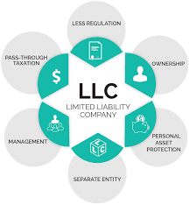
Figure 1 LLC Business
Source: (Elastpath, 2021).
An LLC structure aligns with strategic BrewGreen Cafe mission and values by:
- Enhancing credibility with customers, partners, and investors.
- Offering tax advantages along with operational flexibility.
- Attract potential investors for future growth opportunities.
The founder will manage the day-to-day operations and critical decisions; however, whenever necessary, input from outside advisors and experts will be considered regarding pertinent business strategies to ensure innovation and sustainability (Abubakar et al., 2019).

Staffing Plan
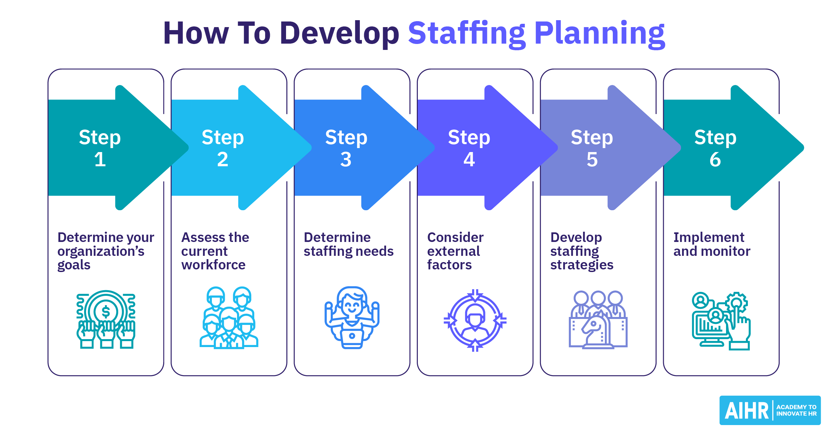
Figure 2 Staffing planning
Source: (AIHR, 2022).
The cafe will initially employ five team members:
The staffing plan is designed to optimise operations while adhering to financial constraints. BrewGreen Cafe will begin with a lean team structure, gradually scaling up as revenues increase.
Role | Number of Employees | Monthly Salary (Per Employee) | Total Monthly Cost
Baristas | 3 | £1,000 | £3,000
Cashier | 1 | £1,200 | £1,200
Manager | 1 | £2,000 | £2,000
Total | 5 |  | £6,200

Justifications:
- Baristas: Responsible for preparing and serving high-quality, sustainable beverages while engaging with customers to promote loyalty.
- Cashier: Handles point-of-sale systems, customer queries, and stock-level monitoring.
- Manager: Oversees operations, manages staff schedules, ensures smooth workflow, and aligns daily activities with strategic goals.
The plan ensures that staffing levels are scalable and adaptable, providing flexibility to reallocate funds for other operational needs as required.

External Expertise
To support the cafe’s operations, the business will engage the services of:
Designation | Role
Accountant | Accurate bookkeeping, tax compliance, and financial planning.
Legal Advisor | Ensure regulatory compliance, especially concerning food safety and labor laws.
Marketing Expert | Design and execute promotional campaigns that highlight the cafe’s sustainable practices, leveraging both traditional and digital platforms (Zhu, 2024).

Evaluation of the Business Idea
In order to evaluate the external and internal factors influencing the company, SWOT analysis can be conducted that would identify the strengths, weakness, opportunity and threats for the business.

Strengths
BrewGreen Cafe's primary strength lies in its commitment to sustainability. That is why the offer of organic coffee and products with environmental elements can fit the trend of a growing number of people’s conscious choice of ecological-oriented enterprises. This commitment does more than set BrewGreen apart from other coffee businesses; it also targets a population group with an increasing concern for the environment (Lingnau, Fuchs and Beham, 2019). Further, the cafe’s products like the retainable coffee holders or mugs and compostable packaging add value to the logo, hence attracting clients’ loyalty. The incorporation of rewards for more environmentally friendly customers also discourages the continued consumption of foods that harm the environment, building a population of clients who support the value of the cafés.

Weaknesses
BrewGreen Cafe has some significant advantages Nevertheless, BrewGreen Cafe has certain threats. The action of incorporating sustainability in the supply of the raw material will somehow affect the cost of each product and this will hit the profit lines since in the initial stages of its operation, the cost of sourcing sustainable supplies is relatively high (Bonini and Swartz, 2014). However, concentrating on the environmentally friendly audience only may contradict the broader client selection, which in turn influences the revenues. It was also noted that sustainability as a concept implies educating and engaging customers to embrace sustainable products they may not be interested in.
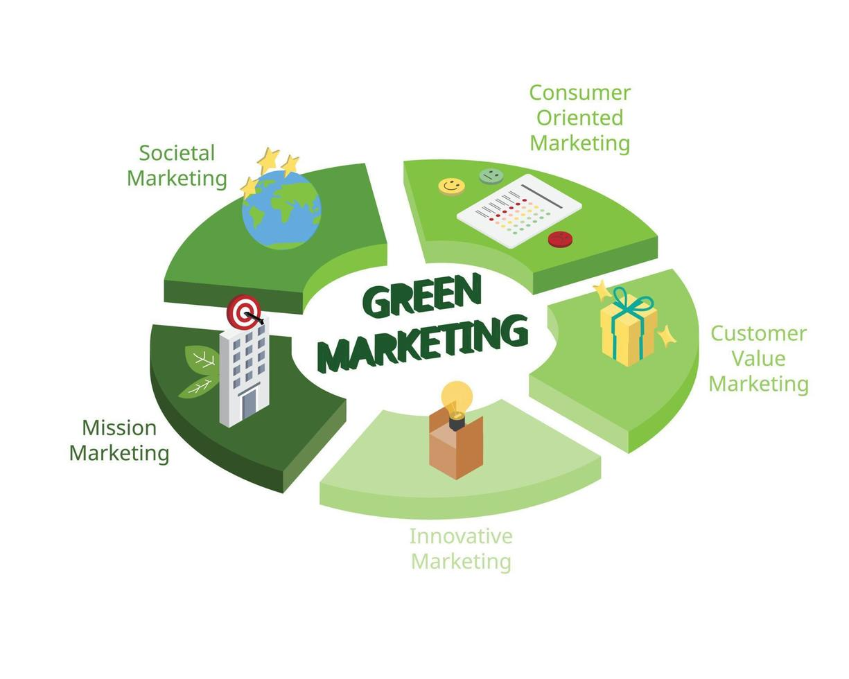
Figure 3 Green marekting
Source: (Veceetszy, 2022).

Opportunities
The current market presents several opportunities for BrewGreen Cafe. The choices show that local suppliers can be used not only to minimize costs but also to actively develop cooperation with the community and increase the profile of the cafe. Further, the government grants & incentives that are provided for environment-sustainable ventures can also be the source for supporting finance that boost growth and business expansion (Agrawal et al., 2023). Over the last few years, there has been a tendency towards the development of sustainable food services; therefore, the further establishment of BrewGreen as a unique and environmentally friendly cafe will be more beneficial in this environment.

Threats
There are threats that exist for BrewGreen Cafe to deal with. One threat is the competition with fully developed stores with better funding and awareness. Such competitors can easily benchmark on these identified sustainability practices eroding BrewGreen’s USP. Besides, changes in customer preferences can alter the forte of the cafe since consumers’ preferences for sustainable products may change. It also seemed that changes in the general economic conditions or the disposable income could impact consumer expenses on the premium and ‘green’ products.
Factor | Details | Strategies
Strengths | Sustainability focus attracts eco-conscious customers. | Highlight eco-products in marketing; expand reward programs.
 | Rewards for eco-friendly behavior build loyalty. | Partner with local eco-brands for promotions.
Weaknesses | High costs of sustainable sourcing affect profits. | Negotiate bulk discounts; source locally to cut costs.
 | Limited appeal to broader audiences. | Introduce affordable eco-options to attract diverse customers.
Opportunities | Local supplier partnerships reduce costs. | Secure contracts with local suppliers for cost stability.
 | Government grants support eco-businesses. | Apply for green incentives to fund expansion.
Threats | Competition from established brands. | Differentiate via unique eco-products; focus on brand storytelling.
 | Economic changes impact spending on premium products. | Offer flexible pricing tiers to maintain affordability.

Application of the 4Ps of Marketing
The 4Ps of marketing—Product, Price, Place, and Promotion—serve as a foundational framework for developing effective marketing strategies. For BrewGreen Cafe, an eco-friendly coffee shop, applying this model ensures alignment with its sustainability mission while meeting market demands.
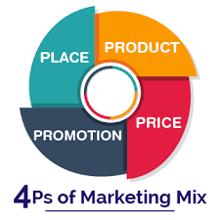
Figure 4 4 P's of marketing
Source: (Bywe, 2022).

Product
BrewGreen Cafe’s product focuses on organic products including coffee drinks and snacks to reflect the company’s conscience for the environment. The most common products are certified organic coffees and teas and veganism-friendly plant-based products on the menu. Packaging is environmentally friendly since it uses compostable items in the packaging in order to reduce the level of waste. Also, the cafe provides reusable mugs for taking coffee, as well as encouraging customers’ use by providing discounts for those who use them. This product strategy is relevant to today’s increasing consumer concern about environmentally friendly products.

Price
Costs used in BrewGreen Cafe bear the merits of organic and sustainable food items in the market. The prices are quite reasonable and competitive in the specialty coffee niche market, but slightly above the normal price to capture the cost of sourcing and packaging for environmentally conscious offerings. This, however, makes sense when choosing a premium pricing system because consumers are willing to pay a premium price for an environmentally friendly vehicle. However, providing customers with incentives for using their own mugs is beneficial in terms of building consumer allegiance to the cafe while at the same time being a strong signal to consumers about the company’s waste minimization goals.

Place
The location strategy focuses on urban areas with high foot traffic, particularly near universities and business districts. These areas are populated with students and professionals who are likely to embrace sustainable production and equally, have the income to afford the expensive coffee products. The timeliness of the services is also important for the customer experience and the interior of the cafe uses eco-friendly furniture to improve people’s well-being. This placement is intentional so as to make it easy for them to locate and access products by their targeted clients in order to ensure they lure and retain customers.

Promotion
Promotional strategy includes online marketing and community on social media to reach target consumers’ awareness. Promotion accounts on social networks describe the activities in the field of sustainability and nourishment that the cafe offers to its customers as well as share some entertaining and instructive content. Participation in social activities and sponsorship of conservation firms reinforce the position of the cafe as a green café. Promotions like free cups for coffee to consumers using their own tumblers encourage the use of environmentally friendly materials and also market the product to such consumers. This multilevel promotional approach results in creating a unique image of the cafe that emphasizes its key values (Freya Higgins-Desbiolles, 2015).
Promotion Activity | Description | Budget Allocation | Measurable Metrics
Social Media Marketing | Create engaging content about sustainability and nourishment on platforms like Instagram and Facebook. | £1,500 | Social media engagement (likes, shares, comments), follower growth.
Sustainability Awareness Posts | Share educational and entertaining content about eco-friendly practices. | £500 | Post reach, content interactions.
Community Participation | Sponsor conservation events and collaborate with local green initiatives. | £1,000 | Event attendance, partnership inquiries.
Incentive-Based Promotions | Free cups for customers using their own tumblers. | £500 | Number of redemptions, eco-practice adoption.
Total Budget |  | £3,500

Cash Flow Forecast for the First 12 Months

Startup Costs
Segment | Cost
Lease Deposit (3 months) | £3,000
Renovation and Interior Setup | £5,000
Equipment (espresso machines, grinders) | £4,000
Furniture and Fixtures | £2,500
Initial Inventory (coffee beans, teas, snacks) | £2,000
Licenses and Permits | £500
Marketing and Branding | £1,000
Miscellaneous Expenses | £1,000
Total Startup Costs | £19,000

Monthly Revenue Projections
Segment | Cost (£)
Employee Salaries (5 staff) | 6,200
Rent | 1,000
Utilities | 500
Inventory Restocking | 3,000
Marketing | 1,000
Miscellaneous | 500
Total Monthly Expenses | 12,200

Net Cash Flow
Month | Revenue (£) | Expense (£) | Net Cash Flow (£)
1 | 13,500 | 12,200 | 1,300
2 | 14,000 | 12,200 | 1,800
3 | 14,500 | 12,200 | 2,300
4 | 15,000 | 12,200 | 2,800
5 | 15,500 | 12,200 | 3,300
6 | 16,000 | 12,200 | 3,800
7 | 16,500 | 12,200 | 4,300
8 | 17,000 | 12,200 | 4,800
9 | 17,500 | 12,200 | 5,300
10 | 18,000 | 12,200 | 5,800
11 | 18,500 | 12,200 | 6,300
12 | 19,000 | 12,200 | 6,800

Reference list
Abubakar, A.M., Elrehail, H., Alatailat, M.A. and Elçi, A. (2019). Knowledge management, decision-making style and organizational performance. Journal of Innovation & Knowledge, [online] 4(2), pp.104–114. doi:https://doi.org/10.1016/j.jik.2017.07.003.
Agrawal, R., Agrawal, S., Samadhiya, A., Kumar, A., Luthra, S. and Jain, V. (2023). Adoption of green finance and green innovation for achieving circularity: An exploratory review and future directions. Geoscience Frontiers, [online] 15(4), p.101669. doi:https://doi.org/10.1016/j.gsf.2023.101669.
Bonini, S. and Swartz, S. (2014). Profits With Purpose: How organizing for sustainability can benefit the bottom line. [online] Available at: https://www.mckinsey.com/~/media/McKinsey/Business%20Functions/Sustainability/Our%20Insights/Profits%20with%20purpose/Profits%20with%20Purpose.ashx.
D.A. Tasci, A. (2017). Consumer demand for sustainability benchmarks in tourism and hospitality. Tourism Review, 72(4), pp.375–391. doi:https://doi.org/10.1108/tr-05-2017-0087.
Dorland, A. (2024). How are LLCs taxed? LLC tax benefits and ways to reduce taxes. [online] Tax & Accounting Blog Posts by Thomson Reuters. Available at: https://tax.thomsonreuters.com/blog/how-are-llcs-taxed-llc-tax-benefits-and-tips-to-reduce-taxes/.
Freya Higgins-Desbiolles (2015). A Taste of Sustainability: Case studies of sustainable cafes in Australia. ResearchGate. [online] doi:https://doi.org/10.13140/RG.2.1.1200.6882.
GOV.UK (2018). Data Protection Act. [online] GOV.UK. Available at: https://www.gov.uk/data-protection.
Hoory, L. (2021). Sole Proprietorship Vs. LLC: Here’s What You Need To Know. [online] Forbes Advisor. Available at: https://www.forbes.com/advisor/business/sole-proprietorship-vs-llc/.
Lingnau, V., Fuchs, F. and Beham, F. (2019). The impact of sustainability in coffee production on consumers’ willingness to pay–new evidence from the field of ethical consumption. Journal of Management Control, 30(1), pp.65–93. doi:https://doi.org/10.1007/s00187-019-00276-x.
White, K., Hardisty, D. and Habib, R. (2019). The elusive green consumer. [online] Harvard Business Review. Available at: https://hbr.org/2019/07/the-elusive-green-consumer.
Zhu, Y. (2024). Leveraging Social Media Marketing: A Case Study of Starbucks Digital Success. Advances in Economics Management and Political Sciences, 102(1), pp.199–204. doi:https://doi.org/10.54254/2754-1169/102/2024ed0108.

