
BA International Hotel Management
Operating Hotel Facilities
BMIH4006

Assignment Title: Component 3

Student ID: 2232071
Student Name: Rebecca Flavia Macavei

Table of Contents
Introduction 3
Attitude guidance training 4
Fitness training 5
Hygiene maintenance training 6
Guest Etiquette training 7
Health and safety training 8
Time management training 9
Operational training 10
Laundry training 11
Hotel equipment training 12
Performance management training 13
Conclusion 14
References 15

Slide 1
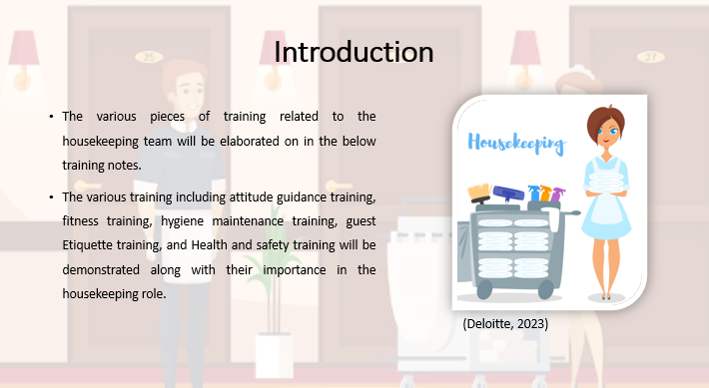

Introduction
Notes:
The various pieces of training related to the housekeeping team will be elaborated on in the below training notes. The various training including attitude guidance training, fitness training, hygiene maintenance training, guest Etiquette training, and Health and safety training will be demonstrated along with their importance in the housekeeping role. Along with that, other training related to time management, operational and laundry training and hotel equipment training will also be demonstrated by highlighting their importance in the hospitality sector.

Slide 2
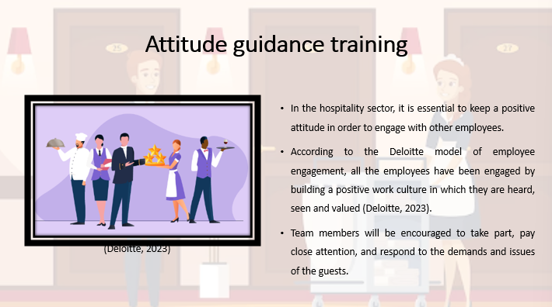

Attitude guidance training
Notes:
In the hospitality sector, it is essential to keep a positive attitude in order to engage with other employees. The training on positive attitude building will emphasise the importance of this approach to do each activity with passion and a sincere dedication to satisfying the requirements of the visitors. According to the Deloitte model of employee engagement, all the employees have been engaged by building a positive work culture in which they are heard, seen and valued (Deloitte, 2023). Team members will be encouraged to take part, pay close attention, and respond to the demands and issues of the guests.

Slide 3
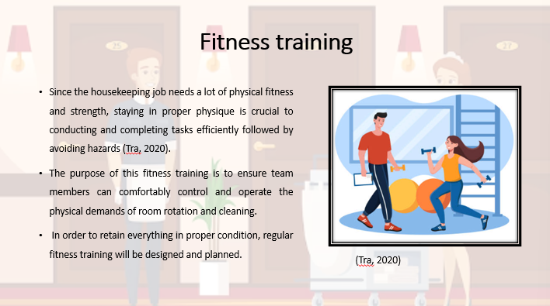

Fitness training
Notes:
Since the housekeeping job needs a lot of physical fitness and strength, staying in proper physique is crucial to conducting and completing tasks efficiently followed by avoiding hazards (Tra, 2020). Strength, adaptability, and physical endurance will all be enhanced through the training of physical fitness and stretches. The purpose of this fitness training is to ensure team members can comfortably control and operate the physical demands of room rotation and cleaning. In order to retain everything in proper condition, regular fitness training will be designed and planned.
Slide 4
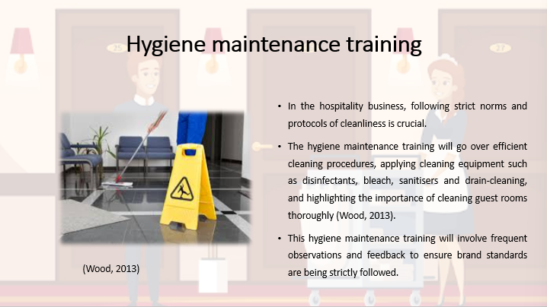

Hygiene maintenance training
Notes:
In the hospitality business, following strict norms and protocols of cleanliness is crucial. The hygiene maintenance training will go over efficient cleaning procedures, applying cleaning equipment such as disinfectants, bleach, sanitisers and drain-cleaning, and highlighting the importance of cleaning guest rooms thoroughly (Wood, 2013). Critical as well as high-touch surfaces will get additional care to minimise the threats of spreading infections and allergies. This hygiene maintenance training will involve frequent observations and feedback to ensure brand standards are being strictly followed.
Slide 5
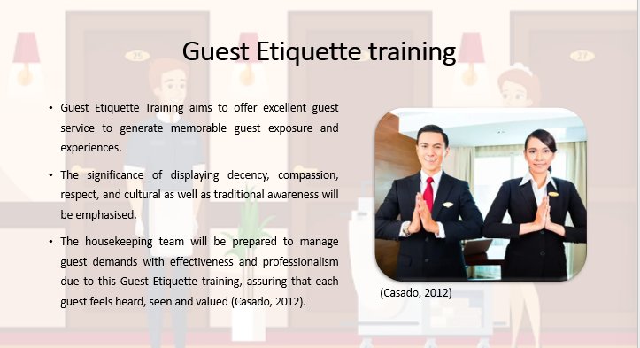

Guest Etiquette training
Notes:
Guest Etiquette Training aims to offer excellent guest service to generate memorable guest exposure and experiences. Staff members will get training on the different ways to welcome guests, address their issues and demands, and foresee their needs. The significance of displaying decency, compassion, respect, and cultural as well as traditional awareness will be emphasised. The housekeeping team will be prepared to manage guest demands with effectiveness and professionalism due to this Guest Etiquette training, assuring that each guest feels heard, seen and valued (Casado, 2012).
Slide 6
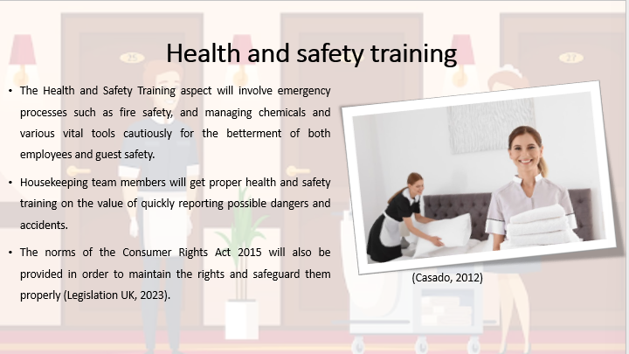

Health and safety training
Notes:
The Health and Safety Training aspect will involve emergency processes such as fire safety, and managing chemicals and various vital tools cautiously for the betterment of both employees and guest safety. Housekeeping team members will get proper health and safety training on the value of quickly reporting possible dangers and accidents. In order to remain updated with the laws and practices of both the regional government and hospitality sector, this health and safety training will be updated periodically. The norms of the Consumer Rights Act 2015 will also be provided in order to maintain the rights and safeguard them properly (Legislation UK, 2023). Routine checklists and continuous monitoring will foster a culture of safety and security.

Slide 7
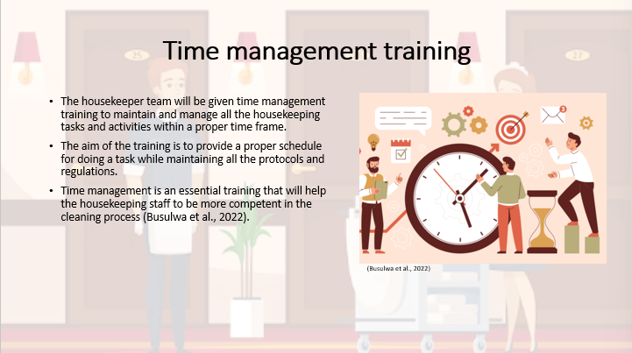

Time management training
Note:
The housekeeper team will be given time management training to maintain and manage all the housekeeping tasks and activities within a proper time frame. The aim of the training is to provide a proper schedule for doing a task while maintaining all the protocols and regulations. Time management is an essential training that will help the housekeeping staff to be more competent in the cleaning process (Busulwa et al., 2022). Time management skills will help the workers and staff to complete the whole cleaning process before the guest's arrival and after the guest checks out from the hotel. Time management will help the staff to increase their productivity.

Slide 8
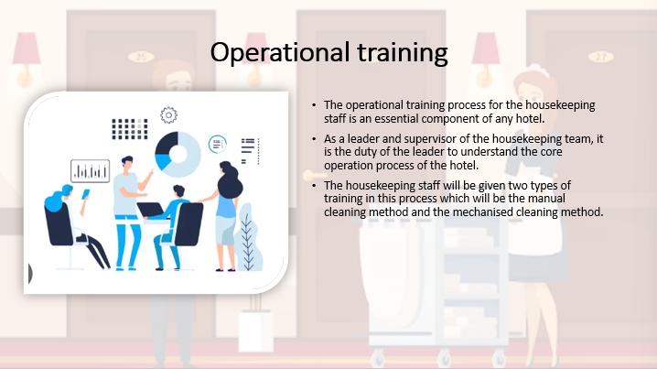

Operational training
Note:
The operational training process for the housekeeping staff is an essential component of any hotel. As a leader and supervisor of the housekeeping team, it is the duty of the leader to understand the core operation process of the hotel. The housekeeping staff will be given two types of training in this process which will be the manual cleaning method and the mechanised cleaning method. According to Deloitte's model of employee engagement, the workforce in the organisation should be developed professional well-being and therefore, it is very necessary to understand the operational process within the organisation (Alexakis and Jiang, 2019). The core operational training for the team will be working with co-workers efficiently and connecting with every department of the hotel.

Slide 9
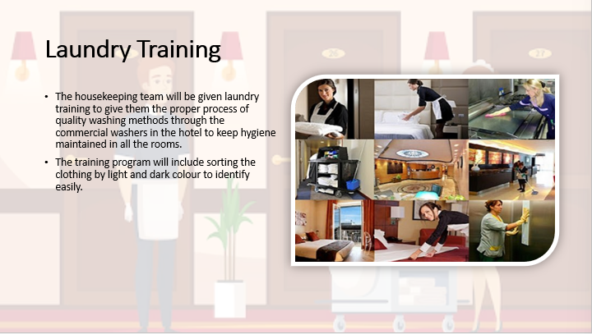

Laundry training
Note:
The housekeeping team will be given laundry training to give them the proper process of quality washing methods through the commercial washers in the hotel to keep hygiene maintained in all the rooms. The training program will include sorting the clothing by light and dark colour to identify easily. The training will be given to the team to place the clothes in the right way to avoid any hampering the clothes (Fallon & Rutherford, 2010). Pre-treatment training will be given to the staff to maintain the quality of the product. The management of the commercial washer with a visual time-setting technique will be provided to enhance the knowledge. The staff will be given training on friction, light pressure, application of suction and machine wash to enhance their skills.

Slide 10
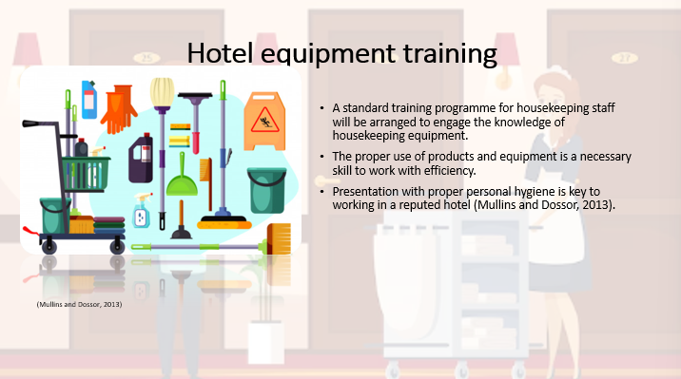

Hotel equipment training
Note:
A standard training programme for housekeeping staff will be arranged to engage the knowledge of housekeeping equipment. The proper use of products and equipment is a necessary skill to work with efficiency. Presentation with proper personal hygiene is key to working in a reputed hotel (Mullins and Dossor, 2013). In the training program high touch surface disinfection process, glass and mirror cleaning, bathroom tub and shower cleaning, carpet vacuuming technique and all the equipment that is necessary for the cleaning process in the hotel will be provided.

Slide 11
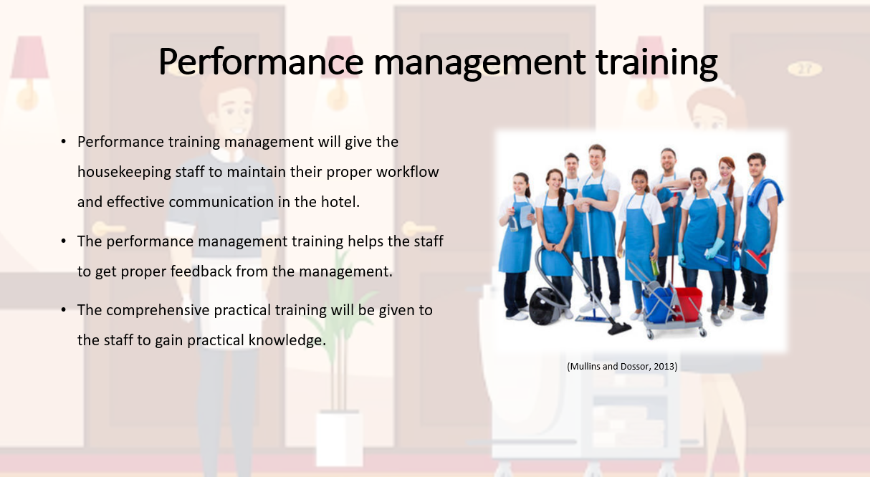

Performance management training
Note:
Performance training management will give the housekeeping staff to maintain their proper workflow and effective communication in the hotel. The performance management training helps the staff to get proper feedback from the management. The comprehensive practical training will be given to the staff to gain practical knowledge.

Slide 12
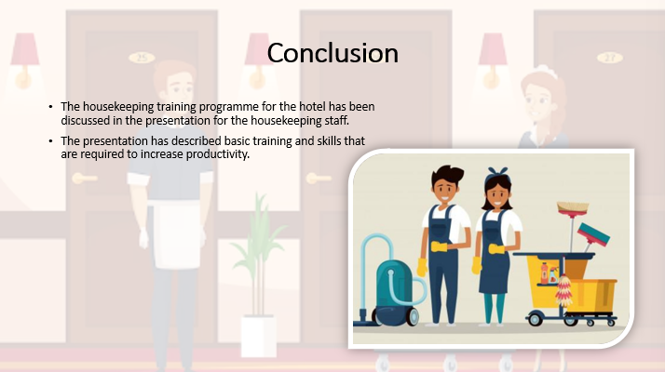

Conclusion
Note:
The housekeeping training programme for the hotel has been discussed in the presentation for the housekeeping staff. The presentation has described basic training and skills that are required to increase productivity.

References
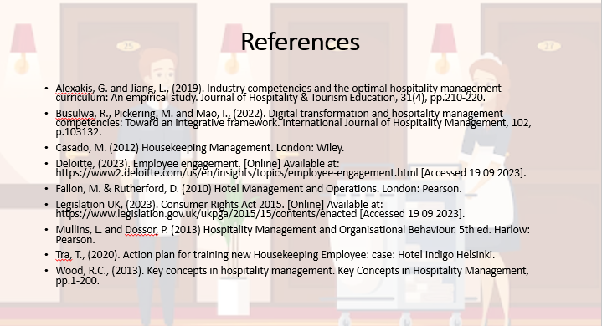
Alexakis, G. and Jiang, L., (2019). Industry competencies and the optimal hospitality management curriculum: An empirical study. Journal of Hospitality & Tourism Education, 31(4), pp.210-220.
Busulwa, R., Pickering, M. and Mao, I., (2022). Digital transformation and hospitality management competencies: Toward an integrative framework. International Journal of Hospitality Management, 102, p.103132.
Casado, M. (2012) Housekeeping Management. London: Wiley.
Deloitte, (2023). Employee engagement. [Online] Available at: https://www2.deloitte.com/us/en/insights/topics/employee-engagement.html [Accessed 19 09 2023].
Fallon, M. & Rutherford, D. (2010) Hotel Management and Operations. London: Pearson.
Legislation UK, (2023). Consumer Rights Act 2015. [Online] Available at: https://www.legislation.gov.uk/ukpga/2015/15/contents/enacted [Accessed 19 09 2023].
Mullins, L. and Dossor, P. (2013) Hospitality Management and Organisational Behaviour. 5th ed. Harlow: Pearson.
Tra, T., (2020). Action plan for training new Housekeeping Employee: case: Hotel Indigo Helsinki.
Wood, R.C., (2013). Key concepts in hospitality management. Key Concepts in Hospitality Management, pp.1-200.

