Course: Web Services
Instructor: Tim Bashford
Student: Yi Li
Student ID: 1904719

Content
Part 2 1
Design an API 2
Realize the project 2
Test API 5
Code analysis 6
Engineering realization 6
Code analysis 8
Part 3 9
Definition of serverless technology 9
Feature of serverless 10
Serverless life cycle 13
Application of serverless at this stage 13
circuit breaker pattern 15
Circuit breaker implementation principle in the web 15

Part 2
In WEB services, we often need to use APIs, so we need to learn how to design APIs. The current popular API design style is the REST API. Next, I will introduce what a RESTful API is and its characteristics and how to design it.

REST is an architectural approach and convention, and has nothing to do with the specific implementation, nor does it necessarily have to be Web-based. We generally refer to the Web Service using REST architecture as the RESTful Web Service. In actual project applications, we call this Web Service a REST-style Web Service. The reason is that when we deal with and solve some practical problems, this kind of Service may not fully strictly abide by all the necessary conventions of the REST architecture. RESTful is the currently popular API design specification for the design of Web data interfaces.

Its design principle for URL or API is to treat all operation objects as a resource, and the methods of operating these resources (nouns) are implemented through HTTP method types (verbs):

Design an API
The function desire to implement simple management of users, such as query, add, delete, update operations. The designed API is as follows:

//get all users information
GET /api/v1/users
//add a new user
POST /api/v1/users
//delete a user
DELETE /api/v1/users/{id}
//update user information
PUT /api/v1/users/{id}

Realize the project
I set up a Spring Start Project, then add SpringBoot Starter Web dependency module to my configuration file(pom.xml.
Add user properties class.
UserServiceController.java :
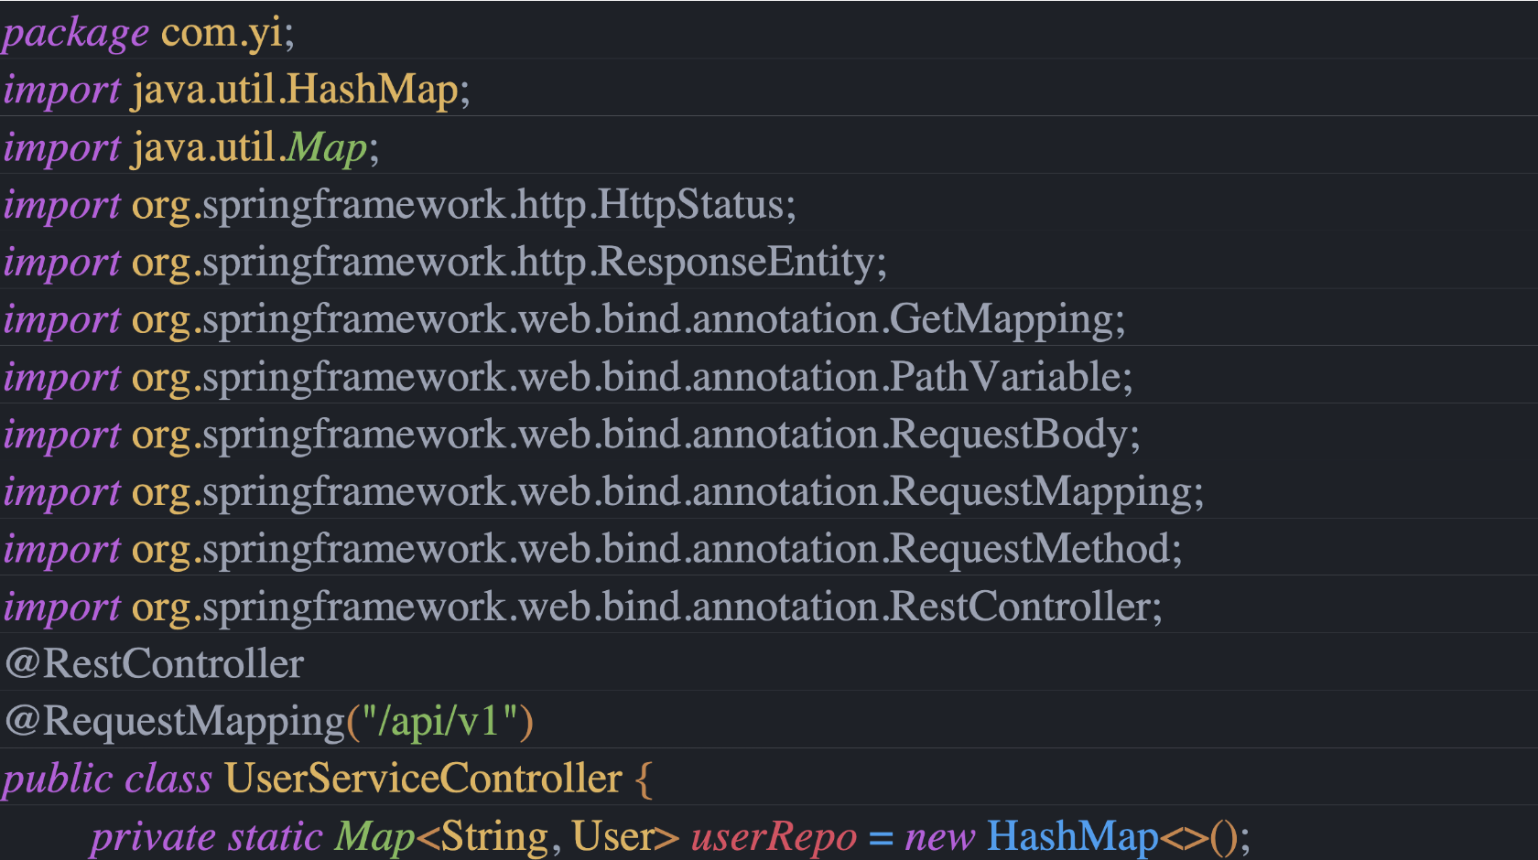
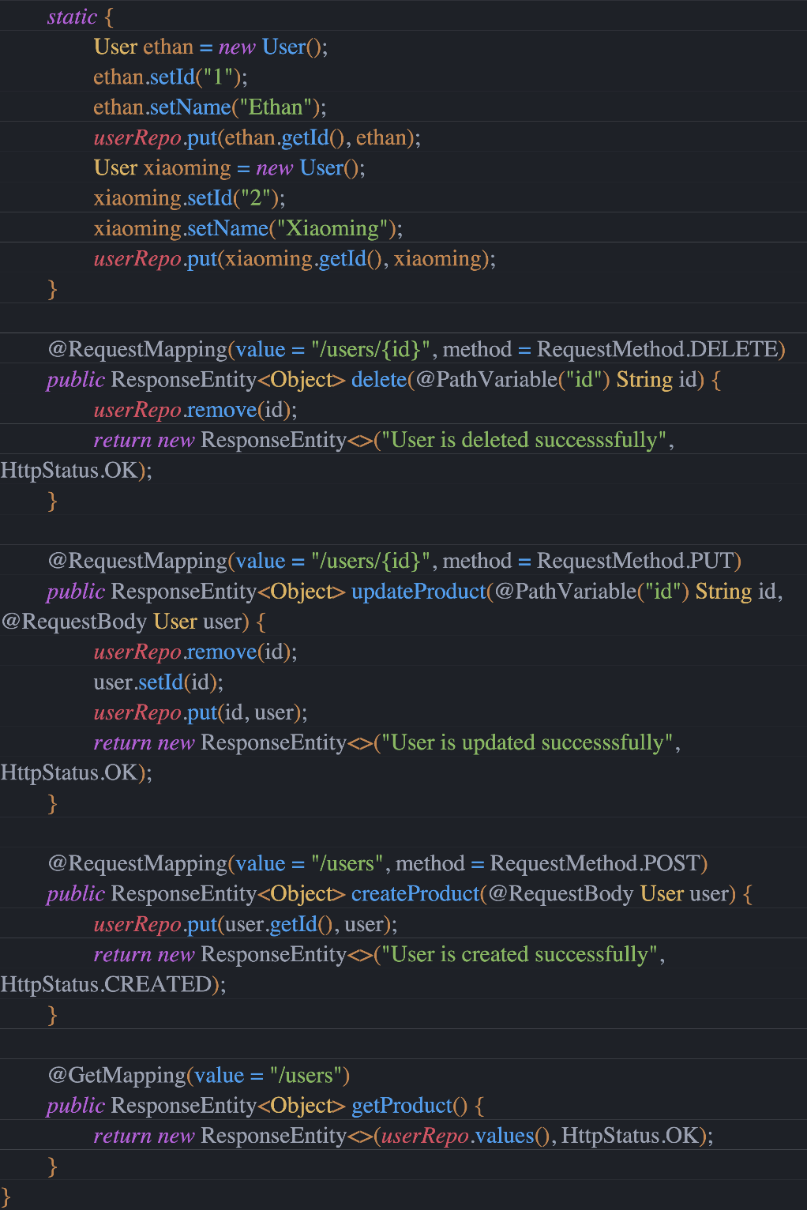
Add application class Test05HelloworldApplication.java ：

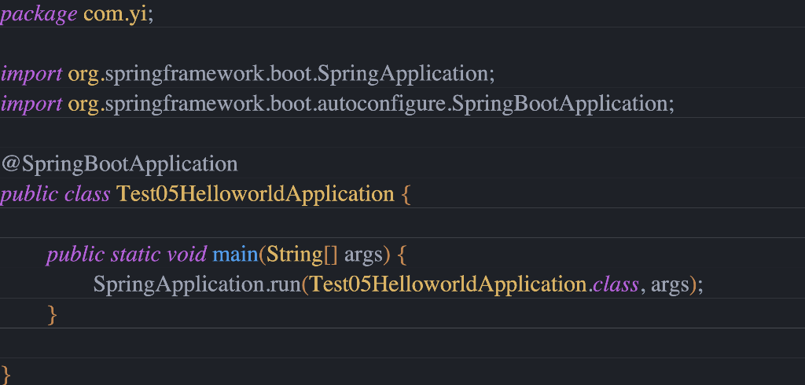

Test API
The compilation starts, and the actual RESTful APIs used are:

//get all users information
GET /api/v1/users
//add a new user
POST /api/v1/users
//delete a user
DELETE /api/v1/users/{id}
//update user information
PUT /api/v1/users/{id}

Use POSTMAN to test the functioning of the interface:
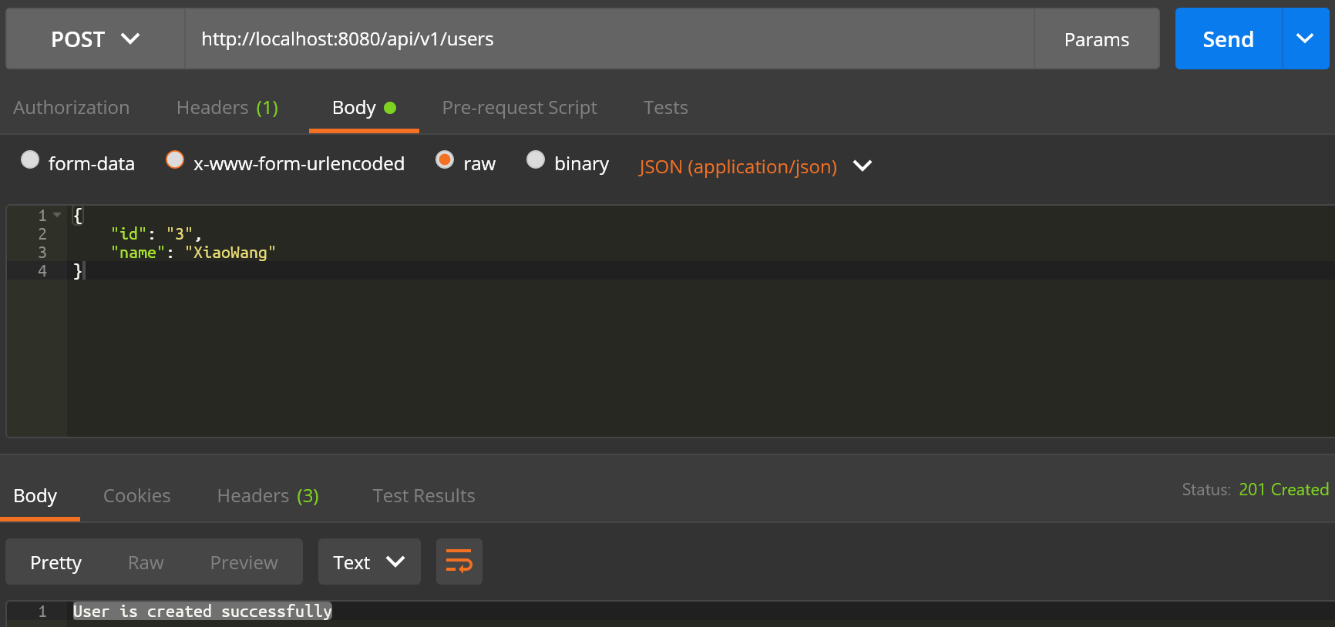
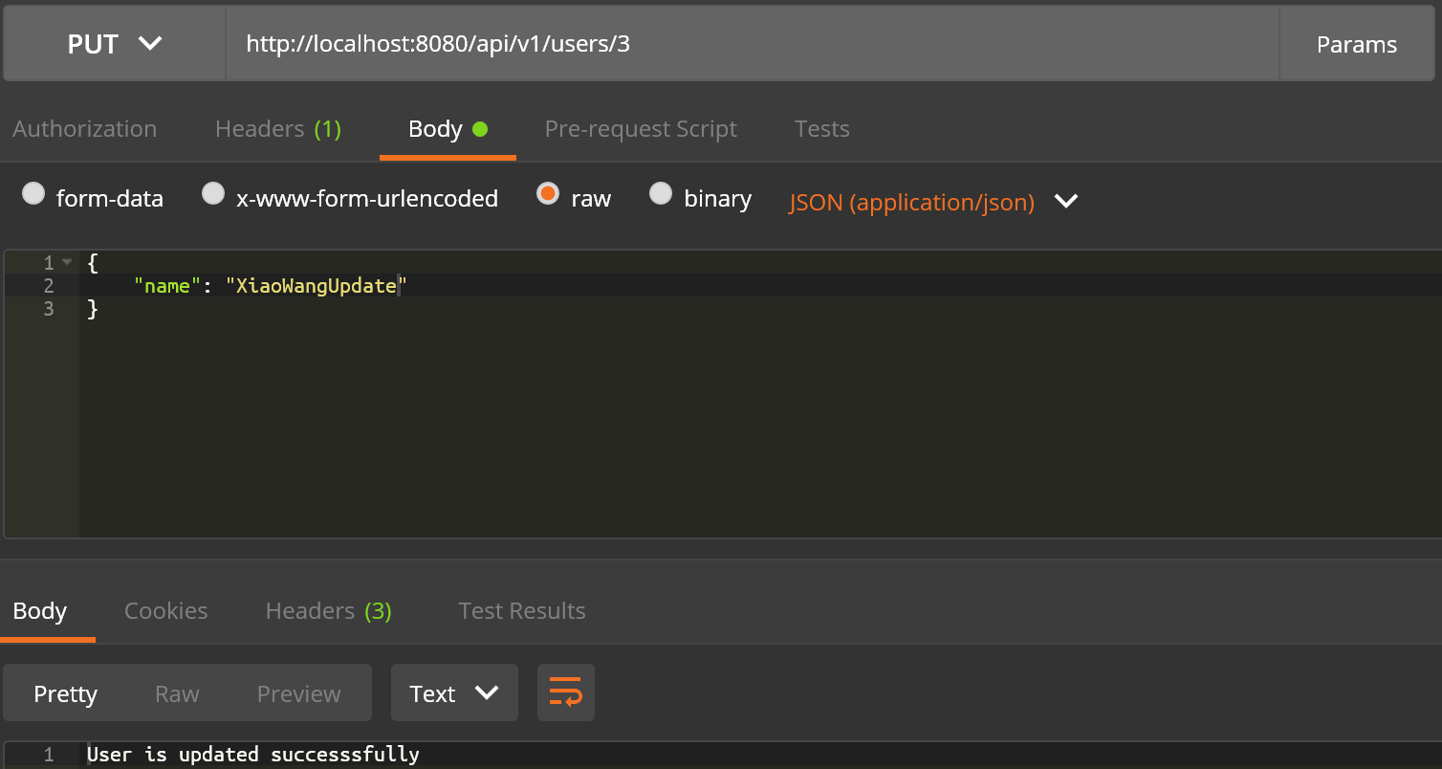

Code analysis
We know @SpringBootApplication = @Configuration + @ComponentScan + @EnableAutoConfiguration.
@ComponentScan scans all types of Components, such as Controller, Service, Repository.
@EnableAutoConfiguration will automatically resolve views, view resolvers, etc. @RestController is a comment added after Spring4. It turns out that @ResponseBody is needed to return json in @Controller.
If I directly use @RestController instead of @Controller, I do not need to configure @ResponseBody. By default, it returns json format.
@RequestMapping is used to configure url mapping, and now will be directly defined with the mapping annotations directly associated with Http Method, such as: GetMapping, PostMapping, DeleteMapping, PutMapping, etc.
@RequestMapping can be mapped to the entire class or a specific processing method In general, class-level annotations map specific request paths (or path patterns) to form controllers, and other method-level annotations act as specific HTTP request methods.
In the controller code, the / api / v1 is mapped to the entire User controller through @RequestMapping, and the specific method in the User controller is applied to the specified HTTP request method by @RequestMapping.

Engineering realization
The above simple RESTful WEB Service construction accesses and manipulates data through the Controller. For the MVC structure, there is obviously a lack of a Model to process data, and the logical processing isolation of the business is not enough. Simple WEB service requirements can also lack Model Yes, after all, this design is not very complicated, but the business is big. We need to reduce the coupling between the business logic and the upper view as much as possible, and increase the reusability of the module. Let's implement the MVC structure below.
First of all, we create a business operation interface UserService.java including the addition, deletion, inspection and modification of users:
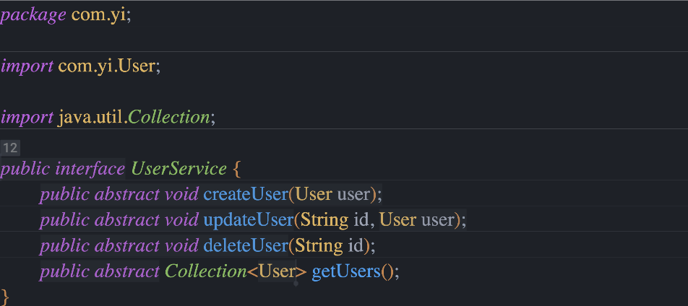
Create a component through @Service and modify users:
xiaoming.setId("2");
xiaoming.setName("Xiaoming");
userRepo.put(xiaoming.getId(), xiaoming);
}
@Override
public void createUser(User user) {
// TODO Auto-generated method stub
userRepo.put(user.getId(), user);
}
@Override
public void updateUser(String id, User user) {
// TODO Auto-generated method stub
userRepo.remove(id);
user.setId(id);
userRepo.put(id, user);
}
@Override
public void deleteUser(String id) {
// TODO Auto-generated method stub
userRepo.remove(id);
}
@Override
public Collection<User> getUsers() {
// TODO Auto-generated method stub
return userRepo.values();
}
}

Finally, use @Autowired in the controller class to assemble the Service interface and implementation.

Code analysis
Compared with the controller-only WEB service, the Model layer implemented by @Service is added here, and the entity of the UserService interface is connected through @Autowired：
There is also a mainstream writing method through the form of a constructor, and the final effect is the same:
UserService userService;;
@Autowired
public UserServiceController(UserService userService) {
this.userService = userService;
}

If UserService has multiple entity classes, I need to use @Qualifier to specify the name of the entity class:

@Service
@Qualifier("a")
public class UserServiceImpl implements UserService { }
@Service
@Qualifier("b")
public class UserServiceImpl1_1 implements UserService { }

Finally, specify the specific entity class name when automatically assembled in the controller:
// method 1
@Autowired
@Qualifier("a")
UserService userService;
// method 2
UserService userService;
@Autowired
public UserServiceController(@Qualifier("a") UserService userService) {
this.userService = userService;
}

Part 3
A recent report indicated that by 2020, 20% of enterprises worldwide will deploy a serverless architecture. This shows that serverless architecture is not just a buzzword, but a well-known cloud computing trend, and has set off a revolution in the software world. Large vendors (such as Amazon, Microsoft, and Google) have invested heavily in serverless architecture to catch up with the revolution. Contrary to its name, the serverless architecture does not actually remove the server. So, what exactly is a serverless architecture?

Definition of serverless technology
Serverless architecture means that applications use third-party functions and services, but do not need to manage the server. The serverless architecture mainly includes two aspects:
FaaS (Function as a Service, Function as a service): Stateless function containing server-side business logic. These functions run in separate containers, are event-driven, and are hosted by third-party vendors, such as AWS Lambda or Azure Functions.

BaaS (Backend as a Service): Use third-party services (such as Firebase, Auth0) to achieve the purpose. Applications that use BaaS are usually rich client applications, such as SPA or mobile apps. The client is responsible for handling most of the business logic, and the rest depends on external services, such as authentication, database, user management, and so on.

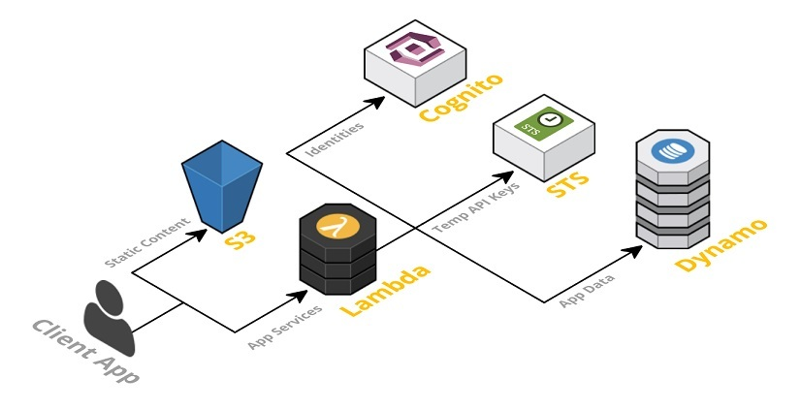

Feature of serverless
Using a serverless architecture can reduce server management costs, thereby reducing development and operating costs. Second, it has the characteristics of auto-scaling and can adapt to different development environments. Compared with servers that work continuously, it runs more secure services. In addition, the running cost of serverless is determined by the number of requests or events. During the development process, it has a simpler packaging and deployment process, which shortens the release cycle.

Serverless computing is very suitable for some applications, but there are some disadvantages to consider before entering the serverless deep end first. If you have been exposed to the cloud computing world, you may have heard of an increasingly popular service: serverless computing.

(1) Unable to maintain infrastructure

The debate about whether serverless architecture can implement virtual servers has always existed, but it only needs to be analyzed with a rational eye, and then serverless technology can be used.

The serverless computer service is a small piece of code for performing a single function. This technical architecture is on a server provided by a third party. As a client, we only have the authority to call this technology, and we cannot make any modifications to this architecture itself. Update.
(2) No charge when the function is not running

Compared with other cloud services, this technology greatly reduces the cost of server operation. Because it is only charged when it is running, this way, the operating cost will be greatly reduced during the server sleep time. This charging model allows developers to have more initiative and time flexibility in the process of development and operation.

(3) Unlimited expansion

The serverless platform represented by Google integrates the characteristics of unlimited expansion. In the actual development process, any development platform that uses serverless architecture technology can use this technology to expand its business.
This is another advantage of serverless technology. Developers do not need to occupy additional servers for new development platforms. Multiple development platforms can run on the same server, which also greatly reduces expenses and improves the use of resources. rate.

(4) Reduce delay
Related research shows that the use of serverless architecture can reduce the delay of customers in the terminal. In other words, when the customer accesses the resources in the database, the system decides to send the data on the server closest to the customer according to the customer's IP (or other characteristic value), which improves the customer's access efficiency and reduces the terminal delay.

(5) Reduce software complexity

I believe that many developers have experienced this. When running code on a local computer, the code depends on the software and hardware configuration of the local computer. Especially when performing certain tasks, many dependencies are required, which greatly reduces the portability and operability of the program.

The use of serverless technology has no such concerns. Because you only need to configure the relevant supporting code and dependencies required by the development platform, everyone can develop on this platform, reducing the operating threshold and improving development efficiency.
Disadvantages of serverless computing

(1) Incompatible third-party API
Vendor control, multi-tenant issues, vendor lock-in, and security flaws can all be caused by third-party APIs. Abandoning system control when implementing APIs may result in system downtime, forced API upgrades, missing features, unexpected restrictions, and cost changes. In addition, the multi-tenant problem also exists in other cloud computing frameworks.

Salesforce (PaaS) imposes some regulatory restrictions on its multi-tenant cloud structure, and developers must avoid related issues when using Salesforce. Specifically, multi-tenant solutions often have problems in terms of security, stability, and performance.

(2) Missing operating tools
Developers rely on vendors to provide debugging and monitoring tools. In general, the task of debugging a distributed system is very difficult, and usually requires access to a large number of related indicators to determine the root cause of the problem.

(3) The complexity of the architecture
Developers usually spend a lot of time evaluating, implementing, and testing specific features before they can finally decide how these features should be subdivided. The number of functions involved in one application call operation should be balanced. Too many management functions will undoubtedly make the problem more complicated, and ignoring the granularity will eventually cause the microservice architecture to become a "mini monolithic" architecture.
Currently, Lambda (a computing service provided by Amazon Web Services AWS, which can execute code in a massively parallel manner in response to events) has set a limit on the total number of concurrent executions that users can run on all lambda expressions. The problem is that this restriction applies to the overall AWS account. Some organizations will use the same AWS account for production and testing. This means that if a worker in the organization embarks on a new load test and attempts to execute 1,000 concurrent Lambda functions, the production application will immediately encounter a denial of service (DoS) situation.

(4) Difficulties in implementation
It is very difficult to integrate and test serverless applications. Compared with other system organizations, the integration unit of serverless FaaS (that is, each function) is much smaller, so we need to integrate a large number of units to complete the test normally. In addition, there are some issues related to deployment, version control, and packaging. You may need to deploy a corresponding FaaS component for each function in the overall logic application. This means that you cannot deploy a group of functions in an atomic manner, and because there is no concept of versioned applications, atomic rollback cannot be achieved. In this case, you may need to close any event source that triggers the corresponding function, deploy the overall function group, and then restart the event source.

Serverless life cycle
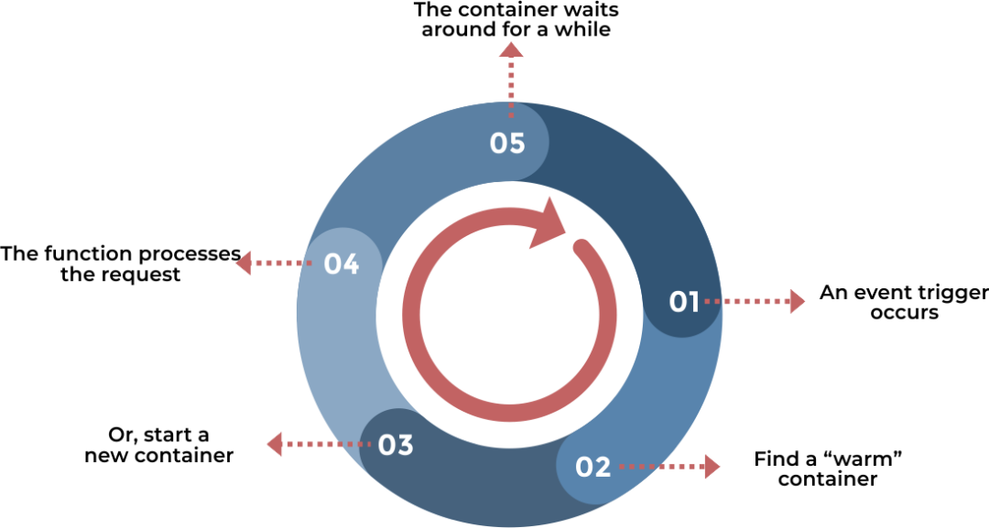

Application of serverless at this stage
Suppose there is a simple online car auction application in which the user can log in and bid, and the highest bidder gets the price at the end of the auction time.
Traditionally, the architecture will include a single server with applications and front-end deployed.
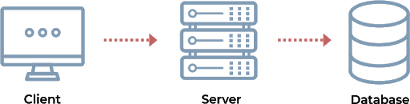
The above architecture uses a thin client approach, and all business logic (such as authentication, call back management, vehicle management, etc.) is deployed on the server side.
So, what would this application look like in a stateless microservices architecture?
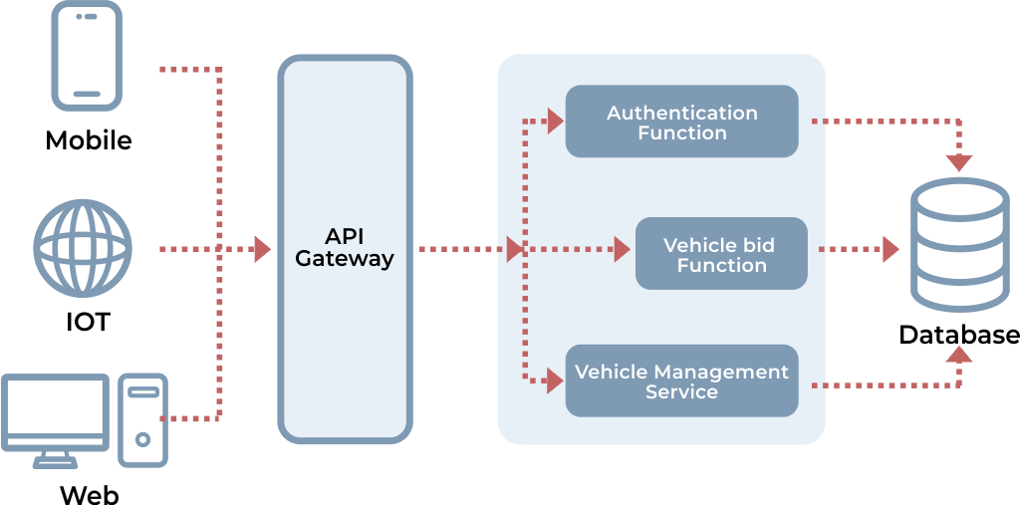
The original monolithic application was split into multiple server-side components.
• Authentication Function: This is a Function (Function, FaaS) used to manage user authentication (login).

• Vehicle management service: A microservice that handles vehicle-related operations, such as listing vehicles, viewing vehicle information, comparing vehicles, and so on. This service can be developed using any language or framework. It communicates with the database and runs independently.

• Vehicle bidding function: This is another function that also communicates with the database and enters the user bidding record.

• API Gateway: Entry point and reverse proxy for all services. The request from the client will reach the gateway first, and the gateway will redirect the request to a specific service according to the routing rules.

When splitting services into microservices or FaaS, you need to consider factors such as business logic, load, and scale.

The above example describes the general process of serverless architecture and the design of microservices based on serverless architecture.

In many cases, the serverless architecture can achieve better results than the traditional model, and it is cheaper and faster to implement. However, we must pay close attention to the above-mentioned disadvantages of this architecture, and strive to find solutions to deal with the above-mentioned drawbacks, in order to promote a more secure and stable development of serverless architecture.

circuit breaker pattern
The circuit breaker pattern is derived from Martin Fowler's Circuit Breaker article. "Breaker" itself is a switching device used to protect the circuit from overload on the circuit. When there is an electrical short circuit in the circuit, the "circuit breaker" can cut off the faulty circuit in time to prevent serious overload, heat, or even fire as a result of.
In a distributed architecture, the role of the circuit breaker mode is similar. When a service unit fails (similar to a short circuit in the electrical appliance), the fault monitoring of the circuit breaker (similar to a blown fuse) returns an error response to the caller Instead of waiting for a long time. In this way, the thread will not be released for a long time due to calling the fault service, and the spread of the fault in the distributed system is avoided.

In the microservice architecture, for example, to ensure the availability of the program, to prevent the program error caused by network congestion, a circuit breaker model has emerged. The condition of the circuit breaker reflects the availability and robustness of a program, and it is an important indicator. Hystrix Dashboard is a component of circuit breaker status, providing data monitoring and a friendly graphical interface

Circuit breaker implementation principle in the web

Hystrix circuit breaker
Hystrix has many features, including:
Protects the delay and failure of dependencies accessed through third-party client libraries (usually through the network).
Prevent cascading failures in complex distributed systems.
Failure is fast, recovery is fast.
Go back and downgrade as gracefully as possible.
Enable near real-time monitoring, alarms and operation control.
Of course, the circuit breaker model embodies these characteristics. Because Hystrix is ​​a library, it implements it in a white box.

Take the Online shop web application as an example. This application consists of different microservices, each of which is based on a characteristic:

Authentication
Directory browsing
Shopping cart management
Pricing and references
other
When the catalog item is displayed, the price of the pricing / quoting microservice will be queried. If it breaks, no matter whether it is a circuit breaker or not, the price will not be refunded, and it is impossible to order anything.

It provides a circuit breaker implementation that allows the fallback mechanism to be executed when the circuit is opened, thus implementing this method.

The Hystrix model is provided as follows:

The most critical place is the HystrixCommand method run () and getFallback ():

run () is the actual code to be executed e.g. get the price from the quote service
getFallabck () Get the fallback result when the circuit breaker is opened e.g. Return the cached price
This can be translated into the following code, using Spring's RestTemplate.

Start Hystrix in the Ribbon project
In the Ribbon project, we need to import the spring-cloud-starter-netflix-hystrix dependency in the pom.xml file.
<dependency>
<groupId>org.springframework.cloud</groupId>
<artifactId>spring-cloud-starter-netflix-hystrix</artifactId>
</dependency>

In the startup class of the Ribbon project, add @EnableHystrix annotation to open Hystrix.

@SpringBootApplication
@EnableDiscoveryClient
@EnableHystrix
public class RibbonApplication {

public static void main(String[] args) {
SpringApplication.run(RibbonApplication.class, args);
}

@Bean
@LoadBalanced
RestTemplate restTemplate() {
return new RestTemplate();
}
}

Then modify the welcomeService method in Service and add the @HystrixCommand (fallbackMethod = "error") annotation to specify the method to call when the circuit is disconnected. And add error method.

@HystrixCommand(fallbackMethod = "error")
public String welcomeService(String name) {
return restTemplate.getForObject("http://client/welcome?name="+name,String.class);
}

public String error(String name) {
return "Sorry，"+name+", error!";
}

Finally, we start the Service, Client, and Ribbon projects in sequence, visit
http://localhost:9003/welcome?name=YiLi and it appears:

“Sorry, YiLi, error!”

From this practice, I know that when access to the Client (program call API interface) fails, it will quickly fail to execute, and return to the content that the user wants to see when the error occurs. Instead of asking the user to wait until the access timed out, this very well controlled the container's thread blocking.

のののののののののののののののののののののののののののののののの

