The rise in
‘Ath-leisure Wear’

Christopher Williams (P145223)
University of Wales Trinity Saint David
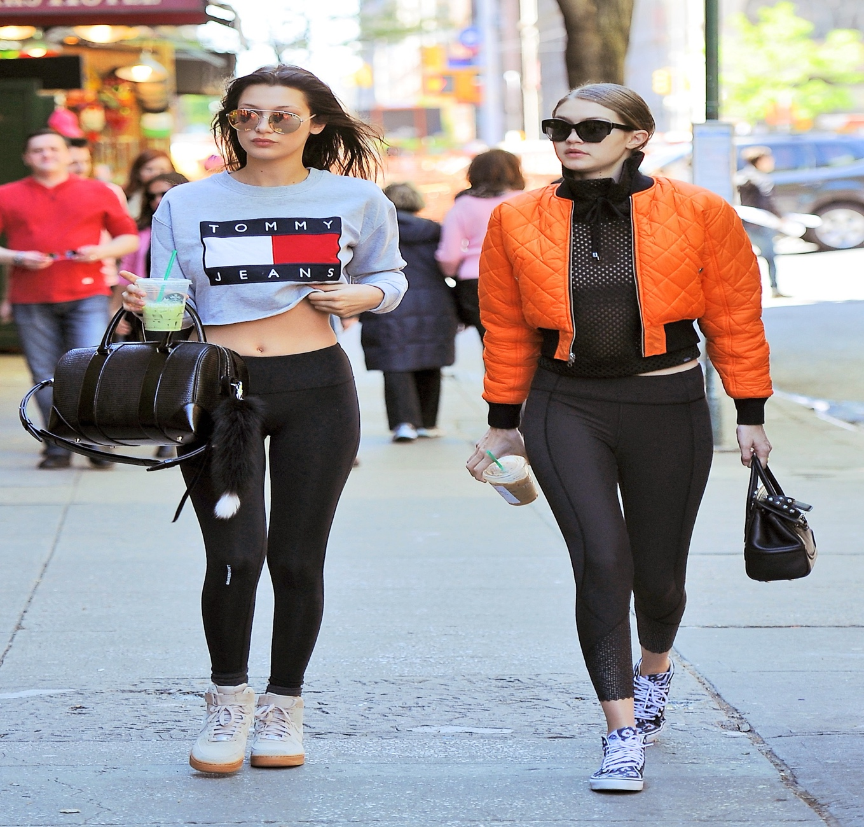

Executive summary
Is 'Ath-leisure' a trend or is it here to stay?

Ath-leisure combines sporty casual with business professional. To make a look that is both ready for the gym and good to go out and have fun. Many celebrities have got behind the fashion and are regular wearers of 'ath-leisure' wear. But is it ok to wear these type of clothes other than for the gym.

This report explores the many reasons why 'ath-leisure' has become so popular and discovers what retailers and brands do to ensure they maximize potential profits and exposure. Some things include marketing and the use of social influencers to promote their products and brands.

This report also looks into consumer’s perception and behaviors towards the trend. Whether or not their perceptions affect the way shops market and operate their businesses.

Is this trend made for women or is it made for everyone?

This reports explores all aspects of retail, marketing, business operations and social aspects that affect the growth of 'ath-leisure' wear.

Table of Contents
1.1 Introduction 4
2.0 Main body 4
2.1 Marketing 5
2.2 Social Influencer's 6
2.3 Consumer Perception 7
2.4 Retail 7
2.5 Women’s Apparel sales. 8
2.6 Business 9
2.7 Online Shopping 10
2.8 Social affects 11
3.0 Conclusion 12
4.0 Appendix 14
5.0 References 15

1.1 Introduction
Athleisure Wear came in to existence in the 1970s. (Oxford Dictionaries | English, n.d.) Merriam-Webster dictionary, defines ath-leisure wear as “casual clothing meant to be worn both for exercising and for general use.” (Forbes.com, 2016). Since then it has grown substantially and recently become worth a great amount of money. “Morgan Stanley has predicted a growth to $83 billion by 2020” from $44 billion in 2016 and out selling non-athleisure wear. (Forbes.com, 2016)

There are many reasons why athleisure wear has become so popular. Peoples motivations for purchasing clothes are different. Some people believe that these types of clothes make them stand out or even blend in as the norm. According to the CEO of Nike, Mark Parker said “Leggings are the new denim” (Salter 2015). If this was true it would mean that this phase isn’t just a trend, but a long-lasting staple to most people’s wardrobes.

Workout wear or athleisure wear has become more fashionable. Brands such as Nike and Adidas are making workout clothes that are seen as fashionable and practical at the same time. Ath-leisure wear can range in prices and most clothing companies have a range. Primark and Tesco could be seen as a cheap range. Wear Nike or adidas would be seen as mid-range. There are also many expensive brands for people with more money to spend on clothes.

The aim of this report is to identify and analyse some factors to why ath-leisure wear has become so popular. Some topics the author will discuss include: Marketing, Social Influencers, Consumer Perception and retail.

2.0 Main body

According to Forbes (2016) “Millennials are currently the largest demographic in the U.S. They now account for almost 80 million of the 319 million people living in the country”. This has a massive impact on who business people and marketers target. As there is a tremendous amount of people under the age of 19, than previous years. Fashion marketers have potentially a massive market to tap in to and focus on. Also these young adults have more disposable income to spend and are more likely to pay for £200 worth of ath-leisure clothes (Forbes, 2016). This may be the reason athleisure wear has been so popular recently.

Deirdre Clemente a professor in history states that ath-leisure clothing is a ‘weird hybrid’ of clothes that are seen as business acceptable and sporty material such as spandex and lycra to create clothes that look casual and professional but sporty and comfy as well (Green, 2017). An example being jeggings (Jeans and leggings combined). Todd Snyder, the former head of menswear at J.Crew told Business Insider “that he thinks athleisure is an "evolution," as opposed to a trend or fad”. He also thinks that it will at least be around for another 10 years (Green, 2017).

A big part to the success of the ath-leisure wear industry is the way they market their clothes.

2.1 Marketing
One major marketing campaign that has been very effective, is the use of social media platforms such as Instagram. Many new and well-known companies are using platforms such as this to market their new and existing collections. According to Armstrong (2016) “an Instagram-led cult around healthy living and “clean eating”, which has spurred 128,384 “athleisure” posts of so-called “yoga bunnies” posing in lycra, clutching green juices” This shows the amount of people use social media as a place to get ideas on how to dress and to follow the trends. Furthermore, many everyday users of Instagram are also posting pictures of themselves in outfits, thus advertising this type of clothing for free (Stampler 2012)

Due to the uncertainty of how long a fashion lines will stay popular, Brands and manufactures have to be flexible in terms of production and entering new lines into the market place (Surchi, 2011). Italy are one of the leaders in Europe in the textiles and fashion industry (Taplin, 2006). According to Eusebio et al (2007) Italy’s “textiles industry enjoys an overall turnover of more than 9 billion euros. Porter (1990) suggests that their success is due to the product innovation and differentiation. Also the quality of the service. Porter cited in Surchi (20ll) also states “Structurally, it is characterised by a large number of small firms, concentrated and localised in industrial districts, specialising in textile or apparel manufacturing, or both.” By setting up networks such as this. They have ensured that Italian fashion companies have kept the advantage of small size, flexibility, creativity and speed of reaction to market changes that bigger retailers struggle to do due to size of their operation and distribution channels (Djelic and Ainamo, 1999).

Fashion retailers have to be more innovative with the way they market and lay out their high-street stores. Most retailers stock well-known brands for a few reasons. One main reason is because it gets consumers into their stores (Ailawadi and Keller, 2004). Ailawadi (2004) also mentions “Manufacturer brands operate almost as “ingredient brands” that wield significant consumer pull, often more than the retailer brand does”. To do this, retailers have to save money and keep costs down. Some retailers spend massive amounts marketing these brands, creating positive images for their products and stores (Newman and Patel, 2004).

Retailers such as JD sports are a good example of creating a positive image from the brands they have on offer. This means they can charge more for the same brands that other retailers such as sports direct charge.

Sports brands including Nike and Adidas connect themselves to successful and/or popular sports teams, to create a positive brand image and publicity for their brand (CARLSON, DONAVAN and CUMISKEY, 2009). This technique is a popular way to get your brand seen by many potential customers, as its directed to the same market segment. Another company that does this are Under Armour. They have associated themselves with sports teams in America, since the late 1990’s. They have recently made a big impact in the UK making deals with Southampton, Tottenham Hotspur, Andy Murray and the Welsh Rugby Union among others (Cave and Miller, 2016).

Under Armor pride themselves in creating new technologies and staying on top of the pack in innovation. Peter Murray, Under Armour’s vice-president of global sports marketing, says “the firm focuses on providing “game-changing technologies” and “product innovations” to support performances of the sports teams and stars it partners” (Cave and Miller, 2016). According to cave and miller (2016) the strategy has worked and the company made a net profit of £2.74 Billion in 2015. This shows that these new technologies are helping make athletic wear more desirable, for people who want to be stylish and perform at their best while exercising and doing sport.

Successful brands such as Nike are good at target marketing and specifically looking at people who are interested or have previously been a customer. Research has shown that consumers like familiarity in the products they buy. They are also more likely to buy the same brand than trying a new one (Sung et al, 2016). Sports companies tend to target market to directly inform those likely to buy their products. This saves time, money and creates less work for these companies. This type of marketing is more successful and proven to work (Kotler, 2013).

2.2 Social Influencer's
Social influencers are a great way to promote and advertise many things such as products including clothing, health products and fitness equipment. Many companies pay celebrities or even normal people with quite a few followers to wear and promote their clothes and products. Celebrities and social influencers act as role models to the many people who follow them on social media platforms(Wiedmann, Hennings and Langner 2010).People are influenced by these individuals and will potentially buy the same things that they have.

High street Companies such as JD sports are utilising celebrities brand images to create collections for some of their clothing brands. Collections include Rita Ora’s Adidas range and Made in Chelsea star Lucy Watsons Puma collection. This strategy is working for JD sports and they have seen a rise in sales for their athleisure wear (Salter 2015). Rival company Sports Direct admitted that JD Sports had the “athleisure market sewn up” (Salter 2015).

Social influencers such as Beyoncé not only create collections with popular high street brands just to make money. Beyoncé stated during an interview with journalists from the telegraph (2016), that she wanted to create a collection because it meant a lot to her and she also felt the struggle to look her best. She said she felt there wasn’t any sports clothes that complimented her body the way she wanted. This type of story will relate to many females across the world and create a positive image for both Beyoncé’s brand image and her clothes collection with top shop. Publicity like this create a positive image for ath-leisure wear and boosts sales for the whole industry (Khatri 2006).

Sport celebrities are commonly used to advertise and promote products for companies to try and increase their product sales. Athletes are good at promoting products, especially athletic wear as they bring a positive image and they act as role models for potential customers and fans (LEAR,RUNYAN and WHITAKER 2009). They would believe if celebrities use the product then they should buy the same product. An example of this is Anthony Joshua. He has a sponsorship deal with under armor worth a lot of money. In return he appears in television adverts and links his name and sporting success with the brand (Aldridge, 2017).This creates brand awareness and creates a positive brand image for the sports clothing brand.

2.3 Consumer Perception

Within fashion these days many individuals try to follow the trends and buy clothes that put them in a certain social class. For example, the 'sweaty betty' brand of leggings is usually worn by individuals with a higher income to spend. This behavior was observed by Okonkwo, (2007) cited in HANSLIN, K. and RINDELL, A ( 2014) "The importance of possessing certain social standing and image among one's peers has become of greater significance and has increased the desire to own luxury products even among young consumers". This is being exploited by fashion retailers to increase their sales among certain target groups.

Previously, sports wear was worn by people at the gym or people who could not be bothered to get ‘dressed properly’ usually associated with the word ‘chav’. However, these days fashion marketers have put the term ‘Ath-leisure wear’ to create a trend that will create a buzz all around the world. Cat walks in Milan have since shown clothing lines that have included active wear (Marlow, 2016). Since then many business people even go to work in athleisure wear as it is seen as acceptable clothing.

According to Wray and Hodges (2008) cited in Chang et al (2015) “The high demand for active wear is influenced by lifestyle and disposable income”. With more people wanting to lead healthier lives and earning more money, they are taking part in more physical activity (Stamatakis and Chaudhury, 2008). Wray and Hodges (2008) also states “The steady rise in disposable income levels has also increased the quality, quantity, and frequency of sporting-goods purchases”. This shows with a higher disposable income and people living healthier lives, there is a higher chance of people paying for sporting apparel.

2.4 Retail

The fashion sector is very time based, with new fashion lines entering very frequently. This does not leave much time for brands and designers to make their mark on the fashion world. The use of ‘pop up shops’ has become very popular (SURCHI, 2011). Surchi states that the way people like to shop has changed from the traditional big retail shop, to a more unique and personal experience. That is where the ‘pop up shops’ come in. More places in the world are adopting this type of practice to increase their footfall and as a great marketing tool.

High fashion is also taking part of the ath-leisure sector. With more people wearing ath-leisure clothes for everyday activities, like shopping or going out for food, fashion designers are creating leggings and other clothing that is suitable for the gym while being highly fashionable and very popular with the younger generation. Active wear is also getting recognition with high fashion magazines and companies across the world. This is due to companies like Nike having a show on the Manhattan runway (Paton, 2014). Mr Parker of Nike estimates there is still growth in the sector and that leggings are becoming the new denim (Paton, 2014).

There are many factors that contribute to customers enjoying their experience at a store. Research shows that the way consumers think of their experience can impact on their future shopping decisions (Baker et al. , 2002; Pan and Zinkhan, 2006; Zentes et al. , 2008). For example, store attributes such as staff friendliness, and the price and quality of products can determine consumer satisfaction (Sivadas and Baker-Prewitt, 2000; Theodoridis and Chatzipanagiotou, 2009). Within sports shops it is important to find what market they are targeting. For example, mid-range or the higher end of the market.

Stores like sports direct sell the same clothes and products as any other sports shop. But what makes them stand out from their competitors is the fact they set their prices lower for the same product. They do this by not spending a lot of their budget on store arrangement or posh advertisement. Also most of their stores are in town centers, and they rely on high footfalls through their stores.

Other stores have a different philosophy when it comes to store layout and marketing. JD sports do the opposite to sports direct. JD sports concentrate a lot of their budget on marketing and promoting their popular brands and products. Their store layout is also well organized and concentrates on a minimal product line. Although more people may prefer JD sports layout, due to there being more space and less cluttered layout. They do charge more for their sport clothing compared to sports direct. The customers have to decide whether price is more important to them or being in a more relaxed and less cluttered shopping environment.

Clothing is not just restricted to specific clothes shops. These days supermarkets sell other products, and not just food. Shops have noticed that consumers like seeing other things within supermarkets and having an overall experience. Supermarkets believe if you make a ‘shop within a shop’ it entices customers to go and have a look, and maybe even have an impulse purchase. (Hart and Davies, 1996). Furthermore, Supermarkets including Tesco and Asda George, have an active wear range that is high quality and reasonably priced. Tesco and F&F recently launched a range of active wear, with Davina McCall (Symester, 2018). This shows they have noticed the need for a range for mothers and women who actually wants to be active in this ‘ath-leisure Wear’ while still looking good at the same time.

2.5 Women’s Apparel sales.

When considering the growth of ath-leisure and sporting apparel. It is important to focus on the main targets and products involved. In previous years clothing apparel sales were at its lowest. However, in late 2015 and early 2016 sales in apparel were on an increase and especially women’s apparel was set to take up 40% of total sales in the us (Anonymous, 2016). There are many reasons why the women’s clothing sector is so big and successful. It could be due to Women wanting to look their best and taking more pride in the way they look.

According to Kell (2014) sourced from Zhou (2017) “sales of female activewear totaled $15.1 billion in 2014, representing half of the U.S. activewear market”. This shows the demand for this type of female clothing is huge and very popular in the US and all over the world. Zhou (2014) suggests there are three product related factors that affect women’s purchasing. These are functional design, colour and size and fit. He also suggests there are two non- product related attributes (price and model imagery) and all these create fulfillment for females which are Mood enhancement, exercise facilitation, healthy and active lifestyle and physical fit body image.

This shows brands and manufactures have to work together to create new and innovative products that satisfy the female consumers wants and needs of a product. Previously, female active/ ath-leisure wear was not solely designed for women. They were basically men’s clothes made in a smaller size and in more feminine colours. Fashion insiders noticed more women are going out and exercising and needing better workout clothes, that not only are practical but fit their body proportions and make them look and feel good (Chitrakorn, 2017). As mentioned before, women’s apparel is becoming a lot more popular and brands are starting to notice.

2.6 Business

Business have to do many things on a day to day bases to survive as a company. These task are vital to the success or downfall of the company.

Jackson T and Shaw D (2001) state there are many things that are essential to shops that sell products such as clothes. These include:

Stock planning, management and control
• Spotting trends
• Analysis
• Relationship between stock and sales
• Use of technology such as EPOS systems etc

Forecasting is extremely important in the fashion industry (Rahman et al 2011). This is due to seasonal changes like weather and seasonal trends. People tend to buy clothes each season to suit the weather at that time of year. There are many ways to forecast trends and changes to what clothes are in or out (Rahman et al 2011). If no proper forecasting is done and all data collected is partial and not completed, then there is no clear evidence to show what clothes shops need to stock for each season. This is important when looking at sport apparel, as initially it was a trend but over the years it has become more and more popular. Which has made more brands and shops take more notice.

Another factor that is important to any business success is stock planning, management and control. According to Fisher and Vaidyanathan (2012) “Getting product assortment right isn’t easy, yet it’s absolutely critical to retail success”. This is due to them carrying research out that noticed when shops took out certain products, customers were not happy, and in some cases they took their business else where. Consumers like to have different choices of the same kind of product to compare and choose from. This also relates to clothing and ath-leisure wear, as there are so many types of leggings and sports top out there, people like to choose from a wide range to see what one they like best.

It is also important as well not to over stock and have too much of an assortment. Having too much will confuse the customer and create frustration which may stop them from purchasing anything (Fisher and Vaidyanathan, 2012). Getting the balance right is essential to optimizing sales success.

When choosing what stock to have in your shop, it is important to understand what attributes are important to your particular customers and clientele (Fisher and Vaidyanathan, 2012). In sports and ath-leisure wear shops it is important that they know what their clientele prefer and want. They get this data from previous sales report and then can analyse, what they think are their best sellers. So they can concentrate on the sale of these and not waste their time on products that they are unsure of how well they will sell. The most popular active wear includes leggings, yoga pants, sports tops and tracksuit bottoms.

Having the right amount of stock is also important to businesses. The worst thing for a customer is to see a pair of leggings or shoes you like, and for the shop not to have them in your size. The customer satisfaction level will go down and their opinion of the shop will also be lower. In shops these days they have modern computer systems that automatically update the system every time a product has been sold. This then will be easy to track what products are getting low in stock for the owner and manager to re-order more of that product before it runs out (Duff, n.d.).

Businesses are continuously trying to improve their supply chain, to make it more efficient and more cost effective. This has forced organizations to focus a lot of their attention on the supplier chain and supply chain management issues (Koblen, Balog and skurkova, 2014). A good example of a supply chain issues is the one KFC had. When none of their stores in Britain received any chicken. This meant they had to shut their stores, until they had a delivery (Weaver, 2018). This relates to all businesses as if they did not receive any of their products, they would have nothing to sell. This shows how important getting the supply chain right is to make a ath-leisure wear company a success.

2.7 Online Shopping
Clothes shopping has usually been just in shops. People used to make a day of it. Usually a group of friends would Go to a shop, try on what you like. If you still like it after you tried it on then you go to the till and queue to buy it. Then go for food afterwards. Since online shopping has come about, many people tend to buy online and get it delivered to their house. Companies can usually get it to you within a few days, in some case the next day. With shops offering a returns policy and offering memberships for free delivery or next day delivery (Kenna, 2017). It’s been made a lot easy for people to buy clothes and send back any they don’t like. They do not even need to leave the house.

There are positives to buying clothes online and buying clothes in the shop. According to Grant Arnott (2016) the positives of online shopping include “cost savings, broader choice, immediacy and convenience”. The benefits to buying in shops include “appeal for the face-to-face interaction, instant gratification of receiving goods upon purchase, and the tactile experience of physically interacting with product”. What makes a customer choose is what they perceive as the major benefit of purchasing online or in shop.

There are many positives to shopping online. However, when you can not find what you want it gets a little frustration and can lead to a person leaving the site. Big online stores are harder to navigate than smaller online shops and can mean big brand shops like Nike may lose custom online, due to the complexity of their site (Park and Kim, 2003). Also some shops, for example DW sports may have a type of leggings instore, but may not have them for online shopping. This means people would have to go to the store if they want a particular item. This technique could work and get people to shop in stores, but it could also deter from them shopping at that place at all.

One major positive of online shopping is the convenience of being able to shop anywhere. You can shop online anywhere as long as you have internet available. Most sites are protected very securely and are 100 percent save to buy things on (Business insider, 2014). People tend to enjoy the process of adding things to your basket and then at the end being able to take out any item you may not be sure about. Thing like this attract customers to online shopping for the ease of it.

Shops are starting to notice there is a place for technology within the shop as well. They believe new technologies will pull on the heart strings of consumers, and make fans be loyal to the store. Emerging technology will help make it easier to blend the physical and digital, to create an immersive experience to provide a better insight into customer behavior and intent (Unknown, 2016). This provides shops with great insights to be able to create an overall great experience.

2.8 Social affects
Athleisure’s popularity may be good for retailers and sports brands to make a lot of money, but how is it affecting people and families all across the world. Young children are Wanting to replicate their hero’s and role models by wearing leggings and a tight lycra tops (Finnigan, 2017). Most children wear these types of clothing not for sporting reasons, just because they see it as the norm and the way they think will look good. How will this type of thing affect these children as they grow up? Seeing their self-image as more important than other things such as health and fitness (Weingus, 2017). This can be detrimental to their future lifestyle and may create body image issues as they get older.

Although ath-leisure is a very popular fashion statement these days. Some people are still not convinced. According to Alex Proud (2016) if you go out in sports tracksuits and do not attend to take part in physical activity, it is sartorial short hand for being a ‘chav’. The way you dress is your individual choice. People’s perceptions of what looks good on them are completely different. What some people thinks looks ‘chavy”, some people may think looks cool and comfy. People use clothes to show their individuality and if they think ath-leisure clothes are good, then it is their choice.

3.0 Conclusion
Fashion gives people the chance to make a statement that represents who they are. Ath-leisure apparel started off as a trend but as mentioned above it is here to stay for at least the forcible future. It combines the sporty and casual with a more professional and trendy look. Ath- leisure is not just leggings but bomber jackets and jeggings. Brands and manufactures are being innovative and current with the way they design these clothes and making ath-leisure wear for all shapes, sizes and ages. This is why it is becoming so popular, as it is fashion for all.

With more people on the internet using social media platforms such as Instagram and twitter. It is making it easier for clothing brands and businesses to show off and advertise their new lines of ath-leisure wear. New ways of marketing using social influencers on social media to advertise clothes for companies is very effective. It is an easy way to get millions of people to see the clothes and what they look like on their favorite celebrities. This then may influence them to go on and purchase the same item. Another effective marketing tool noticed was direct marketing using emailing people that have previously used the website.

New innovation in product design, makes it attractive to potential customers. This is due to them wanting brand new and state of the art things. More and more companies are trying to stay ahead of the pack and create brand new clothing that not only works brilliantly in the gym, but looks good when you go for a coffee afterwards.

Many famous brands such as Under Armour have noticed that getting their brand name in the public eye is extremely important to getting more product sales. Under Armour sponsor many sports individuals and sports teams. This is because it not only creates a positive partnership but it links the Under Armour brand with a positive and successful sports image. Thus creating more product sales.

Ath-leisure is popular among people who want to start leading healthier lives. The sports clothes give them confidence in their ability to do exercise and thinking they look good while doing it. Ath-leisure wear gives people the sense of freedom. They believe these clothes look acceptable enough to do everyday things in, like shopping or going for food, and also gives them comfort in the materials used.

There are types of sport clothing to suit everyone. There are a range of prices, sizes and styles. High street stores are competing for limited consumers. The brands they stock can be extremely important to attract people to their shops. JD sports are excellent in choosing a few very popular brands but integrating them well instore to make them look attractive. Sports direct have more brands available that range from budget brands to more expensive ones. However, the way their stores are layed out makes it less attractive to shop at. Customers have to decide what is more important for them when they shop.

There are many things that can make a shop successful from forecasting, stock management and the supply chain. However, if you do any of these things wrong then it can lead to the businesses down fall as well. Modern technology makes these tasks a little easier and can help a business ensure that they do them correct. Another vital part to modern day business is having an online shop. Online shops make it easier for customers to search for clothes they like and purchase them from anywhere with the ease of a click of a button.

Ath-leisure wear is a very popular and influential trend, It is even starting to influence the way children want to look and dress. This could have a serious effect to the future society and the way children grow up. However, these clothes help people feel comfortable in themselves. This must be a good thing. With social media and celebrities embracing ‘Ath-leisure wear’, it may be a trend that stays for a little bit longer.

4.0 Appendix
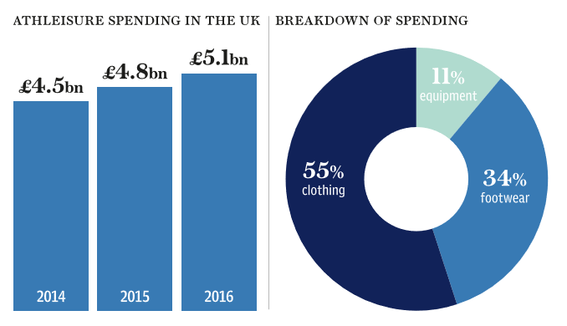

5.0 References

Ailwadi, K.L. and Keller, K.L. (2004), "Understanding retail branding: conceptual insights and research priorities", Journal of Retailing, Vol. 80 No. 4, pp. 331-42.
Aldridge, M. (2017). The 13 commercial sponsors helping Anthony Joshua cash in on success. [online] The Telegraph. Available at: https://www.telegraph.co.uk/boxing/2017/04/27/13-commercial-sponsors-helping-anthony-joshua-cash-success/ [Accessed 3 Apr. 2018].
Baker, J., Parasuraman, A., Grewal, D. and Voss, G.B. ( 2002 ), " The influence of multiple store environment cues on perceived merchandise value and patronage intentions ", Journal of Marketing , Vol. 66 No. 2, pp. 120 - 141 .

Business insider (2014). What Makes Online Shopping So Popular?. [online] Business Insider. Available at: https://www.businessinsider.in/What-Makes-Online-Shopping-So-Popular/articleshow/45690186.cms [Accessed 4 Apr. 2018].

Cave, A. and Miller, A. (2016). How sports sponsorship is driving exponential growth in brand awareness. [online] The Telegraph. Available at: https://www.telegraph.co.uk/investing/business-of-sport/promoting-leading-brands/ [Accessed 3 Apr. 2018].
CHANG, H.J., CHO, H.J., TURNER, T., GUPTA, M. and WATCHRAVESRINGKAN, K., 2015. Effects of store attributes on retail patronage behaviors. Journal of Fashion Marketing and Management, 19(2), pp. 136-153.

Chitrakorn, K. (2017). Global Sportswear Brands Making a Play for Women. [online] The Business of Fashion. Available at: https://www.businessoffashion.com/articles/intelligence/how-sportswear-brands-are-making-a-play-for-women [Accessed 4 Apr. 2018].

DEWSNAP, B. and HART, C., 2004. Category management: A new approach for fashion marketing? European Journal of Marketing, 38(7), pp. 809-834.

Duff, V. (n.d.). The Importance of Stock Control. [online] Smallbusiness.chron.com. Available at: http://smallbusiness.chron.com/importance-stock-control-66905.html [Accessed 4 Apr. 2018].

Djelic, M.L. and Ainamo, A. (1999), "The coevolution of new organizational forms in the fashion industry: a historical and comparative study of France, Italy, and the United States", Organization Science, Vol. 10 No. 5, pp. 622-37.

CARLSON, B.D., DONAVAN, D.T. and CUMISKEY, K.J., 2009. Consumer-brand relationships in sport: brand personality and identification. International Journal of Retail & Distribution Management, 37(4), pp. 370-384.

Oxford Dictionaries | English. (n.d.). athleisure | Definition of athleisure in English by Oxford Dictionaries. [online] Available at: https://en.oxforddictionaries.com/definition/athleisure [Accessed 6 Mar. 2018].

Forbes.com. (2016). Forbes Welcome. [online] Available at: https://www.forbes.com/sites/greatspeculations/2016/10/06/the-athleisure-trend-is-here-to-stay/#25547a8428bd [Accessed 6 Mar. 2018].

Forbes (2016). Forbes Welcome. [online] Forbes.com. Available at: https://www.forbes.com/sites/greatspeculations/2016/01/14/for-athletic-wear-vendors-how-athleisure-can-continue-to-grow-by-remaining-trendy/ [Accessed 3 Apr. 2018].

Fisher, M, & Vaidyanathan, R 2012, 'Which Products Should You Stock?', Harvard Business Review, 90, 11, pp. 108-118, Business Source Complete, EBSCOhost, viewed 4 April 2018.

HANSLIN, K. and RINDELL, A., 2014. Consumer-brand relationships in step-down line extensions of luxury and designer brands. Journal of Fashion Marketing and Management, 18(2), pp. 145-168.

HART, C. and DAVIES, M., 1996. The location and merchandising of non-food in supermarkets. International Journal of Retail & Distribution Management, 24(3), pp. 17.

Khatri, P. (2006). Celebrity Endorsement : A Strategic Promotion Perspective. Indian Media Studies Journal, 1(1), pp.25-35.

Koblen, I., Balog, K. and Skurkova, K. (2014). Supply Selection and Supply Chain Maturity - important areas of the quality production assurance. PRODUCTION ENGINEERING ARCHIVES, 5(4), pp.26-30.

Kenna, S. (2017). Easier Online Shopping Is Just A Click Away With These Simple Services. [online] HuffPost Australia. Available at: https://www.huffingtonpost.com.au/2017/10/09/easier-online-shopping-is-just-a-click-away-with-these-simple-services_a_23237866/ [Accessed 4 Apr. 2018].

Kell, J (2014) Nike makes a big push into the fast-growing women’s segment
http://fortune.com/2014/10/22/nike-women-business/ [October 22 Retrieved from]

Kotler, P. (2013). Marketing insights from a to z. Hoboken, N.J.: Wiley.

LEAR, K.E., RUNYAN, R.C. and WHITAKER, W.H., 2009. Sports celebrity endorsements in retail products advertising. International Journal of Retail & Distribution Management, 37(4), pp. 308-321

Marlow, B. (2016). Athleisure - an excuse to not getchanged or the saviour of the high street?. [online] The Telegraph. Available at: https://www.telegraph.co.uk/business/2016/09/13/athleisure-its-just-an-excuse-for-not-getting-changed/ [Accessed 3 Apr. 2018].

NEWMAN, A.J. and PATEL, D., 2004. The marketing directions of two fashion retailers. European Journal of Marketing, 38(7), pp. 770-789.

Okonkwo, U. (2007), Luxury Fashion Branding: Trends, Tactics, Techniques, Palgrave Macmillan, Hampshire.

Paton, Elizabeth 2014, ''Athleisure' knocks denim out of its stride - Nike and Gap's Athleta are among activewear groups toppling trends as they prove a winner with affluent Americans', Financial Times (London, England), 8 Nov, p. 11, (online NewsBank).

Pan, Y. and Zinkhan, G.W. ( 2006 ), " Determinants of retail patronage: a meta-analytical perspective ", Journal of Retailing , Vol. 82 No. 3, pp. 229 - 243 .

Phau, I. and Cheong, E. (2009b), "How young adult consumers evaluate diffusion brands: effects of brand loyalty and status consumption", Journal of International Consumer Marketing, Vol. 21 No. 2, pp. 109-123.

Porter, M.E. (1990), The Competitive Advantage of Nations, The New Press, New York, NY.

Park, C. and Kim, Y. (2003). Identifying key factors affecting consumer purchase behavior in an online shopping context. International Journal of Retail & Distribution Management, 31(1), pp.16-29.

Proud, A. (2016). Awful 'athleisure wear' is turning us into a nation of chavs. [online] The Telegraph. Available at: https://www.telegraph.co.uk/men/thinking-man/awful-athleisure-wear-is-turning-us-into-a-nation-of-chavs/ [Accessed 5 Apr. 2018].

Taplin, I.M. (2006), "Restructuring and reconfiguration: the UE textile and clothing industry adapts to change", European Business Review, Vol. 18 No. 3, pp. 172-86.

Truong, Y., McColl, R. and Kitchen, P.J. (2009), "New luxury positioning and the emergence of Masstige brands", Journal of Brand Managemen, Vol. 16 Nos 5/6, pp. 375-382.

The Telegraph (2016). Beyoncé talks about her athleisure brand Ivy Park and the pressure to be perfect. [online] The Telegraph. Available at: https://www.telegraph.co.uk/fashion/brands/beyonce-topshop-athleisure-brand-everything-we-know-information/ [Accessed 3 Apr. 2018].

Theodoridis, P.K. and Chatzipanagiotou, K.C. ( 2009 ), " Store image attributes and customer satisfaction across different customer profiles within the supermarket sector in Greece ", European Journal of Marketing , Vol. 43 Nos 5/6, pp. 708 - 734 .

Sowray, B 2016, 'First look at Beyonce's athleisure brand Ivy Park, launching with Topshop', Daily Telegraph, The/The Sunday Telegraph: Web Edition Articles (London, England), 31 Mar, (online NewsBank).

Salter, J. (2015). How workout wear became fashionable. [online] The Telegraph. Available at: https://www.telegraph.co.uk/fashion/style/fashionable-workout-wear/ [Accessed 26 Mar. 2018].

Sivadas, E. and Baker-Prewitt, J. ( 2000 ), " An examination of the relationship between service quality, customer satisfaction, and store loyalty ", International Journal of Retail & Distributions Management , Vol. 28 No. 2, pp. 73 - 82 .

Stampler, L. (2012). These Brands Are Doing Amazing Things With Instagram. [online] Business Insider. Available at: http://www.businessinsider.com/these-brands-are-doing-amazing-things-with-instagram-2012-6?IR=T [Accessed 27 Mar. 2018].

Sung, B., Vanman, E., Hartley, N. and Phau, I. (2016). The emotion of interest and its relevance to consumer psychology and behaviour. Australasian Marketing Journal (AMJ), 24(4), pp.337-343.

Symester, C. (2018). Davina McCall and Tesco F&F clothing launch new stylish active wear collection. [online] mirror. Available at: https://www.mirror.co.uk/3am/style/celebrity-fashion/davina-mccall-tesco-ff-clothing-11784554 [Accessed 3 Apr. 2018].

Unknown (2016). 5 Creative Ways Stores Are Experimenting With Immersive Retail Experiences. [online] Retail Marketing Blog - Retail News, Trends, Store Tips, and More by Shopify. Available at: https://www.shopify.com/retail/127297923-5-creative-ways-stores-are-experimenting-with-immersive-retail-experiences [Accessed 4 Apr. 2018].

Wiedmann, K., Hennigs, N. and Langner, S. (2010). Spreading the Word of Fashion: Identifying Social Influencers in Fashion Marketing. Journal of Global Fashion Marketing, 1(3), pp.142-153.

Wray, A.Z. and Hodges, N.N. ( 2008 ), " Response to activewear apparel advertisements by US baby boomers: an examination of cognitive versus chronological age factors ", Journal of Fashion Marketing and Management, Vol. 12 No. 1, pp. 8 - 23 .

Weingus, L. (2017). Why Women Spend Hundreds On Athletic Clothes They Don't Actually Wear To Work Out. [online] HuffPost UK. Available at: https://www.huffingtonpost.co.uk/entry/athleisure-workout-clothes-not-working-out_n_6323520 [Accessed 5 Apr. 2018].

SURCHI, M., 2011. The temporary store: a new marketing tool for fashion brands. Journal of Fashion Marketing and Management, 15(2), pp. 257-270.

Zentes, J., Morschett, D. and Schramm-Klein, H. ( 2008 ), " Brand personality of retailers: an analysis of its applicability and its effect on store loyalty ", The International Review of Retail, Distribution and Consumer Research , Vol. 18 No. 2, pp. 167 - 184 .

