

Student Name | Joseff Williams
Student Number | P152113
Module Code | ACBA5010
Programme | HND PCM

Assignment Title

Energy Efficiency

Submission Deadline | 28/011/2019
Word Count | 1250 +/- 10%
Contribution | 25%
Lecturer | Juan A Ferriz-Papi

Table of Content

- Introduction
- Body of written work
- References
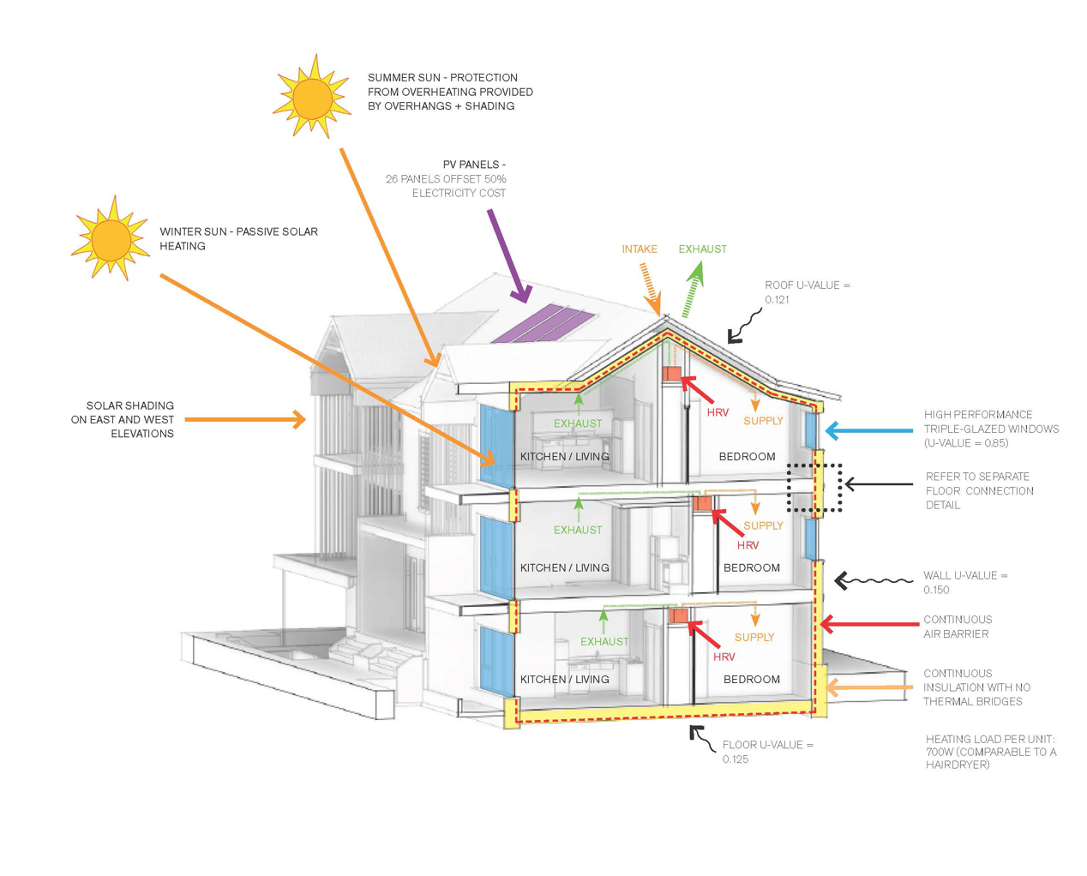

- Introduction
With buildings, construction and operations accounting for roughly 36% of global energy consumption and almost 40% of energy related CO2 emissions, these industries are a key factor of global warming due to the sector size and the output of energy consumed. (Birol, 2017)

The energy efficiency of a building is when the energy consumption per m2 of floor area within the building is measured to determine energy consumption for the particular building and type of construction used under a certain climatic condition.
Energy efficiency is the utilisation of using less energy to provide the same outputs of power, heat and light.

Increasing the energy efficiency of a building will benefit the owner by reducing the monthly operating costs and helping to lower fuel consumption reducing the release of greenhouse gasses, helping to prevent climate change.

Modern technologies, policies and build systems help incorporate new ways to preserve energy throughout the construction and life cycle of the building.
Ways energy efficiency can be improved:
- Developing more efficient building products and processes
- Taking into account the full life-cycle of a building, including disposal.
- Developing controls and systems to increase efficiency.
- Auditing energy consumption, providing advice on technologies and practices.
- Retrofitting or replacing in-efficient energy producing technologies.
- Adding renewable sources of energy to power buildings.

Another way to minimize the operating cost of powering a building is by using methods of renewable energy such as solar power, wind energy, geothermal and biomass energy. Renewable energy is sometimes referred to as clean energy as it comes from natural sources or processes that are constantly replenished e.g. Sunlight and wind.

A Hybrid system will use the active solutions to assist passive measures e.g. heat recovery ventilation, solar thermal systems and ground source heat pumps. In this design I will look to optimise the passive solutions before looking to incorporate hybrid systems or active systems.
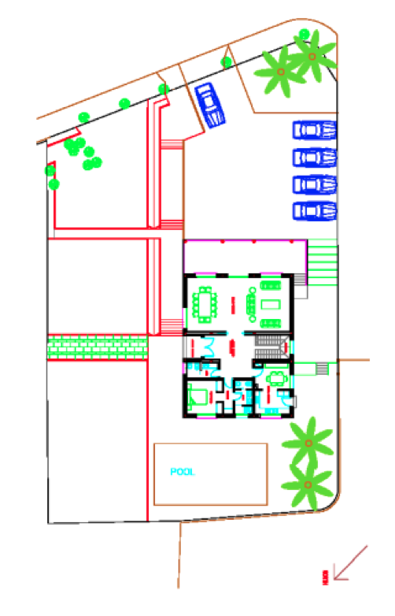
- Body of Works

There are many things we can design in and out of buildings to get maximum efficiency for its intended use. I will be reviewing various passive and active solutions in the adjacent house design and coming up with various solutions and options to consider for the building.

A well-designed energy efficient building will provide years of optimisation whilst reducing the amount of energy consumed.

Orientation of a Building
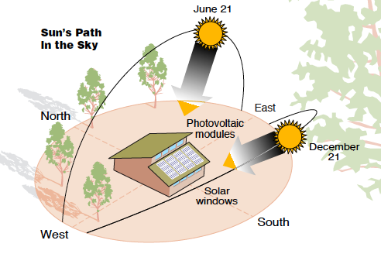
The site and orientation of a building plays a key role in the early stages of any development. For this house situated in the UK I would suggest the main living spaces and larger triple glazed areas to be south orientated to maximise the solar radiation and solar gains from the natural sunlight throughout the day creating a source of heat and light.

The bedrooms and smaller glazed areas would be best suited facing north to allow shading because these spaces are commonly used at night when the sun has gone down. All windows should be installed with triple glazed units.

Natural Shading of the Building

Sun control and modern shading devices should be installed to help reduce the heat gain and cooling requirements of the building in the summer whilst improving the natural lighting quality of the building’s interior in the winter.
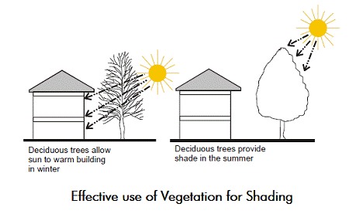
It has been reported that depending on the amount and location of fenestration, there has been a 5%-15% reduction in energy consumption for cooling in a building.
(Prowler, 2016)

Architectural Shading – This can provide an interest in external appearance of a building façade. The size of the overhang depends on the window size.

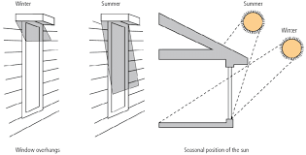
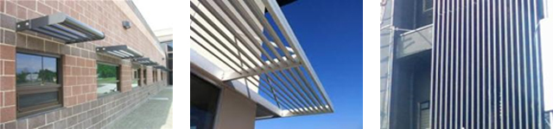

Other methods of solar protection and shading I would recommend include:
- Internal Persian blinds
- Architectural Fabrics E.g. Sail shaped material
- Awnings attached above openings

As well as the control measures above I would suggest utilising modern technologies such as transparent solar panels, this new form of solar panel has provided a new way to create energy through a section of glass that is clear meaning they can be installed for windows, curtain walling, various facades and skylights adding more benefits than the standard glass windows.

Natural Ventilation Solutions
Ventilation is important in buildings as it allows the old air to be replaced with new ‘fresh’ air helping to moderate internal temperate & humidity, replenishing oxygen and reducing dust.

Passive Natural ventilation is a popular option in helping to reduce energy use, reducing mechanical costs and providing a more acceptable indoor environmental quality. In appropriate build types and climatic conditions, natural ventilation as an alternative to air-conditioning can save up to 30% of total energy consumption of a building. (Walker, 2016)

For the design of this project incorporating a full height atrium at the staircase from the ground floor up to the first floor. This would enable stack ventilation to work by having positive air pressure high level and a negative air pressure at the ground. This process can work without having any mechanical extracts, instead a window opening low level and high level allowing air to pass through.

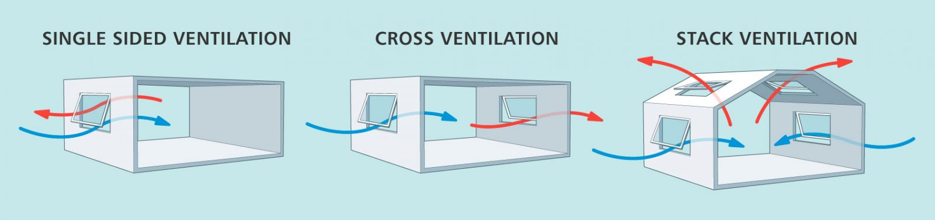
A shallow house design will enable cross ventilation cooling throughout the house and fresh air circulated around the building. Simple features such as trickle vents installed to the windows will allow the building to have a constant flow of fresh air circulating the building.

I would suggest the ground floor layout to be mostly open-plan helping to reduce the amount of lighting, heating systems and services needed to be installed within wall space. Standard rectangular buildings will generally have less heat escaping through the external walls due to the reduced surface of perimeter walls.

Design Envelope

Typical wall, roof and floor structures in an energy efficient (Passive House) building should be designed to achieve a U-value rating up to 0.15W/m$2$K, regardless of the different construction methods used to achieve this with minimal thermal bridging. (Trust, 2019)
Building Regulations Part L stipulates that for a new building, the elements must have maximum U-value of 0.3W/m$2$K for walls, to hit a U-value of 0.30 a 90mm board of Expanded Polystyrene will be used, the thicker the insulation to lower the U-value.

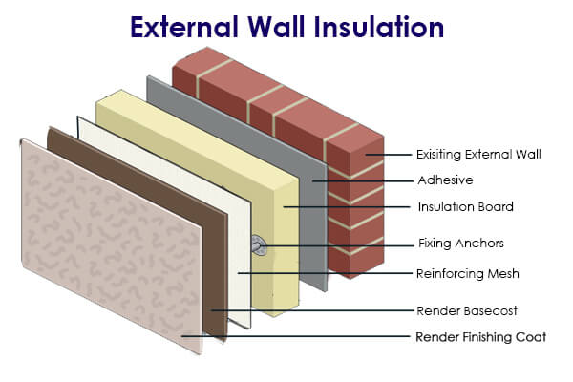
My chosen design type is solid blockwork with external insulation and render system. The reason I have chosen this method is because blockwork is a standard method of construction known by many and the fact external insulation allows a full air tight ‘wrap’ of the building ensuring minimal passage of heat through the external walls.

Another reason I have chosen this system is because the structure and insulation of the building are two separate identities meaning thermal bridging can be minimised. Using external insulation allows a visual inspection when installed to check all areas have been adequately sealed. (Insulation, 2018)

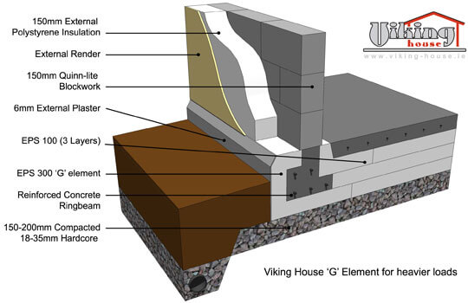
For the ground detail I have chosen to use an insulated floor slab to prevent any cold bridges at the floor junction as there is a lap of external insulation being able to combine into the floor insulated slab creating a full wrap at the ground.
(O'Loughlin, 2013)

The max U-values for the floor fabrics are 0.25.

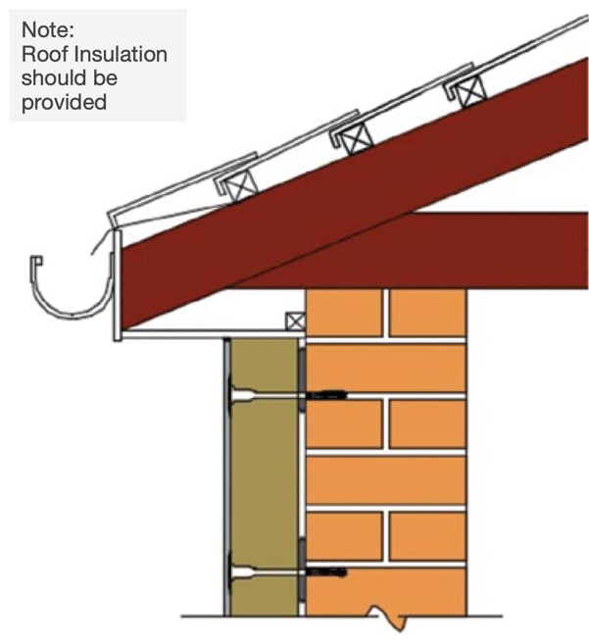
The roof structure I have chosen to use is a typical cold roof with timber trussed rafters due to the fact they are a common roof type, are in-expensive and easy to install.

Bob tail trusses (as below) enable a continuous thermal bridge free junction allowing the insulation to join from the roof to external wall.



Although there may be minimal thermal bridging from timber braces within the trusses penetrating the insulation layer, there shouldn’t be any air movement within the roof space due to a high quality vapour membrane beneath the slates.

Thermal Bridging
In a building that is trying to achieve a high energy efficiency specific attention is required at standard junctions and interfaces where thermal bridging might be an issue, it is at this point where heat loss is most beneficial and can occur through materials creating a thermal bridge. Internal surfaces that have a thermal bridge might result in being damp / cold and create surface condensation and mould growth. Thermal bridges can increase fabric heat loss by over 30%.

Ways to tackle thermal bridges in a property:
- Minimise complexity in the design
- At junction’s insulation should meet without any gaps and should be taped up to prevent air leak
- Insulation should join without misalignment
- Simple details should be designed with adequate tolerances, easy to achieve.
- Minimise service penetrations through external walls.

References

Works Cited
Birol, D. F., 2017. GLOBAL STATUS REPORT 2017. [Online]
Available at: https://www.worldgbc.org/sites/default/files/UNEP%20188_GABC_en%20%28web%29.pdf
[Accessed 10 February 2020].
Insulation, H., 2018. [Online]
Available at: https://heat-insulation.co.uk/external-wall-insulation/
[Accessed 5 february 2020].
O'Loughlin, S., 2013. Viking House. [Online]
Available at: http://www.viking-house.ie/passive-house-foundations.html
[Accessed 19 January 2020].
Prowler, D., 2016. Sun Controlling and Shading Devices. [Online]
Available at: https://www.wbdg.org/resources/sun-control-and-shading-devices
[Accessed 10 February 2020].
Trust, P. H., 2019. How to build a passive house. [Online]
Available at: http://www.passivhaustrust.org.uk/UserFiles/File/Technical%20Papers/ROT/How%20to%20build%20a%20Passivhaus_Chapters%201%20to%204(2).pdf
[Accessed January 2020].
Walker, A., 2016. Natural Ventilation. [Online]
Available at: https://www.wbdg.org/resources/natural-ventilation
[Accessed 10 February 2020].

