

Assignment

Software Development
Section 1

Lecturer: Dr Paul Jenkins
Student: Martin Zhulyov
Student ID: 1912950
Contents
Part 1: Difference between setting a variable to a constant number and using the keyword CONST to define a constant 1
1.1 Declaring variables in c sharp 1
1.2 Using CONST to declare a constant 2
Part 2: Data types explanation, explicit and implicit conversion 2
2.1 Data Types 2
2.1.1 Value Data Types 2
2.1.2 Reference Data types 3
2.1.3 Pointer Data Type 3
2.2 Conversion from one data type to another 3
2.2.1 Explicit conversion 3
2.2.2 Implicit conversion 4
Part 3: Control Structures 4
3.1 Definition 4
3.2 Sequential flow 5
3.3 Conditional flow 5
3.4 Repetitive flow 7
3.4.1 For loop 7
3.4.2 While loop 8
3.4.3. Do/While loop 10
Appendix A 11
A.1 Code explanation 11
A.2 Running the code 12
A.3 Code flowchart 13
Bibliography 14

Part 1: Difference between setting a variable to a constant number and using the keyword CONST to define a constant

  - Declaring variables in c sharp
Variables are containers for storing data values. In c sharp there are different types of variables, each of which is defined with a different keyword:
• Int – stores integers (whole numbers), without the decimal, such as 12, 15, -15, -3;
• Double – used to store floating-point numbers (containing decimals), such as 13.22, -13.22;
• Char – stores single characters;
• String – store text. String values are typically surrounded by double-quotes;
• Bool – stores values with two states: true or false.
In order variable to be created, a type must be specified and a value must be assigned on it. When a number has to be stored inside a created variable, the following syntax has to be followed:
Int number = 3;
Console.WriteLine(number);
Running the program will result in output 3.

The value of the variable can also be post-assigned:
Int number;
number = 3;
Console.WriteLine(number);
If a new value is assigned to variable with already assigned value, the previous value will be overwritten:
Int number = 3;
number = 6; // the value 6 now overwrites the value 3 and 6 becomes the new value.
Console.WriteLine(number);
The output in this example will be 6. (W3schools, n.d.)

1.2 Using CONST to declare a constant
Constants – Adding the keyword const will make the value immutable and once initialized it cannot be changed. Also, declaring a constant variable without assigning a value to it is impossible.
The keyword const can be helpful when we don't need someone to mess with our code, or to change the value by mistake. Trying to change that value will result in an error message:
const int number = 3;
Number = 6; // Error will be displayed. (W3schools, n.d.)

Part 2: Data types explanation, explicit and implicit conversion

2.1 Data Types
C sharp could be taken as a strongly typed programming language because each particular type of data (for an example integer, float, character, and so forth) is predefined within the programming language. All constants or variables, defined for a program, is necessary to be categorized with a specific data type. The three categories of data types are:
- Value Data Types;
- Reference Data Types;
- Pointer Data Type. (Kumar, et al., 2020)

2.1.1 Value Data Types
The value of the variable is straight stored into the computer memory. Signed and unsigned literals will be accepted. The so-called "derived class" for the Value data types is System.ValueType. The different recognized value data types are:
- Signed and unsigned Integral types – 8 integral types, supporting 8, 16, 32, and 64-bit signed or unsigned values;
- Floating-point types:
- Float - 32-bit single-precision, which has 7-digit precision. It is initialized by using "suffix f for F".
- Double – 64-bit double-precision, which has 14-15 digit precision. The initialization process is performed by "suffix d or D".
- Decimal types – they are 128-bit in length, with 28-29 digit precision. Suitable for financial calculations. The initialization is being done with "suffix m or M";
- Character types – represented as 16-bit Unicode character;
- Boolean types – Typically assigned to a true or false value. The programmer can easily write the conversation code as those values are not implicitly or explicitly converted to any other types of values. (Kumar, et al., 2020)
2.1.2 Reference Data types
The variable is not stored directly in the memory. The reference types are string and object.
- String – it represents a sequence of unicode characters. It comes under the name System.String. For example:
- string s1 = “hello” – //it is created through the keyword string.
- String s2 = “welcome” – // it is created through the class String.
- Object – All reference and value types inherit directly or indirectly from an object. When a variable of a value type is converted to an object, It is called boxing. When a variable object is converted to value type – it is called unboxing. (Kumar, et al., 2020)

2.1.3 Pointer Data Type
It contains the memory address of the variable value. Two symbols that are used when we want to extract the pointer details, are ampersand (&) and asterisk (*):
- Ampersand – It is used as an address operator to determine the address of the variable;
- Asterisk – Also known as an indirection operator. Used to access the value of an address. (Kumar, et al., 2020)

2.2 Conversion from one data type to another
The process of converting a data type to another data type is known as type casting and It is divided into two categories:

2.2.1 Explicit conversion
If the conversion cannot be done without losing information, the compiler will ask us to make an explicit conversion, also known as cast. This is explicit way to inform the compiler that we are well aware of the data loss that might occur . For a cast to be performed, a specification of the type of casting should be written in front of the value or the variable, which will be converted. The example below shows how a double is casted to int:
class ExplicitConversion
{
static void Main()
{
{
double y = 1513.7;
int b;
// Cast from double to int.
b = (int)y;
System.Console.WriteLine(b);
}
}
// The output will be: 1513 (Microsoft, 2020)

2.2.2 Implicit conversion
When a compiler converts one data type into another type of data automatically, the process is called an implicit conversion. In this type of conversion, there is no data loss. Implicit type conversion can be made when the value to be stored can fit into the variable without being round off. A variable of type long (64-bit integer) can store any value that int (32-bit integer) can store. The following example shows how the compiler implicitly converts the value of num to a type long before assigning it to bigNum.
int num = 2147483647;
long bigNum = num;
When using reference types, an implicit conversion always can be found from a class to any other direct or indirect base classes. No special syntax is necessary, because a derived class always contains all the members of a base class.
Student d = new Student();

// Always OK
Base a = d;
(Microsoft, 2020)

Part 3: Control Structures

3.1 Definition
Control structures are a way to be visualized the flow of control in programs. Any algorithm or program can be more understandable when it uses a control structure. It essentially analyzes and selects the path in which a program flows, depending on certain parameters or conditions. There are three basic structure logic forms, or control flows, known as:
- Sequential flow;
- Conditional flow;
- Repetitive flow. (skylags, 2020)

3.2 Sequential flow
This is the controlled executing of modules, according to a predefined sequence. The modules will be performed in the same sequence unless new instructions are set. Explicitly, the sequence can be represented as the number of modules that need to be executed. (skylags, 2020)

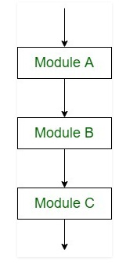Figure 1: Sequential control flow (Source: GeeksforGeeks)
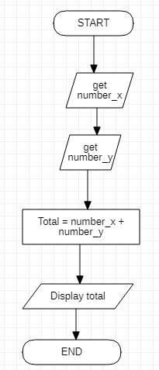
If we want to represent basic calculation operation in sequential flow, it will be visualized as follows:
START [Calculator]
Get number_x;
Get number_y;
Total = number_x + number_y;
Display Total;
END [Calculator]

Figure 2: Basic calculator (created by the author)
3.3 Conditional flow
It involves conditions. The evaluation of the condition to “True” or “False” heads the data flow to the corresponding module.
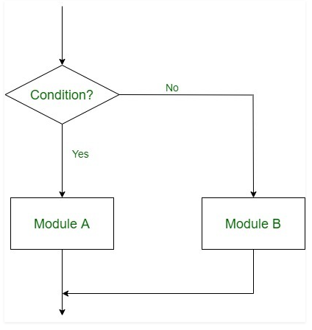Figure 2: Selection with double alternative (Source: GeeksforGeeks)
This type of logic is used by structures known as conditional structures. They are divided into three types:
- Single alternative – it has one if condition and a module inside the condition to be executed when the condition criteria are met.
If (condition), then:
[ Module X ]
[End if structure]

- Double alternative – it has one IF and one ELSE condition.
If (condition), then:
[ Module X ]
Else:
[ Module Y ]
[End if structure]

- Multiple alternatives – it has many conditions.
If (condition A), then:
[ Module X ]
Else if (condition B), then:
[ Module Y ]
.
.
.
Else if (Condition N), then:
[ Module Z ]
[End if condition] (skylags, 2020)

3.4 Repetitive flow
The iteration logic adopts the so-called "loop", which involves repeated statements followed by a module, known as a body of the loop. (skylags, 2020)
The use of this control structure can come in use when there is a requirement for set of instructions to be executed for n number of times unless a given condition is met. This can reduce the working hours of a programmer and increases his coefficient of productivity for a given time.
For purposes of demonstration, three basic types of loops will be analyzed and compared in terms of repetitive flow:

3.4.1 For loop
It comes into use when an action needs to be performed for a predefined number of times. Its structure is:
For (initialization, condition, update)
{
Statements
}
Where initialization, condition, and update are expressions. Initialization and update can be categorized as function calls, and the condition is a relational expression. (Stanford University, 2004)
A basic for loop can be represent as follows:

for (int x = 5; x < 10; x = x + 1)
{
Console.WriteLine("x = {0}", x);
}
The output will be:
x=5
x=6
x=7
x=8
x=9

This loop is being executed in the following way:
- After the start, the condition is checked (x < 10)
- The sequence skips down to the action (Console.Writeline(“x = {0}, x);)
- Then it is going back to the step (x = x + 1)
- Then it is checking the condition again
- Then the action is being executed again
- Check
- Action
- Step
And so on in this circuit motion until the condition becomes false. Then the loop ends. Based on what is seen, the for loop can be called a pre-test loop.

3.4.2 While loop
“A while loop is a block of code that is executed repeatedly until some condition is met. Its structure is:
while(expression)
{
Statements
}
As with an if statement, the expression in parentheses is evaluated first. If it evaluates to non-zero, the statements in the body of the loop are executed. At the end of the loop body, the expression is evaluated again, and the body is executed until the expression evaluates to 0. The expression is normally relational, depending on some value that is being updated in the loop”. (Stanford University, 2004)

Lets take a look over a simple while loop:
int x = 5;
while (x < 10)
{
Console.WriteLine("x = {0}", x);
x = x + 1;

The output will be:
x=5
x=6
x=7
x=8
x=9

This loop is being executed in the following way:
- Like in the for loop, after the start, the while condition is checked.
- The action takes place if the condition is true.
- After the action, the step is executed.
- Then the while condition is checked again
- Check
- Step
- Action
When the condition results in ‘’false’’ during the last check, the loop ends. The while loop is similar to the for loop, but it does the step after the check. The for loop does the action after the check.

3.4.3. Do/While loop
“The do/while loop is a variant of the while loop. This loop will execute the code block once, before checking if the condition is true, then it will repeat the loop as long as the condition is true”. (W3Schools, n.d.)
A simple do/while loop will be visualized as follows:
int x = 5;
do
{
Console.WriteLine("x = {0}", x);
x = x + 1;
} while (x < 10);
The output will be:
x=5
x=6
x=7
x=8
x=9
The sequence of steps for this loop is being done as follows:
- After the start, the action is being performed immediately.
- Then comes the step.
- Then the condition is checked.
- If the condition is true, the action is performed again, followed again by the step.
- Action
- Step
- Check
When the final check evaluates to false, the loop ends.
This loop will execute the action at least once, even if the condition evaluates to false because the testing of the condition is performed after the execution of the action. That's why this loop is called a post-check loop.

Appendix A

A.1 Code explanation
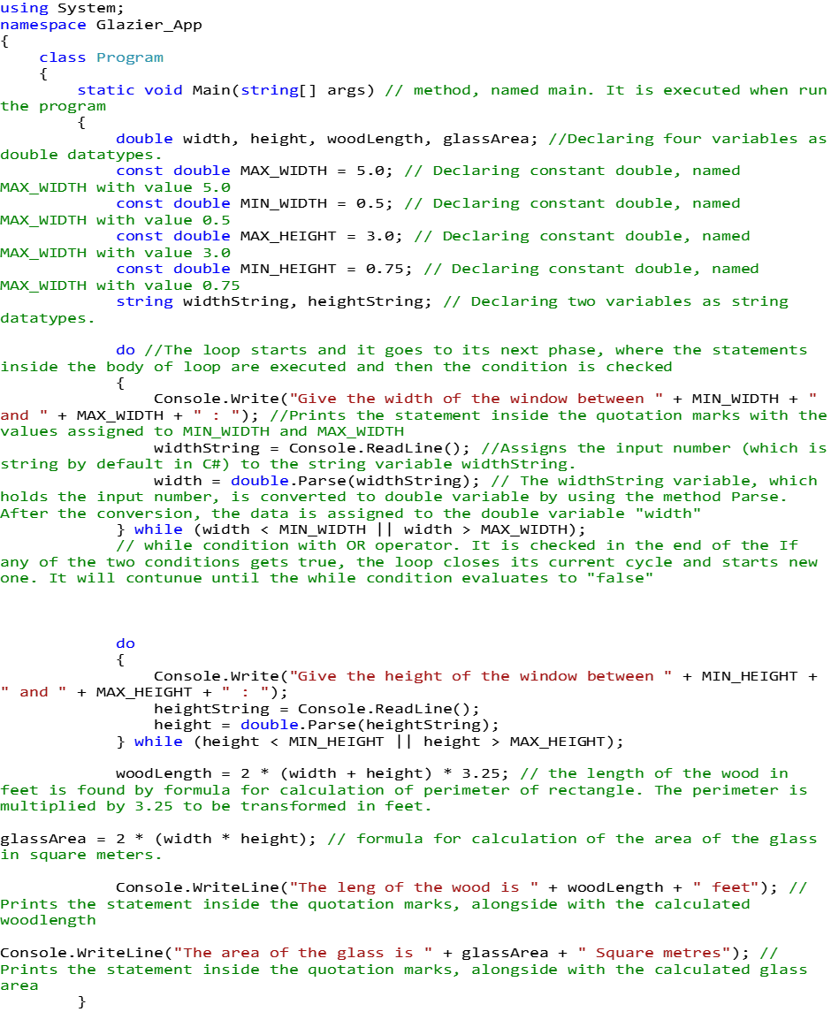

A.2 Running the code
The next is step running the code. In range, parameters were given deliberately in order to give a detailed explanation of how the process is running:
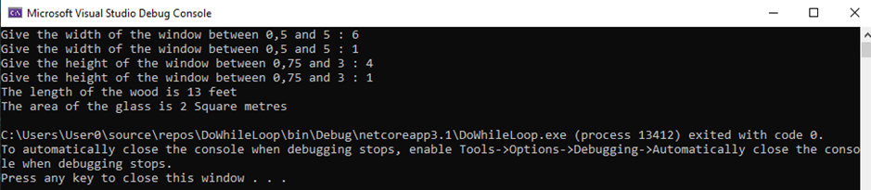
When the code is started, the user is asked to give a parameter of width in range 0,5 – 5.
Since this is a do-while loop, when the user enters parameter in range for the loop (and not in range for the manually written user statement), the declarations are executed, and at the end of the loop, the condition is checked. It evaluates to true and the loop starts spinning, bringing the user again in the starting position where the parameter should be entered. When the user enters a parameter withing outside the given range for the loop (and in range for the user’s statement), the parameter is being read again and converted into a double. Then the condition is checked and this time the condition evaluates as false.
The only way to exit from the loop and to proceed to the next phase of the code is the actual loop condition to become false, e.g. the user has to enter a number, which is not in range.
The same process is happening with the next do-while loop where the user is prompted to enter window height.
Finally, the two parameters entered in both loops are involved in the formulating process of wood length and glass area.
In the end, those two statements are displayed on the screen.

A.3 Code flowchart
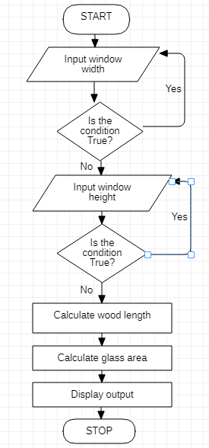

Bibliography
Kumar, M., jit_t & AlokSingh9, 2020. GeeksforGeeks. C# | Data Types, p. 1.
Microsoft, 2020. Microsoft. [Online]
Available at: https://docs.microsoft.com/en-us/dotnet/csharp/programming-guide/types/casting-and-type-conversions
[Accessed 08 19 2020].
skylags, 2020. Control Structures in Programming Languages. p. 1.
Stanford University, 2004. for Loops. [Online]
Available at: https://ccrma.stanford.edu/workshops/mid2005/lectures/programming/programming/for_Loops.html
[Accessed 19 08 2020].
Stanford University, 2004. while Loops. [Online]
Available at: https://ccrma.stanford.edu/workshops/mid2005/lectures/programming/programming/while_Loops.html
[Accessed 19 08 2020].
W3Schools, n.d. C++ Do/While loop. [Online]
Available at: https://www.w3schools.com/cpp/cpp_do_while_loop.asp
[Accessed 19 08 2020].
W3schools, n.d. W3Schools.com. [Online]
Available at: https://www.w3schools.com/cs/cs_variables.asp#:~:text=%20C%23%20Variables%20%201%20C%202%20,the%20console%20window.%20Then%20we%20use...%20More%20
[Accessed 19 08 2020].

