John Hopkins (P151371)

Steady state load transfer & aerodynamic loading
M5X00407

Table of Contents
INTRODUCTION
TASK 1
Method
Results
Analysis

TASK 2
Method
Results
Analysis
References 12

Introduction

This two-part paper will be exploring the effects of vehicle suspension setup on load transfer and subsequently handling characteristics and ability and the aerodynamic effects of varying the front and rear aero devices, both in conjunction and independent of each other. It will also highlight the success and limitations of mathematical modelling versus data collected from simulation software.
This will be achieved by using the Base Performance Simulator on campus and the MOTEC data acquisition software together to produce one set of results. The results can then be compared to the results produced by inputting known constants and data, such as vehicle dimensions and masses, into a series of formulas. The two sets of data produced aren’t expected to be the same due to some reasonable assumptions made, however they should produce correlating characteristics.

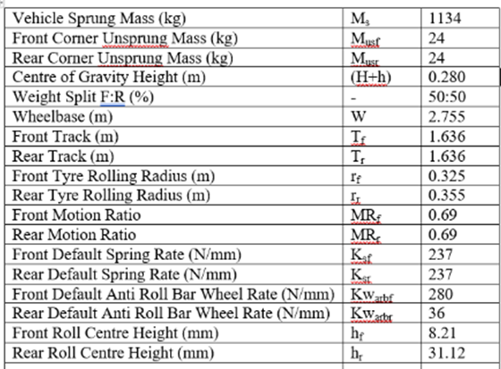
The table to the left shows the known specifications of the vehicle. These can be inputted into our setup sheet and used in formulas to calculate our predicted weight transfer results.
Task 1

Overview

The first task consisted of collecting steady state load transfer data form the simulator and comparing it to calculated data using the test vehicle’s properties. Steady state cornering consists of running a vehicle around an arc of constant radius at a constant speed. By using the MOTEC software and inputting maths channels it was possible to produce figures for weight transfer and subsequently magic number and compare them to predicted results from calculations. The calculations made could be done by using the setup sheet to input the relevant values and within the spreadsheet on excel alongside the simulation results making them easy to compare.

Method

For this test it was decided that the vehicle would navigate an arc of 25m radius at 50 km/h. Various setups were explored with varying combinations anti-roll bar stiffness against a constant spring stiffness.

Before taking measurements, it is important to eliminate variables. This was done by running the vehicle around the arc in both directions and comparing the results. We did this with the springs and anti-roll bars set to their medium stiffness. The car was also tested with the aerodynamics set to the minimum value. Before testing the vehicle was also driven around the arc at 10km/h in order to note its Ackermann steer properties. Having completed the validation runs, all subsequent tests were done in one direction.

The anti-roll bars were adjusted in nine different combinations between their minimum, median and maximum values with springs being set at their median stiffness. With the extra time available it was also possible to collect some data for maximum against minimum values of spring stiffness against constant anti-roll bar stiffness and maximum against minimum data of spring and anti-roll bar stiffness in conjunction with each other. Four combinations of spring stiffness and two combinations of anti-roll bar stiffness were calculated respectively.

Having collected the values required from the software it was possible to begin comparing them with the calculated results. These values were found by inputting any known data into the correct equations. The data produced in the simulator was inputted into the spreadsheet containing the calculated data for easy comparison. In order to do this some assumptions were made. As a result, the figures produced aren’t exactly the same as those measured, but this was expected.

Results

Varying ARB
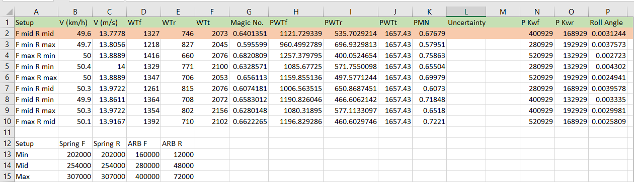
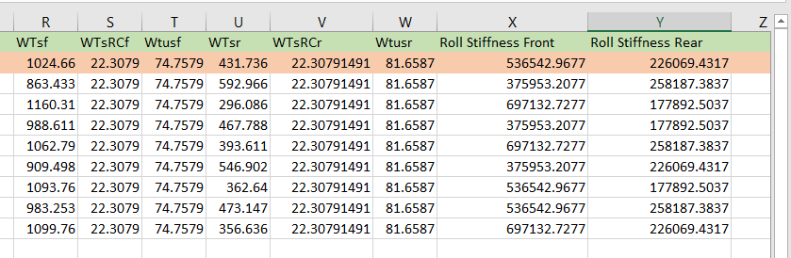

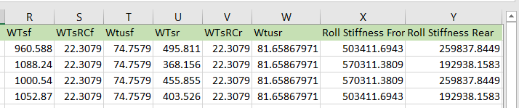
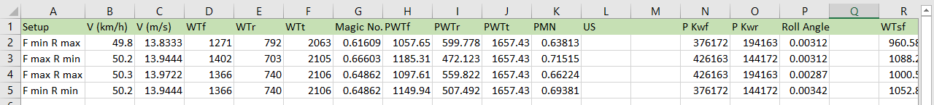
Varying Spring

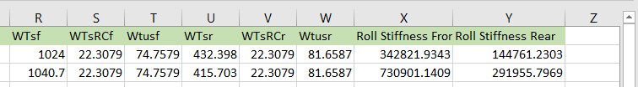
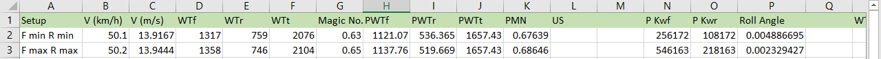
Varying ARB & Spring

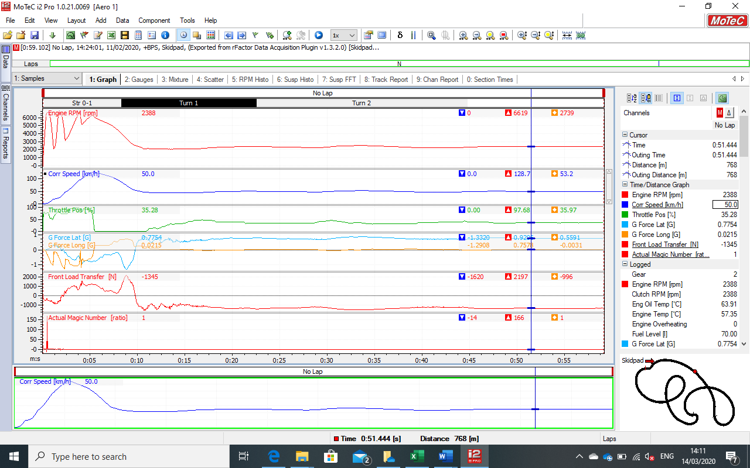
The above image shows the MOTEC software being used to obtain data from the simulator in order to produce the measured values needed to complete the task. In order to ensure the data used is the most accurate possible it must be taken as an average across a data range with as few anomalies whilst remaining as close to 50km/h as is possible. With this being a steady-state test, we are looking for values such as corner radius, speed and throttle position to remain as uniform as possible. The lateral G line remains desirably straight during the measured part of the run.

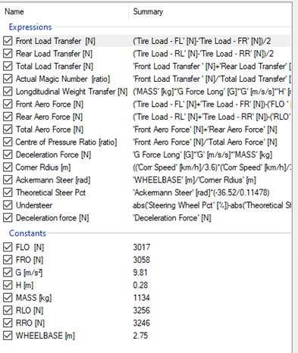
The figure to the left shows the maths channels required to complete both task 1 and 2. These were created within Motec and were accessible in every log file within the project. They required the constants below to produce the results.
Analysis

The measured data from the simulator provided much of what had been expected. Total weight transfer figures fluctuated within a range of around 100N which was reasonable and front rear balances varied as was expected. The best way to illustrate that the results match the theory was by looking at the extremes. The image below compared the anti-roll bars at their minimum stiffness at the front and maximum at the rear with the opposite setup.

The total weight transfer is similar, 2045 & 2076, but the balance is completely different. As a result, the magic number for the two setups vary by almost 0.1, which greatly effects vehicle balance. Having one end of the vehicle ‘stiffer’ than the other can generate greater slip angles and consequently higher grip levels on that side of the car. Knowing this allows us to manipulate the magic number to suit the application. There are however many variables to consider besides steady state cornering; in real world applications, braking forces and power delivery must be considered before settling on a set up as do driver preferences.

Despite the accuracy of the measurements made, there are some limitations to using a simulator with data acquisition software. Replicating conditions from run to run relied heavily on the driver. In order to make the tests entirely fair it would require the driver to maintain perfect throttle position and steering angle for an extended period of time. As a result the data set produced may not be exact but is as close as could be humanly achieved.

The values produced by using given data and making calculations, whilst yielding different results, still showed similar and expected patterns. The below figure shows the predicted results as calculated for the same setups as above.

There are several factors which can contribute to the difference between the predicted and measured results. The equations used relied on a series of reasonable assumptions to simplify the calculations. In the real world a vehicle’s roll centre and centre of gravity will move whilst cornering; as these changes are small it was reasonable to ignore them. Another factor to consider is the tyre radius when static as opposed to when cornering. This influences the unsprung weight transfer both front and rear. Again, it was considered reasonable to ignore these changes as they aren’t significant.

Below are the results from testing the minimum and maximum stiffness combinations of spring rates against front and rear anti-roll bars set to their median settings.
Setup | V (km/h) | V (m/s) | WTf | WTr | WTt | Magic No. | PWTf | PWTr | PWTt | PMN
F min R max | 49.8 | 13.83333 | 1271 | 792 | 2063 | 0.616093 | 1057.654 | 599.7779 | 1657.432 | 0.638128
F max R min | 50.2 | 13.94444 | 1402 | 703 | 2105 | 0.666033 | 1185.309 | 472.1229 | 1657.432 | 0.715148
F max R max | 50.3 | 13.97222 | 1366 | 740 | 2106 | 0.648623 | 1097.611 | 559.8217 | 1657.432 | 0.662236
F min R min | 50.2 | 13.94444 | 1366 | 740 | 2106 | 0.648623 | 1149.94 | 507.4923 | 1657.432 | 0.693808
When comparing the measured results for front and rear stiffness at maximum against front and rear stiffness at minimum there is very little difference as expected. The predicted results however have a great disparity; this is due to the failure to account for certain variables such as tyre radius change and wheel rate change.
Despite this, calculating weight transfer with maximum stiffness front, minimum rear and vice versa produced the change that was expected and mirrors the trend visible in the measured results.

Finally the springs and anti-roll bars were adjusted together to their maximum and minum stiffness respectively. When adjusted together the total weight transfer and magic numbers remained similar as expected.

Setup | V (km/h) | V (m/s) | WTf | WTr | WTt | Magic No. | PWTf | PWTr | PWTt | PMN
F min R min | 50.1 | 13.91667 | 1317 | 759 | 2076 | 0.63 | 1121.067 | 536.3651 | 1657.432 | 0.676388
F max R max | 50.2 | 13.94444 | 1358 | 746 | 2104 | 0.65 | 1137.763 | 519.6693 | 1657.432 | 0.686461

Comparing the measured and calculated values proved to be a worthwhile exercise providing the vehicle remained in a steady state. The calculations, and their assumptions, however, fall short when the vehicle is in a non -steady state. The calculations require that the vehicle maintain several constants such as turning radius, lateral acceleration value and tyre radius; as such it is difficult to accurately analyse behaviour throughout an entire lap without the aid of a simulator and data acquisition software. With Motec is possible to view data at close intervals and to determine averages therein.

Task 2

Overview

Task 2 is a straight-line constant speed and coast down to zero test. The aim of the test is to produce and compare data collected in runs with various levels of front and rear downforce. Straight line testing is the best way to understand how aerodynamic loads can influence vehicle balance and as a result effect handling and aero efficiency. This task should provide information such as varying centre of pressure and lift against drag forces for the various setups. Data such as this allows us to predict not only the balance of the car but also the most efficient setup depending on application.

Method

Following an Ackermann test as done with the previous task, the car is positioned at the start of the drag strip. The driver is instructed to wait for a few seconds at the start line before accelerating at full throttle from zero to flat out in 4th gear, roughly 6600 RPM and 206 km/h. Having held it at full speed for a few seconds the driver must then switch to neutral while maintaining maximum throttle and then allow the car to coast down to zero. This process is repeated for every combination of minimum, median and maximum aero force for both front and rear. The initial test is done in both directions in order to eliminate any variables that could affect the results, namely in this experiment, wind.

Having completed the necessary runs and validated them, it was possible to collect the data from the Motec simulation and input them into the formulas in the excel spreadsheet and produce all the required data. From here the data could be analysed to better understand the vehicles aerodynamic properties.

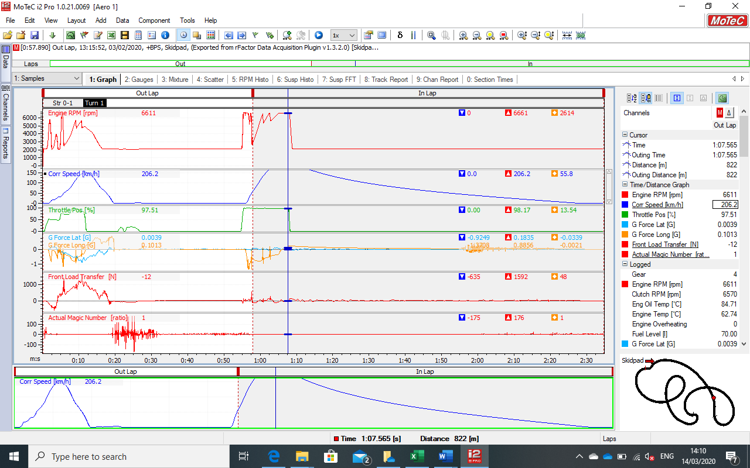

The above image shows the MOTEC software in use during a coast down test in order to analyse the effects of aerodynamic loading on the vehicle. The red engine RPM line clearly shows the vehicle accelerating though the gears before lifting off in neutral and the engine idling as the blue line representing speed gradually tails off before reaching zero. This run was suitable for use as lateral inputs were at a minimum and the deceleration force gradually reduced as expected.

Results

Analysis

Having acquired all data from the simulation software it was possible to plot it into a spreadsheet and analyse it. It was immediately obvious that the higher the total aero force produced from each setup, the higher the drag force and subsequently the deceleration force. The inverse was true for lift coefficient against the aforementioned phenomena. This proved that producing downforce on the vehicle must be a compromise between drag reduction for straight line speed and cornering capability. Despite this it was also clear that the vehicle was at its most aerodynamically efficient, that is lift against drag, at its most aggressive setup.

It was also possible to compare the differing centre of pressure values for each setup. The rear downforce capabilities of the car were much higher than the front. As a result, the centre of pressure would typically shift rearward. Being a high powered rear wheeled drive car however this shouldn’t pose much of an issue. The weight transfer typically moving frontward during braking and turn-in should redress this balance somewhat also when front end grip is needed most.

The findings also showed that the amount aerodynamic force produced by a one end of the car was dependant on the setup of the other end. For example, the maximum aero force produced by the front was 1924N when the rear is at its least aggressive and 16261N when the rear is at its most aggressive. The same behaviour also occurs with the rear end when the front is adjusted. There could be several causes for this; rear wing adjustment could affect underbody flow, likewise, adjusting front aero could cause disturbances to airflow across the rear wing.

The results highlighted the drastic change in aero force during acceleration and deceleration. This change would greatly alter the frictional force produced by the tyres whilst cornering and must be considered throughout a lap. The centre of pressure produced by the most aggressive setups is also far more rear-biased than the centre of gravity. As a result, during a highspeed corner the car’s overall balance would be rear-biased but in slower corners would shift back to the middle again. This could cause the vehicle to be unpredictable throughout the course of a lap.

There are some drawbacks to the nature of the testing conducted; the primary being the reliance on a human pilot to replicate conditions for each run. It is impossible for a driver to lineup the vehicle on the start line perfectly parallel to the drag strip and as a result, minor steering corrections are to be expected. Despite this, it was possible to produce the best possible results be repeating any runs that weren’t completed to the desired standard.

With regards to aero setup limitations, there was no clear ‘aero stall’ found in the results making aero changes linear and more predictable for the driver. Non-linear aerodynamic changes during a lap can be catastrophic and hinder drivability.

References
Chu, T. W., & Jones, R. P. (2008). Analysis and simulation of nonlinear handling characteristics of automotive vehicles with focus on lateral load transfer. Vehicle System Dynamics, 46, 17-31. Retrieved 3 15, 2020, from http://wrap.warwick.ac.uk/28443
Jazar, R. N. (2008). Vehicle Dynamics. Springer. Retrieved 3 15, 2020, from https://books.google.com/books?id=Pvsv78xj7UIC&pg=PP1&dq=Vehicle+Dynamics+Reza#PPA73,M1
Marqués-Bruna, P., & Spiridon, E. (2013). Numerical modelling of aerodynamics for applications in sports car engineering. Retrieved 3 15, 2020, from https://repository.edgehill.ac.uk/4832

(Jazar, 2008) (Chu & Jones, 2008) (Marqués-Bruna & Spiridon, 2013)

