Measures of Centre
1. All of the following are measures of central location EXCEPT:
A. arithmetic mean
B. geometric mean
C. median
D. mode
E. range

2. The measure of central location that has half of the observations below it and half of the observations above it is the:
A. arithmetic mean
B. geometric mean
C. median
D. mode
E. range

3. The most commonly used measure of central location is the:
A. arithmetic mean
B. geometric mean
C. median
D. mode
E. range

4. What unforgivable sin has been committed in the frequency distribution shown below?
A. Class intervals of different sizes
B. Inclusion of an unknown category
C. No column for percent distribution
D. Overlapping class intervals
E. Too many categories

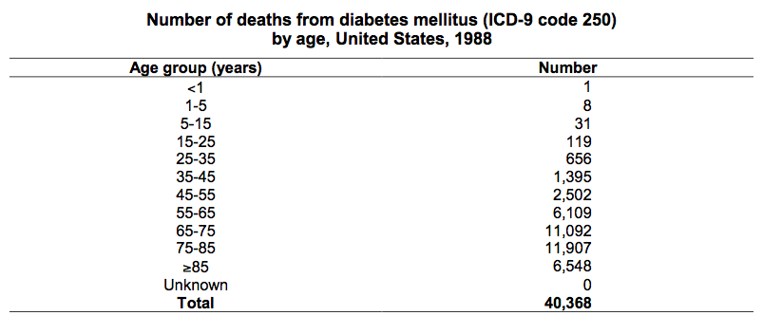
5. All of the following are measures of dispersion EXCEPT:
A. interquartile range
B. percentile
C. range
D. standard deviation
E. variance

6. Which of the following terms accurately describe the curve shown in Figure 3.12? (Circle ALL that apply.)
A. Negatively skewed
B. Positively skewed
C. Skewed to the left
D. Skewed to the right
E. Normal

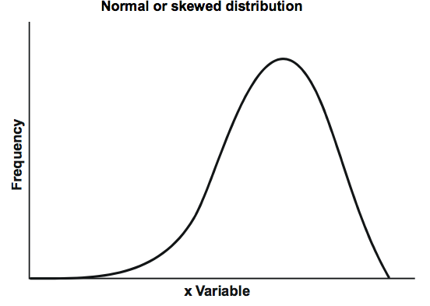
7. The measure of central location most affected by one extreme value is the:
A. arithmetic mean
B. geometric mean
C. median
D. mode
E. range

8. The value that occurs most frequently in a set of data is defined as the:
A. arithmetic mean
B. geometric mean
C. median
D. mode
E. range

9. The measure of dispersion most affected by one extreme value is the:
A. interquartile range
B. range
C. standard deviation
D. variance

10. Which range characterizes the interquartile range?
A. From 5th percentile to 95th percentile
B. From 10th percentile to 90th percentile
C. From 25th percentile to 75th percentile
D. From 1 standard deviation below the mean to 1 standard deviation above the mean
E. From 1.96 standard deviations below the mean to 1.96 standard deviations above the mean

11. The measure of dispersion most commonly used in conjunction with the arithmetic mean is the:
A. interquartile range
B. range
C. standard deviation
D. variance

12. Given the area under a normal curve, which two of the following ranges are the same? (Circle the TWO that are the same.)
A. From 2.5th percentile to 97.5th percentile
B. From 5th percentile to 95th percentile
C. From 25th percentile to 75th percentile
D. From 1 standard deviation below the mean to 1 standard deviation above the mean
E. From 1.96 standard deviations below the mean to 1.96 standard deviations above the mean

13. Given the area under a normal curve, rank the following ranges from narrowest to widest.
A. From 1 standard deviation below the mean to 1 standard deviation above the mean
B. From 5th percentile to 95th percentile
C. From 1.96 standard deviations below the mean to 1.96 standard deviations above the mean
D. Interquartile range
Rank from narrowest _____ < _____ < _____ < _____ widest
For questions 14-16, select the units from the list below in which each measure would be expressed, if we had measured the weights in kilograms of 300 children.
A. kilograms
B. square root of kilograms
C. kilograms squared
D. no units

14. Interquartile range ________________
15. Variance ________________________
16. Standard error ____________________

Data for questions 17-20: 14, 10, 9, 11, 17, 20, 7, 90, 13, 9

17. Using the data shown above, calculate the arithmetic mean.
Arithmetic mean = ________ .

18. Using the data shown above, identify the median. Median = ________ .

19. Using the data shown above, identify the mode(s), if any. Mode(s) = ________ .

20. Using the data shown above, identify the range. Range = ________ .

21. Which measures of central location and dispersion are most appropriate for the following data?
A. Arithmetic mean and interquartile range
B. Arithmetic mean and standard deviation
C. Median and interquartile range
D. Median and standard deviation

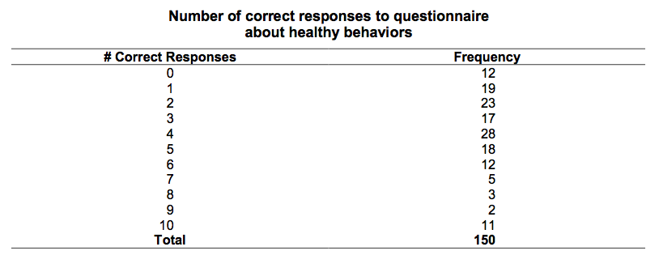

22. Simply by scanning the values in each distribution below, identify the distribution with the smallest standard deviation.
A. 7, 9, 9, 10, 11, 12, 14, 17, 20, 90
B. 7, 9, 9, 10, 11, 12, 14, 17, 17, 17
C. 9, 9, 9, 10, 10, 10, 10, 10, 11, 11
D. 1, 2, 3, 4, 5, 6, 7, 8, 9, 10
E. 90, 90, 90, 90, 90, 90, 90, 90, 90, 90

