Supporting pupil wellbeing
Print this page
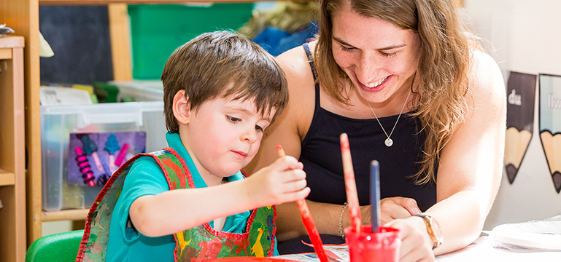

Pupil and staff wellbeing is an important part of school life at Pencaerau primary school. They’re the only primary school in Wales to achieve the Investors in People Platinum award, thanks to their wellbeing clubs for staff. Pupils also benefit from a welcoming environment and enriched extra-curricular activities. Staff build strong working relationships with parents and run workshops to help parents support their children’s wellbeing and learning at home. Parental involvement has had a positive impact on pupils’ attitudes to learning.

Number of pupils: 273
Age range: 3-11
Date of inspection: July 2019

Information about the school
Pencaerau Primary School is located on the outskirts of Cardiff. There are 273 pupils aged 3-11 registered at the school, including 60 who attend the nursery. There are nine single age classes, including two in the nursery. The number of pupils eligible for free school meals on a three-year average is in excess of 40%, which is significantly higher than the national average of 18%. The school has identified 18% of the pupils as having additional learning needs.
Around 78% of pupils are from white British ethnic backgrounds with 22% from a range of ethnic minority groups. No pupils speak Welsh at home.

Context and background to the effective or innovative practice
At Pencaerau Primary, there is a strong established model of partnerships working that enriches provision for all pupils. These make an excellent contribution to raising standards within the school. Strong emphasis is placed on staff wellbeing and, in addition to providing enrichment extra- curricular activities for pupils, there is a variety of wellbeing clubs available for staff. These include Tai chi, Dance and Keep Fit. In recognising the extra effort the school places of wellbeing, it has recently achieved the Investors in People Platinum award. This is the only primary school in Wales to achieve this at present.
Pencaerau Primary has built year-on-year strong working relationships with parents and carers. Parental involvement has been a key factor and has a sustained positive impact on attitudes to learning and school pride.

Description of nature of strategy or activity
“The school provides a tranquil and welcoming environment for all pupils. It is an extremely happy and caring community, which many pupils regard as a second home.”
The school has a dedicated and committed staff who all share the same principles for developing pupils’ self-esteem and encouraging aspirational ideas and thinking. There is a high level of ‘give it a go’ attitude and appetite for risk taking towards new ideas or approaches. This is because all staff are part of the planning and discussion around new concepts and are able to openly share thoughts and ideas and identify any apprehensions before they are put in action.
Pupils are part of the process too and consulted with regularly. Their ideas and thoughts are taken into consideration when planning both curriculum and extra-curricular activities. Although this process is ongoing throughout the year, the school hosts separate Innovation Days for the entire school community to engage in the process.
Pupils have a great sense of pride and belonging to the school as a result of their opinions being genuinely considered and, where appropriate, ideas are put into practice. Over the years, Pencaerau Primary has developed core values for class, which are developed and built upon year-on-year. Each class has a set value to explore during that academic year. Through assemblies and open days, the classes share knowledge and insights of class values with the wider school community. This has the effect of embedding the value concepts and ultimately leading to positive wellbeing.
“The school has a very effective partnership with parents, a secure foundation on which pupils thrive and learn.”
Pencaerau Primary places huge importance on building positive relationships between home and school. The school has a highly skilled parental engagement leader who has put in place a number of workshops and programmes, which develop parents’ skills and interests to support their children’s wellbeing and learning at home. The school has spent several years developing a wide variety of activities to encourage parental involvement. It monitors the success and impact of the programmes and refreshes them regularly to sustain and attract new interest.
The school continues to have a successful partnership with Cardiff University, whereby parents can take selected access courses to enable them to sign up for courses at foundation stage in the future. Several parents have successfully taken advantage of this opportunity.
Pencaerau Primary continues to build on previous successful practice. The school has further developed its networking opportunities with several local, national and international schools. This has kept new initiatives and ideas flowing and opportunities to develop good practice further. The school has fostered strong international partnerships as a follow on from their role within an Erasmus project.

What impact has this work had on provision and learners’ standards?
There is now a greater sense of self-esteem from the whole school community, in addition to developing greater reliance in approaching new ideas and concepts. This has been evident in the continued high standards achieved and the strong value added, from entering the school to the end of key stage 2 for nearly all pupils.

How have you shared your good practice?
The school has continued to develop its international partnership and hosted further visits from European countries to exchange ideas for wellbeing and guidance support. Parents have led some of the workshops, and the school leadership team exchanged best practice. Best practice has also been shared during consortium and local authority training days.
The school’s many parental engagement projects have been celebrated and shared through an event that welcomed professionals from all over Wales. This culminates in an award ceremony to celebrate the year-end achievements of the workshops and programmes. Pupils are extremely proud to see their parents rewarded on these occasions. Several of the programmes have been set up for parents to work alongside their children and cover a variety of areas, for example tea toast and tales, pottery, and IT starter programmes.
Link: www.pencaerauprimary.com

