MBA – Master of Business Administration

Name: Sarah Kokunda
Student Number :1711420
Module: Strategic Management (LCMB 7003)
Tutor: Gladius Kulothungan
Title: Tesla’s Entry into the U.S Auto Industry.

Executive summary
Strategic management involves actions related to continuous planning, organizing, monitoring, evaluating and assessing performance compared to expected outcomes whether they meet expected goals and objectives of a business. In today’s global marketplace, it is common that businesses will go international market. Tesla Plc, from a start-up company, has become leading electric vehicle manufacturing company in automobile industry and it’s been operating more than 35 countries. Realizing the growing awareness of people and importance of saving world through limiting carbon-emission, Tesla has grabbed the market introducing electric cars, renewable energy generation and energy storage systems and thus, brought revolutionary changes in the automotive industry. This report has been prepared analysing the automobile industry in US and Tesla’s internal and external environment analysis to provide some realistic recommendations.

Table of Contents

Executive summary 2
Introduction 4
Automobile Industry in US 4
Revenues of USA automobile industry 5
Composition of Automobile Industry in USA 5
Key trends in USA automobile industry 7
Key Success factors of automobile industry and Tesla 8
Internal analysis of Tesla 10
Value chain analysis 10
The Resources, Competencies, and Distinctive Capabilities of Tesla 12
External analysis of Tesla 14
PESTLE analysis 14
SWOT analysis 16
Market attractiveness of Tesla 17
The linkage between Stakeholder Expectation and Organizational Purpose 19
Mandelow’s stakeholder Analysis 19
Ethical Issues, Sustainability, Corporate Social Responsibility and Their Impact on strategic Development 20
Organizational Culture, Structure and Leadership and Their Impact on Strategic implementation 21
Strategies of Tesla to Sustain the Competitive Advantages 22
Strategic Choice Development 22
Ansoff Matrix 22
Deliberate Strategy: Plan for Market Expansion 23
Emergent Strategy: Recruiting of Skilled Manpower to Expand International Market 24
Eco-Friendly Strategy 24
Strategic Clock 25
Choice of Best-fit Strategy and the Implementation 26
Recommendations 26
Conclusion 27
References 28

Introduction
Auto manufacturing industry is highly competitive. Rising concerns for environment have made alternative to fuel cars market more competitive (Deepak and Santhanavijayan, 2020). This research will cover automobile industry in US, Tesla plc and its strategic business practices to shield its sustainable growth from large competitors. This report starts with an analysis of revenues, key trends and success factors of US automobile industry and then, it covers internal and external analysis of Tesla plc using different analytical tools and techniques. Based on the finding's recommendations have been provided to keep Tesla’s growth sustainable despite potential new entries of large organizations into the existing markets.
Automobile Industry in US
In USA, the market size of car manufacturing was $82.6bn in 2021 with expected growth rate of 12.3 % (2021 Tesla Model Y Prices, Reviews, and Pictures | Edmunds, n.d.) - measured by revenue. For the last five years from 2016 to 2021 the car industry experienced 10.3% decline in revenue per year. Though mostly affected by the COVID-19 pandemic, the automobile manufacturing industry declined faster than the overall US-economy. New car sales are considered the biggest opportunity for automobile industry. Though disposable income of customers and their buying habit have been changed dramatically, people will start buying new cars for personal uses which will create an opportunity for automobile industry. The following figure shows number of all motor vehicle sold in US from august 2019-2020.
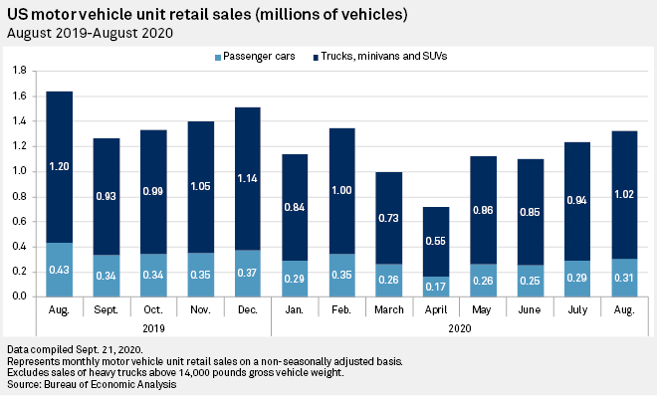
Figure: Unit retail sales of Motor vehicle in US (Automotive industry in the United States - statistics ..., n.d.)
Revenues of USA automobile industry
According to an industry report by IBISWorld, the interest rates and fuel costs are low while the consumer index is quite high. It increases the disposable income of consumers and their credit scores and thus, it is most likely to increase the demand for cars. The cars & automobiles sales generated a revenue of $126.9 billion in 2015. The revenue from new passenger car market in retail sales level was $270 billion in 2016 (US Automotive Industry: A Dominant Link in North American ..., n.d.). Following the peak growth in 2018, it has been estimated that the sales in 2020 will continue to grow. The sales growth remains almost flat since 2015 to 2020 with an increasing trend till 2018 and then a declining growth rate in 2019 and 2020. This growth trend of car sales in terms of revenue shows the increasing demand for new passenger cars in the US.
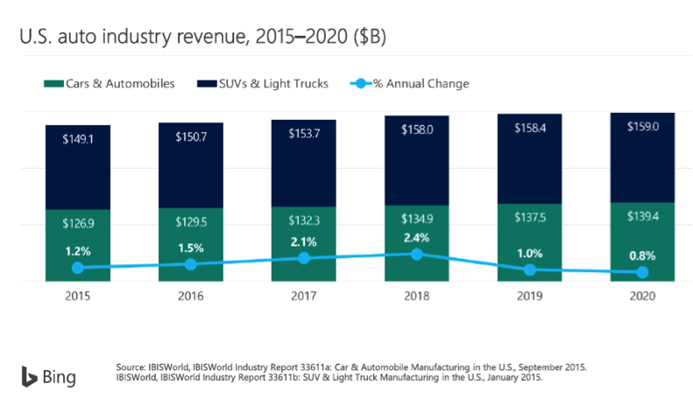
Figure: U.S. auto industry revenue, 2015-2020 (Motorized Industry Spotlight | SelectUSA.gov, n.d.)
Composition of Automobile Industry in USA
The US automobile industry can be broken down into different models of cars being produced. Crossover, light truck, small car, mid/large car, luxury and sporting cars are being produced. From below figure, in 2011-2020 eighteen percent of total cars produced are small cars while in 2021-2024 it will be only five percent. This estimation can largely be validated by the percentage been estimated for Crossover cars at 49% for 2021-2024 while it was 37% in 2011-2020.
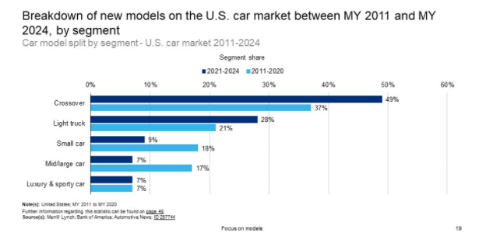
Figure: Different car models on US market (Electric Cars, Solar & Clean Energy | Tesla, n.d.)
More than 17% of cars sold in US were mid/large cars in 2011-2020 but it will be reduced to only 7%. in 2016, nearly 7million new cars were sold in US and 60% of these cars were pickups and SUVs. However, another study shows that the demand for small cars will be approximately 20% of the new cars model in 2023 while it was 18% in 2015.
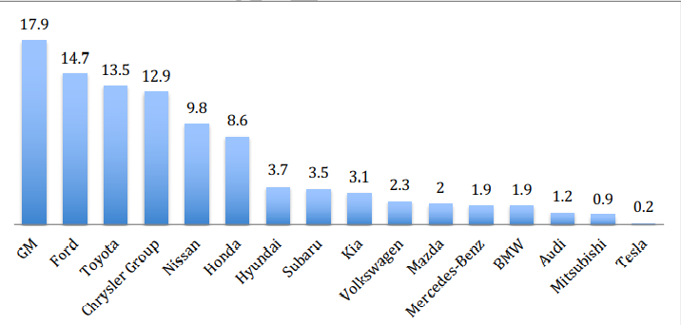
Figure: U.S car manufacturer market share by % (March 2018)
In 2018 General Motors let 17.9% market share, Ford 14.7% and Toyota 13.5%, and Chrysler Group 12.9% and these four companies occupied more than fifty percent of total market share. Tesla had 0.2% market share while Toyota was the leading non-US manufacturer.

Key trends in USA automobile industry
Several changes have reshaped the automobile industry in US in 2018. Some key trends in this industry include customers’ preference towards electric vehicles, autonomous driving, connectivity etc. In 2017, 200,000 electric vehicles sold in US which is 25% more than EVs sold in 2016. People who are concerned about climate changes prefer to buy EVs more. The most expensive part of EVs was the lithium-ion battery which accounted for more than 33% of total price of a car. The following figure shows that the price of this battery has fallen by approximately 80% from 2010 to 2017. These batteries are differed by size, power capacity and miles drive.

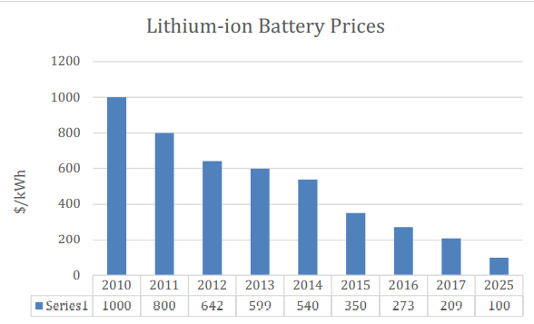
Figure: Price of Lithium-ion Batteries (The U.S. Auto Industry in 2019: Twists, Turns and Bumps ..., n.d.)
Self-driving car would be helpful to eliminate the risk of human destruction while driving. Companies namely Tesla, Uber, Apple, GM and Waymo tested autonomous driving and GM or Waymo is considered to be the winner in launching auto driving cars in the market commercially. These driverless cars can also benefit users from ride sharing rather owning a car.

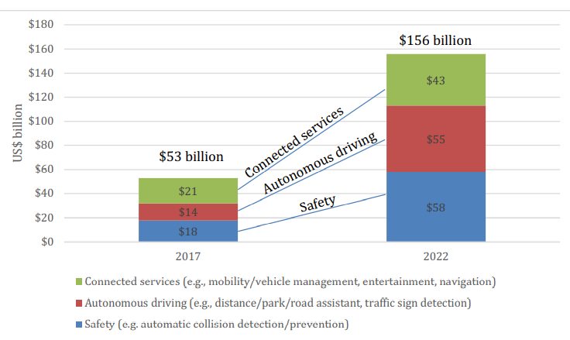
Figure: Estimated Connected Car Revenues by Product Package (How The U.S. Automobile Industry Has Changed, n.d.)
Car manufacturing companies invested millions of funds in developing digital connectivity installing the internet and a variety of sensors that would help to sense surroundings, exchange signals, etc. As shown in the figure above, the expected revenue from connected services had raised to $43 billion in 2022 which was $21 billion in 2017.
Electrification, autonomous driving, and connectivity would alter not only the mode of transportation but also the ownership of private vehicles. Some industry observers claimed that people may prefer view car industry as ‘mobility-as-a-service' where users can buy miles to drive not the vehicle. This would bring radical changes in private car ownership.
Key Success factors of automobile industry and Tesla
Every business has some capacities and capabilities that enable the business to extract benefits from market opportunities and thus, enjoy competitive edge in the market over its rivals (Cusumano, 2018). These factors are critical to the success of a business. A business should make strategic decisions and take actions to ensure optimum use of these factors to ensure highest outputs received from operations. Analysing the successful companies and reasons for failures of some companies in the automobile industry, five critical success factors have been identified – access to capital, high performing battery technology, government support, infrastructural support to charge batteries and customers’ knowledge. Developing an electric car and selling it to users require huge capital and it’s considered most important success factors for car manufacturing companies. Companies even spend millions of capitals in research and development, to test new car models to before launching commercially into market depending on the success of the test. For Tesla, there are four distinctive success factors - strong brand image, customer experience, disruptive technology and superchargers. Tesla owners, especially the original minds, initially raised capital from personal funds which was not enough and thus went to a lead investor, Elon Musk- Co-founder of PayPal and Space Ex. Elon Musk and Valor Equity partners provided required funds to the company upon a successful poof of idea. Government also helped to have fund to bring with new technology and different car models in the market. such government supports in the forms of government policies, incentives, etc. play crucial role in the success of automobile industries in different countries and keep these businesses to grow both with market share and newer technologies. The electric vehicles resulted from the government support in 2012 while President Obama emphasized on clean energy. With extensive support from government, the new trends towards EVs can be heavily accepted in the market.
Companies use lithium-ion battery technology but the costs were high comparatively (Thomas and Maine, 2019). Moreover, the energy capacity was low while taking long time to charge battery. Tesla made heavy investment to develop battery technology to keep its business ahead of competitors. Moreover, time is precious. Battery charging required long time. Tesla developed supercharger that made its cars more acceptable to the customers. Tesla initially launched high-performing sporting cars with disruptive technology was highly efficient and environment friendly that led success to the company. Moreover, Tesla introduced most efficient charging stations in terms of time required to recharge batteries and distance between charging stations.

Internal analysis of Tesla
Value chain analysis
Tesla value chain analysis is an analytical tool that helps in determining the activities Tesla carry out to outperform competitors creating value for the customers and having competitive edge in the industry. The following figure shows the essence of value chain analysis for Tesla-
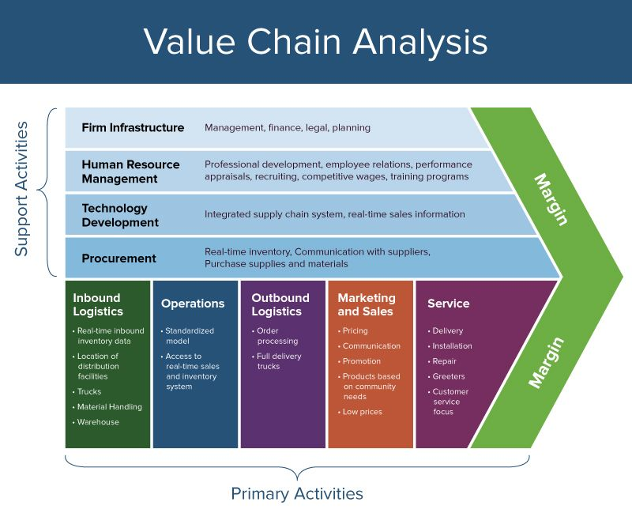
Figure: Tesla Value Chain analysis (Tesla Electric Vehicles: Reviews, Pricing, and Specs, n.d.)
Tesla value chain analysis: Main activities
Inbound logistics
Inbound logistics of Tesla involves with receiving and storing raw materials and scarce raw resources such as teel, aluminium, copper, nickel, lithium, cobalt- to build electric cars, solar panels and energy storage systems. Tesla receives parts of cars in Fremont from thousands of suppliers namely Nevada, Gigafactory, etc. Currently Tesla tries to develop long-term sustainable relationship with suppliers, along with having sophisticated inbound logistics practices.

Tesla operations
Tesla manufactures electric vehicles and assemble its operations in its different manufacturing bases in US. Tesla brought more than half a million cars in market in 2020. In operations Tesla has two segments. In automotive segment, vehicles are designed, developed and manufactured while in energy generation and storage segment involves in designing, manufacturing, installation and selling of energy storages to customers. Tesla’s high-level integration of robots in different manufacturing processes gives it major competency in value creation.
Outbound logistics
Tesla produces electric vehicles, solar panels, and energy storage systems and its outbound logistics involves warehousing and distributing these to the customers. Tesla transports its vehicles to different stores in the US and thirty-five other countries around the world. Tesla also offers direct delivery to end users and thus, need not to be engaged with dealers and retailers highly. Customers mostly choose and orders online for their customized vehicles.
Marketing and sales
Tesla has great market recognition. Its marketing activities are quite unconventional compared to other automaker’s practices (Aaij et al, 2016). The CEO Elon Musk emphasized that Tesla believes in words of mouth. Its marketing strategy is referred as Zero Dollar Marketing. The ability to attract extensive media coverage without spending millions on advertising and endorsements helps Tesla to increase the level of brand awareness and thus, works as a major source of value creation. Tesla also involves in sales of used car and this trade of used car helps to grow its sales of new cars to the owner of the used cars. Tesla sells its cars online and in physical outlets.
Tesla services
Tesla had a bad record of complaints due to not providing great customer services in the past. even customers sued against Tesla due to not calling back to customers or not replying to customers and keeping customers waiting for months to repair his newly realised cars in 2016. However, it has improved its customer service to a great extent. Tesla believes customer experience creates emotional attachment with the business. That’s why Tesla sells directly without any third party to ensure great customer services. It provides post-sales services at company-owned service centres.

The Resources, Competencies, and Distinctive Capabilities of Tesla
Resources
Intellectual property for its electric powertrain is the main resource for Tesla. This electric powertrain consists motor, gear box, battery, control software and power electronics. Tesla produces both electric vehicle and batteries (Kim, 2020). Tesla’s ability to develop new car design capitalizing electric powertrain also facilitates its business. computer aided design developing team members helps Tesla to reduce the time required to develop new car design with light-weight materials that help vehicles to maximize mileage range.
For its uniquely designed batteries, Tesla needs to source millions of lithium-ion cells. To ensure smooth supply of this essential raw material, Tesla made deals with suppliers such as Pure Energy Minerals. Tesla realizes that not having enough lithium will damage its business – Tesla Car Business, Tesla Energy Business and Selling storage systems. That's why Tesla also plans to source lithium from New Mexico. Compared to competitors, such as General Motors which produces and sells mainly cars, an unusual position in the market will be created as car companies go if, anyhow, Tesla lacks of lithium.
Competencies & Distinctive capabilities
Tesla's innovative manufacturing techniques along with power train and vehicle engineering are considered its core competencies. Simultaneously distinctive competencies are high performing battery technology, safety design and distribution network. Tesla gives constant efforts to improve its battery performance in terms of costs association. It considers both cost-cutting calculus and economies of scale. Scaling up production enables Tesla to reduce its costs per unit, along with manufacturing improvements and efficiencies. Tesla business has become unique model due to its distribution. The vertical integration in selling vehicles makes its price non-negotiable that gives it competitive advantage (Ghosh, 2019). Tesla's sales using company-owned showrooms and warehouses enable the business to ensure distinctive customer experience. Tesla’s approach to software that adds several leagues beyond competitors in the market. People believe that Tesla will lead the market with cars installing computers on wheels to have over-the-air updates on out personal computers.
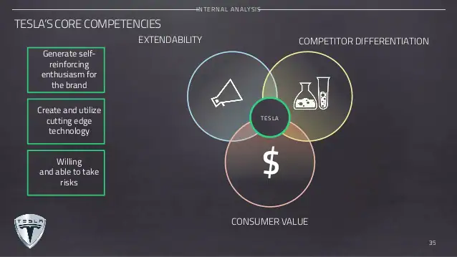
Along with the tangible competencies been discussed above, Tesla has developed some intangible strengths. People believe that Tesla brings superb cars in the market. Tesla Roadster, for example, has greatly changed the concept of electric vehicles from small, slow cars to rapidly fast vehicles. When Tesla brought Model S Sedan, a cheaper one, people who didn’t like electronic cars started adoring Tesla. Moreover, staffs for after sales services add create appealing value proposition, especially for customers seeking customize, luxury and expertise services. There is a great reputation that Tesla always tries to serve customers directly with honesty – just not to brag money from customers. Continuing with this business practice, Tesla will gain more customer loyalties in future.

External analysis of Tesla
PESTLE analysis
PESTLE framework is a widely used strategic management tool that determine how macro environmental factors affect a business (Sathish and Weenk, 2010). In Tesco’s PESTLE analysis, it covers issues that affect motorized industry, energy generation industry and energy storage industry. These factors affect not only Tesla’s operations but also other important factors that affect revenue generation of a business such as customers association, community-based organizations. For example, the market share and customer base of Tesla largely depend on the cost-effectiveness of transportation and technologies this business utilize. PESTLE analysis helps Tesla to identify external factors that bring opportunities and pose threats to the business and thus, helps to overcome challenges. Depending on the findings from PESTLE analysis, Tesla may require to change its business strategies as well.
Political factors
This dimension of macro environment analysis covers any interruptions from government in terms of policies and regulations that impact businesses (Steen burgh and Avery, 2010). Government agencies are prime bodies that shape the operations of a business largely. For example, government introduces new policies on trade that may impact all businesses in the industry and limit the revenues a business might generate. For Tesla, along with other businesses in automotive & energy producing industry, government incentives, new global trade agreements, political stability in major market country are important factors. Government provides incentives for electric automobiles that bring opportunity to strengthen Tesla’s financial position. Moreover, new free trade agreements open up new markets for Tesla to expand its business in global marketplace.
Economic factors
Market growth rate, GDP growth rate, currency exchange rates, trade levels, disposable income level, etc. are the important economic factors for automobile industry. For example, the currently growing demand for Solar energy results in a high growth rate in solar energy market that poses growth opportunities for Tesla’s solar panel business. Tesla needs to consider carefully how battery costs, renewable energy costs and economic stability issues to analyse the influence of these economic factors on the automotive industry. Tesla can take the advantage of customers’ demand for low price by introducing low battery costs that enhance affordability of customers. However, the economic stability in Asia and Europe market posed threats to Tesla.
Sociocultural factors
Socio cultural trends and issues affect a business’s performance influencing its customers, employees, investors and other parties (Huang, 2019). Tesla needs to consider social trend and choices while developing strategies to maximize value of the business. People around the world are becoming more and more concern about climate changes and thus, prefer to low-carbon styles which bring opportunities for Tesla’s electric vehicle business and solar energy generation business. Customers also prefer renewable energy sources that also help Tesla to grow its businesses. Moreover, having increased demand for Tesla’s electric vehicle, this business has increasing wealth distribution in newly growing markets.
Technological factors
Rapidly developing technologies increase the ability of Tesla to develop its automotive and energy solutions businesses. Materials engineering technology, for example, helps tesla to develop high performing batteries that are highly cost-efficient. Continuous changes in technologies bring opportunities to Tesla’s business in terms of production cost efficiency, simultaneously it poses threats obsoleting existing technologies. Moreover, newly introduced trends for automation in business and popularity of online mobile systems create opportunities for Tesla to integrate these systems in its newly designed electric vehicles.
Environmental factors
Climate change, expanding awareness towards environmental programmes and initiatives, and standards for waste disposal are important environmental issues that affect automotive industry. Tesla can promote its products focusing on these factors as its electric vehicles, solar panels, batteries and energy storage systems are highly environment friendly.
Legal factors
Legal or regulatory frameworks affect managerial decisions in terms of business operations and expansion. The marketing mix of Tesla or its HRM practices and business partnerships are subject to legal constraints. The company must comply with the laws related to international patent protection to expand its overseas operations, regulations related to dealership in US that facilitates Tesla’s direct sales and energy consumption regulations.
SWOT analysis
The following SWOT analysis will give a picturesque of the major all-electric vehicle manufacturer Tesla which has a timely vision in terms of increasing focus on renewable energy and sustainable living.
Strengths
Tesla has great market acceptance for its luxury electric vehicles with larges market share of U.S. electric vehicle market - both in percentage number of cars sold and percentage share of the revenue generated. Employees work here are expert and own the organization, with the intent of not leaving Tesla. Direct distribution model has made the business unique with excellent customer experience.
Weaknesses
Compared to large car manufacturing businesses, Tesla has fewer production hubs that means Tesla is unable to growing customers' needs (Matthews et al, 2020). Tesla failed to meet its annual deliveries of 500,000 vehicles in 2020 – it delivered 499,550 vehicles. Batteries are most crucial success factors for electric vehicles but Tesla depends on a single source. Many people believe Tesla=Musk – this one-man show carries risks because without Musk, there will not significant leadership or direction in Tesla. Moreover, high price of vehicles and high debt that lowers the ability to take more debt are also weaknesses of Tesla.
Opportunities
Tesla has targeted to increase its sales volume from 500,000 to 20 million per period in the next ten years. Its investment in Giga factory will enable the business to go for larger volume of production to penetrate markets and lower the costs per unit. like other car companies, Tesla can boom its production and sales taping Asian markets utilizing the production capacity. Tesla is a luxury brand but it can tap into additional customers releasing mid-priced cars in the market. Tesla can focus on in-house battery production in greater number which will decrease costs and thus, will be able to bring more cars into market faster with lower prices.
Threats
Despite having greater market share in electric-car market, Tesla faces intense competition because large car manufacturing companies are coming with electric cars in the market. It also faces threats in the market due to having legal liability from several lawsuits for failures both in quality and performance, defective components produced that have damaged the reputation of the business. Customers' less willingness towards self-driving cars, Musk's eccentric image to public, government regulations might also pose threats to Tesla.
Market attractiveness of Tesla
Michael Porter introduced five forces that shape industry competitiveness. Here this analytical framework will be used to the competitive environment Tesla has for the competitors who manufacture vehicles.
Competitive rivalry
The competition in the electric vehicle market is quite low because there are not many competitors that offer electric cars in the market. For Tesla, the competition is quite low because the competitors offering electric cars are a few and the number of high-end electric cars is quite low- with just one or few versions of their electric cars. Hyundai, Chevrolet and Volkswagen are the electric car manufacturing competitors of Tesla but these businesses are quite far distance in terms of innovation and luxury of Tesla.
Threat of new entrants
The threat of new entrants into fuel vehicle manufacturing industry is moderate due to several reasons (Sosna et al, 2014). major competitors such as General Motors, BMW, Toyotas and Fords have introduced electric cars that are not highly expensive as Tesla’s ones. But these cars are more criticised for trading off between costs and performance- these cars are quite slower compared to traditional fuel-based cars. But Tesla has introduced electric cars- Model 3, Model S, Model X- with advanced technical characteristics and these cars are well recognised for high speed and mileage covers with single charge. Any company that will try to come with electric vehicle will face same problems as mentioned large car manufacturers already faced. As an established business in the electric vehicles market, Tesla will enjoy economies of scale that will be drawback for new entrants in the first few years.

Bargaining power of buyers
Customers have no costs to switch from Tesla’s Model 3 to other companies' electric vehicles such as Audi’s E-Tron Quattro, Jaguar’s I-Pace, etc. Moreover, the price of Tesla’s cars is quite high compared to vehicles from other established manufacturers. Buyer's exercise bargaining power at their most if products are not highly differentiated. Tesla’s cars are highly differentiated from others in performance, design and minimalist. Customers who want high performing electronic vehicles have limited bargaining power while others have high bargaining power.
Bargaining power of suppliers
Tesla's suppliers possess moderate bargaining power because suppliers want to have business with Tesla for its extensive brand recognition in US and global market and Tesla purchase components from different suppliers – it can replace suppliers easily. The consistently increasing manufacturing capacity of Tesla requires high volume of orders for supplies that also reduce suppliers’ bargaining power.
Threat of substitutes
The threat of substitutes for Tesla’s electric vehicle in automobile industry is quite moderate because competitors offer alternative cars and there is public transformation. The costs associated with switching from one car manufacturers to another or private to public transportation is quite low.

The linkage between Stakeholder Expectation and Organizational Purpose
Organizations need to align to stakeholders’ expectations. Studies have shown that organizations that incorporate stakeholders’ expectation in any decision making, or setting organizational purpose or objectives are more likely to perform better (Huang, 2012). There are several theories that explain the relationship between stakeholder expectation and organizational purpose. Here Mande low’s stakeholder analysis been used to show the linkage between stakeholder expectation and organizational purpose-
Mandelow’s stakeholder Analysis
Mandelow’s matrix is an important tool used to analyse the stakeholders and their expectations from the organization. This analytical tool considers two aspects of a stakeholder- the level of interest of a stakeholder in a project chosen to invest or strategy adapted and their preference to use their power while to choose a project or strategy adaption. The following figure shows Mande low’s stakeholder analysis matrix-
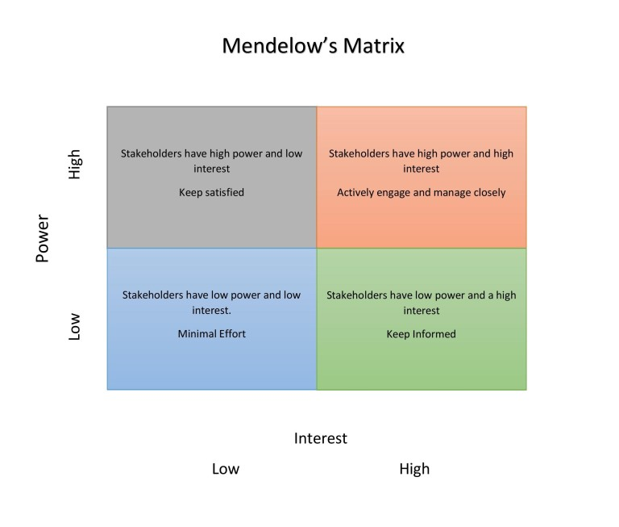
Figure: Tesla Mendelow’s Matrix (Olander and Landin, 2005)

High interest, High power
They have high power and high interest into any actions, decisions of a business. A business needs to keep them actively engaged, considering them key players. They play significant role in any change process or strategy development. Even when they are not agreeing with such changes or policy adaptation, they will withhold such changes exercising power. In Tesla, they are investors in the business. Investors are shareholders who are crucial for company's capitalization and cashflow. Shareholders care about profitability and the growth of a business. Tesla tries to correspond to stakeholders’ expectations.
High interest and low power
These groups have high interest but low power to influence the business. Businesses need to keep these groups informed (Thompson, 2011). In Tesla, customers and suppliers are those groups who have high interest into the business but low power to influence. Following customers demand, Tesla wants to introduce top class electric vehicles into the market to reach high-end customers and simultaneously, it wants to launch Model 3 Sedan to enter middle class affordable customers. Tesla imports backing disks from Europe and most sophisticated battery technology from Japan.
Low interest and High power
this group have low interest but high power and they can move to the high interest, high power group and that’s why they need to be kept satisfied so that they are not to gain interest or not to power exercise. Government and other regulatory bodies have low Interest in Tesla but high power to shape and direct the operations and strategies of Tesla.
Low interest and low power
These stakeholders are most likely to have no interest and give no direction. This happens because they have no power to influence any decision making in any organization. They are likely to accept the position they have in the organization. Employees working in Tesla and other communities have low interest and low power in any strategy the business undertakes.
Ethical Issues, Sustainability, Corporate Social Responsibility and Their Impact on strategic Development
In today's global marketplace, businesses face fierce competition because businesses strive to achieve far more success to capitalize on every business strategy, they undertake that enable a business to be sustainable in the market (Heslin and Ochoa, 2008). Doing so, businesses often violate ethical issues. In recent years, there is a raising voice for ethical business practices and corporate social responsibility (CSR) that lead to sustainable growth of a business. Tesla plc, world’s top Electric vehicle manufacturer, wants to do the most benefiting things for the people or community as a whole being self-driven – no matter it is being observed actively or not. While developing any strategy for the business, they consider Tesla considers ethical code of conduct, employees' safety and security issues to ensure the best benefits for customers and other parties. Despite having some unwarranted actions from Tesla, it tries to ensure the best ethical practices.
Tesla believes that ethical practices and performing CSR activities impact strategic development of a business. Tesla considers corporate social responsibility with great care as it is mentioned in its mission statement that Tesla takes great care of environment. Considering people’s awareness of global climate change, Tesla took strategic decisions and introduced electric car in the market. Thus, Tesla has sustainable business growth in the industry.
Organizational Culture, Structure and Leadership and Their Impact on Strategic implementation
Organizational culture refers to the shared values, beliefs, norms and practices within an organization. Organizational structure sets the hierarchy and relationship between different parties in an organization. organizational structure also influences organizational culture (Kaapor et al, 2013). Leadership plays important role in driving resources to ensure optimum uses so that organizational goals can be achieved. Leadership styles also influence organizational culture. Organizational culture, structure and leadership style set the foundation to develop and implement strategy in a business. These need to be fully considered to develop and implement strategies in any business successfully.
Organization that remains flexible are more likely to adapt its strategies based on the changing circumstances. For example, Tesla, facing customers’ grown awareness towards climate changes, has developed sophisticated Electric cars, renewable energy sources and energy storage systems so that it can reduce the negative impacts on environment most.
Strategies of Tesla to Sustain the Competitive Advantages
Strategic Choice Development
Ansoff Matrix
Ansoff matrix is popularly used as a marketing planning tool. Ansoff matrix gives four different growth strategies for businesses – market penetration, market development, product development and diversification. It can be used to make strategic decisions for Tesla.

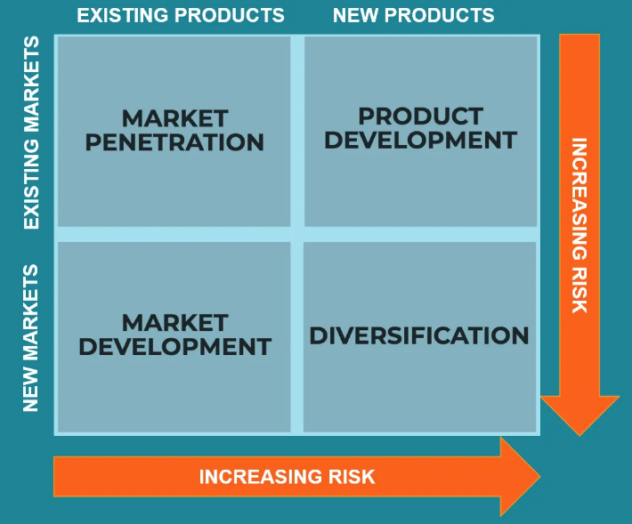
Figure: Ansoff Matrix for Tesla (Luthra and Haleem, 2015)
Tesla plc can use all these four growth strategies in an integrated way that best fit to the organizational goals.
Market penetration
Businesses take actions to increase sales of existing products in the existing markets (Lim et al, 2001). following market penetration strategy, Tesla focuses on selling its existing models - electric vehicles Model S, Model 3, Model X, energy storage products Powerwall 2, Powerpack 2, electrical hardware, solar panels, monitoring devices, inverters in its existing markets.
Product development
Product development involves selling new products into existing markets. Tesla invests huge amount in new product development. These investments mainly occur due to high costs associated with technologies used in existing car models. Tesla acquired a 10,000-acre plot in Nevada to extract metal and build a lithium refinery.
Market development
Successful businesses look for new markets for its existing products. Tesla continuously evaluates a number of markets to find out promising ones. Currently, it considers India as one of the most promising country, considering rapidly growing economy of this country. Tesla considered India would be a strategic market for its electric cars.
Diversification
Businesses develop new products for new markets following diversification strategy. Tesla followed diversification strategy even in recent years. Starting as only an electric car manufacturer in 2003, Tesla Motors Inc changed its name in 2016 into Tesla plc.
Deliberate Strategy: Plan for Market Expansion
The following table presents Tesla’s plan for market expansion through SMART analysis-
Specific | Tesla has decided to expand its business in some countries in Asia and Africa- mostly with high GDP growth rate.
Measurable | It has been estimated that nearly 500,000 new cars of existing models will be sold in targeted countries within next 5 years.
Achievable | Tesla’s Gigafactory production hub will be able to produce and assemble these cars (Zheng and Ming, 2017).
Realistic | Iother large companies also come with eletric vehicles and thus, Tesla will face intense competition in the existing market, hence expanding business new markets is realistic.
Time frame | It will take five years to implement this strategic decision and fulfil targets.
Table 4: Deliberate Strategy through SMART analysis
Emergent Strategy: Recruiting of Skilled Manpower to Expand International Market
Tesla will produce and assemble cars in its existing production hub – Gigafactory- for new markets. But it will require to recruit skilled manpower to expand and establish business in new market.
Specific | Hiring employees who are skilled in promoting automobile businesses in new market, taking responsibility to administer jobs related to show room.
Measurable | The success will be measured based on the customer's’ response how effective was promotional strategies of these employees and customer services they receive (Haselwanter et al, 2010).
Achievable | Tesco has been operating more than 3 countries and HR managers have great experience in hiring such employees.
Realistic | Without hiring skilled employees, the strategic decision cannot be implemented successfully.
Time frame | This strategy implementation will require six months.
Table 5: Application of emergent strategy through SMART analysis.
Eco-Friendly Strategy
Tesla has been long lauded for its continuous efforts towards world’s transition to sustainable energy. The company says to save the world, the world should stop using fossil fuels and turns to a zero-emission future. Tesla has added a new dimension to the auto industry introducing electric vehicles, especially Model 3 in 2017, and developing renewable energy sources to charge its battery, where big competitors namely General Motors, Ford, had failed. Tesla has great acceptance to the corporate elites and tree-huggers for its electric vehicles. Even Tesla mentioned in its mission statement that it is highly concerned about environmental issues. But Tesla is not that much transparent as General Motors and Fords about its overall greenhouse-gas emissions.
Strategic Clock
Bowman’s strategic clock is used to show the different strategic positioning of an organization depending on the customers’ different requirements in exchange of money. These positionings refer to the generic strategies that give competitive advantage to a business in the market.

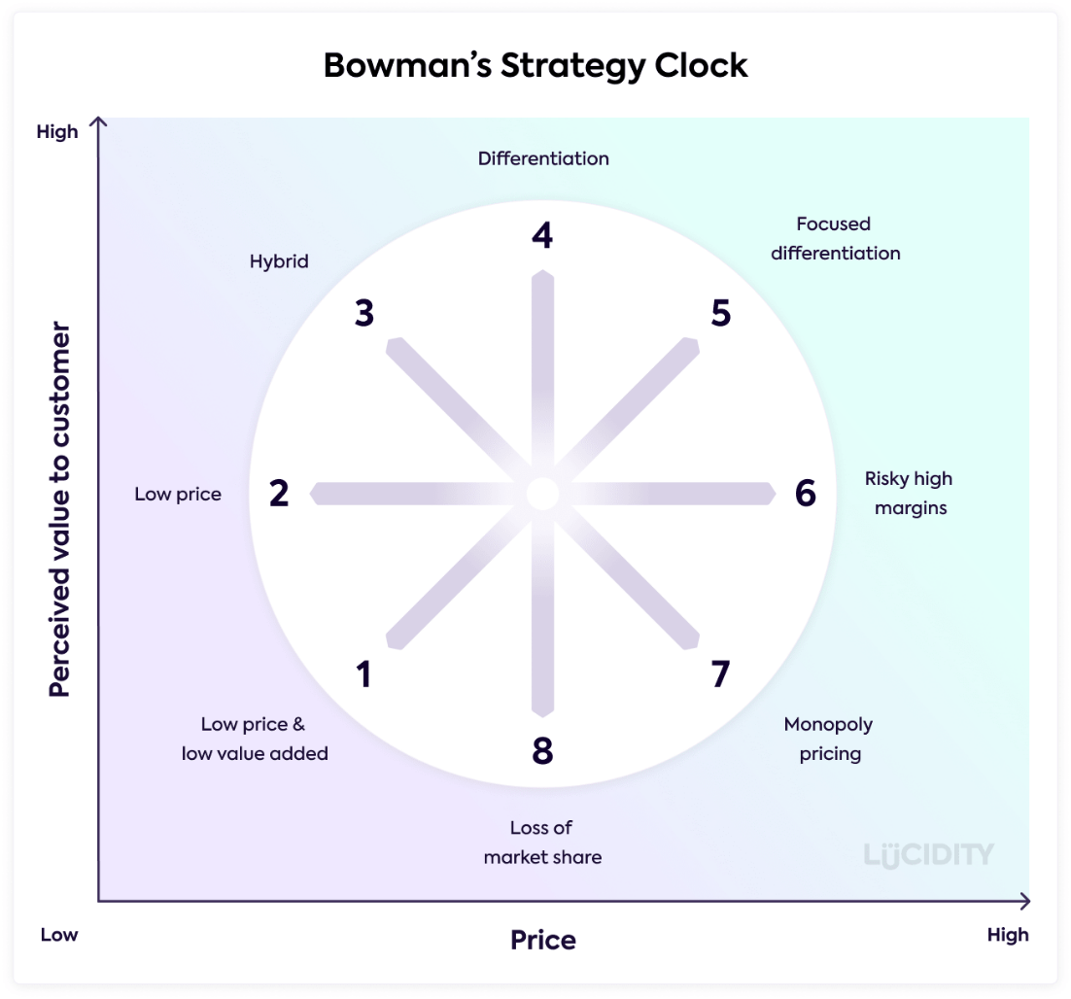
Figure: Tesla Bowman’s Strategic Clock (Hussain et al, 2013)
Tesla Plc is recognised a luxury brand that focuses on small group of customer base. Tesla adapts differentiation strategy concentrating on choices and preferences of rich and environment conscious community and thus, introduces stylish and beautifully designed attractive cars. Tesla chose this customer segment because people would not buy such costly electric cars (more than $60,000) to travel short distance regularly while fuel-based cars are offered at a significantly low cost. Tesla cannot adapt low price or hybrid strategy because this company will not have competitiveness in terms of scale of operations, production capacity and capital to thrive on the market competing with large can manufacturers in the market. Rather its uniquely designed cars give Tesla competitive edge to ensure suitable position in the market.
Choice of Best-fit Strategy and the Implementation
Businesses need to ensure the best-fit strategy implementation carefully to have competitive advantages over rivals in the market. From the above analysis, a deliberate strategy has been chosen for Tesla. Tesla will expand its business operations in new market with existing products. It will enter new promising markets in Asian and African countries. To make this strategic decision successful, an emergent strategy has been developed to hire skilled employees from international market. Tesla should implement both deliberate and emergent strategy as best-fit strategy to have competitiveness in the market over rivals.
Recommendations
Elon Musk ‘s sophisticated leadership and increased popularity of the brand help to improve the profitability of Tesla plc over time. The business has enormous opportunity to grow its business in global marketplace.
Following Bowman’s Strategy Clock analysis, Tesla can shift its business strategy from focus differentiation to differentiation, adding augmentative features that are not provided by the competitors but value additive within the same price. This strategy will help Tesla to grow with long-term profitability. To improve with differentiation strategy, Tesla can bring cars within premium and small premium segments that are affordable for different customer segments, along with premium customers.
Even having with technological advancement, Tesla should continue with R&D to have further innovation and development in technology that will give Tesla competitive edge in costs and quality and will produce new car. Tesla can focus on marketing strategies to create unique brand identity worldwide as it is relatively a new brand.
Conclusion
The report covers Tesla’s current business situation analysis to provide effective strategy development for the business to make it sustainable in competitive business environment. Macro environmental issues along with companies' internal capabilities enable Tesla to produce uniquely designed cars at a convenient price (Steenburgh and Avery, 2010). However, entrance of large can manufacturers with greater economies of scale, production capacity and cashflow will pose threats to Tesla and that’s why it needs to expand business in new markets.

References

2021 Tesla Model Y Prices, Reviews, and Pictures | Edmunds. [online] Available at: <https://www.edmunds.com/tesla/model-y/> [Accessed 2021].
Aaij, R., Amato, S., Anderlini, L., Benson, S., Cattaneo, M., Clemencic, M., Couturier, B., Frank, M., Gligorov, V.V., Head, T. and Jones, C., 2016. Tesla: an application for real-time data analysis in High Energy Physics. Computer Physics Communications, 208, pp.35-42.
Automotive industry in the United States - statistics .... [online] Available at: <https://www.statista.com/topics/1721/us-automotive-industry/> [Accessed 2021].
Automotive Industry Spotlight | Select USA.gov. [online] Available at: <https://www.selectusa.gov/automotive-industry-united-states> [Accessed 2021].
Cusumano, M.A., 2018. Manufacturing innovation: lessons from the Japanese auto industry. MIT Sloan Management Review, 30(1), p.29.
Deepak, G. and Santhanavijayan, A., 2020. OntoBestFit: a best-fit occurrence estimation strategy for RDF driven faceted semantic search. Computer Communications, 160, pp.284-298.
Electric Cars, Solar & Clean Energy | Tesla. [online] Available at: <https://www.tesla.com/> [Accessed 2021].
Ghosh, B.C., 2019. The key success factors, distinctive capabilities, and strategic thrusts of top SMEs in Singapore. Journal of Business Research, 51(3), pp.209-221.
Hasselvander, S., Muskat, B. and Zehrer, A., 2016. Strategic Planning in Micro Businesses: Adapting the Strategic Clock for Micro Firms.
Heslin, P.A. and Ochoa, J.D., 2008. Understanding and developing strategic corporate social responsibility. Organizational Dynamics, 37, pp.125-144.
How The U.S. Automobile Industry Has Changed. [online] Available at: <https://www.investopedia.com/articles/pf/12/auto-industry.asp> [Accessed 2021].
Huang, C.L. 2012. Drivers of environmental disclosure and stakeholder expectation: Evidence from Taiwan. Journal of Business Ethics, 96(3), pp.435-451.
Huang, Y., 2019, February. A Potential Company or Not: the Analysis of Tesla. In 2019 4th International Conference on Financial Innovation and Economic Development (ICFIED 2019) (pp. 401-407). Atlantis Press.
Hussain, S., Khattak, J., Rizwan, A. and Latif, M.A., 2013. ANSOFF matrix, environment, and growth-an interactive triangle. Management and Administrative Sciences Review, 2(2), pp.196-206.
Kaapor, A., Shakoor, N. and Sadeghian, S., 2013. Linking organizational culture, structure, Leadership Style, strategy, and organizational effectiveness: Mediating role of knowledge management. Advanced Research in Economic and Management Sciences (AREMS), 10(1), pp.158-167.
Kim, H., 2020. Analysis of How Tesla Creates Core Innovation Capability. International Journal of Business and Management, 15(6), pp.42-61.
Lim, G.H., Lee, K.S. and Tan, S.J., 2001. Gray marketing as an alternative market penetration strategy for entrepreneurs: Conceptual model and case evidence. Journal of Business Venturing, 16(4), pp.405-427.
Luthra, S., and Haleem, A., 2015. Critical success factors of green supply chain management for achieving sustainability in Indian automobile industry. Production Planning & Control, 26(5), pp.339-362.
Matthews, T., Hirve, M., Pan, Y., Dang, D., Rawar, E. and Daim, T.U., 2020. Tesla Energy. In Innovation Management in the Intelligent World (pp. 233-249). Springer, Cham.
Olander, S. and Landin, A., 2005. Evaluation of stakeholder influence in the implementation of construction projects. International journal of project management, 23(4), pp.321-328.
Sathish, S. and Weenk, E., 2010 Case Study of Tesla.
Sosna, J., Pedrosa, I., Dewolf, W.C., Mahallati, H., Lenkinski, R.E. and Rofsky, N.M., 2014. MR imaging of the prostate at 3 Tesla: comparison of an external phased-array coil to imaging with an endorectal coil at 1.5 Tesla. Academic radiology, 11(8), pp.857-862.
Steenburgh, T.J. and Avery, J., 2010. Marketing analysis toolkit: Situation analysis. HBS Case, (510-079).
Tesla Electric Vehicles: Reviews, Pricing, and Specs. [online] Available at: <https://www.caranddriver.com/tesla> [Accessed 2021].
Tesla Superchargers map: July 2021 | finder.com. [online] Available at: <https://www.finder.com/tesla-superchargers-map> [Accessed 2021].
Tesla’s solar and energy storage business rakes in $810M .... [online] Available at: <https://techcrunch.com/2021/07/26/teslas-solar-and-energy-storage-business-rakes-in-810m-finally-exceeds-cost-of-revenue/> [Accessed 2021].
Teslarati.com - Tesla News, Tips, Rumores, and Reviews. [online] Available at: <https://www.teslarati.com/> [Accessed 2021].
The U.S. Auto Industry in 2019: Twists, Turns and Bumps .... [online] Available at: <https://knowledge.wharton.upenn.edu/article/the-u-s-auto-industry-in-2019-twists-turns-and-bumps-ahead/> [Accessed 2021].
Thomas, V.J. and Maine, E., 2019. Market entry strategies for electric vehicle start-ups in the automotive industry–Lessons from Tesla Motors. Journal of Cleaner Production, 235, pp.653-663.
Thompson, R., 2011. Stakeholder analysis. Mind Tools.
US Automotive Industry: A Dominant Link in North American .... [online] Available at: <https://www.industryweek.com/supply-chain/article/22021603/us-automotive-industry-a-dominant-link-in-north-american-supply-chains> [Accessed 2021].
Zheng, M. and Ming, X., 2017. Construction of cyber-physical system–integrated smart manufacturing workshops: A case study in automobile industry. Advances in Mechanical Engineering, 9(10), p.1687814017733246.

