


MSc Industry 4.0 Advanced Manufacturing

Introduction to Industry 4.0

Module Code: ACPA7004

Assignment 2 - Introduction to Industry 4.0 Essay

Supervisor: Jaymie Phillips

Industry 4.0 Technology
Evaluating the implementation of Industry 4.0 into UKWDG

20th May 2022
Student: Gareth Gooding (2125561)
E-mail: 2125561@student.uwtsd.ac.uk




Industry 4.0 Technology
Evaluating the implementation of Industry 4.0 into UKWDG

Contents

Introduction 3

Industry 4.0 4

Sustainable Development 7

Industry 4.0 in UKWDG - Augmented Reality for Sales 8

Industry 4.0 in UKWDG - Additive Manufacturing 9

Industry 4.0 in UKWDG - Cloud Manufacturing 11

Conclusions 14

References 15

Introduction

The Fenestration Industry consists of Small and Medium sized Enterprises (SMEs). To create a uPVC Window and Door can be a straightforward process using manually operated machinery by low skilled operators. Some small companies still manufacture with this low level of sophistication, producing 50-60 units per day. The Medium sized Fenestration Manufacturers such as UK Windows and Doors Group (UKWDG) produce up to 1400 Units per day. To achieve volumes of 1400 units a higher level of technology must be used.

In the 2000s UKWDG invested in Fenestration Cutting Centres and Automated Production lines. Cutting Centres automatically cut lengths of profile to a desired size, and mill required slots and holes. The pieces output from the Cutting Centres are transferred to the assembly welding Production Line. An Automated Welder moves, clamps, and welds all pieces to produce a Window frame. This frame is automatically moved to a Cleaning Station where weld sprue is cleaned off with the use of drills, scrapers, and miller tooling. Output from this line are full window/door frames as a finished product. Hardware such as hinges, handles and locks are fitted later in the process. To enable the Cutting Centre and Automated Welding lines to process the uPVC profile Batch programming is used to send the necessary information via Ethernet to a DOS/Windows based Computer system.

Since the 2000s the Fenestration industry has been volatile, due to increased competition, economic fluctuations (2008 financial crisis) the Covid-19 Pandemic and more recently Geopolitical crisis (Russia-Ukraine War). This volatility has reduced the disposable Financial Capital in the business and investment in equipment limited.

The company performance since the Covid-19 Pandemic has grown, resulting in improved Financial Capital. UKWDG have a bank facility to make Investment possible, and new equipment specified which includes higher levels of Automation. This investment, however, will not deliver any short-term benefit to the company due to the long lead times for delivery. A shortage in materials, such as semiconductors has hindered Machine manufacturing capabilities, extending lead-times for delivery.

To progress without major investments, alternative ways to increase efficiency and Reduce Costs are required. This essay will explore opportunities for new and emerging Industry 4.0 technology that will enable improved efficiency, Sales, and a flexible approach. UKWDG are also following a Sustainable Development Pathway which these technologies can also improve.

Industry 4.0

Industry 4.0 refers to the 4th Industrial Revolution.

- The first industrial Revolution (1760s -1850s) was a result of the invention of the Steam Engine, boosting industry with the mechanisation of machinery

- The second industrial Revolution (1870s -1910s) was driven by electricity. Electrically powered machinery replaced Steam power and enable the development of the mass production line.

- The third industrial Revolution (1950s -1980s) was triggered by the invention of the Integrated Circuit. Integrated Circuits led to computers, the basis of automation technology.

- The 4th Industrial Revolution or Industry 4.0 was first referred to in the Hannover Fair in 2011 as an internet driven Revolution. The following quote by Pereira summarises this concept efficiently:

“This emerging Industry 4.0 concept is an umbrella term for a new industrial paradigm that embraces a set of future industrial developments regarding Cyber-Physical Systems (CPS), Internet of Things (IoT), Internet of Services (IoS), Robotics, Big Data, Cloud Manufacturing and Augmented Reality”
(A.C. Pereira, 2017)

Cyber Physical Systems

Cyber Physical Systems are systems that involve networks, computers, and digital hardware to manage processes. Digital technology uses networks to communicate data to computerised control systems which determine logical decisions and communicates data to physical technology which carries out instructions, based on the inputs, and prescribed programmed logic. Examples would be Autonomous vehicles, such as Driverless trains and Driverless cars. Other examples would be Smart Factories – relying on systems, such as robotic equipment.

Internet of Things (IoT)

The Internet of Things (IoT) is used to describe devices and ‘things’ that are connected to the internet with the ability to interconnect, interact and communicate data. With Embedded technology these devices are controlled or monitored remotely. Examples are Smartphones and Smart Energy metering devices. Cyber Physical Systems use the IoT to communicate and network physical devices used in the process required.

Internet of Services (IoS)

Internet of Services refers to Software applications. The software, software tools, and platform to run the software are sourced from the Internet. The scope is for the Software and services provided to be more accessible and standardised to enable more Users to access the Applications provided, via the internet. The IoS supports the IoT, providing software for which all stakeholders of the IoT can use.

Robotics

Robots are used for a variety of applications, usually reliant on a Human programmed control unit. Industry 4.0 will allow robotics functions to be more adaptive and autonomous from network connections and Cloud based control systems. This means robots can communicate with other systems and have their function altered remotely whenever necessary.

Big Data

Technology advances have developed smaller sensing devices and faster wireless communications networks. These advances allow a larger number of more sophisticated sensors to collect substantial amounts of data. This data, along with data sources such as videos, HTML, text, GPS data and various others are collectively termed as Big Data. All can be transmitted simultaneously, processed, and potentially stored. The revolution in Cloud networks, storage and processing has allowed Big Data to exist, whereas physical hardware limits the amount of data that could be transmitted, processed, or stored.

Cloud Manufacturing

The advances in IoT and IoS has produced ‘Cloud Manufacturing.’ Cloud Manufacturing is based on the software systems and platforms of a business being ran from a Cloud Based data provider. Providers use data centres for businesses to store software and databases on Cloud based servers. The business accesses the servers via the Internet, removing the physical server requirement. Software can be designed and modelled around the customer requirements and can be used to run a manufacturing operation. Big Data requires big processing power and capacities that would be limited by physical on-site servers. An example of this is Autodesk partnering with AWS (Amazon Web Services) to use AWS services, data centre, and expertise to improve its operational performance, as per the Case Study note below:

“When Autodesk launched in 1982, its desktop software helped transform the architecture, construction, engineering, manufacturing, and media and entertainment industries. The company has continued to innovate in the decades since, now offering subscription software services to more than one hundred million customers worldwide. To meet this exponential growth in customers and data, Autodesk migrated workloads from its on-premises data centres to Amazon Web Services (AWS) in 2012, taking a hybrid cloud approach. As a result, Autodesk has increased efficiency, scalability, and flexibility and enhanced reliability, security, and analytics capabilities—while saving up to 90 percent on data processing costs. Freed from manual processes, Autodesk’s data scientists can now focus on further innovation, using big data, machine learning, and serverless solutions on AWS”
(Amazon Web Services Inc., 2022)

Cloud Manufacturing providers, such as AWS can provide business analytics, using IoT, IoS and Big Data from the partnered company to determine performance, efficiencies, and improvement opportunities, which could not be achieved by conventional physical technologies.

Augmented Reality

Augmented reality uses interfacing devices, such as a Smartphone to overlay digital information on real world imaging. For example, Niantic use Augmented Reality (AR) for their Pokémon GO application. The user looks at the physical world through a Smartphone and the Pokémon GO application overlays a Pokémon onto the physical image, augmenting a situation where a Pokémon is in a real-world situation, such as in the User’s Garden, as below:


(Niantic Inc., 2022)

For UKWDG this technology could enhance the Sales experience – for example overlaying colours and styles of windows onto houses, to portray the windows on a customer’s house. This would remove the need for a visit to a Sales Display centre, or a Sales agent transporting various windows to the customer premises.

These Industrial Developments are only a handful of what Industry 4.0 can offer. The miniaturisation of electrical and electronic components and lower power consumption of technology has allowed the advance of devices to provide Industry 4.0 opportunities.

Industry 4.0 is like previous Industrial Revolutions and does have factors that may limit its progression. Klaus Schwab published a book called ‘The Fourth industrial Revolution’ which discusses the impacts of Industry 4.0. A key topic is the potential risk to the progress of Industry 4.0. Schwab said:

“Still valid today is the lesson from the first industrial revolution – that the extent to which society embraces technological innovation is a major determinant of progress. The government and public institutions, as well as the private sector, need to do their part, but it is also essential that citizens see the long-term benefits”
(Schwab, 2017)

Countrywide strategies such as fast internet need to be adopted, to allow the growth of Industry 4.0. Educational schemes should be promoted to encourage the understanding of the new technologies. A limitation would be that Industry 4.0 is feared due to the development of technology which would remove the need for low-skilled labour.

Sustainable Development

Sustainable Development is a fundamental part of any business. There are five key Capitals that a business must focus on to be a successful business and ensure it is sustainable. Industry 4.0 technologies can contribute to better Sustainability in all five areas of Capital

Financial Capital

A fundamental and influencing aspect of a Sustainable Business is its Financial Capital. Cash, operating profit, EBITDA etc, are all examples of Financial Capital. If this is not a focus, and not sustained, then a business will not develop. It is also a major Influence for Sustainable behaviours of the other four capitals. Businesses will engage with Sustainable Development if a tangible financial gain is relevant. Any gains in Financial Capital allows investment into the other Capitals to boost Sustainability which can result in improved Financial Capital.

Natural Capital

The resources naturally occurring on the plant with which products are made. Oil, salt, and other chemicals are used to manufacture uPVC. Increasing use of raw materials causes a bigger impact on the Natural Capital of the planet. Recycling uPVC, reduces the impact, making the Natural Capital more sustainable. Smart sensors and Real-time analytics can assist the control and efficiency of the recycled material use.
Another example would refer to Energy Usage – the more energy used, the higher the Carbon Footprint, until we guarantee 100% renewable energy. Investment is required to attain the Renewable energy commitment. For the investment, data must be gathered to determine a Business Case for investment. Industry 4.0 technology, such as Smart Metering devices can provide this data for the Business Case.

Manufactured Capital

The buildings and equipment used to produce the product. This would also refer to any technology used in the process. Industry 4.0 technology would be a Manufactured Capital. IoT and IoS can enable the gathering of Big Data and Cloud Manufacturing can store, analyse, and process this data to provide efficient solutions. Using IoT devices for energy monitoring can help determine usages and inefficiencies. This data would determine an Energy threshold to invest in Renewable Energy Sources, such as Photo Voltaic systems (Solar Panels), The energy threshold refers to consumption – High Voltage systems would require many Solar Panels, so alternatives, such as a Cummins Gas Generator with a 2MW capacity installed in UKWDG, Tewkesbury, would be more suitable. (Cummins Inc, 2022)
Both options are Manufactured Capital that would improve the Financial Capital of the business.

Human Capital

Refers to the Personnel working for the company. A focus on the personnel working for UKWDG is required to achieve good performance. Training is provided to enhance the skills of the workforce to control the Manufactured Capital. Better control, better performance. Training is fundamental for the engagement and operation of Industry 4.0 technology.

Social Capital

Social Capital is the interaction and communication with the workforce and the community. Industry 4,0 can contribute to Social Capital by improving communications, and accessibility with the IoT and IoS.

Industry 4.0 in UKWDG - Augmented Reality for Sales

Historically, Business Development personnel would drive to a customer’s house with numerous samples of windows – shapes, styles, colours, hardware, and various other items. These would be showcased in the customer’s premises, where they would have to imagine what they would look like fitted. Another option would be for the customer to travel to a destination which would display the required window on an existing building, or Display showroom.

From an efficiency perspective time is wasted travelling to and from destinations. Sample windows and hardware are non-value added in the production process and involve manual handling to transport between premises. Showrooms use space, which could be used for value added activities. Using Augmented reality can eliminate all these ‘wastes’ and promote swifter, and more efficient Sales behaviours.

“Tommy Trinder” is one service provider in the Fenestration industry who have developed Framepoint Technology that uses Augmented reality for the purpose of selling Windows and Doors. The application uses the camera to display the physical world where overlays of windows and doors are applied. The overlays are shaped, sized and moved into necessary apertures to simulate the selected windows and doors installed on the customer’s premises. The software can be configured to UK Windows and Doors Ltd products and branded for a specified License fee.
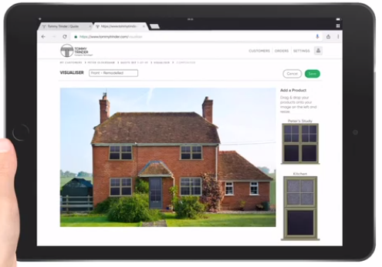
(Tommy Trinder.com ltd, 2022)

UKWDG have evaluated the integration of this technology, with the following benefits.
- Improved Carbon Footprint – less travelling required.
- Reduction in travelling costs / sample manufacture costs
- Reduced Manual Handling for the Sales personnel
- More time to create more sales
- Low cost – potentially £900 per month

Despite the benefits UKWDG are yet to adopt this technology. As stated by Schwab, society need to embrace the technology and see the long-term benefits. The Sales teams are not confident to use the application showing that the fenestration industry is slow to engage with technological development. With personnel having used the same techniques for over 30 years to sell windows and doors, there is a resistance to change, so this Application has not been progressed. To fully appreciate the value coaching, training, and a strategic focus needs to be adopted by UKWDG. The first step in this journey is key personnel undertaking educational courses in Industry 4.0 The knowledge gained by such courses will be used to influence the rest of the company and understand the value of the Augmented Reality opportunity.

Industry 4.0 in UKWDG - Additive Manufacturing – 3D Printing

At UKWDG customers are regularly requesting new styles of PVC profile. The profile design can alter the characteristics, such as surface finish, structural integrity, and thermal properties, just by adding another chamber or adding a bevel to the design. In the past prototype steel tool assemblies would have to be made to form the new design. The new tool prototype would be a high cost, and timely to manufacture in Austria, where the Tooling manufacturer is based.

An Industry 4.0 technology that can be eliminate the need for a prototype tool is Additive Manufacturing technology, or a 3D Printer, which can be used to create samples of these new designs. 3D printing works by creating a CAD image layer by layer to mimic the design required which is converted into a computer file of the design, this design is then read by the 3D printer to create the item layer by layer, using various materials or substances. In this case uPVC can be used to build a section of the new uPVC Profile design. This 3D printed sample piece can then be used as proof of concept and for fit-and-function testing. This solution is a fraction of the cost of a prototype steel tool, and swifter, especially as our System House manufacturer is based in Austria. The transportation costs and Carbon Footprint for a design sample has limited the investment into new designs. On site 3D Printer technology reduces these costs, enabling UKWDG to offer a more flexible range, trialling concept designs on site within 24hrs of a configured design. This concept is an absolute necessity for UKWDG and is currently being developed.

A 3D printer is currently being trialled – a RAISE3D PRO2 3D Printer is in the technical laboratory. 3D CAD designs are being created on Solidworks and transferred to Ideamaker as an STL File. Ideamaker converts the STL to G-code which can be read by the 3D printer. This file is then sent to the printer to produce. The RAISE3D PRO2 offers dual extrusion, and a layer height of 0.1mm

Sample pieces are being produced with the sample below being made from PLA, melting point of two hundred degrees centigrade and taking one and a half hours to produce.

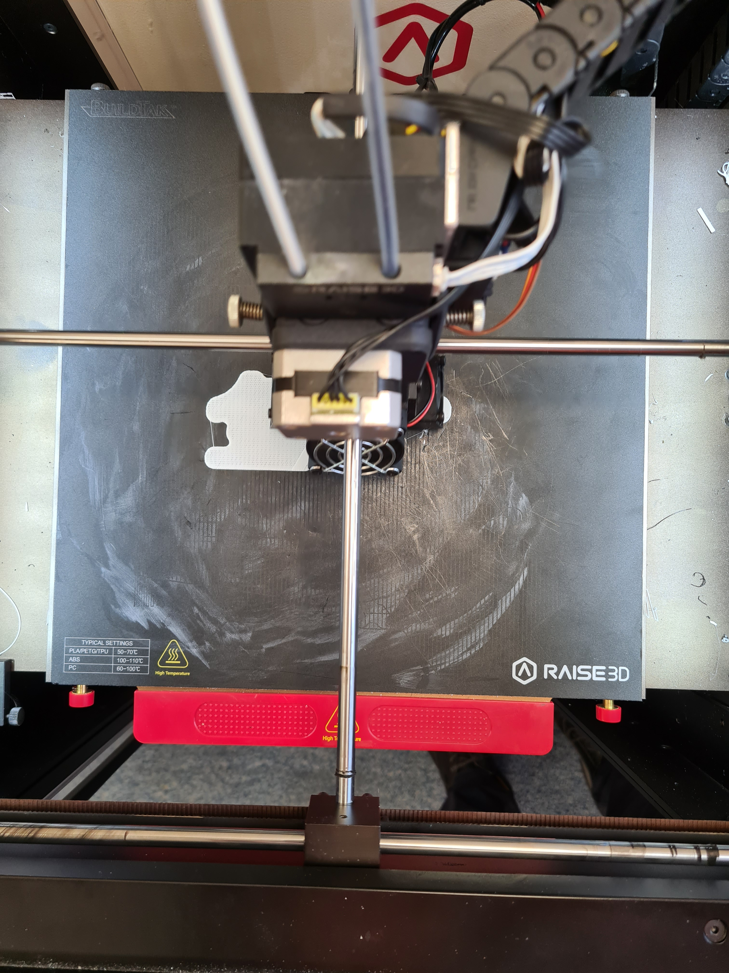
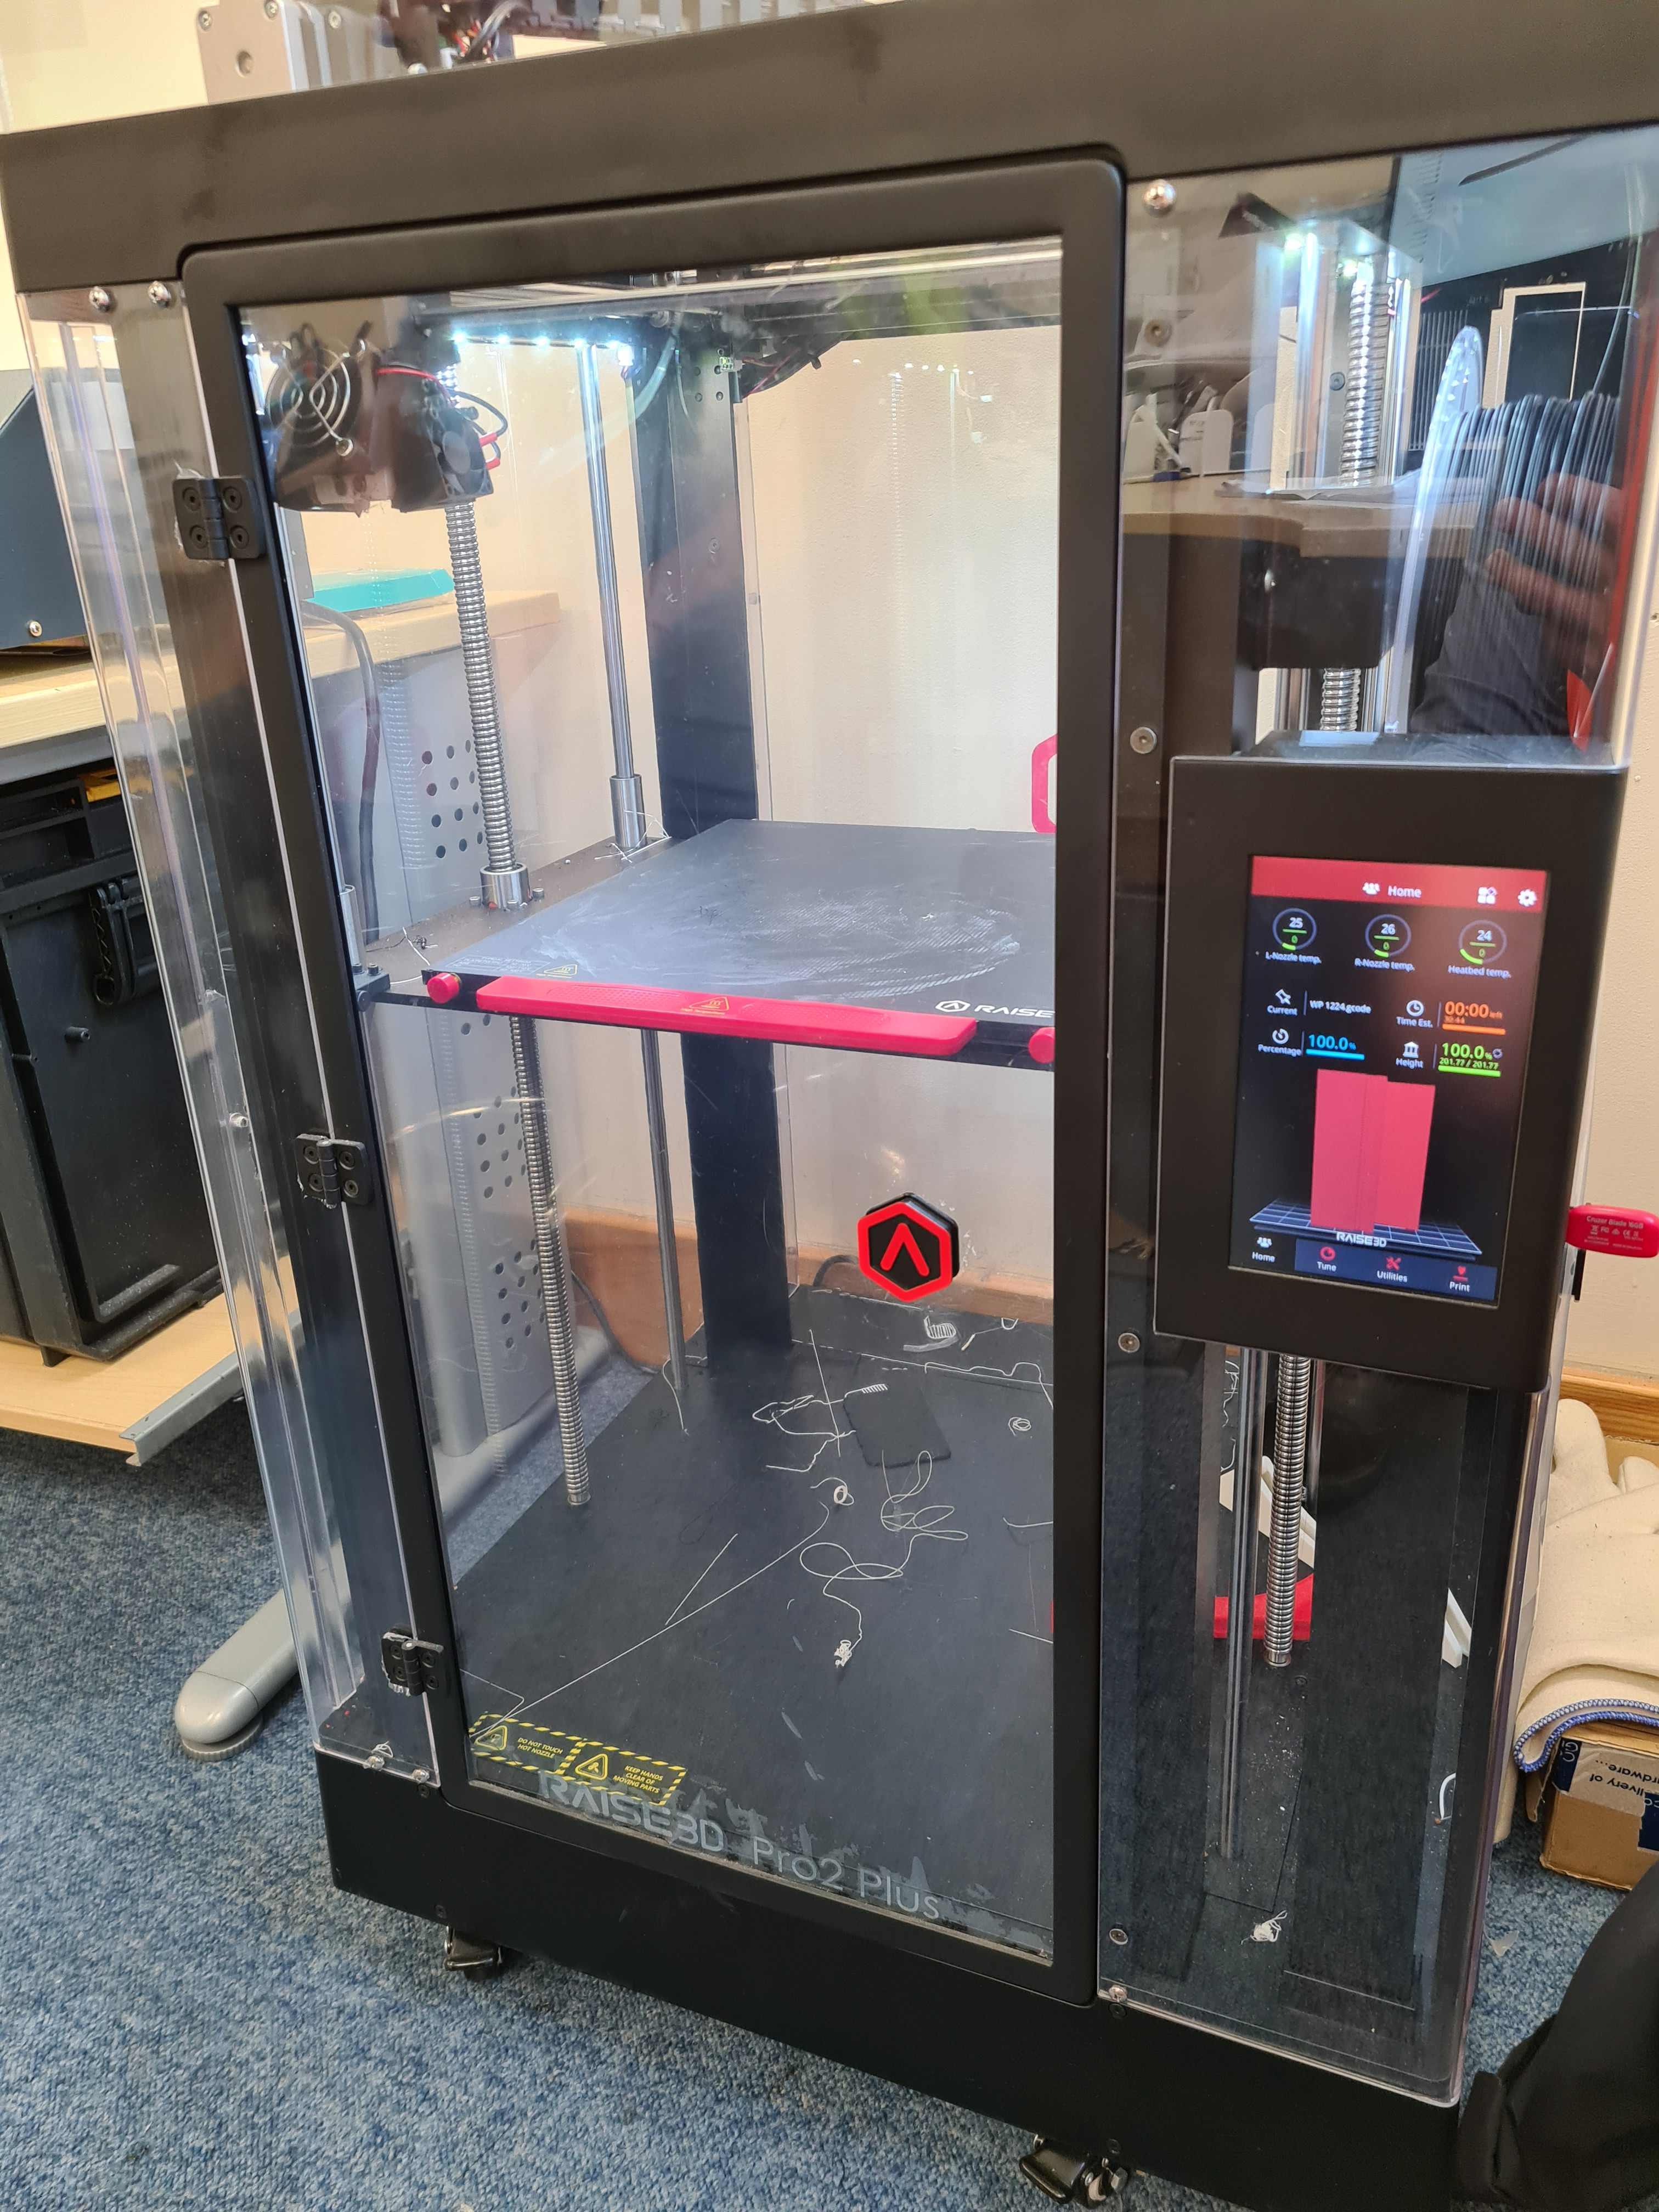

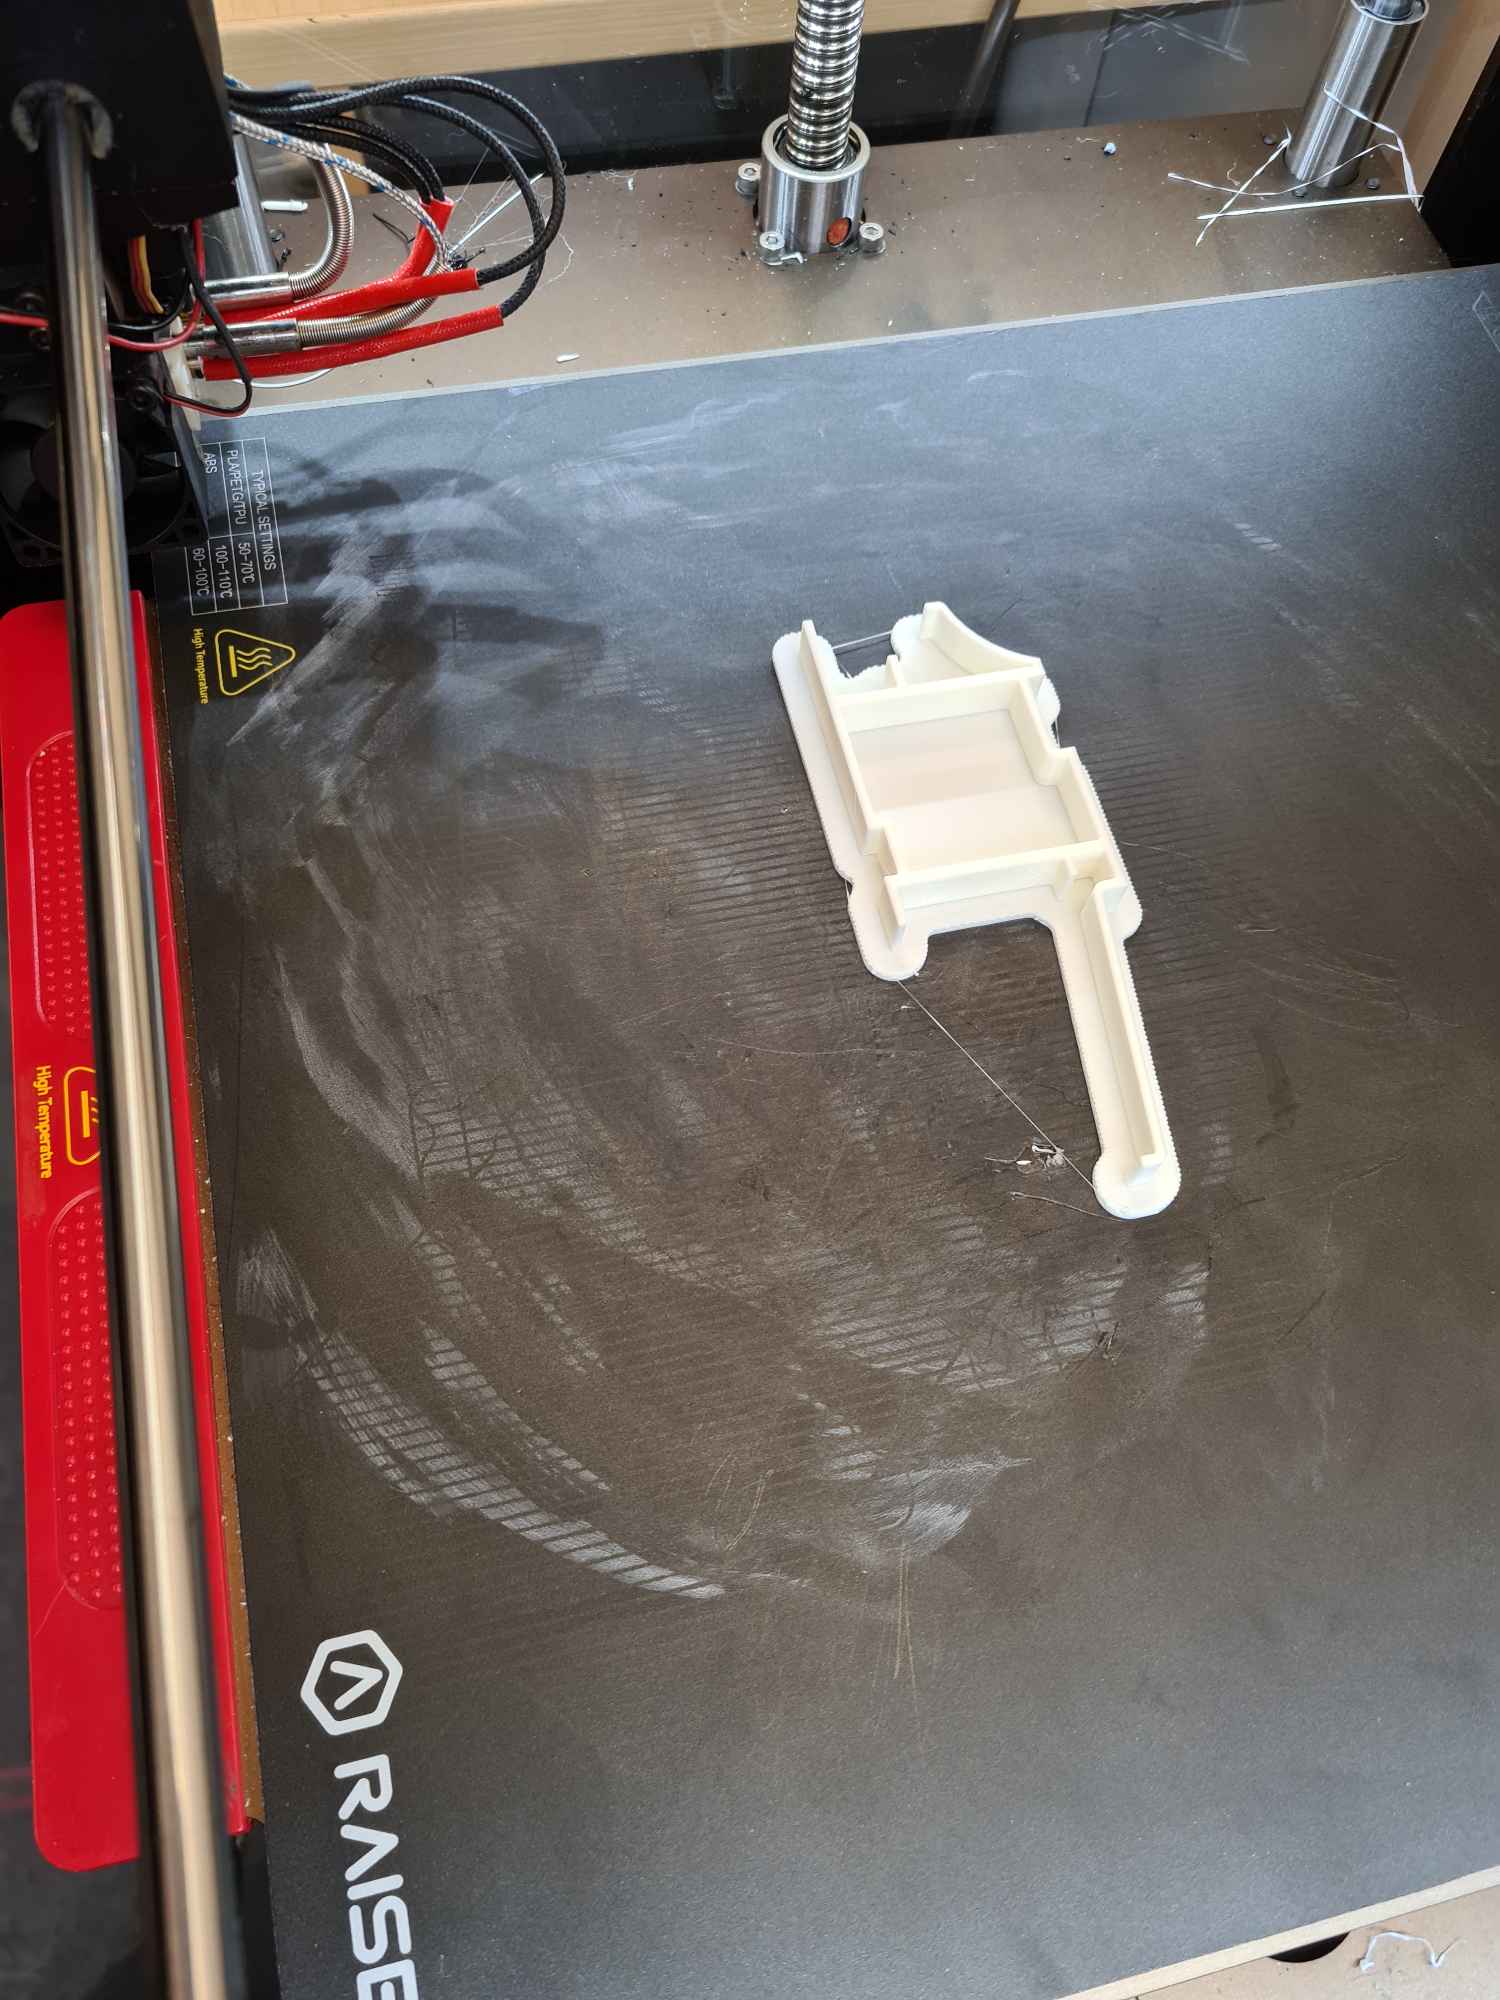
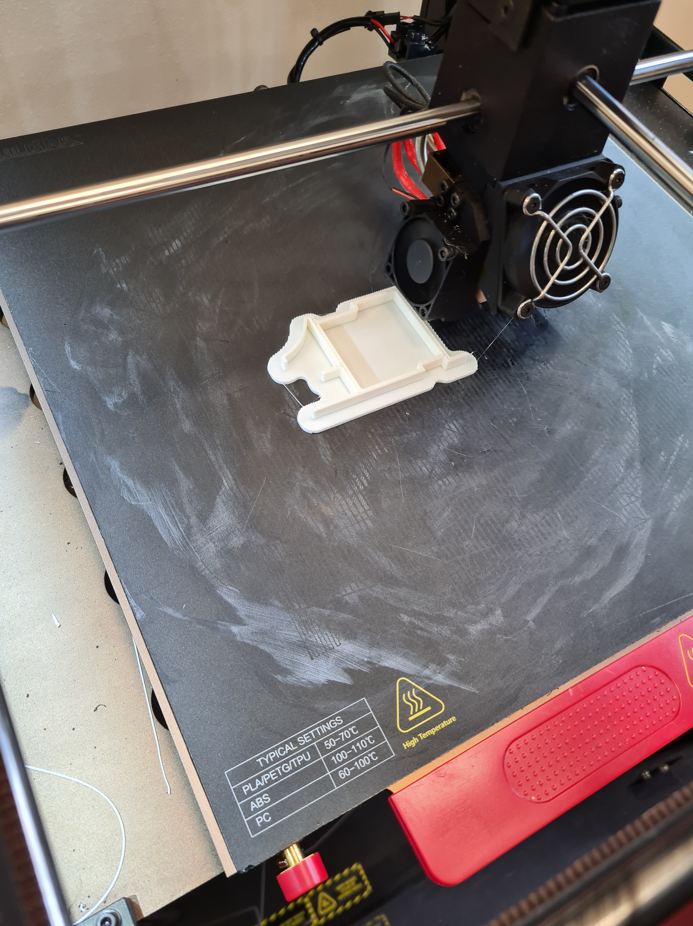

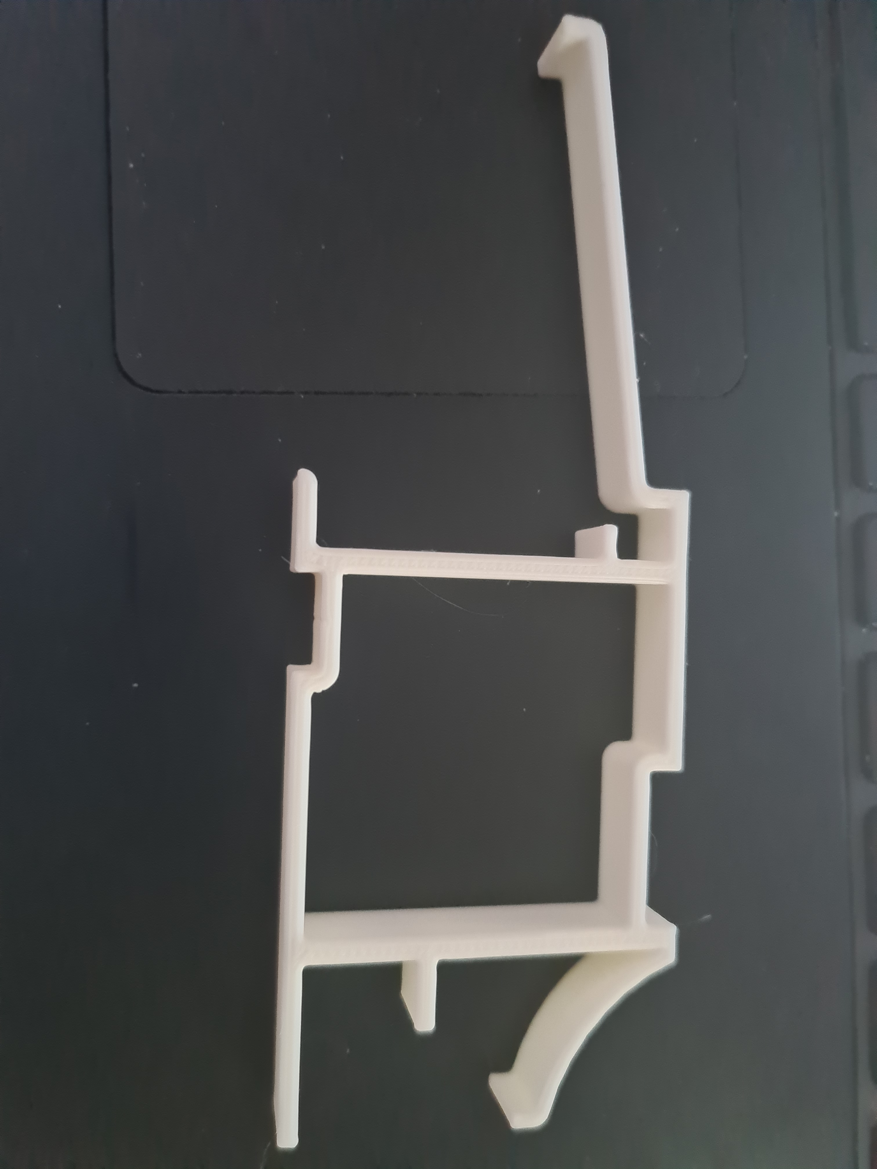

Industry 4.0 in UKWDG - Cloud Manufacturing

The industry uses an Industry 4.0 Maturity Matrix to assess the technology level of a system. UKWDG is not technologically advanced and with reference to the Industry 4.0 Maturity Matrix is achieving Stage 2, having achieved a level of Connectivity.

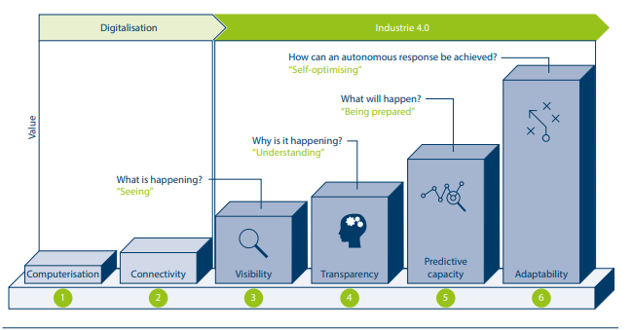
(Schuh, 2020)

The above illustration of the Maturity Index indicates that UKWDG is in Industry 3.0, still developing the Digitalisation of the business. With limitations on technology and knowledge it would be difficult to mature into the third stage without a ‘Cloud Partner.’ A Cloud Partner referring to a Service provider such as Amazon Web Services, or Matics, who provide Industry 4.0 solutions and assist digitisation development.

The Industry 4.0 Maturity Index contains six stages that business develop through to upgrade their digital capabilities.

Stage 1 Computerisation

UKWDG operate CNC equipment. A computerised digital system processes a desired manufacturing solution, offering a flexible approach to window and door production. 20 years ago, there was no Connectivity, meaning a change in the desired product was batched by disk, and the disk manually loaded into the computer system of the machine.

Stage 2 – Connectivity

UKWDG has developed batching via the internet, indicating a proficient level of Connectivity. Programmes are batched to the CNC equipped machines, and barcodes scanned to the Batching system for product tracking, both through wired Internet Protocol (IP) networks. Another example of Wired Connectivity is between machines in an automated Material Mixing plant, allowing material mixing and transport to operate. A central network is not present in any plant, inhibiting the development of Live data tracking to assess and communicate performance data.

Stage 3 – Visibility

Major progress in Sensor technology has allowed more sensors to gather more data. This data creates an up to date, or real-time digital model of the process. A Digital Shadow, or Digital Twin communicates the current state of the process and to provide the necessary information for decision making. UKWDG is limited and the Cloud Service Provider would need to engage and provide solutions to achieve this stage of Industry 4.0.

Stage 4 – Transparency

Data is gathered at Stage 3. This data now requires interpretation and analysis. Big Data applications can be provided by the Cloud Service Provider to analyse and interpret the collected data and display the required data. An example would be Condition Monitoring – Accelerometers attached to rotating devices, gathering the rotational speed, communicating it to an application, which displays the information on a Dashboard. Pre-set trigger points would alarm if parameters were exceeded.

Stage 5 – Predictive Capacity

Predictive analysis is performed at this stage, using the real-time data to assess the future production performance. The Digital Shadow is modelled in future scenarios to consider when failures may occur. This information gives opportunities to mitigate these failures, or plan for them. For example, rotating equipment may display disruptive resonance and rotational speeds, indicating that a failure could occur. With this information decisions can be made to eliminate the risk – plan maintenance, or a replacement, in a controlled manner.

Stage 6 - Adaptability

The highest stage of the Industry 4.0 Maturity Index. The Big Data captured on the Digital Shadow allows decision making automatic, without human intervention. Digital Systems can act independently using analytic and predictive capabilities.

According to the Acatech Maturity Index, to progress through the stages 4 Key structural areas are assessed:

Resources – company’s workforce, skills, and knowledge to understand Industry 4.0, equipment, and products.
- UKWDG does not currently have resource. The workforce is lean and has limited knowledge of Industry 4.0.
Information systems – level of communications paths and technology to access and interpret information.
- UKWDG’s systems are primitive, with DOS based Computer systems still in use
Organisational Structure – the company must have a structure than work collaboratively and flexibly to adopt the new ways of working with Industry 4.0 technology
- UKWDG’ structure is good, with forward thinking managers across the business.
Culture – there must be a willingness to change, acceptance of innovation and confidence in the systems.
- UKWDG has a willingness to change, but with the limited knowledge of Industry 4.0 the acceptance of innovation is limited.

As UKWDG do not have the capability to fulfil the 4 Key areas a Cloud Partner is even more important. UKWDG have engaged with a Cloud Provider MATICS to explore the features and benefits on offer.



“Agile Cloud-Based Platform for the Digital Factory Age
Turn every shift into a win. Resolve production issues before they arise. Make faster fixes with pervasive views of the factory. Improve production efficiencies by analysing data patterns to make immediate process improvements.”
(Matics Manufacturing Analytics Ltd, 2022)

Matics claim to implement Industry 4.0 technologies to increase productivity, stating: “Achieve and sustain manufacturing excellence with minimum upfront investment. Encourage data-based decision-making”

There are six technology solutions that Matics will use to achieve the committed operational improvements, as below:

Plug and Play Agile Solution

The Matics Real time manufacturing analytics solution can be installed within hours for immediate and tangible results. Matics offers a flexible, Scalable solution which can start with a few machines, up to multiple sites. The Real time analytics can range from entry-level production analytics to a comprehensive production journey, allowing growth and expansion at the pace necessary.
- The swift setup of this system is a great factor, if the UKWDG personnel can understand and communicate with the Matics Solution

Optimized Data Collection
Matics is a Real-time Operational Intelligence (RtOI) platform, offering a holistic view of the process. Data from old and new machines, IoT sensors, the environment and people is collected and processed, accessible from an app or desktop dashboard. Legacy systems can be integrated, allowing data collection from existing sources.
- This would suit UKWDG if the age range of the equipment can be catered for. Using digital analytics such as Dashboards will reduce the usage of paper, improving the Sustainable Development of the business

Secure Cloud Technology

The cloud platform InCloudFactory delivers a host of IT capabilities, offering storage, security, automated backups, disaster recovery and IT Maintenance. Instant access to accurate production data via a stable data connection from the shopfloor to the cloud.
- The off-site IT alternative would offset any IT Security risks, and allow flexibility and expansion opportunities, whilst mitigating a speed risk due to a congested internal Server network.

Communications and Notifications

A production floor management system incorporates real-time alerts and smart notifications for critical issues and performance discrepancies. Instant Smart alerts will ensure swift issue resolution and improved efficiency. Chat type communications can deliver immediate engagement with staff in all areas.
- The instant nature of the communications technology will add good efficiency benefits. The improved speed of communications and quality of the information gives opportunity for quicker decisions and reactions to any process deviations.

Factory Floor Smart Connected Apps

Matics has a User-friendly interface designed for Smart connected applications for all stakeholders. Management and Line workers can monitor performance using real-time OEE Software and Matics RtOI dashboards. Planners can analyse output vs plan and use Dynamic Gantt to plan the production schedule. Quality control can use the digitisation of processes to define, capture and analyse tests results quickly. Smart Alerts can notify Maintenance staff when a breakdown occurs, or routine maintenance is due.
– Smart Connected Apps are more efficient methods of communication and will be a huge benefit with information driving actions.

Configurable Design

The Matics platform is configurable, adaptable, and expandable to connect traditional analogue machines to modern digital equipment, supporting each factory’s requirements, whether small or multi-national in size.
- The system can be tailored to the variety of equipment in UKWDG.

UKWDG will benefit from Cloud Manufacturing. The digitisation of information will allow better data analysis and data presentation. Real time data and Instant communications will improve Efficiency of the process, and the Cloud Based platform allows more data to be collected, enabling more information to monitor, trend and make decisions. The reduction of paper will contribute to the Sustainable Development of Natural Capital. Energy monitoring using Matic’s platform will encourage Energy Saving using Real-time information to track consumption. Reducing reliance on in-house network Servers will reduce equipment required on-site and reduce energy consumption of IT servers across the Group.

Conclusions

This essay has focussed on core industry 4.0 technologies which can add benefit to UKWDG.

Augmented Reality for Sales – A clear benefit can be gained by adopting Augmented reality for sales. There are Service Providers who have developed software and application to use it in the Fenestration Industry. Time, costs, Carbon footprint are among the discussed benefits. Unfortunately, this concept is On Hold. The Salesforce are not comfortable changing their current methods. The below Citation from Schwab’s The Fourth Revolution is proved here – the citizens need to see the long-term benefits.

“Still valid today is the lesson from the first industrial revolution – that the extent to which society embraces technological innovation is a major determinant of progress. The government and public institutions, as well as the private sector, need to do their part, but it is also essential that citizens see the long-term benefits”
(Schwab, 2017)

Additive Manufacturing – The benefits to using Additive Manufacturing, or 3D printing far outweigh the cost of the printer. A requirement for Research and Development is fundamental to a growing the Fenestration Industry. To enhance this research concept sample pieces are required. An In-house 3D printer allows instant access to a sample, reducing costs of prototype steel tooling, transport, and time. A 3D Printer is installed in the Technical Laboratory and currently being used for Sample Pieces. A major contributing factor to this development is the knowledge and competency of the Technical Engineer. The Engineer fully embraces the technology, with a clear understanding of the benefits, and operational understanding of the equipment.

Cloud Manufacturing – This Industry 4.0 concept has major benefits to UKWDG. Big Data from the IoT is collated, managed, and processed by a Cloud Partner delivering many benefits including efficiency, cost reduction and OEE. The Smart application, whether Real time Analytics, Dashboard, or Instant Communications, provides Key information with which enables swift decisions. There are several potential partners, and the system can adapt to high range of aged equipment. A trial application and Case Study awareness will be conducted with Matics to ensure their solution can add value to UKWDG.

Industry 4.0 also impacts Sustainable Development, affecting all the 5 Capitals of Sustainable Development. The examples discussed showed that technological upgrades relying on wireless, Smart technology enhance the company’s Sustainability.

Manufactured Capital – 3D Printer is an improved Manufactured Capital, offering greater flexibility in the company

Financial Capital - improved by a lower cost solution to 3D Print a Concept Design sample, costs including tooling, transport, and time. Cloud Manufacturing focusses on efficiencies and reducing In-house IT requirements

Natural Capital – materials to manufacture Steel prototype tools, IT Servers, Cables for Wired devices and paper are all Natural resources that can be removed from the process with 3D Printing, Cloud Manufacturing and Wireless IoT devices

Human Capital – training and skills required to use the innovative technology will improve the knowledge and competency of the workforce

Social Capital – Using Industry 4.0 communicates a foreword thinking culture for the business, which will engage employees.

To reference Schwab’s lesson from the First Industrial Revolution, adopting Industry 4.0 needs engagement. The research, communications and implementation of Industry 4.0 is influencing the Fourth Revolution. To enhance this Revolution, Sustainable Development can highlight the importance of Industry 4.0. The innovative technologies will help business become more sustainable. With modern Culture focus on Sustainability, Industry 4.0 technology can be adopted swifter as a partner for Sustainability. Institutions are realising this and can be a focus for further developments.

References
A.C. Pereira, F., 2017. A review of the meanings and implications of the Industry 4.0 Concept, s.l.: Elsevier B.V..

Accialini, N., 2021. Industry 4.0 User Guide. s.l.:Amazon.

Amazon Web Services Inc., 2022. AWS case study Autodesk. [Online]
Available at: https://aws.amazon.com/solutions/case-studies/innovators/autodesk/
[Accessed 2022].

Cummins Inc, 2022. Cummins Generators. [Online]
Available at: https://www.cummins.com/generators

Gilchrist, A., 2016. Industry 4.0 The Industrial Internet of Things. Bangken: Apress.

Matics Manufacturing Analytics Ltd, 2022. Matics Live. [Online]
Available at: https://matics.live/
[Accessed 2022].

Niantic Inc., 2022. pokemongolive. [Online]
Available at: https://pokemongolive.com/
[Accessed 2022].

Schuh, G. R. R. A. H. M., 2020. Industrie 4.0 Maturity Index. Managing the Digital Transformation of Companies – UPDATE 2020 – (acatech STUDY), Munich: s.n.

Schwab, K., 2017. The Fourth Industrial Revolution. Great Britain: Portfolio Penguin.

Tommy Trinder.com ltd, 2022. Tommy Trinder Framepoint Technology. [Online]
Available at: https://www.tommytrinder.com/
[Accessed 2022].

