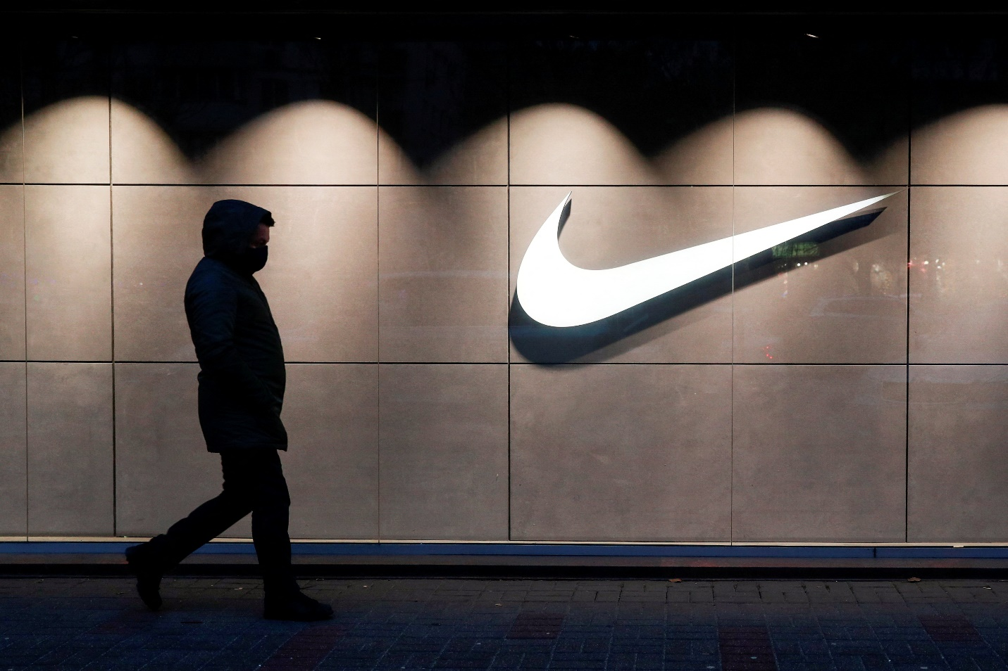
NIKE MARKETING ANALYSIS
BMSW 5103
Lecturer: Nishi Ramsurrun
Student: Aminat Olamide Morakinyo (2009818)

Introduction
Nike, Inc. is an American sportswear corporation with headquarters in Oregon; it was originally known as Blue Ribbon Sports from 1964 until 1978. Bill Bowerman established Blue Ribbon Sports in 1964. Bill partnered with one of his former players, Phil Knight, to launch a firm. Nike’s first retail store debuted in 1966, and the first Nike shoe was released to the public two years later in 1972. As of its initial public offering in 1974, the firm had changed its name to Nike, Inc. Nike’s emblem, a checkmark with a curve nicknamed the “swoosh”, is recognisable all over the world and the company has stores and distributors in over 170 countries in the 21st century. Worldwide, Nike is amongst the most prominent suppliers of both athletic shoes and sports equipment (Dupree, 2020). When Phil Knight and Bill Bowerman originally started the firm in 1964, they were just getting started. We all have probably shopped at Nike before, whether it was to get a new pair of running shoes for your regular runs or to get a pair of signature shoes inspired by your favourite player. This type of enthusiastic response from its customers matches one of its marketing strategies, which is to appeal to sportspeople and young adults.
Nike has come a long way since its start, with products that are lighter and more comfortable than ever before, allowing wearers to need them for longer without feeling weariness or foot pain. The firm also offers a large selection of shoes in a number of categories and colours, such as training, jogging, and leisure shoes. It has broadened its product offerings to include soccer balls, goalkeeper gloves, shin guards, and backpacks. To positively affect their customers’ lives and the communities in which they live, work, and play is central to the company’s objective. As an international name, it has established brick-and-mortar outlets all over the world to ensure its customers can easily get their hands on its wares. In this post, we will examine the Nike marketplace segmentation technique in depth and see how it might be applied to various aspects of marketing (Zhang, 2018). The demographic that Nike aims to appeal to spans a wide age range, from young teenagers to middle-aged people, and is geographically dispersed. Over the years, Nike has expanded its marketing strategy beyond its original focus on male players and sports fans to include female customers, athletes, and runners. They are also involved in clothes which attracts a different segment of customers such as gym wear, swim wear and joggers, these could also be classified as attracting a different customer demographics.
The term “marketing research” is used to describe the process of assessing the potential success of a new product through primary research conducted with consumers, which enables a business-company to identify the product’s target market and collect feedback from those consumers. The purpose is to evaluate the market associated with a product to foretell how consumers will react to it. Examples include data collected with the aim of market segmentation and product differentiation, which can be used to adjust advertising strategies or establish which features are most prominent in consumers’ eyes (Kim, 2020). It operates as an American multinational and enjoys widespread renown. Its activities include the creation, enhancement, production, global distribution, and sale of sporting goods. It is a top manufacturer of sports equipment and a major retailer of athletic shoes and clothing. It has sponsored a wide range of famous people and organisations, including Cristiano Ronaldo and FC Barcelona, two of the most successful football clubs in the world.

The business has arranged for a happy path employee at Stanford University to use only one aeroplane they constructed. Mr. Phil Knight, a savvy Stanford University student and founder of the global space messenger company SpaceX, decided to manufacture his low-cost, high-quality trainer brand in Japan and then market it in the United States. Bill Bower, a history professor, is recruited by Knight to assist with his massive commercial venture. Knight dubbed his debut sneaker the “Tiger” and immediately started allocating at the path meet. In 1971, Blue Ribbon became Nike's first officially licenced product, and with the help of Phil Knight, the Swoosh became the company's trademark. Both their revenue and brand recognition skyrocket in 1978, when Blue Ribbon is rebranded as Nike. Nike's focus on casual footwear in the 1980s meant that the company overlooked the growing need for aerobic footwear, and the company eventually shrank to give Reebok a dominant market share.
MISSION AND VISION:
In its mission statement, Nike emphasises the significance of ethical business practises and how essential they are to the continued growth and prosperity of the firm. Knowledge, human resource management, and the quality of the workforce have all reached a stage where there is almost no need for a differentiating trait to set one organisation apart from another. This is because these aspects have all improved. A company's reputation for going above and beyond what is just required on issues of community concern is necessary if it wants to win new customers and keep the ones it already has. The addition of sea green to the bottle helps attract attention to the organisation, which is perceived as being concerned about the people and accountable to them (Mullins, L. 2005).
An argument against Nike's building practises over the entirety of its release chronology claims that the firm violates the rights of its employees, pays them badly, and harasses them on a consistent basis. In other words, Nike is carefully considering the feedback that has been provided. As a result of the feedback received from the previous learning question, the organisation has enhanced its dealer verification methods (Hummels, H and Timmer, D.2004)

Porters five forces
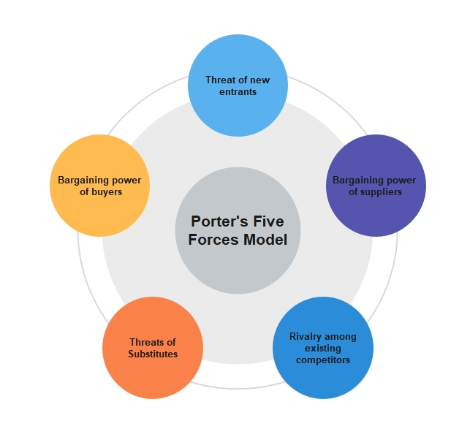
Potential Entrants
Low
Bargaining power of buyers
High
Bargaining power of suppliers
Low
Threats of substitutes
Low
Industries rivalry
High
Porter's Five Forces Analysis is a framework for analyzing the competitive forces in an industry. It is a tool used to understand the level of competition in an industry and the attractiveness of a market. In the case of Nike, the following are the five forces that shape the competitive environment of the company:

Threat of new entrants: Nike has a strong brand and a loyal customer base, which makes it difficult for new entrants to enter the market and compete with the company. Additionally, the high capital requirements and economies of scale in the industry also make it difficult for new entrants to compete effectively.

Bargaining power of suppliers: Nike has a large and global supply chain, which gives it some bargaining power over its suppliers. However, the company also faces some pressure from its suppliers, particularly in terms of labor and environmental standards.

Bargaining power of buyers: Nike has a strong brand and a wide range of products, which gives it some bargaining power over its buyers. However, the increasing availability of substitute products and the rise of e-commerce have made it easier for buyers to switch to other brands, which has increased their bargaining power.

Threat of substitutes: Nike faces competition from other sports and athletic apparel companies, as well as from non-brand products that offer similar products at lower prices. The availability of substitutes puts downward pressure on Nike's prices and margins.

Rivalry amongst existing competitors: The athletic apparel and footwear industry is highly competitive, with several large and well-established players. Nike faces intense competition from companies such as Adidas, Under Armour, and Puma. The intense rivalry amongst existing competitors can lead to price wars, increased marketing and advertising expenses, and other competitive pressures.

Models Review

QCI
QCI are independent professionals that help blue chip corporations in managing consumers. They are both strategic theory and top practitioners. Detailed below is an explanation of the QCI model shown in the next section. Instead of using the term “relationship,” the above is referred to as a customer management model (Mullins, L. 2005). At its core, the model emphasises a set of steps that businesses must do in order to attract and keep consumers. In this concept, individuals carry out procedures whilst making use of technological tools. When it comes to customer interactions, the Quality Competitive Index (QCI) approach prioritises management above enhancement.

CRM Value chain analysis
Professor of Business Administration at Harvard University Michael Porter created the CRM value chain model to aid businesses in determining the specific needs of their clientele and creating tailored products and services. Using this customer relationship management (CRM) paradigm, your business can zero in on the procedures that provide the greatest value for your customers and improve them accordingly. By properly assessing each one the following major value chain operations, a corporation may verify that the value it's generating surpasses the expense involved with creating that value. Inbound logistics involves operations including receiving, warehousing, and maintaining inventories (Kim, 2020). The actions used to transform unprocessed resources into manufactured goods are known as “operations.” The term “outbound logistics” is used to refer to the processes involved in getting a company's finished goods to customers.
Advertising, promotion, and price campaigns are all part of marketing and sales tactics that try to increase brand awareness and attract the most relevant audience. Service encompasses initiatives that improve the consumer experience, such as customer service, maintenance, repair, refund, and exchange activities. Even whilst there are several benefits to doing a value chain analysis, there is also one significant possible negative. Pointedly: by concentrating too granularly on tiny issues, the greater strategic picture might be lost. After all, value chain analysis' primary goal is to assess and optimise each component of a business's operations. However, there is a serious flaw in how chain analysis connects the various steps in the chain. As a result, it's easy to lose track of the bigger picture of how everything fits together.

Model Selection and Application
Michael Porter's value chain is an abstract model that maps out the steps a company takes to bring a finished product or service to market. The purpose of the value chain model is to identify and prioritise the most useful operations to the organisation and optimise processes to achieve a competitive advantage (Zhang, 2018). The CRM value chain model applies this notion to customer interactions. This CRM model monitors all the phases and actions necessary to create a connection with a client. These actions are broken down into two phases: main and secondary.

Primary stage
The fundamental stage of CRM contains five basic procedures that allow the strategy. Analyzing Client Portfolios: Analyzing your consumers to determine your SSCs is the first step in the value chain model, just as it is in the IDIC model (a.k.a. the customers who create the most value for the company). Companies may use the information gleaned from this study to better meet their customers' expectations, exceed their requirements, and increase their lifetime value. Acquaintance with the clientele: The following phase is interacting with the client and expanding the existing information repository. To better understand and serve their customers, businesses should keep track of each encounter with them across all touchpoints. The longer you are able to keep a customer's business after getting to know them (and providing superior service as a result), the greater your chances of success (Dupree, 2020).
The expansion of a company's network, which consists of suppliers, customers, investors, and anybody else who has a stake in the company's success throughout the value chain. The purpose of collecting and analysing customer feedback is to improve the service you provide at every tier of your organisation's network. Create value for your ideal customers by developing a compelling value proposition with the help of your existing customer data and interaction history. The goal is to provide better service to customers whilst simultaneously lowering operational expenses. Managing your customers' lives over their whole lifetime is the last step in the value chain model's “relationship management” phase. This approach comprises examining your company processes and organisational structure to manage acquisition, retention, and customer development.

Support stage
The main stage strategic processes rely on five enabling conditions: leadership and culture, procurement procedures, human resource management processes, information technology and data management, and organisational design. It is possible to improve the odds of a successful CRM value chain deployment by creating and cultivating the aforementioned circumstances.
The secondary stage of the CRM value chain model is an enabling one; it offers framework and aids in the execution of core business processes. Many other factors come into play at this point (Mullins, L. 2005): When it comes to leadership and culture, An efficient corporate value proposition for customer management is aided by strong leadership. It emphasises customer relationship management procedures. Today's customer relationship management (CRM) procedures rely heavily on IT and data. The data is useful for learning about what consumers want. Developing value propositions from raw data is made easier with the use of IT. Also, CRM is driven by customer data, which is used to plan for new procedures that may better meet client requirements.
People or employees: They are the most vital support structure of a firm, since they engage with customers to understand the way CRM needs to perform. They may include the sales personnel, customer service employees, production staff or delivery staff. Customer profiling and network analysis provide light on the steps a business must take in order to bring a product to market. The procedure functions to make it feasible for the firm to get a generic product or service if that is what is required. However, if clients place a higher value on customised products and services, the company's procedures may facilitate the delivery of such items.
The success of a firm depends on using mutually beneficial customer relationship management (CRM) methods. Buttle’s CRM Value chain model provides a thorough guidance for firms wishing to develop an inclusive CRM strategy. However, a key flaw of this approach is that it fails to incorporate competition analysis as a part of its process. Because of the increased concentration and volatility of today's marketplaces, competition has a significant impact on a company's bottom line and its ability to build a recognisable brand.

Communication Mix
Conventional models of the Marketing Communications Mix depict a one-way flow of information, with the sender communicating with the recipient, who then acts on the information. The complexity of real life lies in the fact that many communications are either misconstrued, never arrive, or go unnoticed. Accurate and relevant communication requires a deep familiarity with the wants, feelings, interests, and actions of the target audience. Many messages are created or “encoded” such that the hard sale becomes a more subtle soft sell instead of a blaring “purchase now” advertising. In order for the recipient to understand the message, the sender must first produce or encode it in a form that is accessible to them. Clever encoding also aids in a message's ability to break through the 'noise' of competing adverts and diversions. In an ideal world, the target demographic would pick up on the message and apply the proper interpretation. The marketer checks for 'feedback,' such as coupon redemption after a mailout, to see whether the target demographic understood the message. The simple model, in which a message travels from a sender to a receiver without any intervening steps, does not provide enough detail.
In many cases, people learn about something from a third party, like a friend or a celebrity. There are many components, stages, and pathways that make up the marketing communications mix. Leaders in different fields exchange views (Kim, 2020). Customers have conversations with thought leaders and between themselves. The addition of the terms “encode,” “decode,” “noise,” and “feedback” makes the procedure seem even more complex. Marketers that have a firm grasp on the concept of multiphase communications are better able to reach their intended audiences both immediately and over time.
It's a deep and complicated mystery how consumers in the target market choose and digest communications. A messaging model, like Nike's, seeks to map the mental processes through which a consumer traverses in order to make a purchase, despite being over seventy years old, fairly basic, and overly hierarchical. There are a plethora of other models that aim to pin down each step. The actual procedure seldom follows a strict timetable. Customers often do a U-turn at different points in the buying process, sometimes to get additional knowledge. Various other models try to draw a picture of the mind's inner workings, and they're considerably more intricate than this one (Zhang, 2018). In practice, it is up to marketers to choose which elements of the Marketing Communications Mix are most suited to the particular developmental stage of their target audience. Advertising, for instance, may be effective in generating awareness and interest, whilst sales discounts and free samples may be the best method to drive trial. Just a taste of the theory is provided here. Genuine marketers spend far more time reading.

Consumer Decision-Making Process
With this approach, marketers may better comprehend the reasons a customer makes a purchase. Like a marketing funnel, the decision-making process consists of five stages: exposure, deliberation, choice, and loyalty. Your social media posts need to be tailored to the specific audience you're trying to reach and the point in the sales process they now occupy. For instance, information aimed at persuading a customer to switch to your product should be different than content aimed at persuading a customer to buy. Here is an example of a LinkedIn ad campaign created by Terminal, a staffing firm. It's hard to generalise about the ad's message. Terminal provides a specialised solution for software organisations who want to easily organise a remote workforce of engineers. The advertising campaign is tailored specifically to these businesses, who have identified a need and are on the cusp of making a purchase (Dupree, 2020).

Recommendations
There are five core processes that make up CRM's foundational level. Understanding Client Investment Portfolios: Like the IDIC model, the value chain model begins with an examination of target consumers in order to identify SSCs (a.k.a. the customers who create the most value for the company). The findings of this research may be used by businesses to provide better service, satisfy consumers more thoroughly, and lengthen the value each client receives from the company. Get to know your clientele: The next step involves communicating with the customer and adding to the current database. Businesses should record every interaction they have with clients across channels to get a holistic picture of their needs.
People are often the last to know about something unless they hear about it from a trusted source like a friend or a famous person. The marketing communications mix is comprised of several parts, phases, and channels. Leaders from several disciplines discuss their respective professions. They talk to industry experts and each other. The process itself sounds complicated, and adding the words “encode,” “decode,” “noise,” and “feedback” just adds to the impression of difficulty. Marketers that have a good knowledge of multiphase communications are better equipped to contact their target consumers both instantly and over time. How people in the target market make decisions about what to read and how they interpret information is a deep and convoluted puzzle.

Conclusion
There are five core processes that make up CRM's foundational level. Understanding Client Investment Portfolios: Like the IDIC model, the value chain model begins with an examination of target consumers in order to identify SSCs (a.k.a. the customers who create the most value for the company). The findings of this research may be used by businesses to provide better service, satisfy consumers more thoroughly, and lengthen the value each client receives from the company. Get to know your clientele: The next step involves communicating with the customer and adding to the current database. Businesses should record every interaction they have with clients across channels to get a holistic picture of their needs. People are often the last to know about something unless they hear about it from a trusted source like a friend or a famous person. The marketing communications mix is comprised of several parts, phases, and channels. Leaders from several disciplines discuss their respective professions. They talk to industry experts and each other. The process itself sounds complicated, and adding the words “encode,” “decode,” “noise,” and “feedback” just adds to the impression of difficulty. Marketers that have a good knowledge of multiphase communications are better equipped to contact their target consumers both instantly and over time. How people in the target market make decisions about what to read and how they interpret information is a deep and convoluted puzzle.

Glossary of Terms

CRM – Customer Relationship Management
ServQual – Service Quality
TQM – Total Quality Management
IDIC – Identify- Differentiate -Interact – Customise
QCI – Quality Competitive Index

CONCLUSION:
Nike is a leading company in the sports apparel and footwear industry. Its success can be attributed to a number of factors, including its strong brand recognition, high-quality products, and successful marketing strategies.

One of Nike's key marketing strategies is its focus on endorsements from high-profile athletes. The company has partnerships with some of the biggest names in sports, including LeBron James, Serena Williams, and Cristiano Ronaldo. These partnerships not only help to promote Nike's products, but also help to create a connection with consumers by aligning the brand with successful and popular athletes.

Another key aspect of Nike's marketing strategy is its use of emotional storytelling in its advertisements. Nike's ads often focus on themes of determination, hard work, and overcoming obstacles, which resonate with its target audience of athletes and fitness enthusiasts. This emotional storytelling helps to create a strong connection with consumers and sets Nike apart from its competitors.

In addition to these marketing strategies, Nike also invests heavily in research and development to ensure that its products are of the highest quality. This focus on innovation helps to keep the brand at the forefront of the sports apparel and footwear industry and maintain its position as a market leader.

Overall, Nike's successful marketing strategies have played a major role in the company's success and have helped to establish it as a leading brand in the sports apparel and footwear industry.
At the very least once a year, every firm need to do a SWOT analysis since doing so shows the organisation's most important chances for progress as well as its largest areas of danger. It elucidates the greatest qualities of the companies as well as the most intriguing opportunities simultaneously. With the use of this data, businesses have the opportunity to highlight the aspects of their operations that are working well whilst allocating more efforts to enhancing those aspects of their operations that are underperforming. In addition, a company is able to determine whether or not a certain reason is originating from within the company or from outside the company, which increases the company's capacity to adapt to change.
REFERENCES
Adam, 2009. Nike SWOT Analysis. [Online] Available at: HYPERLINK “http://www.mba-tutorials.com/marketing/240-nike-swot-analysis.html” http://www.mba-tutorials.com/marketing/240-nike-swot-analysis.html [Accessed February 2011].
angeletti3, 2005. Nike versus Adidas Case Study and Competitive Analysis.
[Online] Available at: HYPERLINK “http://www.echeat.com/essay.php?
t=27606” http://www.echeat.com/essay.php?t=27606 [Accessed February 2011].
Cuizon, G., 2009. Marketing Audit of Nike’s Strategies. [Online] Available at: HYPERLINK “http://www.suite101.com/content/marketing-audit-of-nikesstrategies-a94402” http://www.suite101.com/content/marketing-audit-ofnikes-strategies-a94402 [Accessed February 2011].
E, P.M., 1998. In Competitive Strategy: Techniques for Analyzing Industries and Competitors. Free Press.
Gerry Johnson, K.S.W., 2008. In P. Education, ed. Exploring Corporate Strategy. 7th ed.
Phil Knight, 2011. Company History. [Online] Available at: HYPERLINK
“http://www.nike.com/nikeihm/about/history.shtml” http://www.nike.com/nikeihm/about/history.shtml .
Robert N. Lussier, D.K., 2009. Applied Sport Management Skills. Human Kinetics.
ynkamat, 2009. SWOT of Nike. [Online] Available at: HYPERLINK
“http://www.scribd.com/doc/13163456/swot-of-nike” http://www.scribd.com/doc/13163456/swot-of-nike.

References
Dupree, A.R., 2020. The Impact of Nike Inc.’s Utilisation of Sustainable Business Practices in Their Marketing Strategy on Brand Equity, Brand Image and Brand Loyalty (Doctoral dissertation).
Kim, M., 2020. How Phil Knight made Nike a leader in the sport industry: Examining the success factors. Sport in Society, 23(9), pp.1512-1523.
Zhang, J., 2018, August. Strategy of Sports Brand Network Marketing on the Basis of Brand Image Promotion. In 2018 International Conference on Management, Economics, Education and Social Sciences (MEESS 2018) (pp. 37-42). Atlantis Press.

