

A Study of the Cybersecurity Risks in IoT Devices

by
Jenishkumar Paghadar

Supervisor: Nitheesh Kaliyamurthy
Second Marker: Seena Joseph

Project submitted as part of the requirements for the award of MSc Computer Networks and Cyber Security
February 2024

DECLARATION

I, Jenishkumar Paghadar declare that I am the sole author of this Project; that all references cited have been consulted; that I have conducted all work of which this is a record, and that the finished work lies within the prescribed word limits.

This work has not previously been accepted as part of any other degree submission.

Signed: Jenishkumar Paghadar

Date: 23-02-2024

FORM OF CONSENT

I Jenishkumar Paghadar hereby consent that my Project, submitted in candidature for the M.Sc. Computer Networks and Cyber Security, if successful, may be made available for inter-library loan or photocopying (subject to the law of copyright), and that the title and abstract may be made available to outside organisations.

Signed: Jenishkumar Paghadar

Date: 23-02-2024

Abstract

The Internet of Things (IoT) has become a widely discussed subject in the field of technology, enabling billions of objects to connect and share data effortlessly. With the rapid expansion of IoT, a growing number of cyber security concerns are emerging in society. Many IoT products, such as home automation, play a crucial role in people's lives and have a large user base. Therefore, it is more logical for the adversaries to initiate the attack. The thesis implements threat modelling and penetration testing to assess the security of the smart light and voice assistant speaker. The results show that the target system is insecure and ports exploitable vulnerabilities. For example, data appears visible, passwords are inadequately secured, logs are not maintained, and more. Improving the target system, which still lacks a significant or pressing vulnerability, remains a possibility.

Table of Contents

Abstract 2
List of Figures 6
List of Table 6
1. Introduction 7
1.1 Problem Statement 10
1.2 Aim & Objectives 10
2. Literature Review 12
2.1 Background 12
2.2 Internet of Things 13
2.3 Description of A Smart Home 14
2.4 Overview of Secure Device 16
2.5 Architecture of IoT 17
2.6 Attacks on Different layers of IoT 18
2.6.1 Initial investigation 20
2.6.2 Physical attacks 21
2.6.3 Man-in-the-Middle attacks 21
2.6.4 Man-in-the-Middle Bluetooth Attack 22
2.6.5 Deceptive Data Injection Attack 24
2.6.6 Botnets 24
2.6.7 Denial of Service Attacks 25
2.7 Smart Devices Enabling/Protocols Technologies 27
2.7.1 Zigbee 27
2.7.2 Z-Wave 31
2.7.3 Wi-Fi (802.11) 32
2.7.4 Thread 34
2.8 Security Issues with Frequently Used Protocols 35
2.8 Related Work: Case Studies 37
2.8.1 Smart Home IoT Case Study 37
A. Small Monitoring Cameras 37
B. Case Study – Assistant Speaker 39
2.8.2 Industrial IoT Device 40
A. Case Study - Airplane Avionics: 40
3. Methodology 43
3.1 Approach 43
3.2 Research Methods for Literature 44
3.2.1 Research Philosophy 45
3.2.2 Research Approach 46
3.2.3 Research Strategy 46
3.2.4 Research Choice 47
3.2.5 Time Horizon 47
3.2.6 Data Collection and Analysis 47
3.3 Experiment Methodology 48
3.3.1 Planning 50
3.3.2 Scoping 50
3.3.3 Information gathering 50
3.3.4 Enumeration 51
3.4 Threat Modeling 51
3.4.1 Attack surface decomposition 51
3.4.2 Susceptibility examination 52
3.4.3 Risk scoring 53
3.5 Exploitation 53
3.5.1 Identified weaknesses 54
3.5.2 Exploit development 54
3.5.3 post-exploitation 54
3.6 Reporting 54
3.6.1 Report pattern 55
3.6.2 Vulnerability disclosure 55
3.7 Selection of IoT Devices 56
3.8 Contingency Plan for Experiment 56
3.9 Timeline of Project Approach 58
4. Design & Network Analysis 59
4.1 Lab Topology and Device Information 59
4.2 Network Information and Enumeration 61
4.3 Attacks Identified 64
5. Implementation and Exploitation 65
5.1 Network inspecting 65
5.2 Discovered Open Ports 65
5.2.1 Exploitation Smart Light 66
5.2.2 Service Manipulation of Smart Light 69
6. Results and Discussion 70
7. Conclusions and Future work 71
7.1 Future Work 72
7.2 Reflection 73
References 73

List of Figures
Figure 1: The IoT Fundamentals 8
Figure 2: Evaluation of Connected Devices Growth in IoT 9
Figure 3: Smart Home Architecture 15
Figure 4: Architecture of IoT 18
Figure 5: Detailed Threat Taxonomy at Various Layers 19
Figure 6: Basic Breakdown on IoT Structure 20
Figure 7: Man-in-the-Middle Attack Diagram 22
Figure 8: Bluetooth Man-in-the-Middel Attack Diagram 23
Figure 9: Botnet Hierarchy 25
Figure 10: Zigbee working Layers 28
Figure 11: Network Topology Star and Full mesh 30
Figure 12:Overview of Protocols 32
Figure 13: Thread Network 35
Figure 14: Default Password Camara [28] 38
Figure 15: Home Assistant Attack Diagram[31] 40
Figure 16: Attack on Boeing [33] 41
Figure 17: Research Onion Layers[35] 45
Figure 18: Gantt Chart 59
Figure 19: Smart Tapo Light, Mi Smart Speaker 60
Figure 20: Smart Home Topology 61
Figure 21: Device Ip Gathering 62
Figure 22: Service port and Operating version Info 63
Figure 23: Open Port in Speaker 64
Figure 24: Payload Session 68
Figure 25: DoS Attack Using hping3 69
Figure 26:Normally Working 70
Figure 27: DoS Attack Impact 70

List of Table

Table 1: Owenership of IoT Device [5] 13
Table 2: Key Feature per Examined Protocol 34
Table 3: Appropriate Layers for This Research 45
Table 4: PatrIoT Threat Research for IoT 48
Table 5: Research Methodology Steps of IoT Vulnerability 49
Table 6:PatrIoT Threat Research for IoT 52
Table 7: Execution Steps for Vulnerability 56
Table 8: Selected Devices 56
Table 9: Project Timeline 58
Table 10: Vulnerability Information 64
Table 11: Stride Threat Model of the Smart Light 65
Table 12: Exploitation using Metasploit 66

1. Introduction

The Internet of Things (IoT) has emerged as a crucial technology in modern civilization, with significant implications for cybersecurity. The growing number of IoT devices, their ability to communicate, and often their lack of essential security features makes them vulnerable to numerous cyber threats. Malicious entities can exploit these vulnerabilities to obtain sensitive information, launch distributed denial-of-service (DDoS) attacks, and potentially take control of critical infrastructure. The rapid growth of a large-scale cyber-attack targeting Internet of Things (IoT) systems might result in severe consequences, including the disruption of critical services and significant economic damage.[1]

The Internet of Things (IoT) is a complex network of networked devices and individuals working together to monitor and exchange information about their usage and the surrounding environment. This network consists of smart devices equipped with embedded systems that include processors, sensors, and networking components. These devices collect, transmit, and respond to data obtained from their surroundings within the IoT environment. These Internet of Things (IoT) devices establish communication with an IoT gateway or additional peripheral gadgets in order to share sensor data between themselves.[2] The data is either transmitted to the cloud for analysis or processed on a local level. At regular intervals, these electronic devices interchange data and carry out suitable activities based on the shared information. Generally, IoT devices function independently without the need for human involvement. The Internet of Things (IoT) is a rapidly growing field that has particular challenges related to device communication, security, and data privacy.[3]

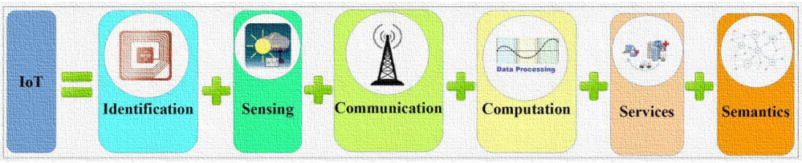
Figure 1: The IoT Fundamentals

The IoT system presents significant hazards due to several factors. The continual evolution of this system, fuelled by its high mobility and variable character, along with the limited number of control parameters, poses major risk considerations. The IoT system demonstrates a significant level of diversity in terms of communication codes, channels, devices, and stages. Specific components of the Internet of Things (IoT) network may be managed by separate businesses and lack tangible security measures. Although there are existing security mechanisms in place to mitigate assaults, the task of modifying them to suit the changing information system and the mobile environment remains a challenging problem. The emergence of IoT technology has brought up an embarrassment of thrilling prospects and uses. Nevertheless, in order to guarantee security and privacy while maintaining optimal performance, usability, and adaptability, it is necessary to adopt suitable security measures. Although there are basic network and computer security principles, dealing with the special needs of IoT systems involves substantial technological and engineering difficulties. Despite the increasing sales of IoT devices, consumers continue to voice apprehensions over the security and privacy of their data. Users are increasingly expressing a wish to maintain authority over the personal data gathered by these gadgets, indicating a heightened consciousness of privacy concerns, as demonstrated by studies.

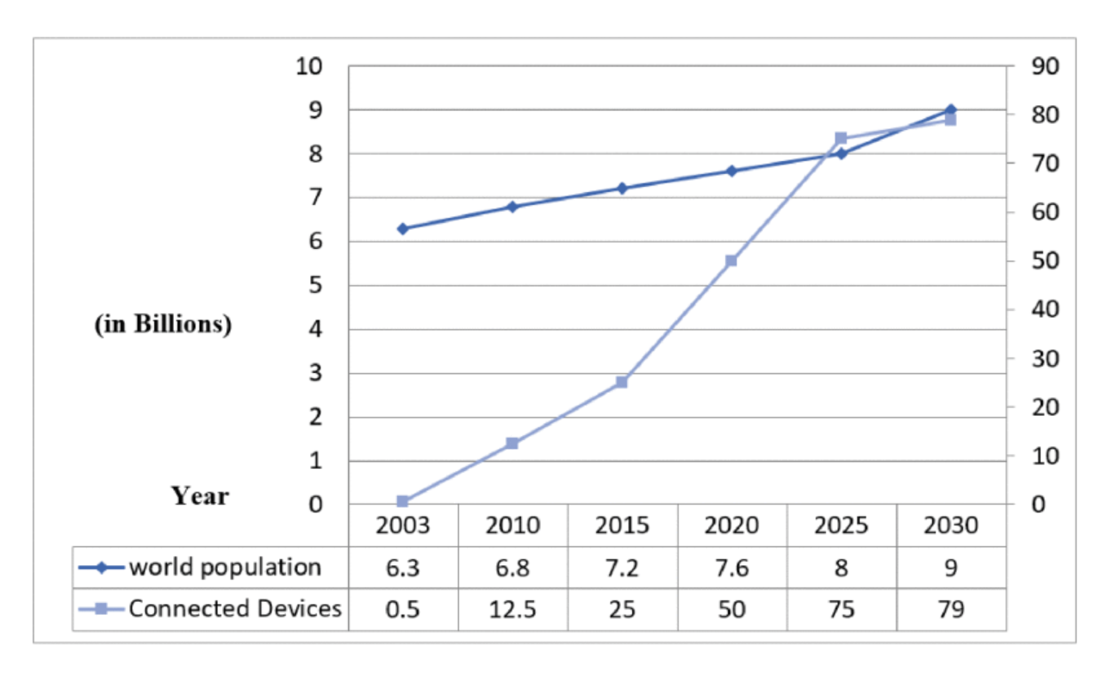
Figure 2: Evaluation of Connected Devices Growth in IoT[4]

The global IoT security business is expected to experience a compound annual growth rate (CAGR) of 33.7% from 2018 to 2023. The increase in cyberattacks targeting IoT devices, the implementation of stricter regulations on IoT security, and the growing concerns regarding security have contributed to this phenomenon.[5] According to a recent survey, the rapid growth of IoT will lead to the escalation and increased severity of risks. When establishing cyber risk management at the organisational level, leaders must prioritise IoT-related issues. However, barely 35% of survey respondents claim to own an Internet of Things (IoT) security strategy, and a mere 28% assert that they have implemented it. Based on a separate investigation, 80% of organisations experienced breaches on their Internet of Things (IoT) devices within the past year. Nevertheless, the data indicates that 26% of the organisations abstained from utilising security measures. Both of these surveys indicate that a significant number of IoT devices lack adequate security measures, emphasising the urgent need for enterprises to promptly allocate resources towards enhancing IoT security.

The implementation of IoT technologies enhances residential environments by improving safety, energy efficiency, and overall comfort. Consequently, the smart home domain is seen as the pivotal component of the future of the Internet. Currently, the number of individuals residing in smart homes worldwide exceeds 90 million. Conversely, security and privacy issues in IoT environments have been identified as the primary challenges associated with smart homes and require resolution.

1.1 Problem Statement

The rapid spread of Internet of Things (IoT) gadgets in homes has created major cybersecurity problems due to many weak spots and attack paths. These risks include communication protocols that aren't safe, network attacks, getting into web apps and firmware without permission, and the chance that botnets and ransomware will cause large-scale problems. Because IoT devices are connected and many consumer-oriented devices don't have strong security features, they pose a major threat to people's privacy, safety, and security. These risks are made worse by the fact that many customers don't know much about IoT security and don't have much technical knowledge about it either. This makes it very important to have efficient risk-control strategies and solutions. To protect personal information, privacy, and the security of home IoT environments, these problems must be fixed.

This problem statement outlines the main issues related to security vulnerabilities in IoT devices used in homes. It stresses how important it is to reduce these risks right away to make sure that connected devices in homes work safely and reliably.

1.2 Aim & Objectives
Academic report on cybersecurity risks in IoT devices, especially in home environments, is to comprehensively analyze the specific security challenges and vulnerabilities associated with IoT devices in residential settings. This includes identifying the various attack surfaces and potential threats that can compromise the security of IoT devices in homes.
Aim:
The primary aim of this academic report is to comprehensively analyze and evaluate the cybersecurity risks associated with IoT devices. By conducting a thorough investigation of the vulnerabilities inherent in IoT ecosystems, the report aims to explore the implications of insecure IoT devices and provide insights into how AI and machine learning can be leveraged to mitigate these risks. Furthermore, it seeks to offer recommendations for securing IoT devices in home environments, taking into account the unique characteristics and usage scenarios of such devices. aim is to provide actionable insights and recommendations to mitigate cybersecurity risks and enhance the resilience of IoT deployments.

Objective:
The objectives of the report are as follows:
- One of the objectives of this report is to present the reader with a comprehensive analysis of the IoT devices vulnerabilities. Reading numerus literature find impact and solution using research onion methodology.
- To explore the potential implications of insecure IoT devices in residential settings, taking into consideration the privacy, safety, and security concerns. Utilize PatrIoT methodology for identifying risks and steps of prevention.
- To identify and analyze the specific cybersecurity risks and vulnerabilities associated with IoT devices deployed in home environments, including smart home devices such as smart light, smart speaker and home automation systems.
- To investigate the role of AI and machine learning in addressing cybersecurity risks in home-based IoT devices, including the potential use of these technologies for threat detection, anomaly identification, and risk mitigation.
- To provide practical recommendations and best practices for securing IoT devices in home environments, considering the limited cybersecurity knowledge and resources typically available to individual consumers.

These objectives aim to contribute to a better understanding of the unique security challenges posed by IoT devices in home settings and to offer actionable insights for homeowners, device manufacturers, and cybersecurity professionals to enhance the security posture of residential IoT deployments.

2. Literature Review

The literature review provides a detailed examination of IoT and its inclusion in smart homes. The initial part of this section provides a historical summary of smart houses, the impact of IoT, and its present status in smart home settings. The next parts explain IoT, outline smart houses, analyze the architecture of IoT systems, cover security measures, and emphasize important smart home protocols and supporting IoT technologies such as Wi-Fi, Thread, Zigbee, and Bluetooth Low Energy. The chapter also gives a summary of the environmental and economic impacts of IoT gadgets and their security.

2.1 Background

The utilization of the Internet has experienced a substantial surge within the past decade. More than seven billion individuals have access to online platforms, employing the Internet to transmit and acquire electronic messages, peruse webpages, avail themselves of electronic commerce facilities, engage in recreational activities, and disseminate their encounters on social networking sites. The widespread use of the Internet has fuelled the contemporary utilization of automated systems and intelligent devices that interact, cooperate, and make assessments based on real-life circumstances.

Various pieces of equipment, such as appliances, sensors, interfaces, and monitors, are part of intelligent residential technologies (IRTs). These devices are integrated to enable automation and regulation of the home environment both locally and remotely. The possibilities of integrating IRTs into homes are extensive, including controlling heating, hot water, lights, windows, curtains, garage doors, refrigerators, TVs, and washing machines. Sensors and monitors detect environmental elements, including temperature, lighting, motion, and humidity, which are then processed by various intelligent devices.[6]

Traditionally, bus-based building management systems like KNX, which were dominantly controlled by leading companies like Siemens, Schneider, Honeywell, and ABB, were employed in smart homes. In the realm of smart buildings, KNX and BACnet were the two protocols commonly utilized as the fundamental frameworks. These technologies necessitate physical wiring to establish connections between each intelligent device. Presently, both KNX and BACnet offer a diverse range of gateways that facilitate interoperability and integration with other communication protocols.

The smart building sector has transformed over the past decade as a result of the Internet of Things (IoT) revolution, which is already evident. Emerging players in the smart home industry, such as Apple, Google, Cisco, Amazon, and Microsoft, are striving to assert their respective solutions. These prominent corporations endorse various open, standardized protocols and technologies and actively engage in the process of standardization. However, they also aspire to maintain or enhance their market positions.

The development of these protocols for actuator networks and wireless sensor actuator networks has gained momentum and attracted considerable interest from the academic community, business sector, and standard-setting organisations. Wireless home automation networks, or WHANs, allow for monitoring and controlling systems to make household administration more convenient.

2.2 Internet of Things

The Internet of Things (IoT) has gathered significant attention over the past ten years, prompting numerous investigations into this field. While the concept of merging tangible entities with the internet is not entirely novel, recent research has focused on refining its definition and exploring the associated challenges about privacy and security.
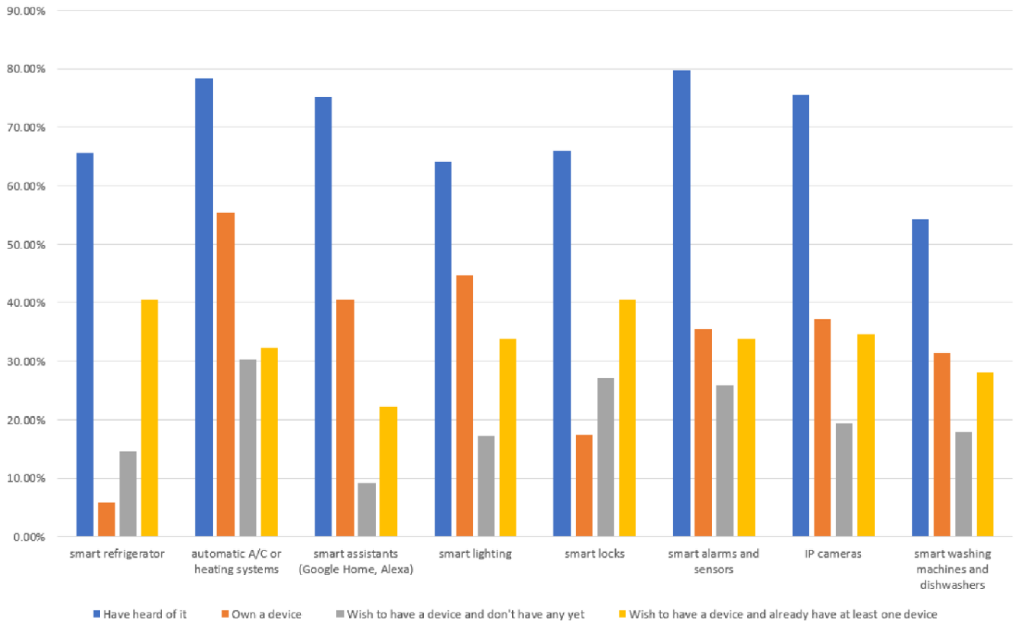
Table 1: Owenership of IoT Device [7]
Kevin Ashton, employed at Proctor & Gamble in 1999, is recognised as the originator of the term "Internet of Things." He gathered data from RFID antennae on a store shelf to ascertain the amount of lipstick sold. IEEE has also put a lot of attention on IoT, which they define as "a network of interconnected items, each with sensors that are linked to the Internet."

Cerullo and colleagues delineate IoT devices through five core elements: identification, computing, communication, sensing computing, and services. Identification mechanisms pertain to methods employed to uniquely characterize and identify individual devices within a network. Sensing entails devices gathering data from the network and relaying it to a centralized database. Communication technologies facilitate the interconnection and data exchange among devices, ensuring a reliable, swift, and secure service. Computation encompasses both the hardware and software components responsible for processing data and managing IoT operations. Services refer to the applications and functionalities that leverage the capabilities of the Internet of Things (IoT).

Dorsemaine and colleagues characterize "IoT" as a network of infrastructures facilitating the connection of objects and facilitating their oversight, data examination, and accessibility to the data they produce. A linked device is described as sensors and/or actuators capable of interacting with other devices and executing a designated task. It serves as an element within a broader structure that facilitates the transmission, storage, manipulation, and retrieval of data generated by individuals or other systems.[8]

According to Kurose and Ross, Internet of Things (IoT) devices are interconnected devices that utilize low-energy, short-distance technologies to link up with nearby hubs or built-in Wi-Fi. With the increasing prevalence of cloud computing, these interconnected devices can send their data to more robust computers for tasks such as data analysis and producing more accurate predictions.

2.3 Description of A Smart Home

Before comprehending the full impact of IoT devices on smart homes, it is imperative to establish a comprehensive understanding of the fundamental characteristics that define a smart home. Although a precise definition of a smart home remains elusive, it can be understood as a dwelling that possesses the capability to automate and regulate numerous aspects of the household, including heating, security, and lighting, through the utilization of internet-connected devices and sensors.[9] The homeowner can control and monitor the home from a remote location using a smartphone or computer, while sensors like motion and temperature sensors are commonly connected to a central IoT hub or platform, which is known as controlling systems, according to Schiefer.

The convenience aspect stands out as a major benefit of living in a smart home. As per findings by Ikezawa and colleagues, homeowners can efficiently save time and effort by remotely adjusting temperature settings or monitoring entry points, eliminating the need for physical presence within the residence. Additionally, automated functions like temperature and lighting management contribute to energy efficiency and cost savings for the homeowner.

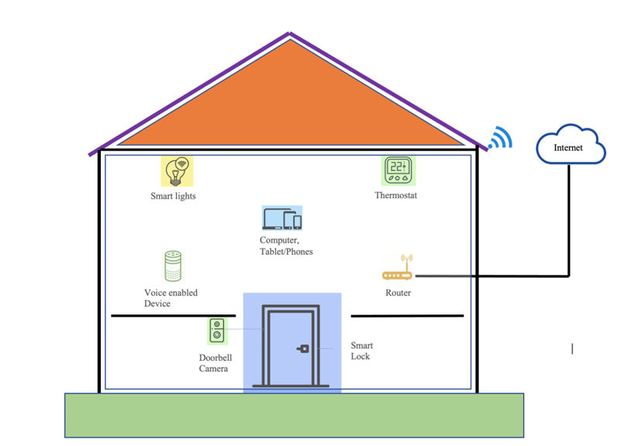
Figure 3: Smart Home Architecture[10]

Security represents another vital element of a smart home. To deter burglaries and mitigate potential risks, smart homes often incorporate features such as smart locks, security cameras, and other security system elements. Nevertheless, despite their widespread adoption, Viderberg has shown that modern smart locks may contain various security issues, especially concerning state consistency, password regulations, and password reset procedures.

Additionally, smart homes have the potential to enhance health and well-being through the incorporation of features like air quality monitors and intelligent smoke alarms. Furthermore, they can foster accessibility by integrating diverse internet-connected products and platforms. For instance, instead of using a traditional key to gain entry into the house, one can utilize a smartphone. Similarly, if one is absent from home during a package delivery, communication with the mailman can be facilitated through a smart doorbell. Depending on the individual's current sleep stage, awakening in the morning can be synchronized with the preparation of a freshly brewed cup of coffee. Thus, a smart home can encompass all of these above-mentioned scenarios.

2.4 Overview of Secure Device

Before exploring the complexities of guaranteeing the protection of IoT devices, it is imperative to engage in a discourse on comprehensive security principles. Ordinarily, a secure device is characterized by a meticulous design and manufacturing process that prioritizes security, thereby ensuring its ability to safeguard crucial assets and uphold the integrity of its operations. In the present interconnected environment, which is predominantly influenced by IoT devices, the significance of prioritizing security is increasingly of utmost importance.

A device with high levels of security possesses the capacity to provide protection and defence for individuals' personal information and businesses against cyberattacks and various other forms of security threats. A secure device has been constructed with precautionary measures in place to shield it from potential hacker intrusions and other types of security risks.[11] This typically entails the implementation of technical mechanisms such as encryption, which serves to safeguard the transmitted or stored data on the device, as well as the utilization of robust authentication processes to verify the identities of users or devices during device usage. Additionally, access controls are employed to prevent any unauthorized entry or modification of the data or functionality.

A secure device may have intrusion detection to alert users or administrators of potential security issues, firewalls to prevent unauthorised access to the device's network, and additional safety measures to defend against attacks. Utilising intrusion detection systems can deter attacks by increasing the perceived risk of being apprehended and experiencing repercussions, therefore reducing the probability of such incidents occurring.

2.5 Architecture of IoT

When considering the architecture of devices used in nowadays IoT-based smart homes, there are multiple levels to consider. Adopting a layer-based approach makes it easier to understand the different security issues that may develop. A generally accepted view of the IoT architecture is a three-layered architecture, which is usually divided into the application layer, network layer, and perception layer. Additionally, a five-layer model is often used, which describes the communications between a computing system using five different abstraction layers: Application, Transport, Network, Data Link, and Physical.
The application layer of the Internet of Things (IoT) serves as the ultimate point of contact between the IoT device and the intended end-user or application. Through the utilization of application-layer protocols, data packets are exchanged, enabling communication between applications in different end systems.

Message Queuing Telemetry Transport (MQTT) and Hypertext Transfer Protocol (HTTP) are used in the application layer. MQTT is a lightweight message protocol designed for small sensors and mobile devices, emphasizing performance optimization in high-latency or unreliable networks. It is meant to help establish connections with distant sites that have restricted network bandwidth. HTTP is a protocol used to convey data over the internet. The main function is to facilitate the transfer of requests and responses between a client and a server. HTTP is commonly used in web-based applications and services, but it is regarded as less efficient than MQTT.
The network layer's job is to set up the ways for data and information to get to the IoT hub and devices, and apps through integrated networks is the job of the network layer.[12] This occurs after the information that has been processed arrives from the physical/perception layer. This layer is the most important part of the architecture because it contains gateways, hubs, cloud computing platforms, communication technologies and switches.

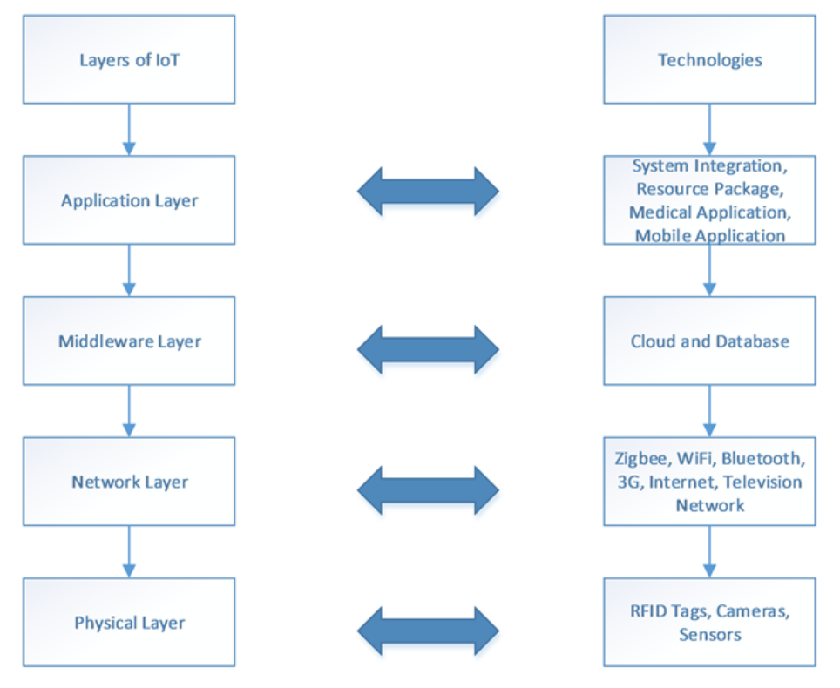
Figure 4: Architecture of IoT[13]

The purpose of the perception layer's goal is to collect data from the environment using actuators and sensors. From this layer, data is recognised, collected, processed, and sent to the network layer. This layer also controls IoT node collaboration of IoT nodes in nearby and local networks.

2.6 Attacks on Different layers of IoT

The Internet of Things (IoT) environment has been subjected to a wide array of security breaches. Nevertheless, due to their diverse composition, robust autonomous functioning, capacity for internet connectivity and control, and resource constraints, they are susceptible to remote attacks and large-scale attacks. Active attacks within the IoT realm are characterized by their impact on real-time network operations or the modification of system resources to render them unresponsive to fresh requests. Passive attacks, on the other hand, differ in that they indirectly target IoT resources by eavesdropping, listening, monitoring, and analyzing traffic patterns. Present the detailed threat taxonomy of IoT at different layers in the below figure.

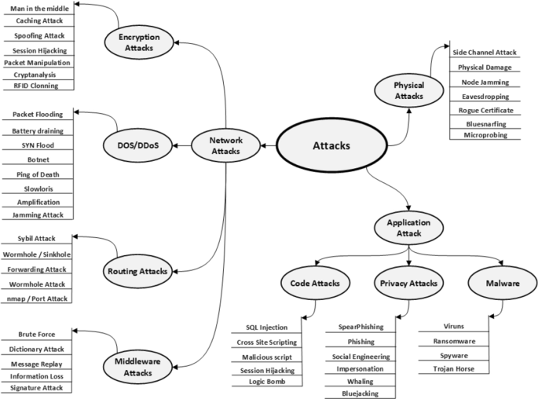
Figure 5: Detailed Threat Taxonomy at Various Layers [14]
Due to the lack of robust security measures on numerous IoT devices, various strategies have been devised by hackers to exploit them. Among these, the most prevalent targets for attacks are the IoT device itself, encompassing both its hardware and software components, the network to which it is connected, and the application through which it communicates. These three areas are particularly susceptible to attacks as they constitute the fundamental elements of an IoT system. In terms of safeguarding these different layers, certain crucial protective measures must be implemented. The application layer assumes the responsibility of ensuring data confidentiality, integrity, and authenticity. Conversely, the perception/physical layer is tasked with ensuring the secure collection of data, while the network layer assumes the responsibility for ensuring the secure transmission of data. Figure 6 describe a basic breakdown of IoT structure.

2.6.1 Initial investigation
Before launching cyberattacks on an IoT device, bad actors typically do a thorough analysis of the device to pinpoint any possible weaknesses. This typically entails obtaining a copy of the specific IoT device being targeted from the market. These individuals use reverse engineering techniques to create a trial attack to understand the possible outcomes and evaluate ways to compromise the device. They might analyze the gadget by examining its internal components, including the flash memory, to understand the software it runs. Tampering with the microcontroller can be used to gather confidential data or cause unexpected behaviour. IoT devices must have hardware-based security features to successfully prevent reverse engineering. The application including processor, actuators, communication including sensors, and power supply, should be placed in a tamper-resistant setting. Moreover, hardware-based security can help with device authentication, allowing the device to prove its authenticity to the linked server.[15]

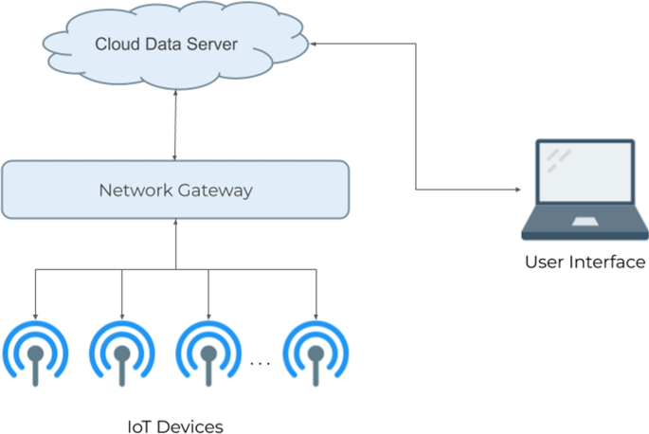
Figure 6: Basic Breakdown on IoT Structure[16]

2.6.2 Physical attacks
Physical attacks are a common type of attack that is often carried out without advanced technology. In these attacks, the attacker uses the hardware of the targeted device to their advantage. Various types of physical attacks exist, such as outage attacks, when the network connecting equipment is intentionally shut down to interrupt its functioning. Another category is physical damage, where devices or their components are deliberately harmed to obstruct their correct operation. Malicious code injection is a physical attack in which an attacker inserts a USB drive with a virus into the target device.[17] Object jamming is using signal jammers to block or alter the signals produced by gadgets. Additionally, physical attacks can result in persistent denial of service (PDoS) attacks, as explained further in this report.

2.6.3 Man-in-the-Middle attacks
The Man-in-the-Middle (MITM) attack is commonly acknowledged as a prominent type of attack on IoT devices. This attack involves intercepting interaction among two nodes in the field of computers, allowing the attacker to act as a proxy. MITM attacks can happen in various types of connections, such as involving a router and a computer, a server and a client, or two cell phones, with the last one being the most frequent situation. Figure 7 shows a simple example of a Man-in-the-Middle (MITM) assault occurring between a client and a server. In IoT, the attacker usually carries out Man-in-the-Middle (MITM) assaults between an IoT device and the application it communicates with. IoT devices are susceptible to MITM attacks because they lack standardized implementations to prevent such attacks. Two common types of MITM attacks include cloud polling and direct links. During cloud polling mode, the smart home device maintains continuous communication with the cloud primarily to request firmware updates. Attackers can control network traffic using Address Resolution Protocol (ARP) poisoning or by altering Domain Name System (DNS) configurations. They can intercept HTTPS communications using self-signed certificates or programs such as SSL strips. The effectiveness of the self-signed certificate approach is increased because several IoT devices do not authenticate or validate certificates. With direct connections, devices communicate with a hub or application on the same network.[18] Mobile apps can detect new devices by scanning each IP address on the local network for a designated port. An attacker can use this method to find devices on the network. An instance of a Man-in-the-Middle (MITM) attack on an Internet of Things (IoT) device includes a scenario where a smart refrigerator can show a user's Google calendar. Attackers found a vulnerability in the system that allowed them to carry out a Man-in-the-Middle (MITM) attack and steal the user's Google credentials by exploiting the lack of SSL certificate validation.

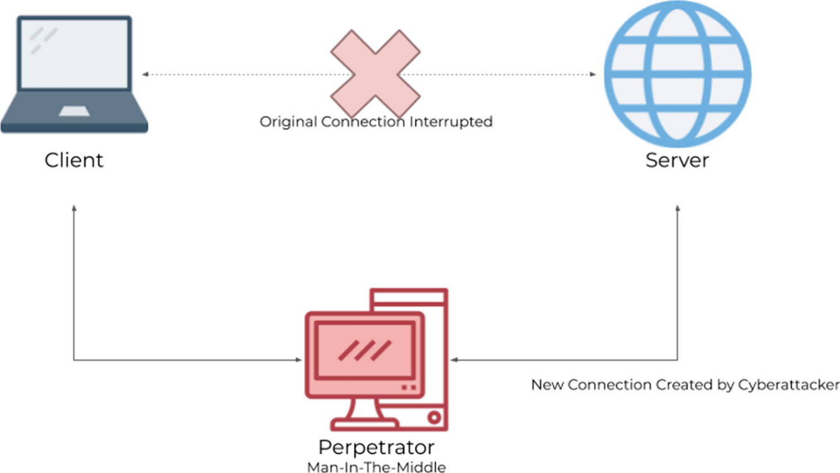
Figure 7: Man-in-the-Middle Attack Diagram

2.6.4 Man-in-the-Middle Bluetooth Attack

One prevalent man-in-the-middle (MITM) attack on Internet of Things (IoT) devices exploits Bluetooth connectivity. Several IoT devices use Bluetooth Low Energy (BLE) technology, which is tailored to meet the requirements of IoT devices because of its smaller size, reduced cost, and enhanced power efficiency. Nevertheless, BLE is vulnerable to Man-in-the-Middle (MITM) attacks. BLE utilizes AES-CCM encryption, a widely recognized secure method. However, the procedure for transferring encryption keys frequently lacks sufficient security protections. Security levels are mostly determined by the technique of pairing and exchanging temporary keys across devices. BLE utilizes a three-phase pairing process: at initiation, the device sends a pairing request, devices share pairing capabilities through an uncertain medium, devices exchange temporary keys, verify possession of the same key, generate a short-term key (some newer devices use long-term key via Elliptic Curve Diffie-Hellman public-key cryptography for enhanced security), and the created key is sent over a secure link for data encoding. Figure 8 illustrates the three separate phases of the pairing procedure.[19]

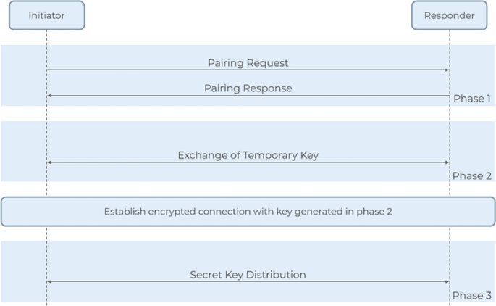
Figure 8: Bluetooth Man-in-the-Middel Attack Diagram

The temporary key is generated based on the pairing process integrated within the device's operating system of the gadget. Three frequently utilized pairing strategies are found in the realm of IoT devices. The initial approach, known as "Just Works," sets the temporary key to 0, which creates a notable security weakness. Although it carries inherent risks, BLE devices are nevertheless commonly used. The "Passkey" approach involves users entering a six-digit number code into the device, providing a relatively secure alternative with potential flaws. The "Out-of-Band" pairing approach involves swapping temporary keys utilizing techniques like Near Field Communication. The security measures of this method depend on the security characteristics of the exchange method. If the exchange channel is secure from MITM attacks, the BLE connection is considered protected. The Out-of-Band technique is not widely used in IoT devices. Another important feature of BLE devices is the Generic Attribute Profile (GATT), which enables connectivity among devices using a standardized data syntax. The GATT specifies the functions, typical behaviours, and other information about devices. Any application that supports Bluetooth Low Energy (BLE) and is within range of an IoT device can access its Generic Attribute Profile (GATT) schema to retrieve essential information. Attackers conducting MITM attacks in BLE networks need to use two connected BLE devices: one posing as an IoT device to connect with the target mobile app, and a fake mobile app to connect with the target IoT device. Additional tools for conducting Man-in-the-Middle (MITM) attacks on Bluetooth Low Energy (BLE) include GATTacker, a Node.js package that scans and replicates BLE signals to create a cloned version of the IoT device, and BtleJuice, which facilitates MITM attacks on Bluetooth Smart devices with advanced security features beyond BLE.[20]

2.6.5 Deceptive Data Injection Attack

The False Data Injection (FDI) attack is a potential follow-on assault when a Man-in-the-Middle (MITM) exploit allows an attacker to access some or all of the devices inside an Internet of Things (IoT) network. FDI attacks entail lightly manipulating values from IoT sensors to avoid detection, followed by spreading the altered data. Various methods can be used to carry out FDI assaults, but in practice, executing them using MITM attacks is the most feasible approach. FDI attacks are typically used against sensors that send data to an algorithm for making predictions or drawing conclusions.[21] Forecasting maintenance systems, also known as algorithms, are routinely used to monitor mechanical machinery's state and predict when maintenance or adjustments will be needed. Maintenance prediction algorithms and similar technologies are critical for smart cities, making them vulnerable to FDI assaults. An example of a Foreign Direct Investment (FDI) attack on a predictive maintenance system could occur with sensors on an airplane engine that forecast when crucial maintenance is needed. Accessing a few of these sensors allows attackers to subtly manipulate data, which can go unnoticed by detection systems but still impact the algorithm's predictions. In testing situations, this exaggeration could cause necessary maintenance to be delayed, potentially resulting in catastrophic malfunction during operation, leading to substantial unanticipated holds or loss of life.

2.6.6 Botnets

Collaborating with many Internet of Things (IoT) devices to carry out Distributed Denial of Service (DDoS) threats is a prevalent method of targeting them. Denial of service (DoS) attacks are coordinated efforts to prevent anyone from legally accessing a service. A DDoS attack involves coordinating attacks from various sources to accomplish its objective. A DDoS attack aims to inundate the infrastructure of the targeted service to disrupt the normal data flow. DDoS attacks typically involve the following stages: communication, exploitation, assault, recruitment, and infection. Internet of Things gadgets are frequently used to infect computers and carry out DDoS assaults because of their accessibility and typically inadequate security measures. The image displays a typical command hierarchy. The attacker's primary computer issues commands to several compromised control and command centres. These centres oversee a collection of zombie devices capable of launching attacks on the target.

The Mirai worm is widely regarded as one of the most renowned malware categories. To date, it has been used in some of the most significant Distributed Denial of Service (DDoS) assaults. Its purpose is to infiltrate and manipulate Electronic Video Recorders (DVRs), Closed Circuit Television (CCTV) cameras, and home PCs linked to the Internet of Things (IoT). Once compromised, these electronic gadgets are integrated into a botnet, a vast network of infected devices capable of executing various forms of DDoS attacks. Mirai was created to be compatible with several Central Processing Unit (CPU) architectures often used in Internet of Things (IoT) devices. The processors mentioned are x86, ARM, Sparc, PowerPC, Motorola, and others. This design's goal is to infiltrate a wide range of devices. The virus remains inconspicuous by maintaining a small size and not residing on the device's disc drive. It is kept in the device's memory. When a device is powered on again, the bug disappears. Conversely, machines that have previously been attacked are susceptible to reinfection due to their vulnerabilities have been identified. Infection might reoccur within minutes. Currently, the source code for numerous prominent botnet vulnerabilities targeting IoT devices, including Okiru, Satori, and Reaper, originates from Mirai.[22]

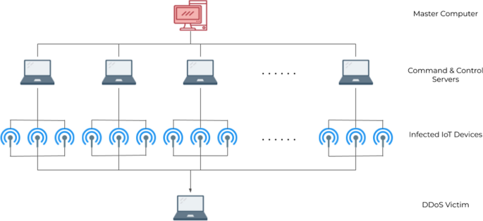
Figure 9: Botnet Hierarchy

2.6.7 Denial of Service Attacks

DoS attacks are prevalent on the Internet of Things (IoT). Nevertheless, IoT devices are also vulnerable to this type of attack. Permanent Denial of Service (PDoS) attacks, which render a system or device fully inoperable, are highly probable for IoT equipment. One might achieve this by either overloading the battery or power systems or by exploiting vulnerabilities in the code. During a firmware attack, an individual exploits vulnerability to substitute a device's fundamental software, typically its operating system, with a corrupted or modified version, rendering it inoperable. Legally, this practice is referred as "flashing," but unlawfully, it is known as "phlashing." The owner of the device is responsible for reinstalling the operating system and associated files after it has been flashed. The programme's severe damage could excessively strain the device's hardware, requiring part replacement for repair. Incidents targeting the device's power source occur rarely, although the resulting damage can be more severe. An instance of this form of assault is a USB device containing malware.[23] Whenever the drive is plugged into a computer, the malware depletes the disc's power to the extent that the hardware becomes irreparably damaged and requires replacement.

BrickerBot is a type of Permanent Denial of Service (PDoS) program. BrickerBot uses forcible dictionary attacks to breach Internet of Things (IoT) devices. After logging in, the bot executes a series of instructions that result in irreparable harm to the device. The instructions involve configuring the device's storage and kernel parameters inaccurately, resulting in the inability to connect to the internet, decreased speed, and loss of all contents. It causes significant damage, frequently requiring the reinstallation of components or the replacement of the entire device. If the hardware remains intact after the attack, the software would need to be modified, resulting in the loss of all data stored on it. BrickerBot was designed to target the same devices as the Mirai botnet, using identical methods and language to execute its aggressive actions. It is crucial to note that BrickerBot was designed to disable any devices that Mirai could potentially utilize to resist the attack.

Attack categorization categorizes security concerns in different IoT domains for applications. Other academics have previously proposed IoT attack classifications that were either broad, lacking, or provided a thorough but not all-encompassing list of threats in IoT settings. In other studies, academics have only provided taxonomies to emphasize security risks without proposing any methods to reduce these vulnerabilities. Literature provides a security classification system for IoT that is based on functionality and platform. It offers a broad summary of security, encompassing legal matters connected to PCI, data-related issues, and device categorization. The authors briefly mention cloud and network security but do not provide attack identification.[24]
A different study developed a categorization of IoT security by concentrating on connected vehicles and illustrating dangers that impact the physical, identity, and communication aspects. The writers briefly mentioned Denial of Service (DoS) assaults occurring at the communication layer but did not elaborate on the various types of DoS attacks or the more severe ones, such as DDoS and botnet attacks. The Internet of Things (IoT) plays a crucial role in improving the healthcare industry. Two classifications were devised by the researchers. The first article discusses IoT security, with a focus on issues related to trust, privacy, and authentication in IoT applications, data, and structures. The following taxonomy provides only a cursory discussion of man-in-the-middle and eavesdropping strategies in the context of the communication domain. The second taxonomy focuses on IoT security in healthcare, specifically addressing concerns with the privacy, integrity, and availability (CIA) of IoT devices.[25] They have a subjective approach, as they only focus on highlighting security concerns without discussing the researchers' strategies for addressing vulnerabilities.
IoT devices have numerous security vulnerabilities, such as malware, data breaches, and unauthorized access. Williams et al.'s research at the University of Arizona revealed that numerous IoT devices, particularly those designed for consumers, are vulnerable to hacking. Data on 156,000 IoT devices was obtained through the Shodan API, a search engine for Internet-connected devices. Following that, Nessus, a vulnerability scanner, was utilized to assess the susceptibility of these devices. Their research does not provide definitive insights into the particular vulnerabilities that consumer IoT devices may possess, but it does indicate that devices in residential, commercial, and urban settings could potentially gather significant amounts of data about their users.[26]

2.7 Smart Devices Enabling/Protocols Technologies

One of the most important things about Internet of Things (IoT) standards is that they allow nodes to exchange information to each other. The standards that have been created allow devices to communicate wirelessly for long periods of time without having to be charged or have batteries replaced. Wi-Fi, Z-Wave, Zigbee, and Thread are some of the most common low-level protocols and protocol stacks used in smart home products today. These protocols will be talked about in more depth below because they are very important to understanding security issues in IoT-based smart houses.

2.7.1 Zigbee

This is a ZigBee protocol stack consisting of five layers, designed as an open-source framework with several tiers. Zigbee's primary goal in its development has been to provide cost-effective battery-operated applications capable of connecting to networks over short distances at an affordable price. ZigBee establishes mesh, cluster, and star tree network topologies by integrating privacy measures as well as app settings that are compatible with one another. The IEEE 802.15.4 standard is founded on the low-rate personal area network (LR-PAN).

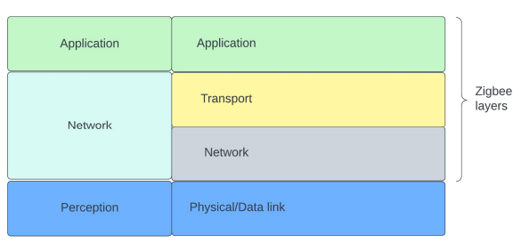
Figure 10: Zigbee working Layers

IEEE 802.15.4 stands out from other technologies by enabling the creation of compact, energy-efficient devices with long-lasting battery life. This technology serves as the foundation for various distinctive products in the realms of home and industrial automation, as well as initiatives to standardize particular industries. IEEE 802.15.4 transmits data via radio transceivers in the 2.4 GHz frequency band, which is also utilized by Bluetooth and Wi-Fi in unlicensed airwaves. The maximum power output is 1 mW, approximately 1% of the power consumed by Wi-Fi or cell phones.[27] The communication range is restricted due to the low transmit power. For information to be transmitted across extended distances, these devices need to utilize mesh networking. The ZigBee protocol stack consists of multiple levels, with the fifth level being part of the network structure and being open source. Zigbee was developed with the primary objective of creating cost-effective, battery-operated applications capable of connecting to networks within short distances. ZigBee enables the creation of mesh, star, and cluster tree network configurations by incorporating compatible parameters for apps and information security that are compatible. This rule is derived from the IEEE 802.15.4 low-rate personal area network (LR-PAN).[28]

Mesh networking accommodates individual nodes' limited power by leveraging neighbouring nodes' capacity to transmit data. Mesh networks are highly resilient due to their numerous backups, making failure unlikely. If a device in the network fails, the remaining devices can continue to connect and communicate with each other. Mesh networks are ideal for environments where reliability and continuous operation are crucial, such as smart home setups. Another advantage of mesh networking is its fast network switching time, which is only a few tens of milliseconds.

There are two different kinds of physical objects in a Zigbee network. The first kind is called a full-featured device (FFD), and it can work within any network layout. It also acts as the network's supervisor and can talk to any other device on the network. There is a second type of device called a reduced function device (RFD) that can only talk to a network controller. In addition, this kind of device can only work in a star structure, as shown in Figure. Every IEEE 802.15.4/ZigBee network needs at least one FFD to act as the network controller so that everything works right. On the other hand, endpoint devices like lights, plugs, and switches can be RFDs to cut down on system costs and power use.[29]

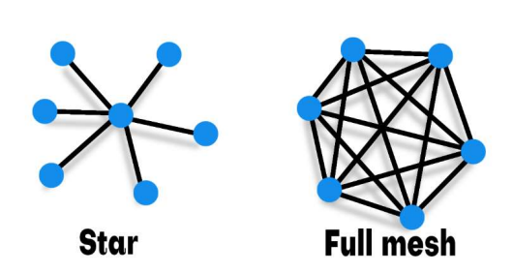
Figure 11: Network Topology Star and Full mesh

The ZigBee network coordinator is responsible for establishing a network, transmitting network beacons, managing network nodes, securing network node data, enabling paired nodes to communicate, and safeguarding network node information while receiving messages. An FFD serving as a coordinator must have sufficient memory for data storage and network configuration, as well as the computational capacity to independently establish the network. Furthermore, the coordinator is responsible for facilitating communication between devices that lack direct communication capabilities. In contrast, a controller requires a significant amount of power and necessitates a direct power supply or a large battery bank for prolonged usage, whereas a Reduced Function Device (RFD) is located at the periphery of the network.[30]

To operate safely, Zigbee requires the involvement of the network supervisor node, also known as the Trust Centre, to operate safely. This node's primary function is to authenticate devices attempting to connect to the network and provide them with security keys. As part of the node verification procedure, the Trust Centre provides the joining device with an encryption key. The encryption key, often known as the "network key," is randomly generated and utilized by all nodes inside the network. These nodes must utilize this key at the network level to ensure the security and decryption of the data they transmit and receive for basic protocol upkeep. Furthermore, this key is occasionally utilized in software that safeguards and decodes user data.

The network key is safeguarded by a shared key between the security unit and the node when it is transmitted to the latest node. The pre-set key is used only once. The Trust Centre can utilise it to authenticate the real identities of new terminals linking.[31]

2.7.2 Z-Wave

Z-wave is a practise stack that shares similarities with Zigbee. It is most effective in networks with restricted capacity, as its primary objective is to ensure that consumer-grade devices connected to it can consistently transmit data with minimal power usage and at a low cost. Examples of such devices include temperature sensors, electronic door locks, audio-visual systems, and light dimmers that may be remotely controlled. Silicon Labs possesses Z-wave, a proprietary protocol stack. The Z-Wave Alliance ensures the compatibility of goods before they are sold. Operating inside the 800-900 MHz spectrum ensures immunity to interference from ZigBee wireless technologies, Bluetooth, and 2.4-GHz Wi-Fi. Furthermore, it has a 100-meter range and utilizes mesh networking technology. An established key safeguards the network key. This key is mutually known by the Trust Centre and the node when it is transmitted to a new node. The preconfigured key is utilized only once by the node. The Trust Centre can utilize it to verify the authenticity of new nodes.

The International Telecommunication Union (ITU) sets the standards for medium access control (MAC) and physical (PHY) layers for narrowband digital radiocommunication transceivers. These layers are included in Z-wave. To put this into practice, it means that Z-wave devices follow a set of transmission standards and protocols set up by the ITU for both their physical and data connections. Z-wave devices made by different companies can link with each other, along with various devices that also follow the same specification without any problems, as long as they follow the ITU specification.[32]

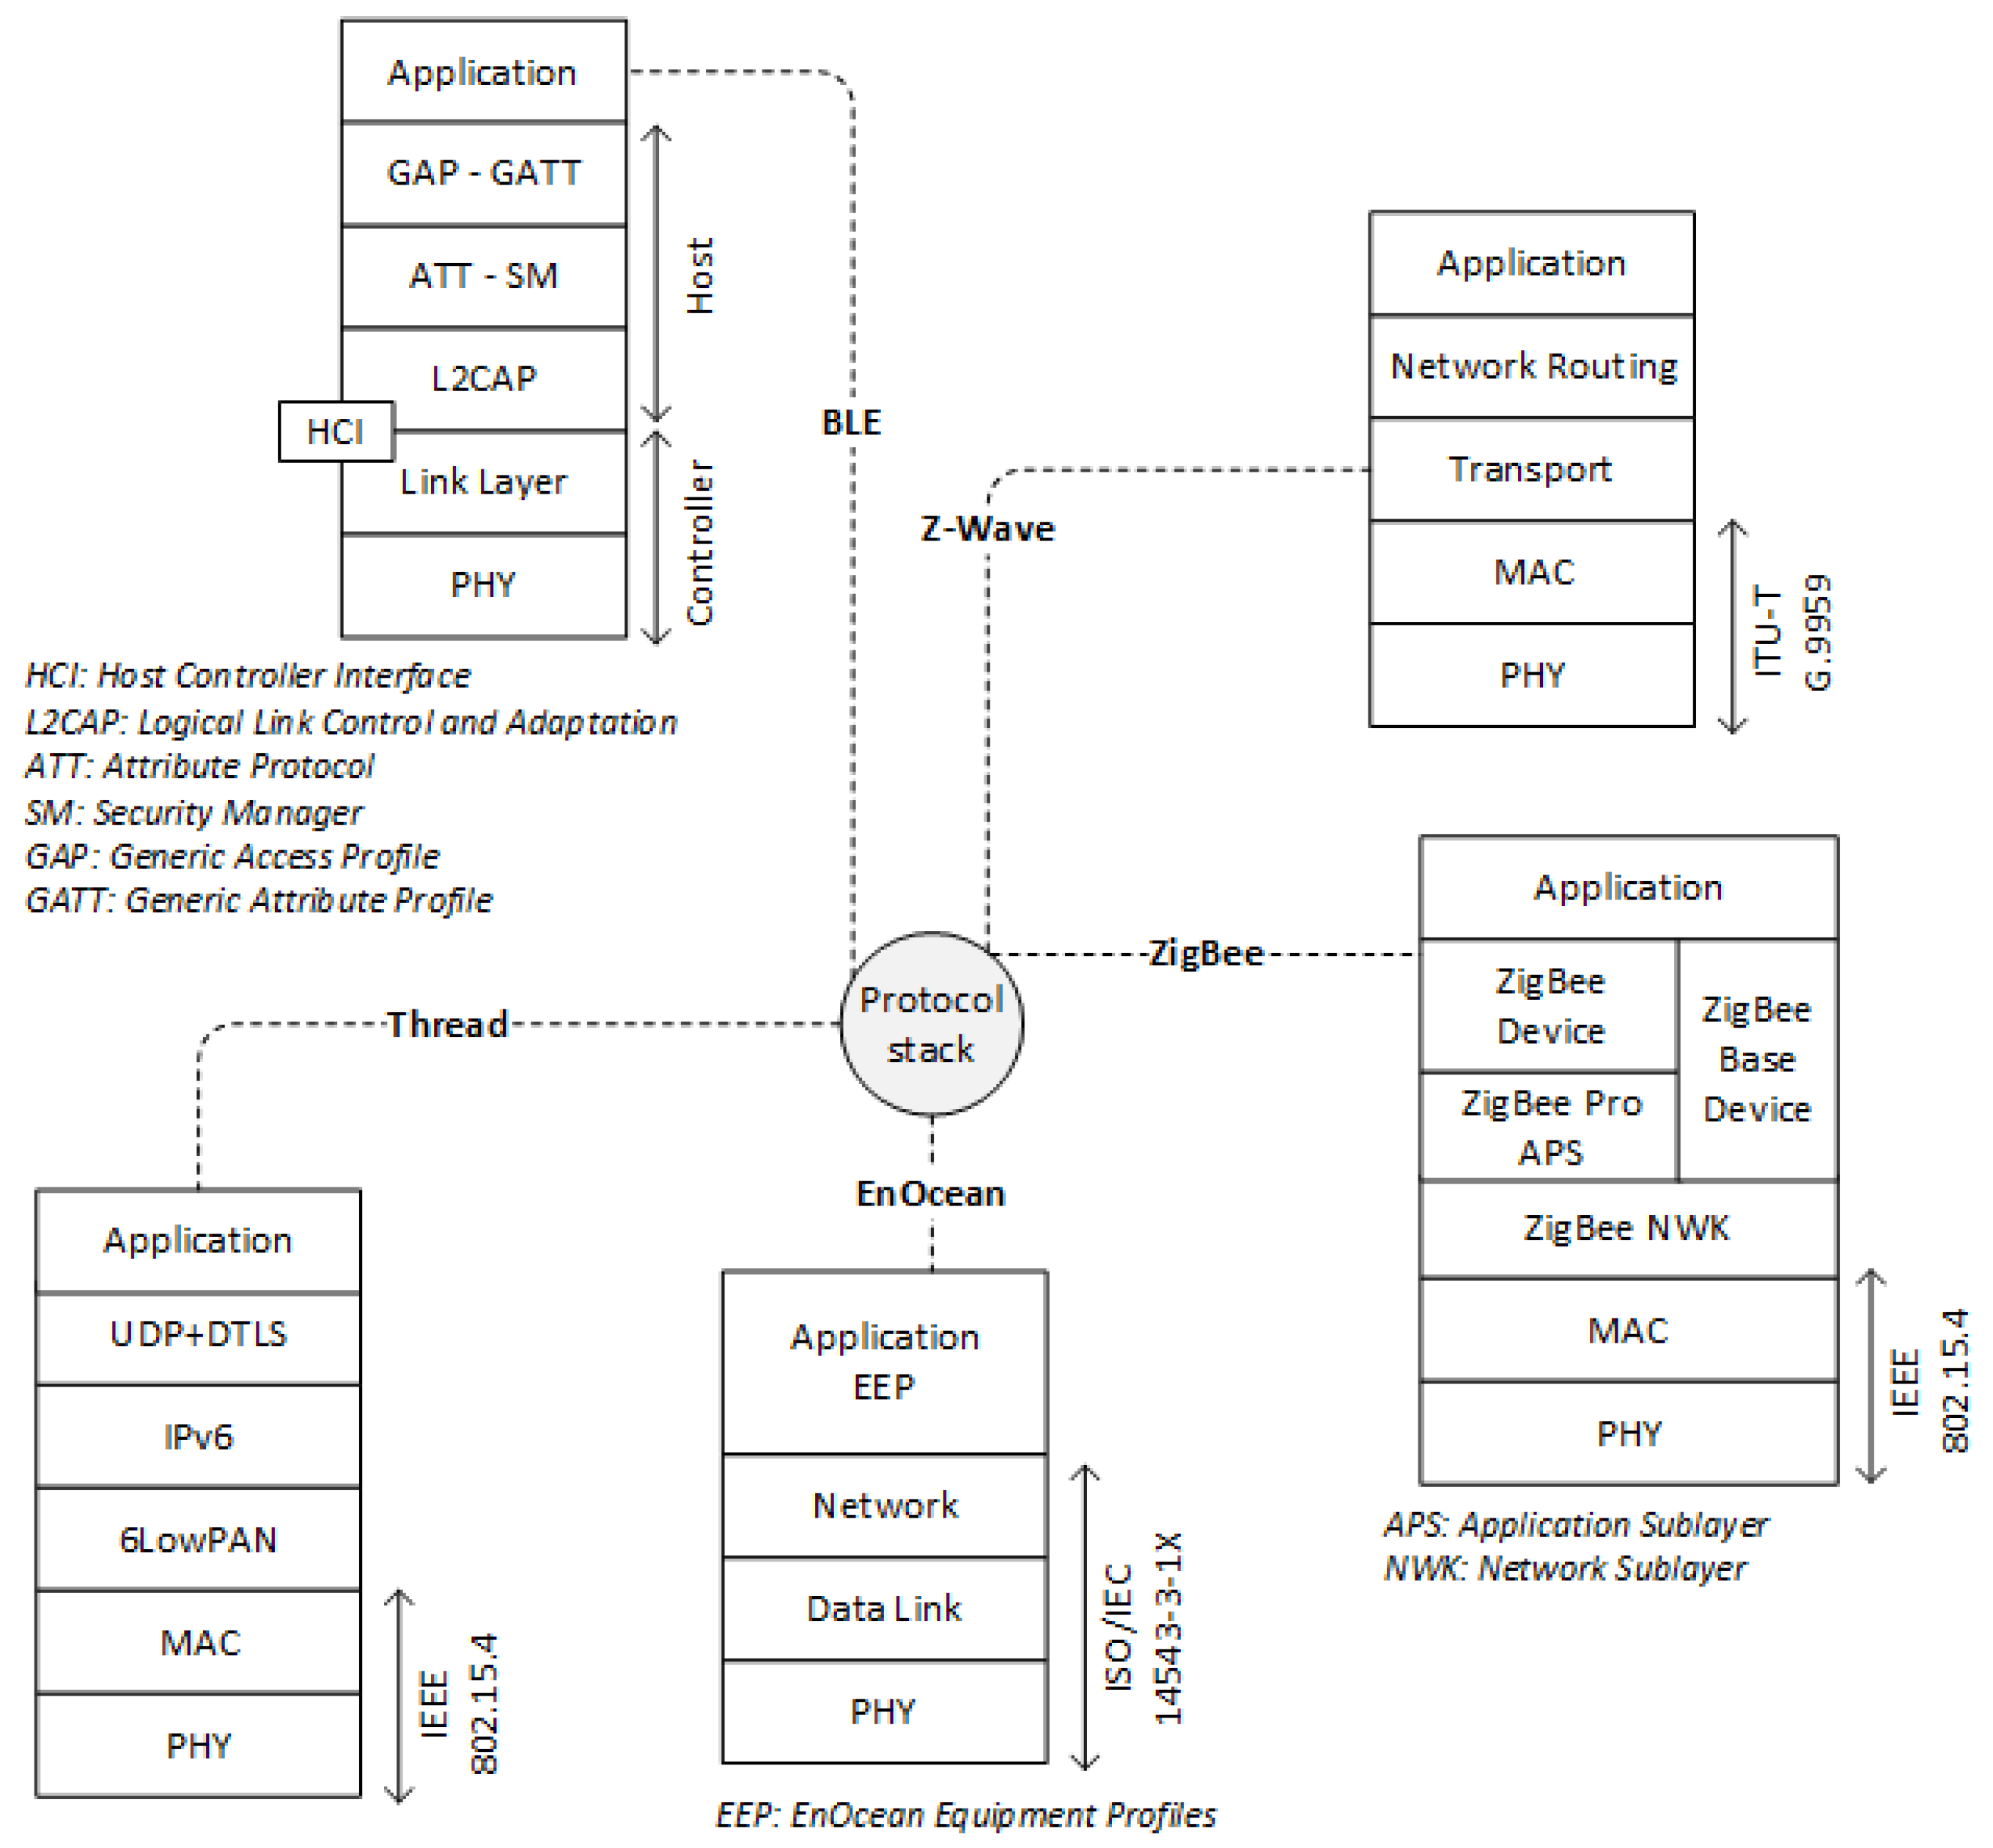
Figure 12:Overview of Protocols

2.7.3 Wi-Fi (802.11)

Multiple smart home gadgets use hardware that is suitable with the standard 802.11a/b/g/n/ac/ax Wi-Fi protocols. Wi-Fi is a technological advancement that allows tablets, smartphones, and computers to communicate wirelessly and connect to the internet via an access point and router, typically combined into one device. Therefore, these gadgets are using the same bandwidth as devices not commonly found in a network specifically built for home automation.

Home automation devices utilizing this protocol are typically directly connected to a power supply. IoT devices using "traditional" Wi-Fi consume up to five times more energy during reception and transmission compared to devices using alternative protocols such as Zigbee. This renders it inappropriate for extended monitoring that relies on battery power. Moreover, Wi-Fi has a limited range and is not efficient in low-speed scenarios.

To address the current problem, a low-power specification known as Wi-Fi HaLow, sometimes known as 802.11AH, has been developed since 2010. 802.11ah is a specification that was developed primarily for situations in which there are a large number of units per access point, and this can occur in both indoor and outdoor environments. It takes advantage of the unlicensed sub-1 GHz radio frequency, which enables it to communicate across vast distances and penetrate materials with great efficiency. Furthermore, it simplifies the process of conducting a comprehensive coverage assessment by combining a single connecting point in conjunction with several sensors. The technologies that are based on 802.11 are distinct from Zigbee and Z-wave in that they concentrate on the physical and data connection layers of the network, whereas the latter two technologies make use of proprietary protocol stacks that cover a wide range of network layers.

(•= full support; ⁕ = exceptional exit)

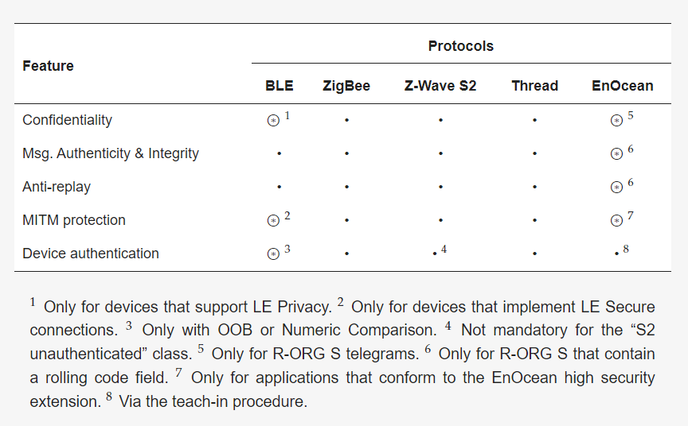
Table 2: Key Feature per Examined Protocol

2.7.4 Thread

Another type of networking technology that was developed specifically for home automation is called Thread. Thread is a networking stack that is based on IP and has a limited number of documents. Thread protocol is a low-power wireless mesh networking technology that runs on the widely known Internet Protocol (IP). It is built using widely recognised and established standards. Thread networks eliminate single points of failure and can sustain communication even when other devices are disconnected. If the Border Router is removed, nearby Thread devices can still communicate with their neighbours.

In addition to assisting clients in securely exchanging credentials, the Thread Network framework automatically selects the most appropriate network for each residence. The strength of Thread depends on other devices passing packets to their neighbours on the network. This forms a mesh that enhances the network's robustness and boosts efficiency.

Thread Group, a consortium of well-known technology companies like Nest, Samsung, Google, ARM, and others, is the organization that came up with the idea for it. This technology's objective is to simplify the process by which devices with minimal power in a Thread network can communicate with any IP-based network that is located near them, such as Wi-Fi or Ethernet. This integration is made feasible by Thread through the utilization of a border router. IPv6 packets can travel via a low-power IEEE 802.15.4 link that is referred to as 6LoWPAN.[33]
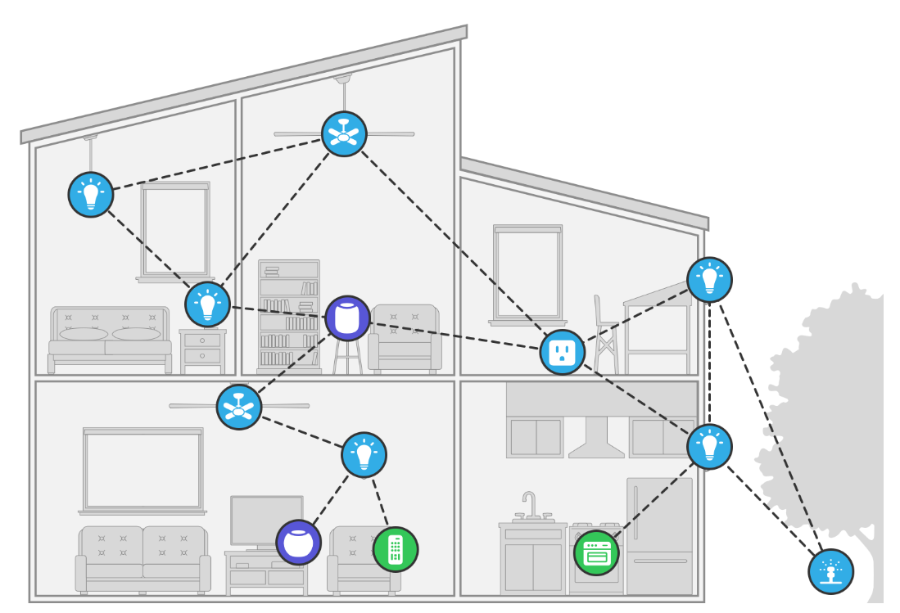
Figure 13: Thread Network

Thread is capable of managing up to 250 nodes in a mesh network by utilising IEEE802.15.4 radio transceivers. Additionally, it provides high degrees of authentication and encryption with its capabilities. Due to the fact that it makes use of mesh networking, any device that is part of a Thread network has the potential to act as a repeater for other devices, which ultimately results in a network that is more resilient and sustainable.

2.8 Security Issues with Frequently Used Protocols

All assessed protocols enable over-the-air encryption, source authentication, and integrity with varying degrees of security. Studies have discovered flaws in several protocols, in spite of their safety promises. Researchers from the University of Milan have formally demonstrated the weaknesses in the Z-wave protocol. They carefully investigated the procedure by which a device connects to a Z-Wave network. A vulnerability was discovered during the verification process that may be used for a Man-In-The-Middle (MITM) attack, compromising the secrecy of the exchanged symmetric keys. An MITM attack usually consists of two devices, or the victims, and an additional group, or hacker. The attacker can intercept and alter the communication path between the two endpoints without their knowledge. The attackers in the MITM attack described in the study might infiltrate the Z-Wave network, potentially allowing them to control all connected devices.[32]

Ronen and colleagues' research found that smart bulbs using the Zigbee protocol are vulnerable to hacking and can be infected with software that displays worm-like behaviour. This firmware is programmed to reproduce and spread from one gadget to another. If a certain critical mass of compatible Internet of Things (IoT) devices is surpassed, the altered firmware will quickly spread to many bulbs. The worm spreads by sending updates through the lamps' integrated Zigbee connectivity and their close physical proximity. The investigation successfully showed full control over the devices, with the ability to permanently turn off all lights, activate or deactivate them, or use them in Distributed-Denial-of-Service (DDOS) assaults. These attacks involve overwhelming a potential target with a high volume of incoming communications via compromised IoT devices.[34]

Ronen et al. used Philips Hue smart light bulbs to detect and verify contamination after discovering a major vulnerability in the Touchlink commissioning procedure. The Touchlink commissioning procedure relies on physical proximity rather than cryptographic verification to easily integrate components into interconnected lighting systems when adding additional nodes to the network.

Morgner et al.'s investigation confirms the Touchlink commissioning process's vulnerability, advising against its widespread use. Research findings indicate that adding just one Touchlink-enabled device can jeopardize the security of a whole ZigBee 3.0 network. They demonstrated how to exploit the Touchlink commissioning procedure of a newly introduced device in a Zigbee network incorporated into an intruder alarm system to extract the network key. This enabled them to control the network by inserting commands and deciphering the following network messages.[35] An unauthorized person might reset the system to its default settings and enter the property unnoticed by sending fake network instructions to components in the alarm system.

Dinu et al performed a thorough analysis of Thread, demonstrating the ability to modify security information and acquire network credentials, particularly the cryptographic keys for the Thread PAN. For this exploit to work, the attacker must be near the router or a device connected to it and use a digital oscilloscope to capture electromagnetic signals. To determine the unknown key, the attacker compares the findings of electromagnetic errors to a theoretical model that includes the unique characteristics of the decryption key to determine the unknown key. The researchers determined that these attacks are now beyond the abilities of an average hacker who only has expertise in software and networking expertise, and they only occur under specific conditions.[36]

2.8 Related Work: Case Studies

This section will analyze real-world occurrences that target consumers, commercial entities, and industrial sectors in the context of the Internet of Things (IoT). Furthermore, we will outline the categorization of these attacks according to our existing taxonomy. We will examine the vulnerabilities in IoT ecosystems and discuss how adversaries exploit these weaknesses to carry out attacks. We will provide an analysis of the effects of these assaults, discuss security solutions designed to reduce their spread in IoT systems, and outline the categorization of these attacks based on our existing taxonomy. The main objective of our attack taxonomy's primary goal is to assist security analysts in creating secure and resilient IoT systems by clarifying the fundamental features of IoT assaults. We will present a variety of use cases with different adversarial goals, along with examining the many attack methods that target the broad IoT attack surface. We will focus on identifying the current weaknesses in these structures.

2.8.1 Smart Home IoT Case Study

A. Small Monitoring Cameras

Biometric monitoring devices (BMCs), popular consumer electronics, especially in households with infants, have garnered public interest. In 2018, a family in South Carolina suspected that their BMC was engaging in suspicious behaviours, which were later validated when they found out that their device had been compromised. The security examination by SEC Consult uncovered many vulnerabilities related to the described BMC. Individuals on the local network of the BMC discovered vulnerabilities in TCP ports 554 and 5000 that could be exploited without the need for identification.[37]

Local access may not be assured in advance, but this restriction can be circumvented if users fail to secure their home networks, leaving all linked devices vulnerable to threats. The Baseboard Management Controller (BMC) has a default setting that enables its peer-to-peer (P2P) cloud capability. This feature transmits unencrypted video data to the cloud, increasing the device's vulnerability. Furthermore, the account and password provided with the majority of home IoT devices are not unique to that specific device and are not randomly generated. The BMC features two UART ports that enable someone with direct access to the device to gain complete control through a root shell.[38]

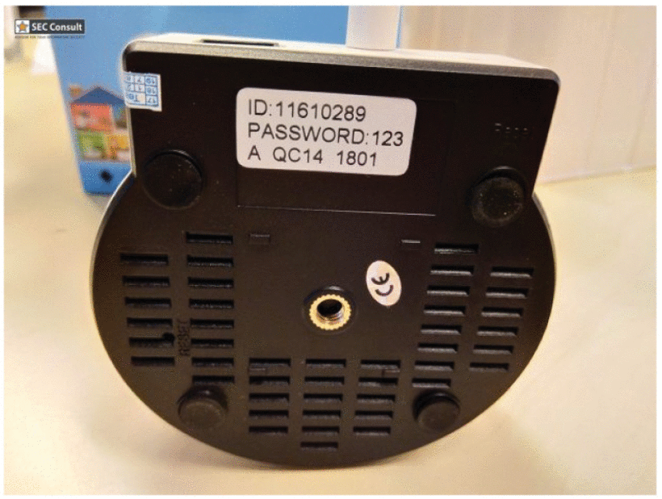
Figure 14: Default Password Camara [37]

Analysis of the identified vulnerabilities indicates that the BMC has clear security deficiencies, making it vulnerable to a range of assaults. These attacks can vary from exploiting the vulnerable UART ports in the equipment group to leveraging the default-enabled P2P streaming functionality in the service category. Examination of the device's security revealed that attackers can utilize BMC's P2P cloud capability to breach the device and violate users' privacy. Attackers can access the camera and monitor individuals by searching for legitimate device IDs using default login information, which constitutes a service-based attack. Attackers can access cloud recordings by executing this infrastructure-based attack through traffic evaluation and packet monitoring.

Users' privacy is still the key concern, but other considerations should not be disregarded. For example, as shown in Figure 14, using the default credentials could lead to attacks that target the service element of the device. The result could be the inaccessibility of legitimate users or the acquisition of access to customer local networks by malicious actors using the infected devices. Users should change default identification, deactivate unnecessary functionality, update firmware, and enable encrypted traffic to maintain consumer security, according to investigators, producers, and service providers. Although these safeguards won't stop persistent attackers, they can lessen the likelihood of hacking attempts.

B. Case Study – Assistant Speaker

The advent of voice helps on smartphones accelerated the rise of home assistants. Even so, a batch of new security holes has emerged due to the extensive use of Internet of Things (IoT) home helpers like Amazon Echo and Google Assistant. Importantly, SRL security researchers were able to hack home assistants by taking advantage of flaws in the gadgets, which rendered them useless and invaded users' privacy. To eavesdrop on users or carry out complex phishing assaults, these researchers developed specialized software frameworks that take advantage of execution faults. Corporations refer to the software as "skills" for Amazon Echo and "actions" for Google Assistant. Ethical hackers have demonstrated the feasibility of such attacks, but malicious individuals might easily use the same methods. This exemplifies an attack strategy targeting smart home assistants in Figure 15.[39] Before publishing custom-built apps in their app stores, attackers need to bypass the initial authentication process conducted by Google or Amazon. After bypassing this safety check, attackers will prompt consumers to update the software they recently installed. However, they must ensure that this modification does not trigger any security protocols or prompt Google or Amazon to revaluate the program.

Malicious features could be transmitted to the assistant devices after the program update, potentially resulting in service intrusions. These attacks encompass activities such as emulating reputable applications, soliciting security credentials, shrivelling user conversations, and executing assaults associated with identity theft.[40] In addition to service attacks, violations of user data confidentiality can result in infrastructure-focused assaults such as account hijacking, which enables unauthorized access to and modification of personal user data. By infiltrating the user's home network or impersonating voice assistance capabilities, communication-based attacks are possible.

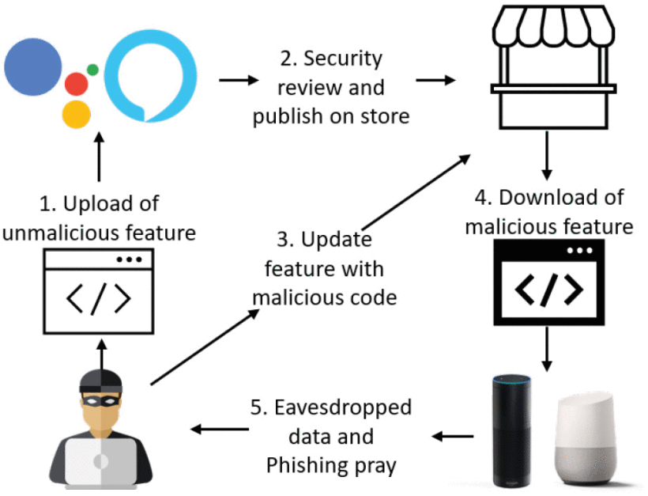
Figure 15: Home Assistant Attack Diagram[40]

Malicious features could be transmitted to the assistant devices after the program update, potentially resulting in service intrusions. These attacks encompass activities such as emulating reputable applications, soliciting security credentials, shrivelling user conversations, and executing assaults associated with identity theft. In addition to service attacks, violations of user data confidentiality can result in infrastructure-focused assaults such as account hijacking, which enables unauthorized access to and modification of personal user data. Attackers can carry out communication-based attacks to infiltrate the user's home network or impersonate voice assistance capabilities.

2.8.2 Industrial IoT Device

A. Case Study - Airplane Avionics:

Notable commercial Internet of Things architectures, such as avionic systems, are susceptible to various malicious attacks that could lead to catastrophic consequences. In 2018, Boeing's network had a poorly secured server that enabled the corporation to access data from avionics system providers and updated code for their 737 and 787 passenger jets. By analyzing publicly accessible data and reverse engineering binary files, vulnerabilities were found in the Boeing 787 aircraft system based on information about the network's setup and Internet of Things infrastructure.[41]

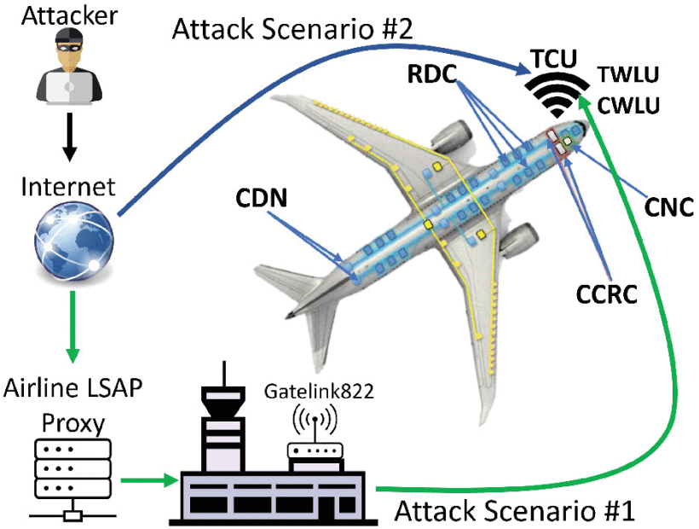
Figure 16: Attack on Boeing [42]

The personnel information system maintenance module security analysis exposes multiple insecure code functions. Attackers can exploit service vulnerabilities through the strcpy, sprintf, and strcat functions, particularly integer and buffer overflows. Vulnerabilities in the system's execution routes, such as unauthorized user commands that cause memory corruptions and out-of-bound readings or writes, expose it to infrastructure attacks. Discovering more severe vulnerabilities in acquired vex files is concerning. Some of the flaws are stack and buffer overflows, remote code execution, an unprotected rudimentary file transfer protocol (TFTP) server, a careless system-call handler that raises privileges, and return-oriented programming (ROP) exploits. The security study identified numerous potential situations where attackers could exploit the vulnerabilities, including zero-day vulnerabilities, to carry out devastating attacks. [42] By using the common computing resource cabinets (CCRs), these situations can breach the common data network (CDN), which serves as the crucial connection linking the aircraft's fuel quantity, low pressure, and electrical systems by using common computing resource cabinets (CCRs).

- Security analysis can develop several hypothetical scenarios based on identified vulnerabilities, including zero-day vulnerabilities that could result in severe assaults.
- These situations can allow unauthorized access to the common data network (CDN), which connects most systems in the aircraft through the common computing resource cabinets (CCRs) that control the fuel quality, low flow, and lightning systems. The CCRs consist of several modules, network switches, and graphic generators.
- The RDCs support both analogy and discrete signals, as well as serial digital interfaces.
- The core network cabinet (CNC) manages the division of data within the open data network (ODN), the isolated data network (IDN), and the CDN.

Making use of the previously mentioned vulnerabilities, Fig. 16 presents two scenarios of communication-based attacks designed to undermine the 787 aircraft's network architecture. In the first scenario, an adversary compromised a proxy server for loadable software aviation components (LSAPs) accessible via the Internet. Both the 737 and the 787 are utilizing two vulnerable servers. By using the hacked proxy server, the attacker gains access to examine the data sent between the aircraft's internal digital distribution system and the ground control tower. This refers to the communication exchanges that take place between the airplane and the ground, specifically involving the uplink and downlink transmissions. Another attack method using the LSAP proxy server involves exploiting the Gatelink822 on-ground aircraft wireless communication system to access either the aircraft's terminals' wireless local area network unit (TWLU) or the crew wireless LAN unit (CWLU). The attacker can access the IDN by attacking rules in the Ethernet gateway module (EGM), leading to a compromise of the CDN through the vulnerabilities highlighted. One option is to utilize either the terminal or cellular unit (TCU) or satellite transmission links, both of which can connect to the Internet through a public IP. This idea is probable, given that it provides access to the TCU. By following EGM guidelines, the opponent can reach the CIS/MS and weaken the defences of the CDN.

The analysis indicates that utilizing the x86 32-bit CPU No-Execute (NX/XD) hardware mitigation is advisable to defend against the purported threats. The Intel Pentium M 32-bit processor's hardware inherently supports this methodology. Include compiler-level mitigation measures for susceptible routines like strcpy and sprintf is strongly recommended. This will successfully prevent overflow attacks targeting the stack and buffer. It is crucial to protect firmware updates, especially for mission-critical subsystems such as the electronic engine control (EEC), wing ice protection system (WIPS), generator control unit (GCU), and bus power control unit (BPCU). Safeguards and integrity checks must be implemented to verify the firmware and prevent any harm that may result from counterfeit firmware during an attack.

3. Methodology

This section details the approach, tools, and tactics utilised during the ethical hacking process on a smart light and smart speaker, as well as the examination of the security vulnerabilities of the Internet of Things (IoT). The literature review included reading and evaluating papers, academic journals, and conference proceedings according to the number of citations included. The study then summarised and utilised pertinent sections and discoveries. Researchers conducted ethical hacking as an experiment to assess the privacy of a smart light and voice assistant smart speaker using the grey box approach. A test bed was set up for network traffic analyzing and decrypting. There were two research experiment performed in the report: Try to enumerate smart light bulb and find loopholes in the smart speaker. The purpose behind this experiment is find vulnerability in the IoT devices and try to find prevention methods as well as apply it in IoT devices.

3.1 Approach

Understanding the underlying motives of ethical hacking is of utmost significance. The primary objective of ethical hacking is to meticulously uncover vulnerabilities through a hacker's lens, thereby fortifying systems with enhanced security measures. An intriguing aspect of the ethical hacking process is its classification into three distinct categories: black box, grey box, and white box. The contrasting factor among these classifications is the extent of information accessible to the assailant at the inception of the attack.[43]

In a white box test, during a test conducted in a controlled environment, the penetration tester has a deep knowledge of network complexities and the required access privileges. This thorough analysis concentrates on the system's architecture and functionality.

In a grey box test, the participant is given limited information about the system. This distinctive method enables an examination of the behavior of a person with exclusive knowledge. It demonstrates how effective safety measures are when dealing with a worker trying to steal private information.

In a black box test, the attacker tries to replicate the behaviors of a real attacker without having any prior understanding of the system or network. A recent investigation utilized the black box methodology to infiltrate a smart plug. The tester used white box network credentials to circumvent the essential step of getting entrance into the local network. The study then summarised and utilized pertinent sections and discoveries.

3.2 Research Methods for Literature

Studying research methodology is crucial for any research project, as it helps the researcher and the audience have a thorough understanding of the various methodologies used. In this chapter, we will explore the various methodological decisions taken during the implementation of this research project, taking into account practical, operational, and philosophical factors. Research involves making decisions as various questions come up during the project's development (Saunders et al., 2007). [44]The researcher's choices and responses to the various options and inquiries lead to the development of levels of abstraction surrounding the study goals, which require assessment and deliberation. This effort aims to reveal the many components of the research, allowing the reader to understand the foundation of the findings. Research Onion layers:
- Research philosophy
- Research approach
- Research strategy
- Choices
- Time horizon
- Techniques & procedures
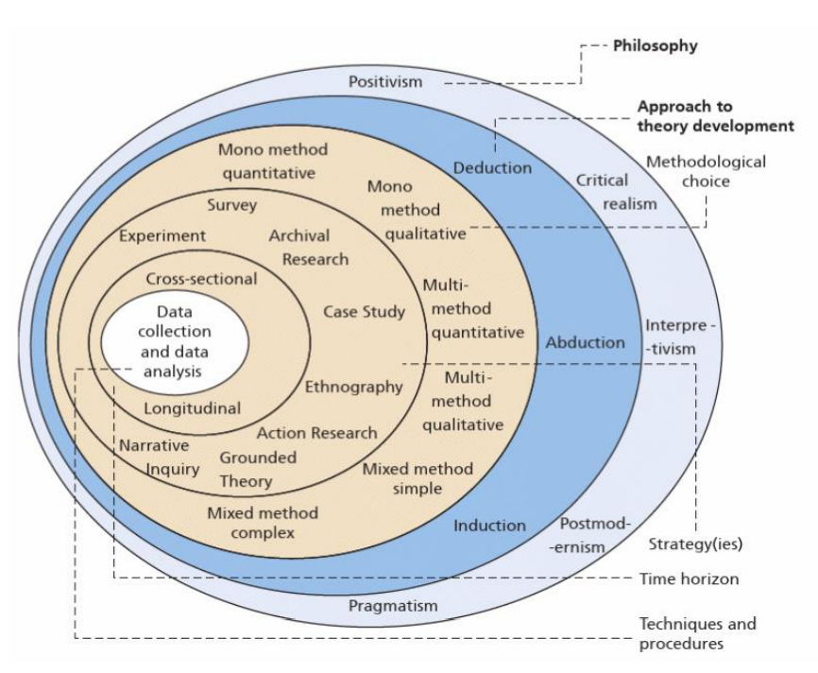
Figure 17: Research Onion Layers[44]

The researcher displays a diagram illustrating the current research based on the research onion model. This aligns with a suitable framework that organises the study's aims, objectives, and circumstances in an organised manner for the development of the current research project.[45]

Philosophy | Pragmatism
Approach | Inductive
Methodological Choice | Mixed
Strategy | Experiment
Time Horizon | Longitudinal
Data | Collection & Analysis
Table 3: Appropriate Layers for This Research

3.2.1 Research Philosophy

Identified three main philosophies on the first layer of their research onion: Positivism, Pragmatism, and Interpretivism.
- Positivist research holds that knowledge exists independently of the subject under investigation. The study must be conducted objectively, without incorporating opinions or personal perspectives.
- Interpretivism highlights how social and cultural variables can impact an individual. This perspective emphasises individuals' cognitive processes and concepts within the context of the socio-cultural environment. The interpretivist concept involves researchers actively engaging in the study to gain a comprehensive understanding of participants' actions, thoughts, and meanings.
- Pragmatism emphasises the significance of utilising the most effective means to study events. Pragmatism aims to approach research practically by constantly questioning and interpreting knowledge, which is not considered fixed. Pragmatism involves investigator engagement and individuality, particularly when making conclusions from participants' replies and judgements.
After go through first layer of onion it is consider that pragmatism phase is suitable for this project.

3.2.2 Research Approach

Recognised two main philosophies on the second layer of their research onion: inductive and deductive.
- Inductive techniques include deriving theories from study rather than beginning a project with a pre-existing theory.
- Deductive methodologies start with a theory and seek to either expand on it or verify it through investigation.
As per different techniques deductive approach is most appropriate for this research aspect because it includes theory and experiment.

3.2.3 Research Strategy

There are several strategies in the third layer of the onion. Experimental research, Action research, Case study research, Grounded theory, Ethnography, Archival research.

- Experimental research is intended to either confirm, challenge, or verify a study theory. This study approach follows to the scientific method's principles and takes place in a controlled environment, such as a lab setting.
- Action research informs researchers identify issues or limitations in real-world encounters.
- A case study is an extensive examination of one topic, such as an individual, a group, an organisation, an event, incident, or problem.
- Grounded theory is the process of allowing evidence to shape the creation of a new theory, paradigm, or framework. The theory you create is firmly based on the data, as the name suggests.
- Ethnography entails observing individuals in their authentic settings and interpreting the significance of their cultural exchanges.
- An archival research strategy utilises pre-existing resources to determine context through a systematic review of the available data. This strategy is particularly suitable for historical research because it can use materials such as manuscripts and documents.
Trying to find vulnerabilities in IoT devices using previous literatures and implement consider in experimental phase of research strategy.

3.2.4 Research Choice

- Selecting a mono approach involves utilising only one data part, either qualitative or quantitative.
- Utilising both quantitative and qualitative data constitutes a mixed-methods strategy.
- Finally, there is multi-method. By applying a multi-method strategy, you would utilize a variety of methods beyond just one quantitative and one qualitative approach.

3.2.5 Time Horizon

- If you need to gather data at various intervals over an extended period, such as weeks, months, or years. Therefore, utilise a longitudinal time frame.
- A analyse the language employed in memes at a specific moment, it would use a cross-sectional temporal horizon.

3.2.6 Data Collection and Analysis

Research literature data and implementation output data both should be analyse and try to find solution based on particular topic or project.

3.3 Experiment Methodology

Penetration testing is the act of trying to penetrate a specific part of a computer system to evaluate its security measures. The term "break-in" is synonymous with "hacking," which involves identifying weaknesses in software or hardware to access a computer system to steal passwords and sensitive data or gain unauthorized control over the system. This procedure is described as a "break-in."

Pen testing, which stands for "conventional" IT penetration testing, is now a common and well-known method. Its major job is to look for and stop possible unauthorized access to computer programs or network-based services like websites. Industry accepts the Information System Security Assessment Framework (ISSAF) and the Open-Source Security Testing Methodology Manual (OSSTMM) as standards for this type of testing. There are five separate steps in the standard IT pentesting process: 1) gathering information; 2) mapping the network; 3) scanning for vulnerabilities; 4) exploiting the vulnerabilities; and 5) cleaning up after the exploits. However, it has been found that the old way of doing things doesn't work well when looking for security holes in an Internet of Things (IoT) system.

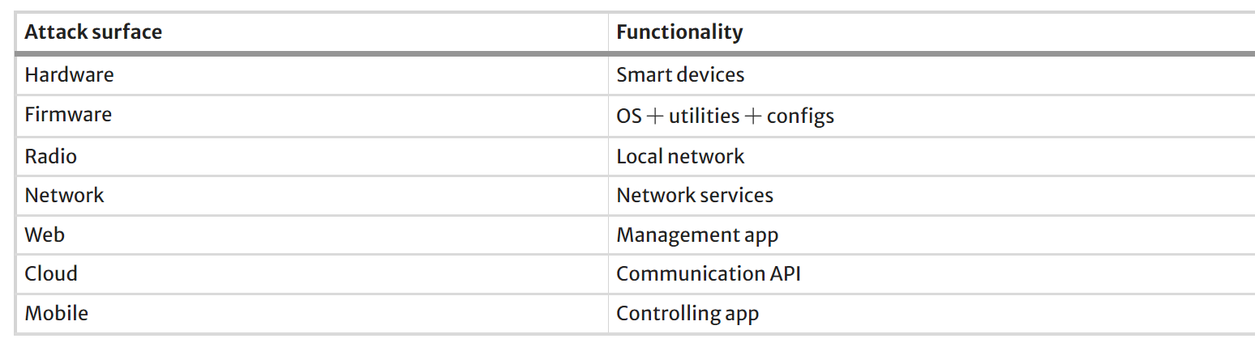
Table 4: PatrIoT Threat Research for IoT

This study utilizes the PatrIoT methodology as its mode of operation. We initially developed this methodology by executing real penetration tests on Internet of Things devices and subsequently refined it through completing multiple projects in the NSE Lab. To put it succinctly, there is a discrepancy between the methodology and skill set utilized in traditional penetration testing methods and the requirements of Internet of Things penetration testing (such as attack surfaces that extend beyond the realm of software alone). In spite of this, Internet of Things penetration testers have been forced to make concessions and rely on traditional resources because there is a lack of teaching on vulnerability testing approaches that are special to the Internet of Things.

It is to provide concrete help resources for penetration testing in the sphere of the Internet of Things that the PatrIoT framework has been established. These resources include templates and general knowledge that can benefit a variety of testing scenarios. The PatrIoT architecture breaks down the attack surface of a particular Internet of Things device into seven distinct surfaces. These surfaces are as follows: hardware, firmware, radio protocol, network surface, web application, as well as cloud services and mobile applications. On the other hand, for the intent of this project, all surfaces will not be taken into consideration because the emphasis will be placed only on the network component.

PatrIoT define a difference between the “device” (in the case, this is the Smart Light) and the “product”.

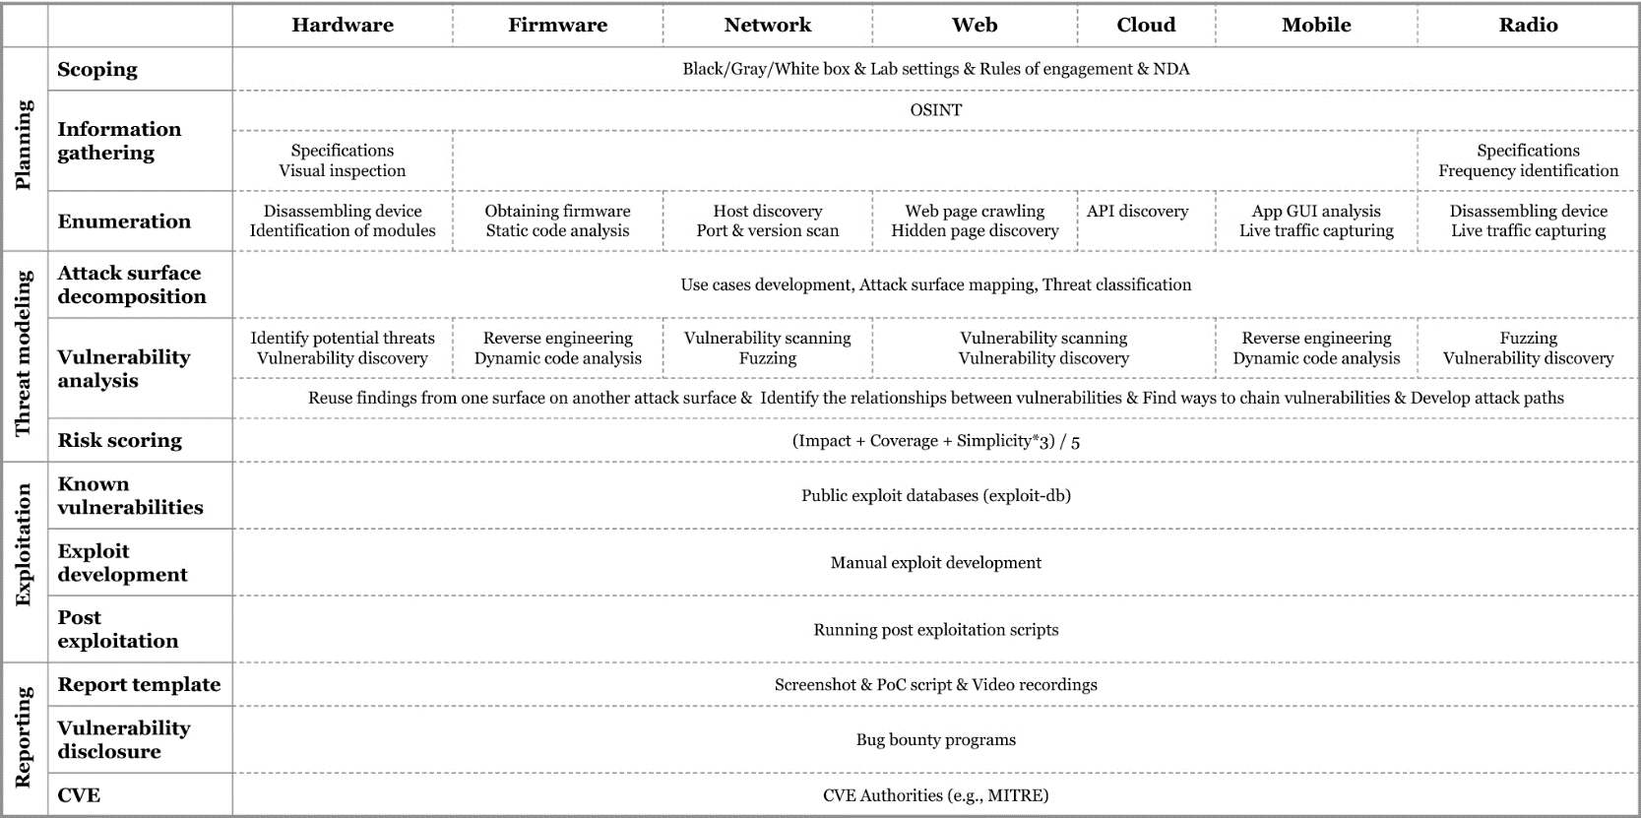
Table 5: Research Methodology Steps of IoT Vulnerability
PatrIoT describes four steps of vulnerability research:

1) Planning
2) Threat modeling
3) Exploitation
4) Reporting

3.3.1 Planning

The objective of the initial stage's objective is to assess the entire infrastructure in order to gain a comprehensive understanding of the functionality of the IoT product's functionality. Subsequently, this stage will enable us to assess the potential vulnerabilities that may exist in particular attack surfaces.

3.3.2 Scoping

Before commencing a vulnerability study, it is essential to establish limits, a process commonly known as scoping. The pentest investigation will focus on specific attack surfaces, such as hardware, firmware, and radio. The test type is categorized as black-box, white box, or grey-box. It is crucial to make a carefully considered decision as the type of test directly influences the vulnerabilities that can be identified. Web application testing often employs a black-box technique. This particular test for web attack surface has inherent restrictions. Forgetting a password is a well-known example of an authentication escape that cannot be fully checked. When a user requests a password reset, the system typically sends a password reset URL containing a random value to the user's email address. The attacker's goal is to change the password of a specific user, such as an administrator, by accurately guessing the random value in the URL. We could potentially make predictions if we knew how this random value is generated. Nevertheless, it is not necessary to always use the white-box technique. When trying to obtain firmware, hardware tests can occasionally cause damage to the device when trying to obtain firmware. Overall, we typically prefer the white-box strategy, although the choice of technique depends on the particular context. We will provide detailed information on how we choose the most suitable method in the relevant area. At this phase, the penetration test team determines the physical location, specifying whether it will occur in a consumer setting or a controlled research laboratory. When we receive IoT devices as a service from a company as a service, we sign a contract that outlines rules of engagement and a non-disclosure agreement (NDA) to protect the confidential information of all parties involved.

3.3.3 Information gathering

This step is additionally known as open-source intelligence (OSINT) because it usually does not involve direct communication with the devices. All assets with functions are identified, and relevant information is gathered through a comprehensive review of the devices' documentation. Through a comprehensive review of the devices' documentation, we gather relevant information on the hardware board used (e.g., a Raspberry Pi, an Arduino, or a custom board), the number of accessible ports, slots, and buttons, the firmware version (proprietary or open-source software), and the operating radio frequency used by the device.

3.3.4 Enumeration

During this step, we use both active and passive scanning methods on all possible attack surfaces. Inspect and physically interact with each gadget that works with the product. At this stage, the primary objective is to collect information that cannot be obtained from a quick impression. We disassemble the hardware and inspect the board for any unauthorized parts. We get the firmware picture so that we can do an outside check, paying special attention to the customized features. We are investigating whether these devices and similar tools operate in the same frequency range or if these devices have a secret way of communicating with each other. These studies have identified all hardware and software parts, as well as communication protocols. You can find detailed information about what each component does, when it starts working, and when it stops, as well as the results of every action. In our public repository, you can find information inquiry templates, as well as detailed steps for gathering and listing information for each attack surface.

3.4 Threat Modeling

The next phase, threat modelling, aims to anticipate possible risks for each attack surface, assess the potential repercussions of successful exploitation, and rank them based on calculated risk scores. Our method does not necessitate any particular tools. Research on each project and select the tools they deem most suitable, allowing for independence.

3.4.1 Attack surface decomposition

To start, we define the Internet of Things (IoT) product's organizational structure. An overall architectural representation gives a summary of the whole system, showing how all the hardware and software parts communicate at a high level, along with the appropriate communication protocols. After that, we break down the design model into seven separate logical parts. As part of this process of breaking down components, the data flow between IoT components, including the communication methods, is modelled. By doing this, we get a clear picture of the places where an attack could happen in the IoT system. At this point, it is crucial to determine the boundaries crossed during communication with each part. This will help us figure out the exact entry points. Second, we use the information from the first stage to develop use cases based on the original purpose of a specific function. The number of use case descriptions varies based on the user profiles, diversity of devices, and penetration test extent. A detailed explanation of the processes in the use case that precede the test's start is essential to guaranteeing testing consistency.

The STRIDE structure consists of six categories: Spoofing, Tampering, Repudiation, Information disclosure, Denial of service, and Elevation of privilege. Additionally, we introduce a new category encompassing code execution. Based on our previous IoT penetration surveys, each category has a unique impact. Evading authentication is associated with spoofing; data manipulation leads to integrity breaches; repudiation undermines authentication and authorization; information disclosure breaches confidentiality; denial of service attacks disrupt availability; elevation of privilege signifies unauthorised access; and code execution involves both integrity and confidentiality breaches.

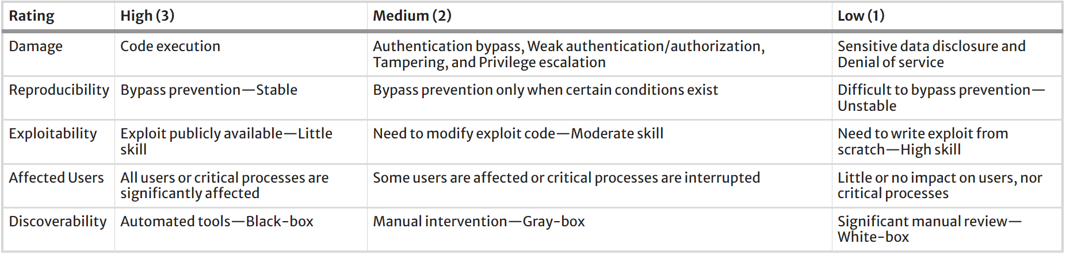
Table 6:PatrIoT Threat Research for IoT

3.4.2 Susceptibility examination

The data gathered from analyzing the attack surface is evaluated in connection to possible vulnerabilities. In the beginning, we use specialized tools called vulnerability scanners tailored to each potential point of attack, such as a firmware security scanner, to automatically detect weaknesses. These technologies can identify both established vulnerabilities and new ones. Using these tools without accurate calibration might lead to many incorrect positive results and may miss vulnerabilities, including those found in public databases. Based on the identified dangers in the previous phase, we tailor these tools to meet our specific needs.

Secondly, we search public databases for previously shared vulnerabilities that are relevant to the various functionalities we have identified. Based on our experience, it is feasible to discover a functional exploit code for a recognized vulnerability that automated tools have overlooked. A manual examination is crucial. Furthermore, online research for established vulnerabilities online motivates weakness experts. A specific set of individuals who tend to introduce comparable defects create a particular product. Researchers frequently identify numerous vulnerabilities in specific aspects of a technology in succession.

3.4.3 Risk scoring

The study utilizes a mechanism similar to DREAD to calculate risk scores but with fewer parameters. They define damage as the level of impact, affected users as the scope of coverage, and together analyze accuracy, exploitability, and accessibility as simplicity (indicating the likelihood of success), as shown in Table 4. To calculate the risk rating equation, assign a value between 1 and 3 to three parameters (impact, coverage, and simplicity), sum them together, and divide by 5.

3.5 Exploitation

The third stage, exploitation, is a frequently employed method to verify system vulnerabilities and assess the possible impact of an attacker exploiting it. If we perform a vulnerability assessment without completing this phase, we may be unable to move beyond guessing about potential threats. Combining multiple minor defects can lead to a significant vulnerability. However, vulnerability analysis is not the only instrument that can assist with this. Recognizing exploitation is a valuable pursuit.

PatrIoT provides CWE-IDs to pinpoint vulnerabilities in Internet of Things (IoT) devices during the compilation phase. The CWE project closely links to the CAPEC project, enabling the identification of related attack vectors using CAPEC-IDs. We have created particular rules for conducting penetration testing on IoT systems. The guidelines include detailed instructions for executing systematic attacks, as well as suggestions for using suitable tools for exploitation.[46] Having a comprehensive set of tools is essential for doing penetration testing on IoT devices. Typically, tailored virtual machines with pre-configured tools are used, especially for hardware and radio interfaces.

3.5.1 Identified weaknesses

Exploit code is typically written in a scripting language and executed manually through the command line. We often obtain exploit code for known vulnerabilities from a publicly accessible database. Sometimes, modifications to the exploit code may be required to effectively execute the planned operation. Using semi-automated tools with pre-built exploit code can streamline and guarantee a successful exploitation process. When there are known vulnerabilities but no publicly available exploits, we create our own by using the provided information about the vulnerability.

3.5.2 Exploit development

Automated technologies, such as vulnerability scanners or fuzzers detect indicators of vulnerabilities and may offer basic payloads for proof of concept (PoC). These clues are utilised to create the functional exploit code.

3.5.3 post-exploitation

Following the acquisition of user-level access to the device's firmware, post-exploitation operations occur immediately. Common behaviours include persistence, escalated privileges, lateral movement, shifting, evasion, data theft, covering tracks, and credential breaking. IoT pentesting primarily involves focusing on boosting privileges and cracking passwords.

3.6 Reporting

The vulnerability study results in the creation of a document called the pentest report, which marks the conclusion of the investigation. When discovering a new vulnerability, the team must take additional actions to produce a vulnerability disclosure report. Both of these report templates are accessible in our repository. Using a standardized framework for reporting findings facilitates a more efficient review process and allows writers to reference past reports. Consistently using a template for all penetration tests helps create detailed statistical analyses and enables quick searches in previous penetration test reports.

3.6.1 Report pattern

An Internet of Things penetration testing report comprises eight sections. The first section is called "General information" and includes details about the service recipient, time range, tested devices, testing objectives, and report content. The following part, known as "Scope," involves identifying the assets and specifying the type of testing, which may be either black-box or white-box. The third section, titled "General testing methodology," outlines the sequential methods taken to conduct the tests. The fourth step, labeled "Risk assessment," includes determining the levels of vulnerability severity. The fifth section includes an "Executive summary" providing a brief review of the devices examined, unsuccessful test types, successful test types, and the subsequent actions performed. The sixth section, named the "Technical summary," offers a detailed explanation of the previously mentioned "Executive summary." The seventh section has 3 tables.

3.6.2 Vulnerability disclosure

Public disclosure refers to the public announcement of security flaws found in software or hardware devices. Stakeholders in this process frequently have divergent priorities. Security researchers tend to quickly share their findings on vulnerabilities in order to receive acknowledgement. Furthermore, it is essential to inform the manufacturer about the found vulnerability to validate its presence and bolster the legitimacy of their discovery. On the other hand, customers using the impacted products or services are calling for prompt system updates. Product owners desire to keep vulnerability disclosures limited to themselves so that they have enough time to fix any weaknesses without affecting user loyalty. Implementing suitable disclosure policies, including accountability, coordination, self, third party, vendor, and full disclosure, has been critical in partially resolving competing agendas.

A conventional approach to responsible disclosure includes several sequential stages. Initially, the researcher detects a security flaw and meticulously describes their findings, providing supportive evidence such as a PoC script and screenshots. The researcher establishes a disclosure timeline. The researcher then informs the vendor of the vulnerability, either directly or through a bug bounty program, ensuring the report is submitted securely. After acknowledging the discovery, the system provider is granted an appropriate timeframe to rectify the vulnerability. When a patch is developed, the product owner releases a security advisory report to inform the public.

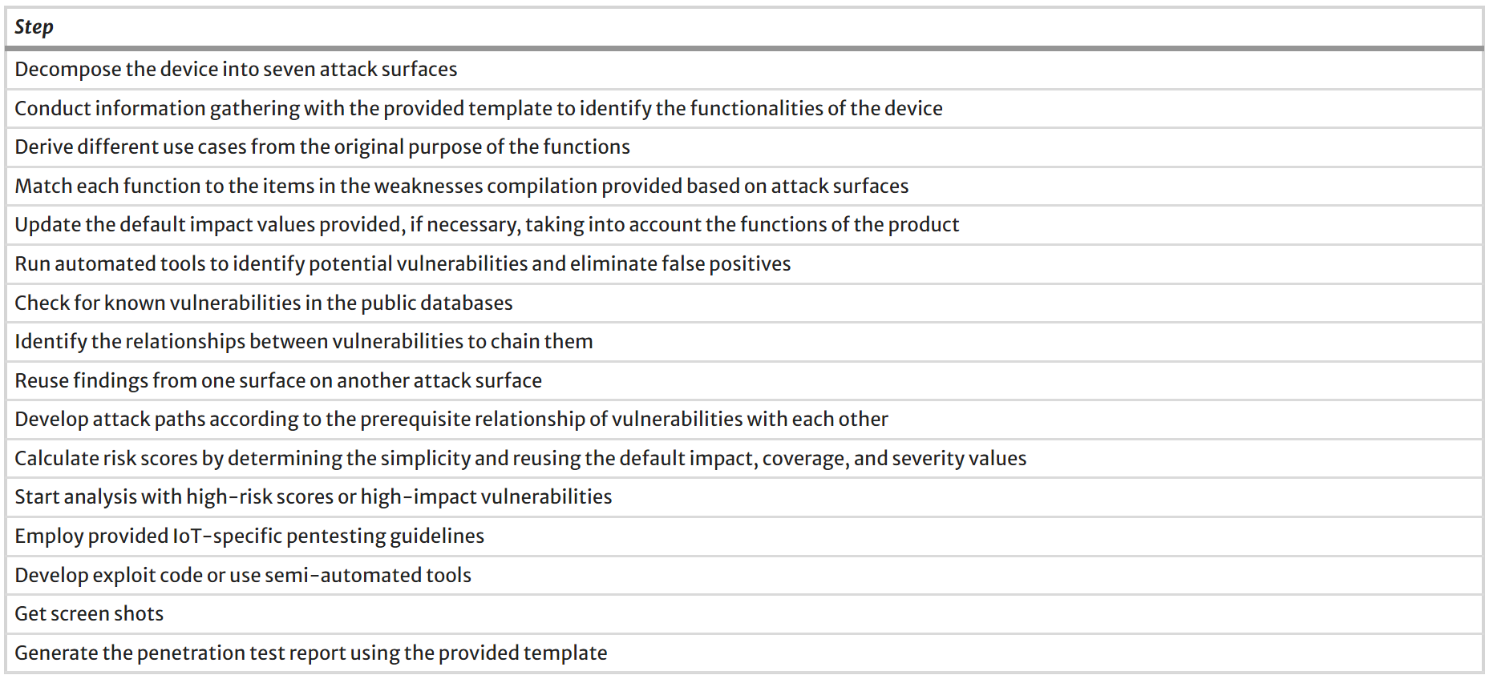
Table 7: Execution Steps for Vulnerability

3.7 Selection of IoT Devices

There are many devices available in the market of IoT devices but most commonly used devices are smart light and voice assistant smart speaker. Setup in the lab environment one router has been used. Devices information given below:

Device Name | Feature
M.I Smart Speaker | Voice Assistant
Tapo – L530 | Smart Light Bulb
Linksys Router | Provide Internal Network
Table 8: Selected Devices

3.8 Contingency Plan for Experiment

Contingency Plan for IoT Device Experiment
Policy

Overview

Purpose:

The purpose of this policy is to set principles and processes to reduce the risks involved in using the different tools during penetration testing.

Penetration activity backup plan in the different aspects and situation consideration and resolution plan.

- Device Malfunction or Failure: A smart light bulb or speaker stops functioning during an experiment.
Backup Devices: Keep spare smart bulbs and speakers on hand to replace malfunctioning ones promptly.
Testing Environment Isolation: Isolate the malfunctioning device to prevent it from affecting other experiments.
- Data Breach or Privacy Violation: Sensitive data (e.g., voice recordings, user preferences) leaks due to security vulnerabilities. Data Encryption: Ensure that data transmitted between devices and servers is encrypted. Configure devices to limit data collection and sharing. Periodically review data logs to detect any unauthorized access.
- Physical Damage to Devices: A smart bulb or speaker gets physically damaged during handling or testing. Train team members on proper device handling techniques. Protective Measures: Use protective cases or covers during experiments. Repair or Replacement: Have a plan in place for repairing or replacing damaged devices.
- Communication and Escalation: Unexpected issues arise during experiments. Emergency Contacts: Maintain a list of emergency contacts (e.g., IT support, supervisor). Escalation Procedures: Define when and how to escalate issues to higher authorities. Establish communication channels within your team for quick updates.
- Ethical Considerations: Ethical dilemmas related to data privacy or participant consent. Obtain consent from participants before collecting any data. Privacy Compliance: Adhere to GDPR privacy regulations. Clearly communicate the purpose and risks of the experiments to participants.
- Documentation and Reporting: You need to report incidents or deviations from the plan. Maintain detailed logs of incidents, responses, and outcome. Reporting Procedures: Define how and when to report incidents to relevant parties.

Concern Person,

Sign:
Date:

3.9 Timeline of Project Approach

Table 9: Project Timeline

Figure 18: Gantt Chart

4. Design & Network Analysis
Reconnaissance is carried out first to collect essential system data for later threat modelling and testing. This section included port scanning on the connection to the Wi-Fi point, traffic analysis, and physical interface inspection.

4.1 Lab Topology and Device Information

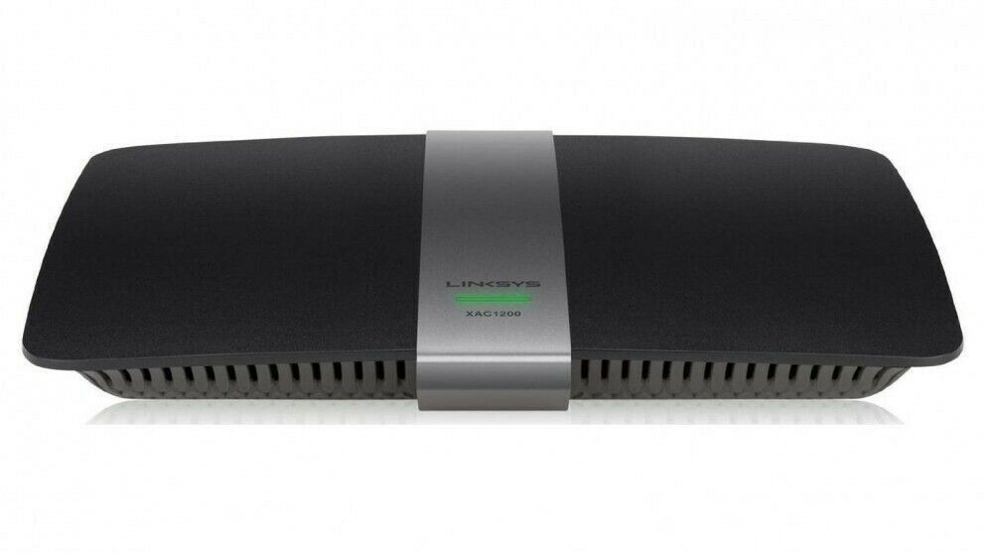

Figure 19: Smart Tapo Light, Mi Smart Speaker

Software List and tools which used to gain access or try to tampering devices and find vulnerability.

- Kali Linux: A Linux operating system widely used for penetration testing in the cybersecurity community.
- VirtualBox: A virtualization software for x86 and AMD64/Intel64 architectures was used in the thesis to run Kali Linux.
- Wireshark: Wireshark is a tool utilised for analysing and monitoring network traffic for many types of reasons.
- Bettercap: Network device scanning and cover device information such as Ip address and mac address of the device.
- Telnet A network protocol utilised for accessing a command-line interface on a remote system. It was used in this theory for banner grabbing.
- Nmap is a network scanning programme utilised for identifying hosts and services on a computer network. It was utilised in the experiment for the purpose of service discovery.

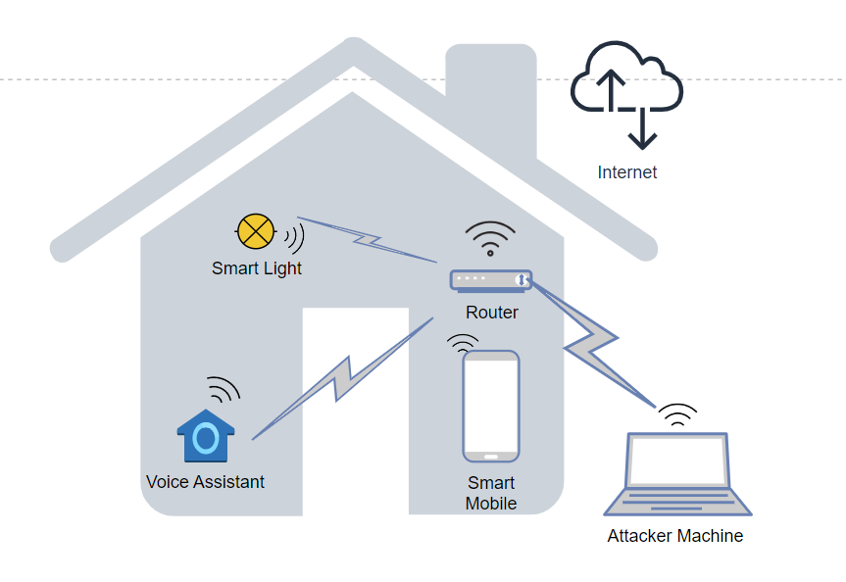
Figure 20: Smart Home Topology

In the further process of penetration testing first of all find out how many devices and which devices connected to the system. We are performing to find out device information. As a attacker machine we are using Kali Linux operating system and device Ip is 192.168.1.102.

4.2 Network Information and Enumeration

In the Kali Linux OS network scanning tool is bettercap. Which is used for gathering network information such as Ip address and Mac address of the device. After scanning of the network, we found out two devices Ip address
and Mac address as well as service provider name. Gathering information using bettercap.
Commands $ bettercap
$ net.show
$ net.recon on

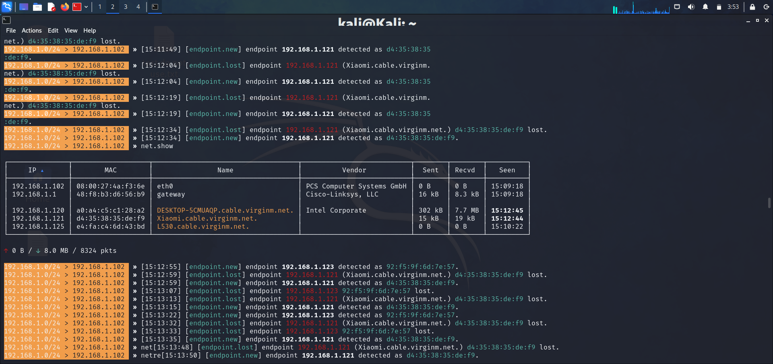
Figure 21: Device Ip Gathering
Scanning network found out two different device Ip as you can see in the figure 21. Which is provide detail below.
Device | Ip Address
Xiaomi.cable | 192.168.1.121
L530 | 192.168.1.125
Cisco-Linksys gateway | 192.168.1.1

Bettercap scanning result devices L530 is smart light, Cisco gateway and Xiaomi speaker found with Ip address.
Now try to deep enumeration using Nmap in the kali machine.

Network:
The smart light bulb was subjected to a thorough port scan using the nmap. The scan was conducted using the following command:
nmap -O 192.168.1.125
We used the nmap programme to discover the operating system specifics. Obtaining information about the operating system and software versions is essential for carrying out any type of attacks. Next, we will attempt to identify open ports on the machines and determine the services running on those ports. We will also collect the version of the services.
nmap -sV 192.168.1.125

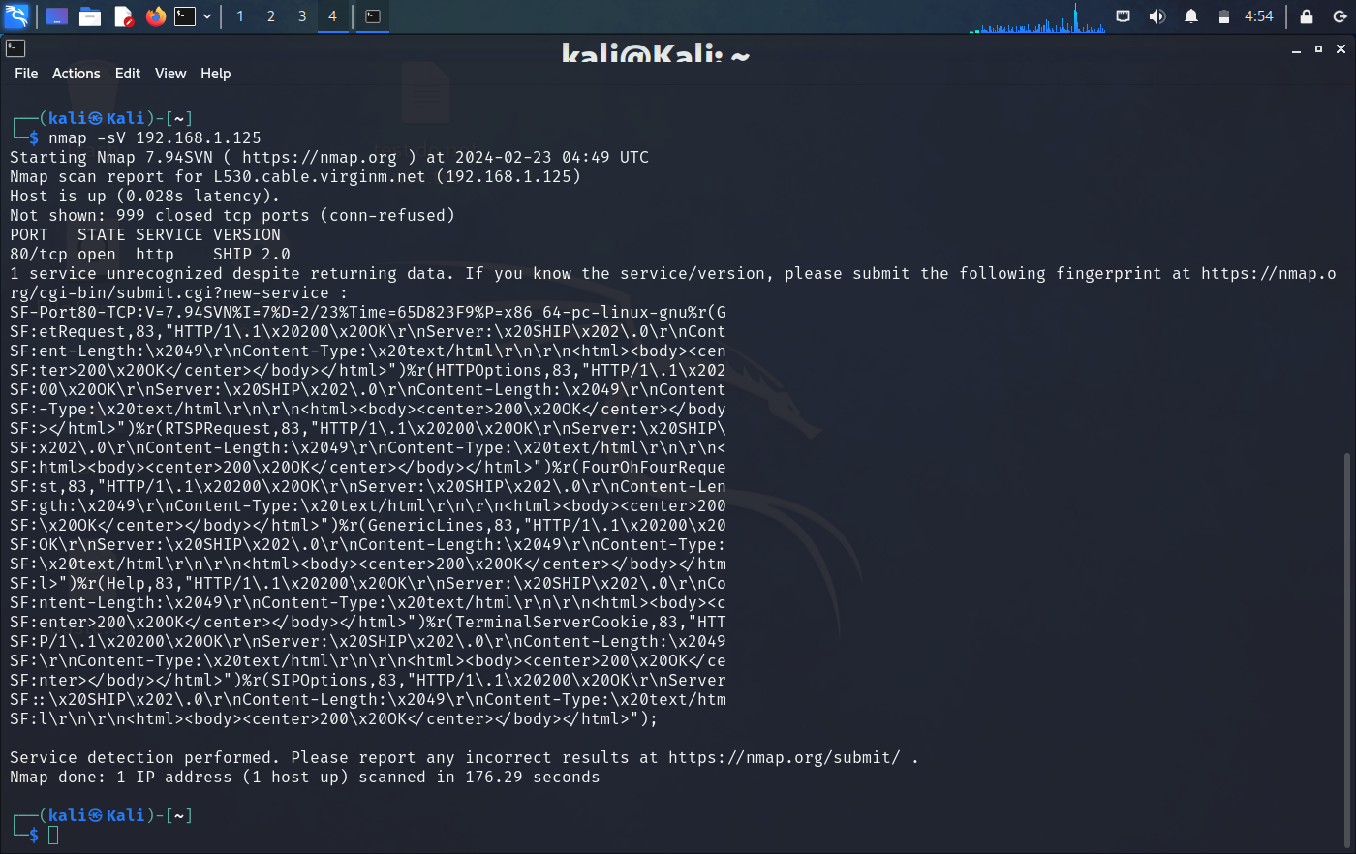
Figure 22: Service port and Operating version Info
As per discovery of port information and running services on the port 80 and its service version, that information is use to find loophole in smart light bulb. Scanning of smart voice assistant speaker using nmap tool. It shows various port are open and which services were being used in particular ports. unfortunately we did not get service information with this command.
nmap 192.168.1.121 -A

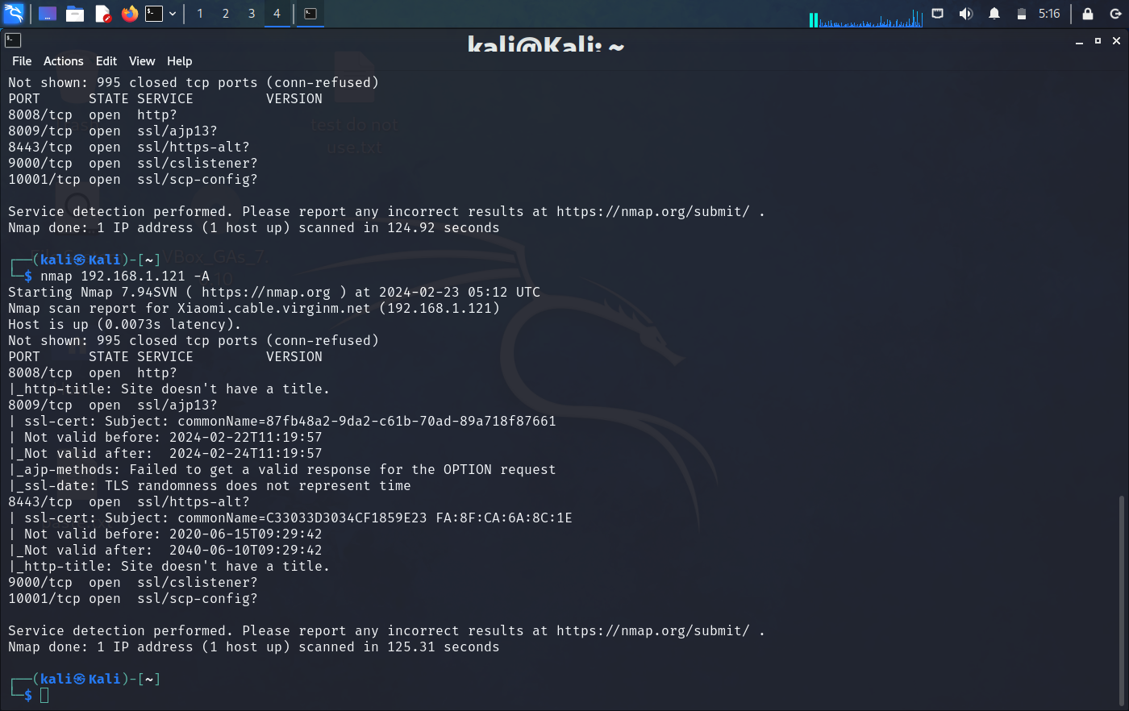
Figure 23: Open Port in Speaker

After gathering information from the network scanning tool, we collected some data, which is shown in below table.
Smart Light Open Port | Functionality
TCP/80 – Open | Management Page

Smart Voice Speaker Open Port | Functionality
TCP/8008 – Open | HTTP Services
TCP/8009 – Open | SSL/ajp13 AJP is a wire protocol. It an optimized version of the HTTP protocol to allow a standalone web server such as Apache.
TCP/8443 – Open | SSL/https-alt Apache utilises port 8443 for SSL text service to prevent problems with the standard HTTPS port 443.
TCP/9000 – Open | SSL/CSListener
TCP/10001 – Open | SSL/SCP-config
Table 10: Vulnerability Information

4.3 Attacks Identified

The STRIDE model is used in this part to determine potential risks to the smart light and speaker. Identifying attacks aids in exposing vulnerabilities and weaknesses in smart IoT devices, enabling proactive vulnerability mitigation. A table displays the documented attacks in this study.

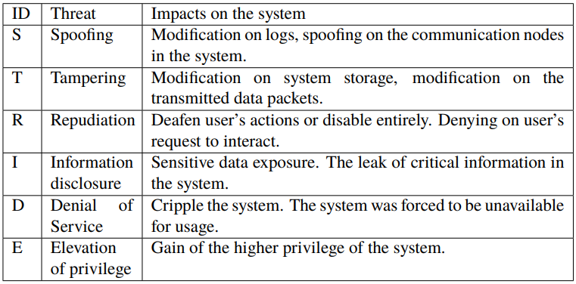
Table 11: Stride Threat Model of the Smart Light

5. Implementation and Exploitation

Penetration Testing: This chapter provides a thorough examination of the attack's outcomes and penetration testing carried out on the target devices. The technique will be followed by presenting the activities conducted, explanations, consequences, and assessments in relation to the preceding explanation. This chapter provides a full explanation of the vulnerability examination, exploitation, and methods used in the technique.

5.1 Network inspecting

Intelligence collection is the first phase of both legitimate hacking and vulnerability testing. Reconnaissance involves using surveillance equipment or vulnerability analyzers to gather relevant data about the device. Network scanning involves collecting data from nearby or distant computer systems across a network. Cybercriminals use this strategy to carry out assaults, along with security assessment and system upkeep. Network scanning consists of vulnerability scanning and port scanning.

5.2 Discovered Open Ports

Nmap is a useful open-source tool for security audits and network analysis. It is designed primarily to scan large networks. Many researchers and attackers use the powerful program Nmap to gather data about the target computer system. With Nmap, an attacker can obtain vital information about their target by scanning the operating system, port statuses, services that are currently running, and communication protocols. Script scanning is one of the most effective scanning methods (NSE). NSE is capable of carrying out tasks like vulnerability analysis and basic service version identification. Despite its remarkable user-friendliness, NSE's considerable complexity makes it a suitable part of the aggressive scan function.

5.2.1 Exploitation Smart Light

The scanning result shows that in the nmap port 80 is open in the smart light. Port 80 is uses for http services. Targeting particular service find that try to enumerate device using php injection. Exploit using http injection need to choose appropriate payload. As you can find below figures, it is explaining step by step process.

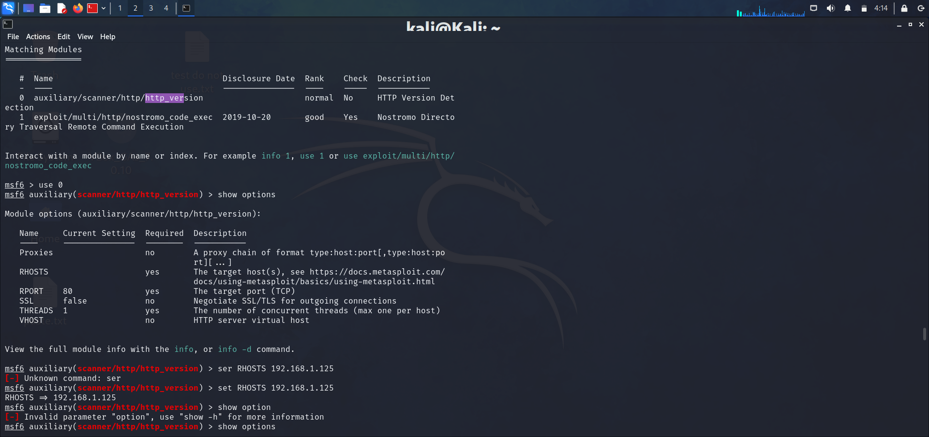
Table 12: Exploitation using Metasploit
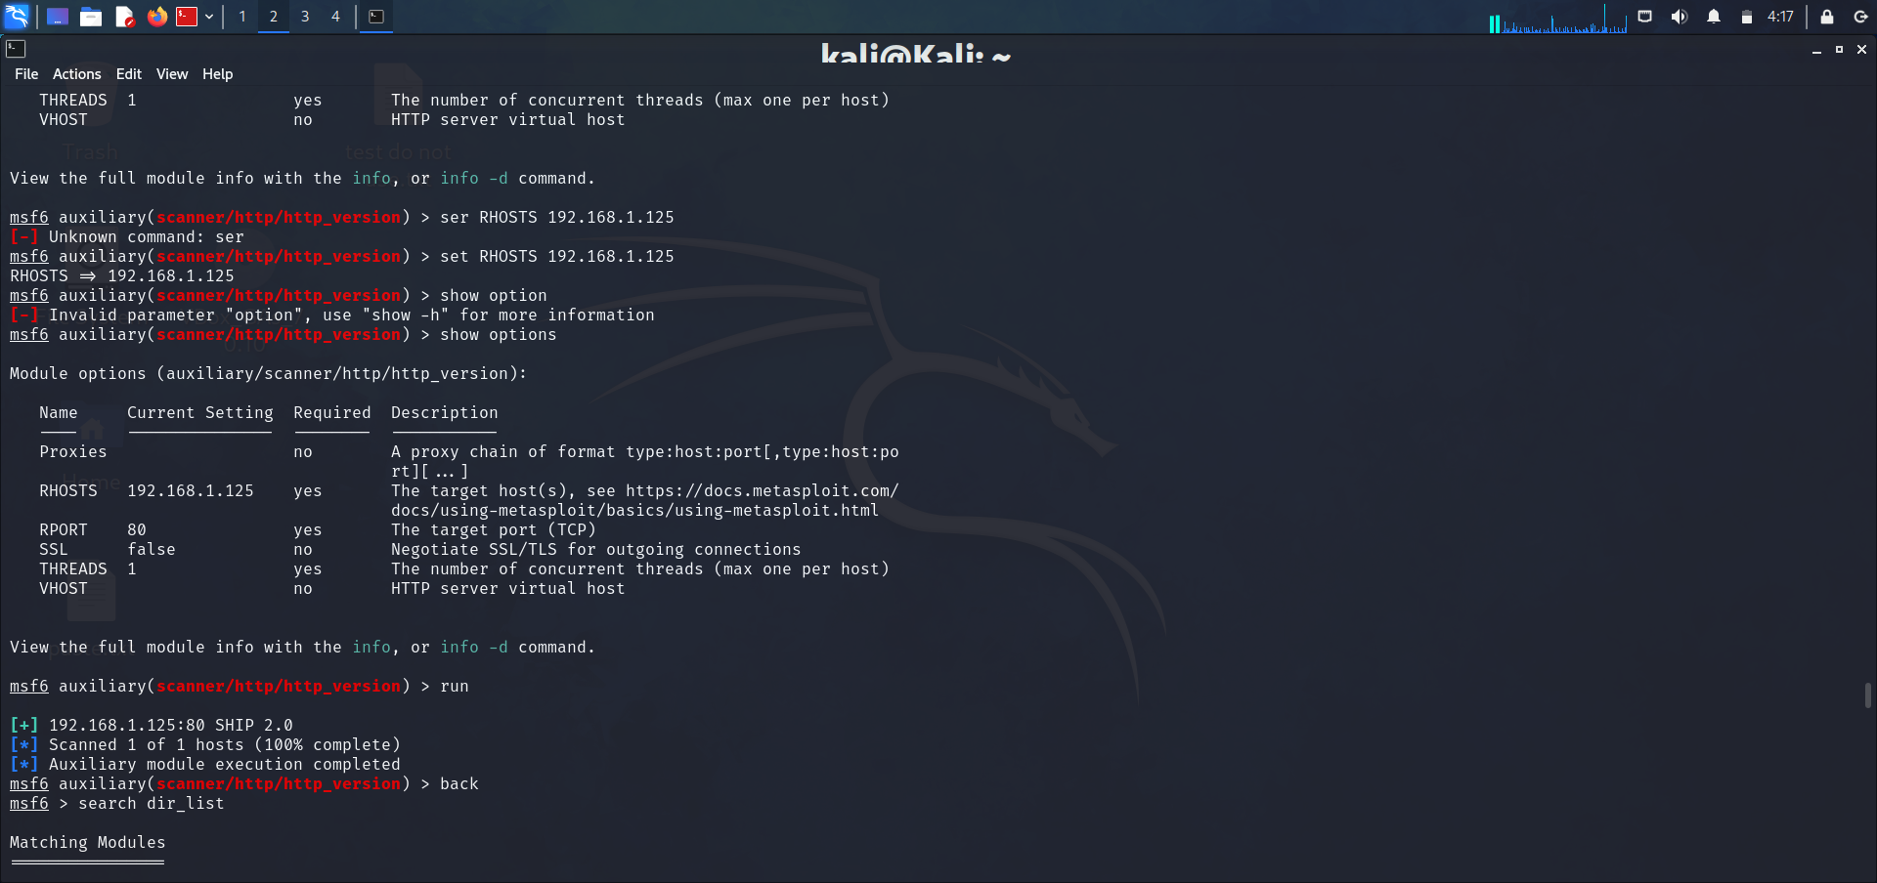


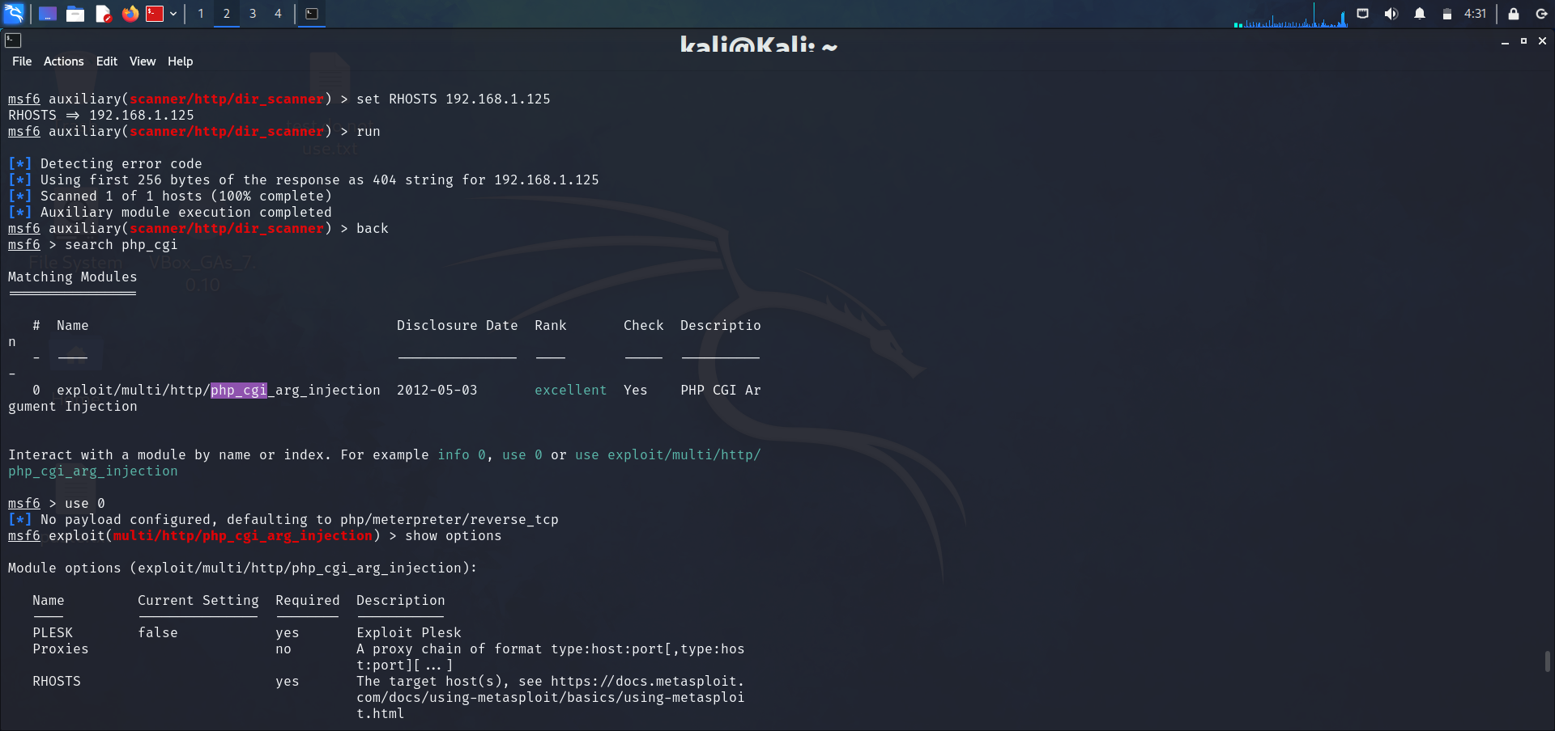

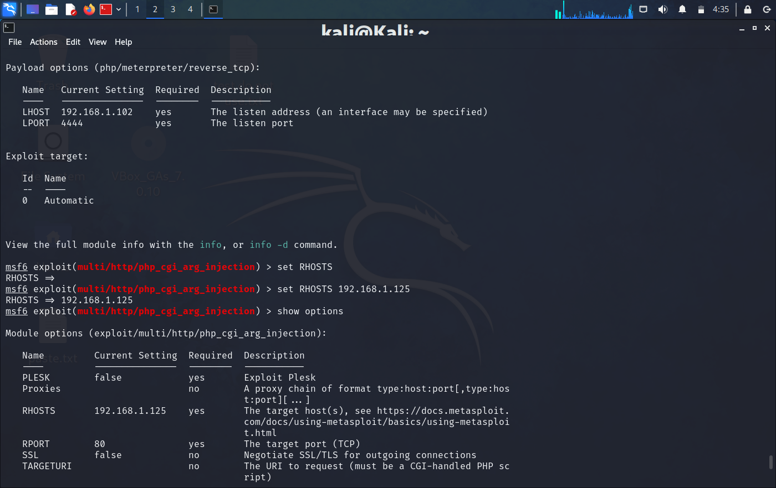

The above screen shots provide payloads. Using exploiting payloads need to find appropriate payload and apply by setting up remote host Ip, listening port Ip, and port number which we want to listen on.

Applying payload data and try to exploit port 80 http service using php injection but it was not successful. After consideration that output try another method to find vulnerability in the smart light.

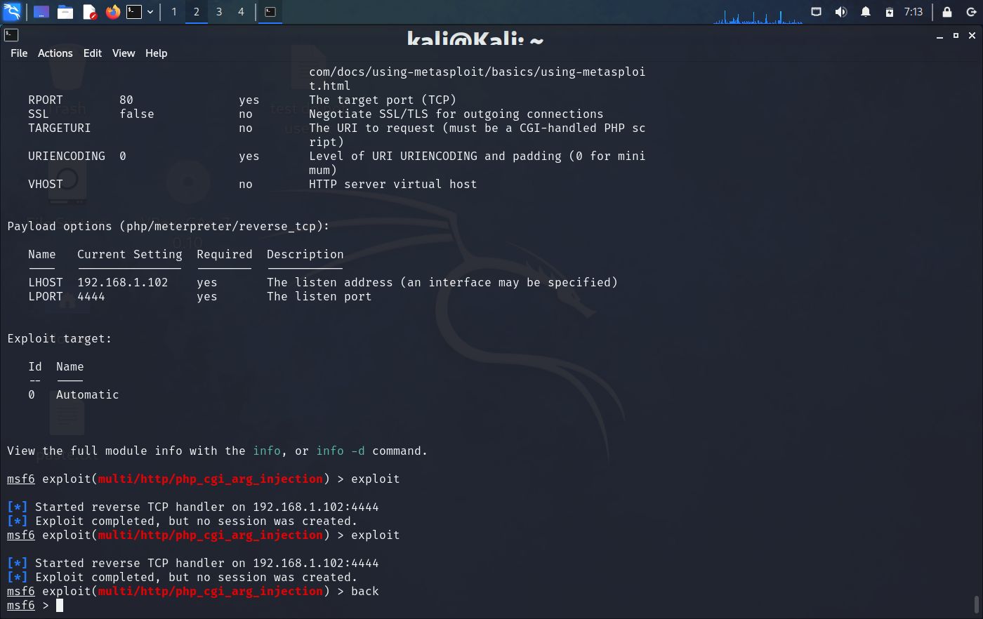
Figure 24: Payload Session

5.2.2 Service Manipulation of Smart Light

Explore vulnerabilities of smart light services apply DoS attack using hping3 tool. Hping3 is a command-line tool that allows us to analyse TCP/IP packets within a network. Hping3 can assemble network packets, aiding pentesters in executing unauthorised activities such as initiating a Denial-Of-Service (DoS) attack and conducting device and service discovery.
The use of hping3 command: hping3 -S (source ip) -a (victim machine ip) -p 135 --flood

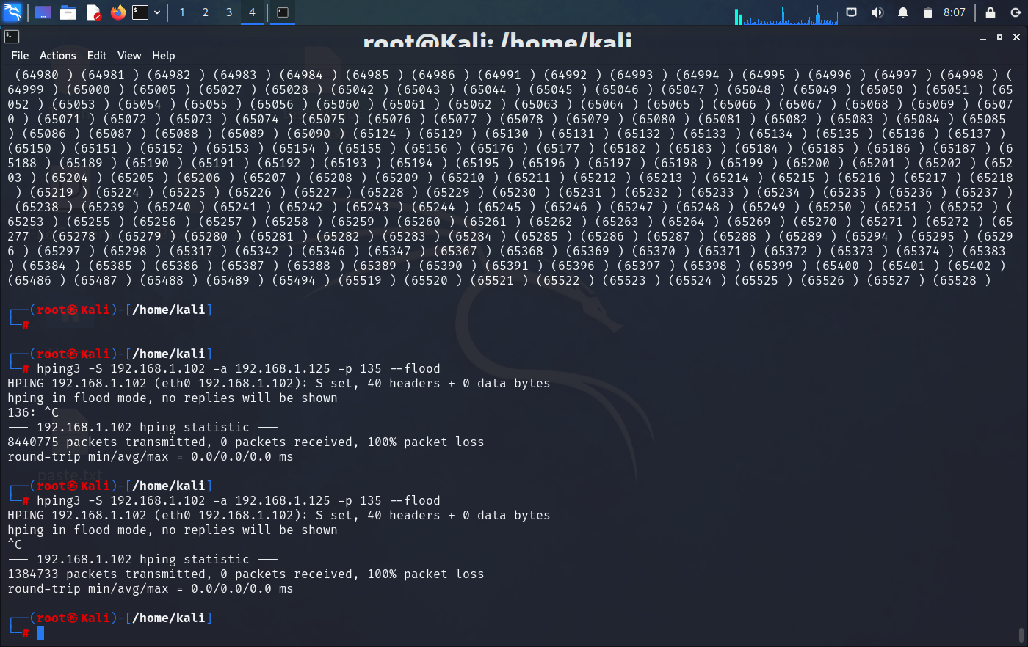
Figure 25: DoS Attack Using hping3

Smart bulb is operating from the mobile application and smart voice assistant both of the way. After giving flood syn packet using hping3, it was not giving output or taking command. Which is shown in the figures below. Figure showing mobile application with colour similarity (working proper way) and colour variation (not working). It was not taking input due to flood packets.

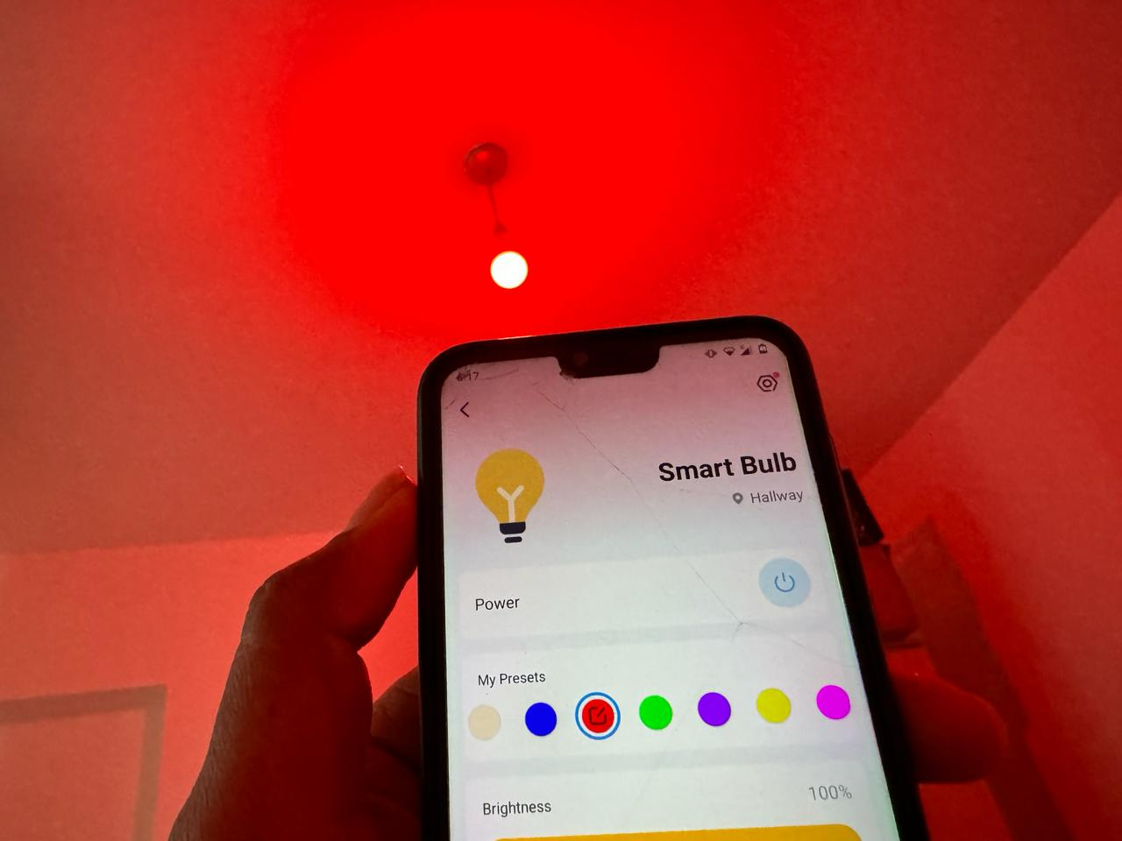
Figure 26:Normally Working

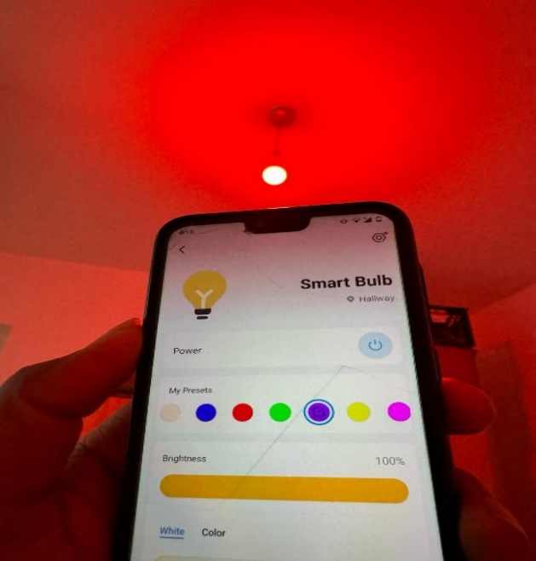
Figure 27: DoS Attack Impact

6. Results and Discussion

The research documents penetration experiments showing that distributed denial-of-service attacks are generally effective. Manipulating the zero-configuration protocol results in a Denial of Service (DoS) attack. Although DoS attacks are recognised as the most common and easiest to carry out on IoT devices, it is crucial to prioritise security considerations to prevent such malicious attacks on IoT devices. This research consistently confirms the effectiveness of DoS assaults, particularly in the context of smart light and speaker devices. This chapter presents an examination of the research findings. Discussions are concerning the research findings, methods, potential alternative approaches, and limits. Ethical and sustainability issues are addressed, as well as compared to prior studies.
The network inspection identifies URLs based on the HTTP protocol and the device's operating system. The effort failed to utilise any available ports on the smart light, and the purpose of the URL value remains unknown. That research aspect can be you for potential study.
Various TCP protocol found at the different service point in the smart voice assistant. Those ports critically try to find loophole but unfortunately it is more secured and updated. It full updated with latest security patches and that is the reason port are open in network inspection but cannot exploit in this research project.
Identification vulnerabilities in the gateway, number of ports are open and more vulnerable rather then other devices. It could lead the privacy concern of households. Furthermore, devices can more secure through a local router because it has connectivity of full house. If it is updated and more secure then privacy level is high and protect from threats.

7. Conclusions and Future work

The smart camera demonstrated resistance to most of the attacks examined in this study. The security system showcases strong protections and resilience against cyber threats. It is vulnerable to mDNS protocol and DoS attacks. Here are some observations on the camera's security level: Improving the security of the file system. Integrating zeroconf protocol with credentials in the system and developing a strategy to mitigate DoS attacks in a cloud-based security environment or creating a response plan for such situations. The network inspection detects URLs that utilize the HTTP protocol and determines the OS system of the device. The attempt was unsuccessful in utilizing any accessible ports within the smart light, and the function of the URL value is still unclear.

The results align with the work's objective and assist the developers of smart IoT devices and mobile apps in enhancing security. Selected attacks in this study are only partially effective, as some of them damage the camera. If further threats arise from this activity, the system may experience an increase in security vulnerabilities and weaknesses. Mobile apps might be vulnerable to attacks through the insertion of malicious code; therefore, doing additional security testing on connections is advisable.

IoT devices are becoming more popular due to technological advancements. It is crucial that you stay current with the safety features of the application. Implement zero-configuration approaches with appropriate security settings. Denial of Service (DoS) attacks remain a security threat for smart cameras, as they do for the majority of IoT devices. The firmware and mobile app must be upgraded to prevent any potential hacking of the present version.

7.1 Future Work

Due to time constraints and expertise, the penetration testing in this work are restricted. There are more approaches that may prove beneficial for the IoT smart devices. Alternatively, from a different viewpoint, additional inquiry could be executed using the proven attacks.

This experiment demonstrated that open interfaces on the device prevent attacks. Conversely, further attacks may originate from this direction. One intriguing method to communicate with the server is via a telnet connection. The requests examined in this study were unsuccessful, although additional attempts could be made until successful requests are identified. Testing the cloud server is prohibited by the regulations of this job, despite its crucial role in the connectivity architecture. Consider testing the cloud server with the company's approval. The HTTP login URL is vulnerable to hacking due to the lack of restrictions on the number of login attempts.

Security testing is an ongoing process due to the fact that no system is entirely immune to contemporary threats. Update the smartphone application and software regularly and perform security checks after each update. Remove the research boundaries and thoroughly explore the limited nature of this investigation.

7.2 Reflection

There might be moral problems with finding flaws in products that have already been sold and then writing a thesis about them. Even though there are good points made, the thesis's main goal is to help gadget makers make their products safer. In order to do this, effective answers must be suggested for all the recognised weaknesses.

Finding gaps in security through investigation has an effect on the economy that goes beyond the costs that companies have to pay to fix the holes. Even though it costs money and time to secure devices initially, doing so protects against hacking and data breaches, which is good for business. It also boosts client confidence, business credibility, and the ability to compete in the market.

The social impacts of conducting penetration testing on IoT gadgets are significant. As these devices increase in significance in daily life, conducting tests to identify weaknesses might impact privacy, trust, and security. Testing is crucial for enhancing safety measures, but informing individuals about potential risks such as data breaches and unauthorised control of devices could deter them from adopting IoT technology.

References

[1] ‘https://www.ncbi.nlm.nih.gov/pmc/articles/PMC10136937/’.
[2] ‘https://www.themartec.com/insidelook/ai-and-iot-of-cybersecurity’.
[3] ‘https://digitalcommons.odu.edu/cgi/viewcontent.cgi?article=1179&context=engtech_fac_pubs’.
[4] ‘https://symantec-enterprise-blogs.security.com/blogs/threat-intelligence/threat-landscape-q1-2020’.
[5] I. Lee, ‘Internet of Things (IoT) Cybersecurity: Literature Review and IoT Cyber Risk Management’, Future Internet, vol. 12, no. 9, p. 157, Sep. 2020, doi: 10.3390/fi12090157.
[6] N. Taimoor and S. Rehman, ‘Reliable and Resilient AI and IoT-Based Personalised Healthcare Services: A Survey’, IEEE Access, vol. 10, pp. 535–563, 2022, doi: 10.1109/ACCESS.2021.3137364.
[7] L. Nemec Zlatolas, N. Feher, and M. Hölbl, ‘Security Perception of IoT Devices in Smart Homes’, Journal of Cybersecurity and Privacy, vol. 2, no. 1, pp. 65–74, Feb. 2022, doi: 10.3390/jcp2010005.
[8] H. B. Alharbi, N. Abdulrazak Baghanim, and A. Munshi, ‘Cyber Risk in Internet of Things World’, in 2020 3rd International Conference on Computer Applications & Information Security (ICCAIS), IEEE, Mar. 2020, pp. 1–5. doi: 10.1109/ICCAIS48893.2020.9096720.
[9] M. B. Yassein, I. Hmeidi, F. Shatnawi, W. Mardini, and Y. Khamayseh, ‘Smart Home Is Not Smart Enough to Protect You - Protocols, Challenges and Open Issues’, Procedia Comput Sci, vol. 160, pp. 134–141, 2019, doi: 10.1016/j.procs.2019.09.453.
[10] A. N. Lone, S. Mustajab, and M. Alam, ‘A comprehensive study on cybersecurity challenges and opportunities in the <scp>IoT</scp> world’, SECURITY AND PRIVACY, vol. 6, no. 6, Nov. 2023, doi: 10.1002/spy2.318.
[11] M. Gupta, C. Akiri, K. Aryal, E. Parker, and L. Praharaj, ‘From ChatGPT to ThreatGPT: Impact of Generative AI in Cybersecurity and Privacy’, IEEE Access, vol. 11, pp. 80218–80245, 2023, doi: 10.1109/ACCESS.2023.3300381.
[12] A. Fatima et al., ‘Impact and Research Challenges of Penetrating Testing and Vulnerability Assessment on Network Threat’, in 2023 International Conference on Business Analytics for Technology and Security (ICBATS), IEEE, Mar. 2023, pp. 1–8. doi: 10.1109/ICBATS57792.2023.10111168.
[13] M. R. Islam and K. M. Aktheruzzaman, ‘An Analysis of Cybersecurity Attacks against Internet of Things and Security Solutions’, Journal of Computer and Communications, vol. 08, no. 04, pp. 11–25, 2020, doi: 10.4236/jcc.2020.84002.
[14] R. Ahmad and I. Alsmadi, ‘Machine learning approaches to IoT security: A systematic literature review’, Internet of Things, vol. 14, p. 100365, Jun. 2021, doi: 10.1016/j.iot.2021.100365.
[15] ‘http://www.iot.electronicsforu.com/headlines/the-right-security-for-iot-physical-attacks-and-how-to-counter-them/’.
[16] F. Farivar, M. S. Haghighi, A. Jolfaei, and M. Alazab, ‘Artificial Intelligence for Detection, Estimation, and Compensation of Malicious Attacks in Nonlinear Cyber-Physical Systems and Industrial IoT’, IEEE Trans Industr Inform, vol. 16, no. 4, pp. 2716–2725, Apr. 2020, doi: 10.1109/TII.2019.2956474.
[17] H. Akram, D. Konstantas, and M. Mahyoub, ‘A Comprehensive IoT Attacks Survey based on a Building-blocked Reference Model’, International Journal of Advanced Computer Science and Applications, vol. 9, no. 3, 2018, doi: 10.14569/IJACSA.2018.090349.
[18] F. Farivar, M. S. Haghighi, A. Jolfaei, and M. Alazab, ‘Artificial Intelligence for Detection, Estimation, and Compensation of Malicious Attacks in Nonlinear Cyber-Physical Systems and Industrial IoT’, IEEE Trans Industr Inform, vol. 16, no. 4, pp. 2716–2725, Apr. 2020, doi: 10.1109/TII.2019.2956474.
[19] P. Radanliev et al., ‘Cyber risk at the edge: current and future trends on cyber risk analytics and artificial intelligence in the industrial internet of things and industry 4.0 supply chains’, Cybersecurity, vol. 3, no. 1, pp. 1–21, 2020.
[20] S. Zeadally, E. Adi, Z. Baig, and I. A. Khan, ‘Harnessing artificial intelligence capabilities to improve cybersecurity’, Ieee Access, vol. 8, pp. 23817–23837, 2020.
[21] P. Radanliev et al., ‘Future developments in standardisation of cyber risk in the Internet of Things (IoT)’, SN Appl Sci, vol. 2, pp. 1–16, 2020.
[22] C. Kelly, N. Pitropakis, S. McKeown, and C. Lambrinoudakis, ‘Testing And Hardening IoT Devices Against the Mirai Botnet’, in 2020 International Conference on Cyber Security and Protection of Digital Services (Cyber Security), IEEE, Jun. 2020, pp. 1–8. doi: 10.1109/CyberSecurity49315.2020.9138887.
[23] X. Liang and T. Znati, ‘A Long Short-Term Memory Enabled Framework for DDoS Detection’, in 2019 IEEE Global Communications Conference (GLOBECOM), IEEE, Dec. 2019, pp. 1–6. doi: 10.1109/GLOBECOM38437.2019.9013450.
[24] T. E. Mathonsi, T. M. Tshilongamulenzhe, and B. E. Buthelezi, ‘Blockchain security model for internet of things’, in the Proceedings of Academics World 158th International Conference, 2019, pp. 52–56.
[25] ‘INTERNET OF THINGS (IOT) MEDICAL SECURITY: TAXONOMY AND PERCEPTION’, Issues In Information Systems, 2020, doi: 10.48009/3_iis_2020_227-235.
[26] R. Williams, E. McMahon, S. Samtani, M. Patton, and H. Chen, ‘Identifying vulnerabilities of consumer Internet of Things (IoT) devices: A scalable approach’, in 2017 IEEE International Conference on Intelligence and Security Informatics (ISI), IEEE, Jul. 2017, pp. 179–181. doi: 10.1109/ISI.2017.8004904.
[27] H. Yu, C. Kim, S. Im, and S. Oh, ‘ZigBee Authentication Protocol with Enhanced User Convenience and Safety’, Jouranl of Information and Security, vol. 22, no. 1, pp. 81–92, Mar. 2022, doi: 10.33778/kcsa.2022.22.1.081.
[28] ‘https://www.bluetooth.com/learn-about-bluetooth/tech-overview/’.
[29] L. Zhang, M. Ma, and Y. Qiu, ‘An enhanced handover authentication solution for 6LoWPAN networks’, Comput Secur, vol. 109, p. 102373, Oct. 2021, doi: 10.1016/j.cose.2021.102373.
[30] A. Barua, M. A. Al Alamin, Md. S. Hossain, and E. Hossain, ‘Security and Privacy Threats for Bluetooth Low Energy in IoT and Wearable Devices: A Comprehensive Survey’, IEEE Open Journal of the Communications Society, vol. 3, pp. 251–281, 2022, doi: 10.1109/OJCOMS.2022.3149732.
[31] B. Mbarek, M. Ge, and T. Pitner, ‘Proactive trust classification for detection of replication attacks in 6LoWPAN-based IoT’, Internet of Things, vol. 16, p. 100442, Dec. 2021, doi: 10.1016/j.iot.2021.100442.
[32] M. Lilli, C. Braghin, and E. Riccobene, ‘Formal Proof of a Vulnerability in Z-Wave IoT Protocol’, in Proceedings of the 18th International Conference on Security and Cryptography, SCITEPRESS - Science and Technology Publications, 2021, pp. 198–209. doi: 10.5220/0010553301980209.
[33] ‘https://www.threadgroup.org/thread-group#OurMembers’.
[34] E. Ronen, A. Shamir, A.-O. Weingarten, and C. OFlynn, ‘IoT Goes Nuclear: Creating a ZigBee Chain Reaction’, in 2017 IEEE Symposium on Security and Privacy (SP), IEEE, May 2017, pp. 195–212. doi: 10.1109/SP.2017.14.
[35] P. Morgner, S. Mattejat, Z. Benenson, C. Müller, and F. Armknecht, ‘Insecure to the touch’, in Proceedings of the 10th ACM Conference on Security and Privacy in Wireless and Mobile Networks, New York, NY, USA: ACM, Jul. 2017, pp. 230–240. doi: 10.1145/3098243.3098254.
[36] D. Dinu and I. Kizhvatov, ‘EM Analysis in the IoT Context: Lessons Learned from an Attack on Thread’, IACR Transactions on Cryptographic Hardware and Embedded Systems, pp. 73–97, Feb. 2018, doi: 10.46586/tches.v2018.i1.73-97.
[37] ‘https://www.npr.org/sections/thetwo-way/2018/06/05/617196788/s-c-mom-says-baby-monitor-was-hacked-experts-say-many-devices-are-vulnerable’.
[38] https://arxiv.org/pdf/2105.06612.pdf.
[39] C. Xenofontos, I. Zografopoulos, C. Konstantinou, A. Jolfaei, M. K. Khan, and K.-K. R. Choo, ‘Consumer, Commercial, and Industrial IoT (In)Security: Attack Taxonomy and Case Studies’, IEEE Internet Things J, vol. 9, no. 1, pp. 199–221, Jan. 2022, doi: 10.1109/JIOT.2021.3079916.
[40] ‘https://autobahn-security.com/alexa-phishing-eavesdropping/’.
[41] ‘https://www.wired.com/story/boeing-787-code-leak-security-flaws/’.
[42] ‘https://i.blackhat.com/USA-19/Wednesday/us-19-Santamarta-Arm-IDA-And-Cross-Check-Reversing-The-787-Core-Network.pdf’.
[43] H. M. Z. Al Shebli and B. D. Beheshti, ‘A study on penetration testing process and tools’, in 2018 IEEE Long Island Systems, Applications and Technology Conference (LISAT), IEEE, May 2018, pp. 1–7. doi: 10.1109/LISAT.2018.8378035.
[44] ‘https://www.aesanetwork.org/research-onion-a-systematic-approach-to-designing-research-methodology/’.
[45] ‘https://gradcoach.com/saunders-research-onion/’.
[46] ‘https://learn.microsoft.com/en-us/azure/security/develop/threat-modeling-tool-threats’.

