MBA – Master of Business Administration in General Management
Module: Human Resource Management (LCMB7000)

Name - Shirinbanu Saiyed
Student ID - 2242206
University Name - University of Wales Trinity Saint David
Lecturer Name - Mohamed Asim
Year - 2023-24


Executive summary
The study has been based on the labour market in the UK. Some emerging changes in HRM strategies regarding Covid-19, Post Brexit and more. It has been observed that trends such as remote working, the young generation’s involvement, outsourcing and others are getting in highlight day by day. The major issue as the skills gap is now there in the labour market.

Table of Contents
1. Introduction 4
2. Definitions 4
3. Key trends in the UK labour market 5
4. Challenges and opportunities in the UK’s labour market 9
5. Changes in the UK labour market in relation to the impact of post-Covid and impact of post-Brexit 11
6. Conclusion 13
7. References 15

1. Introduction
The study aims to project light on some of the key issues and growing concerns related to the labour market and thus HRM in the UK. The labour market is best recognised as the job market. On the other hand, the HRM or human resource department of a company engages with the identification, recruitment and onboarding of new employees. Thus, challenges that affect the labour market, will also impact the HRM department of a company (Armstrong and Taylor, 2020). The labour market is also a major element to balance the economic factors related to the United Kingdom. Stability is the most desired factor in the labour market. However, Covid-19 and Brexit are two particular factors that heavily impacted the labour market as well as the financial health of a country. The study will be conducted from a strategic perspective to analyse the most complicated and critical issues in a unique manner.

2. Definitions
Human resource management: A coherent approach that tends to be a part of the entire strategic management of an organization is recognised as HRM or human resource management (Torrington et al., 2021). In other words, HRM is a strategic approach that helps to nurture employees to provide a sustainable competitive advantage to the company (Armstrong and Taylor, 2020). It has multiple accomplishments in the workplace including recruitment, onboarding, employee compensation, benefits, reward, recognition and so on (Pilbeam and Corbridge, 2010). In this context, employees are considered to be the human capital of organizations (Cumming et al., 2020).
Labour market: A labour market refers to the place where interactions between employees and employers generally take place. Competition has been observed in the labour market between these two parties to get the most satisfying contract or condition as well. As per the current situation, the employment rate in the UK is almost 75.7%.
And it was observed between April to June this year only. However, this represents a detriment of almost 0.1% compared to the results of January to March 2023 (Office for National Statistics, 2023). It has been identified that from March to May the UK reported to have 33.05 employment across the country. Overall, the condition of the UK’s labour market is now comparatively more stable than in the past two years.
Covid-19: Simply put, Coronavirus or Covid-19 virus is a kind of contagious disease that is caused by the virus SARS-CoV-2 (Bell and Blanchflower, 2020). Due to the outbreak of the Covid-19 virus, the UK declared its first phase of lockdown in 2020’s March (Mao et al., 2021). The economic activities of the country deliberately fell by almost 30% in the year (Allas et al., 2022). Almost 23% of companies in the UK entirely shut down by the end of April 2020. The other 60% of businesses encountered significant losses in their revenue and overall growth margin (Allas et al., 2022). According to a report, almost 7.6 million jobs were at risk during the lockdown. This incident completely destroyed the scenario of the UK labour market.
Brexit: Brexit is the event of withdrawal of the UK from the European Union. This event took place on January 2020 (Javorcik et al., 2020). The UK is the first sovereign nation that left the EU. As a result, the EU immigrant labour force was affected heavily. On the other hand, the number and per cent of non-EU workers began to grow.

3. Key trends in the UK labour market
Unfilled positions: In the UK labour market, a considerable number of vacancies has been observed in the recent state (Petrongolo and Ronchi, 2020). However, in the upcoming days, almost 47% of employees will search for new or other job opportunities. On the other hand, another report highlighted a decline in job vacancies by almost 85,000 to 1,034,000.
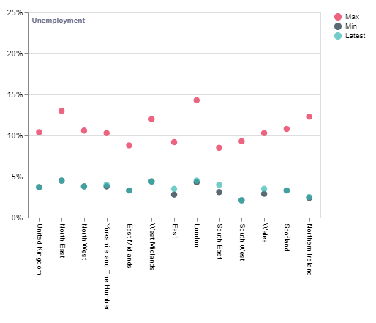
Figure 1: UK’s unemployment rates as well as ITL1 regions
(Source: Economics Observatory. 2023)
Employee wages: Employee wages are a bigger determination in the UK labour market, as it holds the industrial status in a unique manner. The growth in the average pay scale of workers in the UK is the biggest influencing factor that has been observed currently. The average pay is increased by up to 6.9% (Office for National Statistics, 2023). Along with this, the rate of regular pay has also increased up to 7.3% from March to May 2023.
In terms of the regular pay system, the pre-mentioned rate tends to be the highest payout in history. However, the growth in real terms was observed to fail down by 1.2% and 0.8% for total as well as regular pay. The reason behind these statistics is the growing inflation ratio. Alternatively, almost 128,000 working days were disrupted due to labour defaults on May 2023 (Office for National Statistics, 2023).
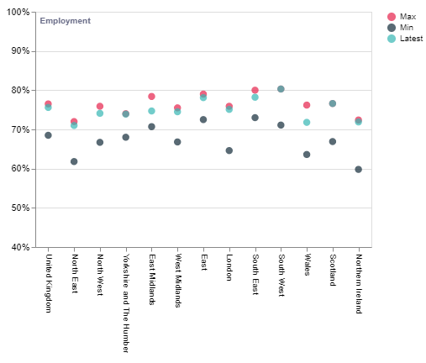
Figure 2: UK’s employment rates as well as ITL1 regions
(Source: Economics Observatory. 2023)
Reduction in the proportion of older people in the population: Economic inactivity is growing due to the declined engagement of older employees. A majority of old are living on pensions and the rest are on savings. This indicates that businesses in the country need to include accessible and attractive strategies for the older population. The enforcement of specific fair as well as inclusive recruitment processes will help them to work for a longer period than it was in the previous.
Development in the number of young employees: Due to Covid-19 and job loss many students in the UK now work part-time or full-time to run their families and maintain their studies (Knight, 2023). As per the reports of the Office for National Statistics, the youth employment rate was now developed by almost 0.4% to 11.36% (Knight, 2023). On the other hand, as per the data from NHS, the total engagement of students or young people seems to be declining as they found only 724,000 people in employment, education or training (NEET) (NHS, 2023).
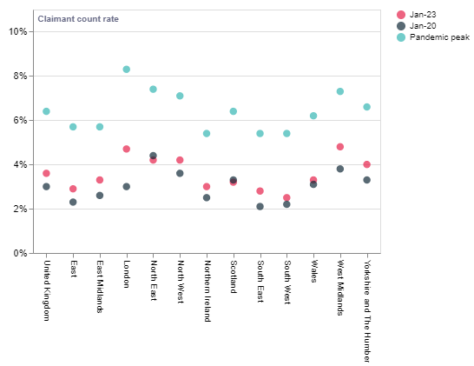
Figure 3: UK’s claimant count rates as well as ITL1 regions
(Source: Economics Observatory. 2023)
Outsourcing: As per the data of NHS, it has been identified that recruiting from outside of the company is a major trend in the organisational context in the UK. Even in the healthcare sector, the UK labour market alone cannot fulfil the growing requirements. Henceforth, outsourcing is becoming a major trend day by day.
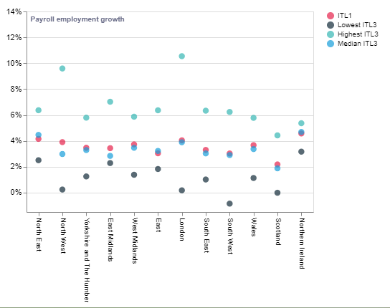
Figure 4: UK’s growth of payroll as well as ITL1 regions (January 2020 to January 2023)
(Source: Economics Observatory. 2023)
It has been identified that in some areas of London and beyond no growth was found in employee payroll. And compared to the last decade there was almost 10% growth reported in employee payroll (Economics Observatory, 2023).

4. Challenges and opportunities in the UK’s labour market
Opportunities in the UK’s labour market: It has been observed that the average weekly growth in payroll is increased slightly. The estimated total pay was £648 whereas the regular pay on April 2023 was £603 (Office for National Statistics, 2023). However, a difference exists between real growth and nominal growth percentage. This happens due to the higher customer prices index along with the CPIH or Owner Occupiers’ Housing Costs. From February to April 2023, 8.6% CPIH was forecasted. In the private sector in the U, the average development in regular pay has been projected as 7.6% in the first half of 2023. The same type of increment has been witnessed in the public sector which was almost 5.7%.
As per analysis, it can be stated that after Coronavirus this was the highest growth in regular in the private sector. During the Covid-19 and world lockdowns, the employment rate in the UK decreased by a significant level. On the other hand, now the employment rate for both women and men has been restored. Nevertheless, with the growing demand and government interventions for making the UK more lucrative for foreign direct investment, new job opportunities and demands will be created day by day.
Challenges in the UK’s labour market: Along with benefits and opportunities, the UK labour market also suffers due to a range of challenges. According to a report, the UK labour market has encountered a skills gap (Kornelakis and Petrakaki, 2020). As per the reports published by Open University’s 2022 Business Barometer, more than 68% of Small-Medium Enterprises along with 86% of market giants are suffering due to a lack of skills among candidates (Lee and Clark, 2019). No doubt this resulted in poor output and outcomes and heavily impacted the overall growth or revenues of these companies (Costa et al., 2020). Almost 78% of companies reported to have reductions in growth and opportunities due to the skill shortage (Kollydas, 2022).
On the other hand, 72% of employers have reported that the skills gap in the sector increased the workload on the skilled workforce and others (Kollydas, 2022). Another key issue or challenge that is interrupting the labour market is the inflation rate of the UK. The growing inflation is creating barriers in regard to the improvement of pay scale or employee compensation. In March of this year, 250,000 vacancies were disrupted (Kollydas, 2022). Therefore, the lack of employment opportunities is now the major issue observed in the labour market. Additionally, inadequate job opportunities also cause harm to the employees’ perceptions. Also, workplace discrimination and illegal practices have increased especially after Covid-19 which forced employees to for ‘The Great Resignation’.

5. Changes in the UK labour market in relation to the impact of post-Covid and impact of post-Brexit
Changes in the labour market due to the impact of Covid-19:
- Remote working: It has been observed that the UK labour market is booming. In the last few years ups and downs were there in employment rates, growth and opportunities associated with the labour market. Henceforth, the UK labour market is growing in every possible aspect. However, due to Covid-19 businesses have to adapt to many changes. One of the major shifts is remote working in human resourcing strategies. And, human resource managers are obliged to adapt to the changes in the market (Wilkinson et al., 2019). Due to the lockdowns declared by the UK government, businesses had to shut their offices and move toward a virtual working setup (Brown and Souto-Otero, 2020). Along with this, some businesses now only operate virtually to avoid this kind of situation in the future. Now, businesses offer permanent work-from-home facilities whereas some preferred to adopt the hybrid model of working.
On the other hand, a majority of businesses reported that after adopting the work-from-home setup or hybrid model of working, productivity has increased at its highest. Most employees even rated the facility rather than the traditional way of working. According to them, work-from-home facilities allowed them to work on their personal improvement, habits and so on. Covid-19 has completely changed the landscape in which human resourcing strategies typically conduct their activities and more. Human resource managers are devoted to the responsibility to manage the changing landscape and talent management (Holbeche, 2022).
- Employment support schemes: The government of the UK has enforced some new schemes to protect the labour market and employees from the difficulties of Covid-19. The Coronavirus Job Retention Scheme (CJRS) was enforced by the UK government in 2020 and the period of the scheme to protect employees went up to September 2021 (GOV.UK, 2023). The aim of the scheme was to offer a grant to organisations of up to 80% of their entire spending based on employee wages. The primary purpose behind enforcing this scheme was to help employees and employers to cope with the changes imposed by the Covid-19 virus. Even this scheme was also applied to employees who were terminated by their employers during the Covid-19 (GOV.UK, 2023. These were the major changes led by the UK government in the history of employment policies and practices. On the other hand, the scheme covered employees in every field that even felt insecure at that time.
- The gig economy: The gig economy is a new and emerging concept that is now visible in the UK labour market. And, it is now the biggest trend in this context. The concept revolves around the people who are doing or working on a temporary basis. That indicates the number of people or workers who are serving as freelancers or part-timers. The growing number of freelancers also work on a short-term basis. In order to manage their personal and professional needs, these people try to adjust their life in this manner. This trend has been driven by control as well as flexibility as part of career opportunities for freelancers. Therefore, freelance work is now the key to achieving these opportunities in life. Nowadays, many organisations mostly do not hire employees and outsource their work from these freelancers across the world. In this manner, they can get the best work at the cheapest rate. The huge cost to run an office can be saved in this way.
Changes in the labour market due to the impact of Brexit: It has been observed that immigration was the central issue in the challenges arising from Brexit and thus the human resourcing strategies engaged to resolve this issue. The changes have been clearly observed in the industries of healthcare, hospitality, social care, transport and many. This happened as many outsides immediately after the situation left the country (Fernández-Reino and Rienzo, 2021). On the other hand, the end of free movement based on the issues of EU citizens is now a major problem that contributed to the labour shortages. This trend after that Brexit imposed on the labour market of the UK particularly impacted the sectors having the least skilled employees. In addition to this, the labour market impacted negatively as Brexit has created a range of difficulties in getting or securing job opportunities in the country (Sumption et al., 2022). Brexit has an extraordinary impact on the supply chains along with UK trading strategies. No doubt these incidents created many uncertainties for the financial health of enterprises.
According to a report, 330,000 employees were impacted significantly when difficulties occurred due to Brexit. The departure of the UK from the EU developed the rate of immigration from other countries. These incidents have also created the need for changing the policies of trading and more. Thus, the Centre for European Reform (CER) has been enforced to change the landscape of the labour market that was heavily impacted by the results of Brexit. Another change in the statistic of immigration showed that almost 540,000 employees left the nation on June 2022 (The Guardian, 2023). The net loss of workers in percentage getting higher day by day.

6. Conclusion
The study has been conducted with the purpose to focus on the labour market and associated factors with it. The study has been developed in a structured manner that focused on each and every possible factor to conduct a thorough analysis related to the labour market. It has been identified that the UK labour market is booming since the last year. However, some difficulties or challenges are creating obstacles for both employees and employers to engage in proactive practices in this context. On the other hand, it can be stated that the UK labour market is now centred around some factors likewise, outsourcing, reduction in older employee percentage, and more involvement of young generations in the UK labour market. One of the biggest challenges the UK labour market is facing is the shortage of skilled labour. Therefore, more effective practices and strategies are required to be implemented in this context.

References
Allas, T, Canal, M and Vivian, D. 2022. Covid-19 in the United Kingdom. Available at: https://www.mckinsey.com/industries/public-sector/our-insights/covid-19-in-the-united-kingd [Accessed on 17th August 2023].
Armstrong, M. and Taylor, S., 2020. Armstrong's handbook of human resource management practice. Kogan Page Publishers. https://books.google.com/books?hl=en&lr=&id=g7zEDwAAQBAJ&oi=fnd&pg=PR3&dq=ebook+Armstrong%27s+handbook+of+human+resource+management+practice+13th+edition&ots=wL1iizmvtT&sig=MgQABXXUp8-m9nF4znz86tCfjq0
Armstrong, M. and Taylor, S., 2020. Armstrong's handbook of human resource management practice. Kogan Page Publishers. 15th edition.
Bell, D.N. and Blanchflower, D.G., 2020. US and UK labour markets before and during the Covid-19 crash. National Institute Economic Review, 252, pp.R52-R69. https://www.cambridge.org/core/journals/national-institute-economic-review/article/us-and-uk-labour-markets-before-and-during-the-covid19-crash/5A8D5A27F1854AF5E6906330B214AFF0
Brown, P. and Souto-Otero, M., 2020. The end of the credential society? An analysis of the relationship between education and the labour market using big data. Journal of Education Policy, 35(1), pp.95-118.https://www.tandfonline.com/doi/abs/10.1080/02680939.2018.1549752
Costa Dias, M., Joyce, R., Postel‐Vinay, F. and Xu, X., 2020. The challenges for labour market policy during the Covid‐19 pandemic. Fiscal Studies, 41(2), pp.371-382. https://onlinelibrary.wiley.com/doi/abs/10.1111/1475-5890.12233
Cumming, D.J., Wood, G. and Zahra, S.A., 2020. Human resource management practices in the context of rising right‐wing populism. Human Resource Management Journal, 30(4), pp.525-536. https://onlinelibrary.wiley.com/doi/abs/10.1111/1748-8583.12269
Economics Observatory. 2023. What’s happening in the UK labour market? Available at: https://www.economicsobservatory.com/whats-happening-in-the-uk-labour-market [Accessed on 17th August 2023].
Fernández-Reino, M. and Rienzo, C., 2021. Migrants in the UK labour market: An overview. Migration Observatory briefing, COMPAS, University of Oxford. https://migrationobservatory. ox. ac. uk/resources/briefings/migrants-in-the-uk-labour-market-an-overview. https://migrationobservatory.ox.ac.uk/wp-content/uploads/2019/07/MigObs-Briefing-Migrants-in-the-UK-labour-market-an-overview.pdf
GOV.UK, 2023. Coronavirus Job Retention Scheme: qualitative research with employees. Available at: https://www.gov.uk/government/publications/coronavirus-job-retention-scheme-qualitative-research-with-employees/coronavirus-job-retention-scheme-qualitative-research-with-employees#:~:text=The%20Coronavirus%20Job%20Retention%20Scheme%20(CJRS)%20ran%20from%20April%202020,a%20result%20of%20COVID%2D19 [Accessed on 17th August 2023].
Holbeche, L., 2022. Aligning human resources and business strategy. Routledge. https://api.taylorfrancis.com/content/books/mono/download?identifierName=doi&identifierValue=10.4324/9781003219996&type=googlepdf
Javorcik, B., Stapleton, K., Kett, B. and O’Kane, L., 2020. Unravelling deep integration: Local labour market effects of the brexit vote. CEPR Discussion Paper 14222. https://www.cesifo.org/sites/default/files/events/2020/del20_Javorcik.pdf
Knight, J. 2023. Labour Market Statistics: July 2023. Available at: https://www.youthemployment.org.uk/labour-market-statistics-july-2023-2/#:~:text=What%20does%20this%20mean%20for,olds%20unemployed%20(including%20students) [Accessed on 17th August 2023].
Kollydas, K. 2022. What Are the Current Challenges in the UK Labour Market and How Can They Be Addressed? Available at: https://blog.bham.ac.uk/cityredi/what-are-the-current-challenges-in-the-uk-labour-market-and-how-can-they-be-addressed/ [Accessed on 17th August 2023].
Kornelakis, A. and Petrakaki, D., 2020. Embedding employability skills in UK higher education: Between digitalization and marketization. Industry and Higher Education, 34(5), pp.290-297. https://journals.sagepub.com/doi/abs/10.1177/0950422220902978
Lee, N. and Clarke, S., 2019. Do low-skilled workers gain from high-tech employment growth? High-technology multipliers, employment and wages in Britain. Research Policy, 48(9), p.103803. https://www.sciencedirect.com/science/article/pii/S0048733319301234
Mao, G., Fernandes-Jesus, M., Ntontis, E. and Drury, J., 2021. What have we learned about COVID-19 volunteering in the UK? A rapid review of the literature. BMC Public Health, 21, pp.1-15. https://link.springer.com/article/10.1186/s12889-021-11390-8
NHS, 2023. In this briefing we explore the current labour market trends in the UK, and how these trends might impact the NHS workforce and employing organisations. We've also shared some helpful resources that will help employers to navigate the economic recovery. Available at: https://www.nhsemployers.org/publications/labour-market-trends-2022 [Accessed on 17th August 2023].
Office for National Statistics, 2023. Labour market overview, UK: June 2023. Available at: https://www.ons.gov.uk/employmentandlabourmarket/peopleinwork/employmentandemployeetypes/bulletins/uklabourmarket/june2023#:~:text=Main%20points,employees%20and%20self%2Demployed%20workers [Accessed on 17th August 2023].
Petrongolo, B. and Ronchi, M., 2020. Gender gaps and the structure of local labor markets. Labour Economics, 64, p.101819. https://www.sciencedirect.com/science/article/pii/S0927537120300257
Pilbeam, S. and Corbridge, M., 2010. People resourcing and talent planning: HRM in practice. Prentice Hall.
Sumption, M., Forde, C., Alberti, G. and Walsh, P.W., 2022. How is the end of free movement affecting the Low-wage labour force in the UK. The Economics of Brexit: What Have We Learned. https://ukandeu.ac.uk/wp-content/uploads/2022/06/Economics-of-Brexit.pdf#page=90
The Guardian, 2023. Shortfall of 330,000 workers in UK due to Brexit, say thinktanks. Available at: https://www.theguardian.com/politics/2023/jan/17/shortfall-of-330000-workers-in-uk-due-to-brexit-say-thinktanks [Accessed on 17th August 2023].
Torrington, D, Hall, L, Atkinson, Carol and Taylor, 2021. Human Resource Management, 11th Edition (xxiv, 722 pages).
Wilkinson, A., Lepak, D., Snell, S.A. and Bacon, N.A., 2019. The SAGE handbook of human resource management. The SAGE Handbook of Human Resource Management, pp.1-638. https://www.torrossa.com/gs/resourceProxy?an=5018454&publisher=FZ7200



