

Programme: MSc Computing portfolio
Course Name: MSc data and AI

Module code: ACFA7004
Module: Research Methods and Professional Development

Title: Machine Learning-Based Detection of Phishing Websites Using URL and Domain-Based Features.

Student Name: Hajee Muzahir Sheikdawood
Student ID: 2518747

Abstract
Overview: This paper is dedicated to the growing hazard of phishing websites in the online setting and the significance of machine learning methods to enhance cybersecurity with the aid of automated identification of suspicious web links.
Purpose: The study will provide the opportunity to develop a machine learning algorithm capable of detecting phishing websites by examining the features of the URL and domain attributes to enhance the process of recognising the presence of malicious online activities.
Method: The paper incorporates the philosophy of interpretivism and an inductive approach with the help of secondary data. There are different machine learning models used to analyse the structure of the URLs and domain attributes.
Expected Results: It is assumed that the research will prove that machine learning models can be effectively used to differentiate between phishing and legitimate websites with the help of particular URL and domain indicators.
Conclusion: This research aims at advancing to more effective phishing website identification mechanisms and assist in the creation of more effective cybersecurity measures.

Table of Contents
1. Introduction 4
1.1 Context and background 4
1.2 Research Problem 5
1.3 Research Aim and Objectives 6
1.3.1. Aim: 6
1.3.2. Objectives: 6
1.4 Research Questions 8
1.5 Significance of the Research 8
2. Literature review 8
2.1 Role of URL and Domain-Based Features to distinguish phishing websites 8
2.2 ML Models for Properly Detecting Phishing Websites 9
2.3 Challenges related to the development of ML-based phishing detectors 10
2.4 Recommendations for reducing the complex features of the ML-integrated phishing detection systems 11
2.5 Theoretical Model 12
2.6 Research Gap 13
2.7 Summary 13
3. Research Methodology 13
3.1 Research Philosophy 13
3.2 Research Approach 14
3.3 Research Design 14
3.4 Data Collection Method and Tools 15
3.5 Research Strategy 15
3.6 Data Analysis 16
3.7 Ethical consideration 16
4. Expected Findings 17
5. Research Limitations 17
6. Timeline 17
7. Conclusion 18
References 20

1. Introduction

1.1 Context and background
Machine learning detection uses algorithms that are able to look at the data, identify patterns, and detect anomalies in the data without being specifically programmed to do so. Machine learning is very important in cybersecurity, fraud detection, and image recognition, which use supervised, unsupervised, and deep learning with neural networks to detect threats such as zero-day attacks in real-time (Guo, 2023). According to the press release of Spherical Insights (2022), the Global Machine learning market size was $14.91 billion in 2021 and is expected to reach 38.1% in 2030 (Refer to Figure 1). The exponential growth of IoT creates significant security challenges; to mitigate these challenges, the use of machine learning needs to increase.
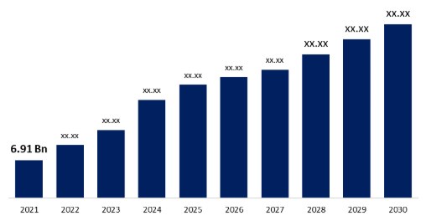
Figure 1: Global Machine Learning Market
(Source: Spherical Insights, 2022)
Phishing is a type of online crime that attempts to deceive unsuspecting online users into revealing their sensitive and valuable personal information to the attacker. The information may include their username, password, financial account information, login details, personal addresses, and social relationships, which are then used for nefarious purposes by the attacker (Alnemari and Alshammari, 2023). The size of the global phishing protection market was estimated at $2.48 billion in 2024 and is expected to grow to $7.16 billion in 2033 at a CAGR of 12.8% during 2025 to 2033 (Grand View Research, 2025) (Refer to Figure 2). The increase in mobile threats, remote working, and the use of advanced social engineering attacks through artificial intelligence are the drivers.
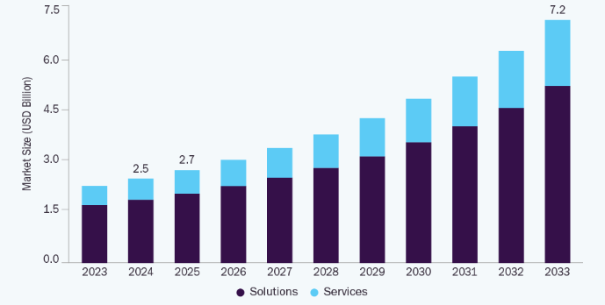
Figure 2: Phishing Protection Market
(Source: Grand View Research, 2025)
The phishing URL and the similar web page have many characteristics which are different from the malicious URL. In order to hide the domain name, the attacker may select a very long and confusing name of the domain, which is very easily visible. On the other hand, attackers can make use of a short domain name, which will be irrelevant for the original legitimate website (Shikalgar et al., 2019). In order to detect phishing websites, different machine learning algorithms are used for URL-based phishing attack detection. Domain-based phishing detection identifies the suspicious URL structure, including length, symbols, and subdomains, HTTPS usage, domain age, and registration details (Deshpande et al., 2021). This research will design a model through machine learning to identify phishing websites using URL and domain-based features to decrease online crime.

1.2 Research Problem
Phishing websites are websites that are used to trick people into revealing personal information, such as passwords, credit card numbers, and personal identities, under the false assumption that they are visiting a legitimate website, such as a bank, social media platform, or online store. This is a serious online security threat because phishing websites are almost identical to legitimate websites. A report by Yahoo Finance (2022) shows that cybercrime increased 61% in 2021, which is more than 1 million attacks and creates significant threats to internet users (Refer to Figure 3). Online fraudsters can easily steal important information from victims through the use of phishing URLs, which are used to trick victims and redirect them to scam websites that are similar in appearance to legitimate websites (Qazi et al., 2024). Therefore, it has been determined that the growing threat of cyberattacks increases the requirement for advanced detection technologies to identify phishing websites through evaluating URL and domain features. Phishing URLs are easily able to trick victims of online fraud; thus, this research can be effective in improving knowledge of the people who do not pay enough attention to URLs.
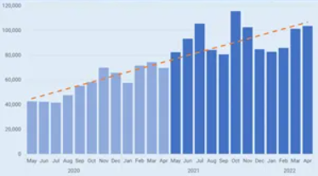
Figure 3: Phishing Attack Report
(Source: Yahoo Finance, 2022)

1.3 Research Aim and Objectives

1.3.1. Aim:
This study aims to design a model using machine learning to identify the phishing websites through analysing URL and domain features to decrease online crime.

1.3.2. Objectives:
Objectives | Specific | Measurable | Achievable | Reliable | Time-Bound
To analyse the role of URL and Domain-Based Features to distinguish phishing websites by using ML techniques | Examination of the indicators related to phishing websites, such as URL length and domain characteristics. | Exploring available features that indicate a threat or any malicious activities. | Utilisation of the advanced ML features. | Checking the frequency rate of the phishing activities | 1 month
To examine different ML models for properly detecting phishing websites using URL and Domain-Based Features | Develop and compare 4 different ML models based on URL and domain-related features for phishing detection. | The performance of the models will be measured based on the accuracy, precision, recall, and F1-score. | Achieved by using Python libraries used for machine learning. | Machine learning is a powerful tool to counter the dynamic threat of phishing attacks. | 3 months
To determine the major issues related to the development of ML-based phishing detectors | Limited access to high-quality, up-to-date, and diverse datasets, which affects the training of the model. | Measured using metrics like accuracy, precision, recall, and F1-score. | Achieved by combining multiple models. | Lack of diversity, real-time data, and limited model interpretability. | 2 months
To suggest recommendations for reducing the complex features of the ML-integrated phishing detection systems | Transition from high-dimensional, manual feature engineering to automated, streamlined feature selection or dimensionality reduction techniques. | Accomplish >95% accuracy (F1-score) and decrease average inference time by 30%. | Using feature selection techniques such as RFE. | Improves speed for real-time phishing detection. | 3 months
Table 1: SMART Objectives

1.4 Research Questions
- How to analyse the role of URL and Domain-Based Features to distinguish phishing websites by using ML techniques?
- What are the ML models for properly detecting phishing websites using URL and Domain-Based Features?
- How are the major issues related to the development of ML-based phishing detectors addressed?
- What recommendations are suggested for reducing the complex features of the ML-integrated phishing detection systems?

1.5 Significance of the Research
The detection of phishing websites by using machine learning (ML) techniques with URL and domain features is of high significance since it offers automatic, efficient, and flexible detection of cyber-attacks, which are dynamic in nature, unlike the static detection techniques used earlier. Conventional approaches, such as blacklists, may not be effective in dealing with the newer "zero-hour" phishing websites that emerge and disappear rapidly (Ahammad et al., 2022). In contrast, machine learning algorithms can be effective in dealing with newer types of attacks that have not been seen before.

2. Literature review

2.1 Role of URL and Domain-Based Features to distinguish phishing websites
URL and domain-based features are very important for detecting phishing and malicious websites, which go beyond blacklists to include lexical, structural, and semantic features such as length, subdomain, special characters, and top-level domains. According to Deore and Bhabad (2025), characteristics of the URL string, such as the length of the URL, the presence of certain keywords in the URL, such as "login" or "secure," certain special characters such as '@', '-', '_', numerical IP addresses, or sub-domains, can be analysed. Analysis of attributes associated with the domain hosting the website, such as the age of registration, inclusion in trusted domain lists, DNS records, or country of origin. On the other hand, Asif et al. (2023), the key information in the above URLs is the methods employed in redirecting a victim to a site with malware and tricking them into revealing information to the attacker. Overall, preventing URL and domain-based features from distinguishing phishing websites is important.

2.2 ML Models for Properly Detecting Phishing Websites
Some of the best machine learning algorithms that can be used to detect phishing websites are Decision Tree (DT), Random Forest (RF), Support Vector Machines (SVM), and Gradient Boosting (XGBoost) for feature-based detection. According to Alnemari and Alshammari (2023), A DT is a tool for aiding a person in making a decision through a tree-like model or diagram showing alternatives and their potential consequences. Decision trees are just one approach among many for demonstrating an algorithm totally composed of conditional control statements. The purpose of a decision tree is to observe a process, and by doing this, it can utilise its characteristics so that it can be classified in a certain category (Refer to Figure 4). On the other hand, Almujahid et al. (2024) state that SVM is a reliable classification and regression technique, which increases the accuracy of a model's predictions while avoiding overfitting of the model on the data used during training. These models analyse URL structures, contents, and security certificates to detect Phishing websites.
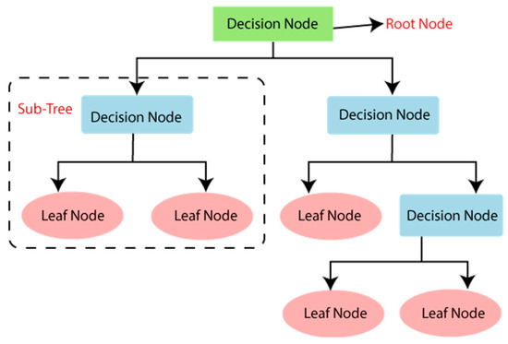
Figure 4: Decision Tree
(Source: Alnemari and Alshammari, 2023)

2.3 Challenges related to the development of ML-based phishing detectors
ML-based phishing detection faces various challenges, including rapid attacker evolution (evasion techniques), the need for large, high-quality, up-to-date, labelled datasets, and high false-positive rates. Based on an article by Safi and Singh (2023), which discusses the types of phishing attacks that include web-based delivery, link manipulation, phone phishing, data theft, malware-based phishing, DNS-based phishing, email or spam (Refer to Figure 5). Attackers usually pose as popular banks, credit card organisations, or popular e-commerce websites, etc., to intimidate or convince the user to log in to the phishing site, which they might regret at a later time. Similarly, Kyaw et al. (2024) found that the scarcity of big data sets is the primary challenge in the study of phishing detection and classification. These challenges need to be fixed to decrease phishing online attacks through machine learning technology.
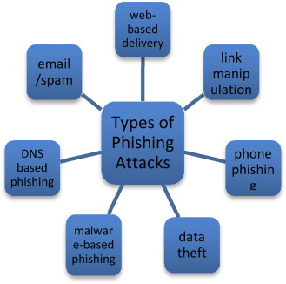
Figure 5: Types of Phishing Attacks
(Source: Safi and Singh, 2023)

2.4 Recommendations for reducing the complex features of the ML-integrated phishing detection systems
Simplification of feature sets in Machine Learning (ML) technology-based phishing detection systems is critical in order to enhance real-time system performance, reduce computational complexity, and sustain high accuracy. According to Tang and Mahmoud (2021), there are five steps before the attacker steals the money from the user’s account or uses the information for other attacks; blocking any step prevents the phishing attack (Refer to Figure 6). On the other hand, Shafin (2024), combination of SLA-FS and RF models can detect phishing websites accurately. Dimensionality reduction of the data from a higher dimension to a lower dimension while maintaining the essential information in the data. Use of algorithms such as Random Forest or XGBoost to test the features and rank them according to their importance, which can be removed if they have the least impact on the detection.
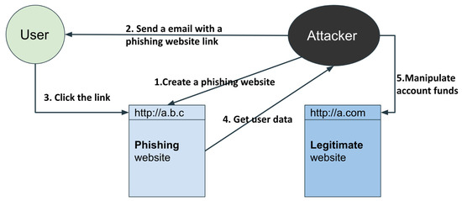
Figure 6: Phishing Life Cycle
(Source: Tang and Mahmoud, 2021)

2.5 Theoretical Model
Diffusion of Innovations models describe five adopter categories: innovators, early adopters, early majority, late majority, and laggards, all of which are influenced by communication channels and perceived product characteristics such as relative advantage and compatibility (Andersor and Stejskal, 2019) (Refer to Figure 7). The machine learning (ML)-based approach for phishing website detection using URL/domain-based features can be said to be in accordance with the diffusion of innovation theory since it can be regarded as an "innovation" with "relative advantage" in the social system of cybersecurity. A combination of machine learning classifiers, namely Random Forest, Gradient Boosting, and Support Vector Machines, has been used in the model (Vimal et al., 2025). A dataset of legitimate and phishing URLs was compiled, and various feature extraction methods were used to extract important features of the URL, such as the URL's length, the presence of special characters, and others related to the domain.
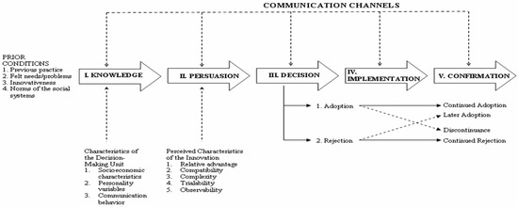
Figure 7: Diffusion of Innovation
(Source: Andersor and Stejskal, 2019)

2.6 Research Gap
Based on the above discussion, it has been found that the majority of the past literature has only focused on discussing the role of URL and domain-based features in the process of machine learning-based phishing detection. Many past researchers have also highlighted the ineffectiveness of ML-based fraud detectors, which are responsible for fighting new, dynamic, or highly obfuscated phishing attacks. Therefore, these identified gaps will be addressed through improved generalizability to various, constantly changing types of attacks (zero-day threats), addressing the limitation of URL disruption, as well as real-time capabilities and data privacy.

2.7 Summary
The literature review of machine learning-based detection of phishing websites using URL and Domain-Based Features discusses the role of URL and Domain-based Features in identifying phishing websites, ML models to detect phishing websites, challenges related to the development of ML-based phishing detectors, and their recommendations with the previous research gaps. Machine learning models, such as DT, RF, SVM, and XGBoost, help to identify phishing websites.

3. Research Methodology

3.1 Research Philosophy
Research Philosophy expresses a few sets of assumptions and theories that will guide the research about required steps to develop. According to Gamage (2025), it expresses the research's perceptual view and precisely defines its steps due to the research's commitment. This research will be developed by using the interpretivism philosophy, which shows the interpretation of the collected secondary data. According to Fischer (2025), interpretivism helps to explore empirical findings that help to identify the internal relationships between the key factors of the research topic, which need to be examined and also provides the necessary explanations. This philosophy will help this study to identify the relationship between phishing websites and their use of misspelt domain names familiar to the original main names. This philosophy will also explain the steps of the machine learning algorithm in detecting those phishing websites by analysing the existing datasets.

3.2 Research Approach
The approach of research basically defines the overall structural plan with detailed in-between steps to operate the study, starting from the process of collecting data, analysing it and the methods of interpretation. This study will be conducted through an inductive approach for developing the specific steps in detecting phishing websites using efficient machine learning algorithms. According to Gamage (2025), the inductive approach works to develop a generalised theory from the intense observations by recognising the pattern of the data. This study will analyse the existing datasets in a bottom-up structure that will follow from the collected data by analysing through machine learning algorithms and identifying the URL pattern that can be proven to be a phishing website. This approach will help to gather relevant data to explore the steps of domain-based analysis to detect phishing websites from genuine websites, and will classify the websites as phishing websites or not.

3.3 Research Design
In order to complete research, there is a need for strategic planning and a brief outlining of the processes and the steps needed to perform, which is refer as the research design. According to Devi et al. (2022), research design can be good by containing a few elements, such as a description of the key variables, a detailed overview of the topic, specific timing of the research, purpose and other factors. This study will follow the experimental research design that will include the building of a machine learning algorithm, the testing of the datasets, and identifying patterns from the URL recognition. This research design will be helpful to organise the steps of the building, analysis of data, finding outcomes and decision-making. This design approach will help to establish the relationship between the dependent factors and the independent factors in detecting phishing websites through analysing the domain and URL characteristics using ML models.

3.4 Data Collection Method and Tools
Data collection is the primary step of finding the answers to the research questions, aim, and objectives, following the analysis. This study will be developed using a secondary qualitative data collection method by evaluating secondary datasets containing valid data about the websites and URLs. According to Taherdoost (2021), secondary data gathers previously collected data that provide a huge background overview of the topic and also help to structure the entire research. The data sets will have a few features, such as the length of the URL, the count of special characters, the usage of HTTPS in the sites, exploring domain age, and the presence of the URL. This step is called feature extraction; thus, it uses the specific features to build a distinct ML model for the analysis. URL and domain-based features are very impactful due to their pattern-based structure in identifying phishing websites using machine learning algorithms. According to Asif et al. (2023), ML models focus on the URLs' lexical features, and the domain name determines the particular website. Different ML models are very effective for this research, such as Support Vector Machine (SVM), Logistic regression, Random Forest model, and decision trees. These algorithms are very complex in nature and building, but it provides the best efficiency in the analysis and theory building.
Data collection method also includes the identification of the correct data, labelling them, then removing the redundant data, and lastly training the model using the modified dataset. ML models will work through some software tools and advanced technologies that operate the process seamlessly. Besides being simpler to understand, Python has an ecosystem to run ML models, and is a very efficient and excellent tool to analyse the data. It will help the ML models to train the data errorlessly and will also provide a large number of libraries to access the required functions. Python provides the advantage of using some important libraries such as Pandas, Numpy, Scikit-learn and others. The models will be implemented in the IDEs such as Google Colab and Jupyter Notebook that support python environment.

3.5 Research Strategy
Research strategy defines the systematic steps of building the research following the data collection, analysis and the outcome and interpreting the data. Strategy is a structural plan for the research development that outlines the outcome, aligning with the research objectives and aims. This study will be developed using a secondary qualitative research strategy, which includes the path of collecting secondary URL and website datasets from trusted websites. According to Lim (2025), qualitative data collection provides deeper knowledge about the research topic and provides the best quality of previously gathered data. This study will experiment with the datasets by evaluating the dependent factor detection of phishing websites by manipulating the variables URL and Domain features.

3.6 Data Analysis
After the data collection process, the crucial part of the research is the analysis of the collected data using the required method. Data analysis is the structural process of identifying duplicate and wrong data, cleaning redundant data, transforming the data into the required pattern, and interpreting the data into the expected outcomes. This study will analyse the data using different ML models, such as SVM, Logistic Regression, Random Forest Model and Decision Trees. In developing the analysis process, the models will be trained through Python in Google Colab or Jupyter Notebook using the required libraries. According to Korkmaz et al. (2020), logistic regression effectively predicts the result by classifying the data into two classes. Logistic regression uses probability factors to categorise the result to create a different class from the other. SVM will find a decision class by simplifying the regression process, which divides data points into distinct classes.
According to Mienye and Jere (2024), decision trees will help to categorise the corresponding decisions and their outcomes through a flowchart. Decision trees are very simple to understand and easy to interpret the data by providing the consequences of the decisions. After the analysis of the data, the result will be visualised, and the pattern will be recognised to create the new theory from it. After the pattern recognition, the findings will be measured with the required scalable factors aligning with the smart objectives of the research. Effective data analysis ensures improved outcomes and correct utilisation of the data resources, improving accuracy and efficiency of the ML models.

3.7 Ethical consideration
The gathered data for the analysis will be authentically sourced and deployed from the valid datasets and resources. All the data will be copyrighted and legitimised, relating to the research topic with valid coefficients. During the data collection, all the guidelines will be considered that are provided by the University for conducting the research. All the data will be transparent, and the data privacy will be kept in accordance with research standards. The collected data will be stored in a password-protected file within a personal system to avoid the risk of data breach.

4. Expected Findings
The primary aim of this study is to explore the effectiveness and also to evaluate the performance of the ML models in detecting phishing websites by feature extraction of the URL and domain-based variables. Phishing URL’s seems a little bit long in length than the genuine URLs that can be identified by the ML models' predictions. Fraudulent and malicious domains are very young or new on the internet that can be separated from the original domains due to long access footprints. The entire study will focus on the analysis based on the features, such as special characters in URLs, matching the URL patterns and the structure of the sub-domain. Thus, it can be stated that the completion of this research will be helpful to protect young adults from fraudulent activities. This study will also find the issues in developing phishing detectors using ML models, which guide future students to drive innovative solutions to overcome this issue. After detecting the issues, it will suggest a few factors to improve the model efficiency and solve the implementation challenges.

5. Research Limitations
Phishing websites are a common problem in the rapidly evolving digital age, where phishing techniques are getting different every day. Scammers are changing their methods due to constant detection and the risk of being arrested. Due to the dynamic nature of cyber-attacks, it is also hard to detect all the phishing websites at the same time. Besides that, this study will have a lack of content-based detection and a large scale of data dependency. The data dependency can be biased due to the limited number of data points and the exact pattern of the data. This study is aimed to finish within a stipulated time, but due to some conflicts, the study may not be completed within the time. Also, the datasets are very costly and often inaccessible; possibly, they may not fit the budget of the research, and in that case, the data quality cannot be controlled.

6. Timeline
Tasks | W1-W2 | W3-W4 | W5-W6 | W7-W8 | W9-W10 | W11-W12
Identification of the research topic
Choosing the Aim and Objectives
Developing the Literature Review
Selecting the Methodology and Data Collection
Data Analysis and Findings
Summarising the Research
Table 2: Gantt Chart
(Source: Self-Developed)
Gantt is a specific tool for planning and managing projects using horizontal graphs that schedule the step-wise tasks of the research. According to Sekuloska (2025), a Gantt chart helps to visualise the plans, stipulated dates, task requirement and monitoring of task commencement as the project timeline.
In the first two weeks, the research topic will be chosen through evaluating the factors to build it. The aim and objectives of the research will also be decided in the first two weeks that will help to provide the expected result. During weeks 3 to 6, the previous studies will be explored for detecting phishing websites through machine learning methods. In weeks 6 to 12, the selection of the methodology and data collection techniques will be confirmed according to the research needs. In this mean time of 6th to 12th week, the data analysis will be performed on the collected secondary data. In the last step, the entire research will be summarised by evaluating the findings within the same 6th to 12th week of the research timeline. Thus, the detailed discussion of the findings helps to address the targeted research objectives effectively.

7. Conclusion
This study explores the topic of detecting phishing websites using ML models through analysing URL and domain-based characteristics. This study includes a brief description of ML models, phishing websites and the manipulations of URLs and website domains. The research problem, aim and objective of the research and the importance of the study are explained briefly. The study consists of the views of previous literature discussing the different ML models, tier efficiency of detecting phishing websites, challenges of developing ML models and recommendations. The methodology of this proposal describes the research design in terms of the research philosophy, approach and design. This part also explains the methods and materials by discussing the data collection methods, research strategy, data analysis and tools for analysing the data. The last quarter of research describes the expected outcomes through conducting the research, data collection and analysis to create the new theory. In the next part, the research limitations are estimated by exploring the different factors used in completing this research and the study gaps. Then the timeline of the project has been elaborated by exploring the tasks and the expected timing to finish the study, showing the dependencies and expected achievements.

References
Ahammad, S.H., Kale, S.D., Upadhye, G.D., Pande, S.D., Babu, E.V., Dhumane, A.V. and Bahadur, M.D.K.J., 2022. Phishing URL detection using machine learning methods. Advances in Engineering Software, 173, p.103288. https://www.researchgate.net/profile/Hasane-Shaik/publication/365790574_Phishing_URL_detection_using_machine_learning_methods/links/638487d3554def61937e5d40/Phishing-URL-detection-using-machine-learning-methods.pdf
Almujahid, N.F., Haq, M.A. and Alshehri, M. (2024). Comparative evaluation of machine learning algorithms for phishing site detection. PeerJ Computer Science, 10, pp.e2131–e2131. doi:https://doi.org/10.7717/peerj-cs.2131.
Alnemari, S. and Alshammari, M. (2023). Detecting Phishing Domains Using Machine Learning. Applied sciences, 13(8), pp.4649–4649. doi:https://doi.org/10.3390/app13084649.
Andersor, H.J. and Stejskal, J. (2019). Diffusion Efficiency of Innovation among EU Member States: A Data Envelopment Analysis. [online] https://www.mdpi.com/. Available at: https://www.mdpi.com/2227-7099/7/2/34.
Asif, A.U.Z., Shirazi, H. and Ray, I., 2023, September. Machine learning-based phishing detection using URL features: A comprehensive review. In International Symposium on Stabilizing, Safety, and Security of Distributed Systems (pp. 481-497). Cham: Springer Nature Switzerland.https://par.nsf.gov/servlets/purl/10523848
Asif, Shirazi, H. and Ray, I. (2023). Machine Learning-Based Phishing Detection Using URL Features: A Comprehensive Review. ResearchGate, pp.481–497. doi:https://doi.org/10.1007/978-3-031-44274-2_36.
Deore, M. and Bhabad, P. (2025). Issue 6 www.jetir.org (ISSN-2349-5162). JETIR2506090 Journal of Emerging Technologies and Innovative Research, [online] 12(6). Available at: https://www.jetir.org/papers/JETIR2506090.pdf [Accessed 10 Mar. 2026].
Deshpande, A., Pedamkar, O., Chaudhary, N. and Borde, D.S. (2021). Detection of Phishing Websites using Machine Learning. International Journal of Engineering Research & Technology, [online] 10(5). Available at: https://www.ijert.org/detection-of-phishing-websites-using-machine-learning.
Devi, B., Lepcha, N. and Basnet, S., 2022. Application of correlational research design in nursing and medical research. Journal of Xi'an Shiyou University, Natural Sciences Edition, 65(11), pp.60-69.https://www.researchgate.net/profile/Barkha-Devi-2/publication/368958213_APPLICATION_OF_CORRELATIONAL_RESEARCH_DESIGN_IN_NURSING_AND_MEDICAL_RESEARCH/links/6401a0330cf1030a566a0022/APPLICATION-OF-CORRELATIONAL-RESEARCH-DESIGN-IN-NURSING-AND-MEDICAL-RESEARCH.pdf
Fischer, F., 2025. Interpretivism vs. positivism in policy studies: Is there common ground?. Critical Policy Studies, 19(3), pp.371-376.https://www.tandfonline.com/doi/pdf/10.1080/19460171.2025.2536645
Gamage, A.N.K.K., 2025. Research design, philosophy, and quantitative approaches in scientific research methodology. Sch J Eng Tech, 2(1), pp.91-103.https://www.academia.edu/download/122341245/SJET_132_91_103c_published_paper.pdf
Grand View Research (2025). Phishing Protection Market Size, Share| Industry Report 2033. [online] Grandviewresearch.com. Available at: https://www.grandviewresearch.com/industry-analysis/phishing-protection-market-report [Accessed 10 Mar. 2026].
Guo, Y. (2023). A review of Machine Learning-based zero-day attack detection: Challenges and future directions. Computer Communications, 198, pp.175–185. doi:https://doi.org/10.1016/j.comcom.2022.11.001.
Korkmaz, M., Sahingoz, O.K. and Diri, B., 2020, July. Detection of phishing websites by using machine learning-based URL analysis. In 2020 11th international conference on computing, communication and networking technologies (ICCCNT) (pp. 1-7). IEEE.https://www.researchgate.net/profile/Mehmet-Korkmaz-13/publication/346238456_Detection_of_Phishing_Websites_by_Using_Machine_Learning-Based_URL_Analysis/links/60b7a3ca299bf106f6f765ab/Detection-of-Phishing-Websites-by-Using-Machine-Learning-Based-URL-Analysis.pdf
Kyaw, P.H., Gutierrez, J. and Ghobakhlou, A. (2024). A Systematic Review of Deep Learning Techniques for Phishing Email Detection. Electronics, [online] 13(19), p.3823. doi:https://doi.org/10.3390/electronics13193823.
Lim, W.M., 2025. What is qualitative research? An overview and guidelines. Australasian marketing journal, 33(2), pp.199-229.https://journals.sagepub.com/doi/10.1177/14413582241264619#:~:text=Importance:%20Generates%20rich%20insights%20and,culturally%20sensitive%20and%20socially%20relevant.
Mienye, I.D. and Jere, N., 2024. A survey of decision trees: Concepts, algorithms, and applications. IEEE access, 12, pp.86716-86727.https://ieeexplore.ieee.org/iel8/6287639/6514899/10562290.pdf
Qazi, E. ul H., Faheem, M.H. and Ahmad, I. (2024). Detecting Phishing URLs Based on a Deep Learning Approach to Prevent Cyber-Attacks. Applied Sciences, [online] 14(22), pp.10086–10086. doi:https://doi.org/10.3390/app142210086.
Safi, A. and Singh, S. (2023). A systematic literature review on phishing website detection techniques. Journal of King Saud University - Computer and Information Sciences, 35(2). doi:https://doi.org/10.1016/j.jksuci.2023.01.004.
Sekuloska, F.M.J.D., 2025. Increasing Project Efficiency by Utilizing Project Management Software & Gantt Charts. Preface to Volume 5 Issue 2 of the Journal of University of Information Science and Technology “St. Paul the Apostle”–Ohrid, 5(2), p.5.https://journal.uist.edu.mk/wp-content/uploads/2025/11/Journal-of-UIST-Vol-5_2_2025.pdf#page=5
Shafin, S.S. (2024). An Explainable Feature Selection Framework for Web Phishing Detection with Machine Learning. Data Science and Management, 8(2). doi:https://doi.org/10.1016/j.dsm.2024.08.004.
Shikalgar, M.S., Sawarkar, D.S.D. and Narwane, M.S. (2019). Detection of URL based Phishing Attacks using Machine Learning. International Journal of Engineering Research & Technology, [online] 8(11). doi:https://doi.org/10.17577/IJERTV8IS110269.
Spherical Insights (2022). Global Machine Learning Market Size To Reach Around USD 302.62 billion by 2030 | CAGR of 14.91%. [online] Spherical Insights. Available at: https://www.sphericalinsights.com/press-release/machine-learning-market [Accessed 10 Mar. 2026].
Taherdoost, H., 2021. Data collection methods and tools for research; a step-by-step guide to choose data collection technique for academic and business research projects. International journal of academic research in management (IJARM), 10(1), pp.10-38.https://hal.science/hal-03741847v1/file/Data%20Collection%20Methods%20and%20Tools%20for%20Research%20.pdf
Tang, L. and Mahmoud, Q.H. (2021). A Survey of Machine Learning-Based Solutions for Phishing Website Detection. Machine Learning and Knowledge Extraction, 3(3), pp.672–694. doi:https://doi.org/10.3390/make3030034.
Vimal, V.R., Thangaraj, S.J.J., Narayanan, L.K., Thangam, S.A., Loganayagi, S. and Balakrishnan, S. (2025). Enhanced Phishing Detection and Classification Using an Ensemble Machine Learning Approach for URL Analysis. Lecture Notes in Networks and Systems, 1507, pp.229–239. doi:https://doi.org/10.1007/978-981-96-8750-3_19.
Yahoo Finance (2022). Phishing Attacks Rose 61% in 2022, New Study Finds. [online] finance.yahoo.com. Available at: https://finance.yahoo.com/news/phishing-attacks-rose-61-2022-110200648.html [Accessed 10 Mar. 2026].

