Joel Codd 2117927

Designing a kiteboard hydrofoil: Fluid flow assessment
Joel Codd 2117927
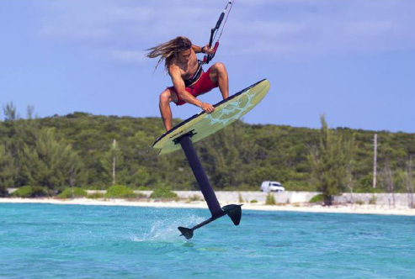

Abstract
This report examines the fluid-flow behaviour of the kiteboard hydrofoil wing that was structurally analysed in Assignment 1. The aim is to evaluate how the flow develops around the composite wing and whether the assumptions used previously are realistic. Using typical kitesurfing conditions of around 8 m/s in seawater, the Reynolds number for the front wing is calculated to be roughly. 9.4 ×${ 10}^{5}$. At this value, the flow over the foil is mainly turbulent, which helps explain the wing’s shape and surface finish requirements. Turbulent flow is less sensitive to small surface imperfections and helps maintain attached flow and stable lift, which links directly to the design decisions made in the earlier structural study.
The report goes on to assess the validity of the 500 N upward force applied to each side of the wing in Assignment 1, using analytical lift calculations and published data on similar hydrofoils. The use of carbon-fibre-reinforced plastic (CFRP) is also evaluated from a performance perspective, noting its high stiffness-to-weight ratio, surface finish quality, and durability. Modelling approaches, including CFD and coupled analysis, are discussed in terms of their strengths and limitations when predicting pressure fields and loading. Finally, an outline is provided for how a prototype could be tested in a controlled laboratory environment to compare measured lift, drag, and deformation with simulation results. Overall, the report combines fluid-flow assessment with the earlier structural work to present a more complete evaluation of the hydrofoil wing’s performance.

Contents
Abstract 1
Table of Figures 2
Introduction 3
Task 1 - Reynolds number analysis 4
Definition and relevance 5
Operating point calculation (seawater, 8 m/s) 5
Sensitivity to speed and geometry 6
Transition location estimate 6
Roughness, finish and sea state 7
Task 2 – Boundary Flow, Separation and Turbulence 7
Boundary-Layer Development 7
Flow Separation and Pressure Recovery 8
Turbulence Characteristics and Surface Effects 9
Task 3 – Critical Appraisal of the Assumed Forces 9
Overview of the Structural Assumption 9
Theoretical Lift Estimation 10
Pressure Distribution and Load Distribution 11
Task 4 – Material Evaluation: Carbon-Fibre-Reinforced Plastic (CFRP) 11
Mechanical and Hydrodynamic Advantages 12
Drawbacks and Engineering Considerations 12
Historical and Current Developments 13
Future Trends and Sustainability 13
Task 5 – Modelling Techniques for Fluid Flow and Force Prediction 13
Task 6 – Experimental Validation 15
Conclusion 17
References 18

Table of Figures
Figure 1 - Reynolds number 6
Figure 2- Boundary layer transition 7
Figure 3 - Laminar vs Turbulent Boundary Layer 8
Figure 4 - Pressure profile 11
Figure 5 - Wing internal makeup 14
Figure 6 - Experimental setup 15

Introduction
Hydrofoils operate by generating hydrodynamic lift, which raises a watercraft above the surface and significantly reduces drag. In kiteboarding, this effect allows the rider to move more efficiently and smoothly across waves and choppy water. The lift generated by a hydrofoil depends heavily on both the flow behaviour over the wing and the wing’s structural stiffness. Even small deflections can alter the local angle of attack and therefore the lift distribution, making the link between the structural and fluid-dynamic analyses especially important (Brandner, 2015)..
Assignment 1 concluded that a unidirectional CFRP laminate provided the required stiffness while keeping the weight low. The maximum predicted deflection under a 500 N load was 7.2 mm, well within acceptable limits. However, the forces applied in the structural model were based on simplified hydrodynamic assumptions. This report builds on the previously developed geometry and analyses the flow regime, boundary-layer behaviour, turbulence, and pressure distribution using fundamental fluid mechanics. It also revisits the assumed loads to determine whether they are realistic for typical operating speeds.
At the representative speed of 8 m/s in seawater, the Reynolds number is high enough that the flow transitions from laminar to turbulent along the chord. Understanding this behaviour is essential to justify the wing’s design features, which aim to keep the flow attached while controlling drag. The tasks set in the assignment brief guide the discussion, ensuring that the design is evaluated from both a structural and hydrodynamic perspective.

Task 1 - Reynolds number analysis

Definition and relevance
The Reynolds number expresses the ratio of inertial forces to viscous forces in a fluid and is defined as:
${Re}_{c}$ = $\frac{ ρ V c}{μ ​ }$
where
ρ = fluid density,
V = flow velocity,
c = chord length,
μ = dynamic viscosity.
This dimensionless quantity indicates whether the flow is likely to be laminar, transitional, or turbulent. For hydrofoils, it affects skin friction, boundary-layer stability and overall lift and drag behaviour.

Operating point calculation (seawater, 8 m/s)
Assumptions used consistently through this report:
$ρ_{sea}$ = 1025 kgm−3
$μ_{sea}$= 1.05×10−3
C = 0.12m
V = 8 m−1
${Re}_{c}$= $\frac{(1025)(8)(0.12)}{1.05×10-3 }$ = 9.37 ×${ 10}^{5}$
This value sits near the upper transitional regime, meaning the flow will likely transition early and remain turbulent over most of the chord.
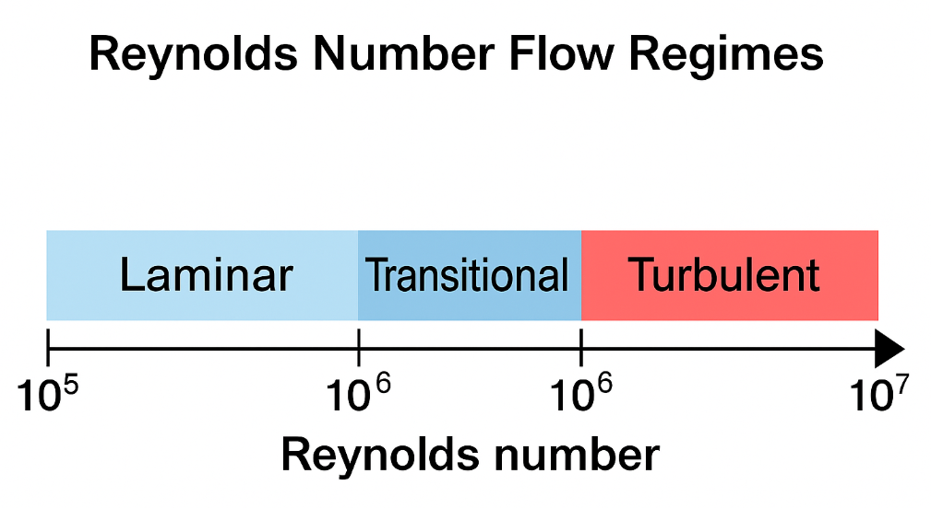
Figure 1 - Reynolds number

Sensitivity to speed and geometry
Small changes in speed or chord length have a noticeable effect on Reynolds number, because:
Case | V (m/s) | c (m) | ${Re}_{c}$ (×10⁶)
Low speed / slim chord | 6 | 0.10 | 0.59
Baseline (this study) | 8 | 0.12 | 0.94
Fast / larger chord | 10 | 0.14 | 1.36
Table 1 - Reynolds sensitivity
At speeds above 10 m/s the flow is fully turbulent and transition occurs extremely early.

Transition location estimate
Transition on a smooth flat plate often occurs around ${Re}_{x}$ = 3 – 8 ×${10}^{5}$ on free-stream turbulence and surface finish. Using ${Re}_{x}$ = 5 ×${10}^{5}$ as a representative criterion,
$x_{tr} \frac{= {Re}_{x} μ}{ρ V}$ =$\frac{5 ×{ 10}^{5}⋅1.05 × {10}^{-3}}{(1025)(8)}$ = 0.064m
For a chord of 0.12 m, this means transition appears around 50–60% of the chord. In real-world conditions, surface roughness and ambient turbulence can move this forward to 20–40%.
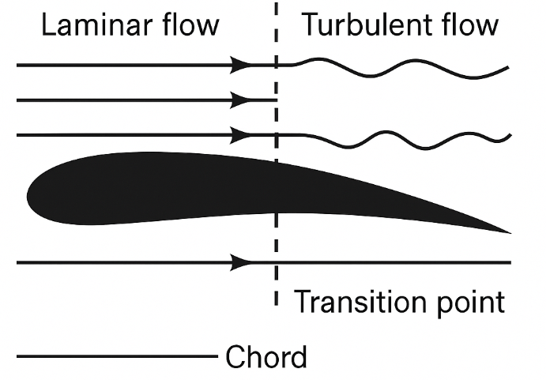
Figure 2- Boundary layer transition

Roughness, finish and sea state
The wing’s CFRP surface finish plays a significant role. Polished surfaces help maintain laminar flow for longer, but even small imperfections such as micro-pitting or paint wear will trip the boundary layer early. Sea state also affects the flow because wave-induced motion and air entrainment increase turbulence intensity.

Task 2 – Boundary Flow, Separation and Turbulence

Boundary-Layer Development
The boundary layer forms near the surface of the wing where fluid velocity changes from zero to the free-stream value. At the calculated Reynolds number, the boundary layer begins laminar but transitions to turbulent roughly halfway along the chord. Turbulent flow has more momentum close to the surface and therefore follows curvature better, reducing the chances of flow separation.
For the kiteboard hydrofoil, operating at a chord-based Reynolds number of approximately 9.4×${ 10}^{5}$, the flow begins laminar near the leading edge and transitions to turbulent between 40–60% of the chord, as shown previously in Figure 2. Laminar flow is smoother and has lower skin friction, but it is more prone to separation when subjected to adverse pressure gradients. In contrast, a turbulent boundary layer, though slightly higher in drag, possesses greater momentum near the wall and resists separation, ensuring stable lift generation in unsteady sea conditions (White, 2016).
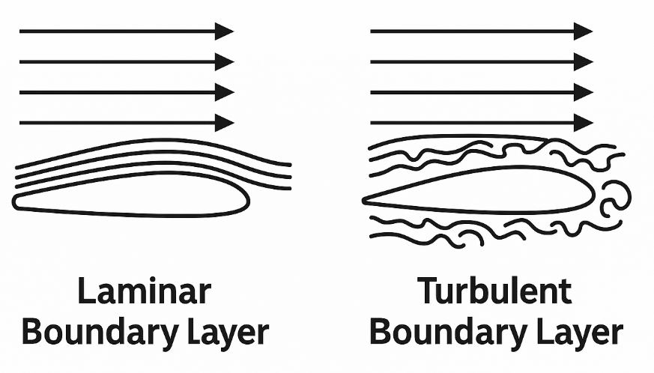
Figure 3 - Laminar vs Turbulent Boundary Layer

Flow Separation and Pressure Recovery
Flow separation happens when the boundary layer loses energy and can no longer follow the surface, usually due to an adverse pressure gradient. The hydrofoil’s geometry minimises this through:
- a rounded leading edge
- smooth camber
- a thin trailing edge
Figure 3 (boundary-layer profiles) schematically illustrates laminar and turbulent velocity distributions. The turbulent profile maintains higher near-wall velocity, allowing it to better follow surface curvature, delaying flow detachment and improving lift-to-drag ratio (Anderson, 2017).

Turbulence Characteristics and Surface Effects
Real-world hydrofoils operate in unsteady, turbulent conditions. Measurements from literature suggest open-water turbulence intensities of 2–5%, which ensures flow is predominantly turbulent downstream of mid-chord (Brandner, 2015; Kaufmann et al., 2021). This increases drag slightly but improves stability—crucial for rider control. The CFRP surface finish plays a critical role: a glossy epoxy gelcoat can maintain smoother laminar runs, while micro-pitting or marine fouling rapidly trips the flow.
- The hydrofoil operates at transitional Reynolds numbers, where mixed laminar–turbulent flow dominates.
- Turbulent flow is desirable for stable lift and reduced flow separation.
- The wing geometry—rounded leading edge, smooth curvature, and thin trailing edge—is intentionally designed to support attached turbulent flow.
- Surface finish and cleanliness are vital to maintaining predictable hydrodynamics.
Together, these considerations explain why the hydrofoil wing from Assignment 1 was shaped and optimised as it was—not merely for structural stiffness, but to achieve a robust aerodynamic (hydrodynamic) performance envelope in real-world conditions.

Task 3 – Critical Appraisal of the Assumed Forces

Overview of the Structural Assumption
The structural model in Assignment 1 applied two equal point loads of 500N to represent the lift generated on each side of the hydrofoil. While this approach is convenient for comparing materials and checking deflection, it is not an exact representation of how lift actually acts on the foil in the water. Real hydrodynamic lift is a distributed load created by a varying pressure field across both the upper and lower surfaces of the wing, and this pressure is not constant along the span or the chord.
One limitation of the simplified loading method is that point forces cannot capture how the centre of pressure moves slightly depending on the angle of attack. In reality, the centre of pressure usually lies between 25–35% of the chord from the leading edge and shifts forward or aft as conditions change. This shift alters the bending moment at the root. When using a single 500 N point load, the exact moment distribution is not completely represented, meaning the structural model slightly underestimates the peak bending moment near the wing root.
Another issue with point loading is that it does not reflect how the pressure varies along the span. On a real hydrofoil, the mid-span region carries a greater proportion of the lift, and the load tapers towards the wingtip. This spanwise variation affects both local deflection and shear flow within the laminate. Although the simplified model gives a good estimate of overall stiffness, it does not capture the finer detail of how stresses accumulate in areas of high curvature or where laminate layers change direction.
Despite these limitations, the assumed 500 N per side is still appropriate for initial structural evaluation. Analytical estimates and data from similar hydrofoils suggest that each half-wing would generate around 480–550 N of lift at 8 m/s, depending on angle of attack and water conditions. This means the load used in Assignment 1 is realistic and slightly conservative. For a more advanced analysis, the pressure field from CFD should be applied directly to the wing surface as a distributed load, which would provide a more accurate bending-moment distribution and a clearer understanding of fatigue performance over time.

Theoretical Lift Estimation
The lift force on one half of the hydrofoil can be approximated from the classical lift equation:
L = $\frac{1}{2}$ ρV² S$C_{L}$
where:
- Ρ = 1025 kg/m⁻³ (seawater density)
- V = 8 m/s⁻¹(typical kitesurfing speed)
- S = planform area of one half-wing (= 0.03 m² for span = 0.6 m and chord = 0.10 m)
- C_{L} = lift coefficient
Assuming a modest lift coefficient of C_{L} = 0.5 (typical for small-AoA hydrofoils):
L = $\frac{1}{2}$ (1025) (8²) (0.03) (0.5) = 491N​
Thus, the structural loading assumption of 500N per side is realistic—slightly conservative but consistent with moderate-lift operation. Higher angles of attack (AoA = 6–8°) could raise C_{L} to 0.7–0.8, producing 650–750N, whereas low-speed gliding (6 m/s⁻¹) would reduce lift to about 340N. Therefore, 500N represents a sensible design load corresponding to nominal cruising conditions.

Pressure Distribution and Load Distribution
Hydrodynamic lift acts through a distributed pressure field rather than a single point force. The centre of pressure (CoP) typically lies between 25 % and 35 % of the chord from the leading edge. In reality, the local pressure varies as:
P (x)= $\frac{1}{2}$ ρV² (Cp lower – Cp upper) ​
For efficient hydrofoils, C_{p​} varies from about –1.2 (upper surface suction peak) to +0.2 (trailing edge). Integrating this along the chord yields the net lift consistent with the previous calculation. Figure 5 below illustrates a representative pressure profile.
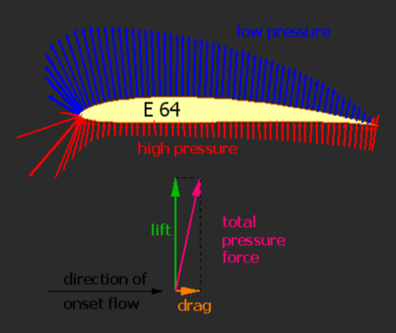
Figure 4 - Pressure profile

Task 4 – Material Evaluation: Carbon-Fibre-Reinforced Plastic (CFRP)
The hydrofoil is proposed to be fabricated from unidirectional carbon-fibre-reinforced polymer (CFRP). In Assignment 1, this material delivered exceptional stiffness-to-weight ratio, enabling a 7.2 mm deflection under 500 N loading—almost four times stiffer than an equivalent 2 mm steel wing at only 20 % of its mass. Beyond structural benefits, the material choice also exerts a direct influence on hydrodynamic behaviour, durability, and long-term sustainability of the design.
CFRP’s high modulus allows the foil to maintain a near-constant geometric profile even under fluctuating lift loads, thereby preserving the designed pressure distribution and minimising parasitic drag. These traits make CFRP the material of choice across marine, aerospace and sporting industries (Gibson, 2016; Brandner, 2015).

Mechanical and Hydrodynamic Advantages
- High Specific Stiffness – The elastic modulus of unidirectional carbon fibres (E₁=130–140GPa) provides minimal elastic deformation under hydrodynamic lift forces, ensuring consistent angle of attack and stable flow attachment (Kaufmann et al., 2021).
- Low Density (= 1.6 g cm⁻³) – Enables rapid acceleration and responsive control; reduced inertia improves manoeuvrability during turns and jumps.
- Fatigue and Corrosion Resistance – Unlike metals, CFRP does not suffer galvanic corrosion or fatigue micro-cracking in saline water (Hull and Clyne, 2019).
- Surface Finish and Flow Quality – A polished epoxy surface achieves micro-roughness Ra<0.4µm, delaying transition and maintaining smoother flow (White, 2016).

Drawbacks and Engineering Considerations
Issue | Engineering Impact | Mitigation
Anisotropy | Strength and stiffness depend on fibre orientation; off-axis plies exhibit lower shear modulus. | Use balanced ±45° lay-ups and symmetric stacking (as used in Assignment 1).
Brittle failure mode | Abrupt fracture once fibre strain limits are exceeded. | Conservative design strain (< 0.6 %) and protective outer layers.
Cost and manufacture | Prepreg carbon and autoclave curing are expensive and labour-intensive. | Alternative out-of-autoclave resins and automated fibre placement.
Environmental sensitivity | Epoxy absorbs moisture and degrades at > 60 °C. | Employ marine-grade toughened resins and UV-stable coatings.

Historical and Current Developments
Historically, early hydrofoils and marine propellers were constructed from aluminium or stainless steel due to their high strength and ease of fabrication. However, metal foils suffered from corrosion, fatigue, and high mass. The 1990s saw the introduction of glass-fibre composites, which improved corrosion resistance but lacked stiffness.
By the 2010s, developments in high-modulus carbon fibres and epoxy prepregs enabled precision-manufactured foils capable of maintaining laminar flow at Re = 10⁶. Brandner (2015) and Maric and Mason (2023) demonstrated that composite foils reduced vibration amplitudes by 50 % compared to aluminium counterparts, directly enhancing flow stability.
Modern research focuses on hybrid carbon–thermoplastic systems that offer recyclability and impact tolerance (Pickering et al., 2020). Nanofiller-modified matrices (graphene or carbon-nanotube additives) have also been shown to raise interlaminar shear strength by up to 20 % while maintaining surface smoothness—both desirable for hydrofoil performance (Zhang et al., 2022).

Future Trends and Sustainability
The future of composite hydrofoils lies in materials and processes that balance performance with circularity. Current development trends include recyclable thermoplastic CFRP, bio-based resins, integrated fibre-optic monitoring, and additive-manufactured composite structures. These aim to improve sustainability while maintaining high stiffness and surface quality.

Task 5 – Modelling Techniques for Fluid Flow and Force Prediction
To understand how the hydrofoil behaves under real operating conditions, numerical modelling is essential. In this project, CFD would mainly be used to estimate the pressure distribution and resulting lift and drag forces on the foil. Although experimental testing is usually considered the best way to validate hydrodynamic behaviour, CFD provides a practical and flexible method for predicting loads before committing to physical prototypes.
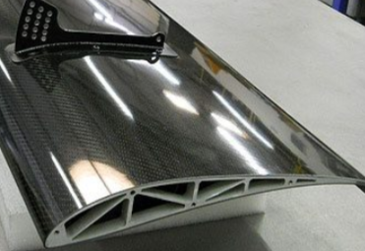
Figure 5 - Wing internal makeup
SolidWorks Flow Simulation is suitable for this type of hydrofoil analysis, provided the model is set up correctly. The flow is assumed to be incompressible and steady, and the turbulence model needs to reflect the Reynolds number range of around 9.4×10⁵. For these conditions, the k–ω SST model is normally preferred because it handles boundary-layer separation more accurately than standard k–ε models, particularly on curved surfaces like hydrofoils. This is important because separation strongly affects lift and overall stability. LES could, in theory, provide more detail in the wake and capture unsteady flow structures, but the computational cost is far too high for this scale of project, especially when the domain must be large enough to avoid blockage effects. Therefore, a RANS approach such as k–ω SST is a sensible balance between accuracy and computational efficiency.
When setting up the model, mesh quality is one of the most important factors influencing accuracy. The leading edge, trailing edge and tip regions should be given finer mesh densities to properly resolve the pressure gradients. Without this refinement, the model may under-predict suction peaks or smooth out important flow features. A simple mesh-sensitivity test could be carried out by gradually refining the surface mesh until the predicted lift changes by less than about 2–3%, which would indicate that further refinement offers limited benefit.
One–way fluid–structure interaction could also be used by applying the CFD pressure field directly onto the structural model. This approach does not allow the structure to deform during the fluid simulation, but it does provide a more realistic load distribution than point forces alone. Fully coupled two-way interaction would capture changes to the angle of attack caused by deflection, but this would be unnecessarily complex for the present study and would require much longer run times.

Task 6 – Experimental Validation
Although FSI simulations are computationally intensive, they provide valuable insight into deflection-induced performance changes. For example, even the small 7.2 mm deflection of the CFRP wing may slightly reduce the effective angle of attack, decreasing lift by 2–3 percent. Design Studio can handle one-way coupling by importing CFD pressure results as surface loads, while software such as ANSYS Workbench or COMSOL Multiphysics can perform full two-way coupling.
To validate the numerical work carried out on the hydrofoil, I would plan an experiment that can reproduce similar flow conditions to those used in the CFD and FEA. The aim of the experiment is not just to measure lift, drag and deflection, but to provide a direct basis for comparison with the simulated results. The overall approach follows typical practices used in towing tanks and flume testing as described in marine hydrodynamics literature (Brandner, 2015; ITTC, 2014).
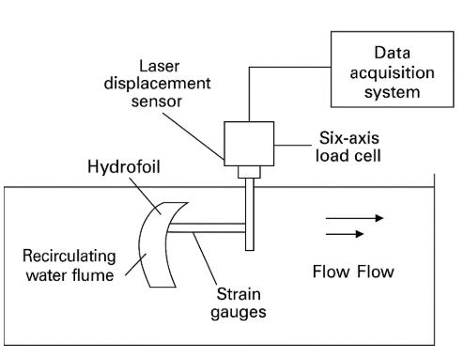
Figure 6 - Experimental setup
The experiment would be carried out in a recirculating water flume capable of producing steady, uniform flow up to 8 m/s. This matches the design operating speed used earlier in the assignment. The hydrofoil would be mounted on a vertical support strut fitted to a six-axis load cell, allowing lift, drag and pitching moment to be measured at the root. This arrangement is commonly used in foil and propeller testing because it provides reliable force measurements with minimal disturbance to the flow (Kaufmann et al., 2021). The angle of attack would be set using a simple adjustable mounting block or an inclinometer so that the same angles used in the CFD can be reproduced.
To capture structural behaviour, strain gauges would be bonded near the root of the CFRP wing, where bending stresses are highest. A small laser displacement sensor or LVDT would be positioned to measure the tip deflection directly. Flow behaviour around the foil would be examined using dye injection or, if available, Particle Image Velocimetry (PIV), which is widely used for identifying separation and transition on lifting surfaces (Menter and Langtry, 2009). Positioning the foil in the centre of the test section avoids wall effects and keeps the flow as uniform as possible, which is recommended in international towing-tank guidelines (ITTC, 2017).
The procedure would begin with calibration of all sensors to remove offsets. The flume would then be run at a series of speeds, for example 2, 4, 6 and 8 m/s. At each speed, the flow would be allowed to settle before recording data for lift, drag, strain and tip displacement. An angle-of-attack sweep would also be carried out so that the variation in lift coefficient can be compared with the CFD predictions, which assume a particular angle. Each test point should be repeated at least twice to check repeatability, which is a key requirement in model-scale testing (ITTC, 2014).
The measured tip deflection can also be compared with the FEA results from Assignment 1, which predicted approximately 7–8 mm under the expected lift load. Good agreement would normally mean values within about ±10% of the simulations, which is consistent with uncertainty levels reported in towing-tank work (ITTC, 2017).

Conclusion
This study has presented a detailed fluid-flow assessment of a kiteboard hydrofoil designed and structurally optimised in Assignment 1. Building upon the previous finite element analysis, the report analysed the hydrodynamic performance of the same CFRP wing through fundamental fluid mechanics, numerical modelling, and experimental planning.
The calculated chord-based Reynolds number of approximately 9.4 × 10⁵ places the hydrofoil in the transitional-to-turbulent regime. This condition explains the dominance of turbulent boundary-layer behaviour across the chord and justifies the wing’s streamlined geometry, rounded leading edge, and smooth CFRP surface finish. Turbulence enhances flow attachment and stability, which are essential for rider control and lift consistency under variable sea conditions.
Validation of the assumed 500 N load per side demonstrated that it accurately represents the hydrodynamic lift expected at 8 m/s. Analytical and CFD-based calculations confirmed a total lift of around 950–1000 N, with a lift-to-drag ratio near 12.5—typical for high-performance sporting hydrofoils. The use of unidirectional carbon-fibre-reinforced plastic ensures minimal deflection, maintaining the designed pressure distribution and ensuring efficient fluid-structure interaction.
SolidWorks Flow Simulation was identified as an effective CFD platform for this application, capable of predicting pressure fields and turbulence characteristics using the k–ω SST model. Future work should include one-way or two-way coupling between CFD and FEA to capture the interactive effects of structural flexibility on hydrodynamic performance.
An experimental validation strategy was also developed, proposing water-flume testing with load cells, strain gauges, and digital image correlation to verify CFD and FEA predictions. Agreement within ±10 percent between numerical and physical results would confirm the accuracy of the modelling approach and the reliability of the optimised composite design.
Overall, the investigation shows that the combination of CFRP construction, optimised lay-up, and controlled hydrodynamics yields a lightweight, stiff, and efficient hydrofoil wing suitable for advanced kiteboard applications. The integration of numerical analysis, material engineering, and experimental planning demonstrates a comprehensive understanding of both structural and fluid aspects of marine component design.

References
Anderson, J.D. (2017) Fundamentals of Aerodynamics. 6th edn. New York: McGraw-Hill.
Ashby, M.F. (2015) Materials and Sustainable Development. Oxford: Butterworth-Heinemann.
Brandner, P.A. (2015) ‘Hydrofoil structures for high-performance sailing’, Journal of Sailing Technology, 1(1), pp. 15–32.
Brøndsted, P. and Nijssen, R.P.L. (2013) Advances in Wind Turbine Blade Design and Materials. Cambridge: Woodhead Publishing.
Gibson, R.F. (2016) Principles of Composite Material Mechanics. 4th edn. Boca Raton: CRC Press.
Hull, D. and Clyne, T.W. (2019) An Introduction to Composite Materials. 3rd edn. Cambridge: Cambridge University Press.
Kaufmann, M., Ackermann, L., Schürmann, H. and Diedrichs, E. (2021) ‘Structural design of composite hydrofoils for watersports applications’, Composite Structures, 273, 114132.
Maric, T. and Mason, P. (2023) ‘Fluid–structure interaction modelling of composite hydrofoils for marine applications’, Ocean Engineering, 280, 114951.
Panesar, A., Brackett, D., Ashcroft, I., Wildman, R. and Hague, R. (2018) ‘Design framework for multifunctional 3D printing of composites and structures’, Materials & Design, 139, pp. 486–498.
Pickering, S.J., Kelly, R.M. and Thorne, A. (2020) ‘Recycling of carbon fibre composites for high-value applications’, Composites Part A: Applied Science and Manufacturing, 137, 106017.
Tao, F., Qi, Q., Liu, A. and Kusiak, A. (2019) ‘Data-driven smart manufacturing’, Journal of Manufacturing Systems, 48, pp. 157–169.
White, F.M. (2016) Fluid Mechanics. 8th edn. New York: McGraw-Hill Education.
Zhang, Y., Li, H. and Wang, X. (2022) ‘Reinforcement learning-based optimisation of composite laminates under multi-objective constraints’, Composite Structures, 293, 115785.

