Place names in Herefordshire

Toponymy is the study of place-names with the aim to find its earliest form and the development into the format it is now. By looking at place-names and integrating historical events, language and their geography, it should give clues of the cultural heritage of an area.
This essay will be examining and explaining meanings for fifty placenames of villages in southwest Herefordshire, near and on the border of England and Wales, which contains some of the ancient area known as Archenfield. (Appendix 1)
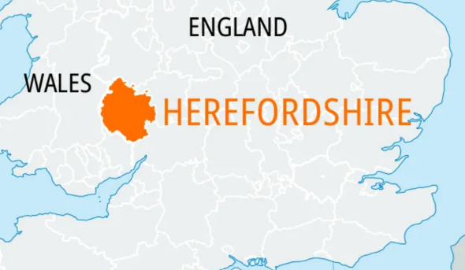

Position of Herefordshire in relation to England and Wales.
The village names (Appendix 2) have been placed in alphabetical order and are distinguished according to being of Welsh or English origin. Some have Celtic names, the name given to the language of ancient peoples that occupied Britain but had migrated to Wales by the sixth century. For the sake of the essay the place-names are being categorised as Welsh or English but Celtic will be mentioned in the essay when relevant to the narrative. The names have also been subdivided into four categories, personal names, religious, inhabitative names and the largest category, topographical subjects. Using these characteristics, the essay will demonstrate to the reader how they are an indication of the geography, history and language of the area.
The books used to locate the origins of these place-names are:- Herefordshire Place-names Bruce Coplestone- Crow ,(BCC) Oxford Dictionary of British Place Names A.D.Mills (ADM) and Place-names of Herefordshire, A.T. Bannister,( ATB.) Two books that contain most references for these books are The Domesday Book and the Testa de Neville, both manuscripts containing lists of feudal holdings dated from 1086 and 1302 respectively although there are many other sources ranging from registers, charters or local and church registers . These provide written evidence of the place-names’ existence when they were written, proving that the place- name is at least as old as the source, but probably much older. There are some instances when the interpretations differ, which means that it is difficult to categorise, for example Garway – ‘Welsh church of a man called Guoruoe,’(ADM) ‘source of the Gamber,’(BCC) and ‘Church of St Michael above the Wye.’(ATB) ( In the study it has been categorised as a church.)

History of Place- names in Herefordshire
Following the collapse of the Roman empire and the withdrawal of the Romans from England, the Anglo Saxons from the fifth and up to the ninth centuries, moved westwards and dominated all areas except Cornwall, the borders of England and Wales, and the northern counties of England. The area within Herefordshire known as Archenfield, was, during the Anglo Saxon invasion, a border territory lying between Wales and the Anglo Saxons of England and then used later as a buffer territory between the English and Welsh following the Norman invasion. Inhabited sites in this early period often started as a single dwelling named after the owner and grew over time into settlements . After the conquest of England in1066 and the subsequent invasion by the Normans, Herefordshire became the most ‘Normanised’ county in England shown by the very many small castles built along the border of Herefordshire with Wales in order to establish their presence. This helped with trading between the two countries although fighting did still continue. The counties on the border became known as the Marches and were given autonomy, with the Normans even moving into Wales -taking the name of the established settlements for example Ewyas Harold was an original Welsh name for the commote of Ewys, and its land was given to Harold the nephew of Edward the confessor in 1086 (BCC.) The marcher lordships were dissolved in 16th century and Herefordshire became purely English although by then its place names were long established, many of which remained Welsh.
Signs of habitation
Habitation place- names account for seven of those listed and can denote the history of the area because it can illustrate how an area was inhabited from its earliest attested source. Of the seven names, six are English which demonstrates that the Welsh were typically less likely to use habitation words than topographical or church names. Ton -the most popular element of a place-name, usually forms the second element of a word. It is a derivative of tun (Old Scandinavian -Saxon,) denoting ‘fence’ or ‘enclosure’ , (ADM)but later developing into farmstead or estate, for example Newton – new farmstead/ estate / village, Longtown -long estate and Kingstone -royal estate. Kilpeck derived from the Welsh cil means corner or retreat and therefore a ‘corner where snares are kept.’(ADM) Much Birch (and Little Birch) are both named for the birch trees found in the area probably as part of an estate or a manor. (BCC)
Personal names
Amongst the study there are eleven personal names as the subject and of those, all but one are English, the Welsh people tending to use saints rather than personal names. Many personal names were most likely from the men who had either established lordships and manors, or someone who owned the homesteads. Nine are compounded with ton, stone or ly and affixed to a personal name as demonstrated by Turnastone ( family de Turnei,) Walterstone –( possibly Walter de Lacy,) (ADM) both of which are known as being Norman lords. The term ley meaning ‘a clearing’ is used for Didly and Madley, probably belonging to Dodda and Madda, who with no historical documentation to back up, these place-names may be all that is known of person whereas others can be backed up with historical documentation.
Churches
The Welsh rarely commemorated themselves and usually attached a noun or adjective to a residing saint’s name rather than landowner. This would have been a common occurrence in the fifth and sixth centuries. Of the fourteen villages that are derived from a church name, eight are English and six are Welsh showing the importance of ecclesiastical meanings in placenames for the Welsh. Llan initially meaning enclosure or clearing but then later being used extensively in connection with Christian places of worship, is the most common Welsh prefix in this study(it is used for four hundred and fifty one placenames in Wales). The place-names commemorated saints, for example Llancillo and St Weonards (BCC)or the churches were named for their location for example Llanwarne ‘church by the alder swamp.’(BCC) The English tended to call their church place-names by an anglicised saints name- Peterstow (stow meaning holy place ,of St Peter,) or they were described for their location or features- Whitchurch and Vowchurch were described as white and multicoloured churches respectively. (ADM)
As can be seen, the personal names, inhabitational names and names of churches (to a lesser degree although they indicated if the village was Welsh or English,) were all able to provide some history to the area giving clues to who lived in the area and what the land was used for.
Geography of the Area
The land of Herefordshire is mainly dominated by rivers, lowlands of the flood plains with interlocking spurs and undulating hills. It does not contain mountains which are found to the West of the area in the Black Mountains, but it does contain much woodland in the area.
Placenames were used to describe geographical features depicting amongst other descriptions, their colour, height form and position plus their relation to other features. Of the place-names in this study, six Welsh and twelve English, illustrate topographical features. The largest quantity of Welsh names are found in the topographical section.
Rivers are considered to be important landmarks, very often forming boundaries to areas or even countries for example the River Wye formed much of the boundary for England and Wales during the Middle Ages and they are also responsible for much carving of the landscape and thus the geography of an area. A few of the place-names take their root from the local rivers as there are many in the area. Herefordshire is dissected by the River Wye, but its tributaries, the Monnow and Dore with their own tributaries of the Escley, Dulas, Gamber and Worm (all names of which are of Celtic origin,) form the river complex within the area studied. Associated with the rivers are their valleys and any manmade features which are used in association with the river for example crossings to the river -Wormbridge or Tretire meaning ‘long ford crossing the Gamber.’ (BCC) Because these names are associated with the river they have been placed in the topographical section although equally they could have been placed in the inhabitation section as they are associated with inhabitation of the area too. Some names actually include the names of a river: - Dulas (meaning ‘dark stream,’) Abbey Dore, and Wormelow , these are all based on the water ways of the same name.(BCC) Some names are associated with an area around the water- Craswell means ‘watercress by the stream,’ Allensmore and Clehonger both are derived from clay soil, suggesting a river valley. (BCC)
Woods were plentiful in the county especially to the west of the area and Herefordshire is thought to have included a royal hunting forest. Llangrove is described as a ‘long grove’ and although it appears to have the familiar Llan root meaning ‘church,’ the English derivative of lang is used for ‘long’ instead. (ADM) Hence showing the importance of an area being checked visually to ensure that the correct feature has been described . Maes-Coed is a Welsh word describing a ‘meadow in the wood’ and Pencoyd – ‘end of wood’ ( The Welsh pen being used as end not the Celtic penn usually associated with hill.)(ADM) These names give evidence of many woods possibly ancient managed woodlands.
Hills are mentioned in several of the placenames, Pencraig, penn is a Celtic version of ‘headland’ or ‘end’ usually associated with a hill. Some of the other names are simple descriptions of hills, Ganarew a ‘hill pass’ (BCC)(although thought of as a Welsh personal name by Mills,) Snodhill a ‘snowy hill,’ Orcop which has derivatives of ora and copp ,both English words meaning hill although copp can mean ‘long narrow summit’, and Callow described as a bare hill , calu meaning bare.(ADM)
The place-names, both Welsh and English, give evidence of a land dominated by several rivers, using either their name or features associated with them for example the description of the wet and clay soil of Allensmore, typical of flood plains. There are several mentions of hills and woods in the study giving evidence that these were also significant of the geography of the area. Some place-names are descriptive for example Clehonger ‘sloping wood on clay soil’ describes a settlement on an unnamed tributary of the River Wye, featuring a lowland slope with woodland giving some detail about the surrounding area whereas Callow is an uncomplicated ‘bare hill’.
Language of the Area
History of a language is an important factor when looking at the place-names of an area as Margaret Gelling feels they could be made up of 6 layers of a language, non indo European, Celtic, Latin, Old English (Germanic,) Old Norse and Norman French. It is important to look at the present language of a placename and then establish the layers of other languages to distinguish their origin. Herefordshire was mainly influenced by Celtic (later to become Welsh,) Old English and Norman-especially seen in personal names associated with placenames. The Germanic language which became known as English, moved westwards, while the Celtic languages retreated to Wales with the interface along the Wales England border. Herefordshire being on the border contains Welsh and English place names which is clearly evidenced in this study. Within the fifty places described, twenty-one are either Welsh or a combination of English and Welsh.
The difference between English and Welsh place names can be discovered by the presence and order of the nouns within the name. Most of the compounds found in English placenames have the first element qualifying the second element, which is usually a noun (They can also be a simplex containing just one element.) In the sixth century this order was altered by the Welsh to a different formation, with the noun placed first followed by its qualifier. The order of a word can often give an idea of what language and therefore where a place name originates from. This can be demonstrated by comparing two villages in Herefordshire, Llanwarne and Peterchurch. The former (Welsh) is described as a ‘church by the alder swamp’(noun first) and Peterchurch is described as St Peter’s church,( noun second.) Most placenames in Wales are of the Welsh language and many are descriptive of a topographical feature or associated with churches. Of the Welsh names within this chosen selection, it can be presumed that the villages were considered as being inhabited by Welsh at some time. It is thought that many of the Welsh place-names in the selected area, predated the Norman conquest and in order to co-exist and keep continuity with the original peoples, many Celtic placenames ( later becoming Welsh,) were borrowed and therefore remained the same or similar in form, for example, Wormbridge- consisting of the Celtic river Worm and brycg (English for bridge) proving that some names have a combination of the two languages. Many Celtic named rivers have kept their names in England, becoming more prevalent the further west one travels as described by Professor Kenneth Jackson and being illustrated by the presence of Celtic/Welsh named rivers of the Dore, Monnow, Escley, Worm and Garren within Herefordshire
The villages are all now part of English-speaking Herefordshire, but it is known that Welsh was so prevalent in Hereford that even the bible and prayer book in medieval Hereford were printed and preached in both English and Welsh. Some areas remained Welsh speaking until the nineteenth century.
The placenames have a very important role in discovering which areas were English or Welsh speaking although there are examples where a place name changed from English to Welsh or vice versa as depicted by Michaelchurch Escley (church dedicated to St Michael, )changed to Llanfihangel (same meaning)in the sixteenth century and then back to its original form of Michaelchurch in the eighteenth century.Although this is an unusual phenomenon it illustrates the flexibility that can be exercised with the language of place-names.

Conclusion

With placenames’ ability to survive , many at least a thousand years old, it can testify how important they are in terms of the history, geography and language of the area .The placenames in this study are either Welsh or English, the Welsh place names typical of Wales, mostly have either topographical roots or are named after churches, while the English names cover many aspects of the common themes of topography, personal names, types of inhabitations and the church. The place-names show that the area was hilly although not mountainous but there are several named after rivers and their tributaries, or descriptions of the area on the flood plains. Descriptions of woods illustrate that there were forests in the area. It demonstrates that with the position of Hereford being on the Welsh, English border it was influenced by being the buffer zone during the Anglo-Saxon period and was neither fully English nor Welsh in some places, therefore influenced by both. The placing of Norman lords to manage the area after the Norman conquest is illustrated by the number of place-names that include names of people of Norman descent (proved by local history sources.) The high proportion of place-names with a religious context indicates the large number of Welsh names as these were of high importance in the naming of their areas. However at the end of this study, the most significant finding is the high proportion of Welsh place-names in the area indicating a previous large number of Welsh speakers within Herefordshire.

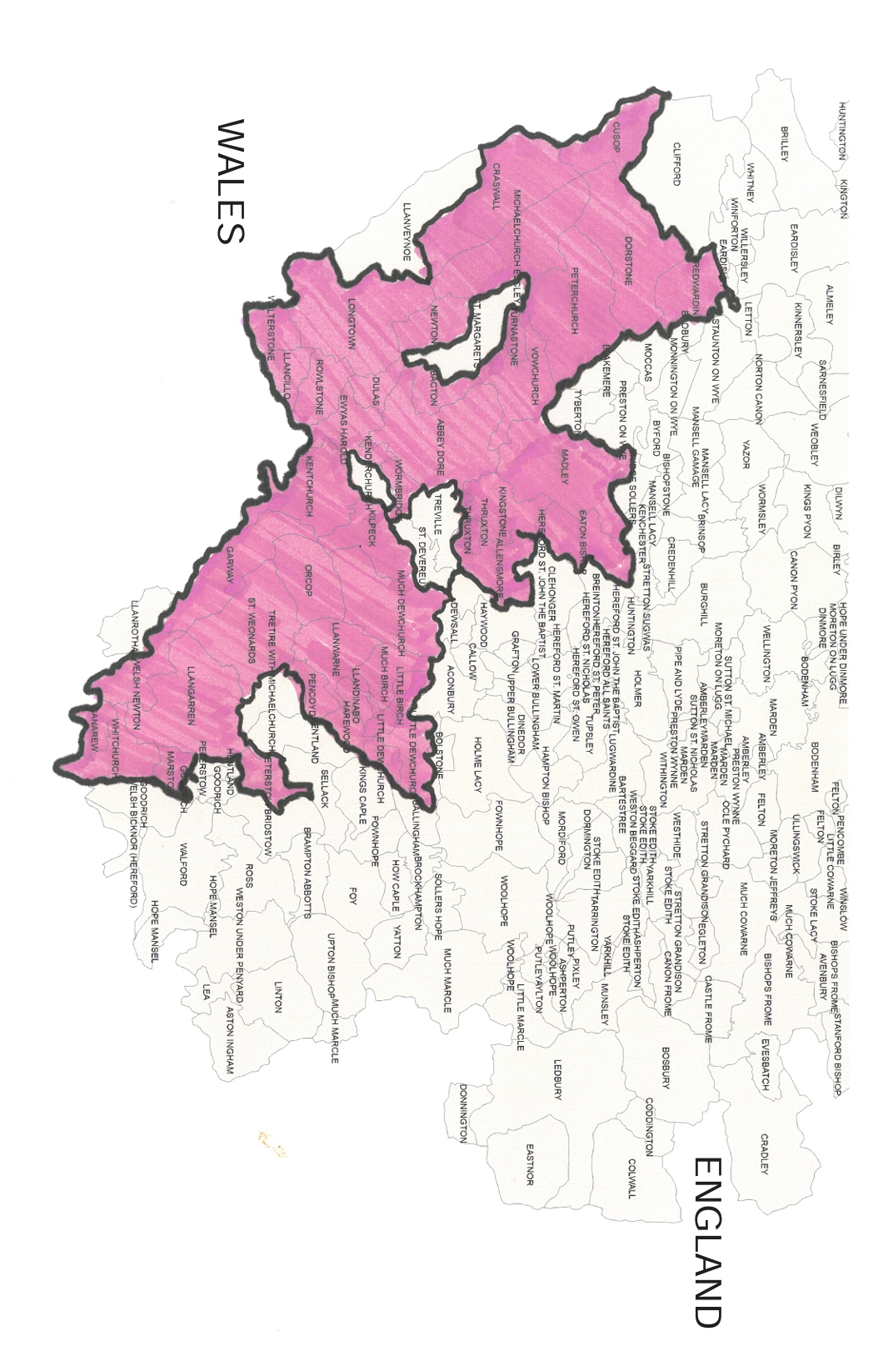
Appendix 1
P

Illustration of the parishes containing the chosen villages.

Appendix 2
List of Place Names in Herefordshire

Name | Language | N | C | T | I | Meaning / other information
Abbeydore | W |  | X |  |  | River Dore/Cistercian Abbey – St Mary
Allensmore | E |  |  | X |  | Wet low-lying ground
Bacton | E | X |  |  |  | Farmstead of Bacca’s
Birch, Much/Little | E |  |  | X |  | Birch Trees
Bredwardine | E |  |  |  | X | Plank enclosure
Callow | E |  |  | X |  | Bare hill
Clehonger | E |  |  | X |  | Sloping wood on clay soil
Clodoch | E |  | X |  |  | Church of St Clydog/ Clodock
Craswell | E |  |  | X |  | Spring/stream where watercress grows
Dewchurch, Much/Little | W |  | X |  |  | David’s church
Didley | E | X |  |  |  | Meadow of Dudda/Dodda
Dulas | W |  |  | X |  | Dark stream
Eaton Bishop | E |  |  | X |  | River Estate ?of bishop
Ewyas Harold | W | X |  |  |  | Sheep district, given to Harold
Ganarew | W |  |  | X |  | Hill pass
Garway | W |  | X |  |  | Church of Guoruoe
Harewood End | E |  |  | X |  | Hare wood
Howton | E | X |  |  |  | Estate of man called Hugh
Kentchurch | W/E |  | X |  |  | Church of St Ceina
Kilpeck | W |  |  |  | X | Corner where snares for animals
Kingstone | E |  |  |  | X | Royal estate
Llancillo | W |  | X |  |  | Church of St Sulfyw
LLandinabo | W |  | X |  |  | Iunabui’s church
LLangarron | W |  | X |  |  | Church on River Garron
LLangrove | E |  |  | X |  | Long Grove Lang+graf
LLanwarne | W |  | X |  |  | Church by alder swamp
Longtown | E |  |  |  | X | Long farmstead/estate
Madley | E | X |  |  |  | Madda’s wood/clearing
Maes- Coed Lower | W |  |  | X |  | Meadow in the wood Coes=dark
Marstow | E |  | X |  |  | Church of St Martin
Michaelchurch Escley | W/E |  | X |  |  | Escley brook/Church of St Michael
Newton | E |  |  |  | X | New farmstead/estate/building
Orcop | E |  |  | X |  | Top of the slope/hill
Pencoyd | W |  |  | X |  | Wood’s end
Pencraig | W |  |  | X |  | Top of the crag
Peterstow | W/E |  | X |  |  | Church of St peter
Pontrilas | W |  |  | X |  | Bridge over three rivers *
Rowlestone | E | X |  |  |  | Rolf/Ralph’s estate
Snodhill | E |  |  | X |  | Snowy hill
St Weonards | W |  | X |  |  | Church of St Gwennard
Name | Language | N | C | T | I | Meaning/ other information
Thruxton | E | X |  |  |  | Thorkell’s estate (Scandinavian)
Tretire | W |  |  | X |  | Long ford
Turnastone | E | X |  |  |  | Manorial name from de Tournay
Vowchurch | E |  | X |  |  | Multi coloured church
Waterstone | E | X |  |  |  | Walter’s estate (de Lacy)
Welsh Newton | E |  |  |  | X | New farmstead /estate /village
Whitchurch | E |  | X |  |  | White church
Winnal | E | X |  |  |  | Willa’s meadow or with willows
Wormbridge | W/E |  |  | X |  | Bridge on worm brook
Wormelow | E |  |  | X |  | Low Hill by the Worm

Key
N= Name of person E=English
C=Church W=Welsh
T=Topographical
I=Inhabitation

Bibliography

- Bannister, A.T. The Place-names of Herefordshire, 1916, (Delhi: Alpha Editions, 2019).

- Britannica, Herefordshire,2023, http://cdn.britannica.com/91/247791-050-FAOEOSCD/Locator-map- Herefordshire.jpg [accessed 17 January 2025].

- Coplestone-Crow, Bruce, Herefordshire Place-names, (Herefordshire:logastonpress.co.uk,2009).

- Ekwall, Eilert, The Concise Oxford Dictionary Of English Place-Names, 4th ed. (Oxford://Oxford University Press,1960).

- Gelling, Margaret, Signposts To The Past, 3rd ed. (Chichester: Phillimore &Co.Ltd. 1997).

- Mills, A.D. A Dictionary of British Place-Names, (Oxford: Oxford University Press, 2003).

- Parsons, David,’ Tracking The Course Of The Savage Tongue: Place-Names And Linguistic Diffusion In Early Brittain’, in Celtic From The West: Alternative Perspectives From Archaeology, Genetics, Language And Literature, ed by Barry Cunliffe, John T. Koch,2010, pp169-184, p. 170 https://doi.org/10.2307/j.ctv13pk64k.11 [accessed 16 January 2025].

- Picton , J.A. ‘The System Of Place-Names In Wales Compared With That In England’ Archeologia Cambresis, Vol 12,4th series, Vol36, pp125-137. <archaeologydataservice.ac.uk/library/browse/details.xhtml?recordid=3051076> [accessed 16 January 2025].

- Proctor, Dr. Eddie. Archenfield:Continuity And Change In An Early Medieval Border Landscape, 2004 <Academia.edu/1487131/Archenfield_Continuity_and_Change_in_an_Early_Medieval_Border_Landscape> [accessed 16 January 2025].

A.D Mills, A Dictionary Of British Place-Names, (Oxford: Oxford University Press, 2003) p.xi.
Britannica, Herefordshire,2023, http://cdn.britannica.com/91/247791-050-FAOEOSCD/Locator-map- Herefordshire.jpg [accessed 17 January 2025].
Bruce Coplestone-Crow, Herefordshire Place-names, (Herefordshire: Logaston Press,2009)
Mills, A Dictionary Of British.
A.T Bannister, The Place-names of Herefordshire, 1916, (Delhi: Alpha Editions, 2019)
David Parsons,’ Tracking The Course Of The Savage Tongue: Place-Names And Linguistic Diffusion In Early Brittain’, in Celtic From The West: Alternative Perspectives From Archaeology, Genetics, Language And Literature, ed by Barry Cunliffe, John T Koch,2010, pp169-184, p. 170 https://doi.org/10.2307/j.ctv13pk64k.11 [accessed 16 January 2025]
Dr Eddie Proctor, Archenfield:Continuity And Change In An Early Medieval Border Landscape ,2004 <Academia.edu/1487131/Archenfield_Continuity_and_Change_in_an_Early_Medieval_Border_Landscape> p. 3. [accessed 18 January 2025].
Bannister, The Place-names of Herefordshire, 1916, (Delhi: Alpha Editions, 2019) p. x.
Ibid. p.xi.
Ibid, p.xv.
Ibid, p.xi.
Mills, A Dictionary Of British Place Names, p.xiii.
Bannister, The Place- names, p.xvi.
J.A.Picton , ‘The System Of Place-Names In Wales Compared With That In England’ Archeologia Cambresis, Vol 12, 4th series, Vol36, pp.125-137, p.133, <archaeologydataservice.ac.uk/library/browse/details.xhtml?recordid=3051076> [accessed 16 January 2025].
Picton , The System Of Place-Names, p.9.
Ibid. p.ix.
Mills, Dictionary Of British, p.xix.
Proctor, Archenfield:Continuity, p.19.
Margaret Gelling, Signposts To The Past, 3rd ed. (Chichester: Phillimore &Co. Ltd. 1997), p.19.
Gelling, Signposts To The Past, p.99.
Proctor, Archenfield: Continuity, p.18.
Ibid.p.13.
Bannister, The Place-names, p.xv.

