

Service improvement report

Failure to rescue a deteriorating patient: a case study of martha mills and the development of martha's rule

Student Name: Hetvi rajendrasinh sangdot
Student Number: 2526007
Module name :– Quality and Service Improvement in Health and Social Care
Module Code : LCHS7006
Lecturer: Dr fahad khan

Table of Contents
1. Introduction: 2
2. Main Body: Analysis of Root Causes: 3
2.1 Fishbone Diagram: 3
2.2 The 5 Whys 5
2.3 The Donabedian Model 6
2.4 SWOT Analysis 7
3. Recommendations and Implementation Strategy: 8
3.1 PDSA Cycle: 8
3.2 Change Management: Lewin and Kotter: 9
3.3 Lean and Six Sigma: 10
4. Benchmarking Against Comparable Schemes: 10
5. Conclusion: 12
6. Reference List 14

Introduction:

This report examines a quality concern central to NHS patient safety policy: the failure to recognise and escalate acute clinical deterioration, illustrated through the case of Martha Mills. Martha, aged 13, sustained a pancreatic injury after a cycling accident in 2021 and was admitted to King's College Hospital (KCH) NHS Foundation Trust under the paediatric liver team. Over the following weeks she developed severe sepsis and, on several documented occasions, would have met criteria for referral to paediatric intensive care (PICU); this referral was not made in time, and Martha died on 31 August 2021, days before her fourteenth birthday (Judiciary, 2022).
The coroner's inquest concluded Martha would probably have survived with earlier intensive care transfer. Her parents repeatedly voiced concerns, including fear she would deteriorate over a bank holiday weekend, yet these were not acted upon and the family was never told sepsis was suspected (Healthcare Today, 2025). The coroner's Prevention of Future Deaths report also found King's paediatric early warning score remained paper-based, unlike the electronic adult system (Judiciary, 2022).
This exemplifies 'failure to rescue': the inability of healthcare systems to recognise and respond promptly to patients showing signs of clinical deterioration. This accounts for an estimated five avoidable deaths per acute trust per month, frequently linked to inattention to the concerns of patients and their families (Welch et al., 2025). scaled across England's 210 acute trusts, this suggests over 1,000 such deaths annually. A 2025 qualitative study in BMJ Quality & Safety similarly found that, despite existing early warning systems, translating patient and family concern into effective escalation remains 'practically difficult to achieve' without reliable organisational structures (Sutton et al., 2025). Martha's case aligns closely with the NHS Patient Safety Strategy's commitment to 'safety involvement', alongside safety insight and safety improvement, as a core national quality priority (NHS England, 2019), exposing a gap between strategic intent and everyday ward-level practice.
In response, NHS England introduced Martha's Rule: a formal route for patients, families and staff to request a rapid, independent clinical review (NHS England, 2025). This report applies the Fishbone diagram, 5 Whys, the Donabedian model and a SWOT analysis to the root causes of this failure, before proposing PDSA, Lewin/Kotter and Lean based recommendations, and benchmarking these against comparable NHS and international schemes.
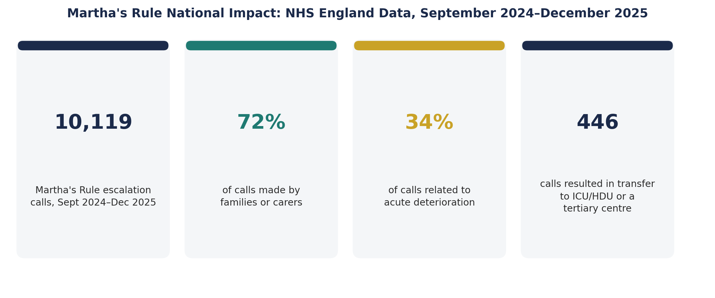
Figure 1: Martha's Rule National Impact : Key Statistics (NHS England, 2026a)

Main Body: Analysis of Root Causes:

Fishbone Diagram:

The Fishbone diagram categorises root causes under people, process, policy, equipment and environment (Ishikawa, 1985). Table 1 summarises the causes identified from Martha's case.
Category | Root Cause(s) Identified
People | Parental concerns repeatedly dismissed; hierarchical culture discouraged junior staff from challenging the consultant's view (Healthcare Today, 2025; Subbe et al., 2024).
Process | No formal family escalation route; liver team retained sole responsibility despite multiple occasions warranting PICU referral (Weightmans, 2024).
Policy | No 'Call for Concern' equivalent or mandated second-opinion right existed at King's in 2021 (Cooksley, Astbury and Holland, 2023).
Equipment | Paediatric early warning score (BPEWS) was paper-based, with no automated deterioration alert, unlike the adult system (Judiciary, 2022).
Environment | Deterioration occurred over a bank holiday weekend with reduced senior consultant presence (Healthcare Today, 2025).
Table 1: Fishbone Root-Cause Summary – Martha Mills, King's College Hospital (2021)
These causes were far from independent. Hierarchical culture (people) was reinforced by the absence of any policy mandate (policy), meaning the paper-based system (equipment) was never supplemented by an independent alert. This interdependency demonstrates why isolated technical fixes alone would have been unlikely to prevent Martha's death without the parallel cultural and policy change Martha's Rule was later designed to deliver. This root-cause identification also rests on several assumptions worth making explicit: that senior clinical judgement, though presented with confidence, is not infallible and can usefully be challenged by an independent second opinion; that a family's persistent concern is itself clinically meaningful data rather than simply anxiety to be managed; and that a paper-based observation chart is an adequate substitute for an electronic, trend-visualising early warning system. Where any of these assumptions do not hold, for example where escalation systems are used excessively rather than judiciously, the balance of benefit may shift which is why the low rates of inappropriate use found in comparable international schemes are important corroborating evidence rather than an incidental comparison (Dwyer et al., 2020).

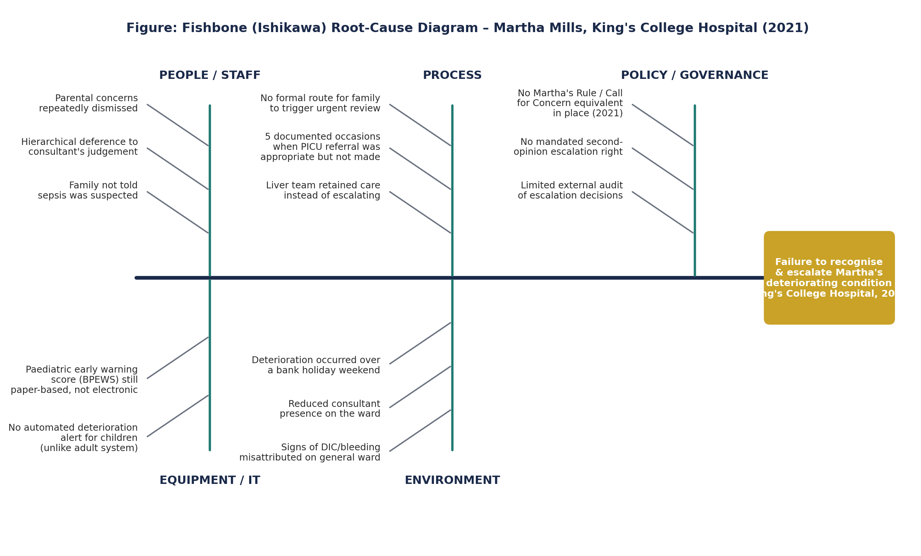
Figure 2: Fishbone (Ishikawa) Root-Cause Diagram – Martha Mills, King's College Hospital (2021)

The 5 Whys

The 5 Whys technique traces a problem back through successive causes (see Table 2), revealing that Martha's death is attributable not to one failing individual but to the absence, at that time, of any national policy requiring an independent escalation route.

Step | Finding
Why 1 | Martha was not transferred to PICU : the liver team judged intensive care unnecessary.
Why 2 | This judgement was not challenged : no formal mechanism existed for the family to request review.
Why 3 | No such mechanism existed : King's had no equivalent of a family-activated escalation scheme in 2021 (Cooksley, Astbury and Holland, 2023).
Why 4 | No escalation scheme existed : no NHS-wide policy at the time required trusts to provide one (Judiciary, 2022).
Why 5 | No national policy existed : patient/family escalation had not yet been recognised as a mandatory safety standard, a gap only closed by Martha's Rule in 2024 (NHS England, 2025).
Table 2: 5 Whys Analysis Why Martha Was Not Transferred to PICU

The Donabedian Model

The Donabedian (1966) structure-process-outcome model remains, six decades after its inception, the dominant framework for evaluating healthcare quality, continuing to be regarded as offering a lasting basis for contemporary quality improvement (Ayanian and Markel, 2016) (see Figure 3). The model proposes that structural resources shape clinical processes, which in turn determine patient outcomes. At King's in 2021, the absence of an electronic early warning score, together with the absence of any independent escalation route accessible to families, represented critical structural deficits (Judiciary, 2022). In direct response, Martha's Rule established new structural resources nationally: a 24 hour helpline staffed by critical care outreach teams, alongside a requirement that patients be asked daily whether they are improving or deteriorating (NHS England, 2025), reflecting Welch et al.'s (2025) argument that reliable escalation structures are essential precisely because failure to rescue is so frequently rooted in 'inattention to concerns of patients or their families about acute deterioration'.
Process indicators include call volume and source: 10,119 calls were logged between September 2024 and December 2025, 72% from families and 34% linked to acute deterioration (NHS England, 2026a). Of 1,781 staff-initiated calls, 61% correctly identified genuine deterioration (NHS England, 2026b) (see Figure 4) a level of process visibility entirely absent during Martha's admission. Outcome indicators include 446 calls resulting in transfer to intensive or tertiary care (NHS England, 2026a); however, as caution, outcomes are hard to attribute to a single intervention given case-mix and confounding factors(Yang et al. 2025).

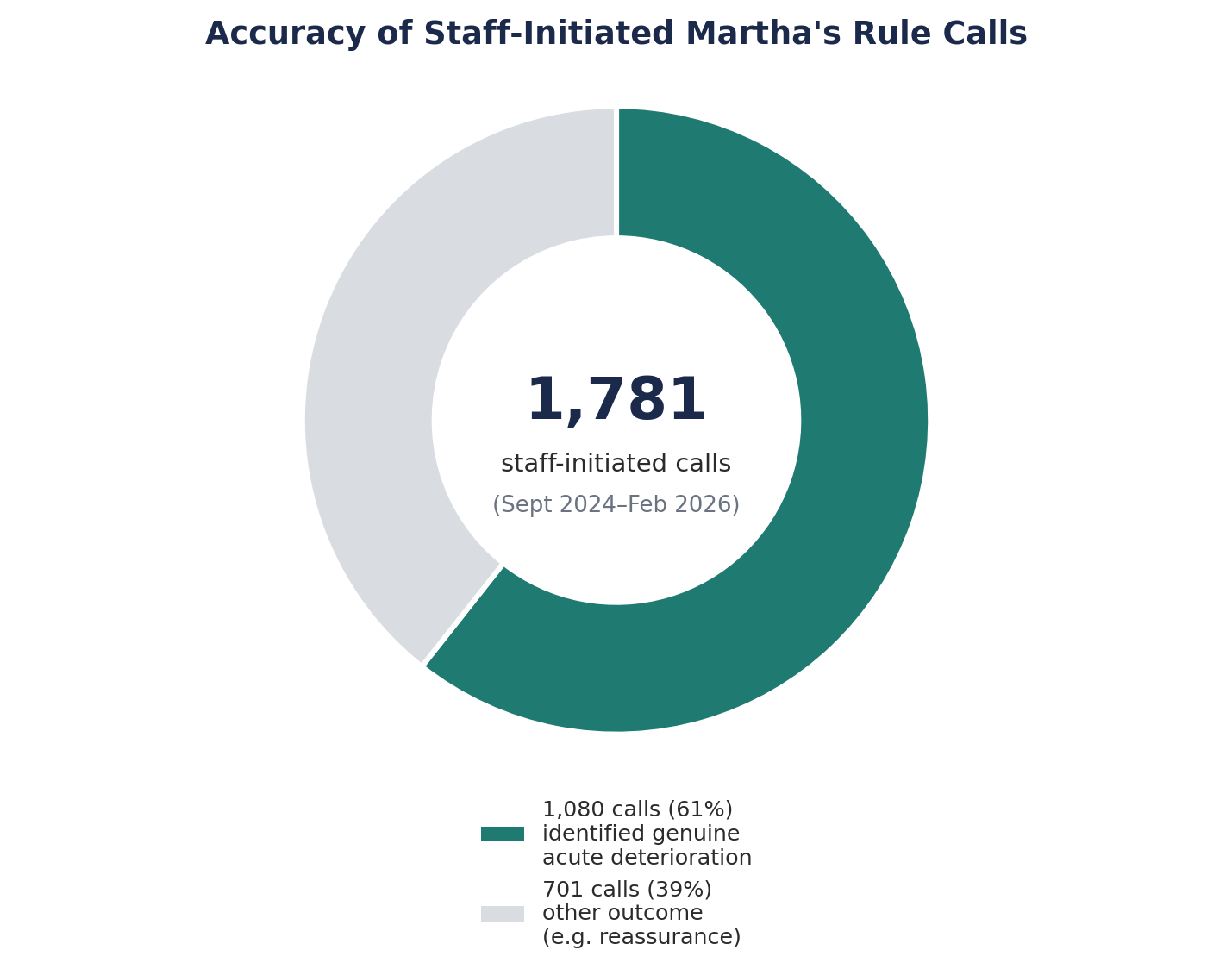
Figure 4: Accuracy of Staff-Initiated Martha's Rule Calls (NHS England, 2026b)

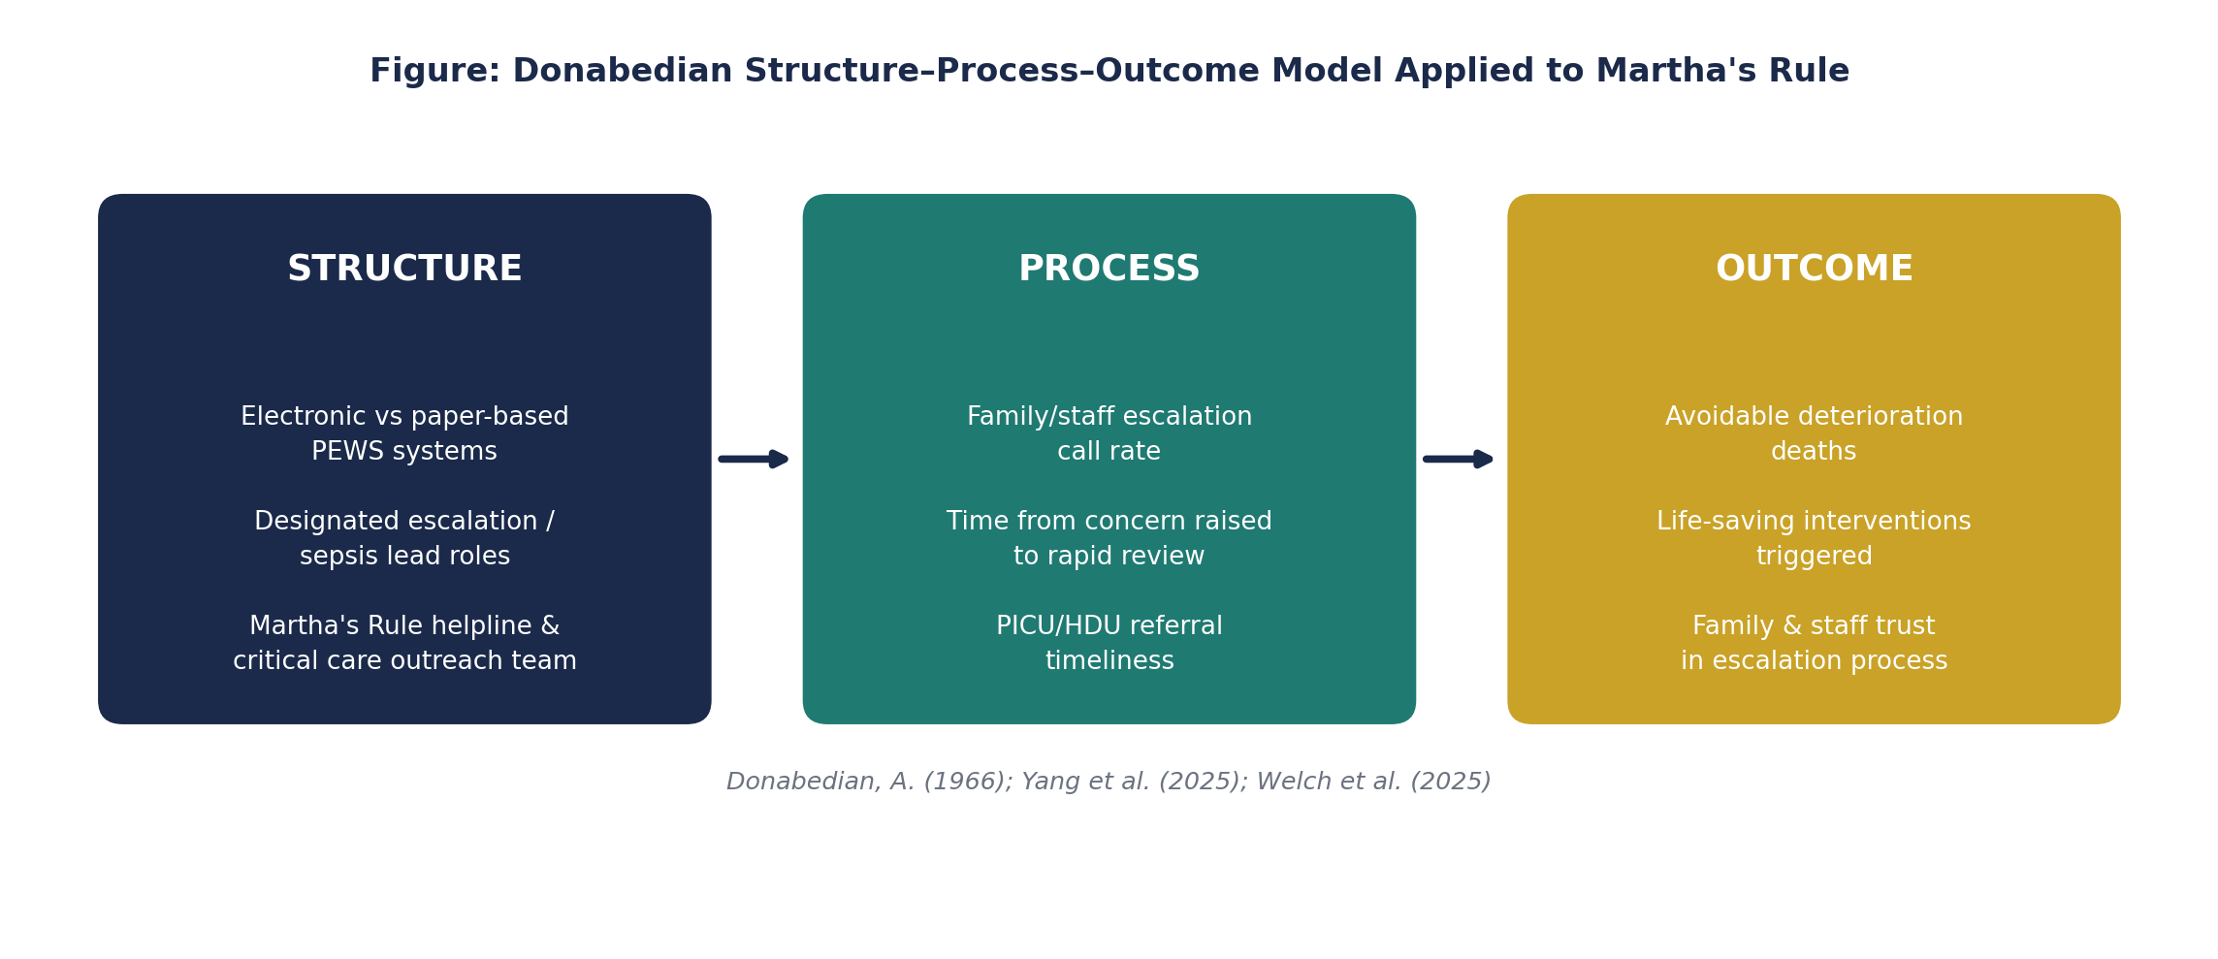
Figure 3: Donabedian Structure Process Outcome Model Applied to Martha's Rule
(Donabedian, 1966; Welch et al., 2025)

SWOT Analysis

A SWOT analysis evaluates factors influencing Martha's Rule's continued success (Harrison, 2010) (see Table 3). The awareness-equity weakness is most urgent, since a family who has never heard of Martha's Rule cannot use it the very groups already at higher risk of poor communication may be least protected. Workforce capacity is the second priority, given rising call volumes without proportional outreach investment. Extending scope to new settings is a lower short-term priority, best following once equity and capacity issues are addressed.
STRENGTHS  - Nationally mandated 24-hour helpline  - Cross-regulator endorsement (GMC, NMC, CQC)  - Rapid rollout in under 18 months | WEAKNESSES  - Only 32% public awareness  - Lower awareness among disadvantaged groups  - Limited so far to acute inpatient services
OPPORTUNITIES  - Continued NIHR-funded evaluation  - Digital integration (portals, EHR alerts)  - Extension to maternity & mental health | THREATS  - Outreach team capacity under rising demand  - Competing national safety priorities  - Risk of awareness plateauing
Table 3: SWOT Analysis : Sustaining and Strengthening Martha's Rule

Recommendations and Implementation Strategy:

3.1 PDSA Cycle:
The phased national rollout, from a 143 site pilot (2024) to all 210 acute hospitals (September 2025), demonstrates iterative, tested change over a single mandate (NHS England, 2025). Table 4 sets out a further PDSA cycle targeting the awareness-equity gap identified above (Institute for Healthcare Improvement, 2021).

Stage | Action | Measure / Evidence
Plan | Co-designed, accessible awareness intervention targeting low-awareness groups (NHS England, 2026b). | Awareness survey score by demographic group.
Do | Pilot in trusts with lower call volumes; train ward staff to support escalation (NHS England, 2025). | Staff training completion; pilot-site call volume.
Study | Compare against 32% national baseline and 61% staff-call accuracy (NHS England, 2026b). | Pre/post awareness data; call accuracy rate.
Act | Scale nationally; extend to maternity/mental health; refine via a further cycle if needed (Deming, 1986). | Roll-out decision; refined intervention design.
Table 4: PDSA Cycle – Awareness and Equity Intervention
Delivering this requires modest resourcing: one three-month cycle (two weeks co-design, two weeks briefing, ten weeks piloting); a named implementation lead using existing patient safety roles; and funding limited to translation, accessible-format materials and training backfill, absorbable within existing improvement budgets.
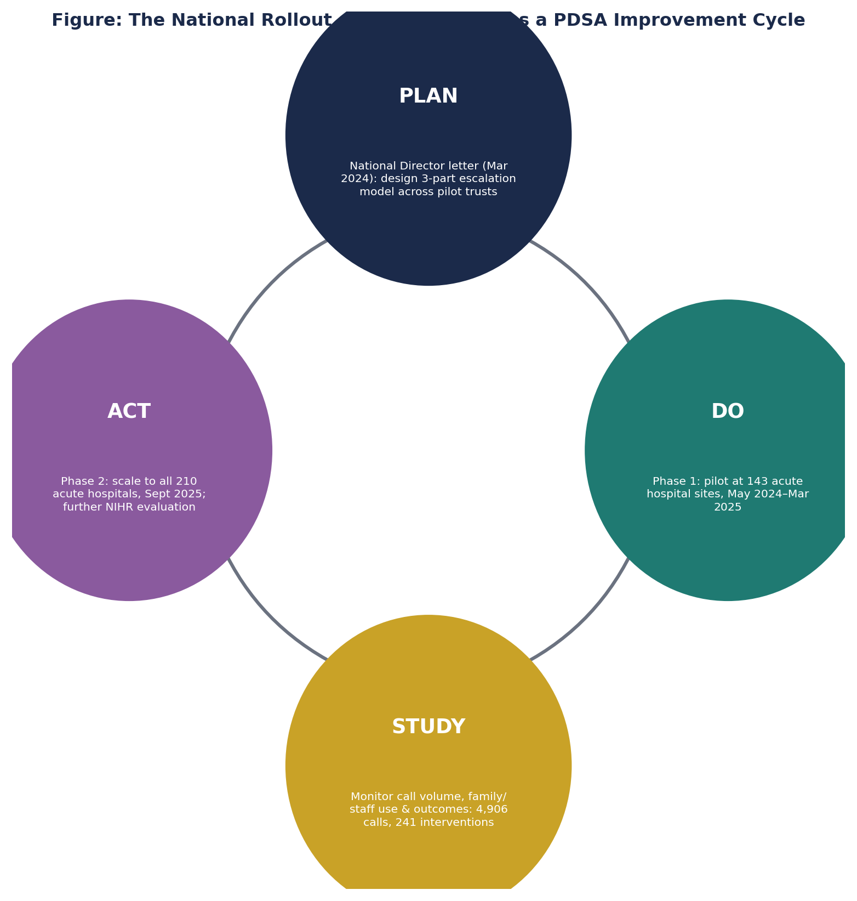
Figure 5: The National Rollout of Martha’s Rule as a PDSA Cycle (NHS England, 2025)

3.2 Change Management: Lewin and Kotter:

Sustaining Martha's Rule requires deliberate cultural change, not process redesign alone, since the Fishbone analysis identified hierarchical culture as a central root cause of Martha's death. A systematic review of 38 healthcare change-management studies found that Kotter's 8-Step Model and Lewin's Unfreeze-Change-Refreeze model were the two most commonly applied frameworks, each valued for providing guiding principles rather than a rigid prescription (Harrison et al., 2021). Applying Lewin's model, 'unfreezing' is represented by the public alarm generated by Martha's inquest and media coverage, which disrupted institutional complacency; 'change' corresponds to the phased pilot and national rollout of the helpline and daily wellness checks; and 'refreezing' requires embedding Martha's Rule into routine ward culture, professional training curricula and CQC inspection standards so escalation becomes normalised rather than exceptional practice. Kotter's model offers a complementary, more staff-facing lens: creating urgency by publicising failure-to-rescue mortality data (Welch et al., 2025); forming a guiding coalition of ward leaders, patient safety champions and family representatives; and communicating short-term wins, such as early increases in staff-initiated calls, to build momentum. Critically, the final anchoring stage, embedding change permanently in organisational culture, was the step most frequently reported as incomplete reinforcing the need for structural safeguards, not policy momentum alone (Harrison et al. 2021).
Resistance should be anticipated: clinician scepticism that escalation implies distrust, and time pressure during admissions. Ryan's Rule evidence counters the first, since under 1% of activations met formal deterioration criteria yet the scheme remained valued by staff (Flynn et al., 2022); the second is addressed by embedding explanation within existing admission documentation rather than treating it as an extra task.

3.3 Lean and Six Sigma:

Lean mapping of the pathway from concern raised to rapid review should remove unnecessary delay, protecting the 'rapid' element central to credibility (George, 2003). Where response-time variation is substantial, Six Sigma DMAIC can identify unwarranted variation between trusts or shifts particularly relevant given Martha's own deterioration occurred during reduced weekend staffing. Trusts should also digitise remaining paper-based early warning systems, directly addressing the technological gap in Martha's case (Judiciary, 2022).

Benchmarking Against Comparable Schemes:

Benchmarking Martha's Rule against internationally established, peer-reviewed escalation systems provides an important external reference point. Queensland's Ryan's Rule, which directly inspired Martha's Rule, is the most extensively evaluated comparator: state-wide, Queensland recorded 2,355 activations in 2023, of which nearly half resulted in no change to planned care (Patient Safety Commissioner, 2026); a larger analysis of 364 activations among surgical patients across ten Queensland hospitals found 92% were resolved through discussion alone, with fewer than 1% meeting formal early warning criteria for deterioration (Flynn et al., 2022); and a retrospective review of 57 activations at one regional hospital found 65% of activators stating they would be comfortable calling again (Dwyer et al., 2020). A closer domestic benchmark comes from Royal Berkshire NHS Foundation Trust's Call for Concern scheme, the direct forerunner of Martha's Rule within the NHS itself. The trust's own 2024-25 Quality Report records a peak of 34 activations in a single month, presented as evidence of sustained staff and family engagement (Royal Berkshire NHS Foundation Trust, 2025), making Royal Berkshire the clearest example of NHS best practice in this area, against which newly rolled-out trusts can measure their own adoption curve, alongside CQC's single assessment framework expectations for partnership working with patients and families Table 5 sets out this comparison against current and target performance; however, differences in population size, health system structure and reporting methodology mean such data should inform, rather than dictate, local improvement priorities(Leeds Teaching Hospitals NHS Trust, 2024).

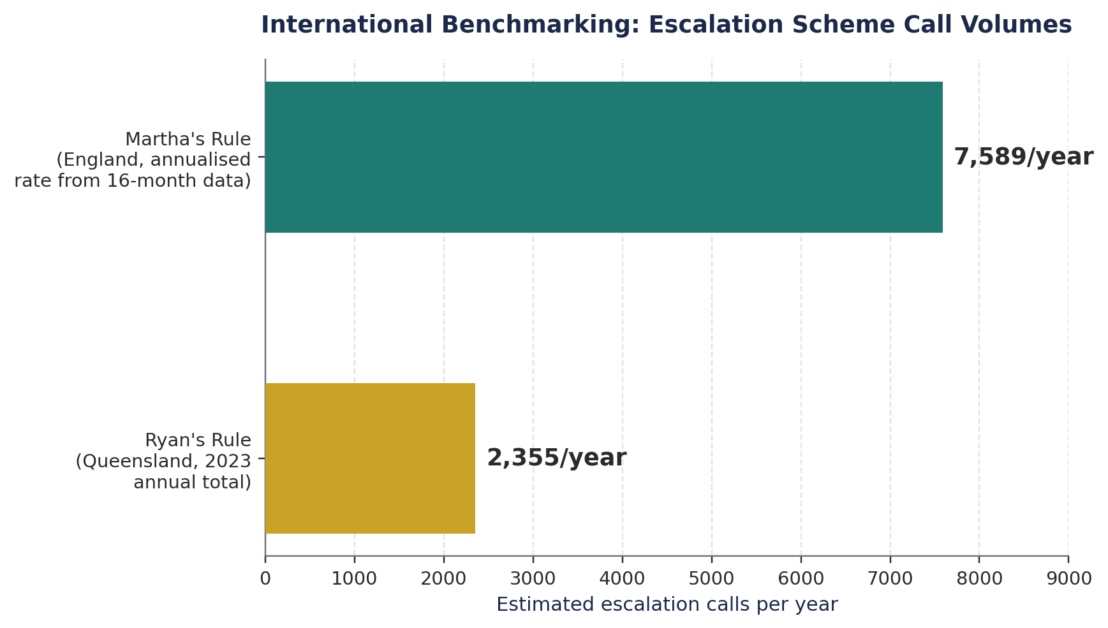
Figure 6: International Benchmarking Martha's Rule vs Ryan's Rule Call Volumes
(NHS England, 2026a; Patient Safety Commissioner, 2026)

Benchmark Area | Current Case (2021) | NHS Best Practice / Standard | Target
Family awareness of escalation rights | No formal right existed; family not told sepsis was suspected (Judiciary, 2022). | Only 32% national awareness (NHS England, 2026b). | ≥60% awareness within 3 years (NHS England, 2026b).
Communication during deterioration | Inconsistent; concerns dismissed without explanation (Healthcare Today, 2025). | Daily structured deterioration checks mandated (NHS England, 2025). | 100% compliance across all 210 trusts (NHS England, 2025).
Family involvement in escalation | Parents' concerns dismissed; liver team held sole authority (Weightmans, 2024). | 72% of calls now family/carer-initiated (NHS England, 2026a). | Sustain >70%; close the equity gap (NHS England, 2026b).
Monitoring & early warning systems | Paper-based BPEWS; no automated alert or audit (Judiciary, 2022). | Monthly national Martha's Rule Data Collection (NHS England, 2026a). | Full digitisation + monthly local audit (Judiciary, 2022).
Appropriateness of use | No baseline data exists. | <1% of Ryan's Rule activations meet formal deterioration criteria (Flynn et al., 2022). | Maintain low over-triage; sustain ≥61% accuracy (NHS England, 2026b).
Table 5: Benchmarking Table Current Case vs NHS Best Practice / Standard vs Target

Conclusion:

This report has evaluated the quality concern exposed by Martha Mills' death: a systemic failure to recognise and escalate deterioration, compounded by dismissal of her family's concerns. The Fishbone and 5 Whys analyses showed this was not one clinical error but an interacting web of hierarchical culture, absent process and policy safeguards, paper-based technology, and reduced weekend staffing. The Donabedian model showed how these deficits were directly addressed by Martha's Rule's structure and process design, while benchmarking against Ryan's Rule and Call for Concern confirmed formal escalation routes are used appropriately rather than overwhelmed by demand.
These findings demonstrate clear integration of theory and practice: quality models informed an implementable, national-scale solution, and Martha's Rule's tested rollout itself exemplifies PDSA operating at system level. The recommendations, combining Lewin's and Kotter's models with Lean-informed pathway protection, offer a realistic path to sustaining this progress, particularly given identify anchoring change in culture as the step most often left incomplete (Harrison et al. 2021). The implications are profound: 446 calls have already resulted in higher-level care transfer, while 1,080 staff-initiated calls independently confirmed genuine deterioration evidence that engaged, less hierarchical ward culture is beginning to take hold (NHS England, 2026a; 2026b).
For NHS leaders, Martha's case offers an enduring lesson: listening to patients and families is a clinical safety mechanism, not a courtesy, whose absence cost a thirteen-year-old girl her life. A newly funded three-year NIHR SafetyNet evaluation across 16 trusts will further strengthen this evidence base (NIHR, 2026). Sustained improvement depends on Martha's Rule being consistently resourced, equitably promoted, and rigorously evaluated, ensuring the lessons of her death become permanent, system-wide practice.

Reference List

- Ayanian, J.Z. and Markel, H. (2016) ‘Donabedian’s lasting framework for health care quality’, New England Journal of Medicine, 375(3), pp. 205–207. Available at: https://www.nejm.org/doi/full/10.1056/NEJMp1605101.
- Cooksley, T., Astbury, S. and Holland, M. (2023) ‘Martha’s Rule and patients’ rights to a second opinion’, BMJ, 383, p. 2221. Available at: https://www.bmj.com/content/383/bmj.p2221.
- george, W.E. (1986) Out of the Crisis. Cambridge, MA: MIT Press.
- Donabedian, A. (1966) ‘Evaluating the quality of medical care’, Milbank Memorial Fund Quarterly, 44(3), pp. 166–206. Available at: https://www.jstor.org/stable/3348969.
- Dwyer, T.A., Flenady, T., Kahl, J. and Quinney, L. (2020) ‘Evaluation of a patient and family activated escalation system: Ryan’s Rule’, Australian Critical Care, 33(1), pp. 39–46. Available at: https://doi.org/10.1016/j.aucc.2019.01.002.
- Flynn, D.E., Flynn, H., Gifford, S. and Smith, K. (2022) ‘Can you hear me? Analysis of a Queensland patient-initiated escalation process and the importance of communication in surgical care’, ANZ Journal of Surgery, 92(6), pp. 1371–1376. Available at: https://onlinelibrary.wiley.com/doi/10.1111/ans.17584.
- George, M.L. (2003) Lean Six Sigma for Service: How to Use Lean Speed and Six Sigma Quality to Improve Services and Transactions. New York: McGraw-Hill.
- Harrison, J.P. (2010) Essentials of Strategic Planning in Healthcare. Chicago: Health Administration Press.
- Harrison, R., Fischer, S., Walpola, R.L., Chauhan, A., Babalola, T., Mears, S. and Le-Dao, H. (2021) ‘Where do models for change management, improvement and implementation meet? A systematic review of the applications of change management models in healthcare’, Journal of Healthcare Leadership, 13, pp. 85–108. Available at: https://www.dovepress.com/where-do-models-for-change-management-improvement-and-implementation-m-peer-reviewed-fulltext-article-JHL.
- Institute for Healthcare Improvement (2021) Plan-Do-Study-Act (PDSA) Worksheet. Available at: https://www.ihi.org/resources/Pages/Tools/PlanDoStudyActWorksheet.aspx.
- Ishikawa, K. (1985) What is Total Quality Control? The Japanese Way. Englewood Cliffs, NJ: Prentice-Hall.
- Judiciary of England and Wales (2022) Martha Mills: Prevention of Future Deaths Report (2022-0063).
- Leeds Teaching Hospitals NHS Trust (2024) Patient Safety and Quality Strategy 2024–2027. Available at: https://www.leedsth.nhs.uk/wp-content/uploads/2024/10/Patient-Safety-and-Quality.pdf.
- National Institute for Health and Care Research (NIHR) (2025) NIHR funds in-depth evaluation of Martha’s Rule.
- NHS England (2019) The NHS Patient Safety Strategy: Safer Culture, Safer Systems, Safer Patients. Available at: https://www.england.nhs.uk/patient-safety/the-nhs-patient-safety-strategy/.
- NHS England (2025) Martha’s Rule rolled out to all acute hospitals. Available at: https://www.england.nhs.uk/2025/09/marthas-rule-rolled-out-to-all-acute-hospitals/.
- NHS England (2026) Martha’s Rule programme statistics. Available at: https://www.england.nhs.uk/statistics/statistical-work-areas/marthas-rule/.
- Patient Safety Commissioner (2024) Introducing Ryan’s Rule, the forerunner of Martha’s Rule. Available at: https://www.patientsafetycommissioner.org.uk/blog/introducing-ryans-rule-the-forerunner-of-marthas-rule/.
- Royal Berkshire NHS Foundation Trust (2025) Quality Report 2024–25. Available at: https://www.royalberkshire.nhs.uk/media/2xpdwmik/quality-report-2024-25.pdf.
- Subbe, C.P., Steinmo, S.H., Haskell, H. and Barach, P. (2024) ‘Martha’s Rule: Applying a behaviour change framework to understand the potential of complementary roles of clinicians and patients in improving safety of patients deteriorating in hospital’, British Journal of Hospital Medicine, 85(2), pp. 1–6. Available at: https://doi.org/10.12968/hmed.2023.0422.
- Sutton, E., Ibrahim, M., Plath, W., Booth, L., Sujan, M., McCulloch, P. and Mackintosh, N. (2025) ‘Understanding the enablers and barriers to implementing a patient-led escalation system: A qualitative study’, BMJ Quality & Safety, 34(1), pp. 18–27. Available at: https://qualitysafety.bmj.com/content/34/1/18.
- Weightmans (2024) Martha’s Rule: What is it and why does it matter? Available at: https://www.weightmans.com/insights/marthas-rule-what-is-it-and-why-does-it-matter/.
- Welch, J., Murkin, J., Edwards, E., Inada-Kim, M. and Subbe, C. (2025) ‘Giving patients, families and staff a reliable voice in acute care: Expert guidance for implementation of Martha’s Rule in UK hospitals’, Future Healthcare Journal, 12(1), Article 100223. Available at: https://doi.org/10.1016/j.fhj.2025.100223.
- Yang, J., Liu, F., Yang, C., Wei, J., Ma, Y., Xu,L., Xie, J. and Wang, J. (2025) ‘Application of Donabedian three-dimensional model in outpatient care quality: A scoping review’, Journal of Nursing Management, 2025, Article 6893336. Available at: https://doi.org/10.1155/jonm/6893336.

