
Module Name: Academic Skills in the Digital Era
Module Code: BMSW4013
Assessment 1: E-Portfolio
Student Name: Kera Ahmed
Student Number: 2441883
Lecturer: Ffion Cumberpatch
Deadline: Friday 21st November 23:59PM

AI Acknowledgement
I confirm that I have not submitted any AI-generated material as my own work.

I confirm that I have copies of my drafts, notes, and other resources that I have used, which I may be asked to provide as evidence.

I acknowledge using Grammarly (https://www.grammarly.com/) on 11/17 to check my work using the following prompt(s):

Please check the following text for readability, grammar, and syntax.

I acknowledge using ChatGPT (https://chatgpt.com/) on 10/27 to research some resources.

Contents
Component 1 – Research and Planning Template (500 words) 4
Source Exploration (200 words) 4
Key Challenge for Students (100-150 words) 4
Key Opportunity for Students (100-150 words) 4
Planning Your Report (100 words) 4
Timeline for Component 2 4
Component 2 – Answering the Question (800 words) 5
Introduction (100-150 words) 5
Challenges Students Face (150-200 words) 5
Opportunities Digital Tools Provide (150-200 words) 5
How Students Can Adapt (200-250 words) 5
Conclusion (100-150 words) 5
Component 3 – Reflective Presentation 6
Slide 1 (Overview) 6
Slide 2 (Research) 6
Slide 3 (Planning & Writing) 6
Slide 4 (Challenges) 6
Slide 5 (Successes) 6
Reference List 7

Component 1
Research.
I selected the study by Denojean-Mairet (A literature review on the integration of microlearning and social media), and the study was published in 2024. The main point of the source is that applications such as TikTok and Instagram can function as effective educational tools by providing short instructional videos and quick feedback for students. I chose this source because it supports the idea that social media can be used for learning as well. This source will help me answer the main question by providing evidence that digital tools—especially social media platforms—are not only sources of distraction but can also be educational resources that enhance student learning when used responsibly.
Students face many challenges in the digital age. I will mention two challenges, which are: First, the distractions that students experience while studying, whether physical or digital factors, but I will focus on the digital aspect. Digital devices such as phones, tablets, and other digital tools, whether games or social media, have become a major factor in distracting students. The other is the excessive use of artificial intelligence tools. Students have started using these tools even in the simplest matters, thinking that all the answers they receive are correct. This is completely wrong, as most of the time the tools do not recognize the content of the question correctly, which leads to incorrect feedback. Just as there are challenges, there are also great opportunities for students in this field. Among these opportunities are digital learning tools such as social media platforms, where students can watch educational videos on YouTube for those who prefer visual learning, or short clips on Instagram and TikTok for those who prefer faster learning. Students can also communicate with their peers and teachers using Microsoft Teams. Furthermore, students can showcase their skills and resumes using LinkedIn and gain experience for the future. These opportunities help students refine their current skills and prepare themselves for future careers.
Planning my report
In the second component, I will address both the challenges and opportunities of the digital era equally, as they are crucial to students' lives. Platforms such as ChatGPT, YouTube, Microsoft Teams, and LinkedIn will be mentioned in the report because they are frequently used in students' academic lives. I will then discuss how students can overcome those challenges by using methods such as time management, critical thinking, and responsible use of tools. Finally, I will conclude with a comprehensive summary of everything discussed. The structure will be (Introduction - Challenges - Opportunities - How students can adapt- Conclusion).

Task | Date/ Deadline
Finish research | 25th of OCT
Draft first section | 30th of OCT
Complete first draft | 10th of NOV
Final editing | 20th of NOV

Component 2

Introduction

In recent years, with the development of digital tools and the booming demand for them, their impact on students' academic, professional, and practical lives has become significant. Students now need to use these tools extensively in their studies, research, and communication with others, unlike in previous decades. They may also need to use these tools in their work environments. This has led to students facing many difficulties and challenges in the digital sphere, but they also have many opportunities in this area. This report will address these challenges and opportunities, as well as propose potential solutions to these issues.

Challenges Students Face.

There are many challenges facing students in the digital world, and distraction is one of the biggest. Digital devices and tools provide the perfect environment for student distraction. With the abundance of distractions such as electronic games and social media platforms, and their irresponsible use, students have easily become distracted and spend their time doing unproductive things for long periods, instead of spending it on more important activities such as their studies (Deng, Zhou, 2024). Therefore, students must try to organize their time and set a schedule for themselves, and also try to stay away as much as possible from distractions while studying and realize the importance of prioritizing their tasks. If they do not realize this, it will lead to low productivity, or in the worst cases, they will not accomplish anything.
Another major challenge facing students is the rapid development of artificial intelligence tools, especially in the last three years. With the emergence of applications like ChatGPT and others, and their high speed in solving problems and providing results, students have become increasingly reliant on these tools, believing that they will complete all their tasks (Zhai, Wibowo, Li, 2024). This leads to a decline in students’ ability to produce tasks and their capacity for critical thinking and information analysis, as they assume that all the information they receive is 100% correct. This is, of course, incorrect, as artificial intelligence does not always understand the questions, and it is also possible that the answers it provides are wrong. Furthermore, excessive reliance on artificial intelligence tools will cause students to lose their self-confidence, and will constantly need to use them, leading to feelings of pressure and stress after submitting what was required of them, and this may also lead to cheating (Delikoura, A., et al., 2025).

Opportunities Digital Tools Provide.

While there are challenges in the digital age for students, it has also provided them with many opportunities. Social media platforms are one of these opportunities that students can exploit to their advantage, as they can use them for their studies by watching educational videos that help them develop and increase their skills in what they need through applications such as YouTube and others of this type (Trenhol & Sven, 2024). According to recent studies, using applications such as TikTok and Instagram to publish and watch short educational videos is a type of education and provides quick feedback for students (Denojean-Mairet, 2024). Also, Microsoft Teams is a good option for students, as it allows them to communicate with their teachers and colleagues, and they can also use it to carry out the required projects or hold meetings if necessary. Furthermore, students can use LinkedIn to build their personal and academic profiles, and they can also find training and job opportunities that help them develop their skills and increase their qualifications for future careers (Louise Lexis, 2023). This will enable students to develop their current skills and abilities and prepare for the future by utilizing these platforms.
Research platforms and online libraries are also among the great opportunities in the digital world, enabling students to verify information and find reliable sources. They can conduct research and find sources suitable for their articles. Through these platforms, students will access the latest literary and scientific developments by reading newly published books and articles, which will allow them to develop their knowledge and receive continuous, valuable feedback. Furthermore, increased reading will improve their academic writing skills and enhance their overall academic level.

How Students Can Adapt.

Students can succeed in their learning environment by implementing practical time management strategies. One important strategy is using digital tools such as Google Calendar and Microsoft To-Do. These applications help students organize their study schedules, break down large tasks into manageable steps, and receive reminders before deadlines. Research shows that students who use digital time management tools experience less academic stress and achieve higher productivity (Zhao, 2023). This strategy works because it helps students control their daily routines, avoid distractions, and prevent last-minute stress.
Another key strategy is developing critical thinking skills when using digital tools. Because the internet contains both reliable and unreliable information, students must learn to analyse sources, question their accuracy, and compare multiple perspectives before accepting information and remaining unbiased. Recent studies show that students who practice critical digital literacy are more successful at identifying misinformation and making informed academic decisions (Liu & Patel, 2024). This approach is effective because it encourages students to think critically, verify information, and become more independent rather than blindly relying on digital tools.
The responsible use of digital tools is also a skill that helps students in this field. Honesty and integrity are essential in their use of these tools; they should not attribute any work to others but simply retrieve the required information (Gustilo & Leah, 2024). This fosters trustworthiness in students’ work and makes them academically and professionally reliable.

Conclusion.

In conclusion, the digital age has created an environment full of challenges and opportunities for students. While issues such as distraction (Dewa & Haryo, 2025), and increased reliance on AI tools can negatively impact student productivity, critical thinking, and academic confidence, the digital world also offers powerful tools that support learning and development. Platforms like YouTube, TikTok (Fekih Zguri, Koç 2024), Microsoft Teams, and LinkedIn have become essential resources that help students acquire new skills, communicate effectively, and prepare for future career opportunities. By adopting practical strategies such as effective time management, responsible technology use, and developing critical digital literacy, students can overcome the difficulties they face and fully leverage the digital tools available to them. Ultimately, students who learn to balance these challenges and opportunities will be better equipped to succeed academically and professionally in a constantly evolving digital environment.

Component 3

Slide 1

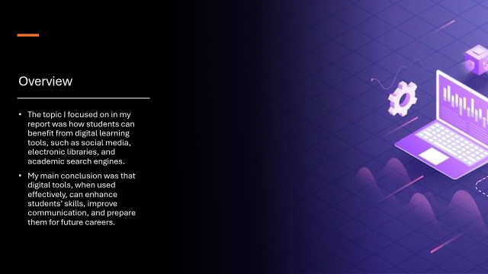
Slide 2
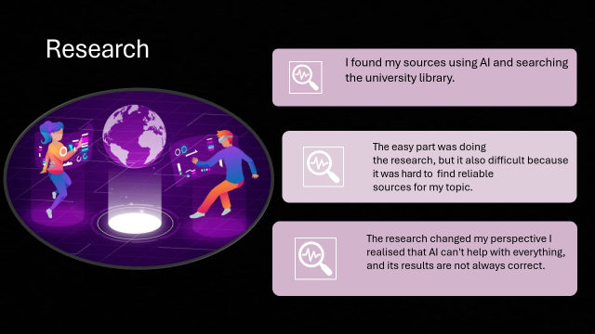

Slide 3

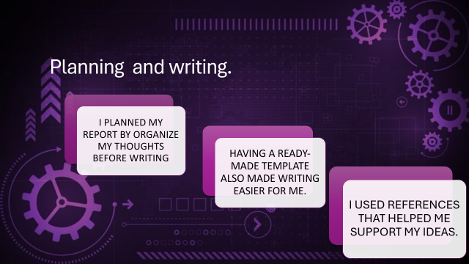

Slide 4
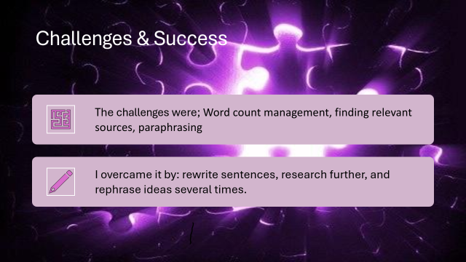

Slide 5

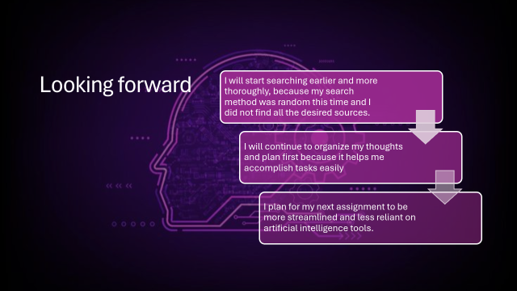

Reference List
Delikoura, I., Yi, R. And Hui, P. (2025) From superficial outputs to superficial learning: Risks of large language models in education. arXiv.
Available at: https://arxiv.org/abs/2509.21972
Deng, L., Zhou, Y. and Broadbent, J. (2024) ‘Distraction, multitasking and self-regulation inside university classroom’, Education and Information Technologies, 29, pp. 23957–23979.
doi: 10.1007/s10639-024-12786-w
Denojean-Mairet, M., López-Pernas, S., Agbo, F.J. and Tedre, M. (2024) ‘A literature review on the integration of microlearning and social media’, Smart Learning Environments, 11(46).
doi: 10.1186/s40561-024-00334-5
Dewa, S. and Haryo, H. (2025) ‘The influence of social media on student learning opportunities and challenges in the digital age’, Journal of English Teaching and Linguistic Issues (JETLI).
Available at: https://ejournal.iaingorontalo.ac.id
Fekih Zguir, M. and Koç, M. (2024) ‘Exploring digital learning opportunities and challenges in higher education institutes: Stakeholder analysis on the use of social media’, Sustainability, 16(15), p. 6413.
doi: 10.3390/su16156413
Gustilo, L., Ong, E. and Lapinid, M.R. (2024) ‘Algorithmically-driven writing and academic integrity: Exploring educators' practices, perceptions, and policies in the AI era’, International Journal for Educational Integrity, 20(1), pp. 3–43.
Lexis, L. (2023) The role of LinkedIn in career development for university students. Professional Skills Review, 4(2), pp. 55–67.
Liu, H. and Patel, R. (2024) Critical digital literacy and students’ ability to evaluate online information. Journal of Digital Learning Research, 7(1), pp. 33–51.
Trenholm, S. and Marmolejo-Ramos, F. (2024) ‘When video improves learning in higher education’, Education Sciences, 14(3), p. 311.
doi: 10.3390/educsci14030311
Zhai, C., Wibowo, S., Li, Y. and Luo, X. (2024) ‘The effects of over-reliance on AI dialogue systems on students’ cognitive abilities: A systematic review’, Smart Learning Environments, 11.
doi: 10.1186/s40561-024-00316-7

