Individual Report Task
Mst. Shalma Pervin
Prepared for: Christian Felices
Date: 27/11/2021

Individual Report Task
Website: https://si-accountingfirm.weebly.com/
Email address: Shalma2019669@gmail.com
Password: dob.12.10.76
Introduction
SI Accounting is a new start-up business aimed to providing accounting, financial and legal services at highly competitive price. In order to start a business, it is important to conduct market research and develop digital content which would help in capitalizing the business. For this report, there was a questionnaire formed and data was collected to evaluate the perceptions of people regarding this business service. The primary data collected from questionnaire helped in creating the targeted website. It helps in identifying the current trends and outline the strategies to provide services.
Questionnaire design & analysis
Conducting primary analysis in the form of questionnaire to the relevant people was very important for this study. Firstly, the company is targeting people and organizations from every segment, hence the market research is very essential. Secondly, identifying the trends of the target market would help in developing strategies to assist them in future. The following graphs represent the findings from the primary data.
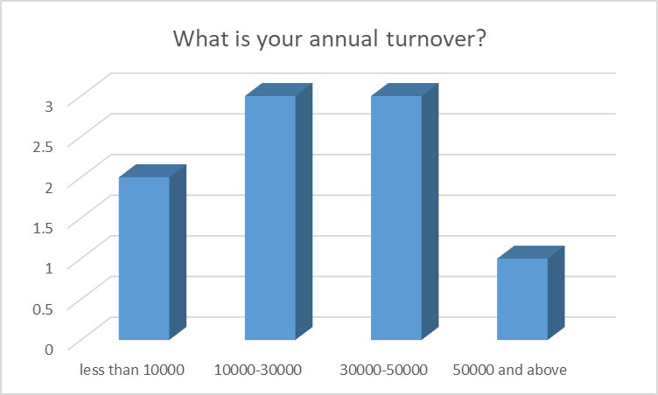
The above graph examines the annual turnover of the participants. It was identified that out of 10 participants, 9 of them answered this question. The results represent that majority of the participants had turnover between 10000 to 50000 pounds as 60% of them stated between this range. Only 1 of them had turnover over 50000 and 2 of them had less than 10000 annual turnovers.
From the findings of the annual turnover, SI Accounting firm can set their pricing strategy as price penetration to cater most of the market. However, each client could be charged according to their revenues and gross sales.
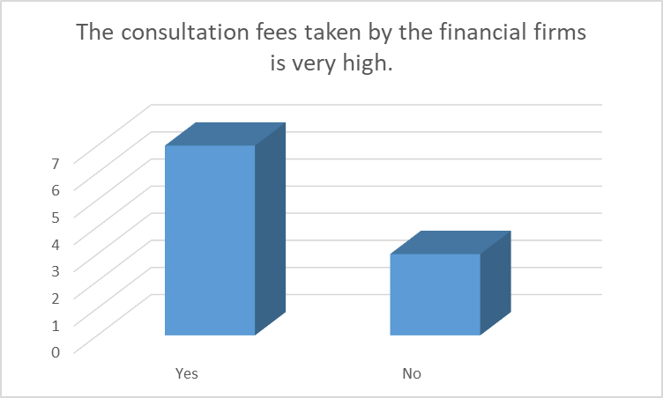
The second question was related to the consultation fees charged by the other firms. 70% of the participants agreed that the fee was very high. This was because the demand for financial services is very high. 30% of them (3 out of 10) disagreed with this statement meaning that they were satisfied and willing to pay higher prices for the services offered to them.
From the findings of this question, it is clear that 30% of the population can pay premium prices while 70% of the participants found these prices expensive. This would help in attracting more clients as the pricing would be set in a way that it is lower than the competitors and is able to attract more clients.
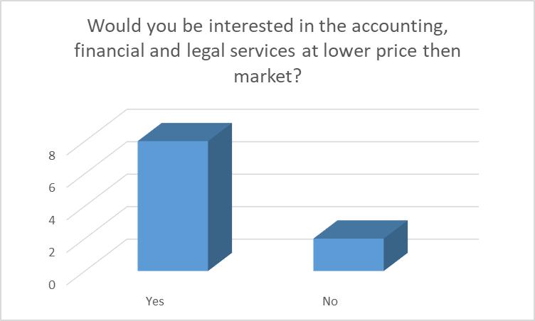
This question was a very important question as it indicated the perception of the people and their willingness to switch for cheaper alternatives. The results showed that 80% of the participants agreed that they would be interested in all sorts of services at lower price then the market. This clearly indicated that there is a high potential for SI Accounting to capture a huge market since people are willing to opt for cheaper services.
Through this question, the company can definitely set its standards and pricing and penetrate in the market to attract the maximum number of customers. Setting out strategies and deciding the market competitive price is a very important task for long term success of the business.

The above question was linked with the preferences of the people over the types of services that would be provided by the SI Accounting firm. It is evident from the graph that 9 of the participants had stated that they would be interested in taxation and management accounting. In addition, 8 of them were interested in audit and financial accounting while 7 of them were interested in the services related to value added tax. This clearly indicated that people would be interested in the services offered by the company and there would be no service that would be left uninterested.
Hence, from the findings of this question, it can be stated that the company can develop their services in a diversified manner to attract more clients.
The results also indicated that primary research is very important for market research. It provides the researcher with useful information and helps in identifying the mindsets of the people. Once the primary research is conducted, the researcher gains further knowledge and is able to formulate long term effective business strategies (Islam and Islam, 2020; Clark and Vealé, 2018). In addition to that, the results of this research helped in identifying that SI Accounting should market its product in a way that it is available to businesses in all aspects such as for the small scale as well as large scale businesses. By providing diversified services at the lesser price then market, SI Accounting can gain in the long run.
Website design
Designing a website which is attractive, user friendly and relevant to the people is very critical and important. Several aspects have to be taken into consideration before making a website (Broeder and Snijder, 2019). Firstly, the results of primary data obtained from questionnaire clearly helped to identify the needs of the people and their income represented that how much they would be willing to pay for financial services. This helped in defining the set of services offered to the people.
The website was designed in a way that it would communicate the message and be highly professional. With the information received from primary data, the business was crystal-clear about what they wanted to achieve. The elements to be added on the website were selected which helped in envisioning the business design to meet the business goals. The front page of the website is as follows:
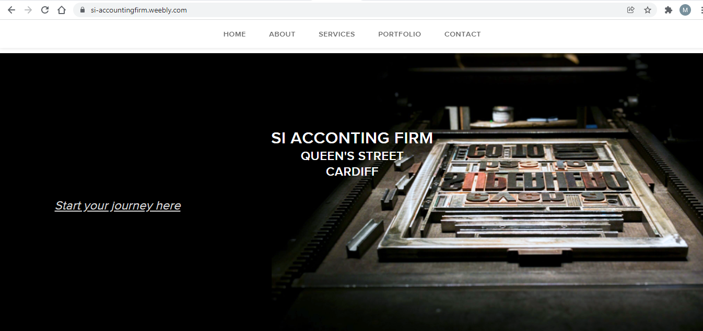
The colour scheme selected was the black background with white font. Selecting the most attractive colour scheme for the website is important (Silvennoinen, Rousi and Mononen, 2017). Black being the dominant colour definitely attracts people. The colour combination helps in establishing the brand identity and black represents boldness, power, authority and dedication. Black being the formal and elegant colour is a symbol to sophistication.
The slogan “start your journeys here” represents the financial journey and the road to success. The image on this page represents that there is a board with several alphabets from which some are missing that are needed to be filled to make it complete. Hence, it represents that SI accounting is willing to fill in all the gaps in the financial aspects of the business as well as to help resolve the issues in different aspects. Hence, the website cover page depicts a very strong message to the potential clients.

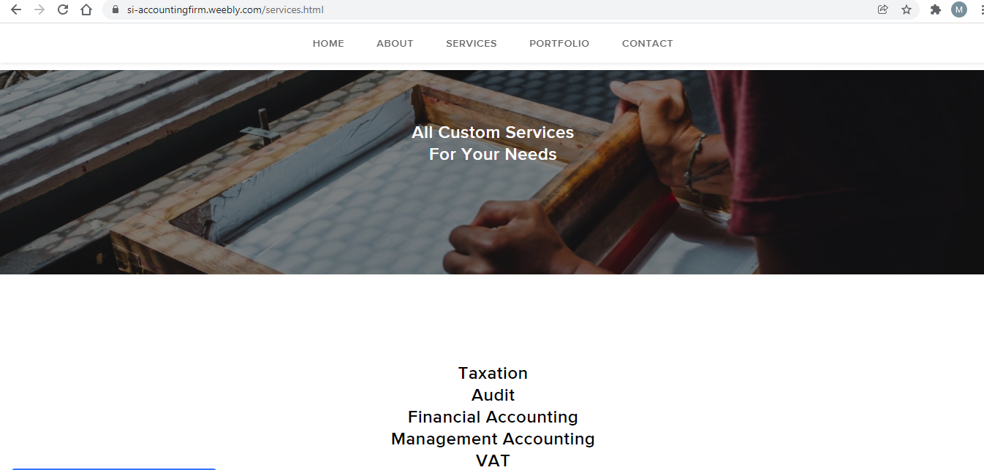
The second page of the website is related to the services offered by SI Accounting firm. The colour scheme selected for this page is white and the picture selected is brown where a woman is seen fixing something. This gives a message that the owner of this firm will provide all sorts of services to help the clients. Several services are mentioned on the page named as taxation, audit, financial accounting, management accounting and Value Added Tax. The words are kept very simple and the tag line used on this page is “all custom services for your needs”. The services are shortlisted based on the preferences of the participants of this research. By conducting primary research, it was very helpful to identify the current mindsets of the people and their willingness to obtain certain services. This would help the company to conduct marketing in the most effective manner that it would reach the maximum population.

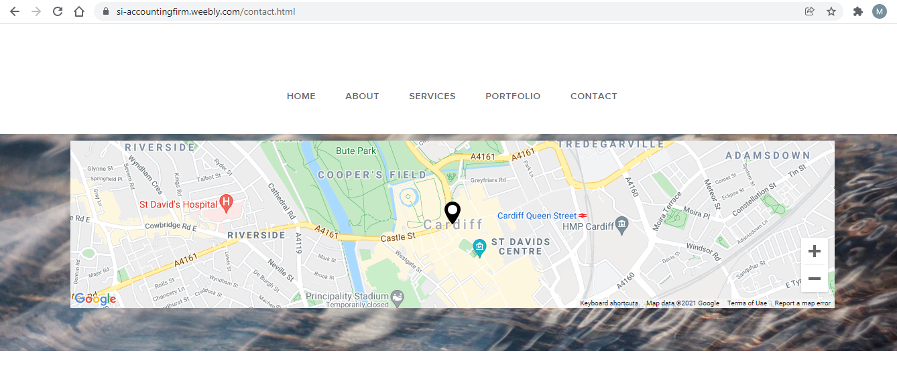
The above screenshot represents the office address through Google maps. This is to provide ease to the people so that they can reach the physical location without any problem. This is a very important strategy as it helps in gaining the confidence of the people as the location is provided to them so there is nothing shady.
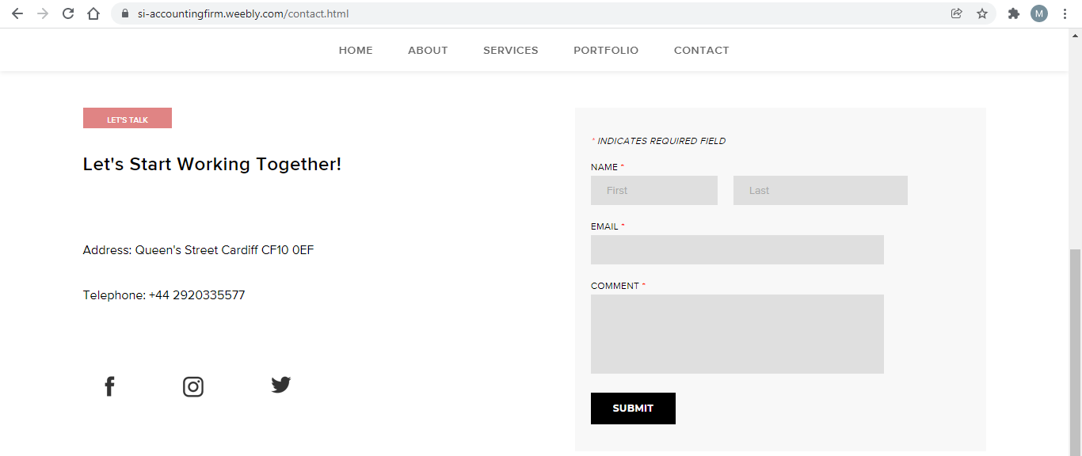
The above screenshot provides the office address and contact number in writing and a form is provided for the people in case they want to connect or have any query. This is a tool which helps in getting connected with the people. It is a very essential way to gain attention and respond to their queries. Even the people are attracted by the prompt responses provided by the company (Ash et al., 2018).
On a whole, the website that is made is very simple and easy to use. This will help the people in getting connected with the company for any of their financial matters. The colour scheme and the key words are also kept very simple so that there is no confusion and the customers are attracted towards simplicity and sophistication.
Conclusion
The idea of this report is to launch a new business and in order to do so, there is a need to conduct an efficient market research. Having efficient digital skills is very essential for the growth of the business; hence, the researcher conducted a primary analysis through questionnaire and collected data from 10 people. The collected data helped in forming the website that would attract potential clients and then SI Accounting will be able to provide them with all the accounting and financial services. Several aspects such as interest of the people, colours, website design, and user friendliness were taken into consideration before developing the website.

References
Ash, J., Anderson, B., Gordon, R. and Langley, P., 2018. Digital interface design and power: Friction, threshold, transition. Environment and Planning D: Society and Space, 36(6), pp.1136-1153.
Broeder, P. and Snijder, H., 2019. Colour in online advertising: Going for trust, which blue is a must. Marketing from Information to Decision Journal, 2(1), pp.5-15.
Clark, K. R., and Vealé, B. L. 2018. Strategies to enhance data collection and analysis in qualitative research. Radiologic technology, 89(5), 482CT-485CT.
Islam, M.N. and Islam, M.S., 2020. Data Collection and Analysis. In Islam and Democracy in South Asia (pp. 49-65). Palgrave Macmillan, Cham.
Silvennoinen, J., Rousi, R. and Mononen, L., 2017. Creative interpretation in Web design experience. The Design Journal, 20(sup1), pp.S134-S145.

Appendix
Questionnaire
Demographics:
Your name: Your age: Gender: Your work experience:

Please answer the following questions:

- What is your annual turnover?
- Less than 10000
- 10000-30000
- 30000-50000
- 50000 and above

- Do you think there is a need to take external help for your financial services?
- Yes
- No

- The consultation fees taken by the financial firms are very high.
- Yes
- No

- Would you be interested in the accounting, financial and legal services at lower price than market?
- Yes
- No

- Which of these services would you be interested in? (tick all that apply)
- Taxation
- Audit
- Financial accounting
- Management accounting
- VAT
- Consultancy

- What do you expect from an accounting firm?

____________________________________________________________________________

- Any suggestions?

___________________________________________________________________________

Thank you for your time. Your participation means a lot and it will be anonymous.

