MARKETING PLAN FOR MUSIC CYMRAEG CYMRU
Contents
- Market Research
- Product/Service Description
- Advertising and Promotion
- Competitive Strategy
- Selling Methods
- Critical Tasks

- MARKET RESEARCH
Music Cymraeg Cymru is a bilingual music theory teaching business that allows all age groups to expand their music theory knowledge through one to one tuition.

The aim of this business is to help people learn what they lack in schools. This being creative thinking, positive reassurance and lessons which are tailored to their needs. With so many schools teaching from a curriculum, this gives me the chance to focus on the individuals needs based on their level of knowledge and to offer a friendly, supportive service. Not only this, but I will also be able to teach them in the comfort of their own home and in the language, they feel most comfortable speaking in, whether it be English or welsh.

With us, it won't feel like a robotic lesson, the aim is to make students feel comfortable and to allow them to learn in their own time and in their own creative way. Our aim is to emphasise the fact that we are a bilingual teaching business and to ensure that people are aware.

The market place for private tutoring continues to rise and is at an estimated worth of £6bn in the UK. Thus, making it a competitive market. Prices for private tutoring can vary from as low as £20.00 an hour to as much as £40.00 an hour. Due to the competitiveness in prices and market, this makes it difficult for new entries.
But, with rise in technology. Promoting businesses couldn’t be easier. Social media sites such as Facebook, Instagram and Twitter are now known as marketing tools and prove to be very effective with business promoting. There is a specific tool on these social media sites called boosting. Boosting is when you pay to promote your business by reaching out to different audiences, it allows the business to select their target audience.

My potential customer market is parents who are looking to help their child learn music theory for the future, it could also be teachers who are starting out and are looking for some extra help on how to lay out lessons. For them to know how to start teaching music lessons they would possibly require a recap of music theory overall. They might need to experience being taught themselves for them to take notes on how they could improve for when they start teaching or what they find effective within my teaching to help them learn and teach.

- PRODUCT/SERVICE DESCRIPTION
Music Cymraeg Cymru is a Business which is offering Music theory tuition for £15.00 per 30 minutes and £25.00 an hour. Our services can offer anything that will satisfy the customers needs. If for example the pupil is a beginner, lessons will focus on the introduction to music theory, why it’s important in the music industry and will progress from there. Lessons will also be held at a pace the pupil is comfortable with. If the pupil is advanced or intermediate, the business will offer flexibility with the lessons to tailor to the pupils needs. Music Cymraeg Cymru is all about tailoring to the customers needs and keeping them happy.
What the business can’t emphasise enough, is the fact that we are BILINGUAL and MOBILE. This is the business’s Unique selling point. With the welsh language being quite rare nowadays it is hard to find a tutor which will teach you in the medium of welsh. The business is aiming to solve the problem of fluent welsh speakers struggling to understand certain English terminology.
A brief example: With young children who have never been taught music theory but are fluent welsh speakers because they attend welsh primary schools, there might be a language barrier for them with being able to learn music theory. They might not understand certain things because they have not been given the choice to learn in Welsh. With some fluent welsh children, they find it difficult to learn in English because they have only ever been taught in the medium of welsh. Therefore, when it comes to explaining something to them within a subject, they have great difficulty understanding.
With tutoring, people aren’t given enough options and we are here to tackle the learning curve. Whether it be because of difficulty understanding English or whether it be that your child or an individual take longer to process and learn information compared to others. We’re not here to judge, we’re here to help.
Another service we do offer is mobile service. If an individual doesn’t have transport. It’s not a problem. We offer lessons in the comfort of their own homes. This could be beneficial for parents with children. Being able to see that the child is safe in another room of the house where you can keep an eye is a confidence booster alone.
Customers should choose Music Cymraeg Cymru because we are sympathetic towards customers. We care about them. We care about what they think and if they aren’t happy with our services, we will improve and do everything we can to make the customer happy.
We are MOBILE and BILINGUAL. Not a lot of companies can say, we come to you and we can offer our services strictly in the medium of welsh only, if preferred. With the bonus of low prices, friendly staff and an offer of 20% off the first lesson.

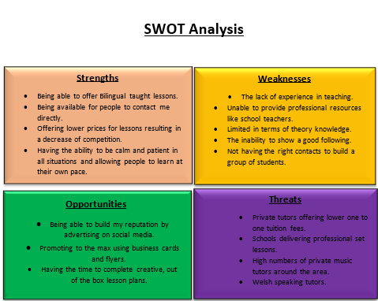
  - SWOT ANALYSIS

Write about the findings (a conclusion) from the SWOT analysis focusing on how you will take advantage of the opportunities that you’ve identified (maximising your strengths), and how you will reduce the threats and the effect on your idea/business...
I will be Building my online reputation using social media platforms such as Facebook and Instagram and boosting the business page in order to keep an active social media market and highlighting my strengths such as being a bilingual tutor at low, affordable prices. Advantage will be taken of distributing flyers and business cards and building a positive online reputation.
Weaknesses can be tackled by studying more music theory, keeping on top of reading and learning and building the correct contacts. Threats can be overcome by offering quality service at lower prices with a lot of active contact such as: showing them who I am, what I do and what I’m offering.

- ADVERTISING & PROMOTION
Promotional Video
Will have a short promotional video in order to promote the business and what we do. This will be uploaded to You Tube. You Tube is also a powerful tool which can be used to promote businesses. You Tube is a great way to promote the business but it’s all about strategy. For example: when a video is posted, make sure that you enter relevant keywords, this will immediately boost views. As well as keywords, URL links to the social media pages.
Facebook Boosting
Facebook is a powerful tool which can be used to target specific audience for a small fee. This is called Boosting. The boosting will be applied to the post for 3 months minimum. This will reach out to as many potential customers as possible. In order to be able to boost, a Facebook page specifically for the business must be made with some recognition beforehand before it can be boosted. This will be done by myself as part of the business’s promotion plan.
Flyers
Flyers will be distributed in music shops and schools. This will also help increase my odds in achieving one to one session with pupils. Flyers and Business cards will be made by myself using an online software called Vista Print. Once these are done, photos must be taken of the business cards and flyers in order to post them on to social media as part of the media promotion strategy. Flyer and cards will be handed out by myself and will be visible in community areas.
Loyalty Bonuses
There is one more strategy that can be used in order to ensure the customers return. This is a common way to earn their loyalty. This is known as Lesson Blocks. Pupils will have the option to book blocks of lessons. But these must be profitable for myself and come across as cheaper than single lessons for the pupils.

- COMPETITOR STRATEGY

My main competitors are online businesses such as Tutorful and First tutors. These are online search engine sites that help people find the tutors for them. The Tutors are worldwide, males and females and some are mobile. But each tutor has a different set price. When you search for different tutors, they all lack a full name or a profile picture, but they all seem to have the qualifications needed to be able to teach the different subjects. This gives me a feeling of uncertainty as to whether they are genuine teachers or not.

Carla
By searching on First tutors, a woman named Carla appeared to be one of my threats. She is a tutor from Merthyr who Is offering multiple studies within music, including music theory. She has a lot of positive aspects; she offers tutoring in all levels of music theory and claims to be a fully qualified teacher. She Is also Bilingual but doesn’t offer welsh. She is fluent in French and English with cheap tutoring at a rate of £25.00 an hour.
Although she has great presentation and great aspects about her she doesn't seem to be offering any less than an hour tuition time, there is no option to directly contact her by Email or Phone, she only has two reviews on her website as well which isn’t reassuring in terms of her being a good tutor and she does not offer home tuition. Meaning she is limited with students she can teach.

Carla V
Moving on to my second competitor who appeared through a tutor search engine website called Tutorful. This woman’s name is Carla V and she also offers tuition in music theory. She appears to have a very good and clear Bio explaining her aims and objectives for teaching, she can show her qualification in teaching and claims to have a degree in popular music technology. Her travel radius is about 20 miles from Swansea city centre. And she also has a direct message button for if you would like to book direct. Her prices seem to be quite steep; she charges £28.00 an hour and doesn’t offer 30-minute lessons. Reviews from previous or present customers.
She is limited with knowledge of all subjects she is offering to teach. This due to her profile offering beginner to intermediate levels only with no discounted offers for first lessons and is unable to offer bilingual services.

Arwen March
Arwen March from Music teachers online is a one to one tutor advertising her services for music theory teaching. She has a personal profile with all her qualifications, she is also able to offer more than music theory alone, thus, showing people that she is an advanced musician in more than one area of music. She is also very cheap. Her price is £15.00 for half an hour and £30.00 an hour.
Though her pricing is cheap, her profile is very dull and simple with no sign of a profile photo. A profile photo is a personal thing, in my opinion it's essential for people to see who you are. She is also missing the ability to speak in the medium of welsh. This lowers the competition immediately.

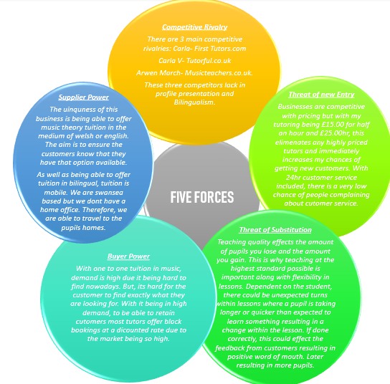
  - PORTERS 5 FORCES ANALYSIS

By doing this analysis I have concluded on how I can overcome the threats and rivalry of other businesses. By overcoming the problems that the other business has encountered I shall use social media marketing to my advantage by boosting and building a reputation and receiving an outcome of positive reviews. Rising above their mistakes. Ensuring that people understand what the business is and what we are offering along with the ultimate selling points such as discounts and the option to speak welsh as well as offering the services at low costs.
PRICING STRATEGY
Music Cymraeg Cymru will offer lessons in half hour or 1 hour slots. A half hour session will be priced at £15, and an hour session will be priced at £25. There will also be a discount for block bookings, 10% off when booking blocks of 10 sessions or more.
There will also be a 20% discount on first lessons.
I have decided to give 20% off first lessons in order to give people a taster of what to expect from me as a teacher and from the lessons.
Block bookings is a way for me to turn the customers in to loyal ones. With individual lessons the prices are reasonable yet not low enough for people to question my ability to teach. The lessons are also lower than other competitors.

- SELLING METHODS

People can contact me direct via phone. They can also message or email me directly. My mobile and email will be reachable on social media platforms such as Facebook and Instagram.
There is a booking system on Facebook if customers wish to book lessons online. This can be found on the Business’s personal page under the button ‘Book now’. A calendar with all available dates and lessons will then appear. It’s a simple and easy system which is linked directly to my mobile. Once the pupil has booked a lesson, Facebook will automatically inform me by text message.
Payment methods for the lessons will be an option of cash or Pay pal machine, which I will be purchasing. Payments will not be booked in advanced unless they are block bookings. Block bookings will also have to be paid for using Pay Pal.

- CRITICAL TASKS

ACTIVITY | TIMESCALE/DEADLINE | ASSIGNED TO | BUDGET
Promotion Video | To be completed by the 30th of April to coincide with Facebook marketing Campaign | Edited by David Cooper Films.  Managed by myself. | £350
Facebook Marketing Campaign | Boosting from the 1st of May for 3 months. | Organized by myself.  Undertaken by Facebook. | £100 Monthly  Totalling: £300
Creating Flyers and Business Cards | To be completed by the 20th of March | Created using Vista Print  Designed by myself | Business cards £27.58 for a pack of 100.  50 Flyers: £28.06.
Distribution of  Flyer and Business cards | To be done on the 1st of April. | Distributed by myself to schools, Music shops and communal areas. | £0
Networking | This is a continuous activity which but will be done a lot for the first few months starting from the 20th of March. | Assigned to myself | £0

