Qualification: CIPD Diploma in Applied Human Resources

Module Name: Using a Research Approach in HR (5CIHR)

Using a Research Approach in HR – Activity 2
Undertake research into an area of HR and write a business report for identified stakeholders. Within your report you should:
1. Assess a range of primary and secondary data sources suitable for the area investigated;
2. Explain how you collected and analysed the data, justifying the methodology adopted;
3. Draw conclusions and make recommendations based on the data.

Word Count: 2665

Student Name: David Harris
Student Number: 1907534
CIPD Membership Number:

By signing below, I confirm that the work/evidence presented is my own, unaided work. I understand the regulations pertaining to candidate malpractice and the action that may be taken as a result.

Signed: 
Date: 12/05/2021

David Harris
Heddlu Dyfed-Powys Police
SMARTER / hybrid Working and its impact on productivity and performance

Executive Summary

This report has been written for the Head of the Business Support Unit, to further the work carried out by Organisational Learning Cell, who undertook a survey with the Business Support Unit on the Force’s approach to the COVID-19 pandemic.
This report aims to identify how an adoption of SMARTER / hybrid working has impacted the work of the Business Support Unit, and what the potential benefits or pitfalls have been on departmental and individual productivity and performance. In addition it aimed to highlight any potential green benefits that could be realised by a reduction in commuting across the department.
Secondary research was undertaken to review the global approach to agile and home working. It is clear that the staff within the Business Support Unit have been affected by the COVID-19 pandemic - and with an increase in the necessity for home working - this has resulted in a requirement to adapt working practices to suit this new way of working. This echoes the findings of the secondary research, with individuals looking for a more flexible, family centred approach to working conditions and working hours. The result of this was almost half of the Business Support Unit staff utilising changes in the working hours to suit their home life, with some choosing to work outside of the ‘normal’ Monday to Friday working week. Additionally, staff also benefitted from a reduction in the time spent commuting to and from work, with some individuals saving up to 2 hours per day off their commute.
This report identifies that there are clear benefits for the individual and department in a more fluid approach to working hours – something which should be further addressed by the department to ensure that this continues beyond the COVID-19 pandemic.
Recommendations made as part of this report are:
- Dyfed-Powys Police formalise the extension of the flexi bandwidth to allow individuals to work more flexibly between the hours of 7am and 10pm – Monday to Friday, thus creating a more ‘family centred’ approach to working hours.
- Dyfed-Powys Police to look to capitalise on the green benefits of an organisational reduction in commuting.
- The Business Support Unit to set up a series of focus groups to further develop best practice changes identified during the COVID pandemic, creating an action plan for delivery across the department, where new ways of working can be adopted.

Contents
1. Executive Summary 2
1. Introduction 4
2.1 Aim 4
2.2 Objectives 4
3. Literature Review 4
3.1 What is SMARTER/Hybrid working? 4
3.2 How many people are working from home? 5
3.3 What are the green effects of working from home? 5
3.4 What affect has home working had on productivity and performance 6
3.5 What is the likely future of home/agile working? 6
4. Methodology 7
5. Findings 7
6. Conclusion 8
6. Recommendations 9
7. Limitations 9
Bibliography 10
Appendix A 12
Appendix B 14

Introduction

Dyfed-Powys Police covers a geographical area of Wales, covering 4,188 square miles and provides a service to the communities of Carmarthenshire, Pembrokeshire, Powys and Ceredigion, with their 515,414 resident population.
The organisation’s administration and back office function are largely delivered by a Business Support Unit, made up of 14 separate and disparate teams and consisting of 82 staff.

2.1 Aim

The aim of this report is to identify what impact the SMARTER / hybrid working practices have had on the Business Support Unit and its staff. It looks to identify what impact the requirement for more remote working practices have had on individual and departmental performance. It also looks to provide some context of how agile and hybrid working is affecting external organisations across the UK and the wider world. This report builds upon the work completed by the Organisational Learning Cell, who conducted a peer review of the Business Support Unit and their response to COVID-19 pandemic. Within this peer review, it is identified that: “there is a real positive opportunity for the BSU to embrace and develop their approach to ‘Smarter& Hybrid working”.

2.2 Objectives

- Identify what secondary research has been conducted assessing the effect of SMARTER/Hybrid working on individual and organisational performance.
- Understand the impact SMARTER/Hybrid working has had on the individual and departmental performance and productivity of the Business Support Unit and its staff.
- Identify areas where improvements can be made and harness areas of good practice across the Business Support Unit.
- Make recommendations for further introduction of performance improvement initiative across the Business Support Unit.

3. Literature Review

A wide range of external literature was reviewed for this report, including the Chartered Institute for Personnel and Development (CIPD), Office of National Statistics (ONS) as well as other on-line journals.

What is SMARTER/Hybrid working?

Working in an agile way and away from the office has seen a steady increase in some sectors over recent years, however the COVID-19 pandemic has caused this to spike dramatically. The Chartered Institute of Personnel and Development (CIPD) define agile working as the:
“ability to stay open to new directions and be continually proactive, helping to assess the limits or indeed risks of existing approaches and ensuring that leaders and followers have an agile and change-ready mind-set to enable them and ultimately the organisation to keep moving, changing, adapting”.
With 43% of individuals looking to alter when and where they work (CIPD, 2014), there is now a significant driver for organisations to adopt a more SMARTER way of working. CIPD (Baker, 2020) research shows an increase in remote working to be a major trend in the way organisations work in the future, with an anticipated increase in the request to work remotely, even after the COVID-19 pandemic is over. This remote and agile way of working comes with a range of possible benefits to individuals, including the ability to balance caring responsibilities with work, adjusting resource and skill deployment and maintaining work motivation (CIPD, 2020). With this in mind, this is an area that organisations will need to assess in the future.

3.2 How many people are working from home?

Since the COVID-19 pandemic gripped the UK in 2020, there has been a dramatic increase in the number of individuals working in a more agile manner. Prior to the pandemic 68% of individuals never worked from home (YouGov, 2020), however this saw a huge upward shift in line with the government’s mandate to ‘work from home’, in an effort to reduce the infection rate.
In April 2020, 48% of individuals carried out some work from home, with this peaking at almost 70% for professional occupations. COVID-19 was of course a factor in this upward trend, with almost 90% (86%) of individuals who worked from home stating this to be the reason (ONS, 2020). When compared to 2019, there were only 30% of the workforce having worked from home (ONS, 2019), with only 45% of professional occupations stating that they had ever worked from home, with just 5.8% working from home regularly.

What are the green effects of working from home?

With the average UK worker spending 400 days of their life commuting to and from work (Total Jobs, 2016), there are clear benefits to be gained by reducing this, for both the individual, but also the carbon impact that reduced commuting can have (Murray-Nevill, 2016). With a reduction in the number of days employees were required to commute to their workplace, this could reduce greenhouse emissions by 54 million tons per year as well as huge reductions in the level of fossil fuel consumed for the purpose of travel (Greenchild, 2020). A reduction in employees travelling to the workplace will dramatically reduce greenhouse emissions, which could total as much as taking 600,000 vehicles off the road.
From a review of the Business Support Unit staff’s travel times, this is an average of 25.6 miles per day, with an average travel time of 45.6 minutes. There are 19 staff regularly travelling up to an hour per day commuting to and from work, with 5 individuals spending 90 minutes or more commuting. The increase in smarter working not only looks to reduce the emissions that regular commuting causes, but also allows staff to reinvest time and better manage their days (Dautovic, 2021), reducing the risk of mental ill health caused by excessive commuting (Roxby, 2014).
Additionally, any reduction in organisational estate could lead to a reduction in energy consumption, with company and residential making up 36% of global energy use (Orrell and Leger, 2020).

What affect has home working had on productivity and performance

There are some clear benefits to less commuting on a regular basis, or a reduction in travelling as part of their work for meetings. As mentioned earlier, this has a positive green impact, however is this enough to continue to work from home and how is this balanced against the impact on performance and productivity?
Over recent years there has been a stigma attached to home working, with this being viewed in a dim light. This now appears to be lifting, with the COVID-19 pandemic forcing organisations to embrace this new way of working. Bloom et al (2015) identifies that the use of home working can increase the productivity and performance of an individual, however also notes that this way of working does not suit everyone. The study saw a 13% increase in productivity of individual who worked from home, with 50% of these individuals also seeing an increase in job satisfaction and increased psychological scores. These findings were also echoed in a similar 2015 study, where individuals who worked from home – even if only infrequently – recognised an increase in productivity levels with 30% of individuals completing more work in less time. These findings are echoed in similar studies with individuals showing an increased ability to deliver more work during a day, with a reduction in commuting and distraction (BBC).
In addition to the organisational benefits, there are personal benefits to this new way of working. Stress levels can be reduced whilst working from home, with an increase in flexibility that this can bring. Additionally, morale has been reported to increase in home workers, which can lead to a reduction in workplace attrition (Small Business, 2017).

3.5 What is the likely future of home/agile working?

What the COVID pandemic has shown is that it is wholly possible for large proportions of a workforce to work remotely from their normal place of work, with minimal or no impact on productivity or performance. Does this mean, however, that this should be what the future of work looks like? Whilst productivity has remained largely unaffected by SMARTER/Hybrid working, there is a need for individuals to feel a social connection which is provided by working with others. That said, individuals have also seen great benefits from increased levels of autonomy and self-direction of role with the introduction of home working (Parry et al, 2021). Parry (2021) confirms that 88% of individuals feel they have got equal or more done from home than in the office and 64% enjoy the flexibility it offers. With these figures in mind, the question should be one of why would we all return to the office?

4. Methodology

During this report, secondary research was reviewed from multiple different academic sources, including the Chartered Institute of Personnel and Development (CIPD), Office of National Statistics (ONS), Government sites, as well as a range of private organisations. In addition, primary research was undertaken by conducting a survey with the members of the Business Support Unit. In total, this survey was sent to 82 employees, who have a mixture of service length and are a mix of genders and positions within the department.
The purpose of this survey was to gain an understanding of the impact of SMARTER / Hybrid working across the different departments within the Business Support Unit, and to identify whether it was felt that this new way of working impacted on personal and departmental performance and productivity. This survey used largely closed questions to allow for simple analysis to be conducted, with a view of a further focus group process being undertaken subsequently to delve into the responses further.

Findings

The survey conducted with the staff from the Business Support Unit resulted in a strong return rate, with 63 respondents in total. This equates to a 75.9% response rate.
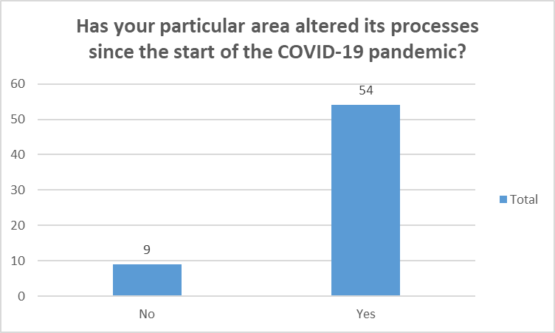
Overall, 75% (n=47) of the respondents felt that the way they worked had altered since the start of the pandemic, with 54 of the total respondents feeling that their particular business area had altered some of its processes to accommodate with the changes.
When individuals were asked what affect the pandemic had on their personal and departmental performance, 56% of respondents felt that the implementation of a SMARTER/Hybrid approach to work had been a positive change, with only 6% feeling this had a negative effect. This was consistent when compared with individuals’ views of the impact to their teams’ performance or productivity. Comments were made within the survey of improvements in processes due to digitisation and an increased emphasis on process improvement and continuous improvement. These are areas which should be explored further in focus groups.
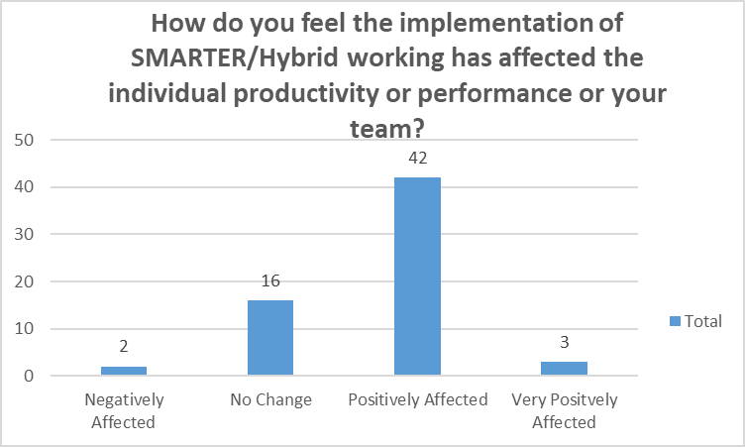
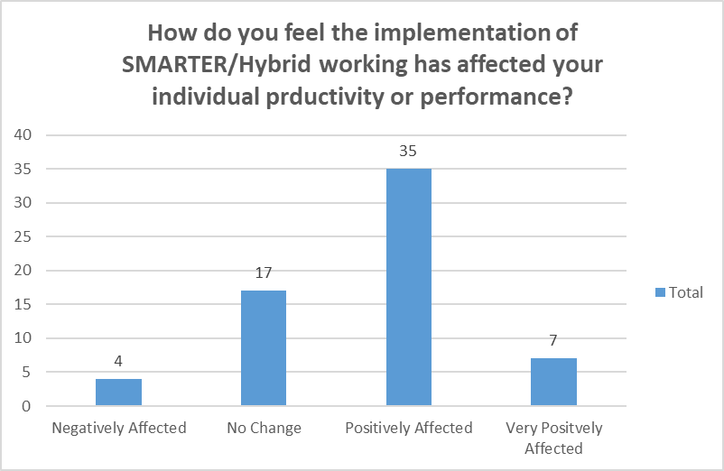
Outside of performance related queries, individuals were also asked if they had utilised the broadening of the organisation’s flexi bandwidth (increase to 7am to 10pm). Of the total responses, 49% of individuals stated they had utilised this extended bandwidth, however only 14% utilised working on a Saturday or Sunday.
Lastly, the survey asked individuals whether they felt there were further areas of work that could be improved within their team, by the use of SMARTER/Hybrid working practices. The responses to this were unanimous, with 95% of respondents suggesting that more could be done to further improve the way they, or their department worked. This is something which the Business Support should investigate further through more focused group sessions with staff across the department, aimed at identifying specifically what has worked well and how this could be used in other business areas.

Conclusion

Considering the evidence provided within this report, it can be concluded that the impact of the SMARTER/Hybrid working has resulted in changes to the way that daily business is delivered. This has resulted in changes in both the practical way that business is delivered, but also the ‘when’ and ‘where’ this is done.
Across the Business Support Unit large numbers of staff have utilised the additional flexibility the organisation has offered for when hours are worked, with 31 staff utilising the increased flexi bandwidth and 9 staff working outside of the ‘normal’ Monday to Friday week. Additionally, the staff within the Business Support Unit have an average commute to work of 25.6 miles (per day) which, if not required to be undertaken each day could have a significant ‘green’ impact, as well as offering reduced travel time and costs for employees. This is also likely to have a beneficial impact on individual’s mental health.
Generally there has a been a positive approach to the COVID-19 pandemic with staff adapting well to new ways of working, which has brought Dyfed-Powys Police in line with other private sector organisations. It is important that this is now built upon and that the Business Support Unit staff are continued to be engaged with further, so as to harness the positive changes made across most teams within the department. This will ensure that the department as a whole continues to develop practices, utilising IT wherever possible.

6. Recommendations

In light of the information contained within this report, I would recommend the following actions be considered by the Head of the Business Support Unit and the Business Support Unit Management Team.
- Dyfed-Powys Police formalise the extension of the flexi bandwidth to allow individuals to work more flexibly between the hours of 7am and 10pm – Monday to Friday, thus creating a more ‘family centred’ approach to working hours.
- Dyfed-Powys Police to look to capitalise on the green benefits of an organisational reduction in commuting.
- The Business Support Unit to set up a series of focus groups to further develop best practice changes identified during the COVID pandemic, creating an action plan for delivery across the department, where new ways of working can be adopted.

7. Limitations

This report is limited in that it only captures the views of the employees who work within the Business Support Unit and does not provide a view of the wider organisation. In addition, it only contains the views of those individuals who engaged in the survey.

Bibliography
There are no sources in the current document.

CIPD (2014). ‘HR: Getting smart about agile working’. Accessed at: hr-getting-smart-agile-working_2014_tcm18-14105.pdf (cipd.co.uk). Accessed on 29/03/2021.
YouGov (2020). ‘Most workers want to work from home after COVID-19’. Accessed at: Most workers want to work from home after COVID-19 | YouGov. Accessed on 29/03/2021.
ONS (2020). ‘Home Working’. Accessed at: Homeworking - Office for National Statistics (ons.gov.uk). Accessed on 30/03/2021.
Gov.UK (2021). ‘Covid-19: epidemiology, virology and clinical features’. Accessed at: COVID-19: epidemiology, virology and clinical features - GOV.UK (www.gov.uk). Accessed on 30/03/2021.
Gov.UK (2020). ‘Working safely during coronavirus (COVID-19)’. Accessed at: Other people's homes - Working safely during coronavirus (COVID-19) - Guidance - GOV.UK (www.gov.uk). Accessed on 30/03/2021.
ONS (2019). ‘Coronavirus and home working in the UK labour market: 2019’. Accessed at: Coronavirus and homeworking in the UK labour market - Office for National Statistics (ons.gov.uk). Accessed on 30/03/2021.
Parry J et al (2021). ‘Working from Home under COVID-19 lockdown: Transitions and tensions, Work after Lockdown’. Accessed at: Wal+Bulletin+1.pdf (squarespace.com). Accessed on 31/03/2021.
Bloom et al (2015). ‘Does working from home work? Evidence from a Chinese experiment’. Stanford University. Accessed at: OP-QJEC140033 165..218 (stanford.edu). Accessed on 07/04/2021.
CoSo (2015). ‘CoSo Cloud Survey Shows Working Remotely Benefits Employees and Employers’. Accessed at: Press Release | CoSo Survey Shows Working Remotely Benefits (cosocloud.com). Accessed on 07/04/2021.
Small Business (2017). ‘Half of the UK workforce to work remotely by 2020’. Accessed at: Half of the UK workforce to work remotely by 2020 (smallbusiness.co.uk). Accessed on 07/04/2021.
Baker M (2020). ‘9 Future of Work Trends Post COVID-19’. Gartner.com. Accessed at: 9 Future of Work Trends Post-COVID-19 (gartner.com). Accessed on 09/04/2021.
CIPD (2020). ‘Coronavirus (COVID-19): Flexible working during the pandemic and beyond’. Accessed at: Coronavirus (COVID-19): Flexible working during the pandemic and beyond | Guides | CIPD. Accessed on 09/04/2021.
Murray-Nevill J (2016). ‘UK workers will spend over a year of their lives commuting’. TotalJobs.com. Accessed at: UK workers will spend over a year of their lives commuting | Totaljobs. Accessed on 09/04/2021.
Greenchild (2020). ‘The Environmental Benefits of Remote Work’. Accessed at: The Environmental Benefits of Remote Work (greenchildmagazine.com). Accessed on 09/04/2021.
Orrell B & Leger M (2020). ‘Building a more resilient workplace for the post-Covid-19 world’. American Enterprise Institute
Roxby P (2014). ‘How does commuting affect wellbeing?’ BBC News. Accessed at: How does commuting affect wellbeing? - BBC News. Accessed on 26/04/2021.
Total Jobs (2016). ‘UK workers will spend over a year of their life commuting’. Accessed at: UK workers will spend over a year of their lives commuting | Totaljobs. Accessed on 26/04/2021.
Dautovic G (2021). ’30 Statistics About Working From Home That Prove The Future is Remote’. Fortunly.com. Accessed at: These Working from Home Stats Prove the Future is Remote | Fortunly. Accessed on 26/04/2021.
BBC (no date). ‘The remote work experiment that upped productivity 13%’. Accessed at: The remote work experiment that upped productivity 13% - BBC Worklife. Accessed on 30/04/2021.

Appendix A
Survey Question Set

Heddlu Dyfed-Powys Police Business Support Unit (BSU)
This questionnaire is designed to gather internal feedback from staff/officers who work within the BSU. Nobody will be identified from their responses and please be open and honest containing your narrative within the spaces provided. The questionnaire should take about 10 mins to complete.
Q1 What BSU Section do you work in?
❑ HR  Financial Admin Unit
❑ Payroll  Pensions
❑ Criminal Justice Processing: PNC & Traffic  Print Room
❑ Firearms Licensing  Property/Exhibit Management
❑ Stores  Vehicle Recovery
❑ Reception  Fleet Admin
❑ Creditors/Debtors  HR and Finance Systems

Q2 Have you altered the way you work since the start of the COVID-19 pandemic?
❑ Yes  No

Q3 If you answered 'Yes' to Q2, please explain what have you altered?
_______________________________________________________________________________________________________________________________________________________________________________________________________________________________________________
Q4 Have you utilised the extended flexi bandwidth in your role?
❑ Yes  No
Q5 If you answered ‘Yes’ to Q4 please explain why:
_____________________________________________________________________________________________________________________________________________________________

Q6 Have you utilised working days outside Monday to Friday in your role?
❑ Yes  No

Q7 If you answered ‘Yes’ to Q6 please explain why:
_____________________________________________________________________________________________________________________________________________________________
Q8 Has your particular area altered its processes since the start of the COVID-19 pandemic?
❑ Yes  No
Q9 If you answered ‘Yes’ to Q8 please explain:
_____________________________________________________________________________________________________________________________________________________________
Q10 How do you feel that the implementation of SMARTER/Hybrid working has affected your individual productivity or performance?
❑ Very Positively Affected  Negatively Affected
❑ Positively Affected  Very Negatively Affected
❑ No Change
Q11 Please explain your answer to Q10:
_____________________________________________________________________________________________________________________________________________________________
Q12 How do you feel that the implementation of SMARTER/Hybrid working has affected the productivity or performance of your team?
❑ Very Positively Affected  Negatively Affected
❑ Positively Affected  Very Negatively Affected
❑ No Change
Q13 Please explain your answer to Q12:
_____________________________________________________________________________________________________________________________________________________________
Q14 Do you feel that there are further areas where the use of SMARTER/Hybrid working could improve yours or your teams work or performance?
❑ Yes  No
Q15 If you answered ‘Yes’ to Q14 please provide details of what these additional improvements could be:
_____________________________________________________________________________________________________________________________________________________________
Q16 Please make any additional comments regarding the use of SMARTER and Hybrid working across the Business Support Unit that you consider relevant and beneficial?

Appendix B
Travel to Work Data

