Scott Jones
1803767 - 23/04/19
Assignment

Internet technology and security
Computer Networks and Cyber Security

Contents
Contents 1
Introduction 2
Requirements 2
The Subject 2
The Purpose 2
The Target Audience 2
The Relevance 2
Implementation 3
The Images 3
Home Page 3
About Page 3
Services Page 4
Gallery Page 4
4
Contact Page 5
5
Validation 6
Evaluation 7

Introduction
This report will cover all of the details and processes of creating a website through hand written HTML code. It will talk about how the website was created and everything about the website. It will also cover the about the business and what is the entire purpose of the website. Also, any problems that were encountered during the process along with the methods used to resolve them. The report also contains images of all the pages within the website, explaining why such layouts and colour schemes were used.

Requirements

The Subject
The webpage is based on a fictional computer business. The business aims to provide cheap computer services from software to repairs to custom builds.

The Purpose
The purpose of the webpage is to have an easily accessible page that even the most basic users can navigate through. The goal was to have a functioning website

The Target Audience
The target audience for the webpage is male-youth based. It’s widely known that teenagers play video games a lot. The business mainly focuses on Gaming Computers, yet the business could tackle any problems from software to hardware. They could build office computers, casual computers or gaming computers. In reality, anybody could benefit from this company. It needed to appeal to everybody in some why to increase the customer base.

The Relevance
Computers are rapidly becoming more popular, with all of the new components and possibilities constantly being released, the need for computers is consistently growing. This means there will be more computers needing repairs and other services. Due to this, it would be unlikely that the business will struggle to find customers.

Implementation
All of the pages have a consistent theme and layout. The reason for this is to make the pages easy to navigate and make it more user friendly. The consistent colour scheme makes the webpage look more professional and to appeal to the user. All of the pages have a header, footer and a bar across the middle allowing the user to subscribe to an email newsletter for updates etc. There is no exact reason for the colour scheme other than it is visually appealing.

The Images

Home Page
The home page provides a brief overview of the company. This was the first page that was created, the others are based off this.
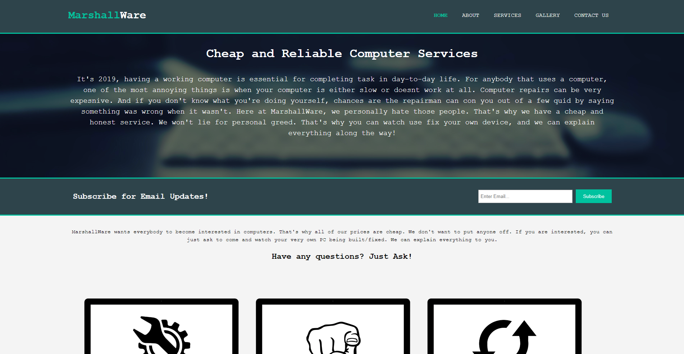

About Page
The about page gives a more in-depth overview of the business.
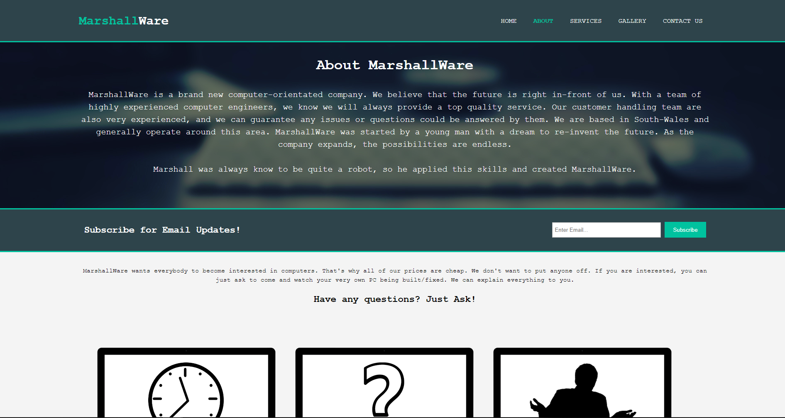

Services Page
The services page displays the multiple services that the business has to offer. This would be the page for the users to go to when they need to decide exactly what they want if they were to order a service.
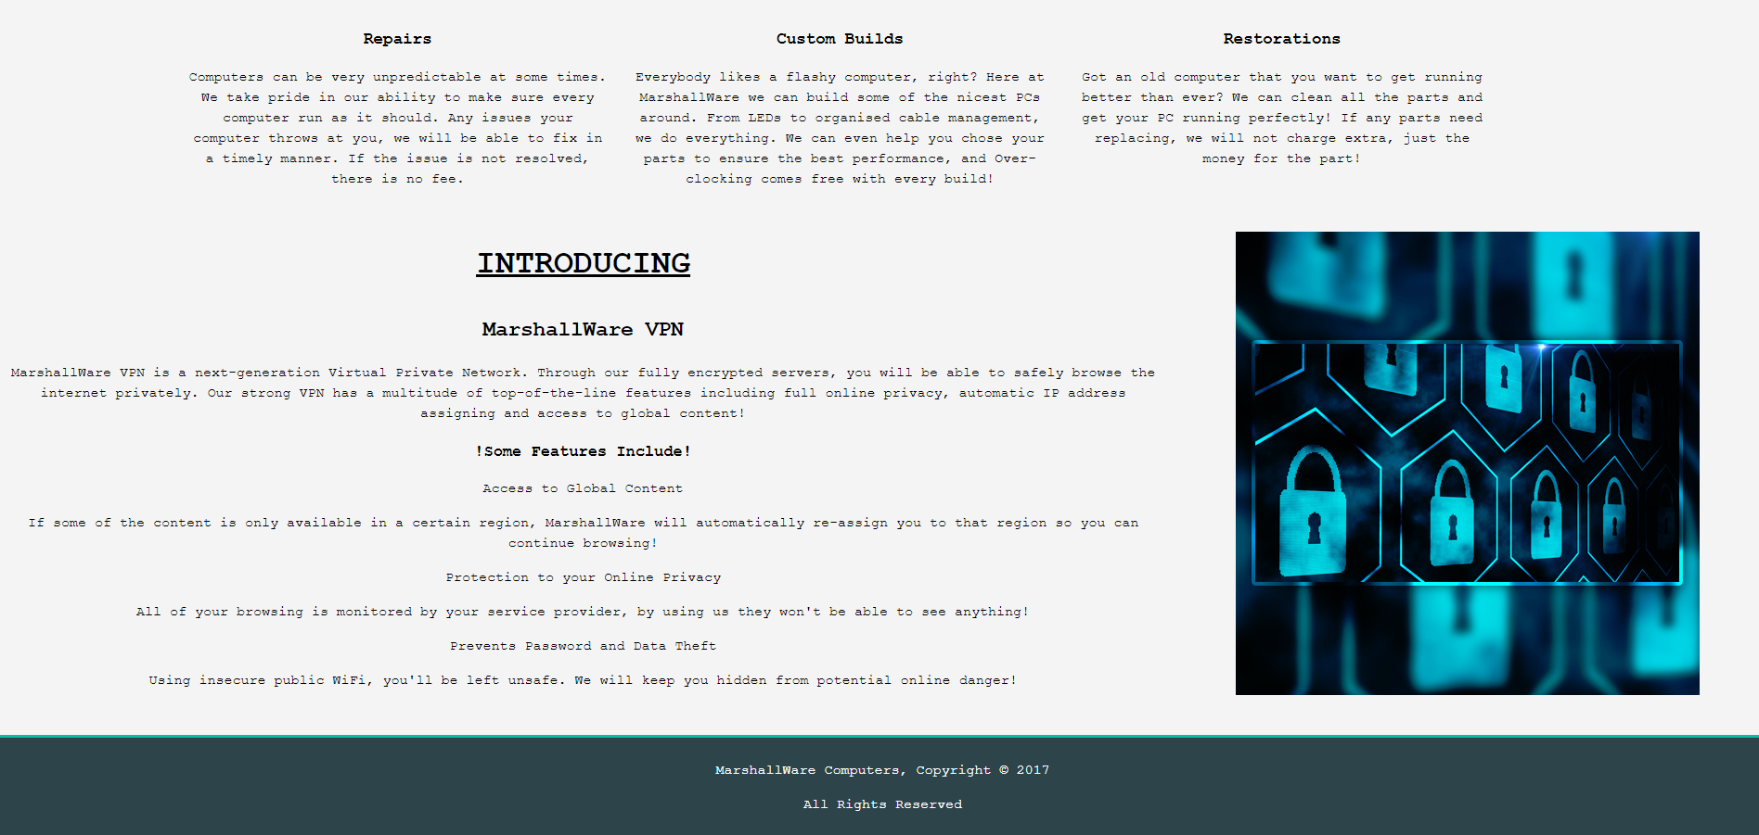

Gallery Page
The gallery page contains a collection of photos for the user to scroll through. There is a message at the top of the page that informs the user that they can send their own PC to be featured in the gallery.

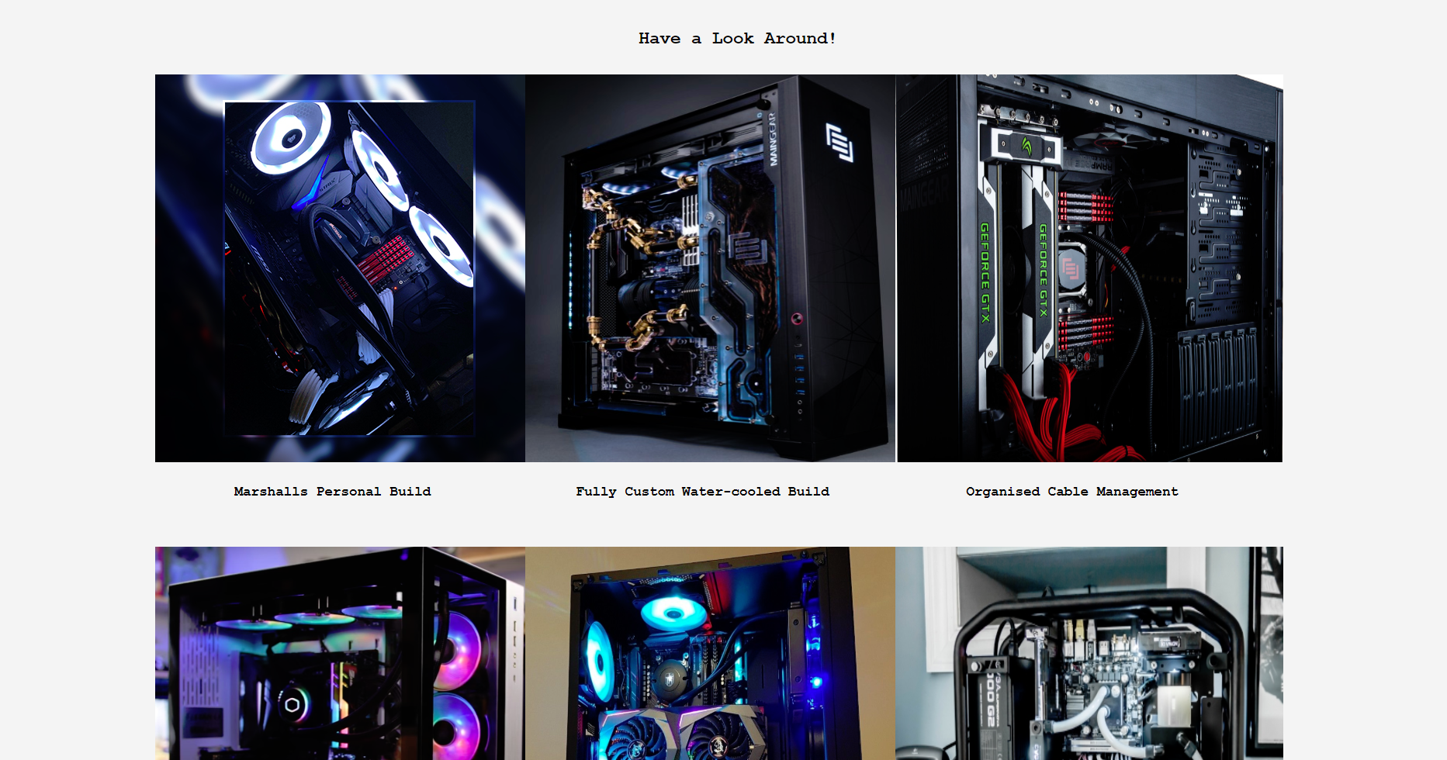

Contact Page
The contact page is the final page on the website. It gives the user the contact details off the company, this is how they would book a service or ask for help in general.

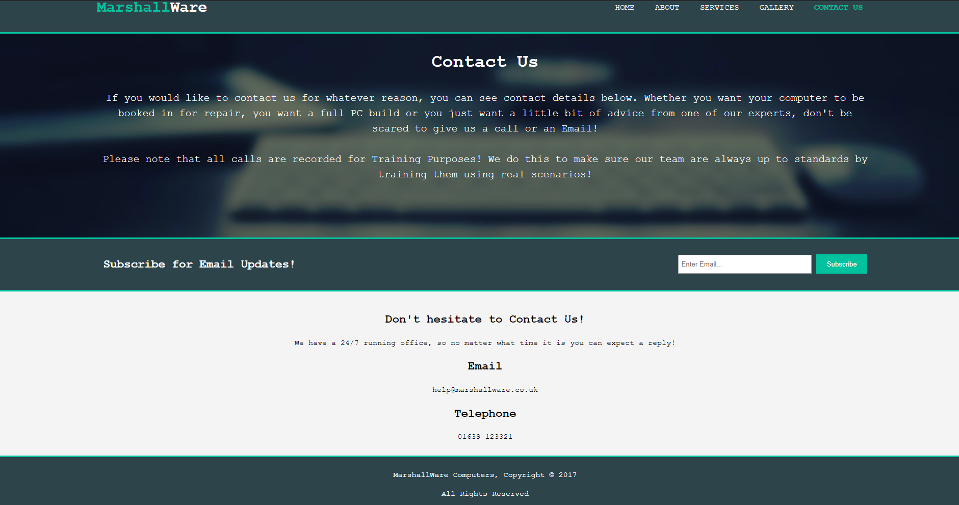

Validation
Here is a screenshot of the validation of the home page (HTML). As you can see below, there is a few errors that were picked up. As a whole, there isn’t any major problems that would need drastic changes.
The main problem was trying to use a shortcut by skipping the CSS for certain elements. Although using <center> in the body of the HTML works, this can provide more long-term issues which wouldn’t be seen at these early stages of web development. If I was to expand this webpage, this will be something I would need to change so it doesn’t become a problem further down the line.
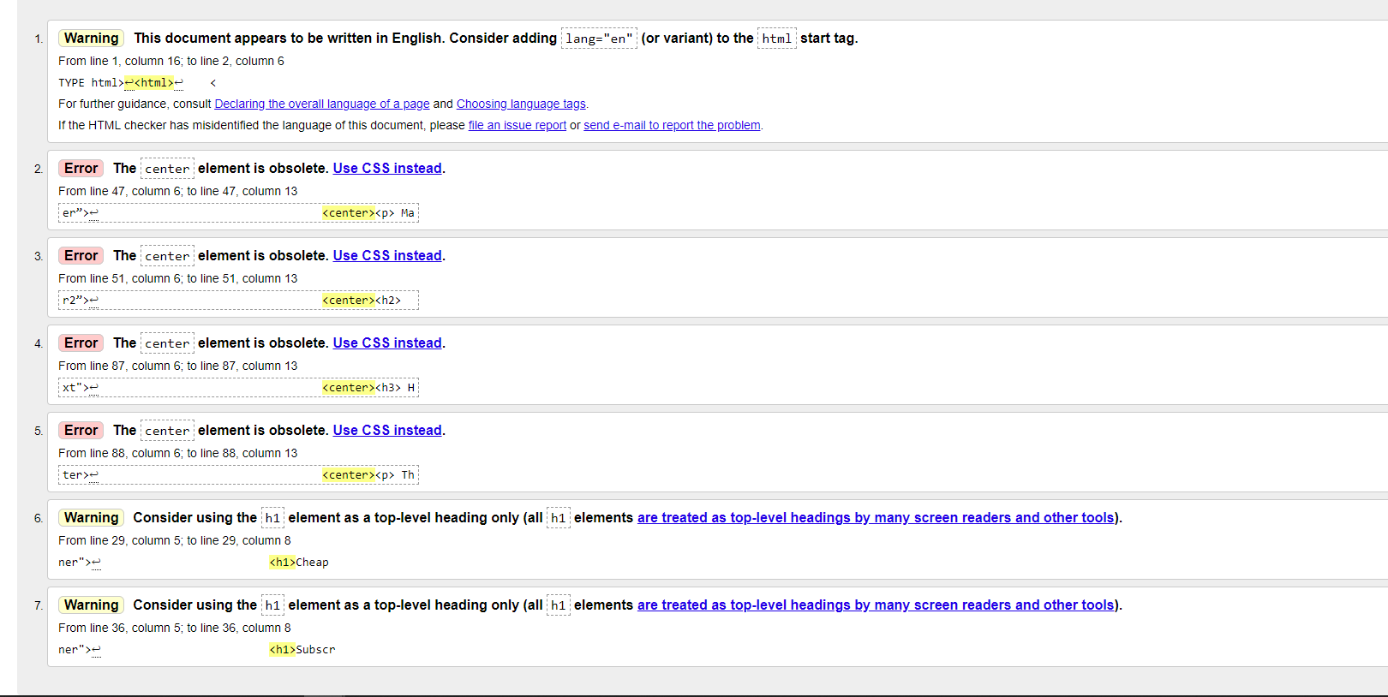

Here is a screenshot of the validation of the style sheet (CSS). Just the same as before, there is no errors that require immediate attention. The webpage still runs exactly how it is supposed to, the errors just haven’t been removed from the HTML. There is mostly values in the wrong places so a few altercations would solve all of the errors.
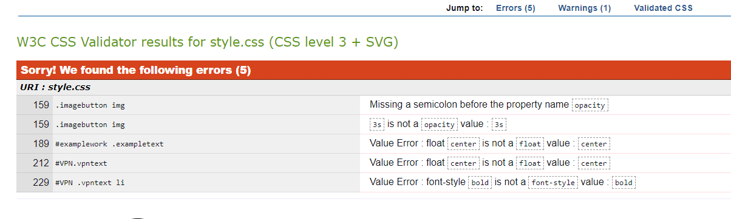

Evaluation
I think that the finished web page was better than I expected. The whole design brought the whole project together. The matching colour scheme gave the page a professional look. The website is based around your average website, having similar factors to avoid the user getting confused by switching layouts for different pages.
There are a lot of things that could be changed and improved on the webpage. Although the layout is consistent, it could be drastically improved. Looking at big websites from billion-dollar companies, there is no limit on what could be achieved. The layout is user friendly, there recurring locations for buttons and banners, its incredibly easy to navigate through the pages. Yet this simple navigating is due to the lack of complexity throughout the design. I didn’t use any bootstrap within the project, I think if I used methods from using boot-strap I could’ve achieved a more complex structure on the webpage. Obviously, Java Script would’ve allowed for a more creative approach, although I haven’t got much experience using Java Script and I didn’t want to cause problems which would’ve later led to more confusion on my part. I would’ve liked to add some more advanced features which would’ve made the page more user friendly. For example, a registration form, or a PC configurator. I knew that the PC configurator would’ve been extremely difficult for somebody at my level and I don’t want to add any extra pressure.
After finishing my website, I noticed that I didn’t actually list any prices within the “Services” page, or anywhere for that matter. It would be useful for the user to be able to see the prices without having to contact us directly. This is a very basic fix, yet I didn’t see this in time before I made the final changes within the HTML. I didn’t spend too much time thinking about the colour. I wanted something subtle but not boring. I think I could’ve implemented he colour in more places throughout the 5 pages. Even in little amounts, the colour can make something stand out and make the page more visually appealing. I could’ve also spent some time creating a logo to make the project look more professional, I could’ve then used this logo throughout the website and implemented it into different things. For example, I could’ve added the logo on the bottom of every photo in the gallery. This is only a small and minor feature, yet it would look a lot better and be more realistic from a business side.
One feature that I would’ve like to add is a search bar. Almost every website on the internet has a search bar or some sort of search mechanism. I think with a little bit more research this could’ve been achieved although realistically since the webpage is so small, at the current stage there isn’t much need for a space bar. If the website began to expand then this would definitely be one of the first features too be added, it would make navigating the page a lot easier because people could go directly where they want to without searching for and following hyperlinks scattered about the many pages.
Overall, I think for the first ever attempt at creating a website through entirely HTML and CSS, this project has been a success. Being able to see what could be achieved if more time and effort was put into the project has motivated me to constantly grow this webpage and add features to it. I believe doing this will greatly increase my skills in web-development. Since I am interested in how the web works, I would happily put some hours aside each day and constantly make changes to this project to make it a lot bigger and a lot better.

