ANALYSE INTENDET CAREER

Module code BMSW4001
Lecturer: Joanna Walsh

Mark Zankov 2030454

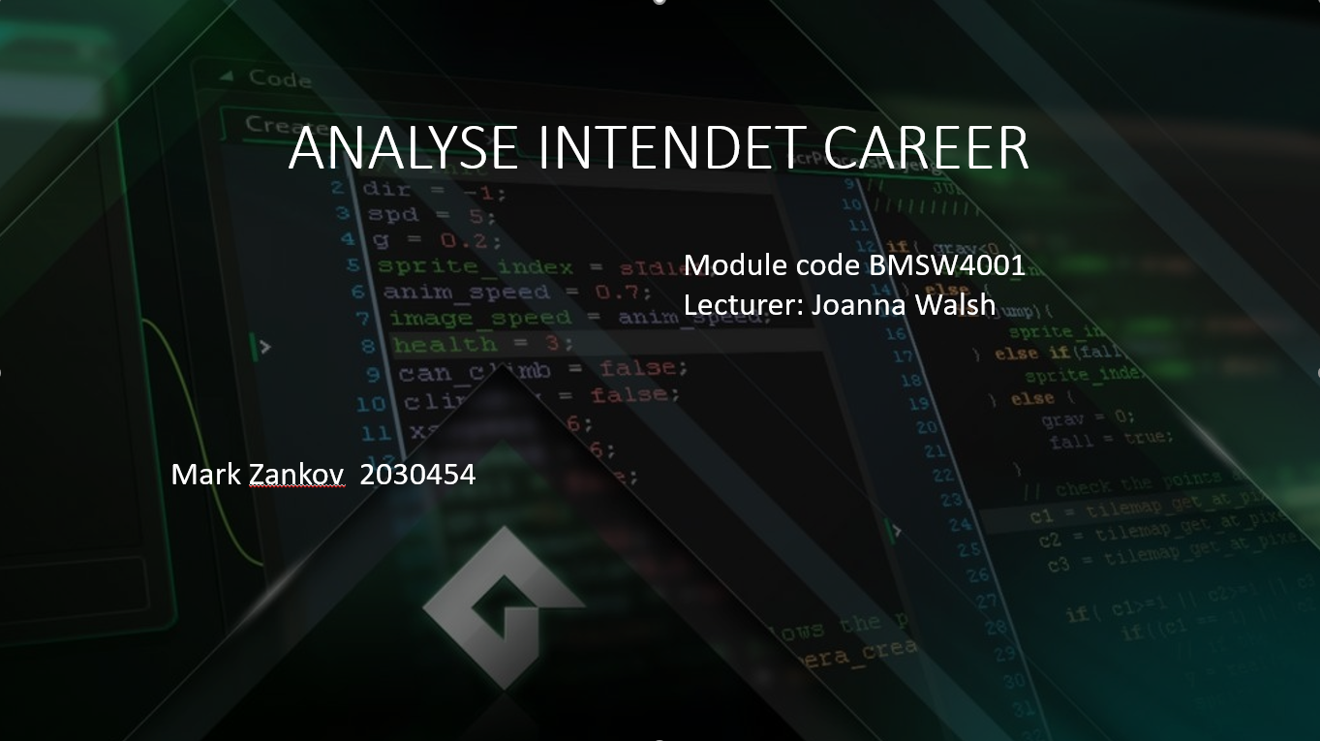

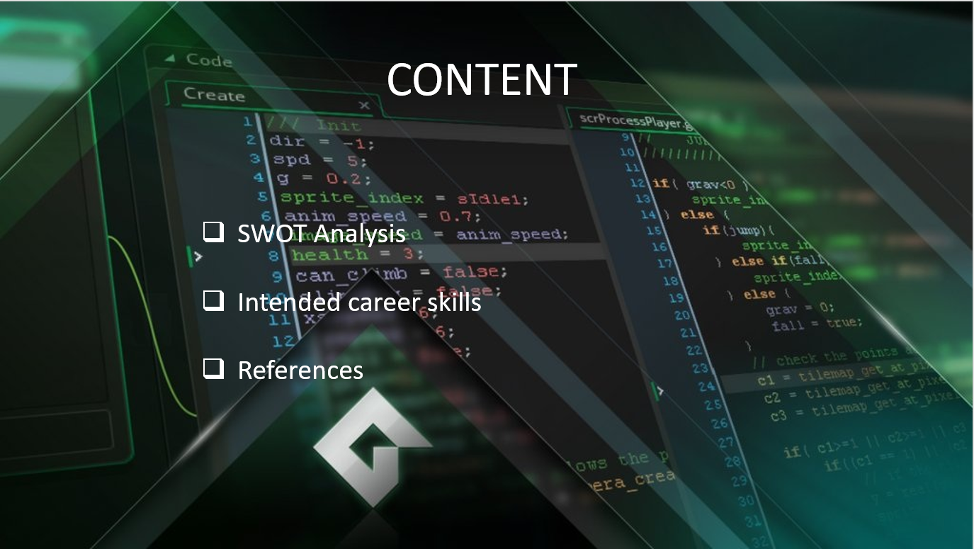

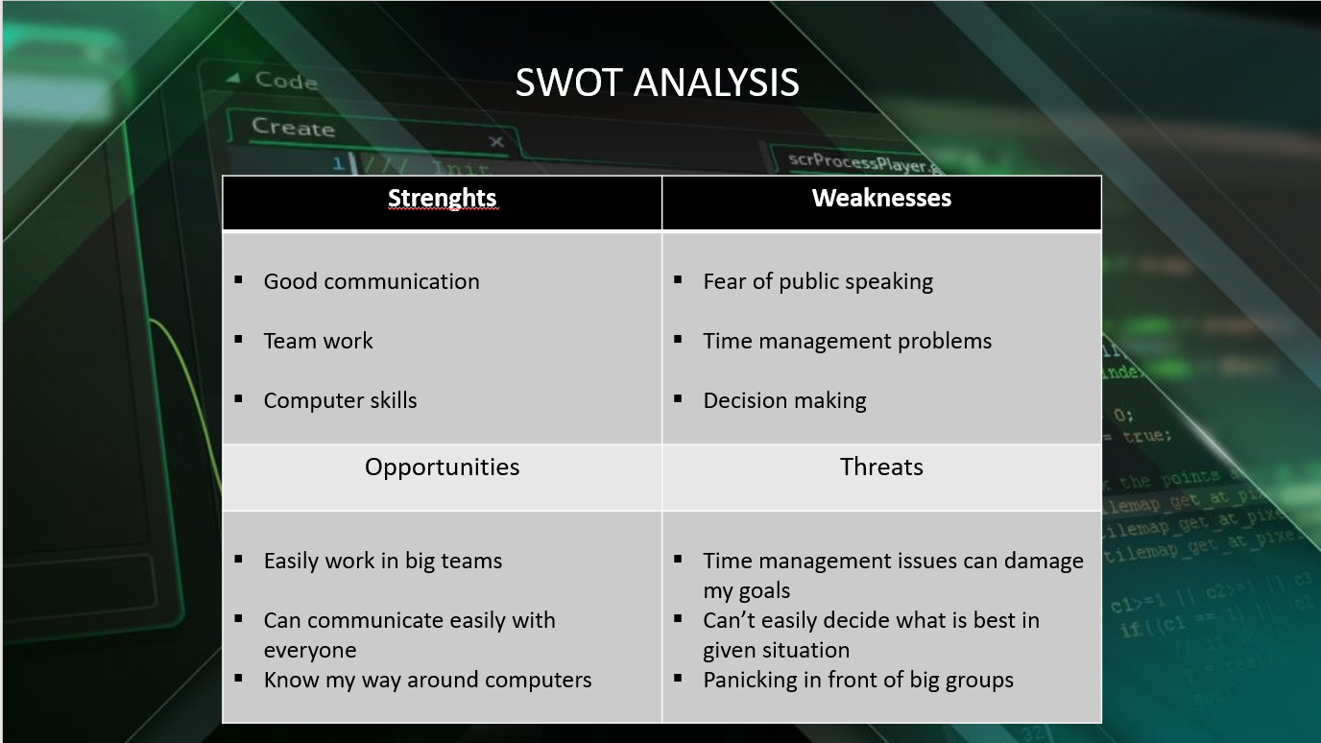

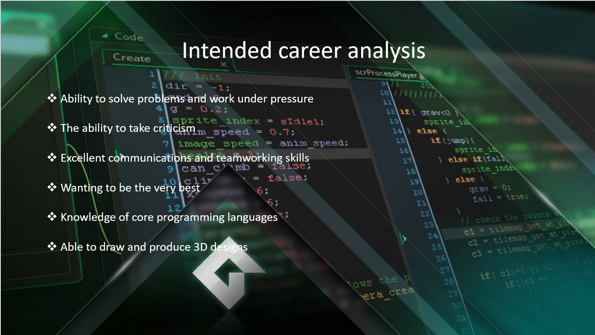

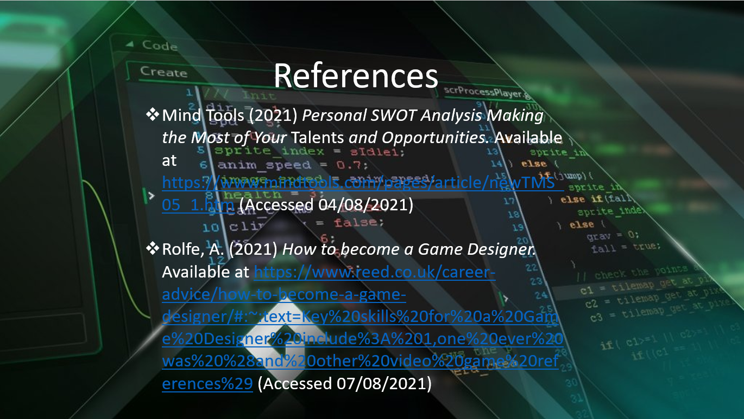

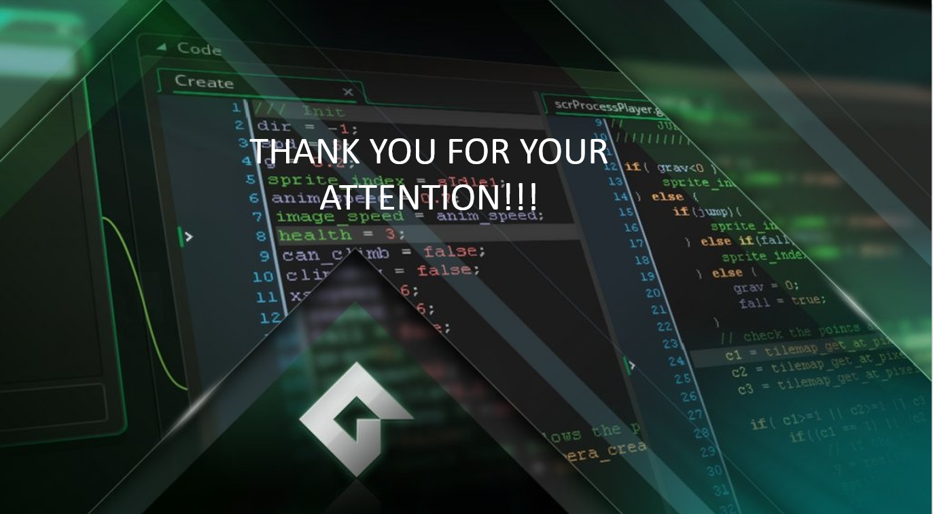

References:
Mind Tools (2021) Personal SWOT Analysis Making the Most of Your Talents and Opportunities. Available at https://www.mindtools.com/pages/article/newTMS_05_1.htm (Accessed 04/08/2021)

Rolfe, A. (2021) How to become a Game Designer. Available at https://www.reed.co.uk/career-advice/how-to-become-a-game-designer/#:~:text=Key%20skills%20for%20a%20Game%20Designer%20include%3A%201,one%20ever%20was%20%28and%20other%20video%20game%20references%29 (Accessed 07/08/2021)

