Title page

People Management (BMSW510_SWAN)

Rasa Vilimaite (2020471)
University of Wales Trinity Saint David
BA (Hons) Leadership and Management
Lecturer: Brynach Heffernan
Word count: 2347

Executive summary

This report of People Management will cover main points of Successful and effective people management. Roles and skills of manager to effectively support team and individuals. Describe what is the importance of successful team and what team is, leadership and how to lead individuals, and importance of motivation in the companies. Describe ethe importance of equity and diversion in the organisation, training, and flexible working. How to evaluate the performance management.

Contents page
Table of Contents
Title page 0
Executive summary 1
Contents page 2
1.0 Terms of References 3
2.0 Procedure 4
3.0 Findings 5
3.1 Introduction 5
Roles and Skills of a Manager 5
3.1.1 Team 6
3.1.2 Leadership 7
3.1.3 Motivation 7
Theories and models that can be used by managers to motivate employees 7
3.1.5 Training 9
3.1.6 Flexi Working 9
3.1.7 Evaluation of Performance Management 9
4.0 Conclusion 11
5.0 Recommendations 12
6.0 Appendices 13
7.0 References 15

1.0 Terms of References

The report was requested by Brynach Heffernan on the 03rd of October 2022. The purpose of the report is to acknowledge and evaluate the roles and skills of managers to successfully support effective people management. Rasa Vilimaite compiled this report to recognize these skills that are required by managers to successfully manage teams. The submission date for this report is the 11th of November 2022.

2.0 Procedure

- Used online library for sources
- Used Scholar articles, websites, journals, and books to reference
- Used Maslow’s hierarchy of needs, Herzberg's theory of motivation, 5 C’S Of the People Management models

3.0 Findings

3.1 Introduction
The process of management is the act of making things happen. To accomplish predefined objectives, managers define goals, identity, and obtain the resources necessary to achieve the goals, assign those resources to opportunities and planned activities, and guarantee that those activities are carried out as planned.
As Drucker (1955) stated: ‘Managers is the dynamic, life-giving element in every business.’ By guaranteeing the smooth operation of their function, unit, or department, managers are there to produce outcomes. They oversee managing their human resources as well as their time and other resources. They have been granted control over individuals who work in their department or unit, and as a result, are responsible to a superior for goal accomplishment. According to the conventional model of management, planning, organizing, motivating, and controlling are all steps in a logical and methodical process (Armstrong, 2018).
Carlyle had the view that notable leaders influenced history in the early 1800s. According to the theorist, some people are simply born with the ability to lead, and that ability cannot be taught. Carlyle's beliefs served as the inspiration for early leadership research, which mostly concentrated on inherited traits. Founded leadership theory on the idea that:
- Certain characteristics lead to specific behavior patterns.
- The same patterns appear in other contexts.
- Skills of leadership are "born" in people.
Even today, books and articles emphasize those necessary qualities to become a great leader, implying that management is somehow inherent in some (or is at least more likely) while being unlikely, if not outright impossible, in others (Cherry, 2021).

Roles and Skills of a Manager
Adair (1973) created the most compelling analysis of what leaders do. He clarified that the three key roles of managers are to:
- Achieve the task
- Build and maintain the team
- Develop the individual
See appendices 2
According to Adair's theory, effective leadership focuses on fulfilling the three demands of the task, the team, and the individual because followers look to their leaders to assist them in completing the assigned task, foster cooperation, and attend to the needs of everyone.
Adair believes that there are eight duties that the leader must carry out and develop to effectively fulfil the three aspects of leadership (task, team, and individual) (Chapman, 2012).
- Task definition
- Planning
- Team briefing
- Controlling
- Evaluating
- Motivating others
- Organising
- Setting an example
See appendices 3 for more detail.
As said in the article (9 people management skills to thrive as a manager | Perkbox, 2020) technical talents are simpler to define than people’s management skills, commonly referred to as "soft skills." Briefly said, they are the abilities you need to manage your employees effectively and to effectively treat, interact with, and lead individuals. They include abilities like workplace communication, trust, and patience, to mention a few. A manager with these skills can make the difference between an underperforming, frustrated team versus one that is engaged, motivated, and productive. According to this article, there are 9 people management skills that every manager should have to support an effective team. See appendices 1 for 9 skills in detail.
- Trust
- Communication skills
- Ability to motivate
- Patience
- Give credit when credit is due
- Problem-solving skills
- Accountability
- Positivity
- Honesty

3.1.1 Team
A team is described as a collection of individuals who collaborate to carry out interdependent tasks in support of a common goal or mission (What is a Team? Types of Teams & Processes | ASQ, 2022).
Starbucks is one of the great examples for an effective teamwork and success as It owns about 4000 branches in the whole world: Starbucks creates a comprehensive strategy to maintain positive working connections between managers and staff. As previously indicated, they refer to all employees as "partners," which reduces the bureaucratic divide. Additionally, they collaborate in the front line to close the gap between various statuses. Thirdly, there are typically three to six people per company. Staff members may quickly and deeply get to know one another because of the small size. Employee suggestions and grievances are given the same consideration. They also have a right to take part in the process of updating corporate policies. In that case, each employee believes that they too have a significant role in the operation of the organisation, and they jointly determine the direction of Starbucks. Not only is it one of the fastest-growing corporations in the world today, but it also has a remarkable business strategy with low staff turnover and strong profit margins (Studocu,2019).

As it said in the article (In Business Info, 2021) there is many benefits of effective teamwork:
- Increased productivity
- Deadlines met
- Problem solving
- New ideas and opportunities
- Support network
- Strong relationships
- Flexibility
- Conflict resolution skills
- Boost morale

3.1.2 Leadership
Leadership is the ability of an individual or a group of individuals to influence and guide followers or other members of an organization (Pratt, 2017).
An effective leadership structure is necessary for society to function. The fact remains valid on a smaller scale in organisations and corporations. Without competent leadership, it is practically impossible for a firm to keep up with the times and develop. A brand without competent leaders will be like a ship sailing without a captain guiding which way to go, especially in these periods when digital technology is transforming every element of how business is conducted and how customers interact with businesses (Ramos, 2018).

3.1.3 Motivation
Motivation is the word derived from the word ’motive’ which means needs, desires, wants, or drives within the individuals (Juneja, 2015). Motivation is what energizes, maintains, and controls behavior (The Importance of Motivation, 2019).

Theories and models that can be used by managers to motivate employees
The statement that "motives can also be mixed, with various concentrated around a primary motive", is mentioned in the John Adair handbook of management and leadership. The value of a stimulating environment and a motivated individual is highlighted by Adair. The third, most essential part is the function of the leader, who, in his opinion, must be wholly self-motivated. Eight fundamental principles are highlighted in Effective motivation to help leaders inspire others to act:
- Be motivated yourself
- Select people who are highly motivated
- Treat each person as an individual
- Set realistic and challenging targets
- Remember that progress motivates
- Create a motivating environment
- Provide fair rewards
- Give recognition

Herzberg's theory of motivation and Maslow's hierarchy of needs (see appendices 4 for more information):
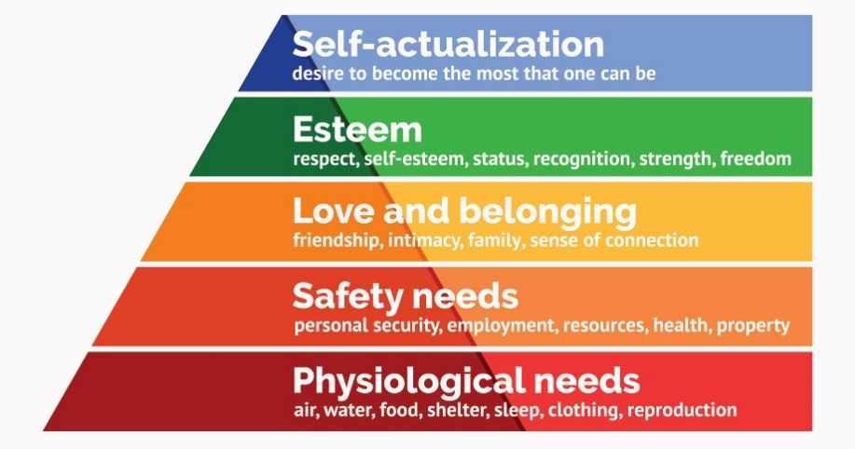
Human behaviour has a purpose. Motivation leads to behaviour that is goal-directed. Motivation enables wants to be managed and purposefully addressed. Understanding the manager's hierarchy of needs will help you comprehend this. Individual needs act as a motivating factor in human behaviour. A manager needs to comprehend the "hierarchy of needs" for this reason. "The Need Hierarchy Model" is an idea put out by Maslow (Juneja, 2015).
5 C’S Of the People Management models:
- Create- a team that will help you grow
- Comprehend- a greater grasp of the present and the future
- Communicate- creating a path for open and transparent communication
- Collaborate- work together on creating better outcomes
- Confront- handling differences in a healthy manner
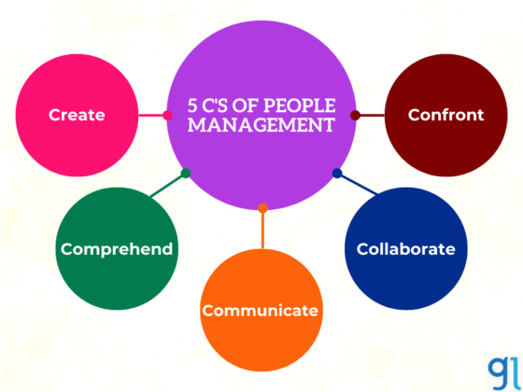
A straightforward framework for comprehending the essential components of people management is the "5C's of effective people management." In the conclusion, it comes down to organizations maximizing the potential of their workforces, from luring in the greatest individuals to provide them with the necessary tools to perform effectively to supporting, directing, and growing them.

3.1.4 Equality and Diversity
1st October 2010 Act
As it said on (Equality Act 2010: guidance, 2013) “The Equality Act 2010 legally protects people from discrimination in the workplace and in wider society. It replaced previous anti-discrimination laws with a single Act, making the law easier to understand and strengthening protection in some situations. It sets out the different ways in which it’s unlawful to treat someone”.
In the journal (Sharma, 2016) said that markets have pushed changes in the ethnic profile of the workforce. A broad workforce includes of individuals from different cultures, each with it is own set of traits, aspirations, and expectations (Cennamo & Gardner, 2008). Employees from various origins have various demands and desires to be appreciated at work. To prevent tensions and conflicts among employees, management needs to be aware of these various groups' demands. Organizations must maintain workplace harmony if they want to boost productivity. In order to promote workplace equality, managers attempt to steer clear of allusions to "us" versus "them" and other similar phrases (Colgan, Creegan, McKearney and Wright, 2007).

3.1.5 Training
“Workplace training and development helps your employees gain new skills or perform existing tasks at a higher level—making them more valuable to your business. Several reports show a direct correlation between high-performing companies and those that spend big on employee training” (Malec, 2022).
“ For many years, Amazon has been focused on creating new jobs, but now we’re investing more in training our current employees and associates on the career and life skills they need to be successful” (About Staff, 2019).

3.1.6 Flexi Working
In the article (Badalec, 2021) said: due to the new digital age and new ways of working, the term "new work" is nearly often related to flexible working hours. This novel work approach was established by businesses like Sanofi even before the problem with the coronavirus. They took a bottom-up approach by asking all of the employees what would make work, play, and family life more harmonious. The ideas were included in the overall design. Employees can select when and where to work between 6:00 and 22:00 as a result. The requirement is that the team and team leaders must consent to this (Campbell and van Wanrooy, 2013). One of the very successful companies with flexi working for over 10 years is Dell. As it said in the article (Professionals et al., 2020) “Tech companies are frequently well-positioned to provide flexible working options, and Dell has more than ten years of expertise developing a flexible working culture”. With platforms like Slack and Microsoft Teams, it enables employees to set their own schedules and work remotely some or all of the time. The company has been able to reduce its office space by 60% of its personnel, which has allowed it to save about $12 million a year in overhead costs.

3.1.7 Evaluation of Performance Management
To successfully support people managers must set clear goals for their employees. As said in the article (Forbes, 2022) Performance management will need to alter as the nature of work changes. Companies must give new approaches to evaluating and enhancing employee performance top priority. The annual review is one of the oldest practices in performance management. However, in a work environment where the workforce is ever-changing, this might not be efficient anymore. The Great Resignation is still going on right now. Annual reviews can lack flexibility and don't take seasonal changes into account. They can also be difficult for both employees and managers (Chellappa, 2022).
The industry will evolve, and employee engagement will need to adapt to keep up. Managers can attain this by bringing alternative performance management strategies into practice. Among such alternative methods are:
- Constant feedback as an alternative to or in addition to the annual reviews.
- Objectives that are established together with employees rather than on an individual basis.
- more frequent feedback as opposed to infrequent feedback.
- Plans for employee development that are made with employee input.
- Opportunities for workers to provide their managers with feedback.

According to research, successful cultures have two connected and overlapping characteristics. First, each high-performing firm has a specific set of qualities that make it stand out from other organizations. Second, these traits help employees feel like they belong and have a purpose as active participants in a company. Additionally, a company's culture fosters a commitment to its work. occurrence also has a significant impact on the organization's productive success and competitive viability. Successful strategy fulfilment is always focused on such winning cultures. The majority of successful organizations get energy and strength from their culture (Craighead, 2018).
“To win in the marketplace you first must win in the workplace” (Conant, 2010).
In 2012 Adobe's senior management made a change in performance management that had an impact on all 11,000 employees. The majority of readers are aware with Adobe's software offerings, which also include Photoshop, Acrobat, Creative Cloud, and the Digital Marketing Suite. Traditional yearly performance assessments, one of the most beloved corporate cows, were slain by Adobe. Company switched from annual performance reviews to more frequent "check-ins" where managers offer employees personalised coaching and guidance. They are just expected to do routine check-ins to communicate expectations, solicit feedback, and assist staff members with their personal development and growth objectives. Instead of waiting months for instructional opportunities to present themselves, the goal is to provide information to individuals when they need it (Sutton, 2018).

4.0 Conclusion
Not everyone has the ability to be an effective leader. It's not simple. Every effective leader must have their vision and goals and/or strive toward achieving them. Effective leadership is essential for raising employee morale and productivity. What then defines a successful leader? Many effective leaders have similar qualities, dispositions, and roles to manage their teams effectively which are:
- Achieve the task
- Build and maintain the team
- Develop the individual

Every organization is different in character and has its own set of performance goals. Everyone on staff must understand the values and goals of the company. Employees may only then match their efforts with the mission of the company. And for that to happen, employers need to get rid of their outdated performance management systems and replace them with modern, more efficient ones (The future of Performance Management, 2020).
Because training can boost employee enthusiasm, increase productivity, and enhance the calibre of work, many firms invest in employee. In addition to doing better at work, trained employees are more likely to have a long-term commitment to their organisation.
The ability to adjust is at the core of flexibility. When compared to other excellent workplaces, the average percentage of employees at winning organisations who stated their organisation effectively reacted to change is better rated by their employees.
The dedication to diversity, equity, inclusion, and belonging is necessary for equity in the workplace.
Profits can increase while also improving the working environment for everyone in the world if a focus is placed on wellbeing, training, flexibility, and equity.

Recommendations

Every organisation should make every effort to support strong leadership. Organizations should, in general, be willing to try new things and be aware of how their markets and customers are changing. For good leaders to perform well and reach their full potential, they require a robust support network.
Due to a better understanding of organizational and human behavior, changes in the historical and economic environment, and generational shifts throughout the past century, management theory and practice have changed. The fundamental changes in organizational structures, business models, the nature of work, and employee needs are reflected in the ongoing evolution of performance management, which also adapts to meet these needs.

6.0 Appendices

Appendices 1:
- Trust: managers must demonstrate to their staff that they believe in them, and there are various ways to do this. “Trust gives you the permission to give people direction, get everyone aligned, and give them the energy to go get the job done” (To Improve Team Performance Try Faster Trust-Building | Humantelligence, 2022).
- Communication skills: a great leader must be able to express ideas and visions to inspire others, emphasize the importance of work, discuss the next steps with employees, and interact well with those around them.
- Ability to motivate: it is important to create a reason or explanation for why something must be done in a specific manner and why it is crucial - for both the person's and the company's goals - when it comes to those less enjoyable activities.
- Patience: it's crucial to have patience as a manager even though when some situations could get frustrating.
- Give credit when credit is due: Recognizing when and how to give recognition and praise to the correct individuals is crucial for managers. It allows for the growth of employee motivation and mutual trust.
- Problem-solving skills: a great manager tries to spot problems and solve them before they grow into bigger problems; to accomplish this, you must have great attention to detail (Gupta, 2022).
- Accountability: successful managers take minimal credit when things go well and hold themselves accountable when things go wrong. When workers witness their managers accepting responsibility for their conduct, they are moved by the gesture and reciprocate it.
- Positivity: since attitudes are contagious, it is the responsibility of managers to ensure that a good attitude, rather than a negative one, is infiltrating the workplace.
- Honesty: entails telling the truth both in good and negative situations.

Appendices 2:

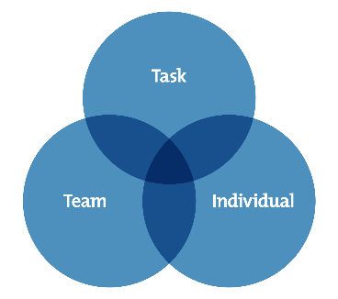
The three circles represent the leader's three primary areas of focus, which are: completing the shared job; growing and addressing the needs of each team member; and forming and maintaining the team. The team becomes effective and delivers the desired results if all three criteria are met.

Appendices 3:
Adair believes that there are eight duties that the leader must carry out and develop to effectively fulfil the three aspects of leadership (task, team, and individual) (Chapman, 2012).
- Task definition: every person and the team must have the task simplified to a clear, SMART (Doran, 1981) objective (Specific, Measurable, Achievable, Realistic, and Time Constrained).
- Planning: it requires the search for alternatives, and it is best achieved in a productive, constructive, and innovative manner with others. Plans should be tested, and contingencies should indeed be considered.
- Team briefing is regarded as a fundamental leadership role that is necessary to establish the ideal atmosphere, foster teamwork, and motivate each individual.
- Controlling: according to Adair, excellent leaders get optimum productivity with the least number of resources in The Skills of Leadership. To do this, leaders need self-discipline, a strong management plan, and proficient delegation and oversight abilities.
- Evaluating: leaders must be proficient at analyzing outcomes, team performance, individual performance evaluation and development, and people.
- Motivating others: In his book Effective Motivation, Adair identifies six rules: be driven yourself; choose highly motivated individuals; create realistic and difficult goals; keep in mind that progress motivates; offer just incentives; and offer acknowledgment.
- Organising: good leaders must be capable of managing their employees, the organization, and themselves (including structures and processes). To get outcomes when leading change, you need a defined purpose and effective organization.
- Setting an example: leaders must be role models for both the team as a whole and individuals on their team. Setting a good example requires constant effort since a poor example is more often observed than a good one.
Appendices 4:
Frederick Herzberg and Abraham Maslow's theories on human motivation are two of the many behavioural theories that the American industry has long recognized and largely accepted. Psychologist Herzberg put up a theory regarding the aspects of the workplace that inspire workers. Maslow, a behavioural scientist, and Herzberg’s contemporaries created a theory about the importance of meeting different human needs and how people go about accomplishing this (Gawel, 2000).
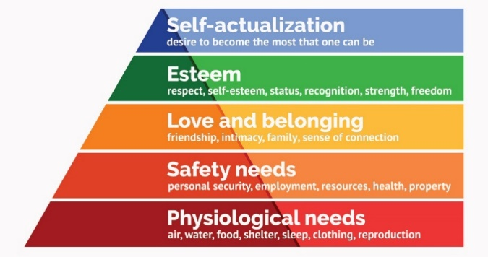
Human behaviour has a purpose. Motivation leads to behaviour that is goal-directed. Motivation enables wants to be managed and purposefully addressed. Understanding the manager's hierarchy of needs will help you comprehend this. Individual needs act as a motivating factor in human behaviour. A manager needs to comprehend the "hierarchy of needs" for this reason. "The Need Hierarchy Model" is an idea put out by Maslow (Juneja, 2015).

7.0 References

- About Staff ., 2019. Training. [online] UK About Amazon. Available at: https://www.aboutamazon.co.uk/news/operations/training [Accessed 21 October 2022].
- Armstrong, M., 2018. Armstrong's handbook of management and leadership for HR. 4th ed. Michael Armstrong, p.29.
- Asq.org. 2022. What is a Team? Types of Teams & Processes | ASQ. [online] Available at: <https://asq.org/quality-resources/teams> [Accessed 17 October 2022].
- Badalec, A., 2021. what (future) female leaders want: how businesses can attract and retain top female employees. [online] Employer.femalefactor.global. Available at: <https://www.employer.femalefactor.global//post/what-female-leaders-want-how-businesses-can-attract-and-retain-top-female-talents?gclid=CjwKCAjw-rOaBhA9EiwAUkLV4is5Z52OGh2YgWzqCPnplMVtZ_3p8247G-bQtP57NCNgiYQTVjtHVxoCkzcQAvD_BwE> [Accessed 17 October 2022].
- Campbell, I. and van Wanrooy, B., 2013. Long working hours and working-time preferences: Between desirability and feasibility. Human Relations, [online] 66(8), pp.1131-1155. Available at: <https://journals.sagepub.com/doi/abs/10.1177/0018726713478641> [Accessed 17 October 2022].
- Chapman, A., 2012. John Adair's Action–Centred Leadership Model – BusinessBalls.com. [online] Businessballs.com. Available at: <https://www.businessballs.com/leadership-styles/action-centred-leadership-john-adair/> [Accessed 16 October 2022].
- Chellappa, S., 2022. Council Post: Performance Management In The Future Of Work. [online] Forbes. Available at: <https://www.forbes.com/sites/forbeshumanresourcescouncil/2022/05/11/performance-management-in-the-future-of-work/?sh=67f32fc327ef> [Accessed 17 October 2022].
- Cherry, K., 2021. Do Great Leaders Share Certain Traits? See What the Research Says. [online] Verywell Mind. Available at: <https://www.verywellmind.com/what-is-the-trait-theory-of-leadership-2795322> [Accessed 16 October 2022].
- Colgan, F., Creegan, C., McKearney, A. and Wright, T., 2007. Equality and diversity policies and practices at work: lesbian, gay and bisexual workers. Equal Opportunities International, [online] 26(6), pp.590-609. Available at: <https://www.emerald.com/insight/content/doi/10.1108/02610150710777060/full/html> [Accessed 17 October 2022].
- Craighead, J., 2018. A winning culture is a key to market success Column - ProQuest. [online] Proquest.com. Available at: <https://www.proquest.com/docview/2162932120?accountid=130472&parentSessionId=F9QahK7%2Fssko%2BwTsrU7TJcqzZwiu8Q5X%2Fy6RE2IgE%2Bk%3D&pq-origsite=primo> [Accessed 17 October 2022].
- Doran, G., 1981. There's a S.M.A.R.T. Way to Write Management's Goals and Objectives. Management Review, 70(11), pp.35-36.
- Examen admitere marketing - academia de stud/L economice din bucuresti mk 1 B1 admitere: Studii. 2019 StuDocu. Available at: https://www.studocu.com/ro/document/academia-de-studii-economice-din-bucuresti/marketing-marketing/examen-admitere-marketing/2302250 [Accessed: 21 October 2022].
- Gardner, D. and Cennamo, L., 2008. Web of Science. [online] Webofscience.com. Available at: <https://www.webofscience.com/wos/woscc/full-record/WOS:000261813400004?SID=EUW1ED0A0AoYy2JWcEZtcSRjl8Psh> [Accessed 17 October 2022].
- Gawel, J., 2000. [online] Scholarworks.umass.edu. Available at: <https://scholarworks.umass.edu/cgi/viewcontent.cgi?article=1066&context=pare> [Accessed 17 October 2022].
- GOV.UK. 2013. Equality Act 2010: guidance. [online] Available at: <https://www.gov.uk/guidance/equality-act-2010-guidance> [Accessed 17 October 2022].
- Gupta, A., 2022. Developing People Management Skills To Thrive As A Manager. [online] My Great Learning. Available at: <https://www.mygreatlearning.com/blog/people-management-skills/> [Accessed 17 October 2022].
- How to build and manage an effective team, 2021 Advantages of effective teamwork. In Business Info. Available at: https://www.nibusinessinfo.co.uk/content/advantages-effective-teamwork [Accessed: 21 October 2022).
- Humantelligence. 2022. To Improve Team Performance Try Faster Trust-Building | Humantelligence. [online] Available at: <https://humantelligence.com/improve-team-performance/> [Accessed 17 October 2022].
- Juneja, P., 2015. What is Motivation?. [online] Managementstudyguide.com. Available at: <https://www.managementstudyguide.com/what_is_motivation.htm> [Accessed 17 October 2022].
- Keup, M. (2019). 9 Inspirational Teamwork Examples. [online] ProjectManager. Available at: https://www.projectmanager.com/blog/teamwork-examples [Accessed 22 October. 2022].
- Kolibri.teacherinabox.org.au. 2019. The Importance of Motivation. [online] Available at: <http://kolibri.teacherinabox.org.au/modules/en-boundless/www.boundless.com/management/textbooks/boundless-management-textbook/organizational-behavior-5/motivating-an-organization-45/the-importance-of-motivation-234-8375/index.html> [Accessed 17 October 2022].
- Malec, M., 2022. Six Reasons Workplace Training is Vital to Your Organisation. [online] Learnerbly.com. Available at: <https://www.learnerbly.com/articles/six-reasons-workplace-training-is-vital-to-your-organisation#:~:text=Workplace%20training%20and%20development%20helps,spend%20big%20on%20employee%20training.> [Accessed 17 October 2022].
- Performance Management, 2020. The future of Performance Management. Available at: <https://www.profit.co/blog/performance-management/the-future-of-performance-management/> [Accessed 17 October 2022].
- Perkbox. 2020. 9 people management skills to thrive as a manager | Perkbox. [online] Available at: <https://www.perkbox.com/uk/platform/recognition/people-management-skills-to-thrive-as-a-manager> [Accessed 16 October 2022].
- Pratt, M., 2017. What is leadership? - Definition from WhatIs.com. [online] SearchCIO. Available at: <https://www.techtarget.com/searchcio/definition/leadership> [Accessed 17 October 2022].
- Professionals, H.R.I.for, Lipman, A. and White, C. (2020) 5 companies that have nailed flexible working, https://www.insightsforprofessionals.com. Insights For Professionals. Available at: https://www.insightsforprofessionals.com/hr/pay-and-benefits/companies-nailed-flexible-working [Accessed 10 November 2022].
- Ramos, T., 2018. Effective Leadership: Why It’s Important And How It’s Achieved. [online] Runrun.it Blog. Available at: https://blog.runrun.it/en/effective-leadership/#:~:text=Helps%20people%20grow [Accessed 21 October. 2022].
- Sharma, A., 2016. Managing diversity and equality in the workplace. Cogent Business &amp; Management, [online] 3(1), p.1212682. Available at: <https://www.tandfonline.com/doi/full/10.1080/23311975.2016.1212682> [Accessed 17 October 2022].
- Sutton, W.by R.I. et al. (2018) Why adobe killed off the annual performance review, CMI. Available at: https://www.managers.org.uk/knowledge-and-insights/case-study/why-adobe-killed-off-the-annual-performance-review/ [Accessed 10 November 2022].

