Abdul Mannaan khan

2435643

LCHS4003

Debra Odeh

Introduction to health and social care
Written assignment

Contents Page
Explain how to communicate with service user and their family members, referring to the core principles of the Equality Act 2010 and incorporating one communication model explored during the teaching session………………………………………………………….3.1
…………………………………………………………………………………………………….3.2
…………………………………………………………………………………………………….3.3
Explain record keeping and applying the principles of the Data Protection Act 2018. This section should draw upon relevant legislation and any policy frameworks which apply in the health and social care sector…………………………………………………………………4.1
……………………………………………………………………………………………………4.2
Describe the approaches used to foster effective collaboration and examine strategies for addressing and overcoming common challenges encountered in multi-agency working….4.3
……………………………………………………………………………………………………….5.1
……………………………………………………………………………………………………….5.2
……………………………………………………………………………………………………….5.3
Conclusion…………………………………………………………………………………………5.4
………………………………………………………………………………………………………6.1

The focus of this report is on Mrs Mann a 72-year-old woman, who having recently been discharged from the hospital. She lives alone and receives daily visits twice from health care professionals which include: a physiotherapist, a GP and carers, who help support her rehabilitation from her hip surgery twice a week. Her first language is Urdu and can only understand some English, therefore information is sometimes transferred through her daughter. There have been some recent concerns regarding inconsistent documentations in her care records and due to this there was delay in adjusting her medication. Finally, this report is to explore the importance of effective communication with Mrs Mann and her relatives. This report will also highlight the administrative skills needed for accurate record-keeping and the value of effective working between professionals.
Effective communication is very key when it comes to taking care of the elderly as they are a lot more vulnerable and at risk when something is misplaced or missed in some cases. The case of Mrs Mann is no different as she is being taken care of by professionals who after some mishaps have ultimately given her medication adjustment later than usual through inconsistent data. Effective communication in health and social care builds character and ensures high-quality, person-centred care, as it leads to better patient outcomes and reduces misunderstandings and medical errors, which didn’t happen in Mrs Manns case. “Strong communication helps care workers build trust with patients, share important information, and work well with colleagues. Without it, mistakes can happen, and people may not feel listened to or cared for”. [IOMH. N.D.]. There are also communication models out their such as the Shannon-weaver model the following image explains this model:
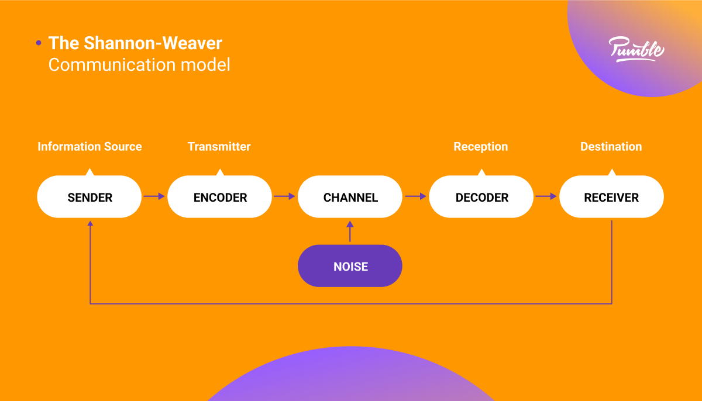
Effective communication is crucial in Mrs Mann’s case because of the complexity of her care needs, the number of professionals involved, and her language barrier. As she has already experienced delayed medication due to miscommunication. Clear and consistent communication helps ensure correct medication administrations, accurate recording of symptoms or side effects and finally timely updates to her care. This will all help and reduce the risk of harm or complications during her recovery. In Mrs Manns case because she receives support from multiple professionals such as carers, a GP and physiotherapist effective communication helps share relevant information, gives a better understanding of her progress and needs and finally helps these professionals work together towards smooth rehabilitation after hip surgery.
Effective communication with Mrs Mann and her family must be grounded in the core principles of the Equality Act 2010, which protects individuals from discrimination and requires services to promote fairness, dignity and equal access to care. In the case of Mrs Mann her first language is said to be Urdu and regarding this the professionals helping her should make reasonable adjustments to communicate effectively with her, with regards to her age and her reduced mobility after surgery. This way they can make sure she understands what is being done to help her and help her to better understand the information she is receiving. On the other hand, the professionals helping her should always ask Mrs Mann before involving her daughter, so her respect and independence are respected. The Equality act 2010 States to “remember not to make assumptions of someone based on age, gender, ethnicity or their language”. This also helps ensure that Mrs Mann receives the same quality of information and involvement as any other person. Using clear and culturally sensitive communication with her and her family supports person-centred care, reduces mistakes, and helps her take part in decisions about her recovery.
Section 2:
In health and social care, it is very key to document everything accurately as this will provide a safe but also effective and person-centred care. In Mrs Manns case this will help her physiotherapist, GP and carers have the same information when it comes to her hip recovery. On the other hand, it also helps factors like her health status and preferences. Finally, when documented correctly the data will reduce the risk of mistakes, as in Mrs Manns case was a medication error. Finally good documentation will also help her daughter and other relatives as to what is being done to help during Mrs Manns hip recovery.
On the other hand, from a legal and professional point of view, good documentation provides evidence that the right measures are being taken care of during her recovery. Therefore, If there are complaints, concerns or safeguarding issues arise. These documentations can explain why they were doing what they were doing at a specific time and date. This helps both the patient and the professionals. Lastly, it is important that they meet regulatory standards set by companies such as the Care Quality Commission [CQC].
Moreover, the accurate documentation being taken contributes to the correct continuity of care. These records can then be referred to during handovers or when a new set of carers of professionals begin supporting Mrs Mann. These records will also help these workers to reflect back upon to see where they can improve in certain areas of their care. Overall, the reliability of accurate documentation is key when it comes to maintaining the high quality of care. Ultimately promoting service user safety and will help ensure accountability within health and social care settings.
Furthermore, poor record keeping can lead to serious risks for the patient or even the professionals. On the other hand, when data and records are not kept up to date or are inaccurate this can lead to safeguarding concerns and sometimes this information is important towards the patient’s health needs and medication. The likelihood of errors increases. This can occur when the wrong medication is given, or the wrong treatment is being provided. Or even failing to notice changes in someone’s condition directly compromises a person’s safety and wellbeing.
These poor records create risks linked to data security and confidentiality. According to the data protection act 2018, health and social care providers are meant to that the personal information is accurate, kept up to date, stored securely and can only be shared when it’s appropriate. When the record keeping is inaccurate or careless it can lead to breaches of confidentiality, loss of sensitive data or unauthorised access. Certain breaches can harm these professionals by exposing their private information. Finally, this can then lead to legal consequences, fines and loss of trust in these services.
The NMC Code (2018) states that nurses and midwives must “keep clear and accurate records relevant to your practice” and ensure that all documentation is completed promptly, objectively and securely. When these measure are not being followed correctly it can lead to the risk of professional registration. Poor record keeping is seen as a failure to uphold the safe and effective practise the act preaches. This can also lead to doubt of whether the right the treatment is being provide to the right people, as inaccurate records make it difficult to understand what treatment was administered.
Overall, poor record keeping undermines safe practise and breaches legal requirements. This then fails to meet professional standards, putting both service users and the patient which is Mrs Mann in this case at significant risk.
Multi-agency collaboration in healthcare is very essential when it comes to addressing complex health challenges that extend beyond organisational boundaries. It involves mixing health and care professionals working together to plan and coordinate care for individuals with complex needs. This will ensure that all the individual’s situations are considered, avoiding gaps in care or misunderstanding that can lead to ineffective solutions. The collaboration process considers not only medical or social care needs but also housing, education, and safety concerns. By doing this these professionals can plan out the perfect recovery for the individual. They will ultimately do this pooling together knowledge and resources to produce an outcome of better health care and social care. Multi-agency is a key component of integrate care, which will improve population health by coordinating action across different sectors. According to care learning organisation multi–Agency Meetings bring together health and social care professionals from various sectors to coordinate care for individuals with complex needs, ensuring a holistic approach. [April 12th, 2025].
Conclusion
Effective communication, strong administrative skills, and meaningful collaboration are essential for achieving productivity and maintaining smooth operations in any workplace. Communication ensures that information is shared clearly, expectations are understood, and problems are addressed before they escalate. It builds trust, strengthens relationships, and supports positive team dynamics. Administrative skills provide the organisational backbone that keeps tasks, schedules, and resources on track, enabling teams to work efficiently and meet deadlines. They help maintain accuracy, consistency, and accountability across all processes. Collaboration brings together diverse strengths, perspectives, and expertise, allowing teams to generate better ideas and make more informed decisions. It encourages mutual support, sparks creativity, and leads to more effective problem-solving. Together, these three elements create a well-functioning environment where goals are met, challenges are managed proactively, and teams can perform at their best.

Reference List:

Care learning organisation
What are Multi Agency Meetings in Health and Social Care? – Care Learning

NMC code 2018
The Code: Professional standards of practice and behaviour for nurses, midwives and nursing associates - The Nursing and Midwifery Council

Data protection act 2018
Data Protection Act 2018

Equality Act 2010
Equality Act 2010: guidance - GOV.UK

IOMH [inspire, overcome, motivate, hope]
The Importance of Communication in Health and Social Care

