

Postgraduate/Distance Learning
Assignment coversheet & feedback form

THIS SHEET MUST BE THE FIRST PAGE OF THE ASSIGNMENT YOU ARE SUBMITTING (DO NOT SEND AS A SEPARATE FILE)

For completion by the student:
Student Name: Maria Luis Neiva Duarte Almeida

Module code:HPCA7009  Module title: Skyscapes, Cosmology and Archaeology | Student ID number: 1916359 |  |  | Educational support needs:  Yes/No  NO
Module tutor: Bernadette Brady

Assignment due date: 13/08/2020
If your module has multiple submissions please indicate which piece of work this is.

1st 2nd 3rd 4th 5th 6th
I confirm that this is my original work and that I have adhered to the University policy on plagiarism.
Signed ……………………………………………………………
Email submission: if you are submitting this form via email, please tick this box
(as a substitute for your signature) to confirm that you agree to the above declaration.
Assignment Mark
1st Marker’s Provisional mark
2nd Marker’s/Moderator’s provisional mark
Agreed Internal Mark:

External Examiner’s mark (if relevant)
Final Mark

NB. All marks are provisional until confirmed by the Final Examination Board.

For completion by Marker 1 :
Comments:

Marker’s signature: |  |  | Date:
For completion by Marker 2/Moderator:

Comments:

Marker’s Signature: |  | Date:
AGREED INTERNAL MARK (where necessary):

Comment on process of arriving at agreed mark:

External Examiner’s comments (if relevant)

External Examiner’s Signature: |  | Date:

The Sauna of Citânia de Briteiros: A Skyscape Study

Introduction

Citânia de Briteiros is one of the largest fortified settlements in Iberian Peninsula dated from Iron Age, located in the north of Portugal near the city of Guimarães. Situated on a hilltop visually dominating the landscape, the settlement comprises four lines of walls that enclose the village structure composed by an extensive area of constructions distributed along several streets (Fig. 01). The castro (hillfort) was discovered by the archaeologist Francisco Martins Sarmento (1833-1899) who bought the lands where the settlement is located, around 1875, in order to conduct proper archaeologic investigation. Though the Iron Age in Iberian Peninsula spans from the eighth to first century B.C. it was from the second century onwards that this type of large settlements were built in this Indo-European region, where two languages were spoken, as mentioned by Quintela, Estevez-Garcia and Veiga:
‘The area is culturally Indo-European, with two languages, the isolated Lusitanian language and a second language of Celtic origin.’
The construction analysed in this paper, though is part of the settlement, is located in the outskirts, further down in the southern side of the hill. It wasn’t until 1930, during the construction of a road that the structure now known as bath or sauna was discovered by the workers. This longitudinal building plan was built underground and its four rooms are still visible today. This type of construction can be found in other Iron Age settlements of Iberian Peninsula, though they are commonly divided in two groups, the northern and the southern, for geographical and formal differences, as explained by García Quintela, Gonzáles-García and Veiga:
“Both types of saunas are located in the outskirts of the habitats, but while the northern ones are inside the castro, next to the main entrance, those of the south are away from the habitat and sometimes in wall enlargements. (…) The pedras formosas only appear in the southern group, while the northern ones present a large stone at the entrance to the sweat room. The southern monuments are underground, while those in the north are not.(…) in the northern saunas the water was carried to recipients built inside the saunas, while in the southern ones the water was conducted through canals to the sauna.” The sauna of Briteiros is therefore part of the southern group.
The purpose of this study is to analyse the location, orientation, decoration and the possible celestial alignments of the sauna building, searching for connections between human habits and heaven motions, following a skyscape approach. The researcher Fabio Silva proposed the use of the word skyscape when the intention is to study ‘the heavens and the celestial bodies and how they relate back down to human beliefs and practices, to their notions of time and place, to their structures and materials remains’.
Concepts as “orientation” and “alignment” should also be defined before proceeding. According to Frank Prendergast, ‘orientation is taken to mean the measured direction of a structure’s facade or axis with respect to the local meridian (azimuth), while the use of “aligned” is reserved for cases where human intentionality in a monument’s axial direction toward a target is argued.’

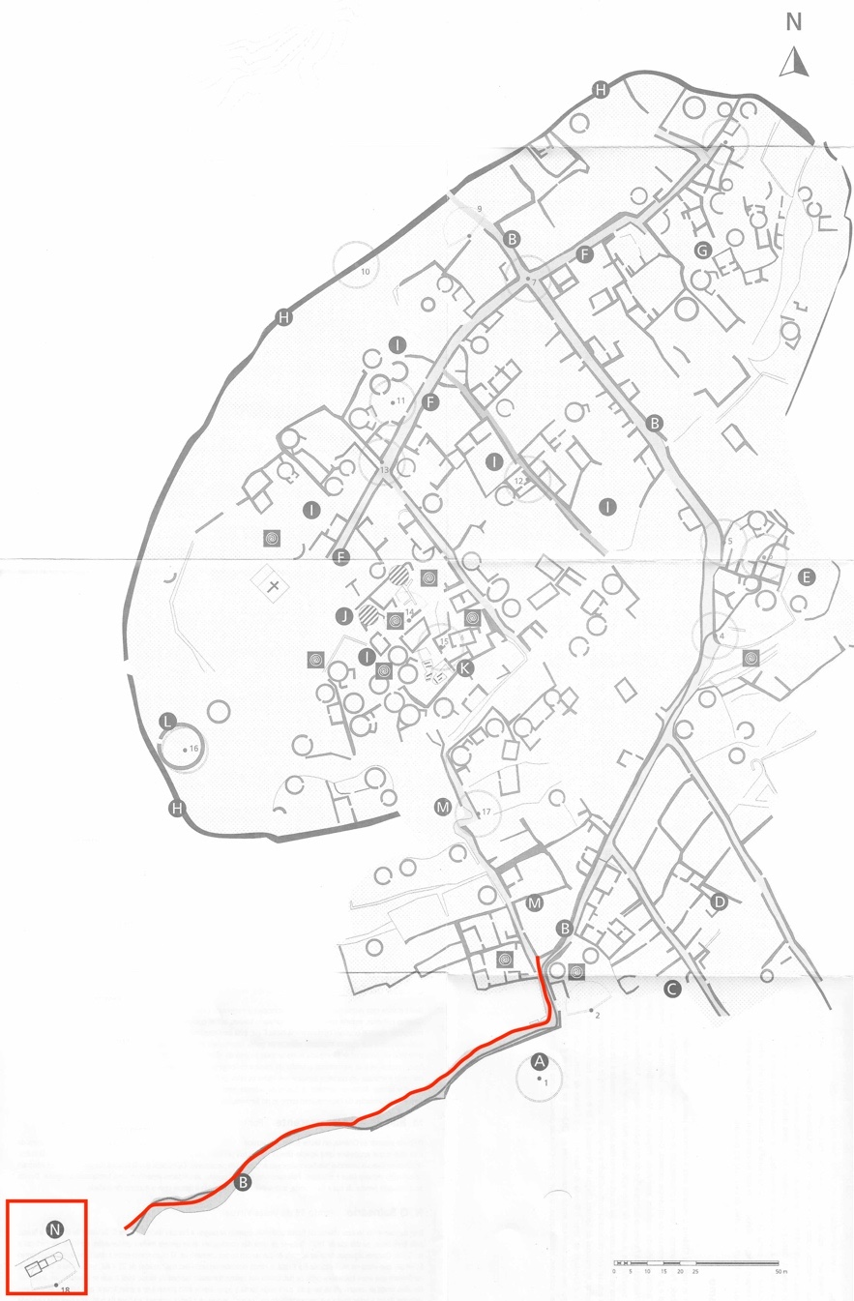

Fig. 01: Settlement plan. The sauna building is inside the red rectangular and the red line marks the stone path.

Methodology

This type of analysis requires a field survey where specific measurements are taken, as the latitude and longitude of the site, and the azimuth and horizon altitude of the direction intended to be measured, in order to calculate the declination - the angle of a point in the celestial sphere to the celestial equator.
Due to the recent pandemic situation that forced all the institutions to close to the public, the measurements that were meant to be taken onsite had to be done digitally, using the website heywhatsthat, software as Google Earth, SkyscapeR v.04.1b (20 IV 2017) and Stellarium and the SCA module spreadsheet. According to Google Earth, the sauna building is located at the latitude of 41,49N and longitude of 8,38W at 270 meters from sea level. This data was inserted on heywhatsthat in order to generate the landscape panorama. Working on the satellite view, it was defined a line from the center of the construction and parallel to the longitudinal axis of it, up to the highest peak aligned with its center, in order to get the azimuth, horizon altitude and distance (Fig. 02). The building is oriented southwest and according to heywhatsthat its true azimuth is 239º, the horizon altitude 1.89º and horizon distance is 6 km. The SCA module spreadsheet was used to verify the horizon altitude (Google Earth shows the peak height in front of the site at 485 meters above sea level) which result was 2.05º and to calculate the declination, defined as -21.25º. The panorama view generated by heywhatsthat was imported to SkyscapeR and Stellarium in order to analyse which celestial bodies were visible from the sauna site within the period from 200 BC to 100 AC.
Luckily, it was possible to visit the settlement after the confinement restrictions, which made it possible to rectify some measurements and to acknowledge certain aspects of the surrounding landscape and some details of the construction. The measurements taken onsite were done by a GPS, compass and clinometer applications from Iphone. Though the GPS and compass data were very close to the ones taken digitaly, the horizon altitude was totally off, so it was disregarded.
To resume, the measurements assumed to develop the alignments’ study were: Lat 41,49N; Long 8,38W; Az 239º; HA 2º; Dec -21.25º.

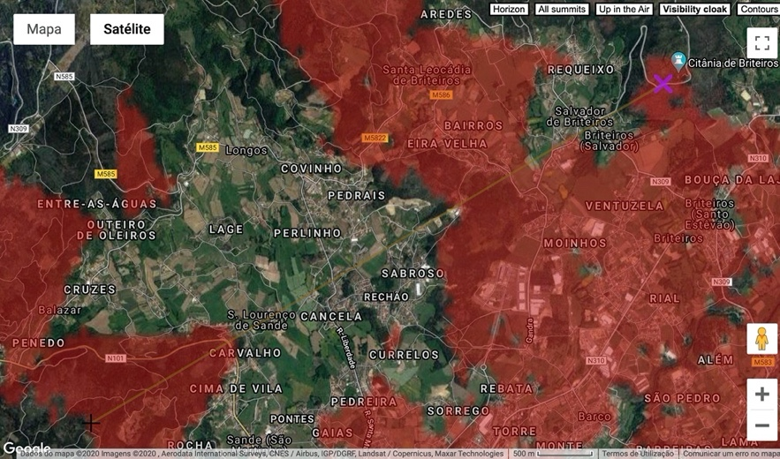

Fig. 02: Satellite view showing a line from the center of the construction and parallel to the longitudinal axis on the top right up to the highest peak ahead, at the bottom left.
The Sauna

Located further down at the southern side of the hill, the sauna is connected to the village through a rough stone paved street flanked by the water conduit that lead the water to the tank (Fig. 03). Walking down this path, it is impossible not to notice the peak of a mountain right in front, and though the last meters of the lane are quite winding, once one arrives to the sauna, it is clear that the structure is aligned to it, as the results from heywhatsthat had shown (Fig. 04).
The sauna is composed by a longitudinal sequence of four rooms – a vestibule with a water tank; an ante-chamber that would have had benches on both sides; the steam room and an enclosed oven (Fig. 05). These spaces are semi-subterranean, meaning that in order to go in, a descendent movement is required. The ante-chamber, steam room and oven were roofed with large granite slabs, some still in place today, and is thought that the entrance was covered at Fall and Winter with seasonal and perishable material (Fig. 06).
The entrance from the antechamber to the steam room was made through a semi-circular opening in the central bottom of a pentagonal shaped stone slab positioned vertically, only possible to be crossed by a person crawling on his back (Fig. 07). This stone, known as pedra formosa (literally meaning beautiful stone) is decorated with astral motifs in bas-relief.
The approach to the building is done from the back, which corresponds to the oven side. This might suggest that its entrance, on the opposite side, was meant to be oriented towards the mountain ahead, with the center of pedra formosa aligned with it.

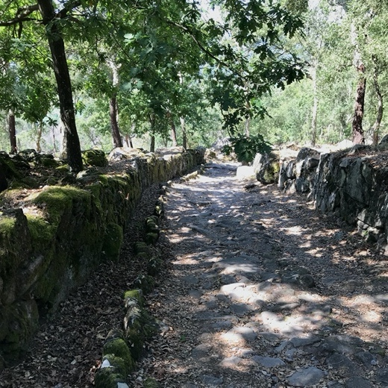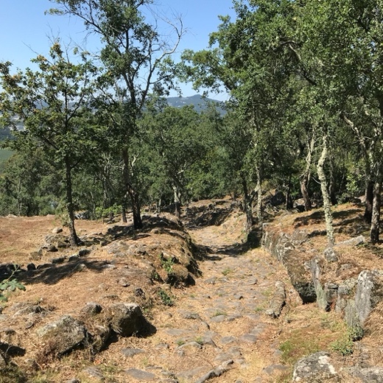

Fig. 03: Photograph of the cobbled path down to the sauna. Fig. 04: Photograph of the mountain peak between the
On the left side is possible to see the water conduit. trees. Photo by Maria Almeida
Photo by Maria Almeida

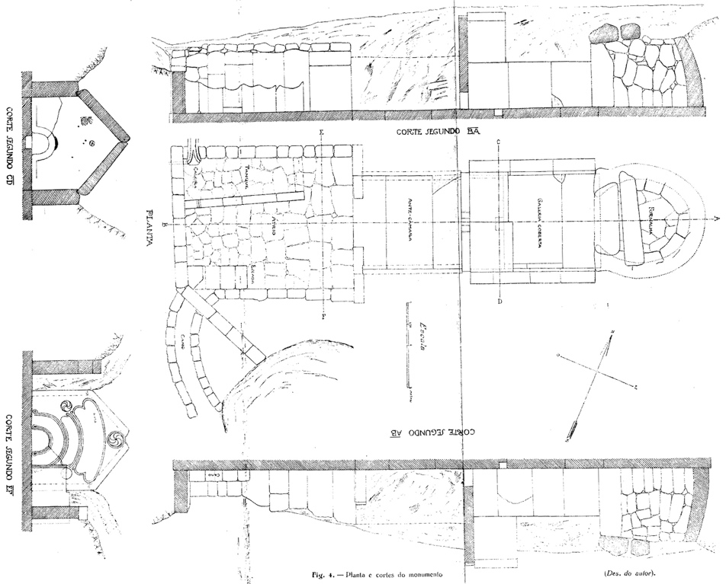

Fig. 05: Plan, Elevations and Sections of the sauna building. Drawings by Mário Cardozo.

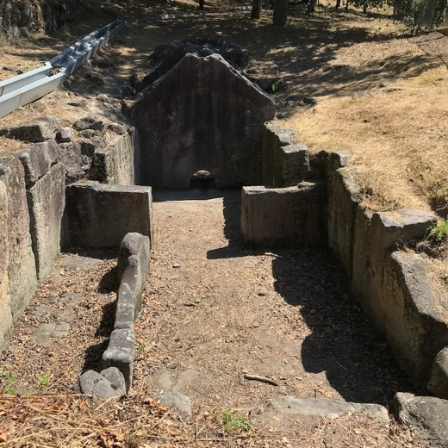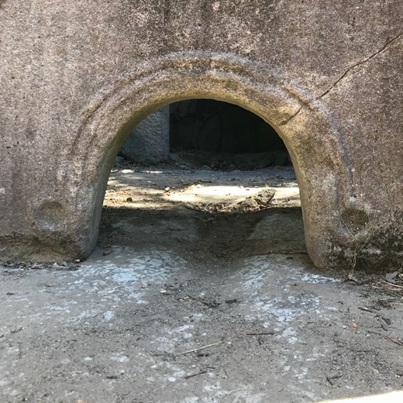

Fig. 06: Photograph from the entrance, showing the Fig. 07: Photograph of the semi-circular opening
vestibule and the tank, the antechamber and the measuring 50cm wide and 40cm high.
pedra formosa.
Photos by Maria Almeida

The function of the Sauna

The hypotheses regarding the function of this type of construction evolved throughout the years. In the beginning of the twentieth century, as Quintela and Santos-Estévez mentioned, the theories ‘were speculative: sacrificial altars, sanctuaries, bread ovens, pottery kilns, metal workshops and slaughterhouses.’ It was from the fifties onwards that some scholars as F. Conde-Valvís Fernández, C.A.F.Almeida and A.C. da Silva purposed its use as a bath structure, based on fieldwork excavation and on a text from antiquity, assigned to Strabo, describing the northern peoples of Iberia: ‘Now some of the peoples that dwell next to the Durius River live, it is said, after the manner of the Laconians—using anointing-rooms twice a day and taking baths in vapours that rise from heated stones, bathing in cold water, and eating only one meal a day; and that in a cleanly and simple way’. The water conduits towards the vestibule, the water tanks and the rocks exposed to fire inside the ovens were all characteristics of the structures surveyed, leading to the conclusion of its function as a steam-bath lodge.

The purpose of the Sauna

Starting from the assumption that these constructions functioned as steam/bath structures, questions arose regarding the way they were used, by whom and for what purpose. The idea that they served for ritualistic purpose is now widely accepted by the researchers in this field, based on some of their characteristics: the structures are isolated, located away from the domestic areas; the type of construction is unique among the other structures of the castro; and the astral motif decoration of the pedras formosas indicates a possible celestial connection.
The researcher Nadya H. Prociuk claimed that the saunas ‘were used to safeguard the community from spiritual contamination’. From her point of view, the steam baths had a ritual purpose, to protect those who left the settlement and purify the ones who had been away, before enter the village, proposing the following: ‘Perhaps the successive chambers of the bath structures, from patio to outer chamber to inner chamber, represented the stages of a journey, from the exterior world of light and everyday life to a dark interior world characterized by the elements of fire and water, surrounded by stone and anchored in the earth, and then returning outward again.’
The purifying ritual and the importance of the elements of fire, water, air and earth are also considered in the sauna-womb theory of García Quintela: ‘The steam room is therefore a stone metaphor of the uterus in which a kind of pregnancy is recreated as a result of the combination of water and fire, but also of air and stone (earth) culminating in childbirth.’ The air is essential for the oven to work and the longitudinal structure of the building conducts it from the outside to the furnace, and the earth is present in the subterranean type of construction and in the material from which is built. García Quintela proposed that the ritual of rebirth would be performed by the warriors who returned home after the battles, full of war fury, in order to purify themselves before going back to the community.

The Sauna Pedra formosa

I propose a closer examination of the pedra formosa’s decoration and possible symbolism, as it might reinforce a celestial alignment theory.
The first archaeologist that studied the pedra formosa was Mário Cardozo when the construction was discovered by accident in 1930. Along with the discussion about the function and purpose of the structure, the motifs in relief technique depicted on the stone were subject of reflection in five articles about the last discovery at the Citânia, published in Revista de Guimarães from 1930 to 1932.
The stone slab placed vertically is an irregular pentagon with a tectiform top, that supported a pitched roof made of stone slabs. The symmetry and the curved lines dominate the ornamentation which depicts four concentric arcs in relief joined by circular forms, from the semi-circular opening in the bottom to the upper part of the slab. Quintela and Santos-Estevéz characterized the use of curved lines a ‘feature that associates them with what is known as ‘Celtic art’’. At the top center of the slab there’s a triskele made of crescents revolving clockwise carved inside a circle with 40 centimetres. On the left side of the slab, aligned with the third arc, a smaller crescent triskele revolving counter-clockwise, was carved inside a circle with 27 centimetres. Symmetrically placed on the other side, a disc with the same size was carved (Fig. 08). For Cardozo, the triskeles and the disc are both representations of the sun and the moon, the triskeles representing their celestial motion and the disc depicting their circular form. Cardozo didn’t consider the opposite movement of the crescent triskeles, arguing that ‘The sculptor wanted simply to represent the sun’s translation movement not its movement direction.’ In his first article he characterized the concentric arcs as purely decorative disregarding any symbolic meaning. It is very interesting to see that, a year later, he revised his opinion saying that ‘even the concentric arcs might have not only a decorative intention, as considered before, but they could represent the celestial vault where the stars gravitate’. In my literary research for this essay, I haven’t found any other author who attributed meaning to the concentric arcs, focusing only to the triskeles and disc as a source of symbolism.
The inner face of the pedra formosa, that would be completely in the dark as it was facing the steam room’s interior, has also carved symbols, a cross inside a circle with 10 centimeters and a S-shapped motifs which García Quintela and Santos-Estevéz considered ‘rock art carvings’ though they didn’t elaborate on their meaning. Cardozo’s opinion is that the cross in a circle is a ‘solar symbol’ as many found in the north of Portugal and Galiza. (Fig. 09)

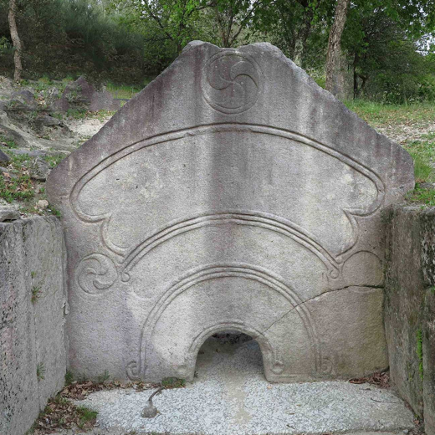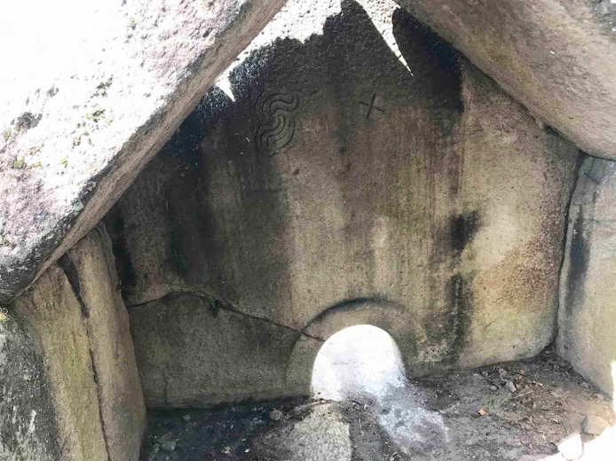

Fig. 08: Pedra Formosa – outer face. Fig. 09: Pedra Formosa – inner face.
Photo by Francisco Goberna Photo by: Maria Almeida

Discussion

The measurements and the field survey indicated that the entrance of the sauna is aligned with the highest mountain that can be seen from inside the vestibule, the same hill that can be spotted on the way down to the site. This peak is known as Monte do Outinho, where a chapel dedicated to Nossa Senhora da Saúde (Our Lady of Health) was built in 1696. There’s a parish report from 1080 on the online municipal archive of Guimarães that notes that there were some remains of a castro on that hill, but I couldn’t find further information about the site.
Considering the motion of the celestial bodies and knowing that the sauna’s orientation is towards southwest, it is plausible to assume that the sauna might have been used later in the day or night. From inside the vestibule and water tank, it was certainly possible to gaze the setting of some heavenly bodies on that hill.
Having been able to visit the site proved to be extremely helpful thus it was possible to experience the descend from the entrance of the castro located uphill to the sauna further down, through the same extant stoned path from more than two millennia ago. The mountainous landscape is not higher than our horizon, with the exception of Monte do Outinho that appears right ahead, guiding our way down. Once arrived at the sauna, the descending movement continues, in order to go in the vestibule as the construction is semi-subterranean. Considering that the function of the structure was ritualistic, I would speculate that the descent and its relation with the landscape would be part of the ritual. The physical action of the people going down the path until entering the sauna would mimic the celestial bodies crossing the sky and setting on the mountain.
Regarding the measurements, and specifically the declination value of -21.25º, both SkyscapeR and Stellarium were used to define which celestial bodies would set within eight degrees east (-29º) and and four degrees west (-17º) of the determined declination, corresponding to the right and left valleys of the hill, within a period from 200 BC to 100 AD. Along with this, specific dates and events were considered as the winter solstice, the lunistices and the Celtic festivals.
The declination of the sun at the winter solstice is -23.4º, the major and minor lunar standstills are respectively -28.55º and -18.25º and as the declinations demonstrate, all the three events fit within the defined frame, the sun almost setting on the hill peak, and the moon setting on both sides of it (Fig. 10). Both the sun and the moon will eventually set on both sides of the peak due to its declination range (Fig. 11).

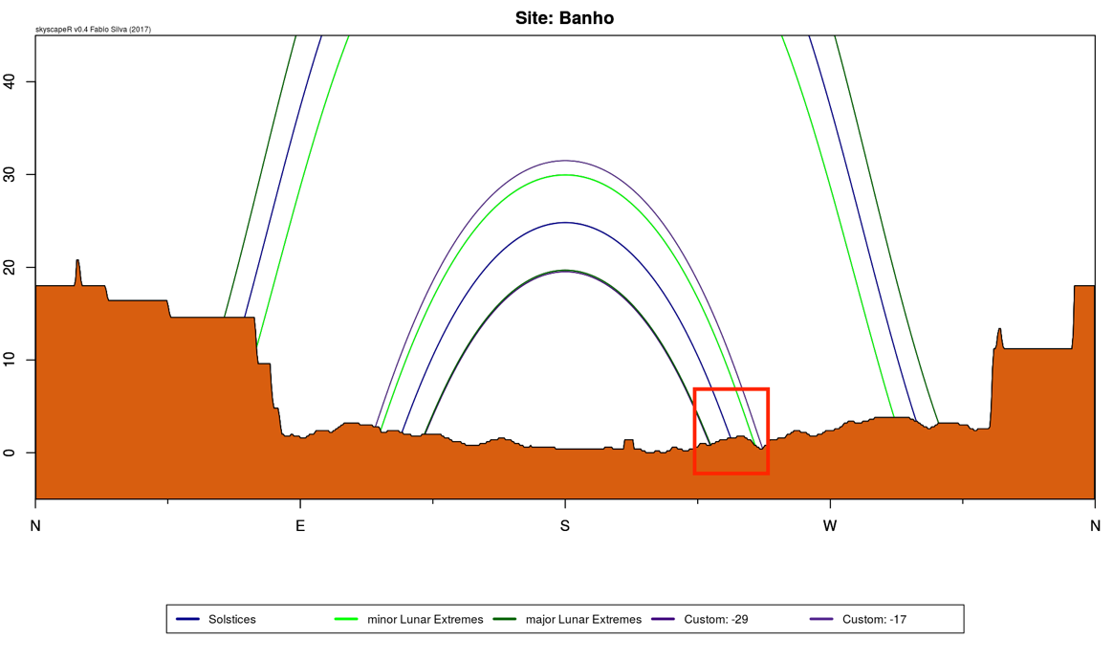

Fig. 10: Solstices and Lunar extremes within the defined declination frame. Image from SkyscapeR.

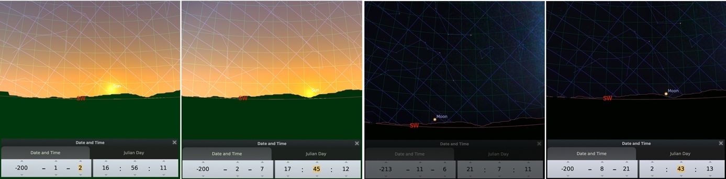

Fig. 11: The sun and the moon setting on both sides of the mountain. Image from Stellarium.

Antares, the most brilliant star from the Scorpio constellation is the brightest star visible to the naked eye that sets within the frame, and if it is possible to see it in the sky nowadays with all the city light pollution, it would certainly be perfectly visible at the time. Antares would be visible setting on the western side of the peak from the beginning of May until the beginning of October. The star Sirius from the constellation Canis Majoris which declination is -16.42º, was included in the analyses for being the brightest star in the night sky and because its declination is less that a degree apart of the western limit of the defined declination frame. Sirius sets in the western valley of the hill from around mid-November, until beginning of May. At the time Sirius disappears in the valley into the morning sky, Antares starts being visible upon the hill and between October and November they switch positions. (Fig. 12, Fig. 13, 13.1). García Quintela and Gonzalez-Garcia in their article about the Celtic calendar mentioned that ‘(…) the “strong” months, which divided the year into two halves, were May, marking the start of the light macro-season of summer, and November, marking the start of the dark macro-season of winter. (…) According to this system, the days that marked the start of the seasons were important, and those that started the two macro-seasons especially so’. The Celtic festivals that correspond to these dates are Samhain, on the first of November, marking the beginning of the winter, and Beltane on the first of May, marking the start of the summer. If this culture was Celtiberian, as proposed by Quintela, Estevez-Garcia and Veiga, the motions of these stars might have been a season marker.

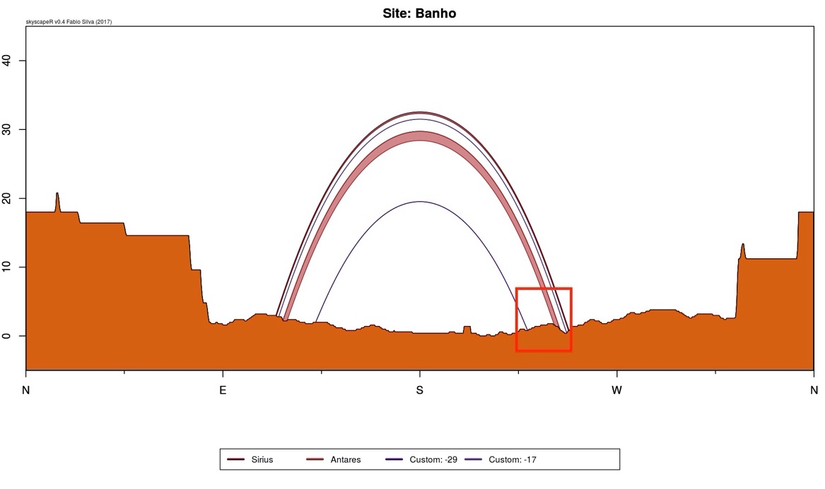\

Fig. 12: The motion of Antares and Sirius in relation with the defined declination frame. Image from SkyscapeR

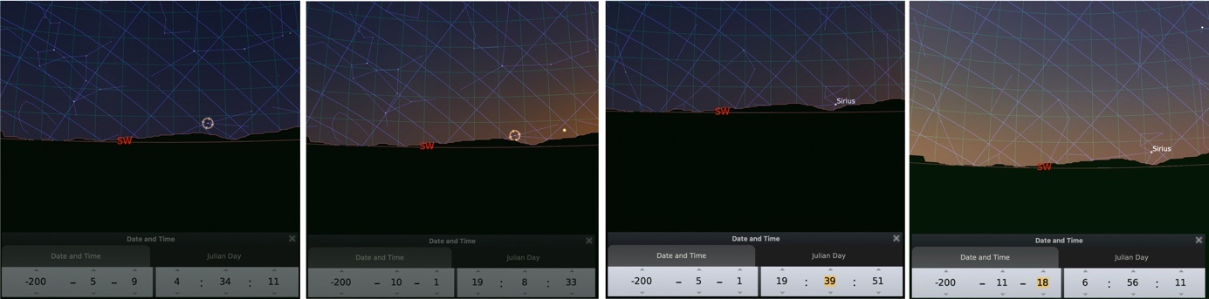

Fig. 13 Fig. 13.1
Fig. 13: Antares first appearance in the beginning of May and last appearance by the end of October.
Fig. 13.1: Sirius last appearance in the beginning of May and first appearance by mid-November.
Images from Stellarium.

Another event spotted on Stellarium that caught my attention was the impact of the brightest and densest part of the Milky Way and its relation with the mountain. It is visible approaching the hill and disappearing into the western valley around the summer solstice until the end of October, when it starts appearing further west (Fig. 14, Fig. 14.1). Though the rise of the sun at summer solstice is exactly at the opposite side and therefore impossible to be seen from the sauna, the appearance of the dazzling Milky Way in the night sky, revolving around that mountain, could have been the night event marking the longest day of the year. The time of the year that coincides with its movement away from the mountain to the west is again the Samhain festival, the beginning of winter.

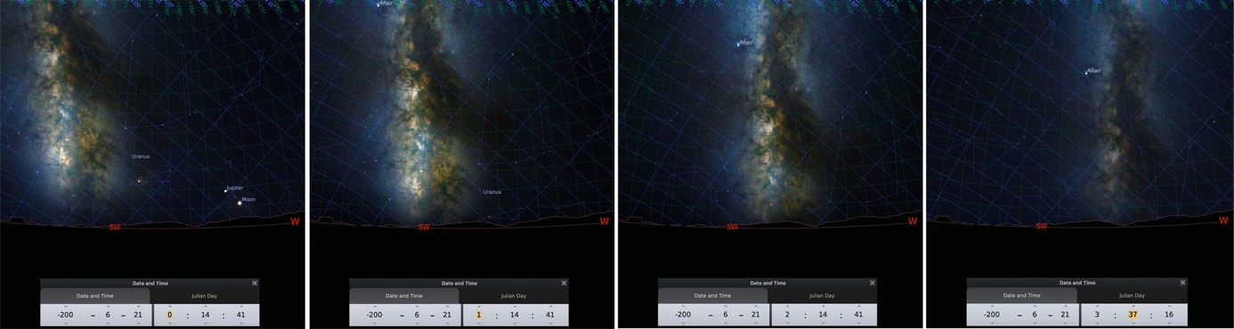

Fig. 14: First appearance of the Milky Way above the mountain on the night of Summer Solstice. Images from Stellarium.

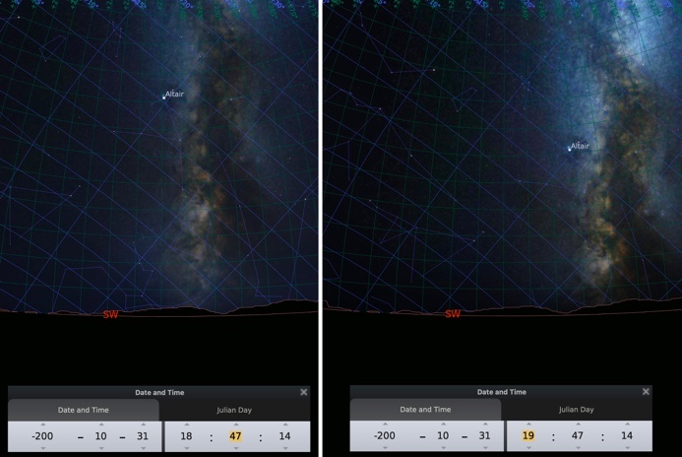

Fig. 14.1: First appearance of the Milky Way above the mountain in the end of October. Images from Stellarium.

Not disregarding Cardozo’s opinions on the symbolism of the arcs as representation of the celestial sphere and on the irrelevant shape of the triskeles’ crescents I would like to propose another point of view. The arcs could be a representation of the mountain, the ever-present, perpetual landscape. The bigger triskele at the top of the mountain, with its crescents turning to the right might represent the Milky Way, always constant in its motion from left to right, east to west. The smaller triskele at the center left whose crescents are turning to the left, could symbolize both sun and moon, which indeed also move from left to right, west to east. The disc at the right side of the mountain could represent Sirius and Antares, the constant bright spots setting on that side of the mountain. As said before, all these events could have been seen from the vestibule, from inside the water tank and probably even from the path way down.
Considering that the antechamber was a roofed space with an entrance it would be difficult to see the landscape from inside, so I suggest that the depictions on pedra formosa would simulate the landscape and the motion of celestial bodies, preserving the connection needed to perform the ritual. Passing through the small opening of the stone to the steam room, would maybe have been the final step of the ritual, the entrance to a place of rebirth.
As mentioned before, the inner face of the stone has also two carved symbols, a solar representation and a S-shapped. If the front of the stone is facing the sunset at the winter solstice, the inner face is facing sunrise at the summer solstice, therefore the solar symbol is aligned with the rise of the sun at the longest day of the year. The S-shapped motif seems to simulate the interior atmosphere, obscured with steamy clouds.

Conclusion

The castros from the Iberian Peninsula established in the beginning of the second century BC were large settlements located on the top of the hills, with massive defensive walls enclosing the residential areas. The sauna construction, singular among the others due to its characteristics, is today unanimously considered to have functioned as a ritualistic structure. The pedra formosa, a stone slab positioned vertically with a small semi-circular opening on the bottom, through which the entrance to the steam room was made, might be the key to understand this building from a skyscape perspective: its symbolic decorations on the outer façade seem to duplicate the landscape aligned with it along with the motion of celestial bodies, and a carved solar motif on its inner face is aligned with the sunrise at summer solstice. These connections might imply that there was an intentionality in aligning the building with that specific mountain and all the celestial events taking place around it, as the sun setting at winter solstice, the lunistices, specific bright stars marking the seasons and the milky way.
Several questions still remain to be answered: whether the rituals were performed either by men or/and women, to purify or protect their physical or spiritual bodies, throughout the year or in specific dates.
Further research on the symbolic decoration of the pedras formosas might contribute with more understandable information regarding the importance and the impact of the sky on human cultures.

Bibliography

Cardozo, Mário, 'A última descoberta Arqueológica na Citânia de Briteiros e a interpretação da "Pedra Formosa" Parte III, in Revista de Guimarães, 41, 1931, pp. 250–60.

Cardozo, Mário. 'A última descoberta Arqueológica na Citânia de Briteiros e a interpretação da "Pedra Formosa" Parte IV, in Revista de Guimarães, 42, 1932, pp.127-39.

García Quintela, Marco V., ‘Sobre las saunas de la Edad del Hierro en la Península ibérica: novedades, tipologías e interpretaciones’, in Complutum, 27.1 (2016), pp. 109–30.

García Quintela, Marco V. and Santos‐Estévez, Manuel, ‘Iron Age Saunas of Northern Portugal: State of the Art and Research Perspectives’, in Oxford Journal of Archaeology, 34.1 (2015), pp. 67–95.

García Quintela, Marco V., A. González-García, César, and Veiga, Yolanda Seoane, ‘The Iron Age Saunas of the Northwest Iberian Peninsula: An Archaeoastronomical Perpective.’, Mediterranean Archaeology & Archaeometry, 14.3 (2014), pp. 133–142.

García Quintela, Marco V. and Gonzalez-Garcia, A. César, ‘Archaeological Footprints of the “Celtic Calendar”?’, in Journal of Skyscape Archaeology, 3.1 (2017), pp.49–78.

Henderson, Jeffrey, ‘The Geography of Strabo: Book III: Chapter III: Section 7’, Loeb Classical Library <http://www.loebclassics.com/view/strabo-geography/1917/pb_LCL050.73.xml?mainRsKey=Romnp8> [accessed 8 August 2020

Prendergast, Frank, ‘Techniques of Field Survey’, in Handbook of Archaeoastronomy and Ethnoastronomy, ed. by Clive L.N. Ruggles (New York, NY: Springer, 2015), pp. 389–409.

Prendergast, Frank, ‘Techniques of Field Survey’, in Handbook of Archaeoastronomy and Ethnoastronomy, ed. by Clive L.N. Ruggles (New York, NY: Springer, 2015), pp. 389–409.

Silva, Fabio, ‘The Role and Importance of the Sky in Archaeology: An Introduction’, in Skyscapes: The Role and Importance of the Sky in Archaeology, Ed. by Fabio Silva and Nicholas Campion, (Oxford: Oxbow Books, 2015), pp. 1-7.

Marco V. García Quintela, A. César González-García, and Yolanda Seoane Veiga, ‘The Iron Age Saunas of the Northwest Iberian Peninsula: An Archaeoastronomical Perpective.’, Mediterranean Archaeology & Archaeometry, 14.3 (2014), 133–142. p.134. [hereafter García Quintela et all, The Iron Age Saunas]
García Quintela et all, The Iron Age Saunas. pp.134,135.
Fabio Silva, ‘The Role and Importance of the Sky in Archaeology: An Introduction’, in Skyscapes: The Role and Importance of the Sky in Archaeology, Ed. by Fabio Silva and Nicholas Campion, (Oxford: Oxbow Books, 2015). pp. 1-7. p.3
Frank Prendergast, ‘Techniques of Field Survey’, in Handbook of Archaeoastronomy and Ethnoastronomy, ed. by Clive L.N. Ruggles (New York, NY: Springer, 2015), pp. 389–409. pp.390, 391.
The information regarding the seasonal roofing was taken from the Citânia’s prospectus, written by the archaeologist Francisco Sande Lemos.
Marco V. García Quintela and Manuel Santos‐Estévez, ‘Iron Age Saunas of Northern Portugal: State of the Art and Research Perspectives’, in Oxford Journal of Archaeology, 34.1 (2015), 67–95. p.73 [hereafter García Quintela, Santos-Estevéz, Saunas State of Art]
Jeffrey Henderson, ‘The Geography of Strabo: Book III: Chapter III: Section 7’, Loeb Classical Library <http://www.loebclassics.com/view/strabo-geography/1917/pb_LCL050.73.xml?mainRsKey=Romnp8> [accessed 8 August 2020]. p.73.
Nadya H. Prociuk, ‘Protection and Purity: Symbolic Functions of the Iron Age Saunas of the Iberian Northwest’, Cambridge Archaeological Journal, 29.1 (2019), 125–40. p.126. [hereafter Prociuk, Protect and Purity]
Prociuk, Protect and Purity. p.137
Marco V. García Quintela, ‘Sobre las saunas de la Edad del Hierro en la Península ibérica: novedades, tipologías e interpretaciones’, Complutum, 27.1 (2016), 109–30. p.121.
García Quintela, Santos-Estevéz, Saunas State of Art. p.85.
Mário Cardozo, 'A última descoberta Arqueológica na Citânia de Briteiros e a interpretação da "Pedra Formosa" Parte III, in Revista de Guimarães, 41, 1931, pp. 250–60. p.254. [hereafter Cardozo, Pedra Formosa III]
Mário Cardozo, 'A última descoberta Arqueológica na Citânia de Briteiros e a interpretação da "Pedra Formosa" Parte IV, in Revista de Guimarães, 42, 1932, pp.127-39. p136.
García Quintela, Santos-Estevéz, Saunas State of Art. p.88.
Cardozo, Pedra Formosa III. p.255.
‘Paróquia de Sande (São Clemente)’ <https://archeevo.amap.pt/details?id=5951&ht=> [accessed 11 August 2020].
Marco V. García Quintela and A. César Gonzalez-Garcia, ‘Archaeological Footprints of the “Celtic Calendar”?’, Journal of Skyscape Archaeology, 3.1 (2017), pp.49–78. p.54

