The purpose of this assignment is to reflect on a Welsh lesson that was planned, delivered and reviewed last year while on Professional Teaching Experience (PTE). The assessment will expand on the reflection points that were previously made and discuss how the writer has progressed and
improved their linguistic skills since the initial lesson. The original lesson plan can be seen in appendix 1, which highlights that the children being taught were high year 1 and average year 2. The main learning objective was for the children to “follow stories read to them and respond appropriately”, as the writer was aware that stories are influential learning tools when teaching a second language (Welsh Government 2015, p.38). During the time of filming the writer felt the lesson was appropriate for their welsh ability but did require elements of improvement. Since filming, these reflective points have been improved on and therefore, will be discussed with relation to the Welsh Competence Framework.

Reflection
A point of reflection previously made was the need for improvement in elements of oracy and confidence. Firstly, the pronunciation of some Welsh used was incorrect e.g. asking the question pa lliw? instead of pa liw? Which therefore resulted in bad modelling for the learners. This could be improved by practicing and checking pronunciation of words and phrases prior to taking a lesson to ensure children are not listening to and learning incorrect vocabulary. This is supported by Estyn (2013, p.41) who emphasis that teachers need to “use clear and precise pronunciation of Welsh words and phrases” in order to provide effective modelling for learners. Furthered by Lightbown and Spada (1999) who highlight the importance of ensuring confidence in teachers oracy, as children improve their own language when they are influenced by knowledgeable adults such as a teacher.

Therefore, since filming the writer has aimed to improve their Welsh pronunciation outside of university by using the training course SaySomethingin Welsh, an online platform where daily tasks are set to complete that aim to help improve personal Welsh oracy skills (SaySomethingin 2020). In addition, the writer has also used the app Duolingo to improve further. Welsh Government (2016) supports the use of initial Welsh teaching courses as they are an effective way of strengthening existing language skills. This writer has also aimed to use welsh in conversation as frequently as possible using it in lectures, with friends and at home, as Seedhouse (2005) and Sangki (2017) suggest that second language is acquired more effectively through interactional experiences. As a result of the actions taken to improve, the writer now has increased confidence in Welsh pronunciation and has greater ability to model language effectively. Furthermore, by developing the role as a teacher the writer is more organised and aware of the need to practicing pronunciation of words that will be used prior to taking a lesson; due to understanding the importance of teacher language in improving learner's language. Jones (2013) emphasises that the words heard linger in the mind of learners, eventually becoming part of the active listeners’ vocabulary.

Another point of reflection is the lack of incidental and subject specific Welsh planned and used through-out the session. It could have been improved by using key vocabulary sentences while reading the book such as ‘dw I'n mynd I ddarllen llyr’, ‘edrychwch a grandwch ar y stori’ and
‘diwedd y stori’. In addition, greater use of Welsh classroom commands should have also been used such as dwylio y fyny, ‘ydy pawb yn barod?. This is important as a prominent factor effecting second language learning is the level of exposition to it, therefore consistent Welsh spoken by the teacher and heard by the children improves language acquisition (Welsh Government 2013). However, due to these phrases not being prepared and included in the lesson plans they were not incorporated into the session and therefore did not progress learner's language. Estyn (2013) highlights how incidental Welsh is important for learners as it exposes children to a range of language and gives them the practice in developing communication skills. This is furthered by Thomas, Apolloni and Parry (2018) who emphasises how incidental Welsh allows children to learn language without over thinking, especially for young children as their brains have the capacity to learn Welsh implicitly.

Therefore, since the initial reflection the writer has taken time to learn and revise a range of language patterns to use in the classroom, following the PTE guidance sheet (appendix 2). Furthermore, by attending weekly Welsh university sessions the writer has been able to develop and learn specific vocabulary to use, for example when reading a book (appendix 3). As a practitioner it is important to develop through personal research (Welsh Government 2019). Due to this drive to improve vocabulary the writer now includes more incidental and specific Welsh phrases into lesson plans as a reminder of what needs to be said during delivery of the lesson. Not only this, but strategies such as wall displays or post it notes are also used as a physical reminder of terms to use until they become part of routine in lessons.

Moreover, in the previous reflection it was emphasised how it is important to let children respond and interact with Welsh language to improve confidence (Welsh Government 2018a). Therefore, during the planned lesson there was very little writing used, due to the follow up activities focusing on developing children's oracy skills. As a result, the writer believes that they have not progressed in their Welsh writing since filming and is something that needs further improvement. Nevertheless, Cook (2008) and Estyn (2017) states how second language speech should be developed prior to introducing writing, as reading and writing is dependent on spoken language. Therefore, highlights the importance of incorporating a range of techniques into a lesson plan. However, initial reflection emphasised that there was a lack of second language teaching techniques planned and used to help the learners. There was an attempt to use total physical response technique by repeating the line ‘beth wyti’n wisgo Tedi Twt?’ with an action. Total Physical Response Theory suggest that children learn second language more effectively when spoken words or sentences are combined with actions, due to it reinforcing the word (Asher 1969). However, more teaching techniques such as singing the colour of the rainbow song or tasked based games for learning could have been used for children to learn vocabulary through meaningful sessions. This is supported by Welsh Government (2018b) who suggests that pupils learn a second language through engaging projects that are related to personal interests. Therefore, since filming the writer has improved their teaching by completing a Welsh module and assignment that explored the way in which children learn a second language providing valuable research on the subject. On reflection in further reference the writer would aim to include all areas of language competence within a theme of lessons.

Overall Progression and Further Development
Overall, from expansion of the reflection points from last year and discussion of improvements, it is clear to see that the writer believes their personal linguistic skills have progressed. The writer will now assess this progression in relation to the Welsh Competence Framework.

Initially, the writer felt the Tedi Twt book chosen was at an appropriate level for the learners. At the time of filming the writer believes their reading competence was at foundation level, as the text was read effectively with discussion and portrayed meaningfully through tone of voice, actions, and interactions. Fisher (1995) emphasises how purposeful, varied language helps maintain second language learners’ focus and attention. Since the filming, the writer as continued to explore and use a range of Welsh books for their chosen age range (Foundation Phase) and is confident in their ability to read and discuss them with learners. However, in order to further improve and reach intermediate the writer needs to begin to gain the ability to discuss content and opinions on more complex books for more able and older learners.

Amongst oracy skills, speaking and listening, the writer believes they were at entry level during the time of filming due to being able to interact and respond to learners with only simple questions, instructions and feedback, with some inaccuracy in pronunciation and clarity. However, since improvement from online Welsh courses and university sessions extending vocabulary, the writer believes they have progressed to foundation level. This can be seen from the ability to now plan to and use more Welsh sentences, objectives and conversations with clear pronunciation and greater confidence. To further improve and reach intermediate level the writer plans to continue to use online teaching platforms such as Forvo (2020), UWTSD Geiriadur (2020) and Saysomethingin (2020) to ensure pronunciation and language is continually practised.

Regarding the writing strand, as previously mentioned, there was no interaction of it from both the writer and the children during the initial lesson. Since filming, the writer believes this is something that has not been improved on very much, due to lack of opportunity to use it in the classroom as a result of cancellation of third year PTE. Therefore, the writer believes they are still at entry level and needs further improvement. To improve, writer plans to use the Cymraeg Dysgu online course that has specific focus to writing (Welsh Government 2018c). Furthermore, the writer will also ensure to involve writing into lesson plans, as Welsh Government (2017) states it is important not to shy away from learning and progression, as if a learners skill level is above a teachers, the learners may become restricted on the learning continuum due to lack of support.

Finally, to further extend competence in teaching of Welsh the writer also hopes to develop greater confidence to teach Welsh in other areas of learning and experience, supported by Estyn (2013) who emphasises, the most effective practice draws on opportunities to introduce Welsh in the other six areas of learning.

Work count: 1646

Name of Trainee: Caitlin Ford Session ref: Lesson 1  Personal Training Target(s) : Include a range of second language teaching techniques to improve learners understanding. Use more incidental and subject specific Welsh. |  | Date: 13/05/2020 Class: Year 1  No of chn: 26 Age: 5-6 |  |  |  |  |  | Foundation Phase Focus Plan  2d
Theme: Teddy Bears Picnic  Picnic Tedi  Learning objectives/intentions:  -For children to respond to literature they hear, by speaking and reading familiar words and phrases.  -To experiment with newly learnt vocabulary.  Success Criteria:  -Listen and interact with story.  -Write a shopping list with food vocabulary.  -Participate in loop game using reading, speaking and listening skills. |  |  |  |  | Meeting learners’ needs  -Differentiated worksheets  -Extension
Introduction/plenary tasks | Main Activities |  |  | Resources/ Key Vocabulary |  |  | Assessment for Learning (strategies and opportunities)
Introduction:  Ydy pawb yn barod?  Rydyn ni’n mynd i ddarllen llyfr. Grandewch a edrychwch ar y llyfr ‘da fi.  -Introduce and read the Welsh story book ‘Picnic Tedi Twt’. Think Pair Share what they think the book will be about. (Use a ruler to follow the words to show children where is being read, Develop reading and listening skills. Get them to all join in with the sentence with action ‘Beth sydd yn a fasget?’ Total Physical Response. When item is pointed at ask ‘beth ydy hwn?’  -Once book has been read, Children to sit in a circle. Teacher will have a basket and get children to sing ‘Beth sydd yn a fasget?’ song (Farmer wants a wife).  - Pull out different objects for a picnic from the basket. ‘beth ydy hwn?’  -Use drilling technique to help children learn the name of them. e.g. Repeat after me, Teacher:Afal, Pupil: Afal (Repeat). Developing speaking skills. | Main Activities  Activity 1- Loop Game  Developing, speaking, listening and reading skills.  (Children have been previously taught and understand, Ga i... os gwelwch yn dda).  -Introduce a loop game. All children will have a card with a picture and Ga i.. sentance. The first person must read out what sentence is on the card, for example, Ga i afel os gwelwch yn dda.  - All children must listen carefully to object being said as whoever has a picture of an apple must then go next. They would reply Afal, and read out what the sentence on their card, for example, Ga i oren os gwelwch yn dda. The game continues until they get back to the person who started.  (Children have played loop games before so have understanding)  -Game suitable for all abilities but HA will be expected to complete the loop quicker.  Activity 2- Play dough Mats  Developing reading  -Children to read play dough mats and make the objects with correct amount of each for the teddy bears at the picnic.  -Activity suitable for all abilities. Extension, use a white board pen to write your own for a friend to make for you.  Trainee focused task – Writing a shopping list. Developing reading and writing.  -Explain that they have to write a shopping list to get ready for the picnic. They have to check what objects and how many of each Tedi Twt wants for the list.  -Recap on welsh numbers by singing ‘Un bys, dau fys, tri bys yn dawnsio’ song previously taught.  -Basket on the table, teacher to pull out laminated pictures of objects with different amounts e.g. 1 afal, 3 bananas, 10 siocled.  -Children have to count how many there are in Welsh and then write it on the shopping list.  -All children should be encouraged to write numbers with little support as it is a topic previously covered.  HA-10 objects with higher quantities. Encourage to try writing food independently.  MA- 7 objects, give support if needed to write the food. (Encourage them to look at displays around them).  LA- 5 objects, given word mat with the objects on.  Continuous Provision  Maths Area  Role Play Area  Enhanced Provision  -Role play area to be transformed into a shop with food and basket for children to use the words learnt. Developing speaking and listening skills.  -Maths area to have Welsh numbers 1-10 on individual flashcards (e.g. un, dau, tri). Children to try and peg them on number line in correct order. Developing Reading |  |  | Resources  -Tedi Twt Book  -Basket with food objects in.  -Loop Game  -Shopping list worksheets  -Laminated cards with food objects on.  -Shop role play (baskets, money, food, sentence reminder sheet)  -Maths Area (Time line, pegs, laminated Welsh number words)  Key Vocabulary  Basget  Picnic  Afal  Oren  Banana  Sudd  Siocled  Teisen  Creision  Brechdanau  Mefus  Ga i ... Os gwelwch yn dda.  Diolch  Numbers 1-10 in Welsh. |  |  | Key Questions  Beth sydd yn a fasget?  Faint?  Beth ydy hwn?  Beth ydy’r rhain?  AFL-  -Think, Pair, Share.  -Name in pots at end of lesson.  -Answering a question in Welsh before they can leave.
Plenary
-Come back to carpet, children to place their name in pot to assess how they found the work.
-Then answer a question/ give teacher something learnt in Welsh today before they can leave.

Curriculum coverage (range and skills)
Language, Literacy and Communications
Literacy Fires Imagination and Inspires Creativity (progression step 1)
have experienced literature.
I am beginning to respond to literature I hear and view.
I am beginning to write using familiar words and phrases.

Understand language us is key to understand the world around us (Progression step 1)
I can use context and pictures to help me understand words.
I can experiment with newly-learned vocabulary.
Expressing ourselves through language is key to communication (Progression step 1).
I can contribute to shared writing for different audiences and purposes.
I can use familiar words and phrases and experiment with newly-learned vocabulary.
Literacy (LNF) |  |  | Numeracy (LNF)  -I can notice, recognise and write numbers in a range of media, through a multisensory approach, from 0 to 10 and beyond.
ICT | Thinking |  |  | ESDGC |  | YCC  Welsh language development

Resource- Loop Game Example:

Ga i Afal os gwelwch yn dda.


Ga i Banana os gwelwch yn dda.


Ga i Siocled os gwelwch yn dda.


Resource- Shopping List Worksheet

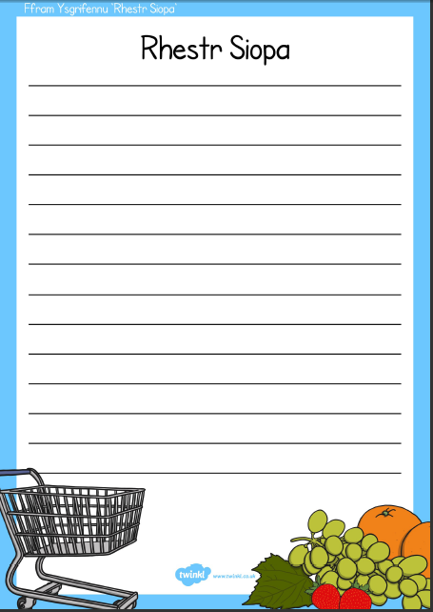

Resource- Play dough mats
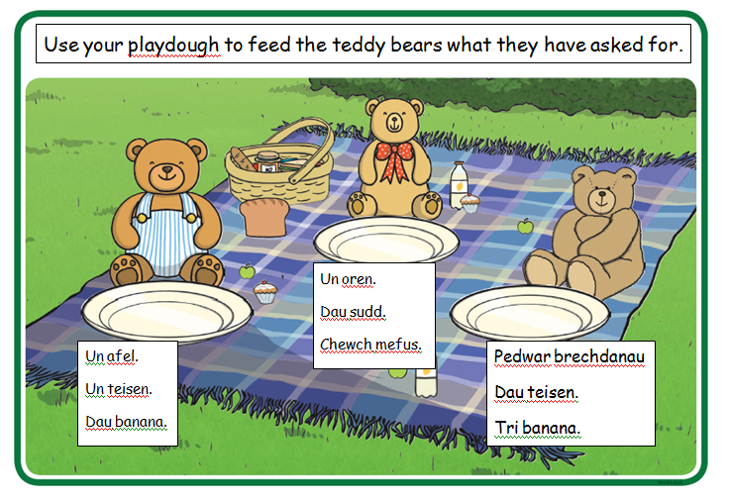

Name of Trainee: Caitlin Ford Session ref: Lesson 2  Personal Training Target(s) : Include a range of second language teaching techniques to improve learners understanding. Use more incidental and subject specific Welsh. |  |  | Date: Class: Year 1  No of chn: 26 Age: 5-6 |  |  |  |  |  |  | Foundation Phase Focus Plan  2d
Theme: Teddy Bears Picnic  Picnic Tedi  Learning objectives/intentions:  -For children to be able to read, speak and write familiar vocabulary. Success Criteria:  -Recognise vocabulary and match to corresponding pictures (bingo)  -Use vocabulary in meaningful real life activity (weather report) |  |  |  |  |  |  | Meeting learners’ needs  -Differentiation of activities.
Introduction/plenary tasks | Main Activities |  |  |  | Resources/ Key Vocabulary |  |  |  | Assessment for Learning (strategies and opportunities)
Introduction:  Pawb yn dawl  Eisteddcwch, grandewch a edrychwch arna i.  Pwy sy'n barod i ddysgu  -Discuss how to have a teddy bears picnic that we have done a shopping list for we need to have the correct weather because Tedi Twt does not like to eat outside in the rain  -Recap on different weather by Sing the song ‘Sut mae twydd heddiw?’ (Addams Family) showing flash cards of Tedi twt in different weathers. Children should respond according e.g. mae hi’n heulog.  Developing speaking skills. | Main Activities  Activity 1- Weather bingo game  Developing listening skills  -Children will have a card that has 6 different weather pictures on them. Teacher will read out a weather e.g. Heulog and children who have the corresponding picture must cover it with a counter. The first child to cover all shouts BINGO and they swap cards over and start again.  -Once the game is over the children will use white board pens to write in the space the correct weather.  -Suitable for all abilities, more supported needed for LA.  Trainee focused task- Weather Report Meaningful Learning  Developing reading and speaking skill.  -Use green screen app and props children to create a weather forecast report (filmed by teacher). There will be a large weather chart with the days of the week on. They must place a weather sentence and picture on the chart and read it out e.g. Ar dydd llun mae hi’n Heulog.  -Give children post it notes at the end of the activity to write a comment on how they found the learning.  HA- for the week.  MA- for 5 days.  LA- for 4 days.  Continuous Provision  -Sand and water area  -Role play area  Enhanced Provision  -Role play area shop with items in but sentences adding to prompts.  Developing speaking and listening  -Sand enhanced with the ‘heulog  heulog ar y traeth’ with buckets and spades and water area is enhanced with ‘bwrw glaw yn yr dref’with little umbrellas, and buckets with holes to make it rain. |  |  |  | Resources  -Tedi Twt flashcards  -Bingo cards  -Counters  -White board pens  -Green screen app  -Ipad  -Weather chart (pictures and sentences)  -Props (microphone)  Key Vocabulary  Twydd  Heulog  Boeth  Wyntog  Gymylog  Bwrw glaw  Bwrw Eira  Oer  Braf  Days of the week. |  |  |  | Key Questions  Sut mae twydd heddiw?  AFL  -Post it notes to leave comment about how they found the learning.
Plenary
Watch video, How the weather?
After they say the English sentence,
get childrento join in with Welsh e.g It is sunny, Mae hi’n heulog.
It is raining, Mae hi’n bwrw glaw
https://www.youtube.com/watch?v
=6MGRkUlFZws
Curriculum coverage (range and skills)
Language, Literacy and Communications
Literacy Fires Imagination and Inspires Creativity (progression step 1)
I am beginning to respond to what I hear and view.
Understand language us is key to understand the world around us (Progression step 1)
I can use context and pictures to help me understand words.
Expressing ourselves through language is key to communication (Progression step 1).
I can communicate meaning through speech and gesture.
I can use familiar words and phrases and experiment with newly learned vocabulary.

Literacy (LNF) |  |  |  | Numeracy (LNF)
ICT  Green screen app used children filming and editing their weather report. |  | Thinking |  |  |  | ESDGC |  | YCC  Welsh language development

Bingo Game
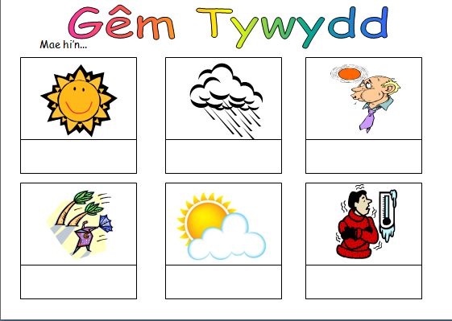
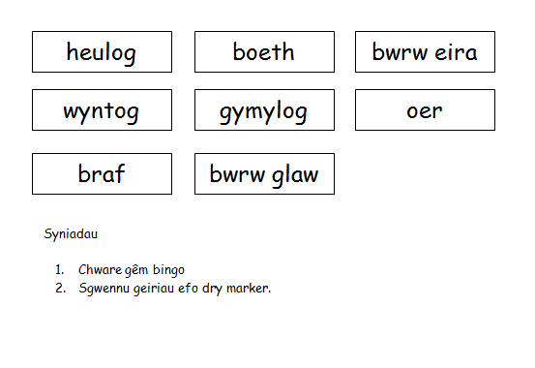

Weather chart
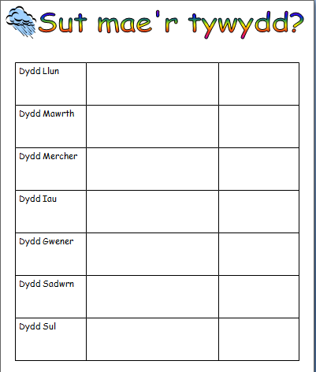

Reference List
Asher, J. (1969). The Total Physical Response Approach to Second Language Learning. The Modern Language Journal.
Cook, V. (2008) Second Language Learning and Language Teaching, 4th ed. London: Arnold.
Estyn (2013) Welsh Language development in the Foundation Phase. Cardiff: Crown.
Estyn (2017) Improving the Learning and Teaching of Early Reading Skills. Cardiff: Crown.
Fisher, R. (1995). Teaching Children Learning. England: Stanley Thornes Ltd.
Jones, G. (2013) My guinea pig died with its legs crossed, Ceredigion: Atebol Cyfyngedig.
Lightbown, P. and Spada, N. (1999) How languages are learned, Oxford: Oxford University Press.
Sangki, K. (2017). Conversation Analysis and Second Language Acquisition. Kate Forum, 41(2), pp. 32–35.
Seedhouse, P. (2005). Conversation Analysis and language learning. Language Teaching, 38(4), pp.165-187.
Thomas, E. Apolloni, D. and Parry,N. (2018) Bilingual Teaching Methods, Bangor: Bangor University.
Welsh Government (2013) One language for all - Review of Welsh second language at Key Stages 3 and 4. Cardiff: WG.
Welsh Government (2015) Foundation Phase Framework, Cardiff: Crown.
Welsh Government (2016) Review of a project to encourage Welsh-medium teaching in English-medium primary schools. Cardiff: Crown.
Welsh Government (2017) Welsh in education Action plan 2017–21. Cardiff: Crown.
Welsh Government (2018a) Rapid Evidence Assessment: Effective Second Language Teaching Approaches and Methods. Cardiff: Crown.
Welsh Government (2018b) An overview of approaches to second language acquisition and instructional practices, Cardiff: Crown
Welsh Government (2019) Professional standards for teaching and leadership, Cardiff: Crown.
Websites
Frovo (2020) Welsh pronunciation dictionary. Available at: https://forvo.com/languages/cy/ (Last Accessed 14th May 2020)
SaySomethingin (2020) Available at: https://www.saysomethingin.com/ (Last Accessed 14th May 2020)
University of Wales Trinity Saint David (2020) Geiriadur. Available at: https://geiriadur.uwtsd.ac.uk/ (Last Accessed 14th May 2020)
Welsh Government (2018c) Cymru Gwaith. Available at: https://learnwelsh.cymru/work-welsh/work-welsh-courses/teachers-part-1/ (Last Accessed 14th May 2020)

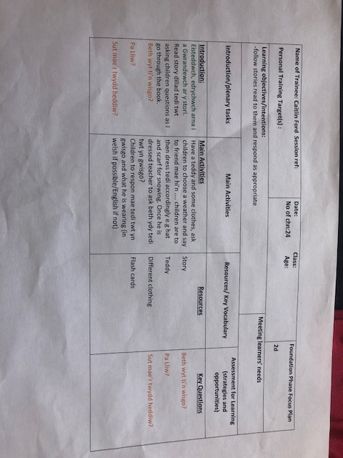
Appendix 1- Original Lesson Plan
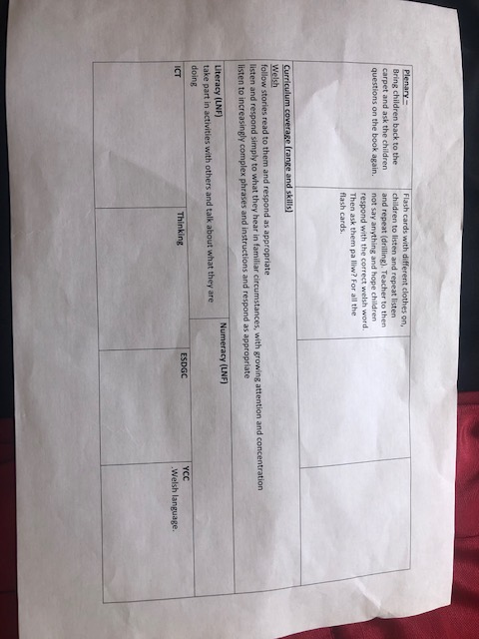

Appendix 2- PTE Welsh guidance sheet

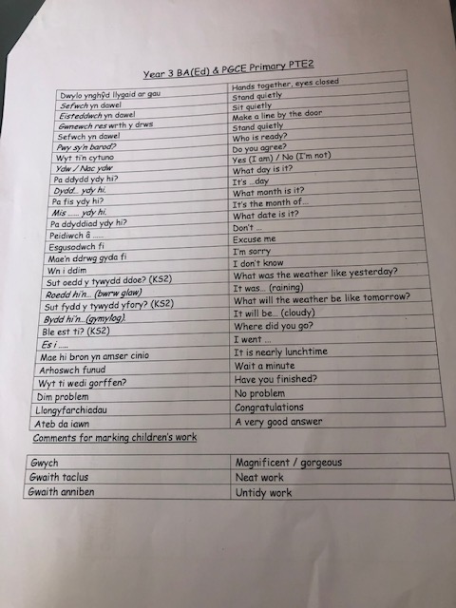

Appendix 3- University Handout
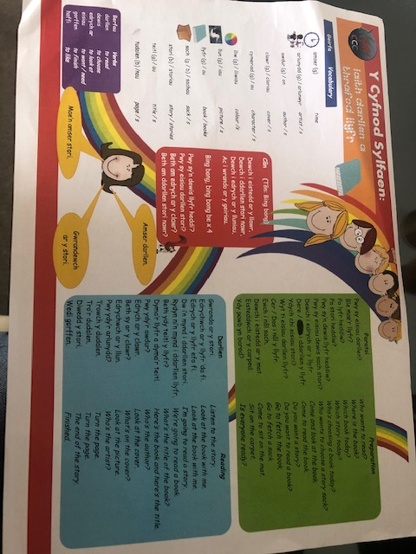
Appendix 3- University Handout



