Functions in Python

Functions are used when there a section of code which will be repeated in your program, but not necessarily consecutively, as with a loop.

Functions also help you to organise your program and makes it easier to maintain.

Also, functions can make it easier for more than one person to contribute to a program (each person can work on a function separately and then they can be linked to the main program later)

Here is a program which has some code that appears more than once:

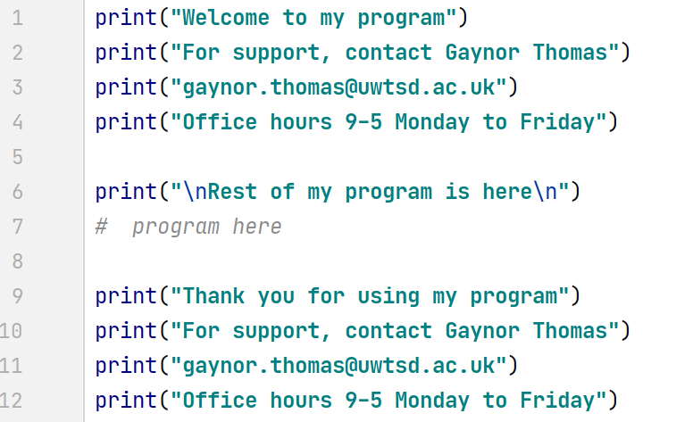
same code

same code

Instead of having two copies of the same code, I can put the repeating code in a function, and then call it whenever required.

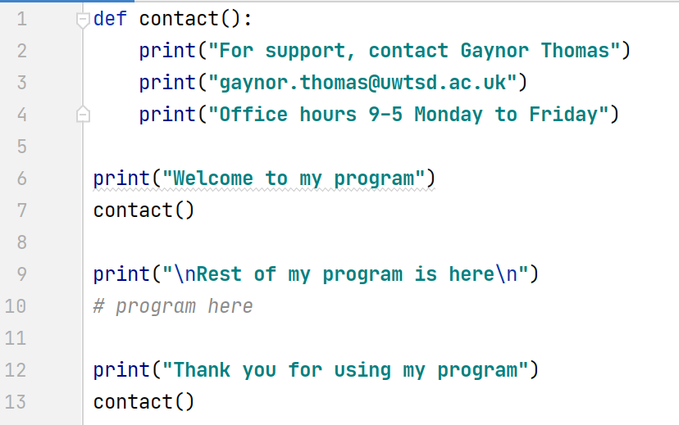
function
1 copy of code

call function

call function

The function contact() is reusable. In the above example, I have called it twice.

Functions will only run when called. If they are not called, they will not run

In this program the code will start on line 6:

4 continue program

5. call function again
(return here when finished)

6. end of program
3. At end of function, return to where call started
1 start here
2 call function

Here is the output from the program:
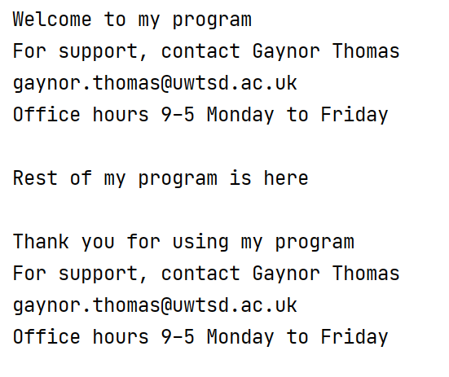
Note the syntax for functions. Like the if/elif/else, while and for structures, functions also depend on the tab to note where their content is.

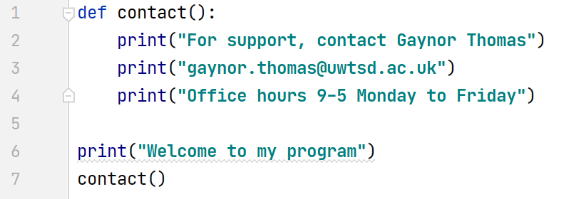
tab in
function
content

outside function ,
(main program)

Let's do one more example. In this example I have a function to welcome someone to my program.

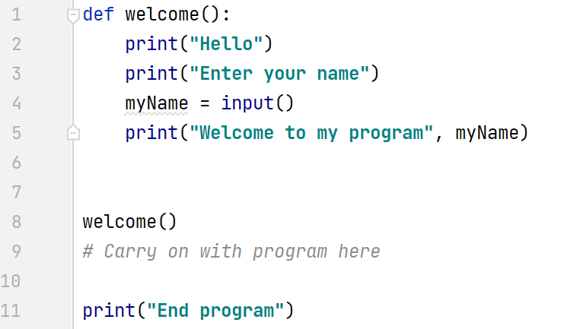
call function

return from function
function

Another really useful thing with functions, is, once written, you can separate them into an external file, and import them into other programs if required.

For example, I could put the above function into a separate Python file (I'll call it gaynor_general.py)

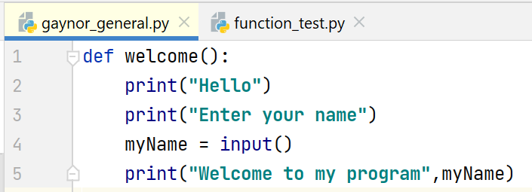

Then, I can import it into other programs when needed as shown below.

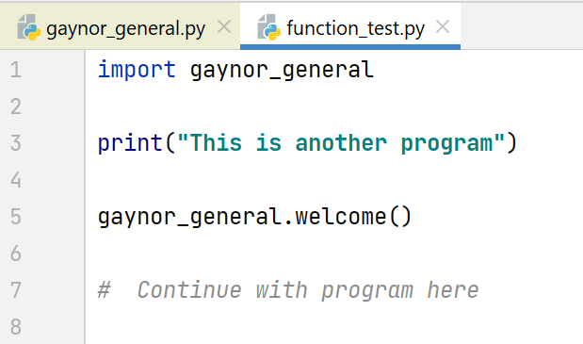
call function
from separate file

In this way, I can write my own library of functions that are useful to me.

A closer look at Python variables

In Python, we have learned about variables (int, float, string) and how they are weakly typed.

We have not yet looked at the concept of scope which is important when it comes to functions.

All variables declared outside a function have global scope. This means that they can be seen from anywhere in the program, including inside functions.

For example:
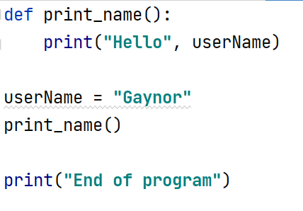
Variable userName – global scope
Prints out from main program and within a function

function

Here's another example, I change the value of username in the main program and then call the print_name() function. The scope of username is global (visible from anywhere in the program)

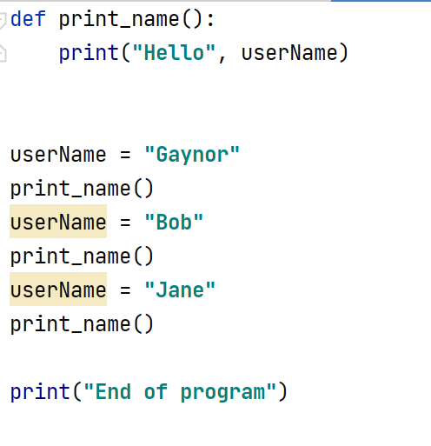

However, if there is a variable inside a function, it has local scope. (ie it can't be seen outside the function)

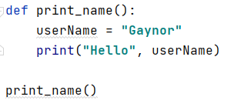
Variable – local scope
Exists only inside its function

Using global scope variables with functions can be dangerous. This is because if I happen to have a variable with the same name within a function, Python sees them as two separate variables – one with global scope and one local to print_name. In this case, the local variable would take priority as shown below:

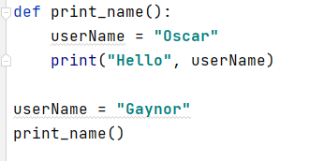
Variable userName – local scope
(exists only inside its function and take priority)

Variable userName – global scope

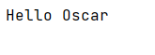

When multiple users are working on a program, or if the program is quite large and complex, you could quite easily choose the same variable name in the main program and within a function and get some unexpected results.

For this reason, it is better practice to use arguments/parameters.

Passing Arguments to Parameters

In the following example, I have enclosed the main part of my program in a function called main() and it is called from below.

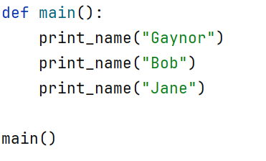

I am sending arguments (Gaynor, Bob and Jane) to a function call print_name with a parameter called theName

Each time I call the function, the argument is sent to the parameter (this then becomes local scope to function print_name)

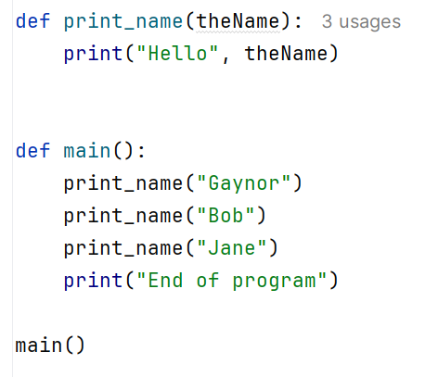

Output:

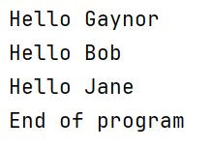

Each time the function is reused, I have sent it a different argument.

I can also send variables as arguments. Here, the contents of userName is the argument, and this value is passed into the theName parameter in the function header.

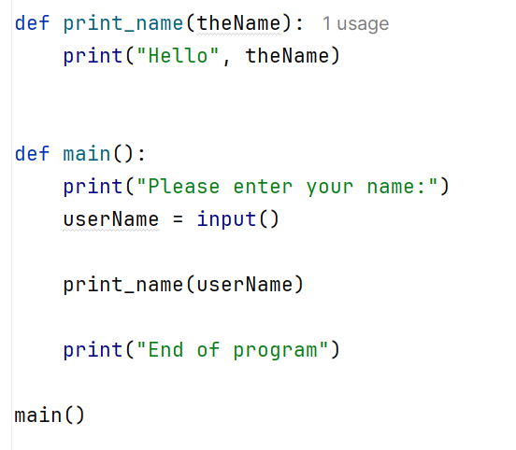

Output:

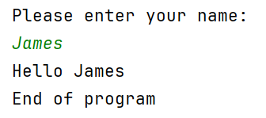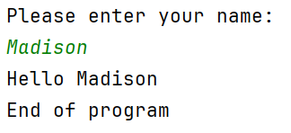

Let's do another example.

In this example, I am sending two arguments:

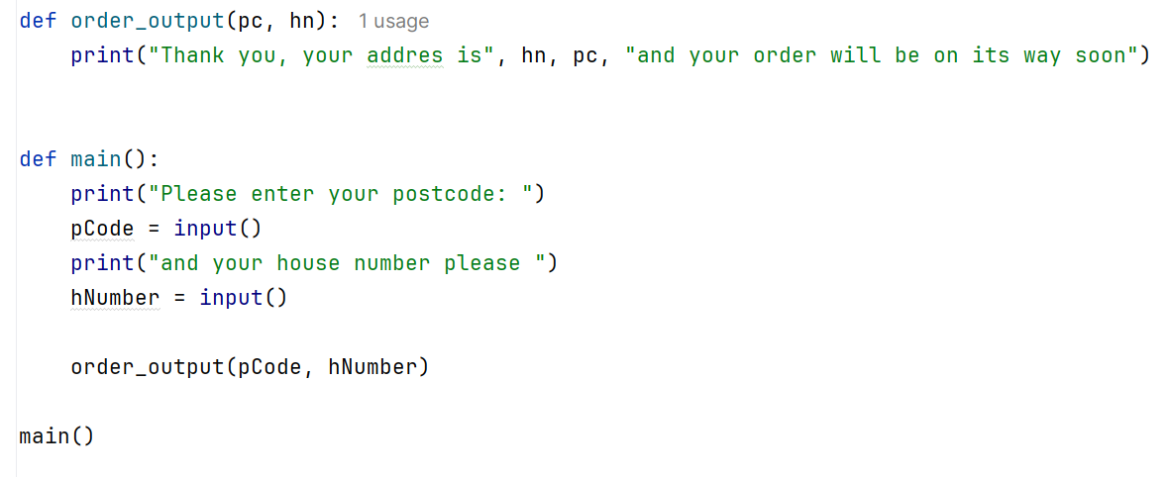

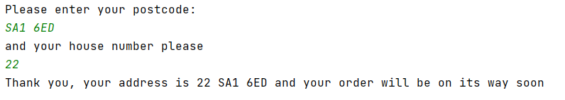

Note that the arguments are mapped on to the parameters in the order they arrive.

In Python, it is also fine to pass a list to a function.

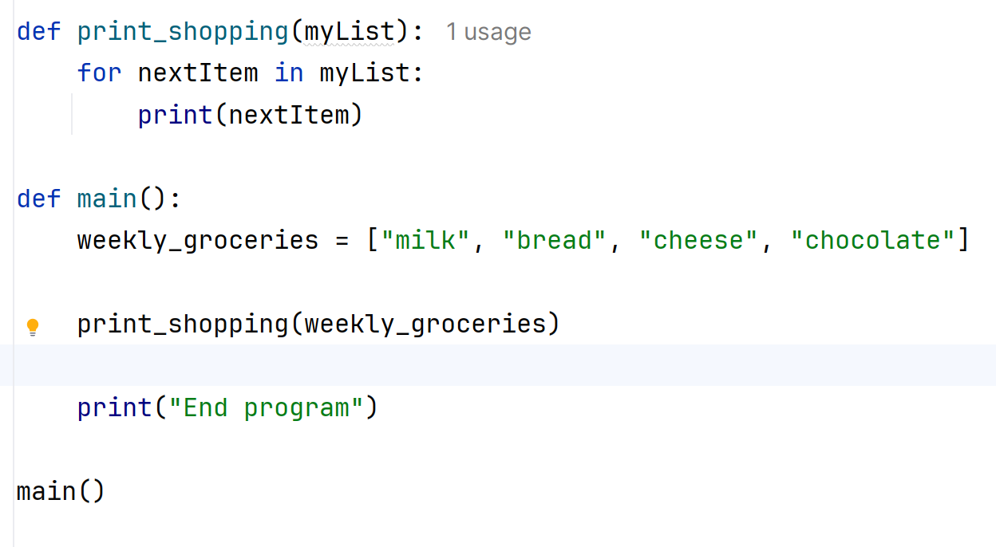
call function, send list as argument

Note: The words "arguments" and "parameters" do have a specific technical meaning, however, the words are often used interchangeably by programmers. You will often hear programmers talk about "passing parameters" when they really mean "passing arguments".

Using returns

Sometimes we want to return a value from a function. For example, we might be doing a calculation in a function, and we want to return the result to the main program.

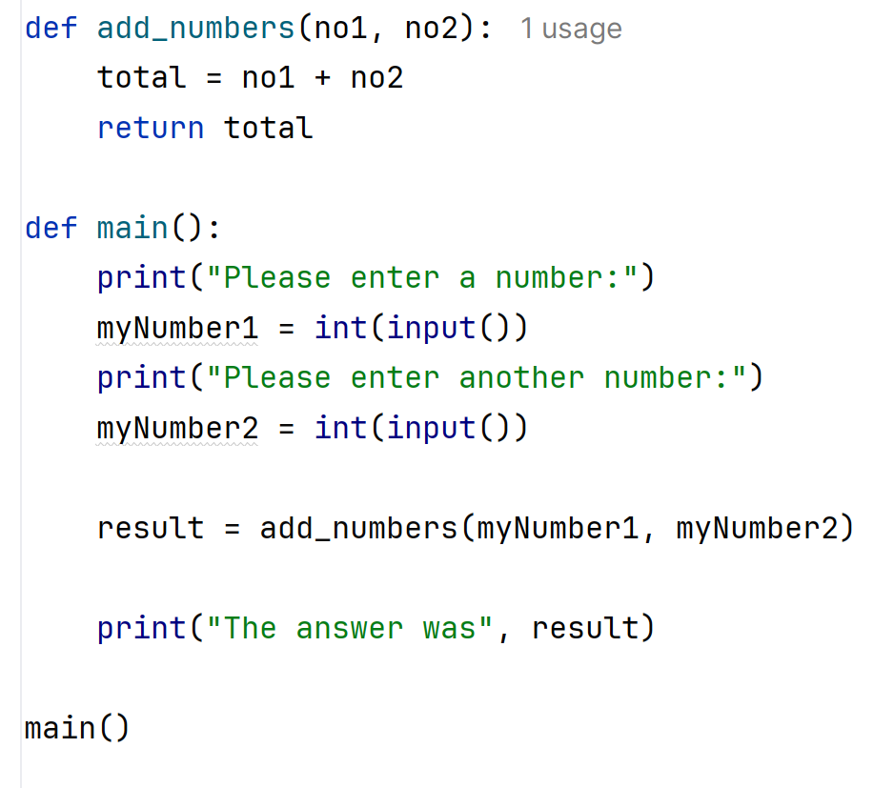
2. return value
- call function

Here, variable result will wait for the function add_numbers to run. When it has, the return value, total will come back from the function and be stored in result .

Output:

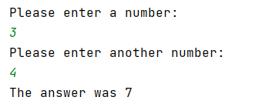

Note: Most programming languages will only allow you to return one value from a function. Python does allow you to return multiple values, however, if I returned two values from the function above, result would become a Python tuple (a bit like a list) rather than staying as a normal variable. For this reason, we will only return one value.

Here's an extended example with two functions:

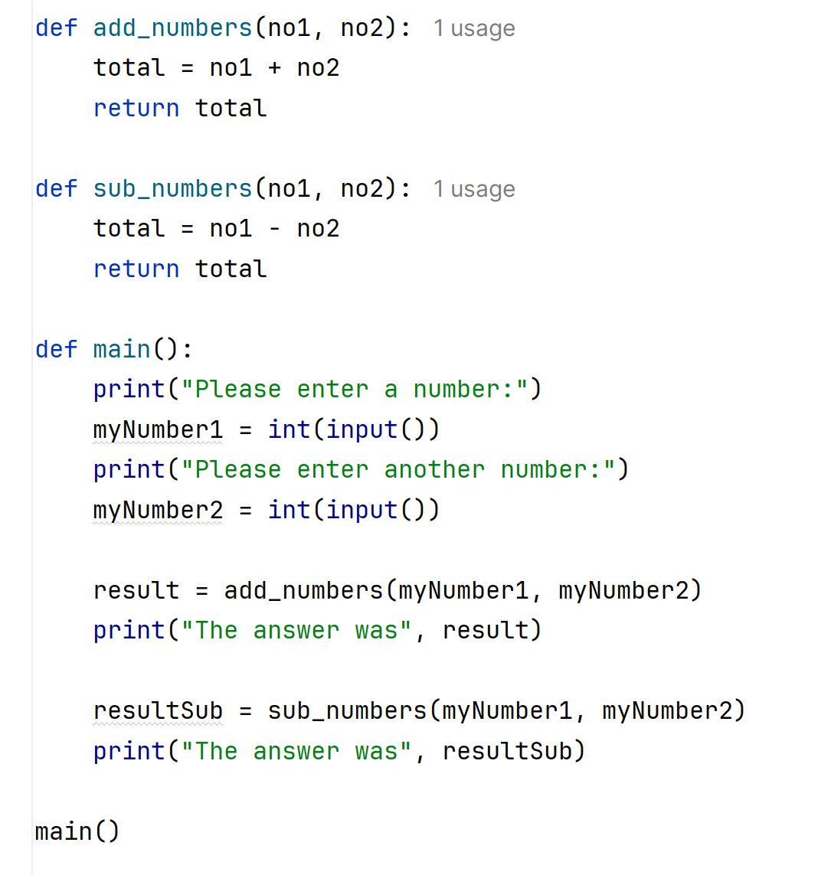

We can combine decisions / loops and other Python skills with function calls of course, here's a further extended example where the user chooses from a menu:



