

Programme: MSc Public Health and Social Care in Practice
Module: Population Health and Digital Health Promotion
Module code: LCHS7007

Student Name: Anil Kumar

Student ID:2331779

Table of Contents
Task 1: Blogs 3
Blog 1: How Chatbots Are Revolutionizing Health Promotion 3
The Challenge: Limited Access to Healthcare 3
Meet the Digital Heroes: Healthcare Chatbots 3
The Growing Impact of Chatbots 3
What’s Working and What Needs Work? 4
Why Chatbots Shine: 4
Where They Struggle: 4
Making Chatbots Better 4
The Takeaway 5
Blog 2: Wellness Ally: Transforming Healthcare with Smart AI 5
The Public Health Crisis: Managing Chronic Illnesses 5
Wellness Ally: A Smarter Way to Manage Health 5
Evidence-Based Impact 6
Challenges and Improvements 6
Conclusion 6
References for the Blogs 7
Task 2: Poster 10
References for the Poster 11

Task 1: Blogs

Blog 1: How Chatbots Are Revolutionizing Health Promotion

The Challenge: Limited Access to Healthcare
Imagine needing medical advice at midnight or living in a remote area with no nearby clinic. For billions of people, this isn’t a rare scenario—it’s daily life. According to the World Health Organization (WHO), a staggering 50% of the global population lacks access to essential health services. In underserved areas, this leads to delays in diagnosis, treatment, and preventable health complications (World Health Organization, 2023). The COVID-19 pandemic only made things worse, pushing healthcare systems to their breaking point and exposing the urgent need for scalable, efficient solutions (Filip et al., 2022).

Meet the Digital Heroes: Healthcare Chatbots
What if you could ask a question about your health and get an instant, accurate response? That’s where healthcare chatbots step in. These AI-powered assistants are transforming the way we interact with healthcare by offering:
- Symptom assessments: Evaluate your health and determine whether to seek medical attention.
- Appointment scheduling: No more long waits or paperwork. Chatbots streamline the process.
- Mental health support: Tools like Woebot provide therapeutic guidance to users directly on their devices (Woebot Health, 2024).
- Chronic disease management: Receive medication reminders and tips for conditions like diabetes (Patil, 2024).
During the pandemic, chatbots like Infermedica proved their worth by delivering accurate, instant information about COVID-19 symptoms and testing to millions (Sundareswaran and Firth-Butterfield, 2020).

The Growing Impact of Chatbots
The numbers don’t lie. Healthcare chatbots are reshaping the industry in real-time:
- The global market is expected to skyrocket from $382.1 million in 2024 to $1.4 billion by 2031, growing at an impressive 20.33% CAGR (Persistence Market Research, 2024).
- North America leads the pack, with a 28% market share, thanks to widespread adoption of AI tools and smart technologies (Market.us, 2024).
- Automation is a game-changer, cutting up to 30% of administrative costs in hospitals and clinics (Varnosfaderani and Forouzanfar, 2024).

What’s Working and What Needs Work?

Why Chatbots Shine:
- Always On: Chatbots don’t sleep. They’re there for you 24/7.
- Super Scalable: A single chatbot can manage thousands of interactions simultaneously, easing the load on healthcare staff.
- Empowered Patients: Apps like Ada Health improve health literacy, helping users make informed decisions.

Where They Struggle:
- Complex Cases: Chatbots can’t replace the nuanced expertise of a human doctor for tricky diagnoses.
- Privacy Risks: Storing sensitive health data comes with potential vulnerabilities.
- Trust Issues: A 2023 survey found that 48% of patients prefer human interaction, concerned about the accuracy of AI recommendations (Robertson et al., 2023).

Making Chatbots Better
To make healthcare chatbots even more effective, here’s what needs to happen:
- Smarter AI: Advanced training models can enhance how chatbots analyze and respond to complex queries.
- Stronger Security: Robust encryption and adherence to regulations like GDPR and HIPAA will protect user data.
- A Human Touch: Pairing chatbots with healthcare professionals ensures users get both speed and expertise (SEO Xeven, 2023).

The Takeaway
Chatbots aren’t just about convenience—they’re about revolutionizing healthcare access, reducing costs, and empowering individuals to take charge of their well-being. With continued innovation in AI and data security, these digital tools are set to become an essential part of our healthcare journey.

Blog 2: Wellness Ally: Transforming Healthcare with Smart AI

The Public Health Crisis: Managing Chronic Illnesses
Around the world over 70% of Health spending is because of chronic illnesses as diabetes, respiratory conditions and cardiovascular diseases (World Health Organization, 2021). These conditions call for regular observation and control but healthcare systems have become overloaded. Studies reveal alarmingly high rates of readmissions amongst chronic illnesses persist in hospitals with poor follow up a significant trigger. Additionally, a 2022 analysis discovered automated solutions like chatbots might decrease the workload of physicians by 30%, reducing daily tasks and freeing up precious time for patients ​ (Karim et al., 2024).

Wellness Ally: A Smarter Way to Manage Health
To tackle this issue, we propose Wellness Ally, an advanced AI chatbot that reimagines how healthcare is delivered. This innovative tool combines real-time data analysis, patient education, and emergency support to create a comprehensive health management system (Ahmed et al., 2020).
Its Symptom Progression Tracker is just one of its primary features - predictive analytics monitor health trends and alerts owners of possible dangers before they turn into problems. For instance, an individual with hypertension might be notified to irregularities through wearable device data, ensuring prompt treatment. In the same time, its critical Response Mode saves lives by finding critical abnormalities and also directing individuals to Emergency services.
Wellness Ally also focuses on prevention and engagement. Features like Personalized Food Scanning guide users toward better dietary decisions, while Health Habit Gamification incentivizes healthier behaviors. Additionally, the AI Health Literacy Tutor simplifies complex medical jargon, ensuring patients fully understand their conditions and treatments (Clark and Bailey, 2024).

Evidence-Based Impact
Wellness Ally builds on proven benefits of healthcare chatbots. A 2023 study found that remote patient monitoring (RPM) tools reduced hospital readmissions by 20-25%, particularly among chronic disease patients (Telehealth Research, 2023)​. Gamification techniques, integrated into Wellness Ally, have been shown to improve treatment adherence rates by up to 50%, ensuring patients stay consistent with their health goals (Patil, 2024a)​. Moreover, chatbots like Wellness Ally can significantly cut operational costs, aligning with findings that automated systems save up to 30% in administrative expenses​ (Chatbots on, 2024).

Challenges and Improvements
Despite its promise, Wellness Ally is not without limitations. Predictive algorithms require high-quality data, and incomplete or biased inputs could lead to inaccurate predictions. Additionally, reliance on smartphones and wearables may exclude underprivileged populations. Privacy remains another critical concern, as sensitive health data becomes a target for cyber threats (Paulus and Kent, 2020).
To address these challenges, Wellness Ally integrates a hybrid model, combining AI efficiency with human oversight for critical cases. Partnerships with NGOs and governments could also make wearables more accessible in underserved areas. Strong encryption protocols and adherence to data privacy laws like HIPAA will further safeguard user trust (Pavlopoulos, Theodoros Rachiotis and Ilias Maglogiannis, 2024).

Conclusion
Wellness Ally isn’t just a chatbot—it’s a step toward a more accessible, personalized, and efficient healthcare system. By combining cutting-edge AI with a patient-first approach, it offers a solution to the complex challenges of chronic disease management. With continuous innovation, Wellness Ally can become a vital tool in transforming global health.

References for the Blogs
Ahmed, Z., Mohamed, K., Zeeshan, S. and Dong, X. (2020). Artificial intelligence with multi-functional machine learning platform development for better healthcare and precision medicine. Database, [online] 2020. https://doi.org/10.1093/database/baaa010.
Chatbots on (2024). Impact of Chatbots on Reducing Customer Support Costs. [online] FastBots. Available at: http://fastbots.ai/blog/impact-of-chatbots-on-reducing-customer-support-costs [Accessed 17 Nov. 2024].
Clark, M. and Bailey, S. (2024). Chatbots in Health Care: Connecting Patients to Information: Emerging Health Technologies. [online] PubMed. Ottawa (ON): Canadian Agency for Drugs and Technologies in Health. Available at: https://www.ncbi.nlm.nih.gov/books/NBK602381/.
Filip, R., Puscaselu, R.G., Anchidin-Norocel, L., Dimian, M. and Savage, W.K. (2022). Global Challenges to Public Health Care Systems during the COVID-19 Pandemic: a Review of Pandemic Measures and Problems. Journal of Personalized Medicine, 12(8), p.1295. https://doi.org/10.3390/jpm12081295.
Karim, M., Alrazeeni, D.M., Akter, F., Latifun Nesa, Dipak Chandra Das, Muhammad Join Uddin, Begum, J., Most. Tahmina Khatun, Md. Abdun Noor, Ahmad, S., Sabren Mukta Tanha, Tuli Rani Deb and Mst. Rina Parvin (2024). The Role of Artificial Intelligence in Enhancing Nurses’ Work-Life Balance. Journal of Medicine Surgery and Public Health, 3, pp.100135–100135. https://doi.org/10.1016/j.glmedi.2024.100135.
Market.us (2024). AI in the Packaging Market Valued at USD 7,337 Million Boom by 2033. [online] Global Trade Magazine. Available at: https://www.globaltrademag.com/ai-in-the-packaging-market-valued-at-usd-7337-million-boom-by-2033/ [Accessed 17 Nov. 2024].
Patil, G. (2024a). Benefits Of Gamification In Healthcare App. [online] IdeaUsher. Available at: https://ideausher.com/blog/gamification-in-healthcare/.
Patil, G. (2024b). Top 10 Ways Healthcare Chatbots Are Transforming The Industry. [online] IdeaUsher. Available at: https://ideausher.com/blog/chatbots-in-healthcare-industry/ [Accessed 17 Nov. 2024].
Paulus, J.K. and Kent, D.M. (2020). Predictably unequal: understanding and addressing concerns that algorithmic clinical prediction may increase health disparities. npj Digital Medicine, [online] 3(1). https://doi.org/10.1038/s41746-020-0304-9.
Pavlopoulos, Theodoros Rachiotis and Ilias Maglogiannis (2024). An Overview of Tools and Technologies for Anxiety and Depression Management Using AI. Applied Sciences, 14(19), pp.9068–9068. https://doi.org/10.3390/app14199068.
Persistence Market Research (2024). Healthcare Chatbots Market Size, Trends & Forecast to 2031. [online] Persistence Market Research. Available at: https://www.persistencemarketresearch.com/market-research/healthcare-chatbots-market.asp.
Robertson, C.T., Woods, A., Bergstrand, K., Findley, J., Balser, C. and Slepian, M.J. (2023). Diverse patients’ attitudes towards Artificial Intelligence (AI) in diagnosis. PLOS digital health, 2(5), pp.e0000237–e0000237. https://doi.org/10.1371/journal.pdig.0000237.
SEO Xeven (2023). Top 10 Tips Effective on How to Train AI Healthcare Chatbot. [online] Xeven Solutions. Available at: https://www.xevensolutions.com/blog/how-to-train-an-ai-healthcare-chatbot-top-10-effective-tips/ [Accessed 17 Nov. 2024].
Sundareswaran and Firth-Butterfield, K. (2020). Chatbots provide millions with COVID-19 information every day, but they can be improved - here’s how. [online] World Economic Forum. Available at: https://www.weforum.org/stories/2020/04/chatbots-covid-19-governance-improved-here-s-how/ [Accessed 17 Nov. 2024].
Telehealth Research (2023). Remote Patient Monitoring and Access to Care. [online] Available at: https://telehealth.hhs.gov/documents/ResearchRecap-Telehealth_and_RPM_09-30-24.pdf.
Varnosfaderani, S.M. and Forouzanfar, M. (2024). The Role of AI in Hospitals and Clinics: Transforming Healthcare in the 21st Century. Bioengineering, [online] 11(4), p.337. https://doi.org/10.3390/bioengineering11040337.
Woebot Health (2024). Woebot for Adults_Instructions for Use_Providers_Jul 18th, 2024. [online] Available at: https://woebothealth.com/img/2024/09/Woebot-for-Adults_Instructions-for-Use_Providers_Jul-18th-2024.pdf.
World Health Organization (2021). Cardiovascular Diseases (CVDs). [online] World Health Organization. Available at: https://www.who.int/news-room/fact-sheets/detail/cardiovascular-diseases-(cvds).
World Health Organization (2023). Billions Left behind on the Path to Universal Health Coverage. [online] www.who.int. Available at: https://www.who.int/news/item/18-09-2023-billions-left-behind-on-the-path-to-universal-health-coverage.

Task 2: Poster
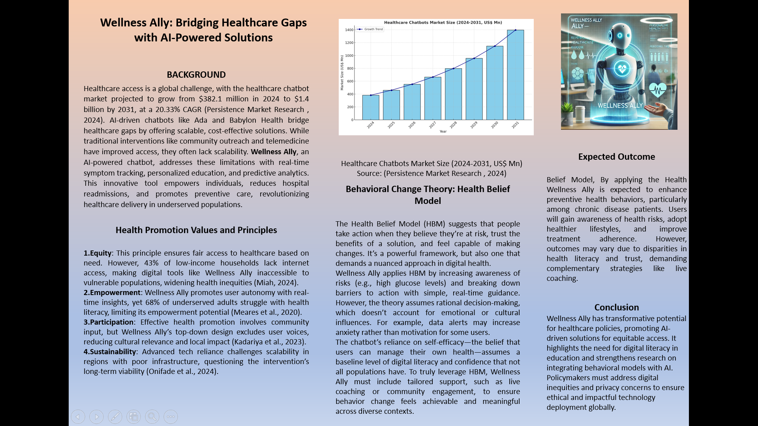

References for the Poster
Kadariya, S., Ball, L., Chua, D., Ryding, H., Hobby, J., Marsh, J., Bartrim, K., Mitchell, L. and Parkinson, J. (2023). Community Organising Frameworks, Models, and Processes to Improve Health: A Systematic Scoping Review. International Journal of Environmental Research and Public Health, [online] 20(7), p.5341. doi.org/10.3390/ijerph20075341.
Meares, P.A., Lowry, B., Estrella, M.L. and Mansuri, S. (2020). Health literacy barriers in the health care system: Barriers and opportunities for the profession. Health & Social Work, [online] 45(1), pp.62–64. https://doi.org/10.1093/hsw/hlz034.
Miah, M. (2024). Digital Inequality: The Digital Divide and Educational Outcomes. [online] ResearchGate. Available at: https://www.researchgate.net/publication/379258768_Digital_Inequality_The_Digital_Divide_and_Educational_Outcomes.
Onifade, M., Zvarivadza, T., Adebisi, J.A., Said, K.O., Dayo-Olupona, O., Lawal, A.I. and Khandelwal, M. (2024). Advancing toward sustainability: The emergence of green mining technologies and practices. Green and Smart Mining Engineering, [online] 1(2), pp.157–174. https://doi.org/10.1016/j.gsme.2024.05.005.
Persistence Market Research (2024). Healthcare Chatbots Market Size, Trends & Forecast to 2031. [online] Persistence Market Research. Available at: https://www.persistencemarketresearch.com/market-research/healthcare-chatbots-market.asp.

