TASK 1- ESSENTIAL SKILLS FOR STUDY & EMPLOYMENT

A vast majority of employers nowadays look to hire employees based on their skills and experience not just paper qualifications. I feel that time management is a crucial skill to possess in employment as employers not only want you to possess good people skills they also want you to be able to get tasks completed on time enabling ‘you to succeed in most work roles’ (Cottrell, 2021). Since studying at University of Wales Trinity Saint David I was introduced to the RAC method (Record Analyse Change) in order to manage your time more effectively it is important to analyse where you are wasting time. According to (Tsoneva, 2017) if ‘you feel like you’re not being productive enough’ and haven’t got the most out of your day you should use the RAC method to help gain control over your life. The RAC method will get you to reflect on the tasks that are not as important and will allow you to reflect and then prioritise your daily tasks.
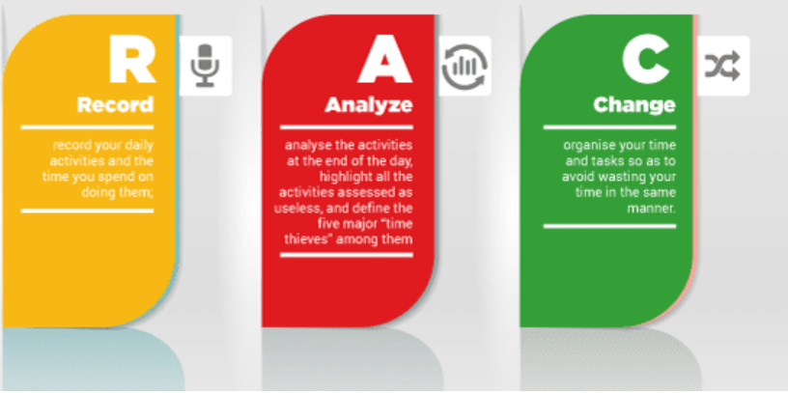 Rac Method (Jovanov, 2016)
One very popular and widely used time management method is Stephen Coveys matrix, time management method which uses a grid split into four sections ‘each representing how your work time is divided based on significance and urgency.’(Gousset, 2021). This will allow you again prioritise your daily tasks in order of urgency. It is very effective method to use to help you to determine ‘whether a certain activity brings you closer to your goals or not.’ (Mueller, 2020).
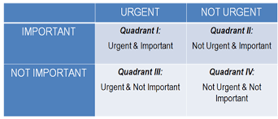Stephen Coveys matrix (Mueller, 2020)
I feel that by incorporating either one of these two methods into your daily life it will boost your confidence in yourself hence will improve your career opportunities.

References
Cottrell, S., 2021. Skills for success. 4th ed. Macmillan Education UK, p.133.
Gousset, D., 2021. Stephen Covey's Time Management Matrix. [online] Human Skills. Available at: <https://humanskills.blog/time-management-matrix/> [Accessed 14 October 2022].
Jovanov, M. (2016) RAC. Available at: Efficient Time Management - International School (international-school.edu.rs) (Accessed: 14 October 2022).
Mueller, S., 2020. Stephen Covey‘s Time Management Matrix Explained. [online] Planet of Success. Available at: <http://www.planetofsuccess.com/blog/2015/stephen-coveys-time-management-matrix-explained/> [Accessed 14 October 2022].
Tsoneva, D., 2017. Effective Time Management. [online] unimy.com. Available at: <https://www.unimy.com/article/mba-preparation/blog-interesting-time-management> [Accessed 7 October 2022].

