

BA BUSINESS MANAGEMENT

INTRODUCING THE MODERN WORKPLACE
Assignment 2 – Individual Reflective Report

Module: Introducing the Modern Workplace
Code: LCBB4003
Lecturer: Dr. Sadeque Shaikh
Name: Maria Alexandra Chesoiu
Student ID: 2123374

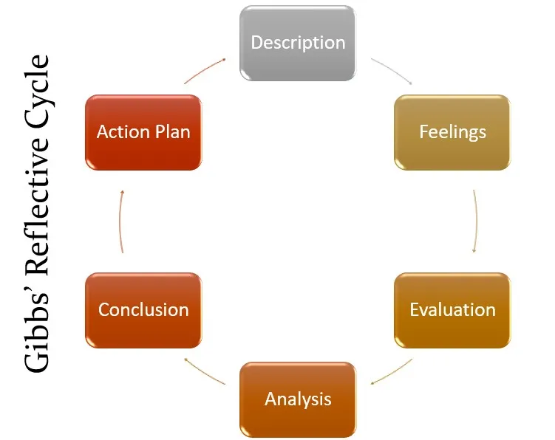

INTRODUCTION
In this report I aim to talk about how my experience working with my team for a common project that we have received and asked to make. The project is a Power Point presentation in which we have to analyze how Tesco Plc corporation operates the big corporation and how the company changes the workplace that is adapted to today’s modern world and employees expectations. This report is focusing on my own personal opinion and experience through the help of Gibb’s Reflective Model and what I learn from working in a team.
This model is known in the entire world, and it can help teams form and work well together efficiently. Originally, Gibbs desire was that the model should be adopted when working often as a team or as a group; this model helps you reflect on how your team is performing, if there are changes that need to be done or other problems to correct. Reflecting on the findings of working in a group can show you what things needs more focus and supports individual reflection which should put things in clearer light and easy to understand. (University of Edinburgh, 2023).

DESCRIPTION
Our team was formed of five people, myself included and we had to do a project and each of us had chosen a task to work on. Although I didn’t have a specific responsibility in the group, I decided to get involved by suggesting how the presentation should look and where we should collect academic information. Our team had some strong people with strong personalities that were very clear with what should we achieve with this project. This way our confidence was building up and we became excited about our project.
ACTION PLAN
Our team leader told us that she would like to establish a deadline for when we should send her our work so she could have enough time to create the Power Point presentation and have it ready for when our assignment and presentation day would come. Everyone in the team was very pleased with what they had to do and although some of my colleagues expressed that they feel stressed about their tasks, they still managed to send their work on time. We speak to the team leader about our opinions, and she listened to us and showed us that she understands how we feel which made things better and we even became more motivated to do a good job. We have exchanged opinions, advised each other where to find more information for our project that helped us advance with our teamwork and progress very much. This way I became confident that we will meet our deadline without any delay.
FEELINGS
At the beginning I was frustrated often because I felt like I cannot find the information I needed for my project and although everyone in the group knew, I did not felt supported and understood. Because the times passed and the project progressed, I asked my team leader for help and was quickly received with empathy as soon as I expressed my worries. My team leader offered me a few advices related to my task and as we begin to exchange details, I started feeling happy with my progress and my confidence. I enjoyed a lot working with my team and I was very appreciative because of their help and kindness. Working for this project I have come to the conclusion that working in a group can help me become more confident with my communication skills, with my English language and with my confidence of expressing opinions. Because we lived far away from each other we did not meet to work for the project and only discussed through video calls or during the weekend when we had classes.
EVALUATION
I would say that as a team we worked alright, I think I would liked to be able to get together and work for our project, exchange opinions and ideas and offer better support to each other. The fact that all the team members were constantly busy has impacted our communication and some a couple of team members felt left out or maybe not supported enough. We had some disputes based on how we want the slides to look like, how people did not want to be first at presenting and one of our colleagues said that she felt that her stress of speaking in public will leave her with frustration and fear of not being able to express correctly in English.
ANALYSIS
Having the opportunity of working with my team, I have improved my collaboration skills which will help me in future work groups. I have developed confidence through communicating my feelings and letting my team know how I feel and what makes me frustrated. I have learned that conflicts have to be resolved with communication, through respect and understanding. I am happy to say that I was received with kindness and understanding which made me feel even more respect for my colleagues and more appreciation for their efforts and continuous support.
CONCLUSION
In conclusion, working in a team offered me important lessons and enriched my experience by boosting my confidence and alleviate the stress of the project that I need to present. With this I have learned to listen actively, learned how important communication is and learned to listen to my colleagues opinions and treat them with the respect that they deserve. I think that this this experience will help me with joining future studying groups and work groups. Our teamwork was a great opportunity for me to learn more about communication and effective work. I am confident that our team will do very good in the final presentation and I am very confident that our results will reflect our hard work and the dedication we put in.

BIBLIOGRAPHY
Edinburgh, T. U. o., 2023. The University of Edinburgh. [Online]
Available at: https://www.ed.ac.uk/reflection/reflectors-toolkit/reflecting-on-experience/gibbs-reflective-cycle
[Accessed 24 03 2023].

