AHAC5008 Palaeoenvironmental Archaeology
Level 5(2), 20 Credits

Lecture program Semester 1 2013-2013

Lectures are every Tuesday, 12.15-2.15 in tbc and Wednesday 9.15-10.15 in tbc

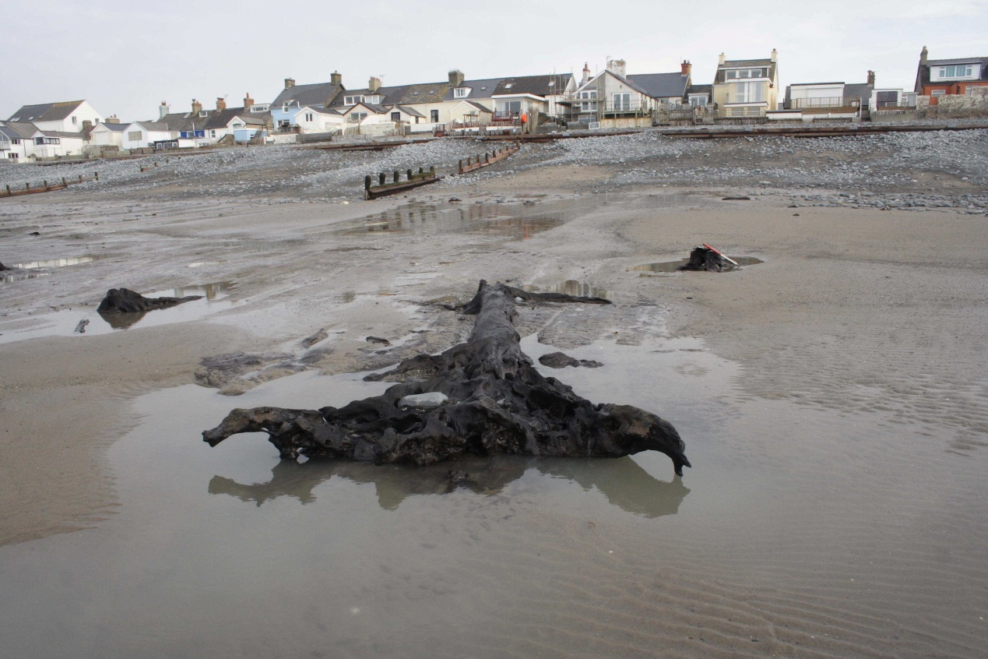

Course outline

The recovery, analysis and interpretation of archaeoenvironmental remains are of fundamental importance when attempting to interpret past human behaviour. The analysis of such remains can highlight the relationship people had with their environment in the past, how people shaped their environment and how the environment shaped their lives. This course introduces students to our ancient landscapes through the investigation of the material remains from a number of commonly occurring archaeological situations and depositional environments. It attempts to show how the recovery and detailed analysis of remains, such as pollen, seeds, soils and sediments, animal bones and wood, can enable the archaeologist to interpret peoples relationship with both landscape and climate change. This course introduces the theoretical frameworks in which palaeoenvironmentalists work and introduces case studies illustrating key areas of research and debate in the discpline.

Lecture list

Unit 1 | Introduction | Hours
1 | 2/10/12 | 1 hr | MRB | Themes and concepts: reconstructing past environments
2 | 2/10/12 | 1 hr | MRB | Preservation of materials
3 | 3/10/12 | 1hr | RC | Environmental archaeology as science
4 | 9/10/12 | 2hrs | NN | Dating the past: frameworks for change
5 | 10/10/12 | 1hr | NN | Radiocarbon dating
6 | 16/10/12 | 2hrs | RC | Scientific theory: Critique of the scientific method
Unit 2 | Environments
7 | 17/10/12 | 1hr | RC | Bones
8 | 23/10/12 | 2hrs | RC | Caves and rockshelters
9 | 24/10/12 | 1hr | MRB | Molluscs
10 | 30/10/12 | 2hrs | NN | Coasts and estuaries
11 | 31/10/12 | 1hr | AC | Plant remains
Reading week
12 | 13/11/12 | 2hrs | AC | Dryland environments
13 | 14/11/12 | 1hr | MRB | Sediments
14 | 20/11/12 | 2hrs | JC | Mediterranean landscapes
15 | 21/11/12 | 1hr | EG-B | Soils
16 | 27/11/12 | 2hrs | EG-B | Urban environments
Unit 3 | Frameworks and key debates
8 | 28/11/12 | 1hr | RC | Animal extinctions & introductions in a changing environment
9 | 4/12/12 | 2hrs | EG-B | Integrating the evidence
10 | 5/12/12 | 1hr | EG-B | Human adaptations to marginal environments
11 | 11/12/12 | 2hrs | MRB | The introduction of agriculture: Mesolithic/Neolithic adaptations

Assessment pattern

Course work 50% (2000 words) Examination 50% one two hour exam
This course will be examined by an essay question and an exam consisting of a series of short answer questions on an unseen paper. In order to answer these questions you will need to attend all lectures otherwise you will be placing yourself at a considerable disadvantage. Students should also note that reading around the subject is necessary and an ability to demonstrate a knowledge of the literature, will be required in order to achieve maximum marks during assessment.

Previous exam papers are held in the Learning Resource Centre (LRC).

Course work questions

Course questions
Students choose from:

- Discuss the impact of changing ground conditions on the preservation of palaeoenvironmental remains and how these factors influence the nature of the questions that can be addressed in an archaeological project. Selecting from at least three or more sites, illustrate your answer with reference to a range of sites and conditions.

- Palaeoenvironmental archaeology is multi-disciplinary in nature. Illustrate your answer with reference to at least two case studies.

In all cases should involve the use of maps and diagrams to support your answer and arguments. You will be expected to have read a range of scientific papers as well as standard texts and your answer should reflect this widespread background reading.

Unit 1. General references: introduction

Bell, M. & Walker, M.J.C. 2005 Late Quaternary Environmental Change: Physical and Human Perspectives. 2nd edition, Addison-Wesley-Longman, London.

Evans, J.G. and O’Connor, T. 1999 Environmental archaeology. Principles and Methods. Alan Sutton: Stroud.

Lowe J.J. & Walker M.J.C. 1997 Reconstructing Quaternary Environments. 2nd edition. Addison-Wesley-Longman: London.

Walker, M.J.C. 2005 Quaternary Dating Methods. John Wiley: Chichester.

Wilkinson, K. and Stevens, C. 2003 Environmental Archaeology: Approaches, Techniques and Applications. Stroud: Tempus

Scientific Method and Environmental Archaeology

Binford, L.R. In Pursuit of the Past London: Thames and Hudson.

Butler, S. 1995 Post-processual palynology. Scottish Archaeological Review 9/10: 15-21.

Chalmers A. F. 1999 What is this thing called science? Open University: Milton Keynes.

Evans, J.G. 2003 Environmental Archaeology and the Social Order. London: Routledge

Johnson, M. 2003/2010 Archaeological Theory: An introduction. Blackwell Publishing

O'Connor, T. 1991 Science, evidential archaeology and the new scholasticism. Scottish Archaeological Review 8: 1-7.

Pollard, A.M. (ed) 1992 New Developments in Archaeological Science. Oxford: OUP.

Thomas, J. 1990 Silent running: the ills of environmental archaeology. Scottish Archaeological Review 7: 2-6.

Wilkinson, K. and Stevens, C. 2003 Environmental Archaeology: Approaches, Techniques and Applications. Stroud: Tempus

Unit 2. Environments

Bones
Binford, L. R. 1981 Bones: Ancient Men and Modern Myths. New York: Academic Press.

Davis, S. 1987. The Archaeology of Animals. London: Batsford.

Lyman, R. L. 1994 Vertebrate Taphonomy. Cambridge: Cambridge University Press.

Mays, S. 2010 The Archaeology of Human Bones. Dawson Books

O'Connor, T. 1996 A critical overview of archaeological animal bone studies. World Archaeology 28(1): 5-19.

Caves and rockshelters

Bonsall, C and Tolan-Smith, 1997 The human use of caves BAR. International series 667 Oxford: Archaeopress

Dowd, A.M. 2008 The use of caves for funerary and ritual practices in Neolithic Ireland Antiquity 82 (316): 305-317

Goldberg , P. and Macphail, R.I. 2006 Practical and Theoretical Geoarchaeology Oxford: Blackwell Chapter 8. pp: 169-187

Molluscs

Evans, J.G. 1972 Land snails and archaeology. Academic Press: London.

Evans, J.G. et al. 1993 An environmental history of the Upper Kennet valley, Wiltshire, for the last 10,000 years. Proceedings of the Prehistoric Society 59, 139 – 195.

Evans, J.G. and O’Connor, T.P 1999 Environmental archaeology. Sutton: Stroud.

Kennard, A.S. and Woodward, B.W. 1901 Non-marine mollusca of the south of England. 16. Buckland, near Dover. Proceedings of the Geologists Association 17, 226-227.

Kerney, M.P., Cameron, R.A.D. and Riley, G. 1979 A field guide to the land snails of Britain and North –West Europe. Collins: London.

Sediments

Brown, A.G. 1997 Alluvial geoarchaeology: floodplain archaeology and environmental change. Cambridge University Press: Cambridge.

Butzer, K.W. 1982 Archaeology as human ecology. Cambridge University Press: Cambridge.

French, C. 2003 Geoarchaeology in action: studies in soil micromorphology and landscape evolution. Routledge: London.

Goldberg, P., Holliday, V.T. and Ferring, C.R. 2001 Earth Sciences and archaeology. Kluwer Academic; New York.

Goldberg, P. and Macphail, R. 2006 Practical and theoretical geoarchaeology. Blackwell Science: Oxford.

Rapp, G.R. and Hill, C. 1998 Geoarchaeology: the earth-science approach to archaeological interpretation. Yale University Press: New Haven.

Stein, J.K. and Farrand, W.R. 1985 Archaeological sediments in context. Centre for the Study of early Man: Orono.

Waters, M.R. (1992). Principles of Geoarchaeology. University of Arizona Press, Tucson.

Mediterranean environments

Atkins, P., Simmons, I.G. and Roberts, B. (1998) People, land & time: an historical introduction to the relations between landscape, culture and environment (esp. Case study: Intensification and environmental degradation in the Mediterranean of classical times, pp. 47-51 and Agricultural terracing, pp. 120-124). London: Arnold.

Bell, M.G. and Boardman, J. (eds) (1992) Past and present soil erosion: archaeological and geographical perspectives. Oxford: Oxbow Books.

Grove, A.T. and Rackham, O. (2001) The nature of Mediterranean Europe: an ecological history (esp. Erosion in prehistory and history: climate, weather or man-made? pp. 288-311; Chaps 7-9 provide detailed background on climate and climate change). New Haven and London: Yale University Press.

Redman, C.L. (1999) Human impact on ancient environments (esp. Environment and culture in the Early Levant, pp. 95-110; and Ancient Greece, Italy and Spain, pp. 110-122). University of Arizona Press.

Unit 3. Frameworks and key debates

MRB/2012

