
This Photo by Unknown Author is licensed under CC BY-SA

Student Name: Lucien Honore Kadia Yao
Module Code: BMSW5104
Lecturer Name: Rexon Nting
Module Name: Managing Project in the Organisation
Managing Projects During Crisis – The Case of a 5-Bedroom Construction Project
Date: 10/01/2022

Table of Contents
Executive Summary page 3
Introduction page 4-5
Project Scope Statement page 6-7
- Project Objective
- Project Delivarables
- Baseline Milestones
Communication Plan page 8-9-10
- Stakeholder analysis
- Information Needs
- Dessemination modes
- Sources of Informations
Resources and Budget Approach page 11-12-13
Project Schedule page 14-15
Change Controle Process page 16-17
Risk Management Plan page 17-18
Conclusion page 19
References page 20-21
Appendix1 page 22-23
Case Study in Class page 24-25

Executive Summary
In the face of the ongoing Covid-19 pandemic, projects are facing unforeseen market conditions, supply-chain bottlenecks, cash-flow shortages, and contracting challenges, including invocations of force-majeure clauses. To this end, the conditions and assumptions underpinning previous project implementation decisions have changed in favour of more agile decisions. This report documents the project implementation plan for a 5-bedroom Duplex project that Fluidis-CI. plans to execute in the face of the ongoing pandemic. The project plan outlines aspects such as project scope, communication plan, budget approach, schedule, and change management. Among the key acknowledgements made throughout the report is that the project manager will face a range of challenges in maintaining delivery pace and momentum during the pandemic. The agile practice elements of virtual and regular meetings, flexibility in altering schedules to accommodate changes in the environment, and transference of risks to third parties will be integral in achieving the project objectives during the Covid-19 crisis

Introduction
This assignment is to demonstrate the potential benefits to the organisation of developing individuals in the workplace, by managing an individual's expectations in respect of personal development.
My assignment is based on a real project. My project is back home in Cote d’Ivoire ( Ivory Coast). A 5-bedroom duplex at the coast of 66 000 000 million CFA equivalent of 70 000 pounds. And the project is right now in process in Africa, especially in Ivory Coast West Africa.
I will say planning and managing a project is a big performance management effort, which typically entails performance appraisal and talent development, which are widely considered to be among the key roles of human resources management.
My organisation falls under the construction industry, where it works on sub-contract basis for individuals and firms. The organisation is responsible for the day-to-day oversight of construction sites, communication of information with all the involved parties, from management to vendors throughout the a project. The company is currently working on a 5-bedroom Duplex, two-story house. There are various teams of employees involved in the execution of my project, including architects, civil engineers, electricians, painters, labourers, and plumbers. The organisation’s HR department is responsible for ensuring that all these workers have the necessary skills, accreditation, license, and use the necessary equipment in different construction processes. Based on experience in the company, the HR department has a standard set of practices that it follows to attract, maintain, reward, and develop skilled workers to ensure a low turnover rate and give the firm a competitive advantage over competitors. However, as Kosek et al. (2014) argue that, the use of standard practices and policies is characterized by limitations such as lack of flexibility, low creativity and response time, loss of responsiveness, and lack of uniqueness.
My final report will focus on determining how effective the HR practices are in talent acquisition and development across the various project teams.
As a HR officer. Fluidis-CI., a construction company where I am currently working, is preparing to build a 5-bedroom Duplex, two-story house for one of its clients. The company’s business model can be described as that of a general contractor because the firm enters into a contract with different individuals and organisations and takes charge of the day-to-day construction activities on behalf of the clients. In other words, the company is in charge of the actual building of houses based on their clients’ ideas. Fluidis-CI. has its own employees, approximately 65, who fit the roles of the project manager, carpenter, electrician, architect, plumber, electrician, and skilled and semi-skilled labourers. Like other contemporary organisations, the company has been struggling with the Covid-19 measures that have been put in place by the government to curb the spread of the ongoing health crisis. The company has to ensure the employees’ safety and foster individuals wellbeing while at the same time striving to remain competitive by meeting clients’ expectations. This paper is an in-depth plan on how the company can ideally design and implement the 5-bedroom duplex. The plan will outline the project objectives, scope, deliverables, the Work Breakdown Structure (WBS), and document the management of stakeholders and implementation of various risk management tools.

Project Scope Statement
Project objective
The objective of the proposed project is to construct a LEED-certified residential house in 10 months in Abidjan, Ivory Coast. This estimate has been drawn from the National Association of Homebuilders (NAHB), which stipulates that it takes between 6.5 and 10.5 months to build a house from the ground up (Agadoni, 2020). The decision to plan for 10 months is also based on the fact that there is an ongoing pandemic, which is likely to cause some setbacks in the delivery of resources and the execution of the work. By using the industry standards, such as the costs per square metre, the project sponsor or client’s budget is £477,000.00. (This is what my Bank Santander’ would have offered. But I founded my own project with my saving £ 40.000 + £ 30. 000 from my pension). This was arrived at by assuming that a typical building costs anywhere between £1,750 and £3,000 per square metre (Bahar, 2021). The building design and specification, including the number and size of rooms, have been described by the client. One of the client’s key specifications is that the house should be as sustainable as possible, and therefore there should be natural light in the house, no elevators, game room, or wine cooler. The proposed project design has been attached in appendix 1.
Project deliverables
- A 4,200 square-foot home, with 2 one-bedrooms on the ground floor, and 3 bedrooms and a terrace on the first floor.
- Steel-reinforced concrete structures, including beams, boards, roof trusses, and columns.
- Exterior and interior finishing in accordance with the aesthetic materials specified by the client, including pebble finish.
- A 2-car garage on the ground floor, with a built-in connection for electric vehicle recharging
- Integrated artificial intelligence (AI) control systems for air conditioning and ventilation (HVAC), entertainment, heating, and lighting
- Interior finishing using environmentally preferable materials
- A kitchen with a built-in microwave, dishwasher, and induction cooktop.
Baseline Milestones
Baseline milestones highlight the anticipated kick-off dates for the key project milestones (Li and Carter 2005, p. 28). The project baseline milestones are outlined in the table below;
Milestone | Date
Drafting of the project plan and design | 20-Dec-21
Customer review and approval of the design | 1-Jan-22
Site acquisition and preparation | 20-Feb-22
Vendor contracts | 11-Feb-22
Tendering the needed materials and contracts | 10-Mar-22
Excavation complete | 20-Apr-22
Completing the foundation and framing | 20-May-22
Roofing complete | 20-Jun-22
Exterior finish | 15-Jul-22
Plumbing and electrical installed | 20-Jul-22
HVAC system installation | 2-Aug-22
Interior finish | 21-Aug-22
Landscaping complete | 16-Oct-22
Final inspection and acceptance by the client | 20-Oct-22

Communication plan
Stakeholder analysis
A stakeholder analysis is often undertaken before the commencement of a project to identify the various parties or individuals that will impact the success of the project, their interest, level of participation, and influence in the project (Buttrick 2013, p.21). A stakeholder analysis aims to determine how best to involve and communicate with each stakeholder group throughout the entire project. In this case, the analysis of the project stakeholders shows that there are at least three key parties or primary stakeholders, including the client, the local authorities in charge of giving permits and authorisations, and FluidisCI the Holder company, which is the main contractor. Other stakeholders include the suppliers, subcontractors, designers and architects, and the members of the project team, including the labourers. All these stakeholders have different levels of participation, influence, and interest in the project, and the groups’ prioritisation during the project execution should depend on their power and interest. The power/interest grid below categorises the stakeholders in relation to their power and interest in respect to the project for effective management of the various groups.
Low
Power
Keep Satisfied  - Regulatory bodies  - Suppliers  High | Manage Closely  - The client
Monitor  (Minimum Effort)  - Local government | Keep Informed  - Environmentalists  - Local residents
Low
High
Interest
Figure 1: Power / Interest Grid for Stakeholder Analysis
Information needs
As showcased in the power-interest matrix figure above, the stakeholders with high power and high interest, including the project client, need to be closely monitored and to ensure that they are satisfied with the project progress (Newcombe 2003, p.841). The project manager will ensure that the project client is regularly updated on the project progress and any foreseeable changes in the project parameters, including scope and cost. This communication will be done after the completion of every milestone so as to offer the client the opportunity to review and offer feedback on the project deliveries. Conversely, the stakeholders with low power and low interest in the project, including the local government, require minimal monitoring efforts and should just be informed periodically. However, stakeholders such as environmentalists and county inspectors have a high interest in the project, and therefore they need to be kept informed on the project progress and any changes in scope.
Dissemination modes
A consensus among various scholars, including Berkun (2008), shows that good communication is among the key success factor for any project. While every project manager has a wide range of communication tools and techniques at their disposal, the unique set of stakeholders and circumstances underlying the project dictate the form of communication that will work best for all. This is particularly the case with the Duplex construction project, which will occur in a timeframe marked by a deadly Covid-19 pandemic. During the ongoing health crisis, organisations and governments across the globe have imposed restrictions on personal contact with the aim of curbing the spread of the catastrophic virus (Deb et al. 2021, p.3). As a result, there have been lockdowns in different regions, and non-essential employees have been forced to work from home. Following these Covid-19 measures, the project manager will ensure minimal in-person contact among the stakeholders, for instance, by ascertaining that only the essential groups will be at the construction site. To this end, video conferencing and seminars will be the primary modes of communication because these techniques offer real-time collaboration while ensuring that the participants are not in physical contact with one another (Lowenthal et al. 2020, p.383). Holding virtual meetings through tools such as Zoom and Skype will help the stakeholders working remotely feel less isolated and more engaged in the project. The project reports will be either shared online or delivered in hardcopies depending on the stakeholders’ preferences.
Sources of information
The information that will need to be communicated to the stakeholders will come from different sources, including weekly status reports, milestones reports, risk register, and iteration and escalation reports. The project manager will prepare a weekly status report summarising all the work that has been accomplished throughout the week and how these tasks will have contributed to the completion of the project. These weekly reports will be shared and discussed with the client and various project team members to offer them an insight into the progress being made. On the other hand, the milestone reports will document the progress of the project relative to the specific requirements of each milestone. These milestone reports will be presented and discussed with the project stakeholders after every milestone to determine the extent to which the various milestone activities have been executed within the stipulated timeframe, budget, and quality metrics. The table below summarises the project communication plan.
Deliverable | Format | Frequency | Owner | Audience
Weekly status update | Conference call | Once a week | Project manager | Development team
Milestone reports | Conference call and webinars | After completion of each milestone | Contractor lead | Client manager
Budget usage | Email | As needed | Project accountant | Client manager
Risk reviewed and update | Video and web conferencing | After every milestone | Risk management team | Environmentalist
Status report | Client satisfaction survey | End of each project phase | Program management office | Client sponsor  Authorities
Figure 2: Project communication plan
Resources and budget approach
To determine the resources and the budget needed to successfully complete a project, the project manager can choose from a wide array of approaches, including top-down method, bottom-up approach, comparative or analogous estimation, expert judgment, and three-point estimating methods (Project Management Institute 2017, p.240). The top-down approach identifies the project goals or deliverables and then breaks them into smaller planning chuck. As noted by Pang (2018), the overall project cost, time, manpower, and resources are first identified, and the individual tasks’ estimations are apportioned from the comprehensive estimates. In this case, the bottom-up approach has been used to determine the project cost because it is more accurate compared to other methods. The technique starts by estimating the time, cost, and resources needed for each individual task or activity in a project. All these individual estimates are then combined to build up the overall project estimates. Since each project activity is assessed individually, the bottom-up approach takes more time, but it is more accurate as compared to the top-down approach (Pang, 2018).
The Work Breakdown Structure (WBS) below outlines the key tasks that need to be undertaken to successfully the project. Alongside the list of the tasks is the estimated cost of each activity, and this breakdown helps determine the overall budget needed for the successful completion of the project.
WBS | Task Name | Resource Names | Cost
 | 5 Bedroom Duplex
1  1.1  1.2  1.3 | Project approval  Project planning  Design  Permitting | Government permit fees | £3,700  £2,500  £1,000
2  2.1  2.1.1  2.1.2  2.2  2.2.1  2.2.2 | Foundation  Excavate  Pour cement  Cure & strip forms  Steel erection  Steel columns  Beams | Foundation materials | £2,200  £2,550  £800  £4,750  £6,600  £7,550
3  3.1  3.1.1  3.1.2  3.1.3  3.2  3.2.1 | Internal finishing  Electrical  HVAC equipment  Communication systems wiring  Solar system  Plumbing  Test and clean | Electric materials  HVAC material  Communication system materials | £3,200  £3,550  £1,200  £2,550  £1,400  £4,750
4  4.1  4.1.1  4.2  4.2.1  4.2.2  4.2.3 | Exterior finishing  Masonry work  Roofing  Building finishes  Painting  Wallpaper  Ceiling tile | Roofing materials, trusses  paint | £7,350  £2,550  £1,400  £4,750  £3,500  £2,150
 | Total price |  | £70,000
Figure 3: Budget Estimation
The bottom-up technique shows that the project needs a budget of £70,000 for successful implementation. A time-phased budget approach is advisable for this project as it can help track payments to the service and products suppliers and aid in conducting schedule compression analysis.
In addition to showing helping with the allocation of cost for each project activity, a work breakdown structure (WBS) helps organise and define the total scope of a project (Project Management Institute 2017, p.156). It shows a deliverable-oriented hierarchical decomposition of the work to be executed by the project team, with each descending level representing an increasingly detailed definition of the project work. To this end, the Duplex project WBS can be constructed as below;

Figure 4: Project WBS
Project Schedule
A project schedule is broadly defined as a timetable showing the start and the completion date of the project tasks and how these dates rely upon or relate to each other (Berkun 2008, p.25). The proposed project is expected to take 250 working days, with the estimated project completion being November 2022. However, with the ongoing Covid-19 pandemic, there is a significant risk of project delay because of challenges in delivering products and services to the site. To overcome these risks and ensure that the project is completed on time, the project manager can embrace various strategies, including crashing critical tasks and identifying the project activities that can be undertaken simultaneously. For instance, concurrent construction, accelerated design implementation, fast-tracking, and swift communication can ensure that the project is delivered in time. Getting the workers to work overtime or even increasing the number of workers will significantly increase the project delivery time.
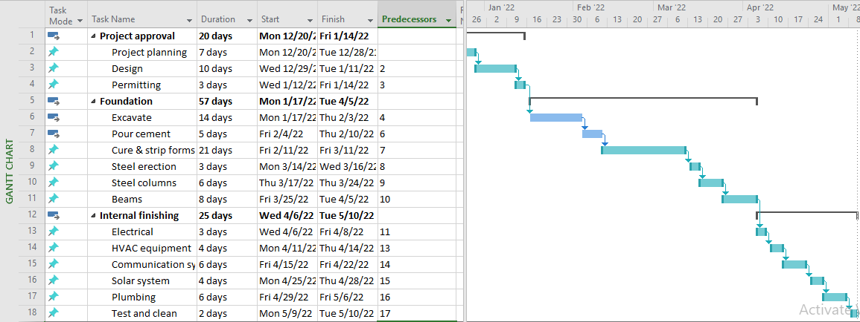
A Gantt chart is often used to provide a visual view of the project tasks scheduled overtime, therefore helping in tracking the project schedule and progress. The figure below showcases the Gantt chart for the duplex program.

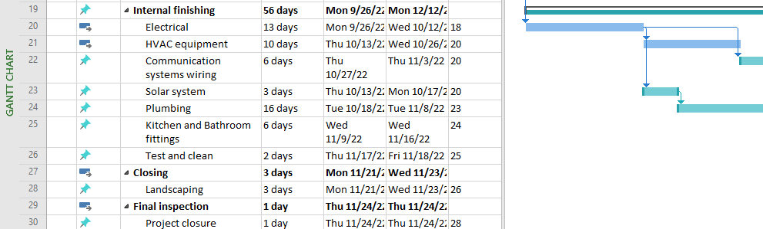
Figure 5: Project Gantt Chart
Change Control Process
In the age of the Covid-19 pandemic, the ability to quickly adapt and implement changes is essential for project success. Controlling changes caused by aspects such as the pandemic will be critical to maintaining the project schedule, scope, and budget. The project team can effectively minimise changes through a wide range of strategies, including planning for possible changes, proactive risk management, and effective resources management (PMI 2017, p.73). Planning agility is the most effective strategy for minimising changes in the project. Project planning should be an ongoing exercise subject to the changes in the project environment, rather than having a long, solid plan, which is less flexible. The project teams need to meet more frequently and make faster decisions to deal with the changes in the environment. As outlined by Mojica (2018), a formal change management procedure will be required when changes are needed to ensure that every key stakeholder is aware of the changes. This procedure entails;
- Identifying and submitting a change request, outlining the reasons, benefits, costs, and impacts of the change
- Reviewing the change request based on the feasibility and benefits of the change
- Approval of the change request
- Closing the change request. Once approved, the change should be communicated to the project team, and the project deliverables should be updated.
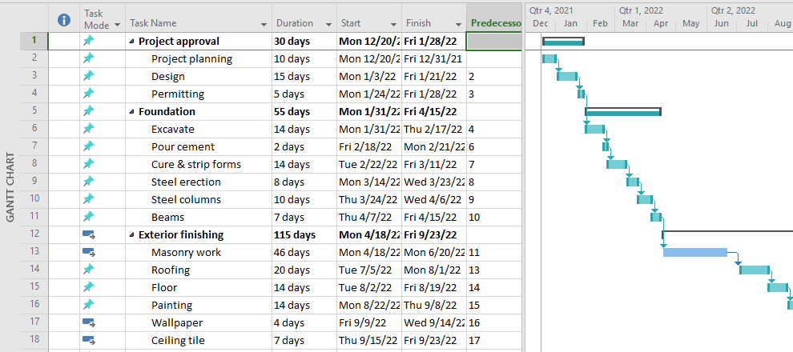
Risk management plan
A risk management plan documents a project’s risk management process whose aim is to eliminate or minimise the occurrence and impact of risk events. These risks often stem from a variety of sources, including financial uncertainties, natural disasters, technology issues, and legal liabilities. With the ongoing Covid-19 pandemic, there is a high risk that the project may not be completed on time and within the estimated budget. For instance, the occasional movement restrictions imposed by authorities with the aim of curbing the spread of the pandemic create a significant risk in the delivery of materials by the vendors to the site. The risk management process often entails a number of steps, including;
- Identifying the potential risks
- Analysing the severity and probability of risk
- Planning mitigations to minimise the occurrence and impact of the risks
- Implementing risk mitigation measures
Following these steps, the risk posed by the pandemic can be managed by first identifying critical suppliers and then assessing the likelihood of supply delay. In this case, the most critical suppliers include those supplying the construction materials and products such as steel and cement. Although most potential disruption to the supply may not qualify as a force majeure event, disruption caused by the pandemic may not attract a legal implication if the supplier cannot deliver against the contract. To this end, the project manager may not consider a legal approach as a mitigation measure after the supplier fails to meet their contractual obligations. Therefore, the alternative mitigation measures may include risk acceptance, limitation, and transference (Buttrick 2013, p.403). Risk transference would ensure that the risk associated with Covid-19 uncertainty has been transferred to other parties, including the suppliers.
In addition to the Covid-19 risk, the project team will determine other potential risks facing the project through brainstorming and develop a risk register. Two weeks prior to the project implementation kick-off, the key project stakeholders, including the client, subcontractors, and the project management team, will meet to discuss, categorise, and evaluate the identified risks. A risk matrix can be ideally used to visualise the various risks affecting the project to enable the project management team to develop effective mitigation strategies based on the severity and probability of the risk of occurrence. The figure below showcases a standard risk matrix
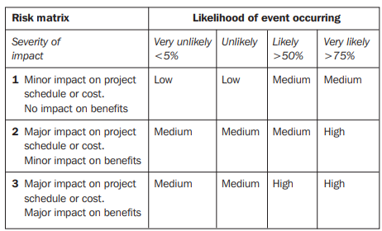
Figure 6: Risk Matrix

Conclusion
As the ongoing pandemic continues wreaking havoc across different parts of the world and industries, project managers face the challenge of protecting the workforce while ensuring project continuity and success. FluidisCI. is currently developing a plan on how to construct a 5-bedroom house for one of its clients. As showcased by this report, to successfully execute the project within the constraints of schedule, budget, and scope, the project manager needs to continually assess risks, adjust operations, embrace digital communication technologies, and adopt an agile posture. The skill of flexibility, collaboration, and facilitation among the project leaders will be critical if the project is going to be successful.

References
Agadoni, L. 2020. Building a House: A Step-by-Step Guide. Retrieved from: https://www.millionacres.com/real-estate-investing/house-flipping/the-building-a-house-timeline-its-more-important-than-you-think/
Bahar, U. 2021. How Much Does It Cost to Build a House? [2021 £/m2 Building Prices]. Retrieved from: https://urbanistarchitecture.co.uk/cost-to-build-a-house-uk/
Berkun, S., 2008. Making things happen: Mastering project management. (Theory in Practice) O'Reilly.
Buttrick, R., 2013. The project workout: The ultimate handbook of project and programme management. Pearson UK.
Deb, P., Furceri, D., Ostry, J.D. and Tawk, N., 2021. The economic effects of Covid-19 containment measures. Open Economies Review, pp.1-32.
Li, W.G. and Carter, D.J., 2005. Construction baseline schedule review and submittal timeframe. Cost Engineering, 47(2), p.28.
Lowenthal, P., Borup, J., West, R. and Archambault, L., 2020. Thinking beyond Zoom: Using asynchronous video to maintain connection and engagement during the COVID-19 pandemic. Journal of Technology and Teacher Education, 28(2), pp.383-391.
Mojica, R. 2018. Change Management Process for Project. Retrieved from: https://www.projectmanagement.com/contentPages/wiki.cfm?ID=396744&thisPageURL=/wikis/396744/Change-Management-Process-for-Project#_=_
Newcombe, R., 2003. From client to project stakeholders: a stakeholder mapping approach. Construction management and economics, 21(8), pp.841-848.
Pamidimukkala, A. and Kermanshachi, S., 2021. Impact of Covid-19 on field and office workforce in construction industry. Project Leadership and Society, 2, p.100018.
Pang, D. 2018. Top-Down & Bottom-Up Estimates Comparison. Project Management. Retrieved from: https://www.projectmanagement.com/contentPages/wiki.cfm?ID=510124&thisPageURL=/wikis/510124/Top-Down---Bottom-Up-Estimates-Comparison-#_=_
Project Management Institute (PMI). 2017. A guide to the Project Management Body of Knowledge (PMBOK guide) (6th ed.). Project Management Institute.
Salami, B.A., Ajayi, S.O. and Oyegoke, A.S., 2021. Coping with the COVID-19 pandemic: an exploration of the strategies adopted by construction firms. Journal of Engineering, Design and Technology.

Appendix 1
Project design
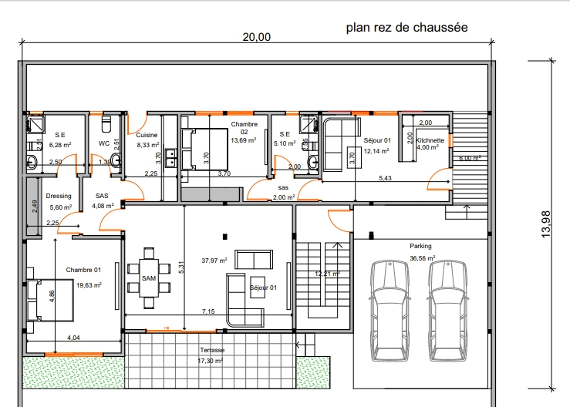

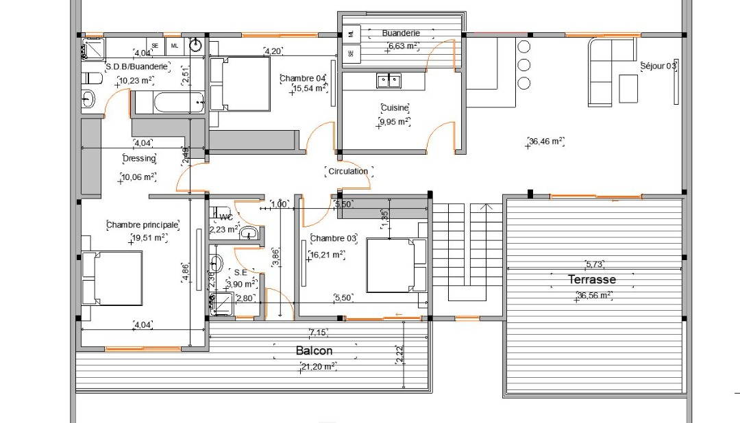

Case Study: 08/12/2021.
Identify the risk, tell us why you think they are risk that could happen, rank them whether they are High, Medium or Low risk in terms of their happen, tell us how you aregoing to manage them.
High:
During the Pandemic, the higher risk my project could fac is the lack of staff. Because most of the buildings site were closed, a decision from the government. Also, people were asked to work from home and avoid mixing with even neighbours and family members from another house.
High:
Starting a building project without a legal permit to build is forbidden in England by the government.
Medium:
The medium risk my project might face is the lack of materials. As most of the shops were asked to close, except the food department. For me it will be wise to wait until the shops reopened.
Medium:
The second risk of management of my project will be the lack of communication, such as: meetings, directions given from managers to employees, training and lack of monitoring the work and also transportation. I can’t see no much solutions. Just wait until life become normal.
Low:
Starting a construction project without a permit to build. In Ivory Coast will your Permit to build is in process, you are allowed to start your project because the process takes time. This is quite the opposite in England.

 | High | Medium | Low
Lack of Staff
Permit to Build | - In England |  | In Ivory Coast
Lack of Materials
Lack of communication, training, monitoring the work.
Lack of Transportation

Case Study: 10/11/2021
Which do feel are your preferred role? Write your answers and explain why.
My strengths are leading and developed others. I believe, I am a shaper. I take challenges to ensure the team work and improve together for the benefit of the organisation goals. The skills I still developing at my work place is challenging people and be challenged. I am a team worker and ready to motivate team members to use their talents to the best and make sure everyone on the team is going in the same direction.
By: Lucien Honore Kadia Yao @ UWTSD London. 10/01/2022

