

Task 1 – Reading Task Template
Upload your photo of your A3 in-class notes here:
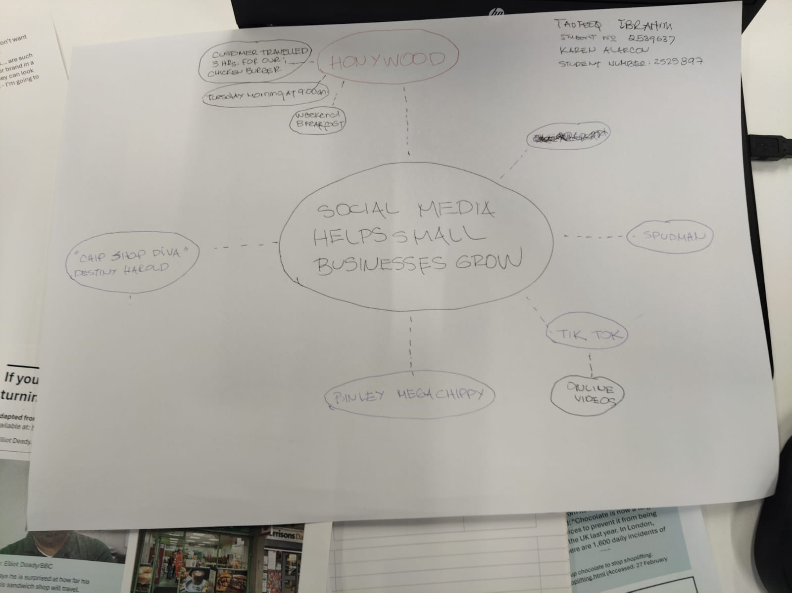

1. Answer these questions using the sentence starters below
a. What is the main idea of the text?
The main idea is that social media helps small businesses grow.
b. What are two key points?
One key point is: Free and viral advertising.
Social media platforms like TikTok give small businesses free exposure. One viral video can make a local shop famous across the country in just a few days.
Another key point is: More customers and higher demand.
Because of online videos businesses get more attention and customers. Ej. The people travelled for hours to try food from Han y Wood, Chip Shop Diva, and Pinley Meg Chippy after seeing them on social media.
c. What part of the text did you find most important? Why?
The most important part is social media, especially Tik Tok, helps small businesses become popular and attract customers from far away without expensive advertising.
d. Was anything unclear or difficult to understand?
I was not sure about – it was costumers, not the business. Honywood has a TikTok, but they didn’t go viral because of their own posts. They went viral because random customers posted videos of the food. So the business didn’t control it.
e. How did your group help you understand the text better?
My group helped me by to understand it better; we had to identify...
- Who? Small UK food shops, Honywood, Binley Mega Chippy, Spudman.
- What? Customers posted viral videos on TikTok/Instagram.
- Result? People travelled hours = sales went up 10x.
3. One sentence reflection
Question: What did you find challenging about this task?
The hardest part was to explain that the businesses didn’t “do” the marketing. They got lucky with the algorithm and their customers.

