

BA Leadership and Management
LEVEL 5

Managing Projects in the Organisation
(BMSW 5009)
Project Title: Supporting local vendors with mobile kitchens
Module Lead: Lan Zhang

Name: Constantin Tanasa

Student Number:2332158

Total word count :2155 Submission Deadline:08 July 2026

AI Statement: Acknowledgement
I confirm that I have not presented any AI-generated materials as my own work

Executive Summary
This report critically reviews the project management tools and techniques used to plan a one-year mobile cooking trailer conversion project for local food vendors and traders. The project is designed to give small food traders access to mobile kitchen units, offering a realistic route into trading without the cost of buying a new catering trailer outright.
Aim: To convert six second-hand horse trailers into safe, and practical mobile kitchen units for local food vendors, within an estimated budget of £18,000–£20,000, recovering the original investment while supporting small local businesses and contributing to local job creation.
The report critically discusses the project's aim and objectives, scope, work breakdown structure (WBS), Gantt chart, stakeholder analysis, risk analysis, communication planning, team roles, budget control and the Iron Triangle, and considers how these tools were used together to plan the project.
Each tool added value, but each also had clear limits:
- WBS clarified the work packages but said nothing about timing
- Gantt chart supported scheduling but depended on estimates that could not fully account for the unknown condition of second-hand trailers
- Risk matrix helped prioritise threats but needed firmer evidence rather than opinion; and the budget required an explicit contingency, since hidden defects in used trailers are a realistic possibility rather than an edge case.
The tools were most effective when used together rather than individually. The project would be strengthened further by more structured stakeholder feedback, more frequent risk review, clearer acceptance criteria for each trailer, and firmer evidence behind the cost estimates.

Contents
Executive Summary 2
1.Introduction 4
2. Findings 5
2.1 Critical Discussion of Project Management Tools and Techniques in General 5
2.2 Critical Discussion of How the Tools Were Used in the Project 8
2.3 Communication and Stakeholders 10
3. Conclusion 14
4. Future Improvement 15
References 16

1.Introduction

This project sets out to convert six second-hand horse trailers into functional, safe and hygienic mobile kitchen units over a twelve-month period, giving small food vendors and traders an affordable route into trading without the upfront cost of a new catering trailer. It is planned as a small, independent, cost-recovery initiative run by the project team on behalf of the local food-vendor community, rather than as an initiative within an established company.
Aim: To convert six second-hand horse trailers into mobile kitchens for local food vendors and contributing to local job creation.
Objectives:
- Identify and inspect six second-hand horse trailers against agreed structural and safety criteria within the first two months of the project.
- Design a standard mobile kitchen layout.
- Complete the conversion of all six trailers, including structural, electrical, water and hygiene work, within the twelve-month project timeframe, phased through the Gantt schedule.
- Keep total project spend within the £18,000–£20,000 budget, including a contingency allowance of at least 10% for unforeseen repairs.
- Maintain and review a risk register at monthly intervals throughout the project.
- Establish and follow a documented communication plan with stakeholders.
- Evaluate each completed trailer against defined acceptance criteria for safety, hygiene, before handover.

2. Findings

2.1 Critical Discussion of Project Management Tools and Techniques in General
Project management tools help a team organise tasks, allocate resources and make decisions, but depends on judgement, since projects involve people, uncertainty, resources and change (Meredith, Shafer and Mantel, 2018; Larson and Gray, 2021).
Clear aims and objectives are vital, since they translate a broad idea into measurable action: the aim describes the overall value the project is intended to deliver, while the objectives set out the specific, time-bound targets used to judge whether that aim has been met (Bjerke and Renger, 2017; Maylor, 2010). These objectives depend on factors that cannot be fully known in advance, such as the true condition of the trailers, so they should be treated as a working plan to be reviewed rather than a fixed commitment.
Scope and deliverables define what a project will and will not cover, and what it must produce. An unclear scope tends to increase cost and uncertainty, whereas explicit deliverables make outputs easier to check (Burke, 2013; Kerzner, 2022).
A Work Breakdown Structure (WBS) divides a project into smaller work packages, helping a team understand and allocate the work (Project Management Institute, 2011).

WBS
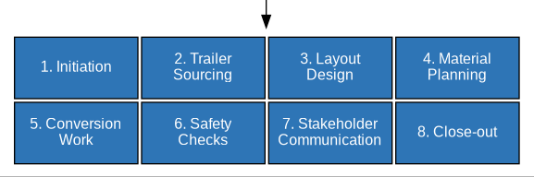

A WBS says nothing about timing or dependencies, however, so it must be paired with a scheduling tool such as a Gantt chart (Burke, 2013).
A Gantt chart makes it possible to plan tasks against a timeline, but it can mislead planning if task durations are not realistic or are not updated regularly (Lock, 2020; Kerzner, 2022); and each has limited analytical value in isolation from the other.
Risk analysis identifies events that could affect time, cost, quality or safety, which is especially important in practical, hands-on projects where unforeseen complications are common.
Risk assessment can become subjective if it rests on opinion alone, so risks should be supported by evidence and reviewed continually rather than assessed once (Aven, 2015; Hillson, 2024).
Stakeholder analysis identifies the people or groups who can affect, or be affected by, a project, and helps a team assess their interests, influence and communication needs (Freeman, 2010; Bourne and Walker, 2005). Because stakeholder relationships change over time, stakeholder management should be treated as an ongoing activity rather than a single exercise carried out at the start (Eskerod and Lund Jepsen, 2016).
Communication planning sets out who needs which information, in what level of detail, and through what channel. Without a communication plan, decisions may not reach the people who need them, and stakeholders with different levels of interest and influence may be given the same generic updates regardless of what they need (Kerzner, 2022; Anantatmula, 2010).
Belbin's model argues that teams work more effectively when members contribute different strengths rather than all performing the same function (Belbin, 2010), while Tuckman's model shows that teams develop through stages and need active communication to become effective (Tuckman, 1965). Leadership matters here because a team's effectiveness depends on direction, coordination and clear responsibility, not only on individual roles (Anantatmula, 2010).

The Iron Triangle is a useful way to compare time, cost and quality, but project success should not be judged on these three criteria alone. Wider measures of success include stakeholder satisfaction, value and long-term use (Atkinson, 1999; Shenhar et al., 2001).

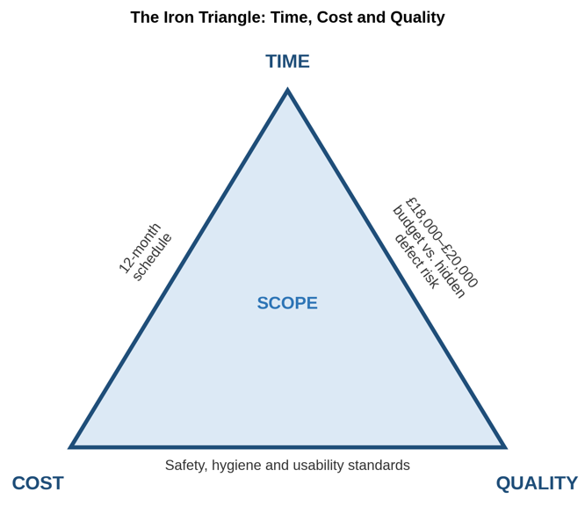

Hard measures such as schedules and budgets therefore need to be weighed against softer factors such as communication, stakeholder expectations and usability (Crawford and Pollack, 2004), alongside other recognised success factors such as planning, communication and control (Pinto and Slevin, 1987).

2.2 Critical Discussion of How the Tools Were Used in the Project
The value of this section lies in showing how the tools would be used to design, plan and evaluate the work, and in being honest about where the plan still depends on assumptions that have not yet been tested.
The project set the team a clear target: to convert six second-hand horse trailers into mobile kitchen units within twelve months and within an estimated budget of £18,000–£20,000.
Scope and deliverables: the intended scope covers sourcing six second-hand horse trailers, designing kitchen layouts, planning the conversion work, controlling costs, identifying risks, communicating with stakeholders, and evaluating the finished units against agreed criteria. Running food businesses on behalf of vendors, or maintaining the units after handover, sits outside this scope.
Defining scope this way was useful because it kept the plan realistic and prevented the project from expanding into ongoing trader support the team could not resource.
The WBS split the project into initiation, trailer sourcing, layout design, material planning, conversion work, safety checks, stakeholder communication and close-out, which made the scale of the work easier to grasp and allocate.
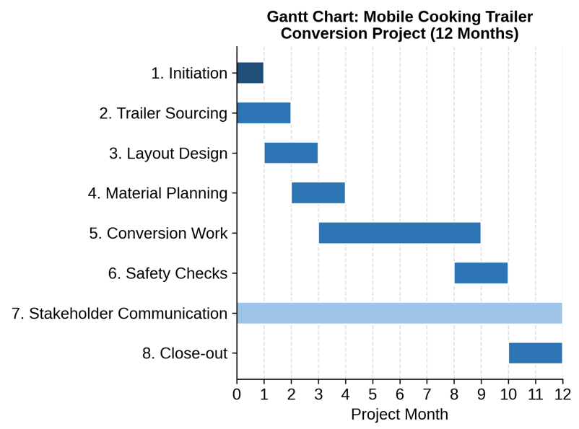

The Gantt chart arguably added more value in this specific project, because the main planning risk was timing – used trailers arriving in unknown condition – rather than simply understanding what work was needed. The Gantt chart is only as reliable as the duration estimates behind it, and those estimates cannot fully account for a trailer that turns out to need more extensive repair than expected.
The estimated £18,000–£20,000 budget, roughly £3,000 per trailer, is intended to cover trailer purchase, structural and electrical conversion work, hygienic surfaces and fittings, water and waste systems, safety certification, and a contingency allowance. Estimating cost per trailer in this way makes the overall figure easier to justify and communicate to stakeholders such as funders.
At the same time because the trailers are second-hand, hidden structural or electrical faults could realistically push individual conversions above £3,000, and the budget as it stands does not yet include an explicit contingency line.
A more convincing budget would set aside a specific contingency, for example 10–15% of the total, and would be backed by indicative supplier quotes rather than a single estimated figure, since stakeholders are more likely to trust a budget whose logic they can follow than one that simply states a total.
The risk matrix identified hidden structural damage, budget escalation, material delays, electrical faults, compliance issues, poor communication and limited stakeholder input as key risks, which helped the team prioritise the threats most likely to affect delivery.
Risk scoring is only as good as the evidence behind it, though, and without physical trailer inspections or written supplier quotes, several of these scores currently rest on assumption rather than evidence (Aven, 2015; Hillson, 2024. Treating these three tools as connected, rather than reviewing each in isolation, would give the team an earlier warning of problems than checking each tool separately.
Within the project team, Constantin Tanasa contribution – (project leader) generating practical, low-cost ideas for converting used trailers into kitchen units – reflects Belbin's Plant role. This was valuable given the project's need for an inventive, low-cost solution, but a Plant-type contribution needs pairing with stronger coordination and monitoring roles to turn ideas into realistic schedules, budgets and deliverables.
The single most significant vulnerability in the current plan is that all four rely on assumptions about trailer condition that will not be confirmed until sourcing begins; this is also where the planning tools are least able to help on their own, since no scheduling or budgeting technique can substitute for physically inspecting the trailers.

2.3 Communication and Stakeholders
Stakeholder theory is useful here because a project of this kind affects a wide range of groups in different ways, with different levels of interest in, and influence over, its success (Freeman, 2010; Bourne and Walker, 2005). It would be easy to treat everyone that the project depends on as an internal stakeholder, but that is not how the distinction works: internal stakeholders are the people who are part of the organisation actually delivering the project – here, the project team itself – while everyone that the project depends on or serves, who is from outside that team, however important their input, is external.

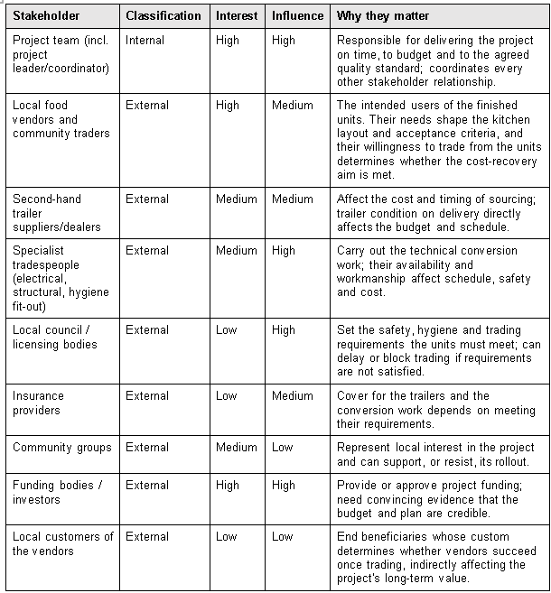

Vendors and traders are high interest, since they are the direct users, so they need to be consulted on layout and usability throughout, not only informed once units are ready.
Council and licensing bodies have lower day-to-day interest but high influence, since they can delay trading altogether if requirements are not met, so they need early, formal engagement rather than late notification.
Funders sit in the high-interest, high-influence group and need the clearest evidence of all, since the credibility of the whole project depends on convincing them the budget and plan are realistic. This mapping should also be reviewed as the project unfolds, since interest and influence can shift once trading begins (Eskerod and Lund Jepsen, 2016).

Communication plan
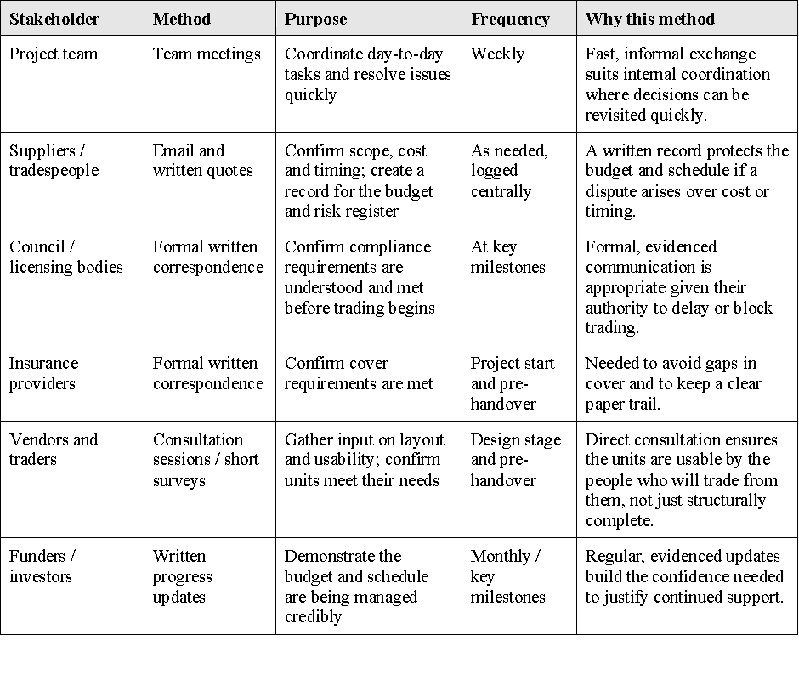
This communication plan goes beyond naming a channel for each stakeholder: for each group, the method reflects how much formal evidence each relationship needs– licensing bodies and insurers need a paper trail because of their authority and liability, while the project team can rely on faster informal contact because decisions there can be revisited quickly – and the frequency reflects how far each stakeholder's needs are likely to change over the project, with vendors needing input at two defined points and funders needing reassurance at regular intervals throughout. The main limitation is the same one affecting the wider plan: the communication plan currently rests on reasonable assumptions about what each group will need, rather than on confirmed feedback, and should be adjusted once initial contact is made (Kerzner, 2022; Anantatmula, 2010).

3. Conclusion
This report has shown that the WBS needed the Gantt chart to add a timeline, the Gantt chart needed the risk matrix to flag what could disrupt it, and the budget needed both to be credible.
Used together and read against real evidence such as trailer inspections and supplier quotes rather than estimates alone, these tools gave the project a workable and realistic structure for a twelve-month, £18,000–£20,000 conversion of six trailers.
The aim and objectives, WBS, Gantt chart, risk matrix and stakeholder map all followed recognised project management logic, but several of the figures and risk scores behind them – trailer condition, per-unit cost, communication needs – are still assumptions rather than confirmed facts. On balance, the tools used were the right ones for a project of this size and type, and they were applied with reasonable consistency; what the project still needs is not different tools, but stronger evidence feeding into the tools it already has.

4. Future Improvement
Four project management lessons stand out for future delivery
- Scope and objectives should be tested against vendor feedback before the design is finalised, rather than confirmed internally and presented to vendors afterwards; this would reduce the risk of building units that meet the team's assumptions but not vendors' actual trading needs.
- Budgeting should build in an explicit contingency, at least 10–15% of total spends, from the outset, backed by written supplier quotes rather than a single estimated figure per trailer, since hidden maintenance costs on second-hand trailers are a realistic and foreseeable risk rather than an edge case.
- Gantt chart and risk matrix should be reviewed on a fixed monthly cycle rather than treated as fixed at the planning stage, so schedule slippage or a newly identified risk, such as a trailer failing inspection, can be reflected quickly rather than discovered late.
- Defined acceptance criteria – covering safety, hygiene, usability and cost – should be agreed for each trailer before conversion begins, so that “complete” has a clear, checkable meaning rather than being judged informally at handover.

Stronger stakeholder communication is the improvement most likely to strengthen every other part of the plan: earlier, more structured contact with vendors, licensing bodies and funders would supply the evidence the current plan still lacks, turning reasonable assumptions about cost, timing and usability into confirmed facts. These changes would not require different project management tools, but a more disciplined and evidence-led use of the tools already selected.

References
Anantatmula, V.S. (2010) ‘Project Manager Leadership Role in Improving Project Performance’, Engineering Management Journal, 22(1), pp. 13–22. Available at: https://doi.org/10.1080/10429247.2010.11431849. (Accessed on: 25 June 2026).

Atkinson, R. (1999) ‘Project management: cost, time and quality, two best guesses and a phenomenon, its time to accept other success criteria’, International Journal of Project Management, 17(6), pp. 337–342. Available at: https://doi.org/10.1016/S0263-7863(98)00069-6. (Accessed on: 29 June 2026).

Aven, T. (2015) Risk Analysis. 1st edn. Wiley. Available at: https://doi.org/10.1002/9781119057819. (Accessed on: 27 June 2026).

Belbin, R.M. (2010) Team roles at work. 2nd ed. Oxford: Butterworth-Heinemann.

Bjerke, M.B. and Renger, R. (2017) ‘Being smart about writing SMART objectives’, Evaluation and Program Planning, 61, pp. 125–127. Available at: https://doi.org/10.1016/j.evalprogplan.2016.12.009. (Accessed on: 28 June 2026).

Bourne, L. and Walker, D.H.T. (2005) ‘Visualising and mapping stakeholder influence’, Management Decision, 43(5), pp. 649–660. Available at: https://doi.org/10.1108/00251740510597680.(Accessed on: 01 July 2026).

Burke, R. (2013) Project management: planning and control techniques. Fifth edition. Chichester, West Sussex, United Kingdom: Wiley.
Crawford, L. and Pollack, J. (2004) ‘Hard and soft projects: a framework for analysis’, International Journal of Project Management, 22(8), pp. 645–653. Available at: https://doi.org/10.1016/j.ijproman.2004.04.004. (Accessed on: 03 July 2026).

Eskerod, P. and Lund Jepsen, A. (2016) Project Stakeholder Management. 0 edn. Routledge. Available at: https://doi.org/10.4324/9781315245881. (Accessed on: 05 July 2026).

Freeman, R.E. (2010) Strategic Management: A Stakeholder Approach. 1st edn. Cambridge University Press. Available at: https://doi.org/10.1017/CBO9781139192675.(Accessed on: 02 July 2026).

Hillson, D. (2024) Managing Risk in Projects. 2nd edn. London: Routledge. Available at: https://doi.org/10.4324/9781003431954.(Accessed on: 02 July 2026).

Kerzner, H. (2022) Project management: a systems approach to planning, scheduling, and controlling. Thirteenth edition. Hoboken, New Jersey: Wiley.
Larson, E.W. and Gray, C.F. (2021) Project management: the managerial process. Eighth edition. New York, NY: McGraw-Hill (The McGraw-Hill series Operations and Decision Sciences).
Lock, D. (2020) Project Management. 10th edn. Routledge. Available at: https://doi.org/10.4324/9781315245911.(Accessed on: 24 June 2026).

Maylor, H. (2010) Project management. 4. ed. Harlow, Munich: Financial Times Prentice Hall.

Meredith, J.R., Shafer, S.M. and Mantel, S.J. (2018) Project management: a strategic managerial approach. Tenth edition. Hoboken, NJ: Wiley.

Pinto, J.K. and Slevin, D.P. (1987) ‘Critical factors in successful project implementation’, IEEE Transactions on Engineering Management, EM-34(1), pp. 22–27. Available at: https://doi.org/10.1109/TEM.1987.6498856. (Accessed on: 25 June 2026).

Project Management Institute (ed.) (2011) Practice standard for work breakdown structures. 2. ed., reaffirmed. Newtown Square, Pa: Project Management Institute.

Shenhar, A.J. et al. (2001) ‘Project Success: A Multidimensional Strategic Concept’, Long Range Planning, 34(6), pp. 699–725. Available at: https://doi.org/10.1016/S0024-6301(01)00097-8.(Accessed on: 27 June 2026).

Tuckman, B.W. (1965) ‘Developmental sequence in small groups.’, Psychological Bulletin, 63(6), pp. 384–399. Available at: https://doi.org/10.1037/h0022100.(Accessed on: 29 June 2026).

