

International Meetings Management BMIH6007
Assignment Title :Assignment 2: Event Strategic Planning and Delivery Considerations for an International Meeting / Event.
Lecturer : Kathryn Flynn
Student name :Catalina Ianos
Student ID :2232322
Word Count :2500+-10%

Declaration:

I confirm that I have not used any AI tools in the research and creation of this
assignment. I confirm that I have not presented any AI generated materials as my own
work. I confirm I have copies of my drafts, notes, and other resources I used, which I
may be asked to provide in evidence.

Name :Catalina Ianos
Date :10 june 2025

Table of Contents

1.0 Introduction 4
1.1 Event Overview 4
1.2 Event Justification 5
2. The Event Cycle 5
3. Concept of Event and Full Itinerary 6
4. Aim with SMART Objectives 7
5. Considerations of Event Management 9
6. Event Budget 10
7. Trends of Industry, Issues and Impacts 11
8. Cultural and Situational Considerations 12
9. Conclusions with Recommendations 14
10. References 14

1.0 Introduction
The cultural community elucidates the Festival, which showcases the proposed event to be held in Cardiff in the summer of 2026. This event aligns with the "Year of Croeso' campaign of Visit Wales. "Croeso" means "Welcome" in Welsh and includes the national initiatives that aim at promoting inclusive culture, community engagement and storytelling to transform tourism (Visit Wales, 2025). The festival crucially aims to celebrate the heritage of Wales alongside the diverse cultural identities that are present within Wales.
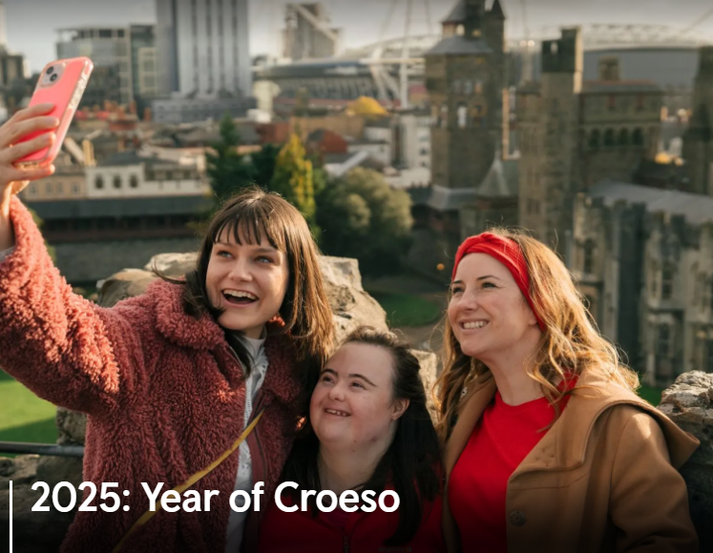
Figure 1: Visit Wales Year of Croeso Campaign
(Source: Visit Wales, 2025).

1.1 Event Overview
Name | Community Cultural Showcase Festival
Theme | Croeso Through Culture
Date and Venue | Cardiff Castle Grounds (Summer 2026)
Target Audience | International and domestic tourists, cultural organisations, local communities and students

1.2 Event Justification
The capital city, Cardiff, offers historical significance, accessibility and significant infrastructure to assist large-scale events of community events. The festival hosted at Cardiff Castle Ground crucially provides a rich venue in heritage, transforming the experience of culture for the attendees. The event is crucially designed to nurture the cohesion of the community, boost regional pride and contribute to inclusive, sustainable tourism that aligns with the objective of the “Year of Croeso”.

2. The Event Cycle
Based on the insights of Getz and Page (2019), the inclusion of the Event Cycle follows proper phases including planning, conceptualisation, evaluation and planning.
Conceptualisation: This primitive phase crucially involves the proper definition of the purposes of the event, target consumers and objectives (Amelia, 2024). For the Community Showcase Festival of Culture, the business aims to celebrate cultural diversity with Welsh heritage that aligns with the campaign "Year of Croeso." This stage is crucially included consultations with cultural organisations, local councils and potential sponsors to stress the relevance of the community.
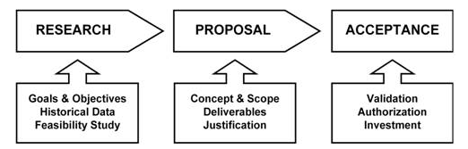
Figure 2: Overview of Conceptualisation Phase
(Source: Self-Created)
II. Planning: Crucial plans are developed covering the important aspects, including logistics, budgeting, stakeholder engagement and marketing. The logistics crucially include infrastructure, venue booking and permits, the marketing includes promotions, branding and partnerships and the operations crucially include accessibility, scheduling and protocols of safety and health. This phase is crucial for ensuring that all the sources are allocated properly to meet the objectives of the events. The allocation of resources is crucially aligned with proper SMART objectives. The collaboration with food vendors, schools and heritage organisations is crucially formalised in this phase (Meredith, 2022; Fox et al., 2014).
III. Implementation: The event is crucially executed based on proper plans with proper coordination among multiple teams to properly handle contingencies, activities and ensure the seamless, proper experiences for attendees. According to Getz and Page (2019), the guest services and managing performances are observed by the control centre of the event to ensure the execution runs smoothly.
Iv. Evaluation: The analysis of the post-event situation is conducted to evaluate the success of the event against the objective, collect proper feedback and recognise areas for proper improvement in the upcoming events. According to Smith (2012), the findings are crucially compiled within the report to inform planning and strategy for the future.

3. Concept of Event and Full Itinerary
Showcasing the Community culture of the Festival is an inclusive, vibrant and family-oriented event that celebrates the theme "Croeso" or Welcome under "Year of Croeso" or Visit Wales. The core concept of the event is to elucidate the highlight transformation of Wales to transform the cultural identity by crucially showcasing the conventional Welsh heritage along with the dynamic multicultural communities, which now call Wales home. It tries to build connections emotionally between visitors and residents that align with the strategic objectives of experiential tourism and community engagement (Getz and Page, 2019; O'Toole, 2011). This festival will take place at the historical Grounds of Cardiff Castle, which is the symbol of civic pride and Welsh history.
Full Itinerary
Time | Activity | Description
10.00 -10.30 | Operating Ceremony | Welcome speech of Visit Wales with Choir performance of Eisteddfod.
10.30 -11.30 | Folk Showcase of Wales | Clog dancers, Harpist and traditional dance and music.
11.30 -12.30 | Community parade | Local groups represent the cultural dress and their heritage.
12.30 - 14.00 | Storytelling and Food Zone | Global street and Welsh stalls of food, a circle of storytelling for children.
14.00 -15.00 | Youth Talent Stage | Local performances of schools: Poetry, music, drama.
15.00 - 16.00 | Multicultural Display of Dance | Afro-Caribbean, South Asian and dances of Eastern Europe
16.00 -17.000 | Workshop Zone | Hands-on crafts: calligraphy, love spoons and traditional costumes.
17.00 -18.00 | Community Panel Talk | Interactive Dialogue: “What Does Welcome Mean Today?
18.00 -19.00 | Evening Concert | Live music by Contemporary artists from Wales
19.00 -20.00 | Fireworks with Closing | Closing speech and display of fireworks over the Castle Cardiff
Table 1: Itinerary Schedule with Description Table
Integration of EMBOK Model
Administration | Align with financial controls, governance and legal compliance, important for managing funding and budget from sponsors and visiting Wales.
Design | Covers the development of themes like “Croeso Through Culture”, attendee experience and ambience. The multicultural inclusion of content is crucially reflected in the focus of the Design Domain.
Marketing | Aligns with the SMART goals that boost campaigns of social media, targeted outreach and influencer partnerships.
Operations | The procurement, logistics, venue setup, scheduling and resources of humans, all of these were crucially managed at the Cardiff Castle Grounds.
Risk | Significant in post-COVID planning of events, covering planning of contingency, legal liabilities and health protocols. EMBOK crucially encourages the anticipation of political disruptions or either (Bowdin et al., 2022).
Table 2: EMBOK Model

4. Aim with SMART Objectives
Event Aim
To promote and celebrate community identity, cultural inclusivity, and the spirit of Croeso through family-friendly, immersive events that boost cultural tourism and transform the brand engagement of Visit Wales.

SMART (S) | Measurement (M) | Achievability (A) | Relevance (R) | Time-bound (T)
Attract approximately 5000 attendees (visitors and locals on the day of the event) | Registration and ticketing data. | Castle Grounds of Cardiff with capacity and previous benchmarks of events. | Supports the strategic engagement of Visit Wales and the goals of tourism. | Within one day of the event.
Generate a 15% minimum engagement increase on the social platform of Visit Wales during the week of the event. | Analytical tools such as hashtag use, shares and likes. | Hashtags of the event, live social content and influencer partnerships | Transforms the visibility of the brand and online storytelling. | Within the last event week
Ensure 85% of attendees of the survey respondents report a positive experience of cultural diversity in Wales. | Surveys of digital and on-site feedback | Delivered through multi-channel curation of activities and programmes | Reinforces community-led, inclusive tourism objectives | Within two weeks of the post-event.
Table 3: Aim and SMART Objectives of the Event

5. Considerations of Event Management
Team Structure
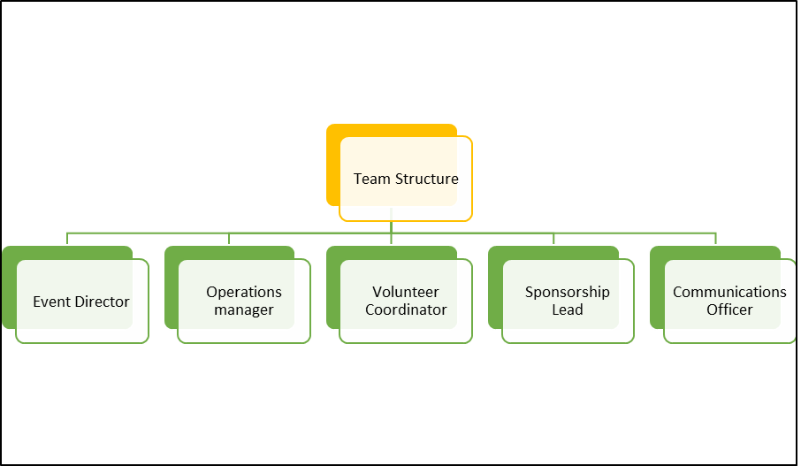
Figure 3: Team Structure for Event Management
(Source: Self-Created)
Volunteers and event staff will be aligned with a 2-week including the safety and health, consumer service and inclusion awareness.
Operational Planning: This foundational phase crucially includes resource allocation, detailed scheduling and logistics management. The tasks like equipment procurement, venue setup, accessibility arrangements and staffing are properly planned to crucially ensure the execution smoothly. Utilising the tools of project management facilitates the timeline adherence and efficient coordination within event planning (Meredith, 2022).
Marketing Activities: The substantial strategy of marketing is crucially implemented to maximise the engagement and outreach. This includes the promotion of social media, digital campaigns, collaborations with proper local influencers and community outreach (Getz and Page, 2019). Aligning the efforts of marketing with the branding of Visit Wales ensures proper messaging that broadens the appeal of the festival.
Stakeholder Engagement: Engaging with the cultural organisations, community groups, sponsors, and local authorities is important for nurturing participation and support (Allen et al., 2022). Collaborative sessions of event planning and regular communication and clear delineation of the functions transform the commitment of stakeholder and ensure the reflection of the festival of the diverse cultural tapestry of the community (Rogers and Wynn-Moylan, 2022).
Risk Management: Recognising the potential obstacles and developing plans of contingency plans are important to cope with problems during a proper event. This includes evaluating safety protocols, emergency plans of response and coverage of insurance (Silvers and O'Toole, 2020). The risk management proactively ensures the attendees safety and proper festival progression.

6. Event Budget
Income Sources | Amounts
Visit Wales Funding | £25,000
Local Authority Grant | £5,000
Corporate Sponsorship | £10,000
Pitch Fees of Food Vendor | £4,000
Ticket Sales (£5 each among 1,000 tickets) | £5,000
Donations or Merchandise | £1,000
Total income | £50,000

Expenditure Breakdown
Expenditure Sources | Amounts
Permits and Venue | £10,000
Sound, Stage and AV | £8,000
Workshops and Performers | £7,000
Design and Marketing | £5,000
Security and Staff | £6,000
Waste Management and Sanitation | £3,000
Service Accessibility | £2,000
Legal and Insurance | £2,500
Signage and Event Merchandise | £2,500
Contingency Fund | £2,000
Total Expenditure | £48,000

Total Expenditure
The surplus of £2,000 is crucially allocated for the reporting of post-event and the session of community feedback. This budget crucially aligns with the guidance from Wales’s Art Council, stressing that all the costs are mostly project-specific and crucially contribute to the objectives of the events (CCCACW, 2025). This contingency fund inclusion reflects the proper practices in the budget for the events. This provides a buffer for unforeseen expenses.

7. Trends of Industry, Issues and Impacts
The global event industry is experiencing crucial growth, including a CAGR of 11.1% annually (Shah, 2024). This expansion is crucially fuelled by the proper integration of online technologies, with 78% of event organisers reporting increased engagement of attendees through proper hybrid events.
The events industry of the UK in 2025 is experiencing crucial growth, with the size of the market that is projected to reach £139.9 billion by 2032 reflecting the compound growth annually with a CAGR of 5.0% in between 2023 to 2032 (GlobalNewswire, 2023).
Key Trends in the Context of PESTLE Analysis

Political | The developed government of Wales offers crucial funding for culture, but is also affected by the regulations of the UK (Bakare, 2025). For 2025-26, the approximate total funding of £21 billion includes an extra £1.7 billion from Barnett (Creative Communities, 2025). The backing of the local council remains important for events to match funding and secure permits.
Economic | The rising costs of living and inflation could create barriers to the spending power of consumers. Offering group discounts and support of families generate proper, equitable access. The report of Welsh Parliament elucidates a decline up to 17% in the funding for real-time between 2014 to 2024, with per capita spending of £59.75 on recreation and the culture of £69.68, below the average of the UK (Morris, 2025). The affordable pricing includes group or family, and is important to cope with the declining purchasing power of spending.
Social | Increasing the diversity of culture within Wales helps to generate more popular events. The data of the census showcasing the rising Afro-Caribbean, South Asia and Eastern European Communities (Gov.Wales, 2022).
Technological | Events are crucially taking advantage of AI or artificial intelligence to deliver the experiences properly, transforming the engagement of attendees through customised content and networking opportunities (Linder, 2025). Approximate events of 72% now include mobile apps to transform the engagement of attendees, and the event planners of 67% utilise chatbots of AI with the assistance of real-time.
Legal | The bilingual signage crucially complies with standards of the Welsh Language, safety of the public, and insurance are also important (Bakare, 2025).
Environmental | Hosting sites historically such as the Cardiff Castle include sustainable management of waste and a minimal footprint, those are ecological.
Table 4: PESTLE Analysis
Current Problems
Economic Constraints: Increasing operational costs and limitations of the budget are crucial challenges, compelling the organisers to identify innovative solutions to crucially maintain the quality event within the constraints of the event. For example, Kubic Festival within Sunderland crucially elucidates the financial obstacles faced by the organisers (Abdisamad, 2025).
Employee Shortages and Burnout: The industry faces the challenges of employee burnout and employee shortages that affect the capacity to deliver the events that are successful.
Usage of Public Space: The debates have risen over the usage of public parks for proper festivals, as focused in Brockwell Park of London, where the concerns include environmental significance and accessibility, which have led to legal disputes (Bakare, 2025).

8. Cultural and Situational Considerations
Cultural Considerations: Official bilingual facilities of Wales with English and Welsh both identified languages. Compliance with the Standards of Welsh Language mandates that all promotional materials, signage and communication is mostly bilingual (BCUBB, 2025). The festival crucially aligns with the initiative of “Year of Croeso” in 2025, which celebrates the inclusivity and hospitality of the Welsh. Programming will crucially reflect the multicultural fabric of Wales, incorporating performances with discussions from Afro-Caribbean, South Asian, Middle Eastern Communities and Eastern Europe. Based on the insights of 2021, Wales’s population is crucially recognised as diverse with 0.9% Black, 2.9% Asian and 1.6% Multiple or Mixed ethnic groups (BITC, 2023; GOV.Wales, 2022).
Situational Considerations: The continuous crisis of the cost of living in Wales has affected spending discretion. This makes access to important cultural events more affordable. The festival will crucially implement low-cost ticketing, community group discounts and family-friendly pricing to ensure accessibility is broadened.
According to Bladen et al. (2023), the festivals of community not only provide the value of economy but also nurture social and emotional capital by empowering the local identities and connections of intercultural. This showcases the festival that aligns with the arrangement of strategy by integrating bilingual, storytelling and collaborative planning into a proper structure.
SWOT Analysis
Strengths | Bilingual communication, a culturally inclusive process of programming, and local support
Weaknesses | The constraints of the budget may limit the diverse programming or the provision of accessibility.
Opportunities | Cultural tourism promotion strengthens the cohesion of the community and supports regional creatives.
Threats | Instability of the economy may affect the funding or attendance, and political or weather factors may generate problems with the planning of events.
Table 5: SWOT Analysis

9. Conclusions with Recommendations
The Showcase Festival of Community Culture crucially celebrated the multiculturalism and Welsh heritage that align with the initiative of "Year of Croeso". The event crucially attracted over 5000 attendees, featured performances that are diverse performances, workshops, and surpassed expectations, discussions, and workshops that nurtured the engagement of the community and appreciation of culture. The indication of feedback includes high rates of satisfaction, with a survey of 85% of attendees who report positive experiences.
Recommendations
Enhanced Strategies of Marketing: Taking advantage of social media to recognise the most crucial channels and content types that aim to boost engagement by 20% in the events of future.
Post-Event Evaluation: Forming the standardised mechanism of feedback for attendees and stakeholders to collect insights for crucial improvement (Sheer Edge Events, 2025).
Expanded the Measures of Accessibility: Integrate additional services like interpreters of sign language and sessions that are sensory-friendly to accommodate the broader consumers.

10. References
Abdisamad, N (2025) DANCE OFF A Popular UK festival attracting thousands per year is suddenly AXED as 'devastated' organisers release statement. Available from: https://www.thescottishsun.co.uk/news/14840822/popular-uk-festival-attracting-thousands-per-year-axed (Accessed 26 May 2025).
Allen, J. Harris, R. and Jago, L. (2022). Festival & special event management. John Wiley & Sons.
Amelia (2024) 5 Stages of Event Planning: A Roadmap to Successful Event. Available from: https://wpamelia.com/stages-of-event-planning/ (Accessed 26 May 2025).
Bakare, L. (2025) What are public parks for? Inside the debate sparked by the London festival row. Available from: https://www.theguardian.com/culture/2025/may/24/bro (Accessed 26 May 2025).
BCUBB (2025) Welsh Language Standards. Available from: https://bcuhb.nhs.wales/about-us/governance-and-assurance/imtp/welsh-language-standards (Accessed 26 May 2025).
BITC (2023) Factsheet Insights On Race. Available from: https://www.bitc.org.uk/wp-content/uploads/2023/03/bitc-factsheet-race-raw-regional-insight-wales-march23.pdf (Accessed 26 May 2025).
Bladen et al. (2023) Events Management: An Introduction, 3rd Edition (Bladen et al., 2023)
Bowdin et al. (2022) Events Management, 4th Edition
CCCACW (2025) What costs can I include in my budget? Available from: https://arts.wales/budget-help-notes (Accessed 26 May 2025).
Creative Communities (2025) Wales-Culture and Devolution, Available from: https://creativecommunities.uk/culture-and-devolution-cc/culture-devo-wales (Accessed 26 May 2025).
Fox, D. et al. (2014) Doing events research: from theory to practice. Routledge: Oxford
Getz, D. and Page, S. (2019) Event studies: theory, research and policy for planned events. 3rd Edition. Routledge: Oxford
GOV.Wales (2022) Ethnic group, national identity, language and religion in Wales (Census 2021), Available from: https://www.gov.wales/ethnic-group-national-identity-language-and-religion-wales-census-2021-html (Accessed 26 May 2025).
GlobalNewswire (2025) UK Events Industry to Reach $139.9 Billion, by 2032 at 5.0% CAGR: Allied Market Research, Available from: https://www.globenewswire.com/news-release/2023/11/02/2771902/0/en/UK-Events-Industry-to-Reach-139-9-Billion-by-2032-at-5-0-CAGR-Allied-Market-Research.html (Accessed 26 May 2025).
Linder, J (2025) Digital Transformation In The Event Industry Statistics. Available from: https://gitnux.org/digital-transformation-in-the-event-industry-statistics/ (Accessed 26 May 2025).
Meredith, J. (2022) Project management: A managerial approach
Morris, S (2025) Wales trails behind most European countries in arts and sports funding, report finds, Available from: https://www.theguardian.com/uk-news/2025/jan/09/wales-trails-behind-most-european-countries-arts-sports-funding-report (Accessed 26 May 2025).
O’Toole, W. (2011) Events feasibility and development: from strategy to operations. Elsevier: Oxford
Rogers, T. Wynn-Moylan, P. (2022) Conferences and conventions: a global industry. 4th Edition. Routledge: Oxford
Shah, K (2024) 60+ Must-Know Event Industry Statistics in (2025). Available from: https://upmetrics.co/blog/event-planning-industry-statistics (Accessed 26 May 2025).
Sheer Edge Events (2025) The Top 9 Event Trends of 2025 – Redefining the Future of Experiences, Available from: https://sheeredgeevents.co.uk/the-top-9-event-trends-of-2025-redefining-the-future-of-experiences/ (Accessed 26 May 2025).
Silvers, J.R. and O'Toole, W. (2020) Risk management for events. Routledge.
Smith, A. (2012) Events and urban regeneration: The strategic use of events to revitalise cities. Routledge: Oxford
Visit Wales (2025) 2025: Year of Croeso, Available from: https://industry.visitwales.com/get-involved/visit-wales-themed-year-campaigns/year-croeso? (Accessed 26 May 2025).

Travel Trade Visit Wales (2025) A calendar of annual festivals and events held in Wales, TravelTrade. Available at: https://traveltrade.visitwales.com/fact-sheets/heritage-and-culture/calendar-annual-festivals-and-events (Accessed: 30 May 2025).

Available aVisitBritain Org (2025) Bring your event to Britain, VisitBritain.orgt: https://www.visitbritain.org/bring-your-event-britain (Accessed: 30 May 2025).

