Student name: Neil Edwards
Student no: 2106537
Programme: BSc Sports & Exercise Therapy
Module: Research Project for Sport and Exercise Therapists
Module Code: BMST6003
Assignment Title: CW2: Research Article

A comparison of post isometric relaxation and reciprocal inhibition, which is the most effective in improving range of movement at the hip?

Abstract
Flexibility at the hip joint is crucial for functional movement and injury prevention. This study explores the efficacy of two muscle energy techniques improving hip flexibility, post isometric relaxation (PIR) and reciprocal inhibition (RI). PIR involves a gentle isometric contraction of the tight muscle followed by relaxation to allow therapist to push tissue to a new range. RI activates the antagonist muscle group to illicit relaxation. Both techniques utilize neuromuscular mechanisms to optimize muscle length and joint mobility, and Rehman et al. (2022) has revealed that PIR and RI significantly improve hip flexibility. The purpose of this study was to investigate which technique is more effective in increasing range of motion of the hip in a straight leg raise. There were 12 participants ranging from 18 to 63, with 8 males and 4 females participating. SPSS (version 24) was used to determine if there was a significant difference between the two, using tables to display the results and Microsoft excel to record and organise the data. In this study it was discovered that post isometric relaxation and reciprocal inhibition are equally effective in increasing range of motion at the hip in a straight leg raise.
Contents
Abstract 1
Chapter 1: Introduction 3
Chapter 2: Literature review 6
2.1 Mechanism of action and function of Gologi tendon organ and muscle spindles in post isometric relaxation and reciprocal inhibition. 6
2.2 Physiological and biomechanical effects of PIR and RI 8
2.3 Techniques and applications of MET 9
2.4 Functional outcomes associated with Post isometric relaxation (PIR) 10
2.5 Functional outcomes associated with Reciprocal inhibition (RI) 11
2.6 Straight leg raises 11
2.7 Summary comparison of outcomes 12
2.8 Aims 12
Chapter 3 Method 13
3.1 Participants 13
3.2 Study design: 13
3.3 Protocols: 13
3.4 Data Analysis 15
Chapter 4 Results 16
4.1 Hip angles pre and post PIR (post-isometric relaxation) and RI (reciprocal inhibition) for L (left hip), R (right hip) 16
4.2 Effect of Post Isometric Relaxation 17
4.3 Effect of Reciprocal inhibition 17
4.4 Comparisons between PIR and RI 18
Chapter 5 Discussion 20
5.1 Key findings 20
5.2 Implications 21
5.3 Study Limitations 23
5.4 Future research 23
Chapter 6: Conclusion 25
References 26

Chapter 1: Introduction
Muscle energy techniques originated with osteopaths and are now used by a variety of different clinicians, including physiotherapists, chiropractors, physical therapists, health care professionals, and sports therapists to treat soft tissue dysfunctions. The objective of a muscle energy technique is to improve the range of movement at the joint, reduce pain, and improve functionality. One of the main attributes of muscle energy techniques is voluntary muscle contraction where the patient actively contracts a specific muscle or group of muscles against the therapist’s resistance. The contraction is made in a controlled direction, with an effort of 20% but this percentage does vary per therapist, some will argue for more effort, up to 50% effort, but this does depend on the desired outcome and sport played. Active participation is involved, as unlike other passive stretching techniques, muscle energy techniques do rely on the patient’s contribution. Post isometric relaxation (PIR) and reciprocal inhibition (RI) are two variations of muscle energy techniques, but they differ in how this is achieved, RI operates on the principle of what is known as Sherrington’s central inhibition (Callister et al., 2020), Callister et al., (2020) explains that the neurological reflex reduces the antagonist muscle tone, facilitating an increase in the range of motion and a decrease in muscle tightness.
Muscle energy techniques take two forms. One of the forms of MET is post isometric relaxation, which is where the problem tissue is contracted and used to illicit a relaxation within the same tissue. After an isometric contraction, there is a 20 second window which the therapist has to push the muscle further. The practitioner asks the patient to contract the muscle gently against resistance for 10 seconds and then to relax. When the muscle is relaxed, the practitioner then stretches the muscle to a new length. Post isometric relaxation is used to lengthen shortened muscles, reduce muscle tension and to improve flexibility. Reciprocal inhibition however is based on the principle of contracting the agonist muscle to relax the antagonist and for the antagonist to then be stretched. In layman’s terms the patient contracts the muscle opposite to the one being stretched, allowing for a deeper stretch. Reciprocal inhibition is used to improve muscle stretching, improve mobility at the joint and to reduce muscle spasms.
Muscle energy techniques originated with osteopaths and is an osteopathic technique that is now used by physiotherapists, sports therapists and other physical therapists (Chaitow, and Franke, 2023). As early as 1948 Fred Mitchell introduced muscle energy techniques to treat issues at the pelvis using isometric and isotonic contractions within the hip. In 1950 Mitchell evolved the MET to treat other joints, except the cranial sutures. He used the patient’s muscles to illicit better movement in the joint, producing and restoring physiological movements. In the 1960s, Mitchell lectured on MET, educating those on gentle techniques for the rib cage and spine. In the 1970s muscle energy techniques become widely known and Fred Mitchell gave tutorials to teach practitioners, these lessons gained success and the classes for this subject became full. In the 1980s and 1990s muscle energy techniques became popular and used by manual therapists, chiropractors, osteopaths and physical therapists (Torres and Zipp, 2019). Academic research has been conducted to explore MET’s efficacy in treating MSK conditions such as lower back pain, pelvic imbalance and lack of range of motion at the joint. In the 21st century, studies have shown that muscle energy techniques can benefit those with disability and improve functionality with various MSK disorders, however some literature suggests that METs effectiveness remains limited. Muscle energy techniques are now a common technique in therapy, especially, osteopathy, physiotherapy and sports therapy and are used for muscular hypertonicity, somatic dysfunction and general pain. Future research should aim to further validate the efficacy of muscle energy techniques (Sbardella et al., 2021).
Using muscle energy techniques takes the tendons beyond the point of bind stretching tissue to a new range increasing subjects’ range of movement (Atchison, Tolchin, Ross, and Eubanks, 2021). This treatment helps flexibility and mobility of the joints. Muscle energy techniques alleviate muscle tension and pain, and improve strength and coordination. Reciprocal inhibition is a gentle and safe technique suitable for various patients. The form of MET that is known as reciprocal inhibition (RI) where the opposite antagonist muscle is used to relax the opposite (problem) tissue, is often used when the problem tissue is highly painful as an injured muscle does not like to be contracted or stretched as this would aggravate the tissue further (Sathe et al., 2020). RI contracts the antagonist muscle to the tight, or injured tissue. For example, using reciprocal inhibition on the quadriceps will then relax the hamstrings. One benefit of RI is that the therapist can ask the patient to engage the non-injured tissue to allow the injured tissue to relax and increase in flexibility. It is applied when the patient has an issue with flexibility or injury to a specific tissue. PIR and RI are similar, but studies suggest that PIR is the more effective for chronic issues and RI is more effective in acute injuries. However, more research is needed in showing which is the more effective tool. In the use of RI, the reduction in tone relies on the antagonist muscle contracting and working to produce relaxation of the opposite muscle. When the agonist muscle is contracted motor neurons receive impulses from the afferent pathway, the neurons of the opposing antagonist muscle receive inhibitory impulses at the same time.
Practitioners can use these techniques to improve joint function without excessive force or discomfort and they can be used to the patient’s specific issue and need, making muscle energy techniques a versatile approach for treating soft tissue injuries (Sbardella et al., 2021). The reason for the study is to better understand the efficacy of this treatment and the different variations of the treatment using muscle energy techniques, comparing PIR against RI and researching the most effective tool. The relevance of this study is to understand the most effective form of MET by taking 12 participants and asking them to perform a functional test, and to then measure the functional test before and after intervention. During the first week, 6 participants would take part in Post isometric relaxation and then the second week 6 participants would take part in reciprocal inhibition, by week 3 and 4 these groups would switch and take part in the opposite intervention so that all 12 would have received both interventions and range of motion tested before and after.

Chapter 2: Literature review
The main consensus from literature is that muscle energy techniques improve range of motion in the joints, helping those who have functional limitations (Tedla and Sangadala, 2019). It has also been argued that muscle energy techniques treat a variation of MSK issues, giving relief from discomfort and improving overall function. Kang et al, (2023) showed that the patient’s role in this treatment as the patient contracts the muscle against resistance, which they claimed benefits the patient as tight muscles are taken beyond point of bind into a stretch, which also improves circulation. It was also argued that muscle energy techniques are an alternative route to taking medication for pain, therefore, helping acute and chronic issues. According to Aleem et al., (2022) PIR is more beneficial than RI, but RI becomes the preferred treatment when the injured tissue is too painful to take part in the muscle energy technique, for example, if the hamstrings are injured but need to be lengthened for better flexibility, the patient could then use the quadriceps as the antagonist muscle to relax the hamstrings. Furthermore, much literature indicates that post isometric relaxation is more effective than reciprocal inhibition according to different authors (Osama, 2021; Siddiqui, Akhter, and Baig, 2022; Swapna, Neha, and Pratik, 2023).
To measure the range of motion the instrument used is a goniometer, which has proven to be a highly effective tool in measuring range of movement and literature has affirmed this for over 40 years (Boone et al., 1978). Recent studies have also confirmed this, such as Alawna, Unver, and Yuksel, (2019) using the goniometer for their research. Other studies used the goniometer and discussed the reliability of the universal goniometer and the digital goniometer and found both had good clinical value (Shamsi, Mirzaei, and Khabiri, 2019).

2.1 Mechanism of action and function of Gologi tendon organ and muscle spindles in post isometric relaxation and reciprocal inhibition.

The two neuromuscular concepts are the Golgi tendon organ activation (GTO) and muscle spindle inhibition (Maas et al., 2022)
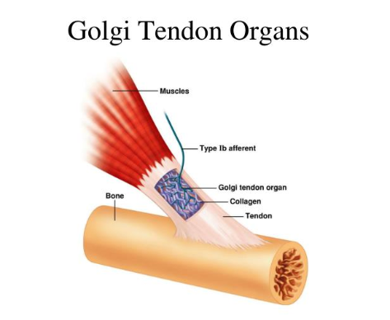
Figure 1: Golgi tendon organ (Antori, 2023).

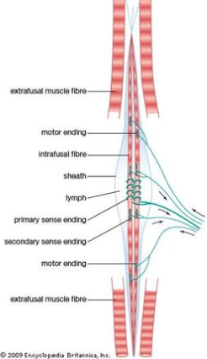
Figure 2: Muscle spindle (Britannica, 2016).
The Golgi tendon organs are sensory receptors located in tendons that detect changes in muscle tension, when a muscle contracts isometrically, the Golgi tendon organs sense the increased tension and trigger a reflex relaxation response. This physiological response is utilized in PIR to enhance muscle elongation following contraction of the muscle (Novianti et al., 2023).
Muscle spindles are sensory receptors within muscles that detect changes in length and rate of stretch. When a muscle contracts, the antagonist muscle is neurologically inhibited to allow for smooth movement. Through these mechanisms muscle energy techniques help reset the muscle and improve joint function and promote MSK balance. Muscle energy techniques enhance athletic performance, the athletes benefit from muscle energy techniques as it helps them maintain flexibility, optimize muscle function, and reduce risk of injury (Kissane et al., 2023). Sports therapists frequently use muscle energy techniques as part of their pregame warmups and post-game recovery sessions to ensure athletes bodies are in optimal condition. Muscle energy techniques also correct poor posture as poor posture comes from muscle imbalances, where certain muscles become tight whilst others weaken. Muscle energy techniques help in bringing balance by stretching shortened muscles helping postural issues such as dowagers hump, kyphosis and lordosis (Thomas et al., 2023).

2.2 Physiological and biomechanical effects of PIR and RI
Muscle energy techniques are used for various conditions, such as postural issues, muscle spasms and strains, sports injuries, joint dysfunctions, and back and neck pain, and some literature claims that muscle energy techniques improve circulation (Thomas et al., 2019). The therapy is based on proprioceptive neuromuscular facilitation (PNF) and physiological processes that influence muscle tone and function, which respects the body’s biomechanics (Masekar et al., 2020). At their core, muscle energy techniques function by engaging the neuromuscular system to promote relaxation and strengthening of muscles (Ahmed, Maharaj and Van Oosterwijck, 2021). The concept involves the practitioners positioning of the patient’s body that engages a targeted muscle group. Muscle energy techniques are classified into many different types, depending on their goal, primary goals are post isometric relaxation, reciprocal inhibition, isotonic contractions, which includes concentric and eccentric muscle contractions to either strengthen or weaken muscles through a controlled movement. Isokinetic contractions, which involves movements at a speed with variable resistance, that are often used for rehabilitation of muscle function and finally joint mobilization by incorporating muscle contractions into joint mobilization techniques (Sathe et al., 2020). PIR is a technique where the therapist targets the muscle that is needing treatment and asks the patient to perform an isometric hold against resistance, which is then superseded by a passive stretch. This technique involves the Golgi tendon organ, allowing the muscle spindles to relax so that muscles can move further, the benefits of which are the muscle becoming relaxed and range of motion increasing. This technique is used for shortened muscles or reduced range of motion at the joint, or reduced flexibility. The proprioceptive response to a stretch is that the muscle spindles relaxing the tissue, whilst the Golgi tendon organ changes in tension and detects the contraction, then the muscle spindles change in length and velocity, and it is then down to the stretch shortening cycle as this is key for movement (Chaudhary et al., 2020). Stretching a muscle sends impulses from the muscle spindles to the spinal cords posterior horn cell. The anterior horn cell then increases motor impulses to the muscle fibres, creating tension that resists the stretch. When muscle tension rises, the Golgi tendon organ detects this and sends signals to the posterior horn cell, leading to an inhibitory effect on the motor stimulus at the anterior horn cell. The inhibitory effect leads to a decrease in motor impulses and induces relaxation. This suggests that prolonged muscle stretching can enhance stretching capabilities due to the relaxation of the Golgi tendon organs, which override the protective contraction, and the muscle spindles, thereby permitting relaxation. Additionally, muscle spindles play a crucial role in preventing injuries. When a muscle spindle is rapidly stretched, it triggers an immediate muscle contraction, thereby protecting tendons and muscles from potential tears. In the absence of muscle spindles, tendons and muscles would be susceptible to injury (Banks et al., 2021).
Post-isometric relaxation occurs through neurological feedback via the spinal cord to the muscle when an isometric contraction is induced, resulting in reduced muscle tone. This reduction in muscle tone persists for approximately 20 seconds, providing a therapeutic window during which the therapist can intervene by repositioning the muscle to a new range. This adjustment allows the muscle to adapt to an improved range of motion comfortably (Dudoniene et al, 2024).

2.3 Techniques and applications of MET
The techniques and applications of MET include PIR, which asks the patient to perform an isometric relaxation and contract the muscle that is targeted to stretch and asking patient to give 20 – 30% effort for 10 seconds, then the therapist moves limb further into a deeper range of movement and holds for 20 seconds. This is then repeated 3 times whilst limb is moved further each time, however RI asks the patient to contract the antagonist muscle to the targeted muscle being stretched and again asked to give 20-30% effort for 10 seconds whilst the therapist gives resistance to make it an isometric contraction and the therapist moves limb into a deeper stretch and holds for 20 seconds which is again repeated 3 times (Latash., 2023).

2.4 Functional outcomes associated with Post isometric relaxation (PIR)
Naweed et al. (2020) illustrated with their study that PIR is a helpful tool in increasing flexibility in the short term and the long term of hamstring flexibility. In this study, 35 students were selected, these were male and female students between the ages of 18 to 25 year olds, the flexibility of the hamstrings were measured immediately post intervention, and according to this study the ‘immediate short term’ and long term effects were ‘equally’ as effective.
D’souza, Mohandas, and Patrao, (2022) discovered there was a significant difference for those that received post isometric relaxation proving it to be an effective tool, and Khan et al., (2022) also states this technique was effective and compared the technique to myofascial release, Khan et al. (2022) found that PIR improved left side flexion and extension of the cervical spine. Clarke and Allen, (2021) also compared MET with another common technique (trigger point) and the study demonstrated that there was improvement when using PIR as a form of MET compared to trigger point therapy. PIR proved more effective, however Noto-Bell, Vogel, and Senn, (2019) found in their study that plantarflexion was improved in both ankles for competitive swimmers, so the consensus in the literature is very positive regarding PIR. In a study conducted by Bhutta et al., (2025) it was suggested that better higher quality research is needed in the area of muscle energy techniques, furthermore it was proposed that muscle energy techniques as an intervention is significant and is useful in rehabilitation programs and is a valuable tool and it was argued that MET can also help with injury prevention.
In another study conducted by Aleem et al., (2022) it was argued that PIR and RI are both effective techniques in increasing range of motion, but post isometric relaxation proved to be a more effective technique in improving range of motion.

2.5 Functional outcomes associated with Reciprocal inhibition (RI)
Rajan and Sudhakar (2024) found that RI as an MET showed significant improvements, they compared the effects of autogenic inhibition with RI on hamstring flexibility with their participants having bilateral hamstring tightness, and they found RI more effective, however, Siddiqui et al., (2022) conducted a randomized control trial with those who had neck pain, which showed RI benefitted by reducing pain, and improving range of motion, and functionality. Literature also suggested more research is needed to understand the mechanisms and effectiveness of reciprocal inhibition in various conditions. Balakrishnan and Sudhakar (2024) highlighted the need for further studies to understand the longer-term effects of reciprocal inhibition.
Osama (2021) argues that there are more effective treatment options than reciprocal inhibition and they used a large sample size of 100 participants to test their eligibility for the study with 78 being selected, comparing three treatment options in their efficacy, this was compared with autogenic inhibition and the study was on the efficacy of these two techniques in neck pain, regardless of the treatment group, both groups received trans cutaneous nerve stimulation (TENS). Similarly, Siddiqui, Akhter and Baig, (2022) found autogenic inhibition was a more beneficial treatment than RI.

2.6 Straight leg raises
Liu et al., 2022 found that straight leg raises are not only used for neurological tests, such as the Bragard test used in therapy, a test which is used to see whether patient potentially has a herniated disc or not (Berthelot et al., 2021). The straight leg raise is used for hamstring flexibility but other factors such as, nerves of the body, fascia and muscles around the hip and thigh also have an impact on the flexibility in a straight leg raise (Lim, 2023). In another study, the researchers found that the straight leg raise was reliable for gauging hamstring flexibility (Hori, Hasegawa, and Takasaki, 2021).

2.7 Summary comparison of outcomes
Post isometric relaxation proves more effective than reciprocal inhibition in increasing range of movement according to Aleem et al. (2022) and it is mentioned in their study that other literature agrees with their findings. Post isometric relaxation is when the muscle contracts isometrically and then the Golgi tendon organs detect tension and sends signals to the spinal cord, which triggers a reflex that inhibits the muscle contraction, and the inhibition allows the muscle to relax making it easier to stretch. PIR increases ROM and reduces muscle tightness, improving hamstring flexibility, enhanced flexibility, pain relief, and improved circulation (Naweed et al., 2020). RI helps with improved muscle balance, reduces risk of injury and provides better neuromuscular control, which differs slightly in outcomes to PIR but both increase range of motion, it also differs scientifically as the antagonist is inhibited, and this inhibition prevents both muscle from contracting at the same time, as the movement is controlled by muscle spindles which detect the changes in muscle length and tension (Chiba et al., 2021).

2.8 Aims
The purpose of the current study is to evaluate the effectiveness of both post isometric relaxation and reciprocal inhibition at improving range of motion around the hip and whether either technique is more effective.

Chapter 3 Method

3.1 Participants
The participants were recruited by the investigator asking family members and private clients if they were willing to take part in this current study. Twelve volunteering adults aged 18-63 year of age were recruited to the current study, inclusion criteria: participant was to be carrying no pre-existing injury to lower limb to allow for optimal testing. It was a cross-sectional study, there was one group, but they were split into two groups for convenience, firstly 6 of the group took part in post isometric relaxation (PIR) and then other 6 took part in reciprocal inhibition (RI), this was then reversed the week after, so all took part in both.

3.2 Study design:
The current study was organised as a controlled intervention where 6 participants were assessed for hip mobility before and after a session of PIR and 6 participants after RI. The following week the interventions were swapped between the groups and comparison made for differences in effect in hip mobility between the interventions.
Written informed consent was provided by all participants and ethical approval for the study was obtained from the university ethics representative prior to data collection.

3.3 Protocols:
Prior to each assessment participants were asked to go for a brisk walk for 5 minutes. Within a clinical setting participants lay on a massage couch and performed a straight leg raise laying in supine and the angle was then measured using a goniometer (see figure 3). After this measure a trained clinician performed a standardised session of either PIR or RI and the angle of hip flexion was remeasured.
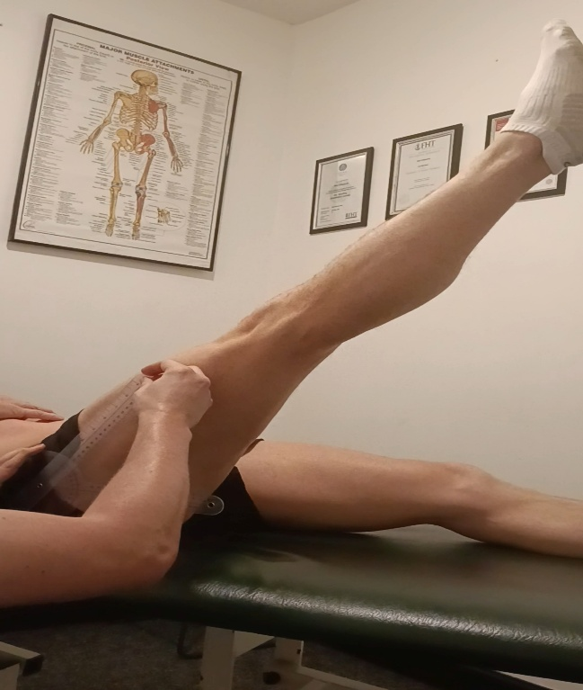
Figure 3: use of goniometer.

Goniometer – The body of the goniometer is placed on the greater trochanter with the stationary arm facing down the side of the femur and the moving arm placed in the same direction, once the leg begins to move the moving arm moves with the femur and stays in line with the centre of the femur.

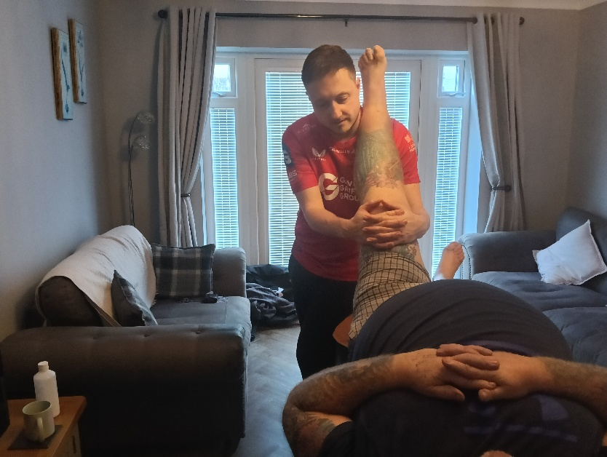
Figure 4: Post isometric relaxation, patient is pushing against therapist.

PIR Routines - this is where the targeted tissue to stretch is contracted, by the therapist asking the participant to push towards therapist with 20 per cent effort against resistance from the therapist for 10 seconds. The therapist then moves the leg to a new range and holds the leg still for 20 seconds, this is then repeated 3 times, (see figure 3).

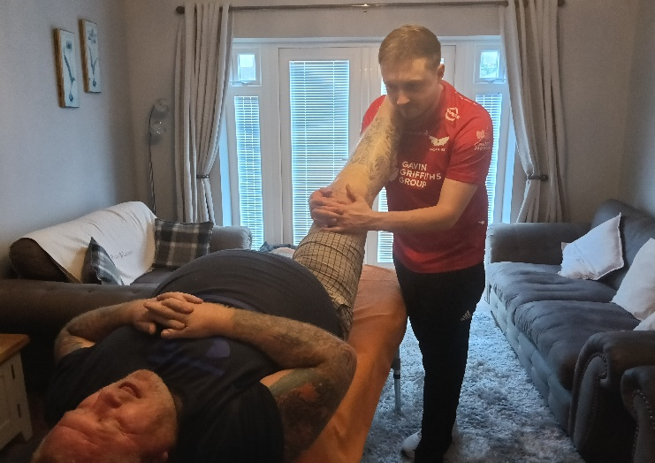
Figure 5: Reciprocal inhibition, patient pulls leg away from therapist.

RI Routine – this is where the antagonist tissue of the tissue targeted is contracted allowing the target tissue to relax. The participant was asked to pull leg away from therapist with 20% effort for 10 seconds, the therapist then moves the participants leg to a new range going the opposite way to where participant pulled the leg. The leg is held for 20 seconds before being moved further, this is also repeated 3 times, with both PIR and RI the leg is moved into hip flexion with knee extended, (see figure 4).

3.4 Data Analysis
Data was recorded and organised using Microsoft Excel. SPSS (version 24) was used for inferential analysis). Paired t-test were used to evaluate the difference before and after the mobilisation intervention with Cohens-d used for effect size. An independent t-test was used to compare between interventions with Cohens-d for effect size. Alphas values for significant effect were P<.05 and for Cohen’s-d a large effect was >.8, moderate effect >.5 <.8 and small effect >.3<.5. All the participants attended to be treated and assessed pre and post intervention.

Chapter 4 Results
Twelve participants completed both trials for PIR and RI that demonstrated significant improvement in hip ROM after both methods (See Table 1). However, there was no difference in the improved ROM when comparing the two mobilisation strategies.

4.1 Hip angles pre and post PIR (post-isometric relaxation) and RI (reciprocal inhibition) for L (left hip), R (right hip)
Table 1
 | Hip angle (⁰) |  | Change (%)
 | Before | After
PIR Left Hip | 77.8 ± 13.1 | 83.6 ± 12.3 | 7.5
PIR Right Hip | 72.7± 12.2 | 77.7 ± 13.2 | 7.0
RI Left Hip | 75.1± 15.0 | 86.8 ± 10.9 | 15.6
RI Right Hip | 73.8 ±15.4 | 79.5 ± 11.2 | 7.5

The findings showed there was no significant difference between post isometric relaxation and reciprocal inhibition, this was shown by <.001 significance in the left leg between PIR and RI post treatments and .014 significance in the right leg post treatments. The results showed that there was no difference in efficacy between post isometric relaxation and reciprocal inhibition, both being as effective in improving range of movement at the hip. Post isometric relaxation improved hip angle by 5.8⁰ (7.5%) for the left leg and 5⁰ (7.0%) for the right leg, that represented significant improvement in range of movement with large and moderate effect size respectively

4.2 Effect of Post Isometric Relaxation
Post isometric relaxation improved hip by 5.8⁰ (7.5%) for the left leg and 5⁰ (7.0%) on the right leg which represented significant improvement in range of movement (see Table 2). with large and moderate effect size respectively.
Table 2
 | Hip angle (⁰) |  | T | df | Sig | Cohen’s-d
 | Before | After
PIR L | 77.8 ± 13.1 | 83.6 ± 12.3 | -2.776 | 11 | 0.018 | .801
PIR R | 72.7± 12.2 | 77.7 ± 13.2 | -2.209 | 11 | .049 | .638

4.3 Effect of Reciprocal inhibition
Evidence in table 1 indicates a 7.5% and 7% increase in left and right hip flexion respectively. A paired sample t-test (see table 3) reveals RI to have a significant positive effect on hip range of movement with large effect size.

Table 3 Paired samples t-test evaluation of the effect of RI on hip angle
 | Hip angle (⁰) |  | T | df | Sig | Cohen’s-d
 | Before | After
RI L | 75.08 ± 14.9 | 86.8 ± 10.8 | -5.278 | 11 | .001 | .1.524
RI R | 73.8 ± 15.3 | 79.5 ± 11.1 | -2.915 | 11 | .014 | .842

A paired sample t-test was also conducted for RI and scored a mean score of 75.1± 15.0 for pre-event and then 86.8 ± 10.9 for post event for the left side. On the right side there was a mean score of 73.8 ±15.4 pre-event and a post event score of 79.5 ± 11.2 following intervention. An independent t-test was then used to determine whether there was a significant difference between PIR vs RI between efficacy and it showed a difference of (t=-2.776) on the left side for PIR and a (t=-5.278) post intervention. For the right side it showed (t=2.209) on the right pre-treatment and (t=-2.915) post treatment for PIR. For RI t value of (t=-2.776) on the left side pre-treatment and (t=-5.278) post treatment and for pre-treatment (t=-2.209) on the right side and (t=-2.915) post treatment. Left and right sides show an increase in hip angles after the intervention, the left side experienced a 7.5% change, moving from 77.8 ± 13.1 to 83.6 ± 12.3 degrees. The right side demonstrated a similar improvement with a 7.0% change going from 72.7 ± 12.2 to 77.7 ± 13.2 degrees. These changes suggest a modest yet consistent increase in active ROM in the straight leg raise across both sides. The reciprocal inhibition left measurement shows the largest percentage increase overall (15.6%), indicating a more pronounced effect of the intervention in a straight leg raise for the left side of the hip compared to both PIR and RI on other sides. PIR changes are more consistent between left and right sides (7.5% vs 7.0%), whereas RI changes show disparity between sides, with the left side responding better than the right (15.6% vs 7.5%). The left side showed a significant improvement of 15.6%, increasing from 75.1 ± 15.0 to 86.8 ± 10.9 degrees. This indicates that the intervention had a substantial effect on the left side in active ROM at the hip in a straight leg raise. The right side exhibited a smaller but notable change of 7.5%, improving from 73.8 ± 15.4 to 79.5 ± 11.2 degrees.

4.4 Comparisons between PIR and RI
Independent t-test analysis comparing PIR to RI in table 4. indicated that there was no significant difference in hip ROM prior to intervention for left or right legs. Table 4 also identifies that there was no significant difference in improvement of ROM between the PIR and RI interventions.
Table 4 Independent sample test
 | PIR (ROM ⁰) | RI (ROM ⁰) | T | df | Sig | Cohen’s-d
Left before | 77.8 ± 13.1 | 75.1± 15.0 | -2.776 | 11 | .018 | -.195
Right before | 72.7± 12.2 | 73.8 ±15.4 | -2.209 | 11 | .049 | -.275
Left after | 83.6 ± 12.3 | 86.8 ± 10.9 | -5.278 | 11 | <.001 | -.299
Right after | 77.7 ± 13.2 | 79.5 ± 11.2 | -2.915 | 11 | .014 | -.150

Independent t-test analysis which compared PIR to RI indicated that there was no significant difference in hip ROM prior to intervention for left or right legs, and it also identified that there was no significant difference in the improvement of ROM between the PIR and RI interventions. For the PIR on the left side there was an increase of 7.5% post intervention, whilst on the right side there was an increase of 7% post intervention. For RI on the left side there was a significant increase of 15.6 %, this was the highest of all out of the four compared. The right side of the hip post RI intervention increased movement by 7.5%, which was the same figure for post isometric relaxation on the left side. The movement of the left side pre intervention had a mean score of 77.8 ± 13.1 in PIR on the left side was recorded and post intervention a mean score of 83.6 ± 12.3 was achieved post intervention. On the right side pre intervention there was a mean score of 72.7± 12.2 with post intervention mean score of 77.7 ± 13.2 for PIR.

Chapter 5 Discussion

5.1 Key findings
In this study, the application of RI resulted in reduction of antagonist muscle activity, contributing to the observed improvements. PIR relies on the Golgi tendon organ (GTO) reflex, which inhibits muscle contraction following a 10 second contraction by the participant and showed it was as effective in increasing the ROM at the hip, reducing hamstring tightness over the hip. The findings showed there was no significant difference between PIR and RI, which was shown by <.001 significance in the left leg between PIR and RI post treatments and .014 significance in the right leg post treatments.
The results showed both treatments were as effective as one another. Sathe et al, (2020) arrived at similar conclusions regarding the efficacy of the treatments explored. Further study is needed on this subject, but Sathe et al., (2020) found that both post isometric relaxation and reciprocal inhibition were effective in improving hamstring tightness, which is in line with the findings of the current study and give credibility to this study, therefore this showed the study demonstrated the efficacy of PIR and RI, and it showed that both techniques improved the angle of the hip and flexibility. These are effective treatments for a clinical practice, whilst they both achieve similar outcomes, however Mesquita et al, (2022) says that PIR is more effective and that muscle energy techniques are a safe and effective tool for patients suffering from joint dysfunction, back and neck pain, sports injuries, postural imbalances, muscle strains, spasms, general pulls and tightness, and that by engaging the patient actively in the process of the treatment, muscle energy techniques help achieve better therapeutic outcomes. Furthermore, while both techniques showed a significant difference in improving the angle at the hip, Naweed et al, (2020) found that post isometric relaxation is more effective than reciprocal inhibition and mentions other literature which claims the same, however this was not the case in this study.

5.2 Implications

Whilst both techniques are effective, PIR is more suitable for patients experiencing tightness without pain as the problem tissue is used to perform an isometric contraction to illicit a stretch in the same problem tissue, therefore RI would be used when the patient is experiencing pain in the area that is tight and in need of lengthening, making RI a useful tool if the patient is in pain, and it is difficult to illicit an isometric contraction in the problem tissue. The patient’s compliance therefore depends on factors such as patient tolerance to the specific muscle involved (Mesquita et al., 2022). It is important to acknowledge that this study had limitations such as the number of participants used, and treatments and assessments were only completed in one session, one for each treatment. Future research may also benefit from examining the longer-term effects of PIR and RI. Changing the protocol can also be considered in future research as this may give a more accurate reading, using instruments such as a measuring tape to measure the angle of the hip and a sit and reach box along with a goniometer increasing the quality of the research (Diaz, Stephenson and Labrador, 2019).
Participants clothing can be a hinderance or an advantage to them being able to lift the leg higher increasing their range of motion at the hip. Some of the participants wore tight fitting clothing, whilst others wore loose clothing such as jogger bottoms or shorts, and this may have impacted the findings and data for this study. Ensuring participants all wear loose clothing or shorts for future studies will improve the integrity of the study as they will have more freedom in their movement and may be easier to move and increase mobility. Future research could also compare male to females (Pazhoohi et al, 2019) in hip range of motion post intervention of muscle energy techniques. Age range could also be reduced, and investigator could use younger populations such as 18 to 30 year olds. Investigators could also use sporting populations or specific sporting population, such as, rugby, football or basketball where engagement of the hamstring and hip may be more in one sport than the other, such as golf where the hip is in play for the swinging movement of a strike to the golf ball (Kanwar et al., 2020).
Utilising more exercises pretreatment may also help in future studies to improve the outcome by causing vasodilation, which may help increase the movement as the muscles will be warmer (Kapilevich et al., 2020). Previous training history plays a role in how the athletes body responds to the treatment. Out of the participants there was one who played grass roots football in his teens, a female weightlifter in her 50s, two males in their 60s, three males in their 50s, a female in her mid-30s who has no sporting background, a male in his late 30s who has completed 6 triathlons, a male in his early 20s who is student and a female in her early 20s who is also a student.
According to Losa-Reyna et al, (2019) MET is a non-invasive and safe technique and is tailored to patients’ needs to improve flexibility and muscle relaxation. The effectiveness of the techniques may vary depending on the therapist’s skill and the patient’s condition. Mesquita et al, (2022) say that literature shows PIR as a more effective treatment than reciprocal inhibition but the current study, it did not show a significant difference between the two.

The results suggest the intervention may be particularly effective for improving range of motion at the hip in a straight leg raise. The substantial difference between RI left and RI right could indicate asymmetry in muscular strength or coordination between the sides, warranting further investigation. It also shows that both techniques are valuable in the clinic setting as both are equally as effective and there showed a significant difference pre and post intervention using the straight leg raise and a goniometer to measure the degree angle of the hip. The findings influence physical therapist’s protocols, giving practitioners evidence-based treatments to improve the hip angle in patients who are restricted in their range of motion because of injury, surgery or chronic conditions. PIR and reciprocal inhibition are techniques for improving range of movement and reducing hamstring tightness, which could reduce the workload for the NHS by utilising sports therapists who are often private therapies that take on patients who are no longer able to wait for care and pay to go private. This could also help people take the conventional route instead of taking the pharmaceutical route. Athletes, trainers, and coaches can utilise muscle energy techniques (PIR and RI) into warmups, cooldowns, or rehabilitation programs to improve flexibility and prevent injuries. Improved hip mobility could contribute to better performance in sports requiring dynamic lower limb movements, such as running, cycling, or martial arts. The treatments have shown they can be trusted by physiotherapists, chiropractors, osteopaths and sports therapists, with the technique originating with osteopaths. PIR is more suitable for individuals with significant muscle tightness as it focuses on relaxation of the targeted tissue (Naweed et al, 2020). RI is preferred in scenarios requiring active engagement of the antagonist muscle, such as in sports performance or functional rehabilitation.

5.3 Study Limitations
One of the limitations of this study is that the assessment and treatment was only conducted on time for each technique. Another limitation is that there were only 12 participants. A further limitation is that it requires active participation from the patient, and the reason this is a limitation is because the patient may push too hard against the therapist when they are only required to give only 20% effort.

5.4 Future research

For future research it would better the quality of the study to have a higher number of participants, which could give a broader view. Investigating the long-term effects of these techniques could also be of value to the study. More focused populations such as, older adults, those with hip osteoarthritis, sports athletes or a smaller age range such as 18 – 25 years of age could be studied, but having a broader range will give a more comprehensive view of the study question. Adding soft tissue massage to the study to compliment the MET treatment can also enhance the study’s findings and interest. Changing the protocols could also enhance the quality of a study, helping give potentially more accurate readings, such as hip angle in a straight leg raise. Comparing PIR and RI with Maitland mobilisations to compliment the treatment is another option. Alternatively, a future study could focus only on symptomatic people, giving more relevance to the study as some of the participants were asymptomatic and did not benefit as much as someone with poor range at the hip would benefit. Having a joint study with another person’s opinion would benefit the study further as it encourages a diverse idea of what protocol to use and literature to search. Future studies could show how these treatments compare to other treatments, exploring long term effects and mechanisms.

Chapter 6: Conclusion

According to evidence presented in the current study both PIR and RI are as equally effective in improving hip ROM. This agrees with evidence from Sathe et al. (2020) but is different from most evidence such as that of that Naweed et al. (2020). This means that these treatments are safe and effective tools for practitioners to use, however this study proves to be limited as it is inconsistent with the majority of other literature that have bigger sample sizes on this subject. Increasing the number of participants and using a broader population of people will benefit future research. The practitioner can use this information to provide better care for patients and have a better understanding of when to use each specific technique at the appropriate time.

References

Ahmed, U.A., Maharaj, S.S. and Van Oosterwijck, J., (2021). Effects of dynamic stabilization exercises and muscle energy technique on selected biopsychosocial outcomes for patients with chronic non-specific low back pain: a double-blind randomized controlled trial. Scandinavian journal of pain, 21(3), pp.495-511.

Alawna, M.A., Unver, B.H. and Yuksel, E.O., (2019). The reliability of a smartphone goniometer application compared with a traditional goniometer for measuring ankle joint range of motion. Journal of the american podiatric medical association, 109(1), pp.22-29.

Aleem, A, Arfan, M.T, Razzaq, A and Ali, M, (2022). Effectiveness of post isometric relaxation versus reciprocal inhibition technique on hamstring muscle flexibility. Annals of King Edward medical university, 28(2), pp.205-209.

Antouri, J. (2023) Golgi Tendon Organ and Functions. Available at: https://propta.com/edu-blog/golgi-tendon-organ-and-functions/ (Accessed: 7 April 2025).

Atchison, J.W., Tolchin, R.B., Ross, B.S. and Eubanks, J.E., 2021. Manipulation, traction, and massage. In Braddom's physical medicine and rehabilitation (pp. 316-337). Elsevier.

Banks, R.W., Ellaway, P.H., Prochazka, A. and Proske, U., (2021). Secondary endings of muscle spindles: Structure, reflex action, role in motor control and proprioception. Experimental Physiology, 106(12), pp.2339-2366.

Berthelot, J.M., Darrieutort-Laffite, C., Arnolfo, P., Glémarec, J., Le Goff, B. and Maugars, Y., (2021). Inadequacies of the Lasègue test, and how the Slump and Bowstring tests are useful for the diagnosis of sciatica. Joint bone spine, 88(1), p.105030.

Blazevich, A.J. and Babault, N., (2019). Post-activation potentiation versus post-activation performance enhancement in humans: historical perspective, underlying mechanisms, and current issues. Frontiers in physiology, 10, p.1359.

Britannica (2016) Muscle Spindle. Available at: https://www.britannica.com/science/muscle-spindle (Accessed; 7 April 2025).

Callister, R.J., Brichta, A.M., Schaefer, A.T., Graham, B.A. and Stuart, D.G., (2020). Pioneers in CNS inhibition: 2. Charles Sherrington and John Eccles on inhibition in spinal and supraspinal structures. Brain Research, 1734, p.146540.

Chaitow, S. and Franke, H., (2023). The History and Context of Muscle Energy Technique. Chaitow's Muscle Energy Techniques E-Book: Chaitow's Muscle Energy Techniques E-Book, p.56.

Chaudhary, S., Patel, T., Makwana, A. and Patel, M., (2020). Improvement of iliopsoas flexibility: a comparative effectiveness between post isometric relaxation and static stretching. Indian Journal of Physiotherapy & Occupational Therapy Print-(ISSN 0973-5666) and Electronic–(ISSN 0973-5674), 14(3), pp.213-218.

Chiba, T., Ide, K., Taylor, J.E., Boku, S., Toda, H., Kanazawa, T., Kato, S., Horiuchi, Y., Hishimoto, A., Maruyama, T. and Yamamoto, T., (2021). A reciprocal inhibition model of alternations between under-/overemotional modulatory states in patients with PTSD. Molecular psychiatry, 26(9), pp.5023-5039.

Díaz, S., Stephenson, J.B. and Labrador, M.A., (2019). Use of wearable sensor technology in gait, balance, and range of motion analysis. Applied Sciences, 10(1), p.234.

Dudonienė, V., Mikalajūnė, K., Pažėrienė, A. and Žlibinaitė, L., (2024). Post-isometric relaxation versus self-stretching for non-specific neck pain in working-age individuals. Applied sciences., 14(16), pp.1-11.

D'souza, A.J., Mohandas, L. and Patrao, A.I., (2022). A study to assess the effect of post isometric relaxation versus isolytic contraction on range of motion in individuals with hamstring tightness. Critical Reviews™ in Physical and Rehabilitation Medicine, 34(2).

Hori, M., Hasegawa, H. and Takasaki, H., (2021). Comparisons of hamstring flexibility between individuals with and without low back pain: systematic review with meta-analysis. Physiotherapy theory and practice, 37(5), pp.559-582.

Kang, Y.H., Ha, W.B., Geum, J.H., Woo, H., Han, Y.H., Park, S.H. and Lee, J.H., (2023), April. Effect of muscle energy technique on hamstring flexibility: systematic review and meta-analysis. In Healthcare (Vol. 11, No. 8, p. 1089). MDPI.

Kanwar, K.D., Cannon, J., Nichols, D.L., Salem, G.J. and Mann, M.D., (2024). Injury risk-factor differences between two golf swing styles: a biomechanical analysis of the lumbar spine, hip and knee. Sports Biomechanics, 23(10), pp.1504-1525.

Kapilevich, L.V., Kologrivova, V.V., Zakharova, A.N. and Mourot, L., (2020). Post-exercise endothelium-dependent vasodilation is dependent on training status. Frontiers in Physiology, 11, p.348.

Kissane, R.W., Charles, J.P., Banks, R.W. and Bates, K.T., (2023). The association between muscle architecture and muscle spindle abundance. Scientific Reports, 13(1), p.2830.

Latash, M.L., (2023). The control and perception of antagonist muscle action. Experimental Brain Research, 241(1), pp.1-12.

Lim, W., (2023). Knee extension test for assessing hamstring flexibility. Journal of Korean Physical Therapy Science, 30(1), pp.31-40.

Liu, H., Shen, Y., Xiong, Y., Zhou, H., Mao, Y., Shen, Q., Hong, W., Liu, M., Liu, Y., Qiu, L. and Zhang, Z., (2022). Psychometric Properties of Four Common Clinical Tests for Assessing Hamstring Flexibility in Young Adults. Frontiers in Physiology, 13, p.911240.

Losa-Reyna, J., Baltasar-Fernandez, I., Alcazar, J., Navarro-Cruz, R., Garcia-Garcia, F.J., Alegre, L.M. and Alfaro-Acha, A., (2019). Effect of a short multicomponent exercise intervention focused on muscle power in frail and pre frail elderly: a pilot trial. Experimental Gerontology, 115, pp.114-121.

Maas, H., Noort, W., Smilde, H.A., Vincent, J.A., Nardelli, P. and Cope, T.C., (2022). Detection of epimuscular myofascial forces by Golgi tendon organs. Experimental Brain Research, pp.1-12.
Masekar, M.B., Rayjade, D.A., Yadav, D.T. and Chotai, D.K., (2020). Effectiveness of muscle energy technique and proprioceptive neuromuscular facilitation in knee osteoarthritis.(2021). Int. J. Life Sci. Pharma Res, 11(1), pp.L16-22.
Mesquita, R.N., Taylor, J.L., Trajano, G.S., Škarabot, J., Holobar, A., Gonçalves, B.A. and Blazevich, A.J., (2022). Effects of reciprocal inhibition and whole‐body relaxation on persistent inward currents estimated by two different methods. The Journal of Physiology, 600(11), pp.2765-2787.
Naweed, J., Razzaq, M., Sheraz, S., Anwar, N., Sadiq, N. and Naweed, S., (2020). Comparison of active isolated stretch and post isometric relaxation for improving hamstring flexibility in young healthy adults. Pakistan Armed Forces Medical Journal, 70(3), pp.770-75.

Noto-Bell, L., Vogel, B.N. and Senn, D.E., (2019). effects of post–isometric relaxation on ankle plantarflexion and timed flutter kick in pediatric competitive swimmers. Journal of Osteopathic Medicine, 119(9), pp.569-577.

Novianti, I.G.A.S.W., Novianti, I.G.A.S.W., Ayu, I.A.A.S.I., Suadnyana, A., Made, I.M.D.P.I., Prianthara, D., Made, I.M.R.A.I. and Antara, R., (2023). Comparison of the effectiveness of muscle energy technique and eccentric exercise in reducing disability in tennis elbow sufferers. The Southeast Asian Journal of Tropical Medicine and Public Health, 54(Suppl 2), pp.106-119.

Osama, M., (2021). Effects of autogenic and reciprocal inhibition muscle energy techniques on isometric muscle strength in neck pain: A randomized controlled trial. Journal of back and musculoskeletal rehabilitation, 34(4), pp.555-564.

Patel, N., Desai, S. and Patel, P., (2021). Effectiveness of muscle energy technique versus positional release technique on upper trapezius trigger points in subjects with neck pain–comparative study. International Journal of Current Research and Review, 13(11), pp.87-91.

Pazhoohi, F., Garza, R., Doyle, J.F., Macedo, A.F. and Arantes, J., (2019). Sex differences for preferences of shoulder to hip ratio in men and women: An eye tracking study. Evolutionary Psychological Science, 5, pp.405-415.

Rehman, A.U., Khan, L.G., Khalid, M., Mumtaz, U., Akhtar, H., Gondal, A. and Waris, S., (2022). Comparison of active release technique and post isometric relaxation in patients with piriformis syndrome. Pakistan Journal of Medical & Health Sciences, 16(05), pp.683-683.

Sathe, S.S., Rajandekar, T., Thodge, K. and Chavhan, A., (2020). Comparison between immediate effects of post isometric relaxation and reciprocal inhibition techniques on hamstring flexibility in patients with hamstring tightness: An experimental study. Indian Journal of Forensic Medicine & Toxicology, 14(4), pp.6871-6875.

Sbardella, S., La Russa, C., Bernetti, A., Mangone, M., Guarnera, A., Pezzi, L., Paoloni, M., Agostini, F., Santilli, V., Saggini, R. and Paolucci, T., (2021), June. Muscle energy technique in the rehabilitative treatment for acute and chronic non-specific neck pain: a systematic review. In Healthcare (Vol. 9, No. 6, p. 746). MDPI.

Shamsi, M., Mirzaei, M. and Khabiri, S.S., (2019). Universal goniometer and electro-goniometer intra-examiner reliability in measuring the knee range of motion during active knee extension test in patients with chronic low back pain with short hamstring muscle. BMC Sports Science, Medicine and Rehabilitation, 11, pp.1-5.

Siddiqui, M., Akhter, S. and Baig, A.A.M., (2022). Effects of autogenic and reciprocal inhibition techniques with conventional therapy in mechanical neck pain–a randomized control trial. BMC Musculoskeletal Disorders, 23(1), p.704.

Swapna, J., Neha Jr, C. and Pratik, P., (2023). The Effect of Reciprocal Inhibition Techniques on Pain, Range of Motion, and Functional Activities in Patients With Upper Trapezitis. Cureus, 15(2).

Tedla, J.S. and Sangadala, D.R., (2019). Proprioceptive neuromuscular facilitation techniques in adhesive capsulitis: a systematic review and meta-analysis. Journal of musculoskeletal & neuronal interactions, 19(4), p.482.

Thomas, E., Cavallaro, A.R., Mani, D., Bianco, A. and Palma, A., (2019). The efficacy of muscle energy techniques in symptomatic and asymptomatic subjects: a systematic review. Chiropractic & manual therapies, 27, pp.1-18.

Torres, J.W. and Zipp, C., (2019). An Osteopathic Approach to Greater Trochanteric Pain Syndrome. Osteopathic Family Physician, 11(3), pp.18-21.

Waxenbaum, J.A., Woo, M.J. and Lu, M., (2024). Physiology, muscle energy. In StatPearls [internet]. StatPearls Publishing.

