Digital Surveying 2021 - ACBA4002

Name of Student: Mark Robinson

Student ID: 0952289

Name of Award: HND Construction managment

Mode: Part Time

Table of Contents
What is surveying? 3
Types of syrvey
Types of survey by - PRIMARY Classifcation 3
Types of survey by - Method 3
Types of survey by - tools used 4
Types of Surveying - Purpose
Mining Survey 4
Cadastral / Boundrey Survey 5
Topographic Survey 5
Digital technologies and their use in listed building surveys
Introduction 6
Linear Measurement - from Tapes to Lasers 6
Cameras - Thermal & Digital 6
Meters - Moisture 6
Drones - LIDAR & photogrammetry 7

reference List 8

What is surveying?
Surveying is deriving the relative positioning on objects using horizontal measurements. The data from these measurements can then be used to map the information in a scaled pictorial format (Basak. 2019). Surveys can be grouped into a variety of different primary classifications, methods, purposes and by tools used as listed below;

Types of syrvey by - PRIMARY Classifcation

Geodetic vs plane Survey
The significant difference between these two classifications of survey is whether the curvature of the earth is taken into account in the linear measurements. The spherical shape of the earth has a very large diameter, so large that if your surveying small areas of land then the curvature would be so minimal that it could be considered flat. In this case you can undertake a plane survey using straight lines and taking linear measurements from point to point as shown in figure 1.
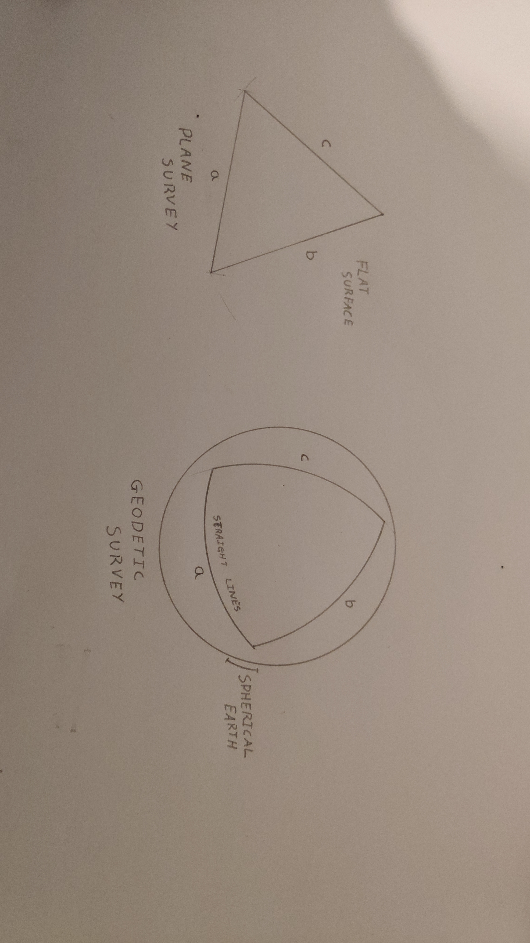 If you are surveying an area over 250km² then the curvature of the earth should be taken into account and would require a geodetic survey in order to have a high degree of accuracy on the measurements. As itentifed in figure two, lines that appear straight would be curved or arched over the specrical shape of the planet, this curvature should be measured and taken into account using trigonomotry (The Constuctor. 2021).

Figure 1 - Plane Survey Figure 2 - Geodetic Survey

Types of survey by - Method

Triangulation, Traversing & Trilateration
The type of survey can be described by its method; figure 3, 4 & 5 show triangulation, trilateration and traversing.
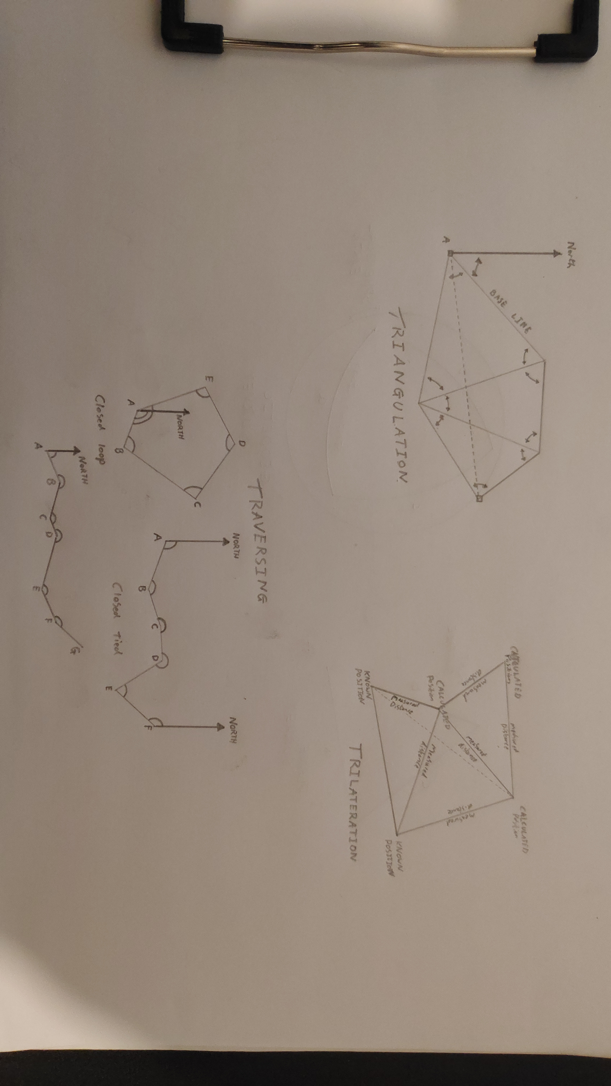Triangulation uses triangles, trigonometry and one measured base line to calculate points. The corners of each triangle should all be measured in order to calculate distance with trigonometry, the angles should be as close to 45 degrees as reasonably possible to maintain a high level of accuracy. To cover greater distances or areas not visible from the base line these triangles can be chained together as shown in figure 3 (Intergovernmental Committee on Surveying and Mapping. n.d.).
Figure 3 - Triangulation Figure 4 - Trilateration Figure 5 - Traversing

Trilateration, similar to triangulation, a triangle of a series of triangles is used to calculate points. Unlike triangulation there is no need to record the angles of the triangle, instead we use highly accurate distance measurement to calculate the length of each side of the triangle. Generally EDM (Electromagnetic Distance Measurement) tools are used such as a total station (ICSM. n.d.).
Traversing is usually carried out as a series of points where a distance and angle is taken to each new point with the initial angle being calculated from north. Accuracy can be increased by closing the loop or by finishing on the last point with an angle to north. This form of survey is often used on large flat landscapes where there are few areas of elevation to use as points of triangulation (ICSM. n.d.).

Types of Survey by - Tools used
You can define the survey into two sub types by the tools that are used.
Traditional tools can be used to conduct surveys but can be a more time and labour extensive. To conduct a survey using traditional tools we would use chalk lines, land chains, ranging poles and pacing (Clancy, 1992, p.29). If we were to undertake the same survey but using modern tools then we would use laser measures, drones, total stations and GPS coordinates.

Types of Survey by - Purpose

Mining / Geological Survey
These surveys are a broad term that can be used to describe two different types of survey. They can involve the mapping of the underground tunnels in relation to the geology around them and to the surface above including country and property boundaries. This can be essential in cases of legal claims such as the ongoing dispute in the village of D Hirehal mandel in western India. A state owned mining corporation has been invited to tender for a 25-hectare iron ore open cast mine, the mine will be on the edge of a state boundary, of which the boundary is not agreed. An extensive mining and cadastral survey will be required to identify the state boundaries and the proposed mine works (Chronicle, 2021).
Surveys can also be undertaken in 3D format. The second type of survey can be used to map the geology of an area by drilling boreholes and using ground penetrating radar to identify the below ground minerals.
The following tools can be used to undertake mining surveys;
- Drones
Various tools can be mounted on drones and used to survey large areas or potentially hazardous terrain quickly and autonomously.

- Ground penetrating Rader
This can identify these potentially high risk features within the ground without disturbing or drilling the ground and reduce health risk from ground gas or weak geological features (Geophysical Survey Systems, 2019).

- XRF Analysis
These are tools that can assess the mineral elements within a sample and give a grade to the ore found within, if used while conducting surveys, areas can be highlighted for the most profitable mining (Chris Calam, 2017).

Cadastral / Boundrey Survey
Cadastral surveys will include distances and bearings in order to locate a land boundary and will correspond with points on the ground such as fence posts that will allow boundaries to be determined. These are usually undertaken for legal disputes on a property boundaries (Clancy, 1992, p.04). In the UK boundaries are usually identified with ‘determined boundaries’ where a boundary is determined on the ground in relation to a hard detail in the location such as brick, stone or concrete (Designing Buildings. 2021).

Topographic Survey
A topographic survey will show all surface features of a landscape, this will include manmade & natural. The survey can also include a number of features that the client can define in addition to contours that represent the height and shape of the land. Additional features can include buildings, water features, roads and woodlands (Indigo Surveys. n.d).
Topographic surveys are essential for land that’s going to be developed. The height and shape of the land will determine steps in foundations, excavation, fill and any retaining walls.
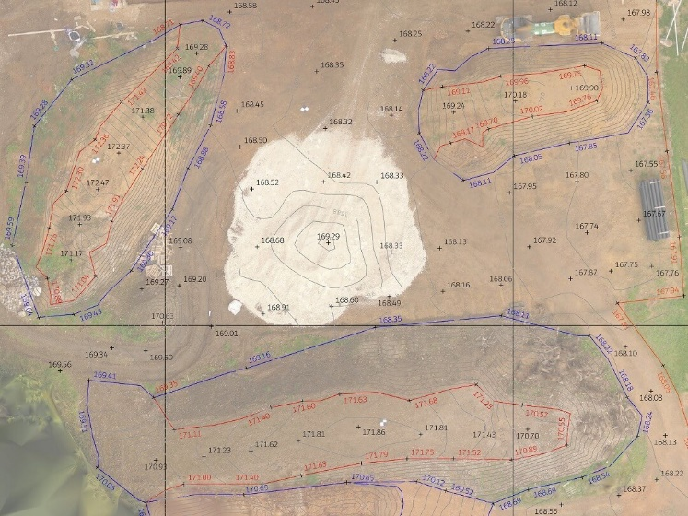
The raw data for topographic surveys can be obtained in a number of ways depending on client requirements, size of the area and any hazards. For small and surveys its common for an operative or team of operatives with total stations, GPS and reflective prisms will be used to conduct a survey one point at a time. This is highly accurate and can be given lists of essential information to collect.
Figure 6
Topographical. (2018) What is a Topographical Land Survey? [Online] https://topographical.co.uk/blog/what-is-a-topographical-land-survey [Accessed 14 Dec. 2021].

Drones have started to be used to conduct laser or photogrammetry surveys that can be used to cover large areas, areas difficult for people to visit or hazardous areas. Both can be linked together with on ground surveys layered over a photogrammetry survey for increased information and ledge ability as shown in figure 6 (Topographical. 2018).

Digital technologies and their use in listed building surveys

Introduction
As Hollis states ‘The inspection of buildings is mainly a visual experience, where the eyes do much of the work, the mind directs the eyes, and the hands touch, tap and stroke.’ (Hollis, 2013, p. 99).
The following report will give brief descriptions of the technologies that aid our senses in the survey of listed buildings, the tools that can be used and the information we collect.

Linear Measurement - from Tapes to Lasers
Steel measuring tapes are the most common way to take measurements of up to 10m which is reliable and accurate, this is usually used for the interior measurements of rooms, window and door openings. The accuracy of steel tapes will depend on their class, Class 1 being the most accurate and having a +/- of 0.9mm over 8m and class 3 being the least accurate and having +/- 3.8mm over 8m (Tool Tech, 2017). For all types of surveying work the most accurate equipment should be used. Fabric or fiberglass Tapes can be used for longer measurements such as exterior linear measurements of a property, these tapes come in longer lengths of up to 100m but with less accuracy.
For the most accurate measurements we now use laser measures, they are small, accurate light tools that can be used to up to 100m with a +/- 1mm deviation (Laser Distance Measurer. 2019). A laser measure can be used for interior or exterior measurements as long as it has a solid, non-reflective surface to bounce from.

Cameras - Thermal & Digital
Taking digital photographs with a DSLR camera or phone I highly recommended. You can use these to help remember ornamental details in the stonework or joinery (Noy, 2005, p. 32) and to capture evidence of faults or issues within the building. Its important to note that photographs should not be taken instead of site notes and that photographs will evidence and support notes taken. Any photographs should be stored under current data protection laws (RICS. n.d.).
Thermal cameras and their use in surveying can help to identify an array of different issues on the buildings structure.
- Thermal Bridges
- Moisture
- Condensation
- Mould Growth
(Red Current. n.d.)
By using a thermal camera these issues can be identified without any damage of exploratory works to the building which would cause damage.

Meters - Moisture
Moisture meters can give recordable figures on the moisture in a material element of the building, they do however take skill and knowledge to use correctly. Many meters will need to be correctly calibrated for the timber species and false readings can occur with materials such as foil backed plasterboards, VLC’s and material impregnated with salts (Watt and Swallow, 1998, p. 50).

Drones - LIDAR & photogrammetry
The use of drones in surveying has had a significant change in the industry. Drones have advantage over traditional survey means in a number of ways:
- Safety - Drones can access areas of buildings such as fragile roofs and other potentially dangerous areas, these can then be photographed and surveyed with different equipment without any risk of damage to the building and risk of harm to the surveyors completely negating any working at height regulation.
- Cost - Without the use of a drone, scaffolding, harnesses and ladders would need to be used to gain access to difficult areas that would come at an increased cost.
- Speed - Drones eradicate the need for scaffolding or ladders that would need erected prior to surveys, the drones can also even be preprogramed, if required to undertake flights and surveys on autopilot and programmed flight paths, these make the process more efficient on site (Halo Drones. 2021).
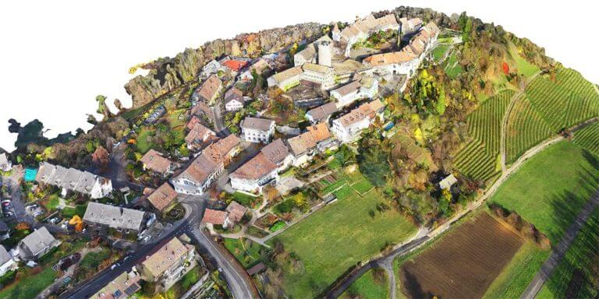
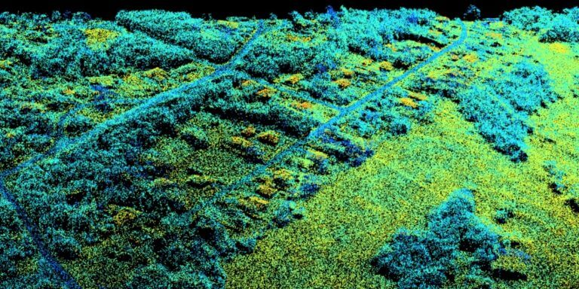
Its also important to understand the limitations of drones in addition to their advantages. This mainly comes down to them being implemented in the correct circumstances, for example drones can be a quick and cheap method for identifying particular areas of a roof that need further investigation (Drone photography services. 2021). Scaffolding can then be erected in the immediate area instead of the whole building and money is saved as a whole.
Figure 7 - Photogrammerty Figure 8 - LIDAR
Wingtra. (2021) Drone photogrammetry vs. LIDAR: what sensor to choose for a given application [Online] https://wingtra.com/drone-photogrammetry-vs-lidar/ [Accessed 20 Dec. 2021].

In building surveys drone can also be used for 3D imaging using photogrammetry or LIDAR. Photogrammetry involves the drone systematically taking overlapping photographs that are meshed together to form 3D shapes. Because the raw data is from photographs the model ends up in colour which greatly aids in identification of points on the map. LIDAR (light detection and ranging) involves the drone sending out pluses of laser light in a plane and recording the time it takes for the pulses to bounce from a surface. A standard LIDAR survey results in a 3D map without colour and can be colourised by using the intensity of the returning signals but this will not be photorealistic (Wingtra. 2021).

Information
After using any equipment in a survey its important to collate and store any information gathered so that it can be used by yourself or others in your team at a later date. This information usually takes the form of a digital report which can be shared with all relevant party’s once complete. Within the report, data such as measurements from moisture meters will be kept along with labelled photographs and elevation and plan sketches showing linear measurements.

Reference List
Basak.N.N. (2019) Surveying. [Online] Available at: https://civileblog.com/surveying/ [Accessed 06 Dec. 2021].
Anon. A. (2021) Boundaries to land and property. [Online] Available at: https://www.designingbuildings.co.uk/wiki/Boundaries_to_land_and_property [Accessed 14 Dec. 2021].
Drone photography services. (2021) Building Inspections and Surveys. [Online] Available at: https://dronephotographyservices.co.uk/aerial-building-surveys-inspection/ [Accessed 19 Dec. 2021].
Calam C. (2017) Types of Land Surveys Utilized by Mining Operations. [Online] Available at: https://www.thermofisher.com/blog/mining/types-of-land-surveying-utilized-by-mining-operations/ [Accessed 03 Dec. 2021].
Chronicle.D. (2021) Controversy over AP mining tenders. [Online] Available at: https://www.deccanchronicle.com/nation/politics/100721/controversy-over-ap-mining-tenders.html [Accessed 02 Dec. 2021].
Clancy. J (1992) Site surveying and levelling. 2nd Edn. Kent: Edward Arnold
The Constructor. (2021) Survey principles and methods of civil engineering. [Online] Available at: https://theconstructor.org/surveying/surveying-principles-methods-civil-engineering/13048/ [Accessed 06 Dec. 2021].
GSSI. (2019) GPR Systems for geophysics and environmental assessment. [Online] Available at: https://www.geophysical.com/wp-content/uploads/2019/12/GSSI-GPRforGeophysicsEA.pdf [Accessed 14 Dec. 2021].
Halo Drones. (2021) Building Surveying With Drones. [Online] Available at: https://halodrones.co.uk/building-surveying/ [Accessed 17 Dec. 2021].
Hollis. M. (2013) Surveying Buildings. 5th Edn. Coventry: RICS
Intergovernmental Committee on Surveying and Mapping. (n.d.) Surveying Methods. [Online] Available at: https://www.icsm.gov.au/education/fundamentals-mapping/surveying-mapping/surveying-methods [Accessed 12 Dec. 2021].
Indigo Surveys. (n.d.) What is a Topographical Survey? [Online] Available at: https://indigosurveys.co.uk/what-is-a-topographical-survey/ [Accessed 14 Dec. 2021
Laser Distance Measurer. (2019) Accuracy and Ultrasonic Distance Meters. [Online] Available at: https://www.laser-distance-measurer.com/accuracy-and-ultrasonic-distance-meter/#.YbmkSb3P2Uk [Accessed 15 Dec. 2021].
Noy. A. E. (2005). Building Surveys And Reports. 3rd edn. Oxfod: Blackwell
Red Current. (n.d.) Building Thermal Imaging Surveys. [Online] https://www.rics.org/uk/upholding-professional-standards/sector-standards/building-surveying/home-surveys/equipment-checklist/ [Accessed 16 Dec. 2021].
RICS. (n.d.) Equipment checklist. [Online] https://www.red-current.com/thermal-imaging-surveys/building-thermography [Accessed 16 Dec. 2021].
Tool Tech. (2017) How accurate are tape measures really? [Online] https://www.tooltech.ee/how-accurate-tape-measures-really/?lang=en [Accessed 15 Dec. 2021].
Topographical. (2018) What is a Topographical Land Survey? [Online] https://topographical.co.uk/blog/what-is-a-topographical-land-survey [Accessed 14 Dec. 2021].
Watt, D and Swallow, P. (1998) Surveying Historic Building. Trowbridge: Carnegie
Wingtra. (2021) Drone photogrammetry vs. LIDAR: what sensor to choose for a given application [Online] https://wingtra.com/drone-photogrammetry-vs-lidar/ [Accessed 20 Dec. 2021].

