

Digital Skills and research methods
Assessment 1
Student Name: Vincent Binoburyo
Student ID: 1806579
Module tutor: Balendran kandasamy

Introduction:
In the era of twenty-first century, uses of digital technology in most organizations are significant (Evan, 1999). Every company is using various types of digital technology to increase the employee’s skills and performance. It increases the communication skills of an employee towards the stakeholder (Richard, 2001). There are several updated technologiesis being used in Travelodge such as web-based email, tablets and smartphone, cloud file storage, web conferencing and so more. I am working here as an executive so I need to use some of them regularly. In the next part of this report, I am going to discuss appropriate use of technology to improve workplace efficiency.

Travelodge: It is a private company and they are running a hotel and hospitality business around the world including the UK. It is founded in 1985. It is popularly known as Travelodge. It is the second largest hotel based on budget sector and third largest hotel chain in the United Kingdom. Its headquarters is situated at Thames, England, United Kingdom. It is origin from the UnitedStates but it is now separate ownership.
The technologyof modern science: It is being already discussed that there are several technologies is used in any organization of the present time. These are given below:
Web-based email: These are normally free email accounts that are operated from a web address(John and Arthur, 1997). There are several email service provider has provided this services such as Yahoo mail, Gmail, Hotmail and AOL mail and so on. They provide free service to send information such as documents, photos, videos, audios and so more from one place to another place quickly.
Tablet or smartphone: Tablet or smartphone is a new innovation of modern science. It helps an organization in various ways. It allows an employee to do multiple tasks at a time. Basically,thisis an example of hardware but it is popular for its software or apps(Richard, 2001). Smartphone also helps the consumer to know the information of any organization via apps of that company.
Cloud files storage: It is a system for storing data or information in the cloud that provides servers and applications to access through the shared file system. For example, Google drive, one drive, Dropbox arean example of cloud file storage. The user can store a certain amount of data at a free of cost but they need to pay if they want to store more data.
Web conferencing: Conferencing means communicating with each other lives. It is an online activity by which a user can hold live meetings, presentation or provide training via the internet by IP. The user needs telephone or computer, speaker and microphones to connect with each other on life. There are several apps such as Whatsapp, Viber, IMO, messenger and so on.
Travelodge uses all of the above technology for their organization for a different sector. But I am using two of them and I am giving some effects of these two technologies. I am using smartphone and web conferencing for my daily activities at Travelodge.

Smartphone: Smartphone is kinds of the phone which work smartly. It has several options and different types of Apps which helps the consumer and employee both to know the information of the organization. Travelodge hotel has own Apps.
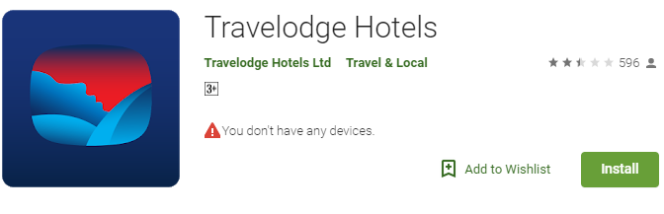
Figure 01: Mobile Apps of Travelodge
It is being used in the workplace for several purposes. The most important uses of a smartphoneare helping the employees. As an executive of Travelodge, I am using smartphone and smart App to the information of the organization. This smartphone is being used here to communicate with colleagues.
How smartphone is being used in the workplace:
1. To communicate with another colleague. So I make audio or video call by using my smartphone.
2. To share information with different stakeholder. I send information to a different stakeholder of the organization by sending the email. Sometimes I also share information by using cloud storage.
3. If I need to inform our valuable clients regarding any services that I use my smartphone to use App.
4. I used a smartphoneto do some research on another hotelof UK to know their strengths and weakness. I use this information to make a better plan for my organization.
5. This smartphone also helps my personal life which is related to the organization. I used time management app to utilize my time so that I can attend the organization every day on time.
6. This is also used to evaluate the project. I use Trello (online app) to run a project and get performance information about my project.
How a smartphone can improve the efficiency of the employee in the workplace: Basically it helps the organization in various ways. Some of them given below:
1. The smartphone makes an employee smarter. It helps me to do some task very quickly. I need information from another hotel of our chain than I don’t need to go there. I can Make a call and get my desired information (Bruce, 2000).
2. It reduces the cost of the organization (Richard, 2001). I don’t need to go outside of the organization to collect information so it reduces the cost of the organization and reduces the consumption of my energy.
3. Smartphone helps the employee to do a group meeting. I can do a group meeting to sit in my office. I don’t need to attend different place to do a meeting. We participate in a group meeting from the different part of the country but we don’t need to leave our own places.
How a smartphone can increase employability: Smartphone helps to increase employability. It increases the performance of the employees. Basically, an employee can do several activities by using this smartphone so automatically employee’s performance has increased. It helps to maintain proper time management of the employees. There are several apps reminds the employee what to do and when. By this way, an employee doesn’t miss any meeting or presentation. An employee can make any presentation by using a tablet or smartphone at any time. They don’t need to wait for the personal computer.
Web conferencing: Web conferencing is a process of live communication. It allows the employee to communicate by video or audio call. An employee can make a call between person to person or group meeting (Anne, 2011).

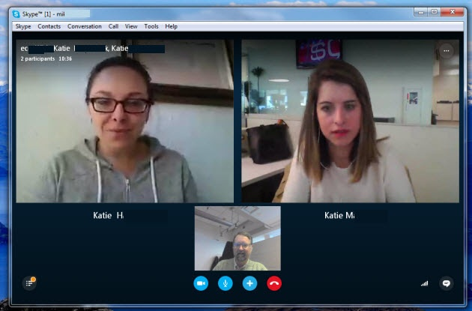
Figure 02: Web conferencing
How web conferencing is being used in the workplace: Basically there are limited uses of web conferencing. It is being only used to communicate with different stakeholder of the organization. I am using this technology to do personal or group meeting with different stakeholder of the organization. Sometimes I need to give feedback to our clients and sometimes I need to communicate with the supplier. So I need this technology. Sometimes I need to see the sample of any work from our supplier. So I make a video call to see the sample from them from my office. I don’t need to go or they don’t need to come to my office for this few purposes.
How web conferencing increase the efficiency of the employee within the workplace: It has already discussed that web conferencing has limited services. But it helps the employee to develop efficiency in the workplace. Web conferencing helps the employee to increase communication skills. An employee can talk with other parties gently with business norms. It improvesmy listening skills. When I talk with other parties by video call then I can see the body movement of that party and it increases the attention of mine to hear them.

How web conferencing can increase employability: Web conferencing increases the employability of the employee. It helps the employee to communicate with several persons of the organization in various ways. It helps me to work fast. I can talk with one person and typing some article at a time. So it helps me to reduce the time of typing or listening.

Use of social media in the work place
There are several applications or social media is popular within the present world. Some of them are being used for connecting with peers and some of them are being used to make an effective professional network. Basically, Facebook, Twitterand LinkedIn are a very much popular form of social media. These are described below:
Facebook: Facebook is mostly used social media all over the world. There are 2234 million users of Facebook all over the world. It is being used for various purposes of users. General people useit for entertainment but the organization uses it to promote the business and corporate people uses it to make a professional group. There are basic steps to open a Facebook account. These are given below:
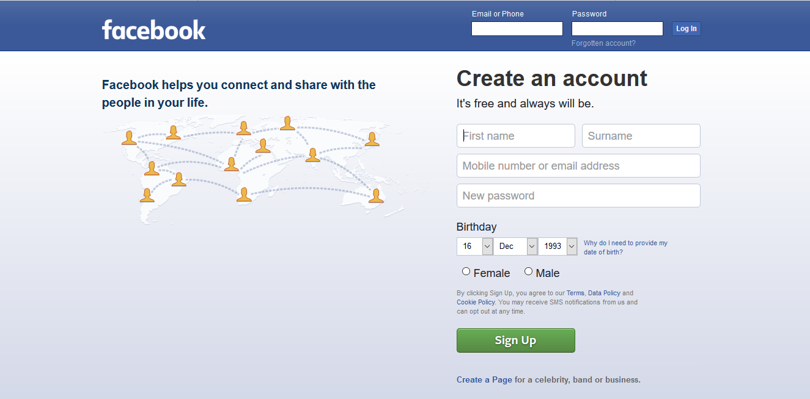
Figure 03: Facebook page
Step 1: Fill up the blank with proper name, email address, new password, date of birth and gender.
Step 2: Click sign up.
Step 3: Enter the code from the mail
Step 4: Set profile picture
Step 5: Set some settings
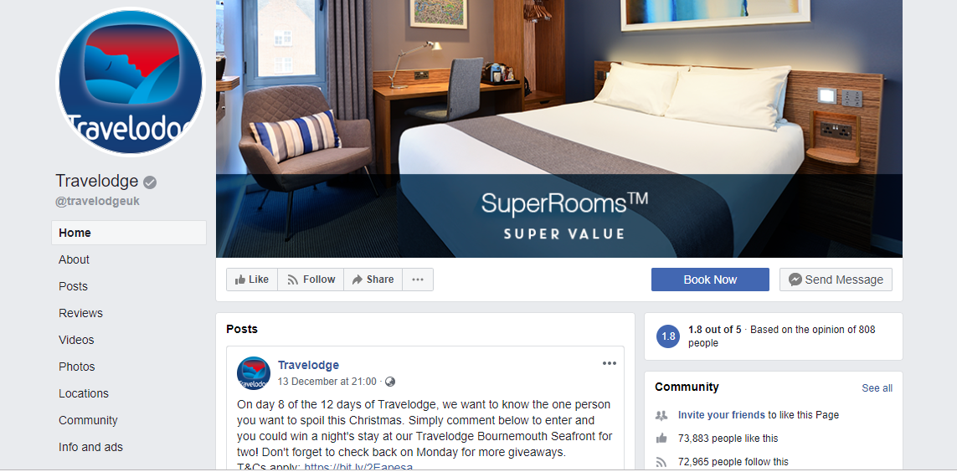
Figure 04: the Facebook page of Travelodge

Advantages of using Facebook in the workplace: There are several advantages to using Facebook in the workplace. These are given below:
1. Free advertisement: Travelodge organization doesn’t need to expend money to advertise their products and services. But if they want to boost up the Facebook page then they need to spend some money.
2.Make a large group: Travelodge can make a group share different types of knowledge of clients.
The disadvantage of using Facebook in knowledge: Some disadvantages are given below:
1. Fake user: Fake user can disturb the organization. They can create a fake page of Travelodge and post some unrelated content.
2.Hacker: Hacker can hack the page and stole the information.
Twitter: Twitter is another popular social media. It is being used by 335 million users all over the world. It works most likely Facebook. But there are some difference exists. It is very easy to open a twitter account. I am giving the simple process of how to open a twitter account.
Step 1: Open Twitter to visit www.twittter.com
Step 2: Click Sign Up
Step 3: Enter your name and mobile number
Step 4: Finally click on Sign up button
Step 5: Now fill up your basic information.
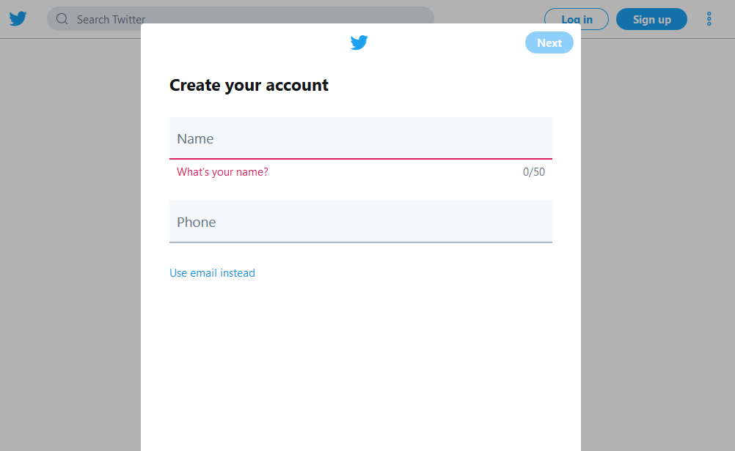
Figure 05: Twitter
Travelodge has a twitter page. This page helps them to provide information to the clients. They have a 41.8K follower.
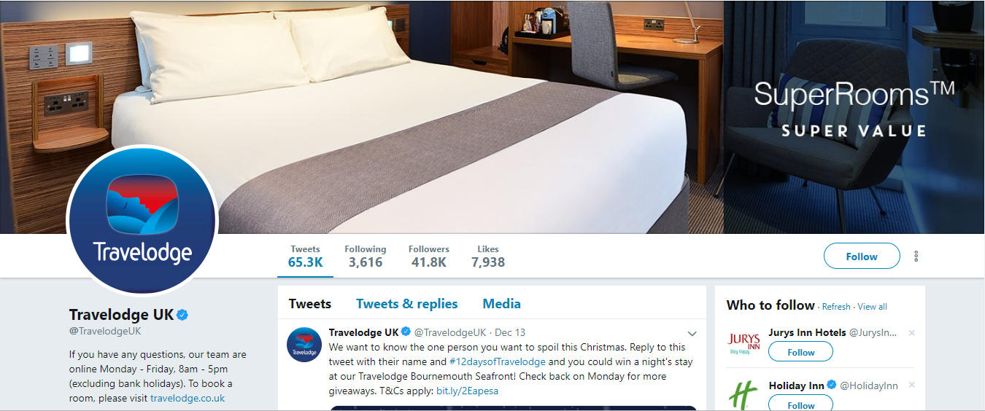
Figure 06: a Twitter page of Travelodge
The advantage of using Twitterin the workplace: There are various advantages of using twitter page. These are given below:
1. Inform clients: Twitter helps their valuable clients by providing different types of information or different package on a different occasion.
2.Creating value: We are giving most preference to our every customer. So we always try to help them in various ways. This process helps us to create the value of Travelodge.
Evidence of personal Twitter account: (See Appendix B)
Disadvantages of using Twitter in the workplace: These are given below.
1. Fake ID: This is tough to open any fake twitter account because We have verified page. But it is not impossible and some person takes this chance and misuses it.
2. Less security: There is sell a security to keep our information safely. If any party hack our page and collect our valuable information than it will create some harm for us.
LinkedIn: LinkedIn is another popular media. But it is very much useful to make a professional channel. It also helps an employee to get a better job. I am giving an easy process of opening a Twitter account below:
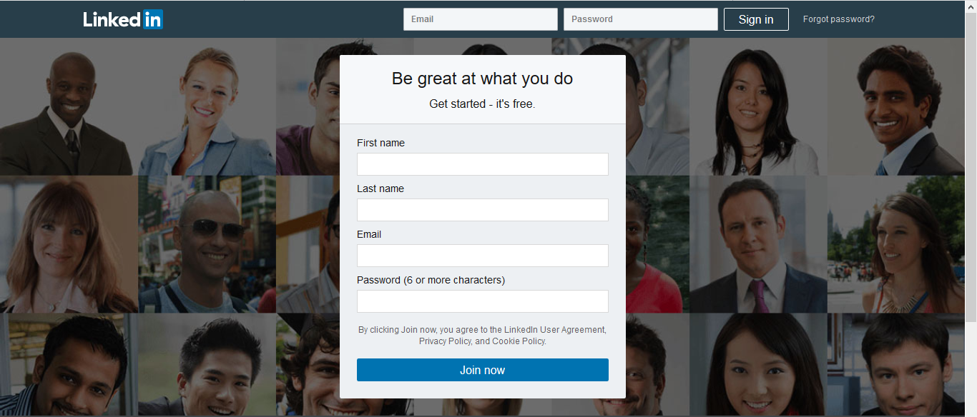
Step 1: Visit the Twitter page atwww.twitter.com
Step 2: Click on sign up.
Step 3: Fill up desire requirements
Step 4: Click Join now
Advantages of using LinkedIn in the workplace: There are several advantages of using LinkedIn.
1. It helps to make a professional channel to get a better job.
2. It also helps the employee to provide different types of information about own company.
I think LinkedIn is a very popular and effective network for searching for a better job. Because the useris being used LinkedIn to make a professional group or community. Professional people endorse my skills and experience. It is the most important advantage for any professional user that somebody is ensuring my skills and experience. I have recently signed up with LinkedIn and started building my profile.
Evidence of personal LinkedIn account: See Appendix A

Conclusion:

Digitalization means using modern devices to enhance the organization’s ability to increase production. Travelodge is using several technologies to increase the employability of their own employee. As an employee of Travelodge, I also use a smartphone and web conferencing system for organizational purposes. Travelodge linked with different media or application to improve the performance of the organization such as Facebook and Twitter. So finally it could be an ended story for Travelodge that they are running their business effectively and efficiently by using digital methods.

References:
Allan Afuah and Christopher L. Tucci, (2001) Internet Business Models and Strategies, McGraw Hill-Irwin, 2001
Anne Leer (Ed.) (2011) Masters of the Wired World: Cyberspace speaks out, Financial Times, London UK
Bruce Schneier (2000). Secrets &Lies :Digital Security in a Networked World, John Wiley & Sons
Evan I. Schwartz (1999) Digital Darwinism : 7 Breakthrough Business Strategies for Surviving in the Cutthroat Web Economy. Broadway Books.
John Hagel and Arthur G. Armstrong (1997) Net Gain :Expanding Markets Through Virtual Communities , Harvard Business School Press.
Richard Coyne (2001) Technoromanticism. Cambridge, Mass.: MIT Press,

Appendix A

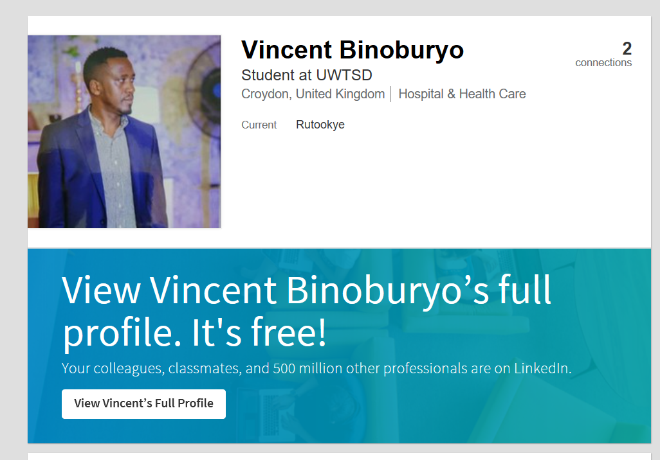

Appendix B



