What is the biggest threat to humanity?

‘Climate change is a long-term change in the average weather patterns that have come to define Earth’s local, regional and global climates.’ (NASA, 2024) ‘Climate change is the biggest health threat facing humanity, the World Health Organization says, estimating that it will cause around a quarter of a million additional deaths each year in 2030-50.’ (World Economic Forum, 2022) I believe that climate change is the biggest threat to humanity because the effects of climate change could potentially lead to humankind to be unable to survive here. The effects of climate change are fatal as ice caps are melting which means hat sea levels will rise however this isn’t the only reason sea levels will rise because when water gets warmer it expands so ‘in 100 years, experts say the global sea level has risen over 7 inches.’(BBC, 2019) ‘Research published in February 2022 shows that sea level rise is accelerating and projected to rise by a foot by 2050.’(Nunez, 2023) the rise in sea levels means that many costal areas, towns and villages could end up being flooded or potentially completely submerged underwater. It is estimated that ‘the world would lose an area of land equal to 1.79 million square kilometres’ (BBC, 2019) The conditions are so bad that ‘in North Wales, one council has already put a plan in place to move all the people from a coastal village in 26 years, or sooner if conditions get worse.’ (BBC, 2019). We have made climate change worse by emitting greenhouse gasses and not reducing our carbon footprint that we may have to adapt to the climate change that is already in place however, we can still stop it from getting any worse.

To try and tackle this issue one thing we can all do to reduce our carbon footprint is drive less as cars emit so many harmful fumes into the atmosphere. This is an easy thing to do as we have all shown through COVID19 lockdowns that we can live without cars even just using public transport is better for the environment. Our COVID19 lockdowns ‘caused a temporary reduction in global greenhouse gas emissions and local air pollution.’ (Met office, 2021)
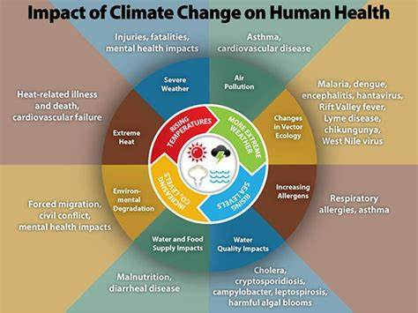

In about ‘1.3 billion years from now humans will not be able to physiologically survive on earth’ (Coffey, 2023) this is due to the rising hot conditions which in about ‘2 billion years the oceans may evaporate’ (Coffey, 2023) by 2500 most of the earth will be uninhabitable and humans could cause extinction to ourselves and other species if we don’t change the way we are living and cut down on our carbon footprint and greenhouse gasses.
(Weiss, 2021)

Bibliography

NASA. (2024) What Is Climate Change? - NASA Science. Available at: https://science.nasa.gov/climate-change/what-is-climate-change/ (accessed: 26/04/2024)

World Economic Forum. (2022) Climate change impacts already 'severe' across the globe | World Economic Forum. Available at: https://www.weforum.org/agenda/2022/09/climate-change-severe-impacts-lives/ (accessed: 26/04/2024)

Nunez, C. (2023) Sea level rise, facts and information (nationalgeographic.com). Available at: https://www.nationalgeographic.com/environment/article/sea-level-rise-1 (accessed: 26/04/2024)

BBC. (2019) Climate change: What impact will rising sea levels have? Available at: https://www.bbc.co.uk/newsround/48352985.amp (accessed: 26/04/2024)

Met office. (2021) How did COVID-19 lockdowns affect the climate? - Met Office. Available at: https://www.metoffice.gov.uk/research/news/2021/how-did-covid-19-lockdowns-affect-the-climate (accessed: 26/04/2024)

Coffey, D. (2023) How long will Earth exist? | Live Science. Available at: https://www.livescience.com/planet-earth/how-long-will-earth-exist (accessed: 26/04/2024)

Weiss, C (2021) Climate Change and Global Health Research at Pitt. Available at: https://www.climatecenter.pitt.edu/news/climate-change-and-global-health-research-pitt (accessed: 26/04/2024)
Most important skills in the acting industry

I think the most important skill in the acting industry is teamwork as the majority of project that you will be working in you will have to be able to work with other actors well because you will need to make group decisions to improve your performance and if you can’t work well the other actors you won’t get employed by any casting directors. ‘By fostering a culture of teamwork and collaboration, directors and producers can increase their chances of producing a successful film’(Guerrilla Wolf, 2024)

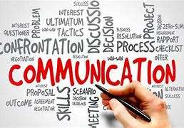
I think another skill you need to work in the industry is communication skills which connects to teamwork as you will need to be able to take criticism and directions from your director, but you will also need to work with the other actors to maintain a clear vision of what everyone is doing so you know your role. You will also need to explain you character choices if the director or anyone else working on the project doesn’t understand them. If you don’t have good communication skills the rehearsal process wont, go as smooth as it should and there would be lots of miscommunication where people may not know what is going on. Overall, ‘acting itself is communication. You have to be a skilled communicator to artfully tell the story you’re performing both for the audience and for your potential scene partner.’ (Pruner, 2024)

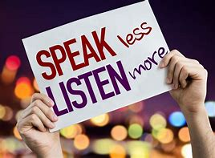
Another skill that is extremely important in the industry is listening skills as this links to communication in terms of if you don’t listen to notes from the director or from other people that are working on the project no one will know what is going on. Listening allows the actor to ‘deeply connect with scene partners and audiences. When actors actively listen on stage, they pick up on subtle cues - a shift in tone, a quickened breath, a telling glance - that reveal volumes about the inner lives of their characters.’ (Genik, 2023) Listening also helps the actors create bonds with each other and it allows them to react to each other during the performance and off stage.

Actors also need basic knowledge in technology as the will need to learn to use an editing software and apps to create show reels to show casting directors to help them gain work. They will also need to learn to use apps such as spotlight and Facebook to show casting agencies and directors who they are and what they can do they will also need to use these apps to maintain contacts they have already made and make new contacts in the industry it will also help casting directors get in contact with the actors. ‘The casting team must coordinate the scheduling, communicate effectively with agents and actors, and manage the influx of audition tapes and actor resumes.’ Actors will also need to take headshots and do self-tapes, so they need a basic understanding of technology. ‘Having a basic understanding of capturing video, editing it, and uploading a self-taped audition for casting to view are necessary acting skills.’ (Pruner, 2024)

Bibliography

Guerrilla Wolf. (2024) Teamwork Makes The Film Work — Guerrilla Wolf. Available at: https://www.guerrillawolf.com/journal/teamwork-makes-the-film-work. (accessed: 16/04/2024)

Pruner, A. (2024) Acting Skills Every Performer Should Have | Backstage. Available at: https://www.backstage.com/magazine/article/acting-skills-to-learn-75028/. (accessed: 16/04/2024)

Genik, D. (2023) The Art Of Listening As An Actor: The Power Of Connection. Available at: https://www.davidgenik.com/blog/the-art-of-listening-as-an-actor-the-power-of-connection. (accessed: 16/04/2024)

Pruner, A. (2024) Acting Skills Every Performer Should Have | Backstage. Available at: https://www.backstage.com/magazine/article/acting-skills-to-learn-75028/. (accessed: 16/04/2024)

Blog 3 – notes

I don’t understand design thinking but what I think it may be is first you have to have a problem then you have to define the problem and
Design thinking is a problem-solving method that includes empathy, define, ideate, prototype, and test and you can develop solutions
Empathy- understanding the problem.
Define- once you know what the problem is you can dive deeper into it and find out what you need to do to solve it
Ideate- in this part you will need to generate ideas to try and solve the problem.
Prototype- you will need to showcase your ideas to try and solve the problem.
Test- you will need to test the prototype to make sure it will solve the problem.
If you can’t get to a solution when you get to the prototype stage you can learn from the prototype to gain new ideas so you can then progress onto the prototype stage to progress further to solve the problem. However, if you get to the test stage and the solution doesn’t work out you can go back to the empathy stage to start from the beginning to generate ideas, or you can go back to the define, ideate or prototype stage depending on what you need to change and what doesn’t work out.

Personally, I would use a different technique such as …… because I find this technique very confusing and I think it could be simplified.

