


School of Applied Computing | Title of Coursework  Software Project Management Tools | Code M4X01498
 | Module Academic Writing
Student: Theresa Darzins  Student number: 1909721 |  | Lecturer:John Rees  Date: April 2020

Table of Contents
1 Introduction 1
1.1 Aims 1
2 Background 2
2.1 History of Project Management 2
2.2 What Project Management Entails 2
2.3 The Project Manager’s Role 2
2.4 Project Management Methods 2
2.4.1 Classic 2
2.4.2 Waterfall 2
2.4.3 Agile 3
2.4.4 Rational Unified Process (RUP) 4
2.4.5 PERT (Program Evaluation and Review Technique) 4
2.4.6 Critical Path Technique 5
2.4.7 Critical Chain Technique 5
2.4.8 Extreme Project Management (XPM) 6
3 Evaluation of the 5 Best Project Management Software Tools in 2020 7
3.1 Monday.com 7
3.2 Wrike 7
3.3 Mavenlink 7
3.4 Smartsheet 7
3.5 Jira 7
4 The Most and Least Useful Software Features 8
4.1 Table 1 - The Top 70 Tools in Decreasing Order of Level of Usage: 8
4.2 Table 2 - Tools With The Highest and Lowest Intrinsic Value 9
4.3 Table 3 - The 20 Most Useful PM Practices by Group of Process and Areas of Knowledge 10
5 Comparison of Top Two Project Management Software Tools: Monday.com vs Wrike 11
5.1 Features 11
5.1.1 monday.com 11
5.1.2 Wrike 11
5.2 Price 12
5.2.1 monday.com 12
5.2.2 Wrike 13
5.3 Ease of Use 14
5.3.1 monday.com 14
5.3.2 Wrike 16
5.4 Security & Privacy 16
5.4.1 monday.com 16
5.4.2 Wrike 17
6 CONCLUSION 18
7 REFERENCES 19
8 PLAN 20

Introduction
This dissertation lists software available, and ranks how useful their various tools are.

Aims
To give an overview of project management, list software tools available, rank popularity, and list features most/least used. The goal is to compare the top two software tools, to conclude which best, and why.

Background

History of Project Management
[1] Frederick Taylor devised a set of concepts to apply to enable smarter working with less inefficiencies, and Henry Gantt, his associate, took those ideas and applied them to bar charts to show when tasks were completed. This was later used in WWII by the military to show critical path planning. It spread to manufacturing and in 1965 and 1969 the International Project Management Association and Project Management Institute were founded. By 2001 the Agile Manifesto had been created to codify methodologies; the 5 stages of Project Management being: initiating, planning, executing, monitoring and closing.

What Project Management Entails
Predictable planning and execution, keeps team to budget, schedule and scope guidelines, resolves road blocks and identifies/escalates problems faster. It also terminates projects that don’t hold value, improves co-operation identifies and plans for risks.

The Project Manager’s Role
Plot a realistic course, assemble teams of specialists, assign defined tasks to each specialist, lead the team, gaining status updates, clearing roadblocks, negotiating disputes, keeping morale up, and training staff. Also, managing budgets and timelines whilst maintaining schedule and engaging Stakeholders.

Project Management Methods
[2]

2.4.1 Classic
Traditional; plan work, estimating tasks, allocating resources, giving and receiving feedback, monitoring quality and deadlines. Suits small teams when unnecessary to go into complex processes.

2.4.2 Waterfall
Sequential undertaking of tasks. Next phase commences when previous one finishes. Used for complex projects.
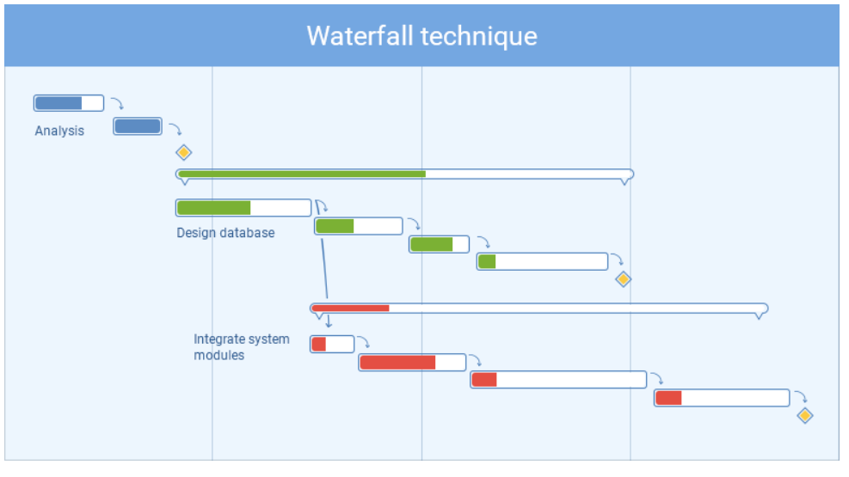

2.4.3 Agile
Value-centric, separating project jobs into sectors, using adaptive plans and lessons learnt. Good for projects that have repetitive tasks done by small teams.
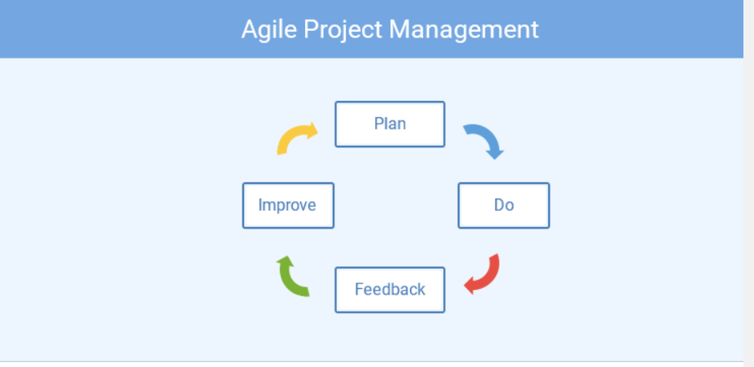

2.4.4 Rational Unified Process (RUP)
Recommends implementing frequentative development process, where feedback from users is taken into consideration for planning future development.

2.4.5 PERT (Program Evaluation and Review Technique)
Complex planning. Analysis of tasks performed within the project. Developed by US Navy during the Cold War. Best for large long-term projects with non-routine tasks and challenging requirements.
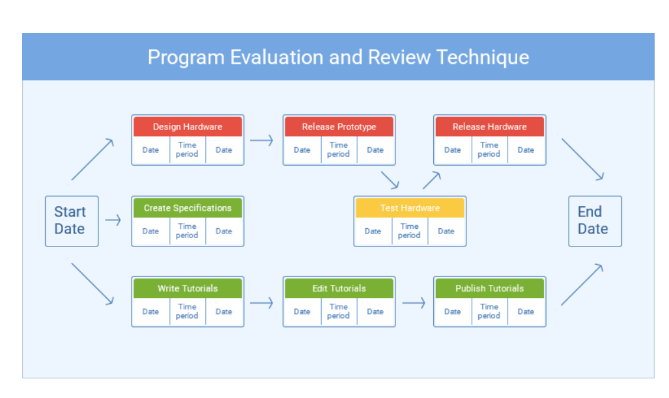

2.4.6 Critical Path Technique
Used in tandem with PERT. Involves finding the longest path from start to finish. Used for complex projects; defence and software development.

2.4.7 Critical Chain Technique
Combining PERT and Critical Path. Less focused on rigid task order and scheduling, flexible in resource allocation. Used in complex projects where resources are limited.

2.4.8 Extreme Project Management (XPM)
Emphasizes flexibility, open approach, reduces formality. Used for large, complex fluid projects.
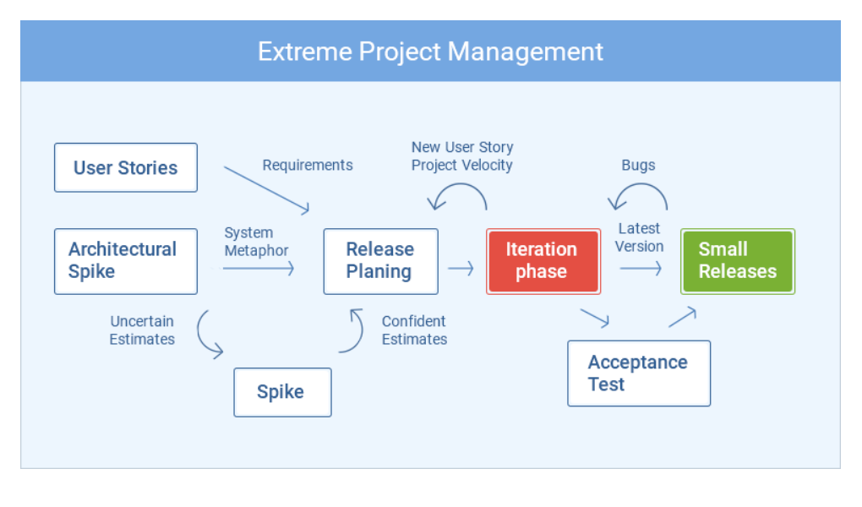

Evaluation of the 5 Best Project Management Software Tools in 2020
[3]

Monday.com
Visual, enables teams to meet deadlines and builds transparency showing what everyone working on. Flexibility key.

Wrike
Powerful tracking, collaboration and reporting. Customisable dashboards, dynamic request forms. Customisable workflows, fields and folder structures enabling flexibility. CRM messaging and accounting.

Mavenlink
Shows project performance to control budget/timelines. Role-based estimating and business intelligence. Reports on performance trends, problem areas, and upcoming needs.

Smartsheet
Real-time work and strong project management features enabling teams to switch from Gantt, card, grid and calendar views.

Jira
Used to plan, track and release software by agile teams. As part of Atlassian integrates with many tools enabling teams to manage projects end to end.

The Most and Least Useful Software Features
[4]

Table 1 - The Top 70 Tools in Decreasing Order of Level of Usage:
1 | Progress Report | 27 | Critical path method analysis | 53 | Bidders conferences
2 | Kick-off meeting | 28 | Bottom-up estimating | 54 | Learning Curve
3 | PM Software to task Scheduling | 29 | Team member performance appraisal | 55 | Parametric Estimating
4 | Gantt chart | 30 | Team building event | 56 | Graphic presentation of risk information
5 | Scope Statement | 31 | Work authorisation | 57 | Database of contractual commitment data
6 | Milestone Planning | 32 | Self-directed work teams | 58 | Life cycle cost (LCC)
7 | Change Request | 33 | Ranking of risks | 59 | Probabilistic duration estimate (PERT)
8 | Requirements analysis | 34 | Financial measurement tools | 60 | Quality function deployment
9 | WBS (Work Breakdown Structure) | 35 | Quality plan | 61 | Value analysis
10 | Statement of Work | 36 | Bid documents | 62 | Database of risks
11 | Activity list | 37 | Feasibility study | 63 | Trend chart or S-curve
12 | PM software to monitoring schedule | 38 | Configuration review | 64 | Control charts
13 | Lessons Learned/Post-mortem | 39 | Stakeholder analysis | 65 | Decision tree
14 | Baseline plan | 40 | PM software for resources levelling | 66 | Cause-and-effect diagram
15 | Client acceptance form | 41 | PM software to monitoring of cost | 67 | Critical chain method and analysis
16 | Quality inspection | 42 | Network diagram | 68 | Pareto Diagram
17 | PM software for resources scheduling | 43 | Project communication room (war room) | 69 | PM software for simulation
18 | Project charter | 44 | Project Web site | 70 | Monte-Carlo analysis
19 | Responsibility assignment matrix | 45 | Bid/seller evaluation
20 | Customer satisfaction surveys | 46 | Database of historical data
21 | Communication plan | 47 | PM software multi-project scheduling/levelling
22 | Top-down estimating | 48 | Earned value
23 | Risk management documents | 49 | PM software Cost estimating
24 | Contingent plans | 50 | Database for Cost estimating
25 | Re-baselining | 51 | Database for lessons learned
26 | Cost/benefit analysis | 52 | Product breakdown structure

Table 2 - Tools With The Highest and Lowest Intrinsic Value
 | Highest |  | Lowest
1 | PM software for task scheduling | 1 | Life cycle cost
2 | Progress report | 2 | Graphic of risk information
3 | Scope statement | 3 | Parametric estimating
4 | Requirements analysis | 4 | Learning curve
5 | Kick-off meeting | 5 | Quality function Deployment
6 | Gantt chart | 6 | Value analysis
7 | Lesson learned/post-mortem | 7 | Trend chart or S-curve
8 | Change request | 8 | Critical chain method and analysis
9 | PM software monitoring schedule | 9 | Control charts
10 | Work breakdown structure | 10 | PERT analysis
11 | Milestone planning | 11 | Cause-and-effect diagram
12 | Statement of work | 12 | PM software for simulation
13 | PM software resources scheduling | 13 | Pareto diagram
14 | Risk management documents | 14 | Decision tree
15 | Activity list | 15 | Monte Carlo analysis
16 | Quality inspection
17 | Baseline plan
18 | Contingency plans
19 | Ranking of risks
20 | Client acceptance form

Table 3 - The 20 Most Useful PM Practices by Group of Process and Areas of Knowledge
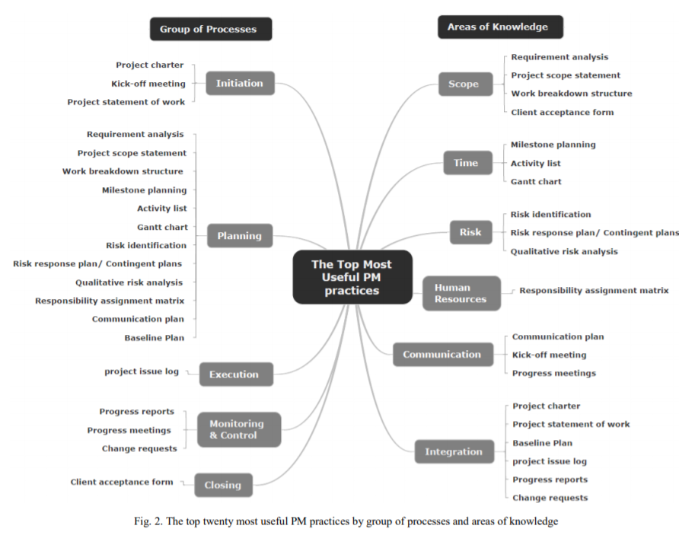

Comparison of Top Two Project Management Software Tools: Monday.com vs Wrike
[5]

Features

monday.com

Although monday.com good at task management, and allows customization, it lacks subtasks/dependency management.

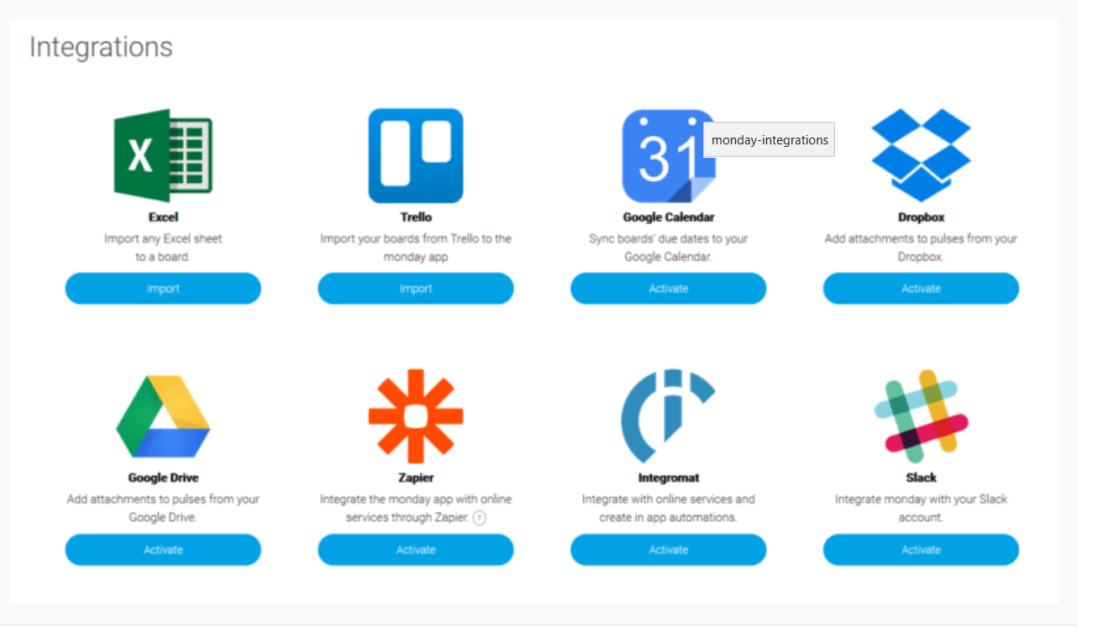

Wrike
Wrike has a multitude of features allowing dependency management and subtasks. This helps to pinpoint bottlenecks and plan around them, therefore, Wrike is better. It is also more usable for file sharing due to larger attachment limit.

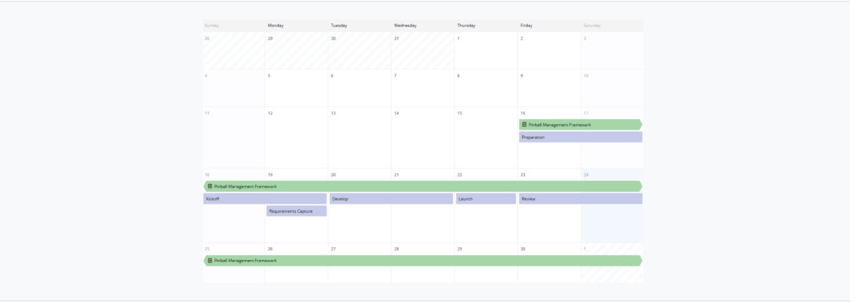
Different views are available: a stream, a calendar view and spreadsheets as well as time tracking and Gantt.
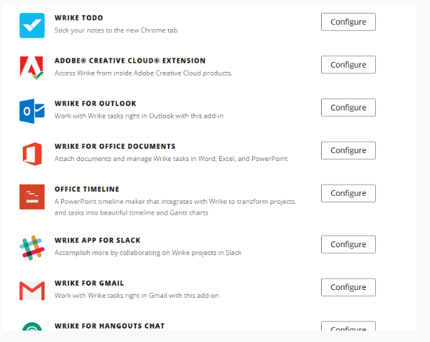
Wrike allows integrations with Slack, Microsoft Outlook and Adobe Creative Cloud. Also works with Zapier, letting you connect to data in wider selection of apps.

- Features: Point for Wrike (good for dependencies and subtasks)

Price

monday.com
monday.com’s prices are for groups of five. No free tier, but it has a fortnight, card-free trial.
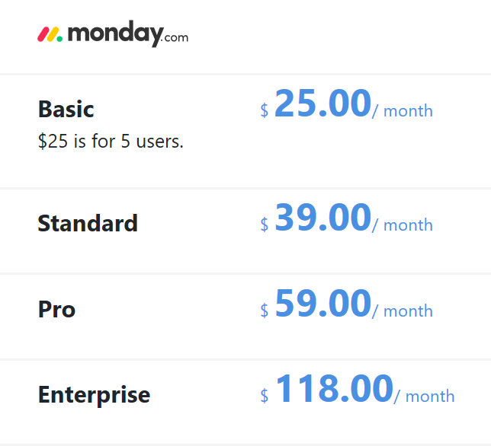
Although no free tier, monday.com are two or three times cheaper on their top plans than Wrike.

Wrike
It has a free tier but this is very limited. Subtasks and Gantt charts require a paid plan and calendars unlock at the Business tier.
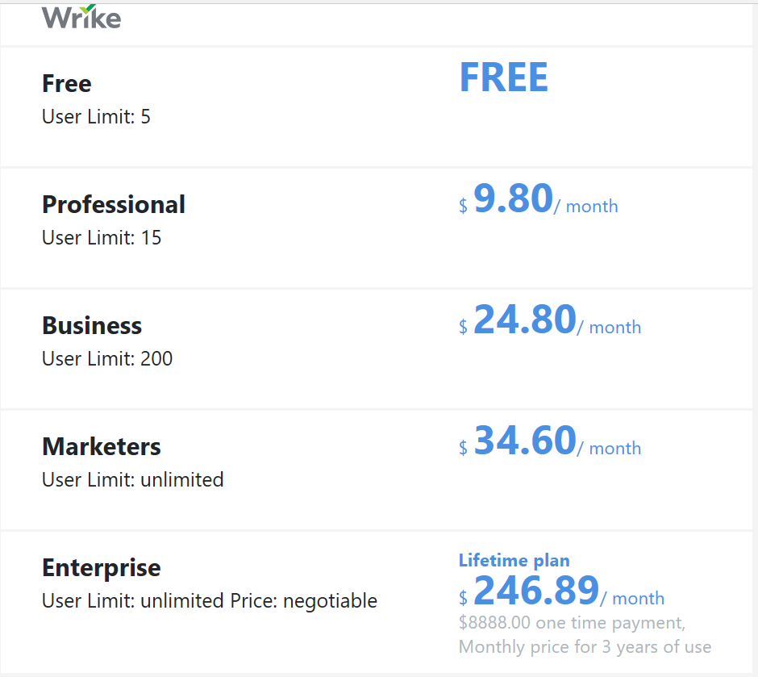
- Price: Point for monday.com (pricing lower)

Ease of Use
This is monday.com’s best area, but Wrike’s weakest.

monday.com
Easy to sign up and choose a template with animated guidance. The use of colours and clear intuitive steps makes it enjoyable to use.
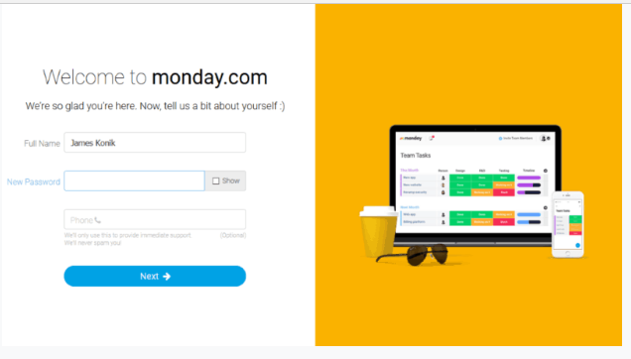
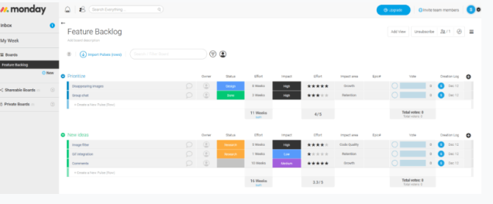
Support is fast and help material available.

Wrike
Wrike has a sign-up process that allows user to email team members to join the platform.
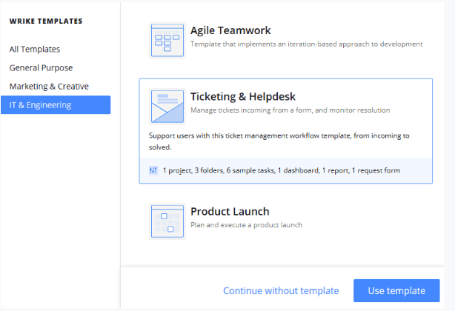
Dependency management is easy to get working.
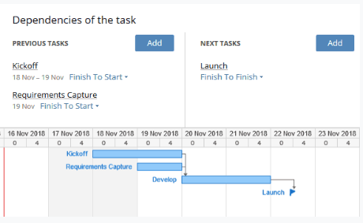
Wrike’s interface is not simple to use, but has excellent support.
- Ease of Use: Point for monday.com (intuitive colour, bold titles)

Security & Privacy
Both platforms are equally strong.

monday.com
Encryption – TLS v1.2 for data in transit and AES 256-bit for storage is feature. Complies with the General Data Protection Regulation and EU-U.S. Privacy Shield. Also has SOC and ISO certifications.
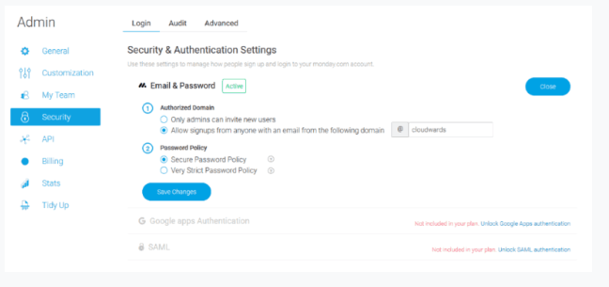

Wrike
Wrike offers two-factor authentication via the Google Authenticator app. Matches monday.com in encryption, with TLS v1.2 and AES 256-bit. Also in its ISO and SOC certifications and compliance with the GDPR and EU-U.S. Privacy Shield. Auditing same as monday.com’s.

- Security and Privacy Draw (equal)

CONCLUSION

Monday.com’s ease of use made it the overall favourite. Neither were expensive, but despite ‘sub dependencies and subtask’ advantages, Wrike’s lack of accessibility let it down (harder to learn).

- Features | - Cost | - Ease of Use | - Security | Points
Wrike |  |  | Wrike | 2
 | monday,com | monday,com | monday,com | 3
One Point Per Category
Although both applications offer equally useful features, Wrike also has ‘dependency management and subtask’. It is a pity Wrike was not as user-friendly as monday.com. Ease of use trumps Wrike’s extra features, as monday.com’s widespread use proves. First rule in computing KISS (keep it simple stupid) applies.

Word Count 1,500

REFERENCES

[1] | Project Management Basics (2020). Available at wrike.com/project-management-guide/project-management-basics/ Accessed on 20 February, 2020
[2] | Project Management Tools and Techniques (2020). Available at actitime.com/project-management/project-management-tools-and-techniques/ Accessed on 20 February, 2020
[3] | Santos, J.M.D. (2020). Top 10 Software Tools in Project Management. Available at https://project-management.com/top-10-project-management-software/ Accessed on 18 March, 2020
[4] | Fernandes, G., Ward, S. and Araújo, M. (2013). Identifying Useful Project Management Practices: A Mixed Methodology Approach. International Journal of Information Systems and Project Management Volume 1, No. 4, 2013, 5-21
[5] | Konik, J. Monday.com Vs Wrike Two Big Names Battle in 2020 (2020). Available at https://www. cloudwards. net/monday-com-vs-wrike/ Accessed on 17 March, 2020

Plan/Methodology
Gantt Chart
 | TASKS  one week allocated per Task | Week  No. | Week Ending Fri | Completed
1 | Decide upon Project | 1 | 14/02/20 | X
2 | Research | 2 | 21/02/20 | X
3 | Compose Question to Answer | 3 | 28/02/20 | X
4 | Organise Structure to Show Steps Towards Answering | 4 | 06/03/20 | X
5 | Slot Research into Appropriate Sections | 5 | 13/03/20 | X
6 | Come to a Conclusion | 6 | 20/03/20 | X
7 | Complete References | 7 | 27/03/20 | X
8 | Submit Draft for Comment | 8 | 03/04/20
9 | Make Alterations as Necessary | 9 | 10/04/20
10 | Submit Final Report via Turnitin | 10 | 17/04/20
11 | DEADLINE THURSDAY (contingency is 6 days) | 11 | 23/04/20
Key:
Black – Complete
Blue – In Progress
Red - Deadline

