Computer Architecture

Student name: Andrei-Daniel Mihai
Student ID: 1912494
Lecturer: Anupam Mazumdar

Table of contents.
Scenario 1…...…………………………………………………………………………. 2
  - Motherboard …… ..……………………………………………………………….. 2
  - CPU ……….………………………………………………………………………. 5
  - RAM Memory …………………………………………………………………….. 6
  - CPU Cooler ..……………………………………………………………………… 7
  - Hard Drive ………………………………………………………………………….8
  - Computer Case and Power Supply ………………………………………………... 8
  - Headphones and Speakers…………………………………………………………. 9
  - Keyboard and Mouse ……………………………………………………………… 9
  - Monitor Screen …………………………………………………………………….10
Scenario 2 ……………………………………………………………………………...11
2.1 Motherboard………………………………………………………………………..11
2.2 CPU………………………………………………………………………………...11
2.3 RAM Memory ……………………………………………………………………..12
2.4 Graphic Card ………………………………………………………………………12
2.5 Hard Drive ………………………………………………………………………....13
2.6 Tower……………………………………………………………………………….13
2.7 CPU Cooler…………………………………………………………………………14
2.8 Power Supply Unit …………………………………………………………………15
2.9 Monitor Screen ……………………………………………………………………..17
2.10 Keyboard and Mouse ……………………………………………………………..18
3.0 Additional Storage Unit ……………………………………………………………18
References ……………………………………………………………………………...20

Scenario 1.
For this task we need to create a PC for our elderly relative. We don’t need to use expensive computer parts, because it will be used only for recreative reasons, like YouTube videos, Skype calls, emails and Microsoft Office.
Following those requirments, we will use the following components:
Asus B360- Plus intel B360(Socket1151) DDR4 ATX MOTHERBOARD - 86£.
Intel Core i3-8100 Processor – 90£.
RAM memory DDR4 PC4-21300 2666MHz 288-pin DIMM , 8GB – 19£.
Artic Alpine 12CO- CPU cooler for Intel socket – 8£.
CiT Classic Mid Tower PC case with 500W PSU – 29£.
Seagate 500GB Hard Drive – 18£.
Acer K222 HQLBID 21.5 inch LCD monitor – 79£.
Asus U2000 wired keboard and mouse – 13£.
Logitech speaker – 22£.
Trust Primo Chat headset for PC – 7£.
Now, after we named all our components (which summed 367£ for the whole machine) we will see the reason why those and no other components.
1.1 First of all, Motherboard – According to Overclockers UK, this Asus motherboard has a variety of technical innovations. Has 6 SATA slots 3.5inch and 2.5 inch for hard drive unit. Has excellent options for external connections like, 3.1 and 2.0 USB ports. Will support 8th generation Intel Core (i7, i5, i3). When it comes to RAM memory, has 4 DIMM that will support 64GB of RAM DDR4 2666/2400/2133 MHz. The last part, the onboard graphic card, which is very useful for us, being said that this PC will serve for web browsing, skype calls and YouTube videos, which will not necessitate more than that.
I will attach print screens in Fig1. Fig2. And Fig3. With more specs about the motherboard.
Fig1.
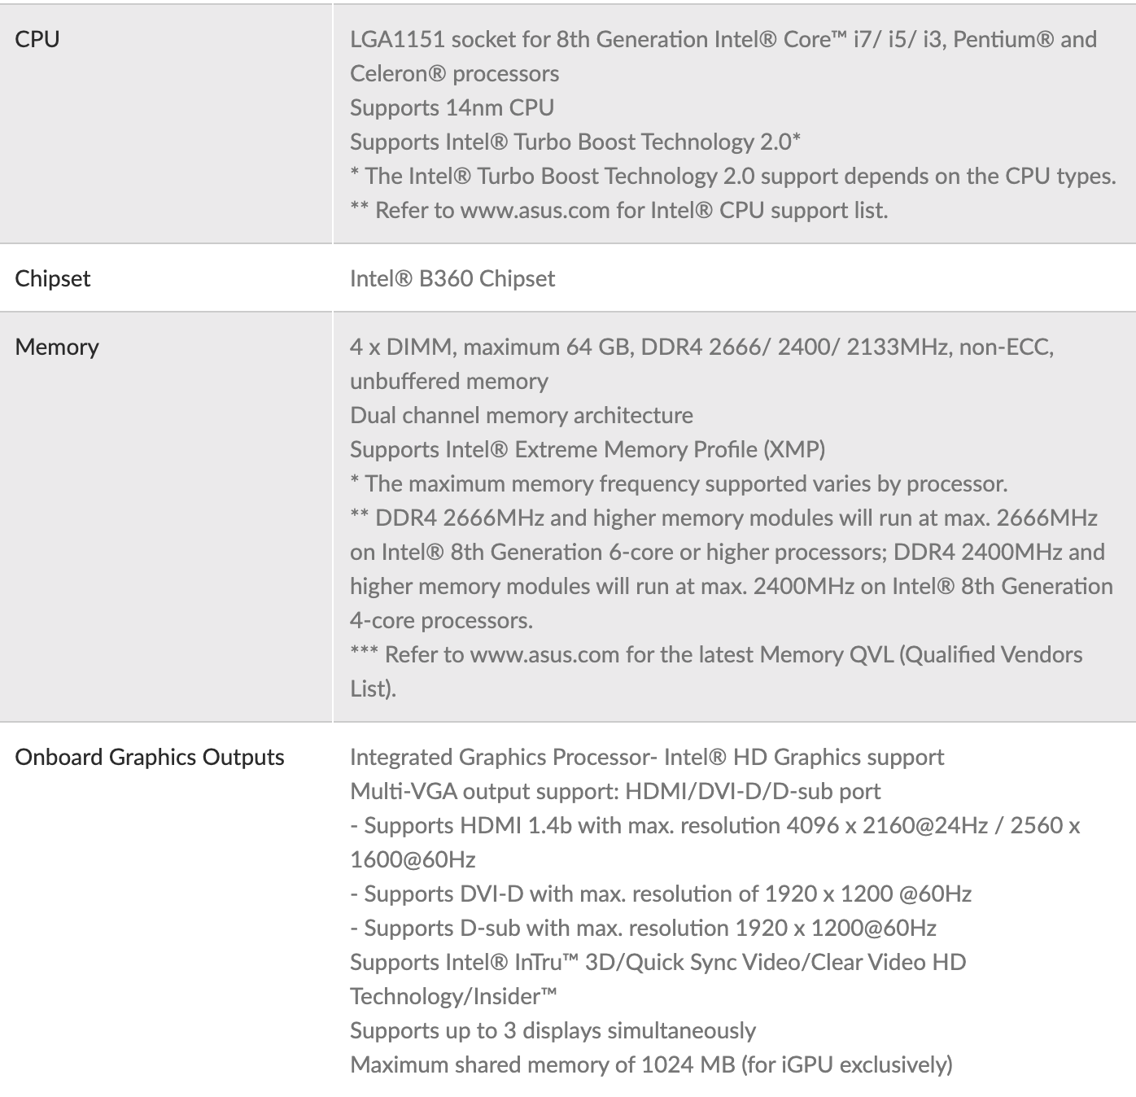

Fig2.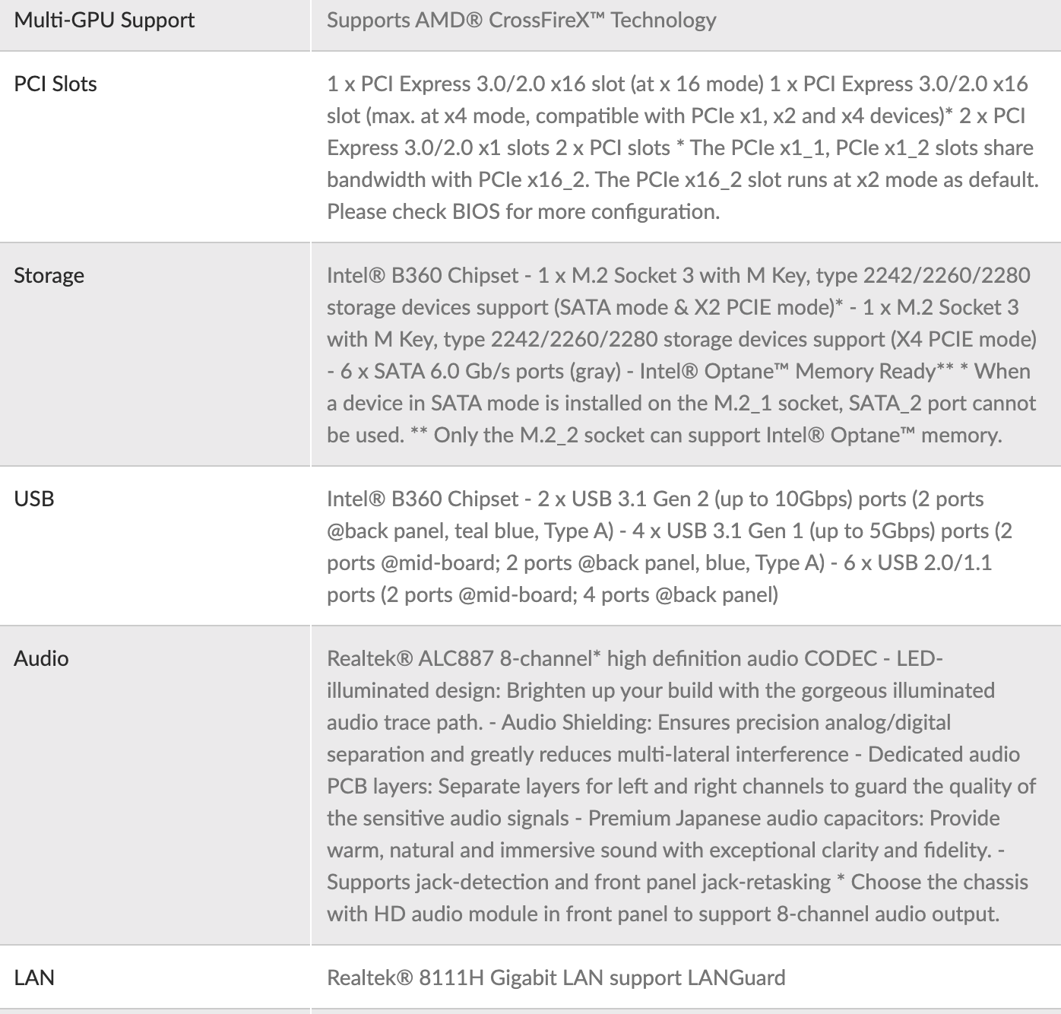
Fig3.
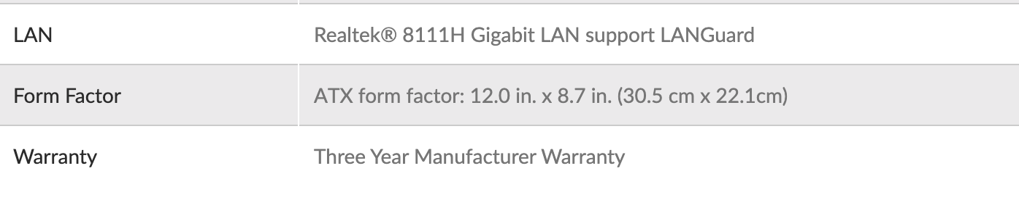

1.2 After motherboard comes the CPU, also a very important part of our computer. On this scenario, I used a i3 processor (Intel Core i3-8100 Quad Core) from Intel.
Why?
Reason is simple. Was design for easy use, it is strong and durable and has a graphic base frequency and like motherboard supports 64Gb of RAM memory.
Another reason why we didn’t used a more powerful CPU like i5 or i7 knowing that our motherboard can support it, is just because we don’t need it. It will be a waste of money and power. Imagine you will fix a Ferrari engine on a FIAT car.
In the Fig4. table you will see all the spec of this CPU.
Fig4.
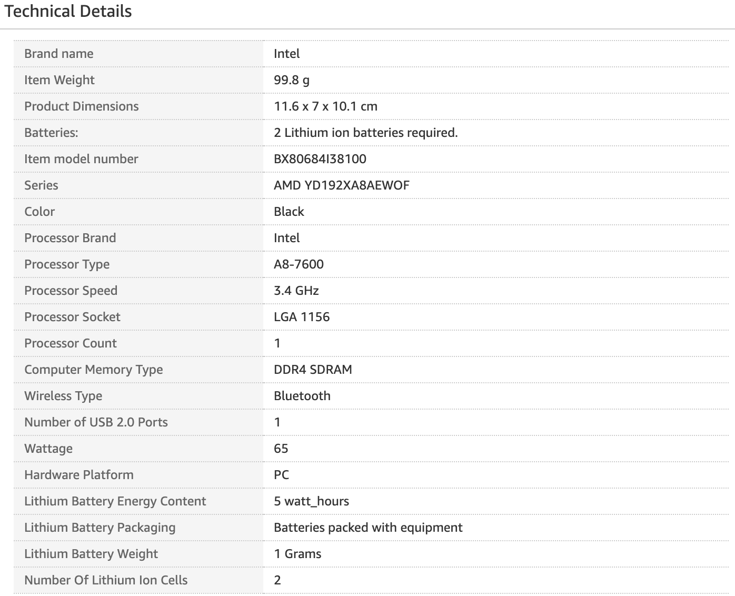

1.3 RAM Memory – Why do we need RAM Memory?
The more RAM memory it is accessible to our CPU, the easier his jobs becomes. But in our scenario, I think that 8GB of RAM should be enough. Remember this is not a programming or video editing use PC. We will not use some complicated RAM, we will use DDR4 pc4 – 21300 2666Mhz 288-pin. Also, this will come with lifetime warranty which help us in the future if we need to improve or add extra RAM memory to our PC.
Bellow in Fig5 we will see the specification of the RAM memory.
Fig5.
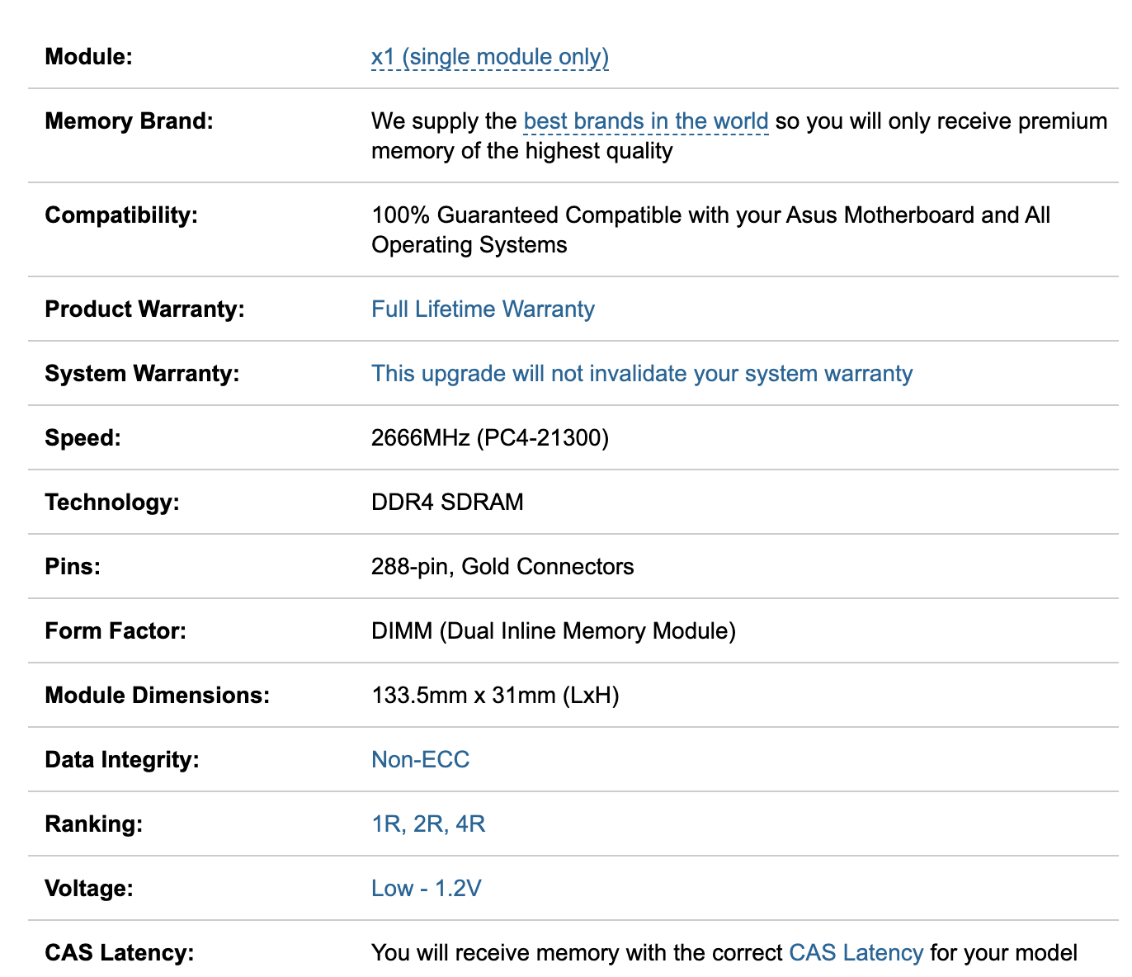

1.4 For the CPU to get cooled and work in normal parameters we need a CPU fan COOLER. We have got for our computer ARCTIC Alpine 12 CO – CPU Cooler for Intel Sockets , up to 100 watts.
This CPU Cooler is very silent, has dual ball bearing, comes with MX-2 thermal paste, it is easy to clean and easy to install. In Fig.6 we can see the cooler specs.
Fig.6 Cooler Specs.
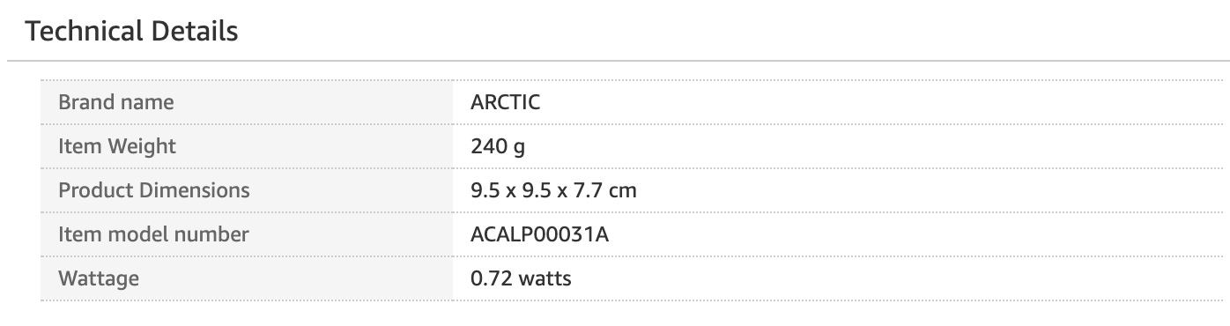
1.5 Hard Drive – Is the place where we save our files, pictures, memories, etc. Knowing that one of purpose of this computer will be, videocalls with relatives from overseas, we thought that maybe we can save some pictures that are been sent to us. So that’s why we choose Seagate 500GB hard drive. It has enough space for pictures files and Windows updates, has 16MB Cache and a SATA interface. And the price of it was only 18.95£ comparative with other hard drives on the market, which makes it more accessible.
Fig.7 will have all the specs.

Fig.7

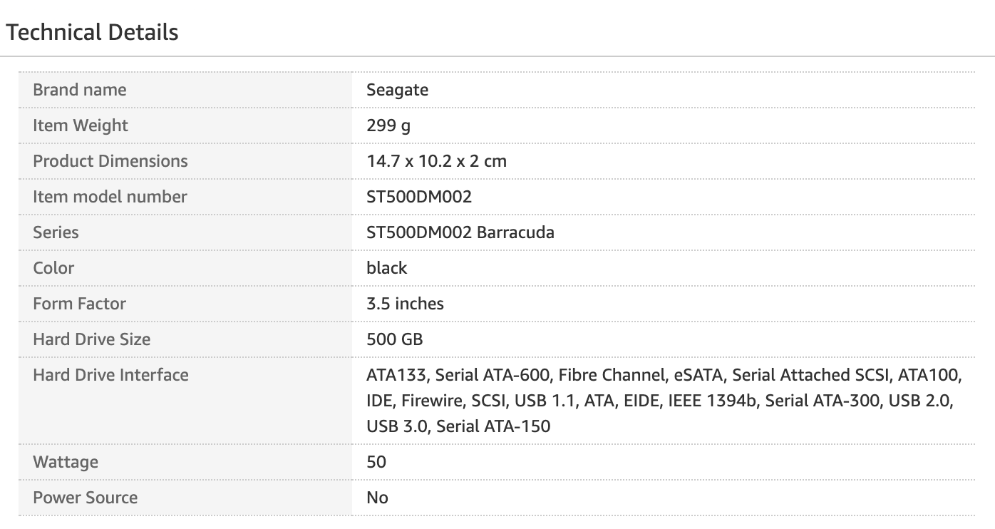
6 X 3.7 GHZ - TURBO 6 X 4.6 GHZ) - COFFEE LAKE
1.6 CiT Classic Mid Tower with PSU of 500W – this is our computer case, who will help us to keep all our components from above all together. The good part is, that this tower comes with a PSU included which will save us some money and some time looking for one. Also is equipped with two 2.0 USB and two 3.0 USB port and can support an extra 80mm fan.
In Fig.8 we see the features of this tower.

Fig.8

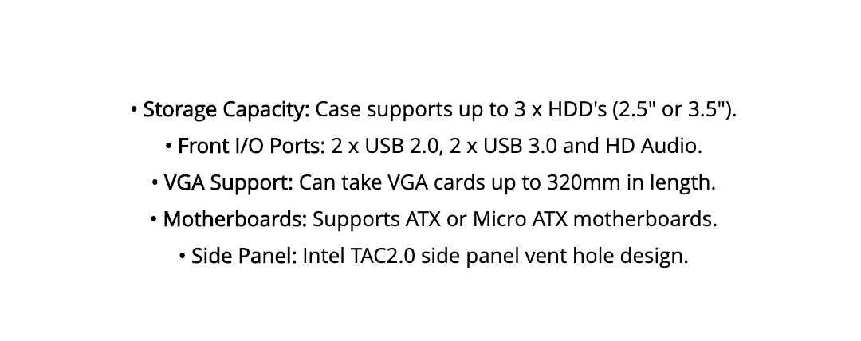

1.7 We have our computer tower, but we still have some missing parts, like a monitor screen, a keyboard, some speakers and let’s not forget about the headphones and mic, video camera.
I’ll start with the headphone. For the headphones and mic, we have Trust Primo Chat Headset. Why them? First of all accessible price, light weight, has an adjustable microphone ideal for skype calls or watching YouTube videos without disturbing the others.
Now you might ask yourself why we decided to have some speakers if we had the headset. The answer is simple. Let’s say we want to enjoy some nice music, but we don’t want to sit in front of the computer. For the speakers we decided to have Logitech Z150 compact multimedia stereo speakers. Has stereo sound that will deliver 3 watts of clear-sound, compatible with all 3,5mm audio input, easy to control and they have a compact design.
1.8 For mouse and keyboard, we have Asus U20 b00 keyboard and mouse – this is a mouse and a keyboard I don’t know what to say about them then, comfortable to use, they are wired so no need to be worried about batteries (for the wireless one) and we manage to find this bundle on a very small price.
1.9 Last part of our computer, which is important like the other components from above is the monitor screen. We have the Acer K222HQLBID 21.5 inch FHD LCD monitor.
It has a full resolution of 1920 x 1080 full HD, smart design, easy to use and high-quality image. Also come with Acer Comfy View technology, which will eliminate the light reflection.
In the bellow figure we can see the specs of the monitor screen.
Fig.9

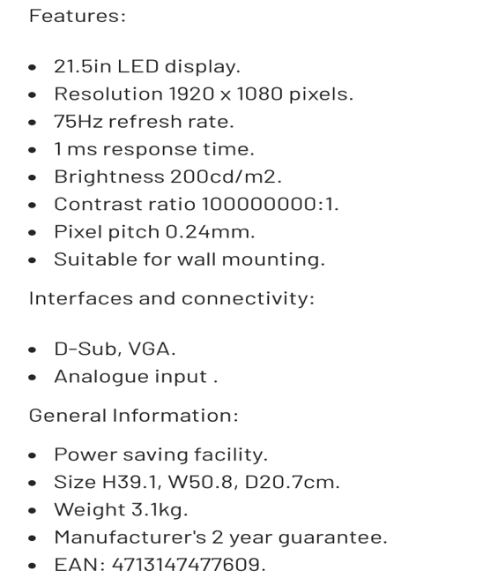

Scenario 2.

For the scenario no.2 we need to build a computer for our friend who tries to build up his own company, producing and editing 4K video content, using advance software programs.
We have a budget of approximately 2500£.

For this computer, I chose the following components:

2.1.Motherboard – ASUS ROG Strix Z390-F Gaming LGA 1151 ( who can support 8th and 9th CPU generation).
I chose this motherboard because it can support a powerful CPU i9 9th generation , has a relatively good price , support 128GB of RAM memory (more RAM memory having in your computer, better and easier the job for the CPU becomes) and of course cooling part. You can install a water and fan cooling which is very important to prevent your components from overheating.
The price for this motherboard is 205£ including the thermal paste for the CPU.
Bellow in the Fig.1 are the specs attached.

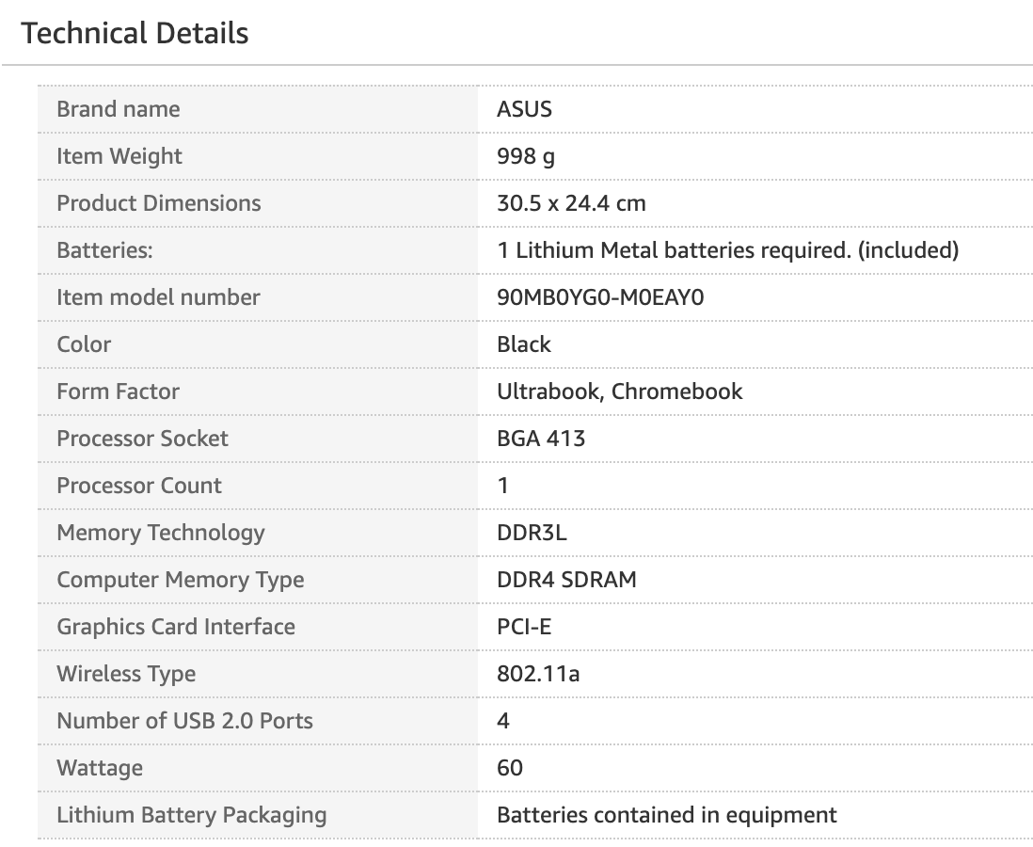

2.2.Central Processing Unit (CPU) – Intel Core i9-9900K (8 Core, 3.60GHz, 16Mb Cache).
This CPU is the new generation with high specs and very powerful. It is built with STIM ( solder thermal interface material) to help maximize heat transfer from the processor to the cooler. It is ideal for 4K videos editing due to the overclocking who will push the system to further.
The only down part of this CPU, is the compatibility with Motherboards based on Intel 300 Chipsets. Overall it is what we need for our system.
The total price for the CPU is 348£.
Bellow in the Fig.2 we have the specs details.
Fig.2
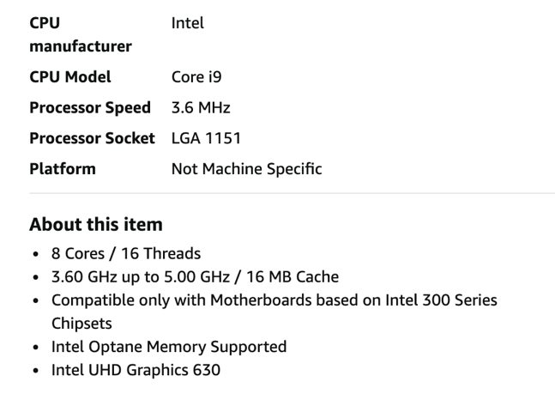
2.3.RAM memory- Corsair Vengeance LPX 128GB (4x32GB) DDR4 2666.
What can we say about RAM memory? We need a decent amount of RAM for our CPU to have a good performance. Knowing that our friend will use his PC for 4k video editing and try to run other software programs in the same time, I consider that 128GB (and that is the maximum that our CPU and Motherboard can support) is more then enough.
Why Corsair Vengeance ? It has a high-performance overclocking (each individual part is made from aluminium so it helps for a faster heat spread). Has a high frequency , great band width and has a lower power consumption.
Bellow in Fig.3 we can see the specs of the RAM.

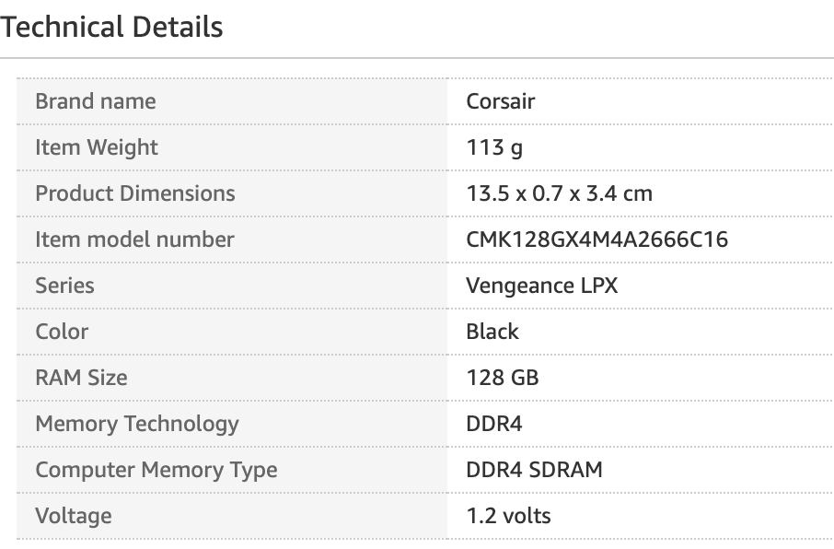
2.4.Graphic Card- GEFORCE RTX 2070 SUPER GAMING OC 3X 8192MB GDDR6 PCI-EXPRESS GRAPHIC.
This graphic is all we need! Comes with 3 fan coolers , has support for NVIDIA NVLink who will combine two similar GPU and GeForce RTX NVLink Bridge which will deliver to us an ultimate experience in 4K videos and VR.
Has integrated 8GB GDDR6 256-bit memory interface and a core clock:1815 MHz.
Another good part is that our friend will run a business and this graphic card will come with a 4years guaranty which will help him saving some money.
See the specs bellow in Fig.4.

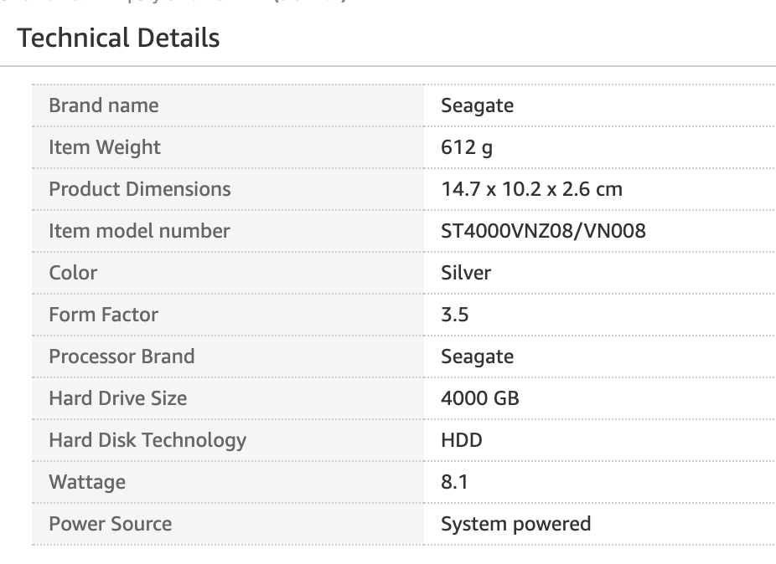

2.5 Hard Drive – Seagate 4TB IronWolf 3.5 , NAS System (5900RPM, 64MB CACHE, )
Knowing that the PC will be used for 4K video editing, we took in consideration the need of storage space. So, we chose this Seagate 4TB hard drive. It is built to be compatible with NAS operating systems which will monitor the drive health. It has 180TB workload per year, which is good for a busy multi-user environment, allowing you to upload more data into hard drive and NAS.
Specs are bellow in fig.5.

2.6.Tower – CiT C100 Mesh Tempered glass ATX MiDi Tower Case.
Thinking of a high pressure and heating that will set on the internal components of our system, we chose a CiT 100 Mesh tower case.
The reasons are simple; has a massive cooling capabilities, being able to attach up to 9 fans which maximize the airflow inside the tower. It has a removable dust filter, which will help you easily to maintain your internal part of the system. Has a nice functional design making it easy to set up your system. Comes with one 3.0 USB and two 2.0 USB ports. Down part of this tower is that PSU is not included.
Please see the specs bellow in fig.6
Fig.6
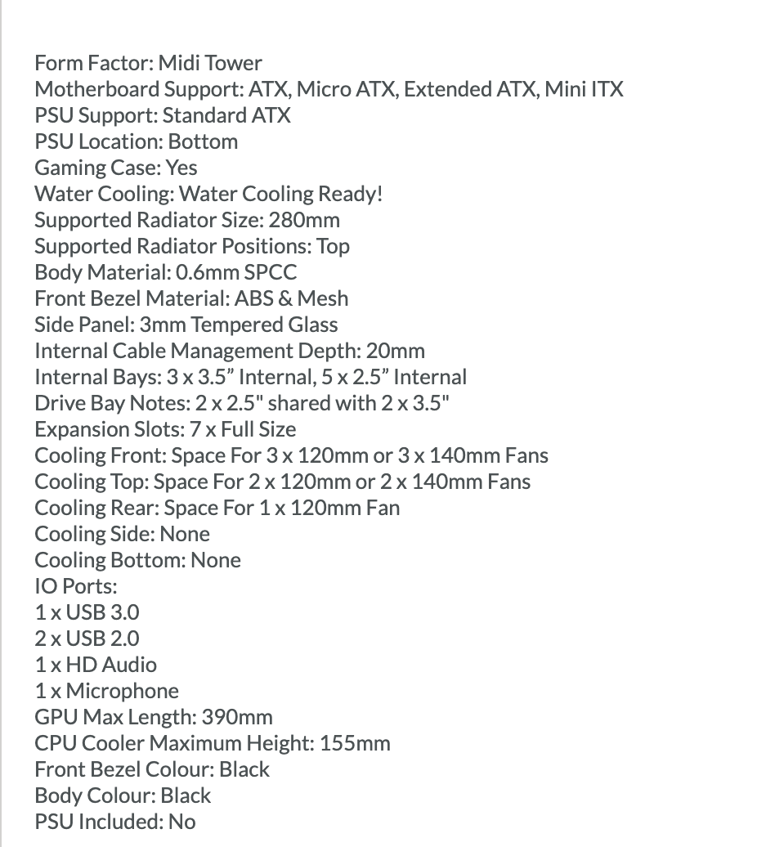

2. 7. CPU liquid cooling system – Corsair Hydro 100i RGB Platinum.
Cooling system is very important for any electronic device, especially for computers when every second, electric impulse are flowing through your components.
Knowing that the CPU is doing most of the job for your computer, you need to keep it as cool as possible, to avoid overheating which will lead to your computer to crush or in the worst scenario, you CPU to get burned. That’s why we use thermal paste and fan coolers or with the new generations of more powerful and performant CPU’s liquid cooling radiator.
Corsair Hydro 100 has two 120mm fans that will run from 400 to 2400RPM, which will cool down your CPU. Being thermal optimized cold-plate and low-noise pump is design to give you a high performance low noise experience.
See spec bellow in fig.7 .

Fig.7
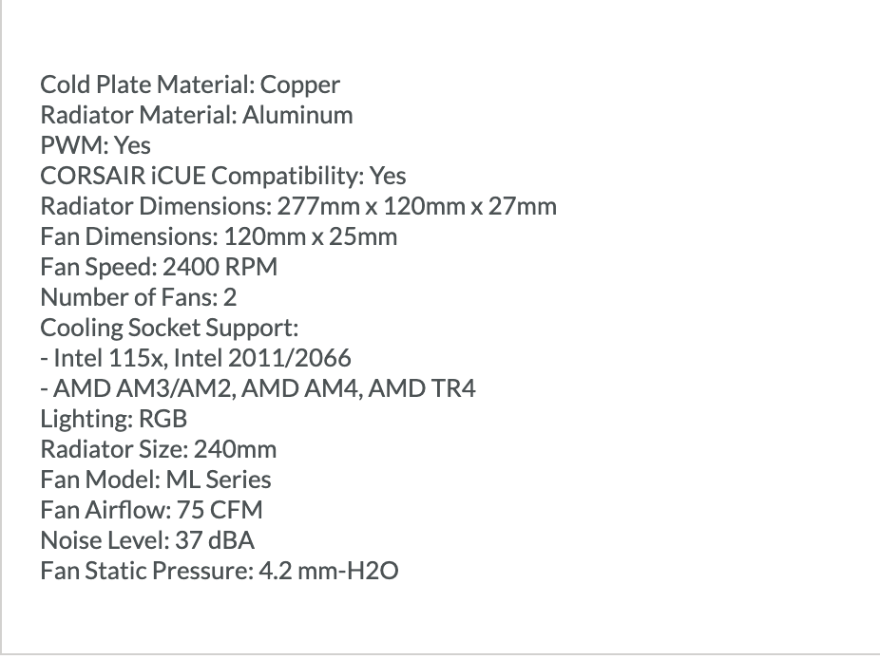

2.8. Power Supply Unit (PSU) – EVGA 600 watts 80PLUS wired ATX PSU/ Power supply.
For our system we will use EVGA 600 Watt 80 Plus wired ATX PSU to keep all our components powered up. This PSU, is very ergonomic which means will not occupy much space and supply enough power (600 watts). It is equipped with a silence Auto Fan, which will not disturb you on your daily operations. Has a built in protection so is ready for heavy-duty operations especially with your NVIDIA graphic card. Also, another plus comes with 3 years guaranty.
Bellow in Fig.8 we have the specs.

Fig.8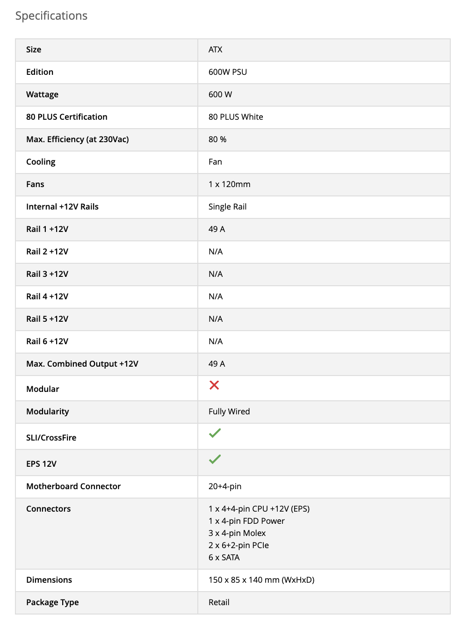

2.9. Monitor – Samsung LU28E570 28” UHD 4K Monitor – Ultra HD 3840x2160, 2 HDMI port , Display Port.
Our system is built to perform 4K video editing so we choose a 4K monitor screen who will help us to do so. This Samsung comes with a wide and generous 28” screen, a 8 milion pixels boost. Also has a fast respond time without motion blur. Connectivity is done by one 1.2 Display Port and two HDMI Ports.
In Fig.9 we can see the specs of this monitor.

Fig.9

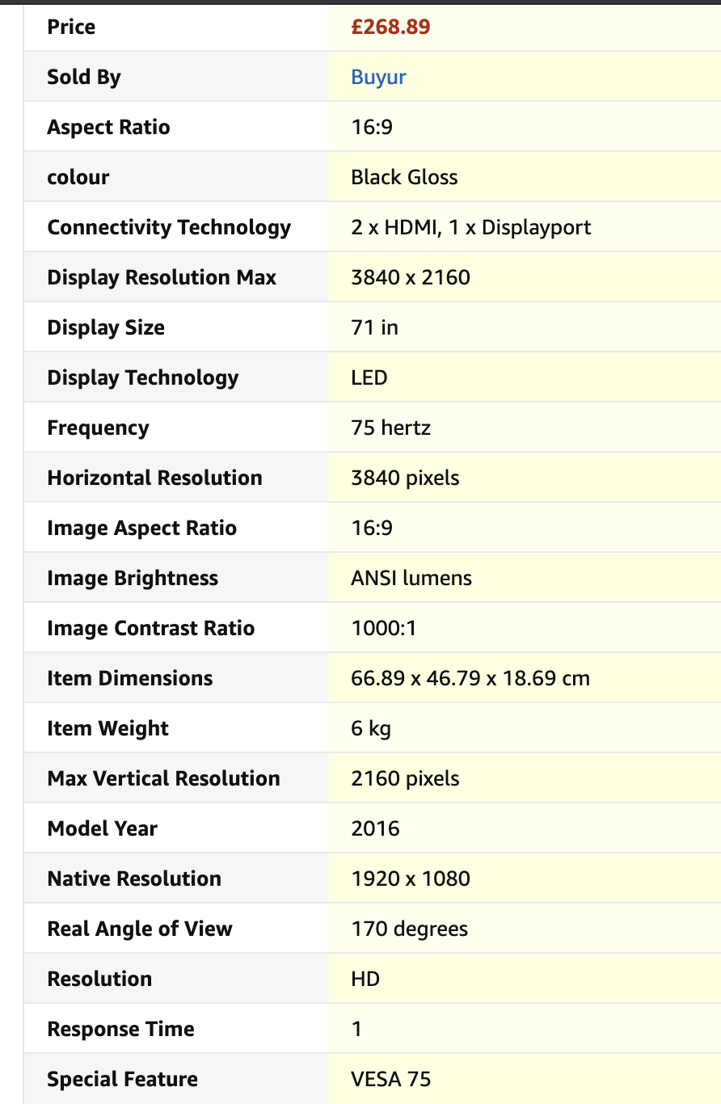
2.10 – Keyboard, Mouse and speakers.
For keyboard and mouse we will use SteelSeries – keyboard (SteelSeries mechanical hybrid) and mouse (SteelSeries Rival 3).
The SteelSeries mouse comes with high level of sensitivity, 6 programmable buttons and guaranty of 60 million click mechanical switches.
The SteelSeries keyboard has a guaranty of 20 million keypresses, illuminated keyboard for a better and nicer environment, magnetic hand rest is provided.
For speakers I chose a JBL Flip 5 portable Bluetooth, with rechargeable battery, waterproof. Why JBL? Because JBL has a history in music industry, special for clubs and cinema theatres. So our user will create 4K movies, this speaker is perfect for him. With the party booster, this speaker is compatible with other wireless devices which will create a perfect surrounding system. Has high capacity 4.800 mAH rechargeable battery which will last for at least 12 hours.

3.Additional Storage.
For additional storage, we chose My Cloud Pro Series PR4100.
This cloud storage starts with a 8TB storage memory but in time can be upgraded up to 56TB. It is easy to access it from anywhere using MyCloud.com, can stream anything because has a buil- in hardware and with Plex Media Server installed. Can save automatically, different files, photos, videos, etc. using a WD SmartWare Pro.
You can stream HD videos and share files with different users because of the quad core Intel Pentium N3710 CPU and 4GB of RAM.
With My Cloud Pro series you can keep your data protected due to RIAD technology and 256-bit AES volume encryption, so will keep perpetrators away from your content. Also come with two PSU, so in case of power failure you still have your data protected.
It is simple to set up and easy to use being very easy to find it on your network and it can be installed using internet helping you up speeding up the process.
All of this comes from a starting price of 699.99£.

In Fig.10 we can see the specs of the additional storage.
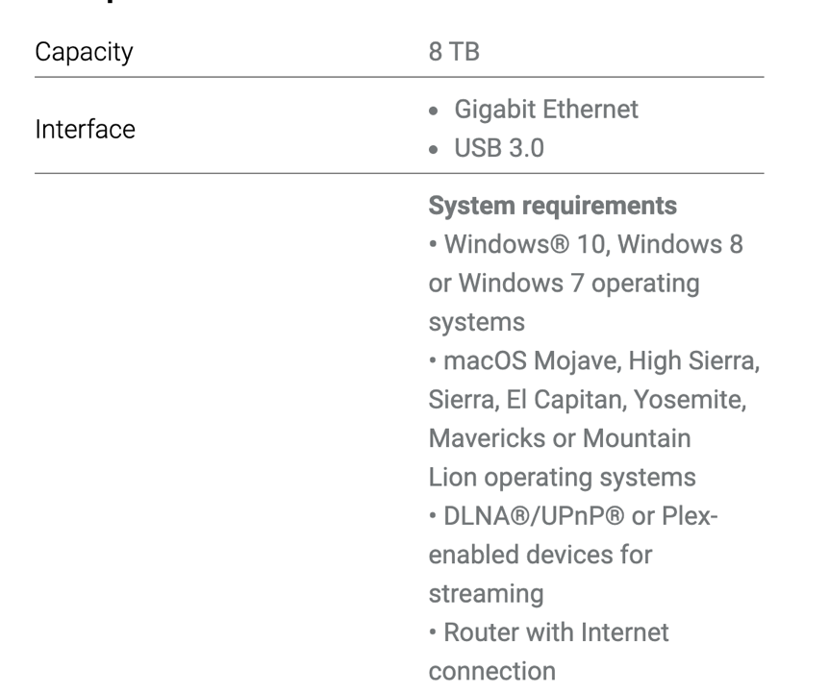

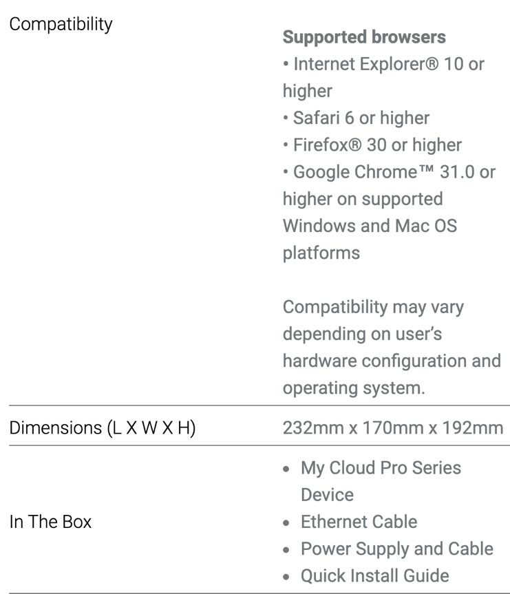

Fig.10

References.
Motherboard - https://www.overclockers.co.uk/asus-prime-b360-plus-intel-b360-socket-1151-ddr4-atx-motherboard-mb-6b5-as.html?gclid=EAIaIQobChMI8-ihhril6wIVh6ztCh0RYQ2ZEAQYBSABEgLi4vD_BwE

Fig1. Fig 2. Fig 3 Source - https://www.overclockers.co.uk/asus-prime-b360-plus-intel-b360-socket-1151-ddr4-atx-motherboard-mb-6b5-as.html?gclid=EAIaIQobChMI8-ihhril6wIVh6ztCh0RYQ2ZEAQYBSABEgLi4vD_BwE
CPU and Fig.4 - https://www.amazon.co.uk/Intel-Core-i3-8100-Retail-Graphics/dp/B0759FTRZL/ref=pd_sbs_147_4/258-2257740-8635939?_encoding=UTF8&pd_rd_i=B0759FTRZL&pd_rd_r=aad562fc-fb73-4c4b-bf6b-87cae1ff0d19&pd_rd_w=QrZwG&pd_rd_wg=DGrJp&pf_rd_p=b9bf232d-9a8a-4c7d-aa9d-641c0995d3a2&pf_rd_r=J5ERWHHHK0BWMQTGGZ1C&refRID=J5ERWHHHK0BWMQTGGZ1C&th=1
RAM and Fig5. - https://www.mrmemory.co.uk/memory-ram-upgrades/asus/motherboard/b360-g-gaming-rog-strix?autodetect=0&gclid=EAIaIQobChMI_pGw57ml6wIVQYBQBh0uVQXpEAQYASABEgI9sfD_BwE#!ddr4-pc4-21300-2666mhz-288-pin-dimm
CPU Cooler and Fig.6 - https://www.amazon.co.uk/Arctic-Alpine-12-Continuous-Operation/dp/B07HJ3DNX2/ref=asc_df_B07HJ3DNX2/?tag=googshopuk-21&linkCode=df0&hvadid=310739933748&hvpos=&hvnetw=g&hvrand=9665073085282447141&hvpone=&hvptwo=&hvqmt=&hvdev=c&hvdvcmdl=&hvlocint=&hvlocphy=1006598&hvtargid=pla-618355446655&psc=1&th=1&psc=1
Hard Drive and Fig.7 - https://www.amazon.co.uk/Seagate-500GB-7200rpm-Cache-Drive/dp/B005CT56R6?ref_=Oct_s9_apbd_omg_hd_bw_bT8RkN&pf_rd_r=FAKKPKVY917YQ1GNGQY7&pf_rd_p=16d55ead-a7fe-5293-a1f2-0efc5cd5dc1b&pf_rd_s=merchandised-search-10&pf_rd_t=BROWSE&pf_rd_i=430527031
CiT tower and Fig.8 - https://www.scan.co.uk/products/cit-classic-black-mid-tower-atx-case-with-500w-psu?gclid=EAIaIQobChMI7vSti-Gl6wIVSOztCh3JHA8bEAQYBCABEgLqO_D_BwE
HeadPhones - https://www.amazon.co.uk/Trust-Primo-Headset-Laptop-Black/dp/B01M0V6VPG/ref=asc_df_B01M0V6VPG/?tag=googshopuk-21&linkCode=df0&hvadid=430752237789&hvpos=&hvnetw=g&hvrand=13311142543091478436&hvpone=&hvptwo=&hvqmt=&hvdev=c&hvdvcmdl=&hvlocint=&hvlocphy=1006598&hvtargid=pla-330845588520&psc=1&th=1&psc=1&tag=&ref=&adgrpid=108575012348&hvpone=&hvptwo=&hvadid=430752237789&hvpos=&hvnetw=g&hvrand=13311142543091478436&hvqmt=&hvdev=c&hvdvcmdl=&hvlocint=&hvlocphy=1006598&hvtargid=pla-330845588520
Logitech Speakers - https://www.amazon.co.uk/Logitech-Stereo-Speakers-Midnight-Black/dp/B00F45E3D6/ref=asc_df_B00F45E3D6/?tag=googshopuk-21&linkCode=df0&hvadid=235207387183&hvpos=&hvnetw=g&hvrand=1598456456797662440&hvpone=&hvptwo=&hvqmt=&hvdev=c&hvdvcmdl=&hvlocint=&hvlocphy=1006598&hvtargid=pla-388797920156&psc=1&th=1&psc=1
Mouse and keyboard - https://www.amazon.co.uk/ASUS-U2000-Wired-Keyboard-Bundle/dp/B075R9TH9H/ref=asc_df_B075R9TH9H/?tag=googshopuk-21&linkCode=df0&hvadid=435641423729&hvpos=&hvnetw=g&hvrand=11668120338474830476&hvpone=&hvptwo=&hvqmt=&hvdev=c&hvdvcmdl=&hvlocint=&hvlocphy=1006598&hvtargid=pla-918538831645&psc=1&th=1&psc=1&tag=&ref=&adgrpid=100698544985&hvpone=&hvptwo=&hvadid=435641423729&hvpos=&hvnetw=g&hvrand=11668120338474830476&hvqmt=&hvdev=c&hvdvcmdl=&hvlocint=&hvlocphy=1006598&hvtargid=pla-918538831645
Water Cooling CPU: https://www.awd-it.co.uk/corsair-hydro-h100i-rgb-platinum-240mm-intel-amd-liquid-cpu-cooler-cw-9060039-ww.html?gclid=EAIaIQobChMIneSv5d2t6wIVh63tCh2pCgg0EAQYAiABEgJ9xvD_BwE
Mechanical keyboard - https://www.amazon.co.uk/SteelSeries-Apex-Mechanical-Key-Illumination/dp/B0831TDP3B/ref=asc_df_B0831TDP3B/?tag=googshopuk-21&linkCode=df0&hvadid=399647596979&hvpos=&hvnetw=g&hvrand=8498082226249382524&hvpone=&hvptwo=&hvqmt=&hvdev=c&hvdvcmdl=&hvlocint=&hvlocphy=1006598&hvtargid=pla-877317012631&psc=1&th=1&psc=1&tag=&ref=&adgrpid=85412341872&hvpone=&hvptwo=&hvadid=399647596979&hvpos=&hvnetw=g&hvrand=8498082226249382524&hvqmt=&hvdev=c&hvdvcmdl=&hvlocint=&hvlocphy=1006598&hvtargid=pla-877317012631
SteelSeries Mouse - https://www.currys.co.uk/gbuk/computing-accessories/computer-accessories/mice-and-keyboards/mice/steelseries-rival-3-rgb-optical-gaming-mouse-10204175-pdt.html?istCompanyId=bec25c7e-cbcd-460d-81d5-a25372d2e3d7&istFeedId=4d7eb93e-055f-499d-8ee5-1cdcc50d67d1&istItemId=ipwrmamwi&istBid=tztx&srcid=198&cmpid=ppc~gg~1016+(Shopping+Ads)+Gaming+Accs+-+Generic~1016+(PLA)+PC+GAMING+ad+group~Exact&mctag=gg_goog_7904&kwid=GOOGLE&device=c&ds_kids=92700054147723562&tgtid=1016+(Shopping+Ads)+Gaming+Accs+-+Generic&=--present--&PLA=1&gclid=EAIaIQobChMI4NmrjYKn6wIVke7tCh1VJQinEAQYByABEgLwWvD_BwE&gclsrc=aw.ds
Aditional Storage - https://shop.westerndigital.com/products/apps/my-cloud-apps
JBL Speaker - https://www.amazon.co.uk/JBL-Rechargeable-Waterproof-PartyBoost-Compatible-Midnight-Black/dp/B07SVH63PX/ref=sr_1_5?crid=1EDNQHCGYOVZ3&dchild=1&keywords=speaker+beats&qid=1598379869&sprefix=speaker+beat%2Caps%2C148&sr=8-5
Web Camera - https://www.amazon.co.uk/Teaisiy-Microphone-Streaming-Conference-Rotatable/dp/B088NWCPW7/ref=sr_1_9?dchild=1&keywords=web+camera&qid=1598380265&sr=8-9

