Cover page



University of Wales Trinity Saint David

Certificate of high education – skills for the workplace

Problem solving and decision making
(BMSW4004-CARD)

online business and its impact on the high street

Lecturer: Christian Felices
Student: Mohamed Babeker Osman Ahmed
Student ID: 211212
March 2022

Table of content

1.0 Cover page 1
2.0 Table of content 2
3.0 Procedure 3
4.0 Introduction 3
5.0 Finding 3
5.1 Define the Problem {nature, scope, Impact 3
5.2 Analysing the Organisations (SWOT analysis). 4
5.3 Macro the Environmental (PESTLE analysis) 5
6.0 Recommendation 7
6.1 Action plan 8
7.0 Conclusion 9
8.0 References 10
9.0 Appendices 11

Procedure

Introduction
Decline of the high street is the stressful thing for organisations and, its managers and decision makers. Therefore, the impacts that it might cause internally, toward the stakeholder, employees, owners, and managers. The factors that, it’s may also impact organisations externally. For example, stakeholders, suppliers, government etc. logically, the organisations must have thought of analysing their business regularly, to identify their strengths, weakness, opportunities, and threats by applying SWOT analysis (Global Data, 2018).
The SWOT analysis help organisations to conduct on the track and look for possible opportunities. Opportunities recures strategic plan to be achieved. Therefore, external analysis should take place instantly. To analyse external environment of organisations, you will need to apply PESTEL analysis (Gao, Zhao, and all, 2020) ‘’political, economic, social, technological environment and legal’’ this procedure helps organisations to choose the matrix choice to make the resilience decisions. In this report discussion will be on, how to make this resilient decision to prevent retailers from downturn because of the Ecommerce and speedy use of intranet ‘’ online business.’’ Moreover, this keeps them in the markets, growing and developing the product. Then set up system that allows the organisation to easily monitor and review with considering customer’s satisfaction.

Finding

Decline of the high street is problem that caused by many reasons. However, the report will explain only one of the reasons which is E commerce and online businesses. To understand what the nature, scope and impact of the problem with recommendations having to help on finding solution by flowing proper action plan.

Define the Problem {nature, scope, Impact

Online business has become a fact that retailers can not avoid but, its reality that must be deal with instead of escaping from the market or given up. In the fact, the problem caused by many reasonable reasons, some of these reasons to mention are ‘’ speedy rise of the internet, smart mobile phone, demographic segment, technologies development, and the impact of covid 19 pandemic etc. As a result, the figure show that 85,000 retail jobs disappeared in the UK according to Britain Retail Consortium, (BRC.ORG. 2022). Furthermore, the employees how have lost their jobs in the retailer’s sector, 9.4 million people has suspended or unemployed according to (Mel Crate, 2020).
These impacts extremely have effects on the communities and families, because when the families living rate effect led to the massive impact behaviour, which could have spreading to the community then introduce anther problems related, things like student may leave the education early etc. This could have significant impacts on the society. However, the owners losing their position in the market competition is huge negative conflict on the GNP ‘’gross national product’’. Because when the GNP drops then the people income will drop accordingly, and its sing for another problem in the future. Moreover, the decline of the high street has magnificent impact on the footfalls, because the speedy rise of the internet and smart mobile phones. These reasons have drop on footfall by 57%–75% according to (Enoch, M. et al. 2021) with considering the lockdown applied back in March 2020 over the country. The internet and smart phones have changed the costumer behaviours toward going in-store shopping! This is anther challenge to the retailers and strategics’ planner in the business and economics. To reduce these impacts, organisation should continuously analyse and be prepared to any potential changes or challenges.

Analysing the Organisations (SWOT analysis).
It is very important that organisations regularly have SWOT analysis internally to make sure they identify their weaknesses and strengths to convert them into opportunities or minimize the threats externally. The importance of the SOWT analysis internally for any organisation is to help the company to identify what does it do well, and what does not do so well. Therefore, by using the SWOT (CIPD, 2021) company will come to understand the strengths are, things that they have inside the organisation like competent workforce, strong financial, and effective leadership. Alongside with old equipment, company location and high running cost as weaknesses. The example of strengths mentioned above could lead the organisation to be able to decide whether invest in new opportunities or not, regarding overcome the weaknesses or avoiding threats. The first step in doing a SWOT analysis according to (Chron, 2019) for a retail company may identifying strengths as flows: -
possible strength may be
- the retailer's financial banking if it has plenty of capital and access to bank loans.
- Another strength may be the retailer's cheap offers inside store only.
- Additionally, the company may offer unique products compared to other retailers.
weaknesses may be such as: -
- Weak brand image and lack of identity in the marketplace.
- Collection sells of cheap and expensive brands.
- Selling items to brands which reduces the competitive advantages.
Some opportunities may retailer’s look for: -
- Consumer’s needs and interests, like consultation services.
- Targeting and purchased some other small and ready business to extend their company.
- Targeting for Seasons selling.
Potential threat retailers might recognise
- Decrease of the costumer’s behaviour and demand, (footfall).
- Increase in competition toward the price.
- Online business can be a major threat for retailer.
So, the benefits of applying SWOT analysis are helping the organisation to make decision in comfort position and assessing the potential risks to avoid them when implementing the plan. Yet, any decision would not be effectively to take unless analysing the external macro environmental analysis to identify the opportunities in relations to take an action on. Additionally, the threats to avoid in regard to have a resilience decision to solve the problems.

Macro the Environmental (PESTLE analysis)

All organisations are affected by the external environmental factors. This factor has first time introduced by (Francis J. Aguilar 1967) which have been known as, PESTLE. Macro environmental analysis to stand for ‘’Political, Economic, Sociological, technological, legal, and Environmental’’. These are tool that help organisation to identify the opportunities and threats to provide strategically advice regarding influence the decision making on market and business (Song, Sun, all 2017). Therefore, organisations need a wider range of skills with their decision-maker and characteristics {managers and workforce} according to (Adiar 2019). These skills allow the organisations to apply PESTLE effectively for better understanding market growth or decline. However, these tools are describing framework that make the organisation to have a big picture about element effecting their business according to (marketingtutor.net, 2022).
Political factors effecting the high street retailers: -
The government and politicians work closely to set the rules and regulation for the country. When these lows established people and business must obey. Additionally, these rules may rise sales taxes then it would increase price products. For example, the political decisions have been made regard Russia vs Ukraine war has hugely affected many organisations especially those who are working on liquid energy field so, it’s important to have ideas about things that indirectly effect the business.
Economic factors effecting the high street retailers: -
Economic activities are an indicators of businesses growth or decline. The magnificent effect that economic leave on the business is, changing people mindset when business activity declining economically, that mean unemployment sector will jump higher and people have less resources and income. Which reduce selling on the high street footfalls. And when the business activity growth the mindset of the costumer will change positively toward the high street.
Social factors effecting the high street retailer: -
Social trends develop the shopping habits of the people, their attitudes and behaviours may change, then their choice and preference could be different. Demographic social factors like age, gender, education level, and income of the costumers affect the high street and retailer.
Technological factors effecting the high street retailer: -
Technological has influenced both online business and high street retailer positively in some ways like cash management, card payment, and electronic receipts. Ecommerce businesses has benefited from the technology the most. Especially, with the speedy rise of the internet, online shopping can advertise their products and services globally without any restrictions on borders. Companies like Amazon and Alibaba are, offering products and services worldwide.
Legal factors that effecting the high street retailers: -
The retail store operates within the legal environment of a country; therefore, they should follow the local employment laws, taxation regulations, and other business laws. When any company play around or refuse to follow the low and regulations of the country, this would result restriction, band, or enforcement closure.
Environmental factors that effecting the high street retailers: -
As the environment problems has become one of the recent issues on the planet, the impact will affect the retailers on the high street internal and external.
The internal, as we know some businesses product item like food, some of these items cannot remain fresh for long time in certain environment, they have a time limit in the stock or the storages. Which would impact on the costs when losing them.
The external, the use of plastic bags for goods, using vehicles for transporting goods, machines in the manufactories and the pollution impact of these kind of businesses. Which has an international low and regulation.
If a retail store doesn’t maintain a standard health and safety environment within the store, then food and safety departments would either ban or punish with some penalty of a certain amount on the store.

Recommendation

Businesses and the retailers on the high street are already on the market to introduce their product and items to make profits, so they always thinking and reading the market and they identify the opportunities. Therefore, the strategics plan long-term and short-term must involve the recent lows and regulations nationally and international, things may help to reduce the decline of the high street can be such as:
- Some organisations have financial capability so, government can open empty or useless properties located in the city towns, to these companies with strong capital to invest which will encourage footfall on the high street.
- Companies should take the high risks of course they used to, to encourage footfall by reword and recognitions in certain seasons, items, outlets, and payment plan on the store only.
- Increase the collaborations between retailers and restaurants for example, to attract customers who are not only want shopping but, eat and drink at the same time.
- Given costumers choice to choose the suitable items for them without pressure, kindly to encourage them to the high street.

Action plan

Increase the collaborations between retailers and restaurants

Monitoring the decision:
Resources needed:
- Financial capability and capital.
- Legal agreements and government permissions.
- Read the target market segments and their interests.

Main Key Indicators:
- The budget set and linked to the time specified in the plan.
- Keep tracking government regulation and update the agreement accordingly.
- Study the costumer’s attitude and behaviours to get their feedback by survey.
- Health and safety procedures and environments regulations

The Targets:
Reorganizing 10 retailers to work collaboratively with restaurants in the town, to increase the footfall in the high street by 5% in general and 45% in specified businesses in the end of 2025.

Data Sources:
- Surveying the community and its living level.
- Select the restaurants with good brand and high costumers.
- Make advertisement and implementation’s plan.

Reviewing the decision:
- How do we convince the costumers to come for shopping in the high street?
- What can we make to grip costumer attentions?
- How can we keep the agreement whether it with government or subcontractors for long-term?
- What the flexibility do we have toward unexpected changes in legal factors?

Communicating the Decision:
Internal Stakeholders  monthly meeting for management and it should be face-to-face to have the clarity of the reports on the matter.  Set a formwork for emergencies. | External Stakeholders  Quarter meeting for representatives on behalf the organisation they represent and it could be on line, to reflect the recommendations for their organisation.

Conclusion

The benefits of applying SWOT analysis are helping the organisation to make decision in comfort position and assessing the potential risks to avoid them when implementing the plan. After carefully studying the political, economic, technological, social, legal and environmental issues that the retail industry has to face. If they follow the prevailing rules and regulations of a country, then it’s good. Otherwise, they would end up in a lot of lawsuits and legal penalties and it would cost a lot to a business.

References

Adair, J.E. (2019) Decision making and problem solving : break through barriers and banish uncertainty at work. Fourth edition. London: KoganPage.
Carter, S.D., Hampton, C.M., Langlois, R., Melero, R., Farino, Z.J., Calderon, M.J., Li, W., Wallace, C.T., Tran, N.H., Grassucci, R.A. and Siegmund, S.E., 2020. Ribosome-associated vesicles: A dynamic subcompartment of the endoplasmic reticulum in secretory cells. Science advances, 6(14), p.eaay9572.
Dixit, S. and Sinha, A.K. (2016) E-retailing challenges and opportunities in the global marketplace. Hershey, PA: Business Science Reference.
Enoch, m. Et al. (2021) ‘when covid-19 came to town: measuring the impact of the coronavirus pandemic on footfall on six high streets in england’, environment and planning b: urban analytics and city science. Doi: 10.1177/23998083211048497.
Gao, L. and Zhao, Z.-Y. (2020) ‘The Evolutionary Game of Stakeholders’ Coordination Mechanism of New Energy Power Construction PPP Project: A China Case’, Sustainability (Basel, Switzerland), 12(3), p. 1045–. doi:10.3390/su12031045.
GlobalData Company Profiles - Strategic SWOT Analysis Review (no date). Global Data Ltd.
https://www.cipd.co.uk/knowledge/strategy/organisational-development/swot-analysis-factsheet#gref
https://www.marketingtutor.net/pestle-analysis-of-the-retail-industry/
Https://www.statista.com/statistics/1230225/changes-in-online-buying-among-uk-consumers-since-covid-19/
Online Sales (B2C Ecommerce), Mail Order, Catalogs and Other Direct Marketing Industry (U.S.) Analytics, Extensive Financial Benchmarks, Metrics and Revenue Forecasts to 2028, NAIC 454100 Published February 12, 2022. 2022. Houston: Plunkett Research, Ltd.
Song, J., Sun, Y. and Jin, L. (2017) ‘PESTEL analysis of the development of the waste-to-energy incineration industry in China’, Renewable & sustainable energy reviews, 80, pp. 276–289. doi:10.1016/j.rser.2017.05.066.

Appendices

decision-making matrix: -
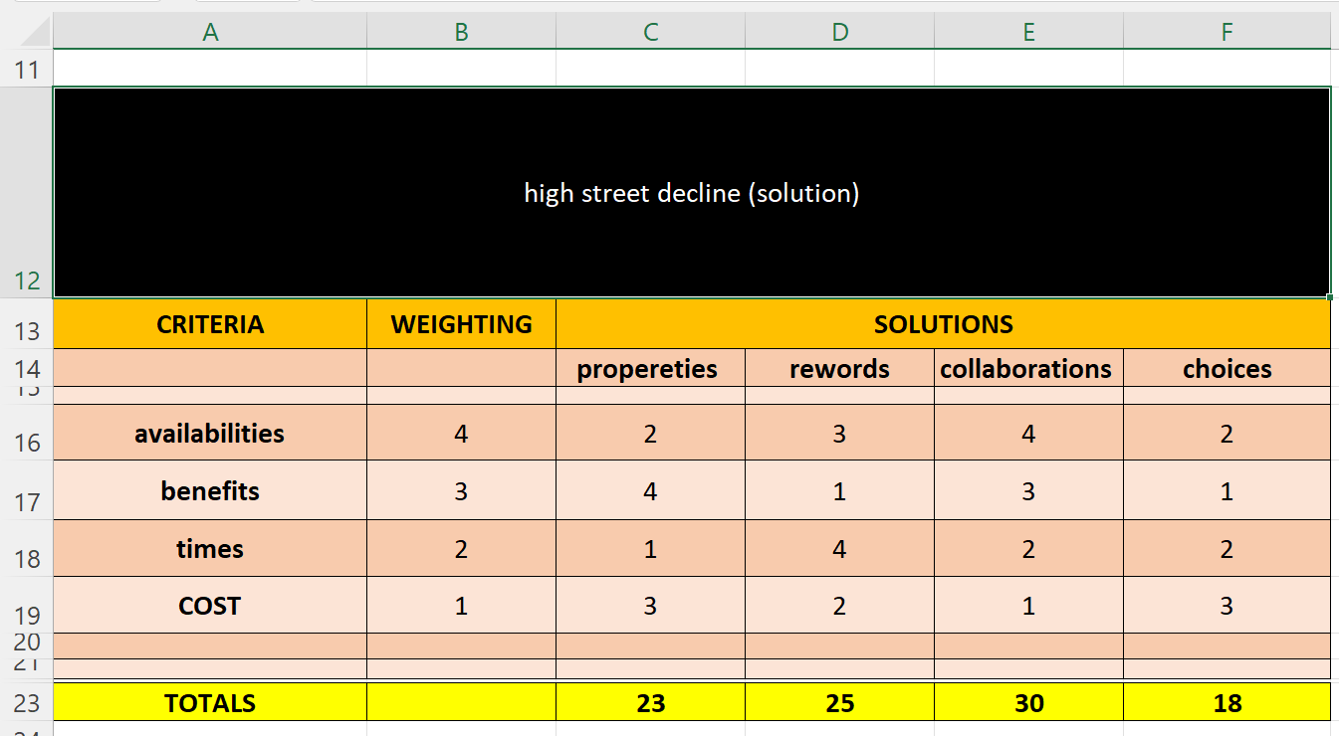

SWOT analysis: -
Strengths | weaknesses
Financial  Workforce  Resource  Offers in store only  Product quality | Limited resources  Weak brand  lack of identity in the marketplace  Weak competitive advantages.
opportunities | threats
Purchase other small businesses  Costumers’ interests  Increase on footfall | Online business growth  Market competition  Technology development

