14/08/2026
Michael Asiedu
LECTURER: DR FAHAD AHMED
Assignment Part A& B
Database Design & Implimentation

Module Name
MODULE NAME: DATABASES AND APPLICATION DEVELOPMENT
MODULE CODE: ACCA5026
STUDENT ID: 2411698
Table of Contents
Introduction 2
Problem Statement 2
Objectives 2
Scope and Significance 3
Database Design Concepts and Principles 3
Entity-Relationship Modelling Fundamentals 3
Normalization Theory and Application 3
ERD Structure 10
Entity Analysis 11
Logical Data Model Structure 12
Constraint Implementation 14
Index Strategy 14
Normalization Verification 15
Business Process Support 15
Data Integrity and Security 16
Performance Optimization Strategy 17
Future Enhancement Potential 18
Screenshots 18
Conclusion 29

PART A

Introduction

MedAssist Clinic is a private healthcare facility located in the United Kingdom that provides a wide range of outpatient medical services, including general consultations, diagnostic testing, and specialist referrals. The clinic is staffed by a dedicated team of doctors, specialists, and administrative professionals committed to delivering high-quality care to its registered patients. As the clinic expands its operations and patient base, it faces a crucial need to modernise its systems and processes through a comprehensive digital transformation initiative.

Problem Statement
MedAssist Clinic’s reliance on manual and fragmented information-management practices for handling patient records, appointment scheduling, and treatment documentation has resulted in significant operational inefficiencies and inconsistencies in data quality. These disconnected processes increase the likelihood of redundancy, hinder effective coordination of patient care, and pose risks to the accuracy and reliability of clinical information. With the clinic experiencing sustained growth in patient numbers and a corresponding rise in the complexity of its service delivery, the absence of an integrated information system has become a critical limitation. Consequently, there is a pressing need for a centralized, structured database solution capable of supporting streamlined workflows, enhancing data integrity, and ensuring secure, coherent management of clinical and administrative information.

Objectives
The overarching aim of this database design project is to construct a fully integrated relational database system capable of meeting MedAssist Clinic’s operational and informational needs. The proposed system is intended to support the efficient management of patient records, medical staff schedules, appointment coordination, and treatment documentation, while enabling secure, concurrent access for authorised users. In alignment with established principles of data integrity, consistency, and normalization, the system will provide a reliable foundation for clinical and administrative workflows. The logical ERD schema developed for this project serves as a conceptual blueprint for the database, offering a structured representation of entities, relationships, and constraints that will guide subsequent implementation and optimisation.

Scope and Significance
This database design project encompasses five principal entities—Department, Doctor, Patient, Appointment, and Treatment—which collectively represent the core operational components of MedAssist Clinic. These entities capture the essential processes underpinning the clinic’s service delivery, ranging from patient registration and clinical scheduling to the documentation of diagnostic and therapeutic interventions. The significance of the proposed design lies in its capacity to support the systematic digitisation and optimisation of clinical and administrative workflows. By establishing a coherent and centralised data architecture, the system is expected to enhance coordination of patient care, reduce administrative burden, and strengthen the reliability of operational data. Furthermore, the structured nature of the design provides a scalable foundation for future developments, including advanced analytical capabilities, performance monitoring, and comprehensive reporting functionalities.

Database Design Concepts and Principles

Entity-Relationship Modelling Fundamentals
The Entity-Relationship (ER) model serves as the conceptual foundation for database design, providing a systematic approach to representing real-world entities and their relationships. In the context of MedAssist Clinic, this modelling approach enables us to capture the complex interactions between patients, doctors, appointments, and treatments in a structured, logical manner that can be implemented in a relational database management system[1].

The ER modelling process involves identifying entities (objects or concepts about which data is stored), attributes (properties describing entities), and relationships (associations between entities). This approach ensures that the database design accurately reflects the clinic's business processes and operational requirements while maintaining data integrity and minimizing redundancy[2].

Normalization Theory and Application
Normalization is a fundamental database design technique that organizes data to reduce redundancy and improve data integrity. The process involves decomposing tables into smaller, well-structured relations that satisfy specific normal forms. For the MedAssist Clinic database, we have applied normalization principles up to Third Normal Form (3NF), which provides an optimal balance between data integrity and query performance[3].

The database design adheres to the three core stages of normalisation. First Normal Form (1NF) is achieved by ensuring all attributes contain atomic values and that each table has a defined primary key, preventing repeating groups or multi-valued fields. Second Normal Form (2NF) is satisfied by eliminating partial dependencies, with all non-key attributes fully dependent on their table’s primary key, particularly important for any table that might otherwise require a composite key. Third Normal Form (3NF) is met by removing transitive dependencies, ensuring that non-key attributes depend solely on the primary key rather than on other non-key attributes. Together, these stages produce a structured, efficient schema with minimal redundancy[4].
Referential integrity is maintained using foreign key constraints, which ensure that relationships between entities remain valid, for example, every appointment must reference an existing patient. Additional constraints, including check constraints, unique constraints, and default values, further support data accuracy, validation, and consistency across the system. Collectively, these mechanisms ensure that the database operates reliably, securely, and in alignment with best practices for clinical information management[5].

To satisfy 1NF requirements:
- Each field contains atomic (indivisible) values.
- There are no repeating groups or arrays within columns.
- Each table has a unique Primary Key (or composite primary key).

Department_ID (PK) | Department_Name | Location_Building | Phone_Extension
1 | General Medicine | First Floor, Suite A | 1001
2 | Dermatology | First Floor, Suite B | 1002
3 | Physiotherapy | Second Floor, Suite C | 1003

Doctor_ID (PK) | First_Name | Last_Name | Specialization | Department_ID (FK) | Contact_Number | Email
1 | Samuel | Simms | General Medicine | 1 | 02012341001 | samuel.simms@medassist.com
2 | Amit | Naik | Dermatology | 2 | 02012341002 | amit.naik@medassist.com
3 | Elena | Rostova | Cardiology | 3 | 02012341003 | fernando.suneth@medassist.com

Appointment_ID (PK) | Patient_ID (FK) | Doctor_ID (FK) | Appointment_Date | Appointment_Time | Status | Reason_For_Visit
1 | 1 | 1 | 2026-08-15 | 09:30:00 | Scheduled | Fever and headache
2 | 2 | 2 | 2026-08-15 | 10:15:00 | Completed | Skin rash
3 | 3 | 3 | 2026-08-16 | 11:00:00 | Scheduled | Chest Pain Checkup

Patient_ID (PK) | NHS_Number | First_Name | Last_Name | Date_Of_Birth | Gender | Street_Address | City | Phone_Number | Emergency_Contact
1 | 987 654 3210 | John | Doe | 1985-04-12 | Male | 12 Main St | London | 555-0301 | 555-0399
2 | 987 654 3211 | Jane | Smith | 1992-09-25 | Female | 45 Park Ave | Manchester | 555-0302 | 555-0398
3 | 987 654 3212 | Alice | Brown | 2018-01-15 | Female | 88 Oak Ln | Birmingham | 555-0303 | 555-0397

Treatment_ID (PK) | Appointment_ID (FK) | Treatment_Name | Description | Cost | Treatment_Date
1 | 1 | Electrocardiogram | 12-lead ECG procedure | 150.00 | 2026-08-15
2 | 2 | X-Ray Knee | Left knee diagnostic imaging | 120.00 | 2026-08-15
3 | 2 | Cortisone Injection | Joint anti-inflammatory injection | 85.00 | 2026-08-15

Feedback_ID (PK) | Appointment_ID (FK) | Patient_ID (FK) | Rating_Score | Comments | Submission_Date
1 | 2 | 2 | 5 | Very attentive doctor and quick service. | 2026-08-15
2 | 1 | 1 | 4 | Waiting time was slightly long, but doctor was great. | 2026-08-15

Key 1NF Features Applied:
- Atomic Attributes: Names and addresses are separated into granular columns (e.g., First_Name, Last_Name, Street_Address, City).
- No Multi-value Fields: If a patient receives multiple treatments during one appointment, each treatment gets its own discrete row in the Treatment table linked via Appointment_ID.

2nd Normal Form
Second Normal Form (2NF) stipulates that all non-key attributes must exhibit full functional dependency on the entirety of the primary key. Within the MedAssist Clinic schema, the Department, Doctor, Patient, Appointment, and Feedback entities inherently satisfy this requirement, as each employs a single-attribute primary key. The use of non-composite keys eliminates the possibility of partial dependencies and thereby ensures compliance with 2NF without necessitating further structural refinement.
A potential deviation from 2NF arises in contexts where treatment-related attributes—such as treatment name and cost—are embedded within an appointment-level table. In such cases, these attributes may depend on only part of a composite key or may introduce functional redundancy, thereby violating the principles of 2NF. To mitigate this issue, treatment descriptors are abstracted into a dedicated, standardised Treatment entity, accompanied by a junction table that associates individual treatments with specific appointments. This decomposition not only removes partial dependencies but also establishes a more coherent and extensible data architecture. Consequently, the revised schema achieves full adherence to 2NF and supports improved data integrity, consistency, and maintainability across the database system.
[6].

Department table
(unchanged-single primary key)
Department_ID (PK) | Department_Name | Location_Building | Phone_Extension
1 | General Medicine | First Floor, Suite A | 1001
2 | Dermatology | First Floor, Suite B | 1002
3 | Physiotherapy | Second Floor, Suite C | 1003

Doctor table
(Unchanged – single primary key)

Doctor_ID (PK) | First_Name | Last_Name | Specialization | Department_ID (FK) | Contact_Number | Email
1 | Samuel | Simms | General medicine | 1 | 02012341001 | samuel.simms@medassist.com
2 | Amit | Naik | Dermatology | 2 | 02012341002 | amit.naik@medassist.com
3 | Fernando | Sineth | Physiotherapy | 3 | 02012341003 | fernando.suneth@medassist.com

Patient
(Unchanged – single primary key)

Patient_ID (PK) | NHS_Number | First_Name | Last_Name | Date_Of_Birth | Gender | Street_Address | City | Phone_Number | Emergency_Contact
1 | 987 654 3210 | John | Doe | 1985-04-12 | Male | 12 Main St | London | 555-0301 | 555-0399
2 | 987 654 3211 | Jane | Smith | 1992-09-25 | Female | 45 Park Ave | Manchester | 555-0302 | 555-0398
3 | 987 654 3212 | Alice | Brown | 2018-01-15 | Female | 88 Oak Ln | Birmingham | 555-0303 | 555-0397

Appointment
(Unchanged – single primary key)

Appointment_ID (PK) | Patient_ID (FK) | Doctor_ID (FK) | Appointment_Date | Appointment_Time | Status | Reason_For_Visit
1 | 1 | 1 | 2026-08-15 | 09:30:00 | Scheduled | Chest Pain Checkup
2 | 2 | 2 | 2026-08-15 | 10:15:00 | Completed | Knee Joint Pain
3 | 3 | 3 | 2026-08-16 | 11:00:00 | Scheduled | Annual Pediatric Checkup

Treatment Table
Stores the standardized master list of available medical treatments and default rates to prevent repeating non-key treatment information across multiple patient visits.

Treatment_Code (PK) | Treatment_Name | Standard_Cost | Description
1 | Electrocardiogram | 150.00 | 12-lead ECG procedure
2 | X-Ray Knee | 120.00 | Left/Right knee diagnostic imaging
3 | Cortisone Injection | 85.00 | Joint anti-inflammatory injection

Feedback
(Unchanged – single primary key)

Feedback_ID (PK) | Appointment_ID (FK) | Patient_ID (FK) | Rating_Score | Comments | Submission_Date
FDB601 | APT402 | PAT302 | 5 | Very attentive doctor and quick service. | 2026-08-15
FDB602 | APT401 | PAT301 | 4 | Waiting time was slightly long, but doctor was great. | 2026-08-15

Summary of 2NF Improvements:
- Eliminated Partial Dependencies: Standard treatment (Treatment_Name, Description, Standard_Cost) was separated from appointment instances so that attributes are fully dependent on Treatment_Code.
- Flexibility: Allows tracking actual charges billed per appointment (Actual_Fee) separately from standard price lists (Standard_Cost).

ERD Structure
Entities and Relationships:

Department (1) ----< (M) Doctor
Doctor (1) ----< (M) Appointment
Patient (1) ----< (M) Appointment
Appointment (1) ---- (1) Treatment
Appointment (1) ---- (1) Feedback

Clinic Database System: Logical ERD Schema Report

Entity Analysis

Department Entity
The database model captures the core operational structure of MedAssist Clinic through five primary entities, Department, Doctor, Patient, Appointment, and Treatment, each representing a distinct component of clinical and administrative workflow.
The Department entity defines the clinic’s organisational hierarchy, storing essential details such as department name, leadership, location, and contact information. The Doctor entity records professional and personal information about medical staff, including credentials, availability, and departmental affiliation. The Patient entity maintains comprehensive demographic, medical, and contact information, forming the central reference point for all clinical activity. The Appointment entity documents scheduled patient–doctor interactions, capturing temporal details, visit purpose, status, and priority. The Treatment entity records the clinical outcomes of appointments, including diagnoses, prescriptions, care plans, referrals, and follow-up requirements.
The relationships between these entities reflect the clinic’s operational processes. Departments oversee multiple doctors (1:M), doctors conduct multiple appointments (1:M), and patients attend multiple appointments (1:M). Each appointment produces exactly one treatment record (1:1), ensuring complete documentation of each clinical encounter. Additional links between Treatment, Patient, and Doctor support efficient reporting and analysis.
Collectively, this structure provides a coherent, normalised representation of the clinic’s workflow, enabling accurate data management, streamlined operations, and a foundation for future analytical and reporting capabilities.

Logical Data Model Structure
Table Structures and Data Types
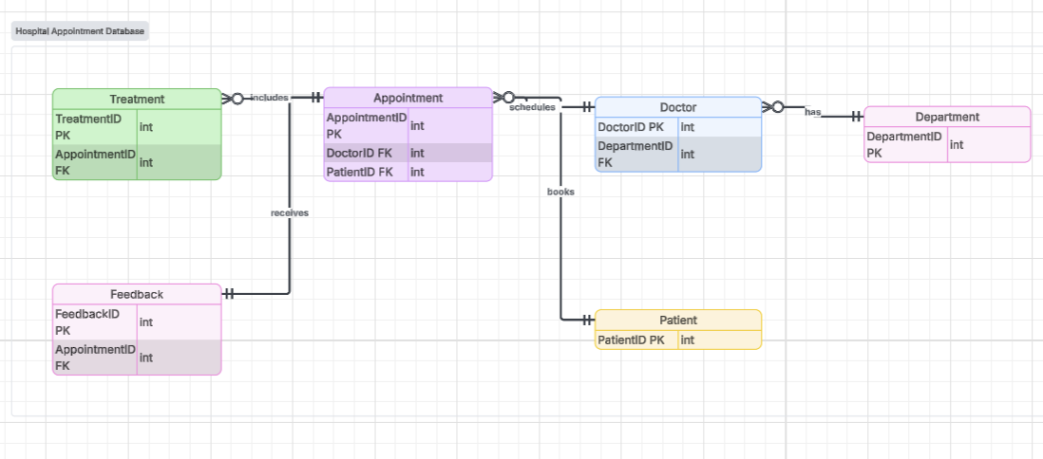
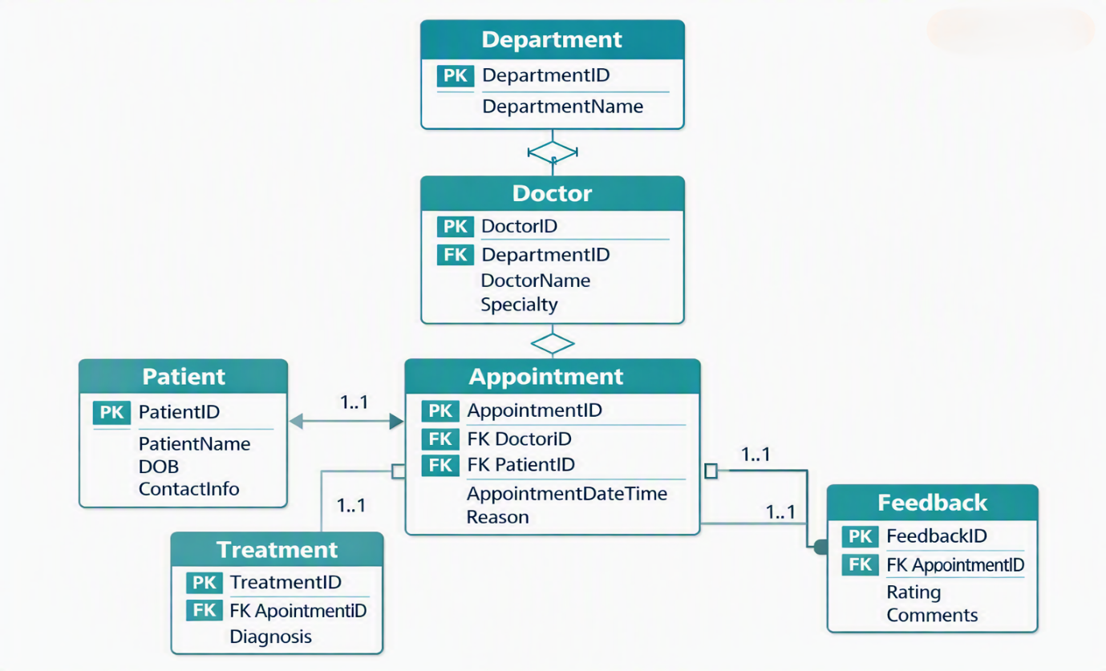

The logical data model defines specific data types for each attribute to ensure data integrity and efficient storage. Key data type decisions include:

- Integer Types: Used for primary and foreign keys (INT) to ensure efficient indexing and join operations.
- Variable Character (VARCHAR): Used for text attributes with predictable length (name, email, phone) to balance storage efficiency and performance.
- Text Types: Used for clinical documentation fields (MedicalHistory, Diagnosis, TreatmentPlan) to accommodate variable-length content.
- Date and Time Types: Used for temporal data (AppointmentDateTime, FollowUpDate) to enable date-based queries and temporal analysis.
- Enumeration Types: Used for limited-domain fields (Gender, Status, Priority) to enforce data consistency and simplify application logic.
- Boolean Types: Used for binary flags (Active, ReferralRequired) to enable efficient filtering and condition checking.
- Decimal Types: Used for monetary values (ConsultationFee) to ensure precision in financial calculations[7].

Constraint Implementation
The logical data model incorporates multiple layers of constraints to ensure data integrity:

Primary Key Constraints: Ensure unique identification of each row in all tables, preventing duplicate records and enabling efficient data retrieval.

Foreign Key Constraints: Maintain referential integrity by ensuring that all relationships remain valid, preventing orphaned records and preserving data consistency.

Unique Constraints: Prevent duplicate entries in business-critical fields such as NHSNumber, Email, and RegistrationNumber, ensuring data uniqueness.

Check Constraints: Enforce domain integrity by validating data against specific rules, such as email format validation, duration range checking, and future date requirements.

Default Constraints: Automatically populate common values (Active flags, CreatedDate) to ensure data completeness and consistency[8].

Index Strategy
The logical data model includes strategic indexes to optimize query performance for critical operations:

Primary Indexes: Clustered indexes on primary keys for efficient record retrieval and table scans.

Secondary Indexes: Non-clustered indexes on foreign keys to optimize join operations and reduce query execution time.

Covering Indexes: Indexes that include frequently queried columns to eliminate the need for additional data lookups[9].

Functional Indexes: Indexes on computed columns or functions (e.g., DATE(AppointmentDateTime)) to support efficient date-based queries.

Normalization Verification

First Normal Form Verification
All tables satisfy First Normal Form requirements by ensuring atomic attribute values and eliminating repeating groups. The Patient table, for instance, stores medical history as a single TEXT field rather than having multiple columns for each condition, enabling flexible storage while maintaining atomicity.

Second Normal Form Verification
The database design satisfies Second Normal Form by ensuring that all non-key attributes are fully functionally dependent on complete primary keys. This is particularly evident in the Treatment table, where all attributes depend on TreatmentID rather than any subset of foreign keys.

Third Normal Form Verification
Third Normal Form is achieved by eliminating transitive dependencies. For example, the Doctor table does not store department head information directly; instead, this data is accessed through the Department relationship, preventing update anomalies and data redundancy.
Table above satisfy 3rd normal form

Business Process Support

Patient Registration
The database design supports patient registration through the Patient entity, capturing comprehensive demographic and medical information. This enables efficient patient identification, medical history tracking, and personalized care delivery.

Doctor Assignment and Scheduling
The Department-Doctor relationship enables efficient doctor assignment and management. The AvailabilityStart and AvailabilityEnd attributes in the Doctor entity support scheduling by defining working hours and consultation availability.

Appointment Booking
The Appointment entity provides a comprehensive framework for managing appointments, supporting scheduling, confirmation, and tracking through status management. The Priority attribute enables appropriate triaging and resource allocation.

Consultation and Treatment Recording
The Treatment entity enables comprehensive clinical documentation, capturing diagnosis, prescription, treatment plans, and follow-up requirements. This supports care continuity and clinical auditing.

Data Integrity and Security

Transaction Management
The logical data model supports transaction management through referential integrity constraints that ensure data consistency across related tables. The 1:1 relationship between Appointment and Treatment, for example, ensures that treatment records are always linked to valid appointments.

Data Validation
Check constraints throughout the schema enforce data validation at the database level, ensuring that only valid data is stored. This includes format validation for NHS numbers, email addresses, and phone numbers, as well as range checking for appointment durations and ratings.

Audit Capability
The inclusion of CreatedDate and ModifiedDate timestamp fields in all tables supports basic audit capabilities, enabling tracking of when records were created or modified. This is essential for compliance with healthcare regulations and data quality monitoring.

Performance Optimization Strategy

Indexing for Query Optimization
The database design incorporates strategic indexing to optimize performance for common queries and operations. Indexes on AppointmentDateTime support efficient date range queries for schedule management, while indexes on PatientID and DoctorID optimize join operations in patient history and doctor workload queries.

Query Performance Considerations
Careful consideration of query patterns has informed the indexing strategy and data structure decisions. The design supports efficient queries for appointment scheduling, patient history retrieval, doctor workload analysis, and treatment tracking through appropriate index placement and data organization.

Scalability and Growth
The logical data model is designed to support clinic growth through scalable structures and appropriate indexing. Entity relationships and data types have been chosen to accommodate increasing volumes of patients, appointments, and treatments without performance degradation[10].

Implementation Considerations

Technology Independence
The logical data model is designed to be implementation-independent, ensuring compatibility with various relational database management systems. Standard SQL data types and relationships have been used to maximize portability and technology flexibility.

Application Development Support
The logical data model provides a solid foundation for application development, supporting various operational scenarios including patient registration, appointment booking, clinical documentation, and reporting. The clear relationships and comprehensive attributes enable efficient application development and reduced implementation complexity[11].

Future Enhancement Potential
The database design is structured to support future enhancements including:
- Integration with external systems (NHS systems, billing systems)
- Analytics and business intelligence capabilities
- Mobile application support for remote access
- Additional clinical modules (lab results, imaging, referrals)

Screenshots
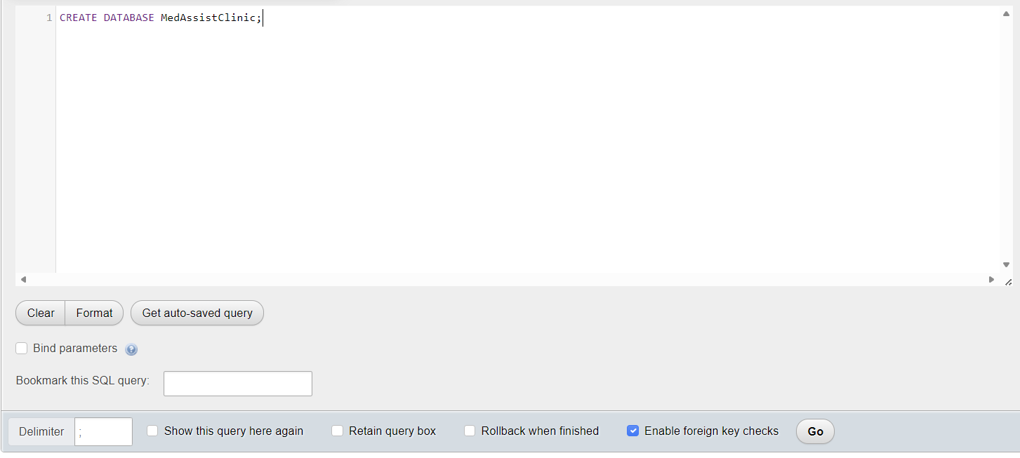
Creation of med assist clinic

Creation of tables
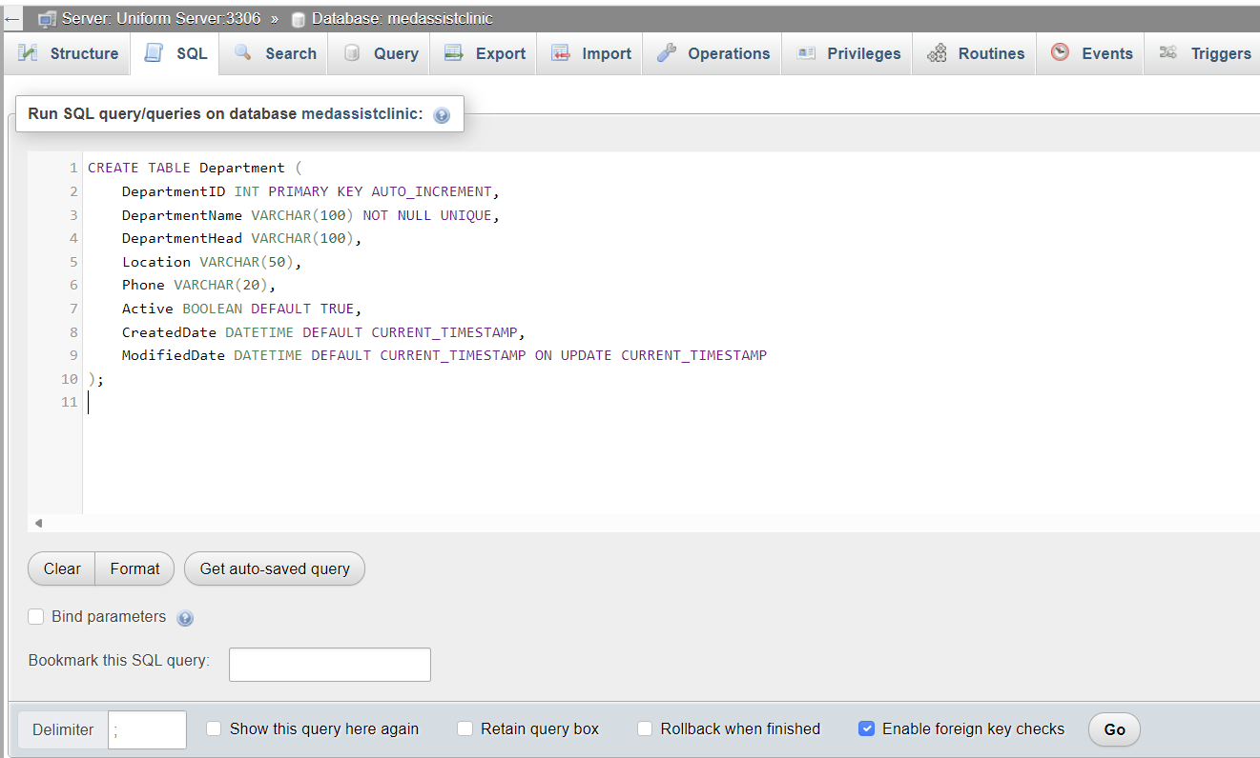

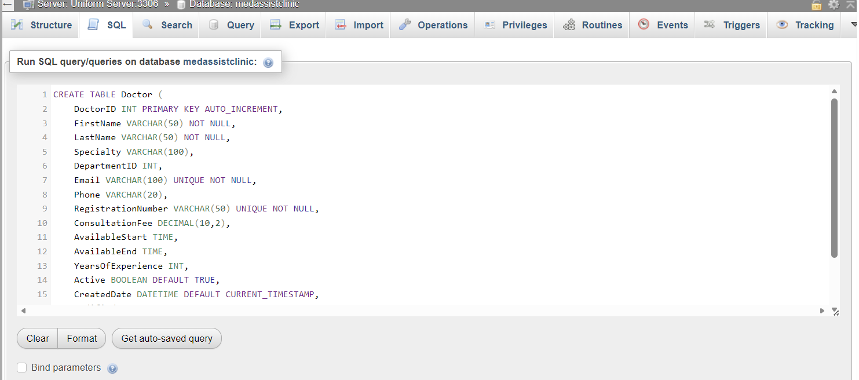

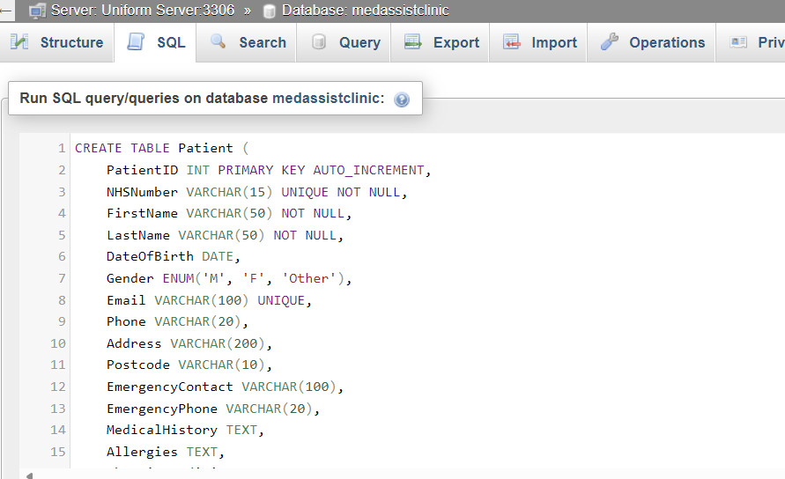

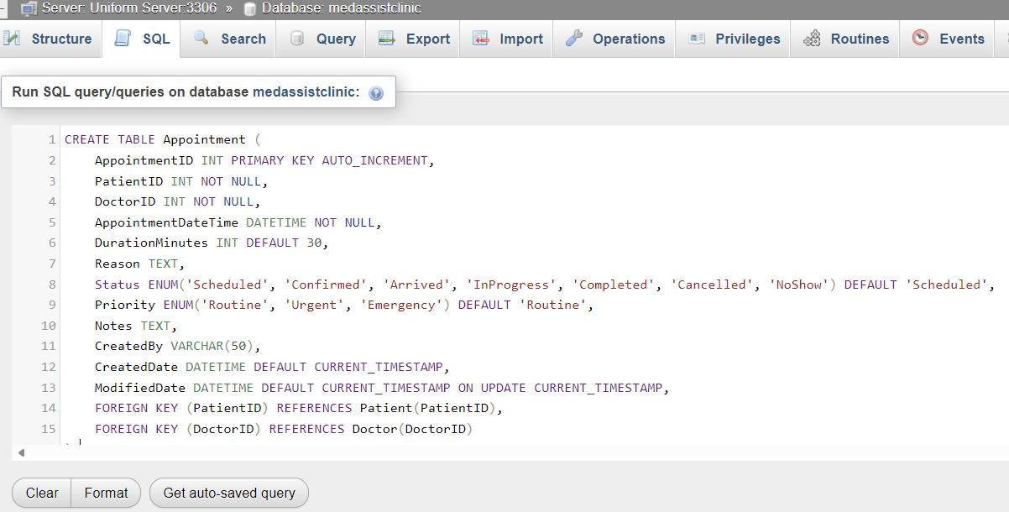

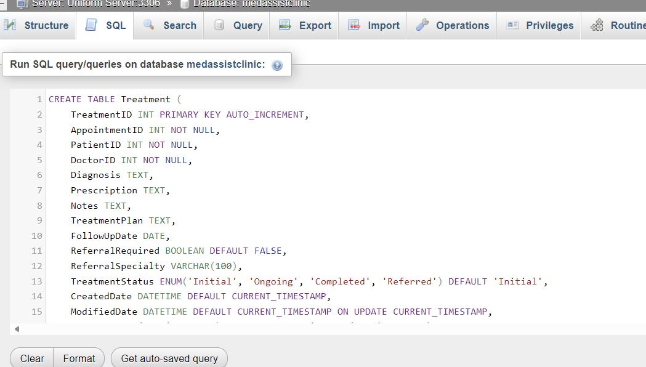

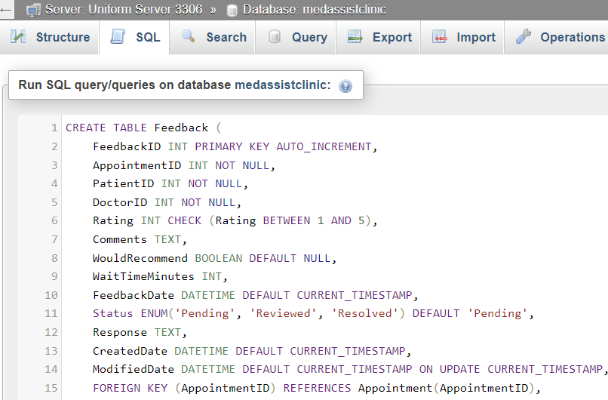

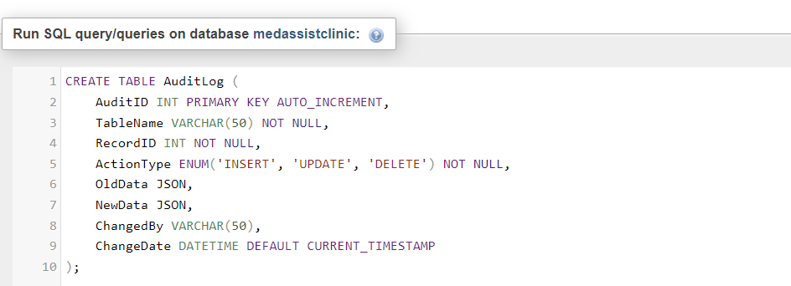

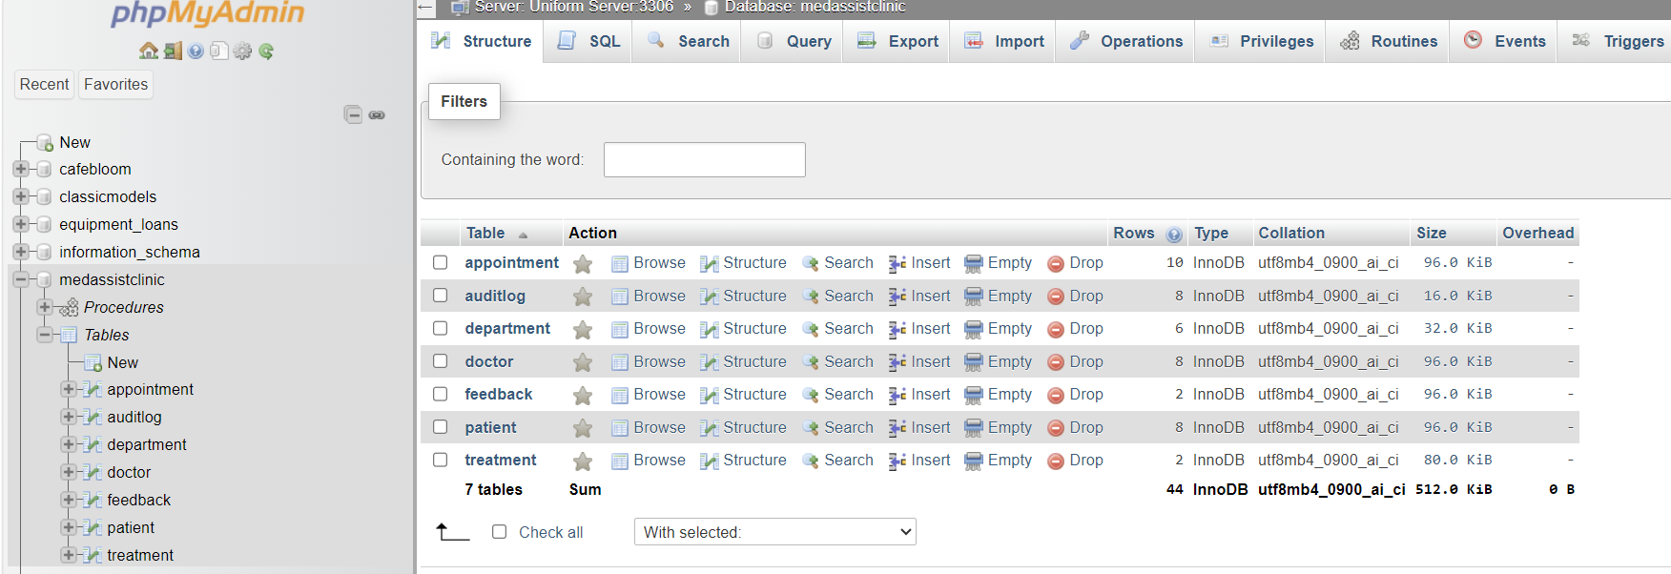
Inserting valued into department
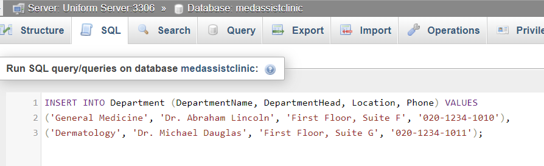
Results after running code
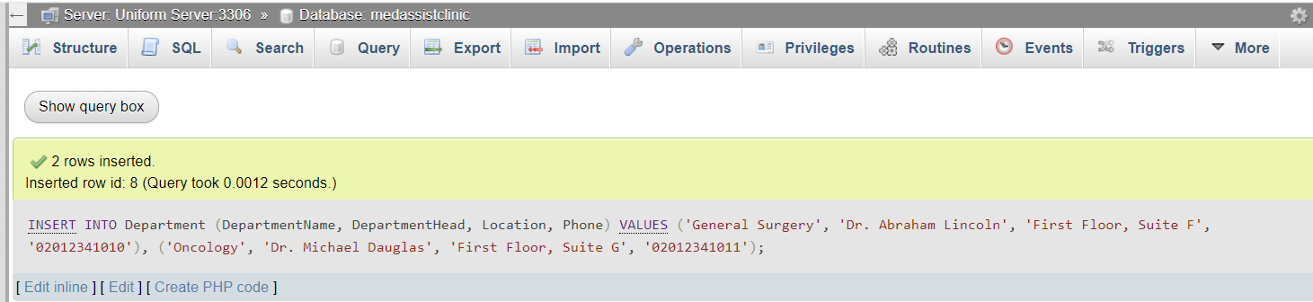

Transaction Scenario: Patient Visit Workflow
This demonstrates a complete patient visit cycle with commit/rollback
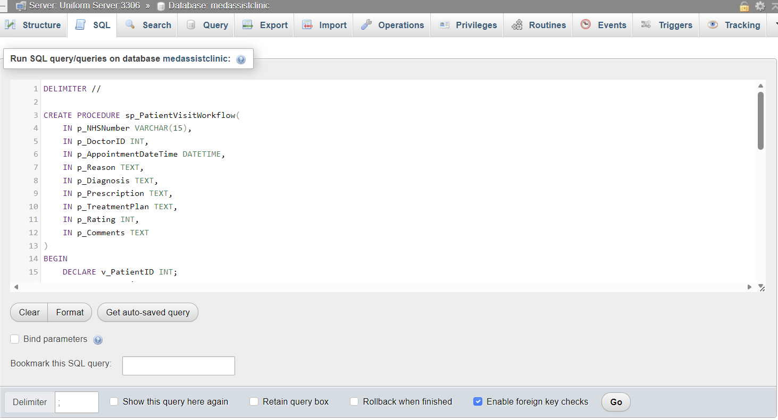
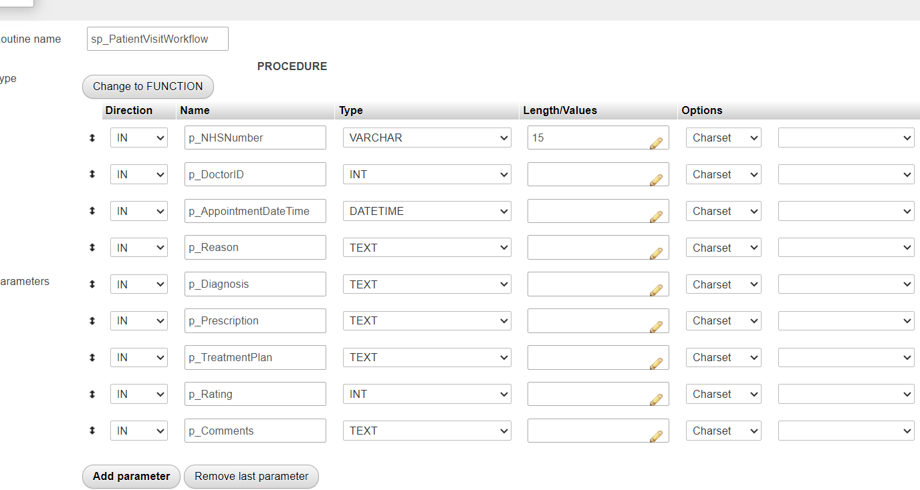

TEST QUERIES FOR PERFORMANCE TUNING

Query 1: Appointments by doctor and date rang

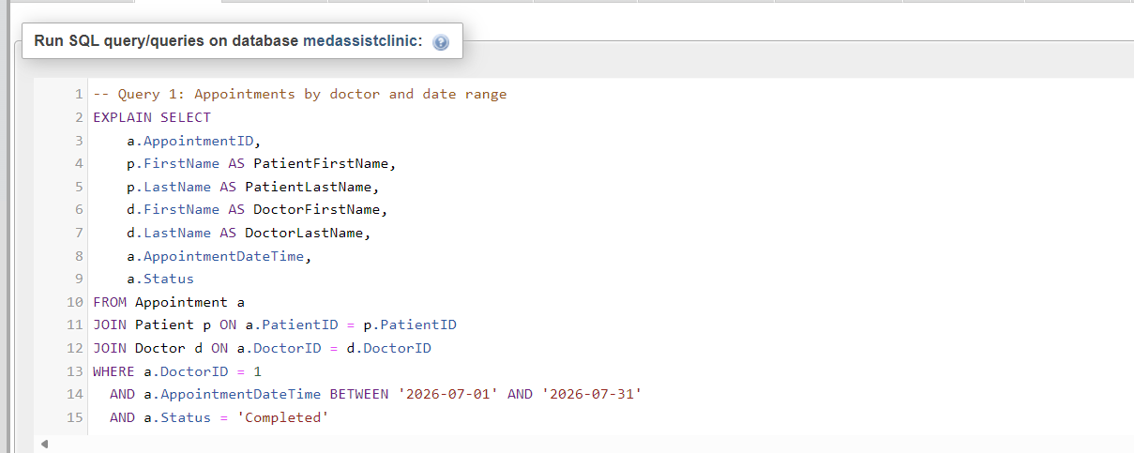

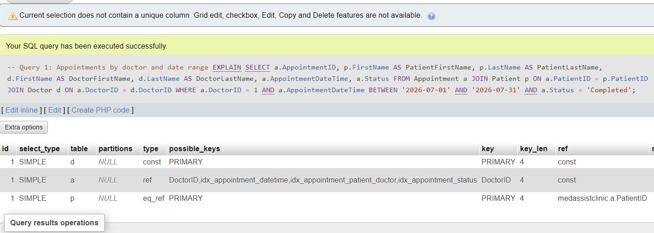

Query 2: Patient appointment history

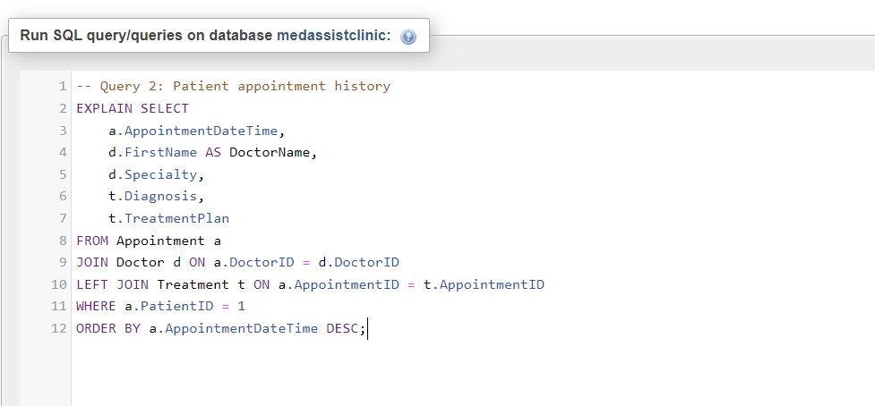

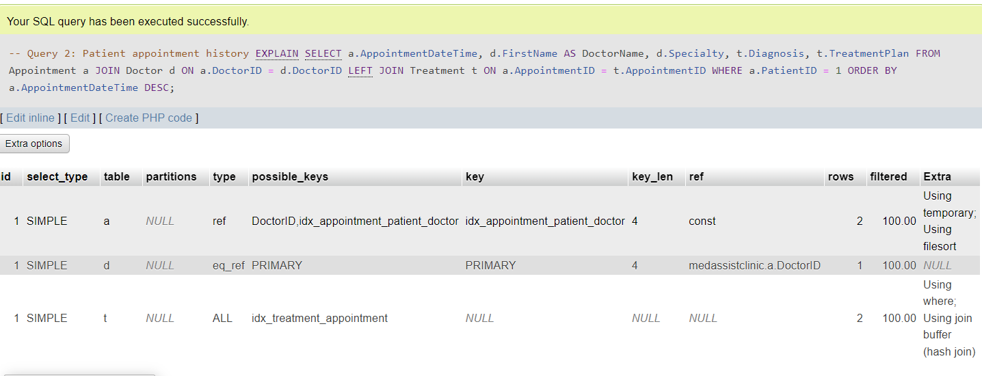

Query 3: Doctor workload statistics

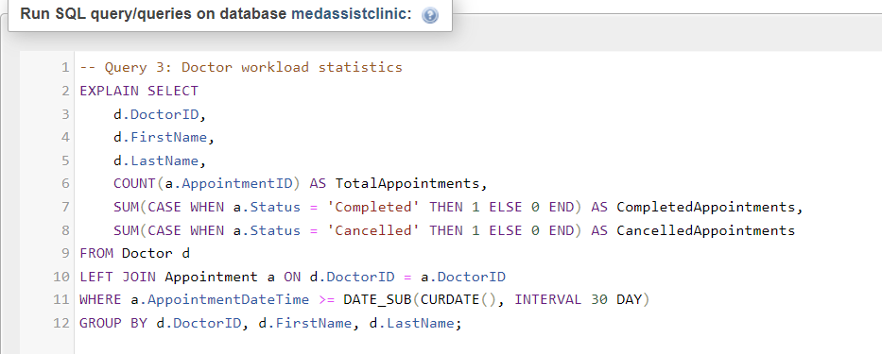

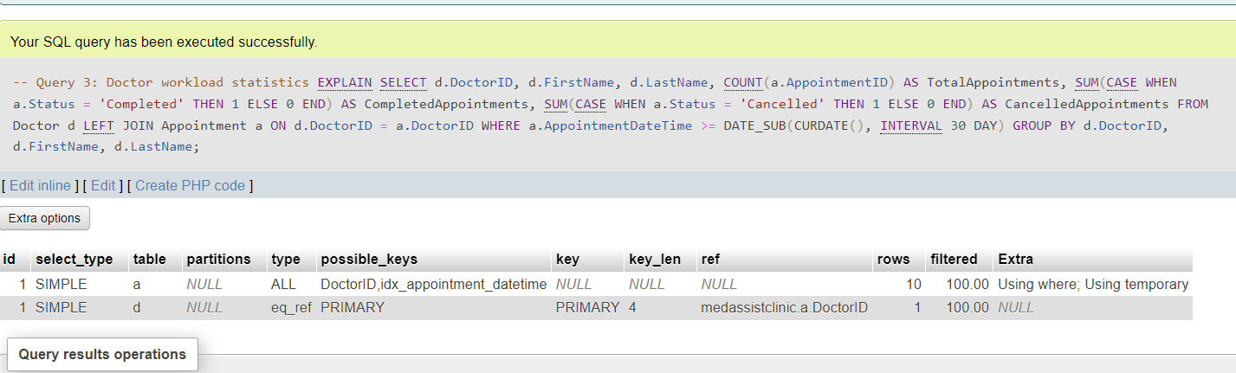

Query 4: Available doctors for a specific date/time
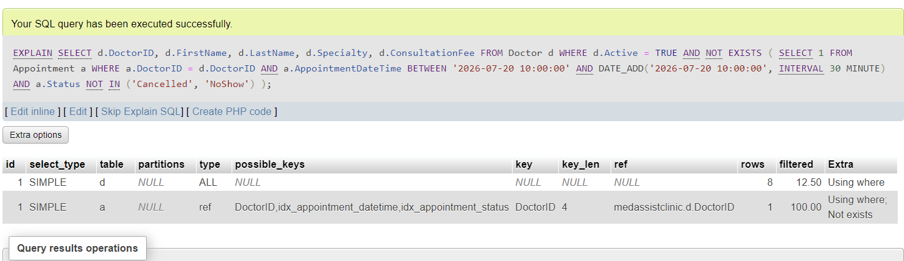

Query 5: Treatment follow-up reminders
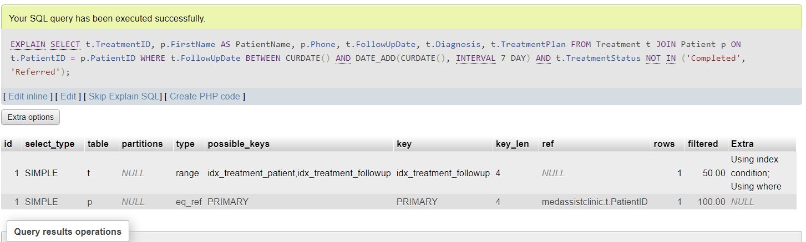

TRANSACTION DEMONSTRATION SCRIPTS

Book an appointment (Success case)
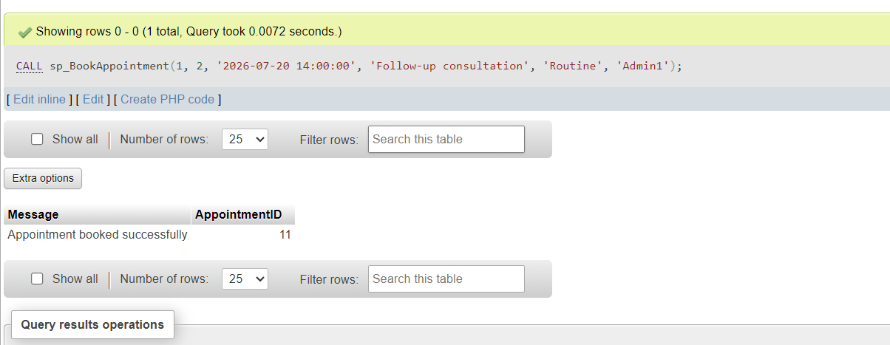

Book an appointment (Conflict case - should rollback)
This will fail because doctor already has appointment at this time
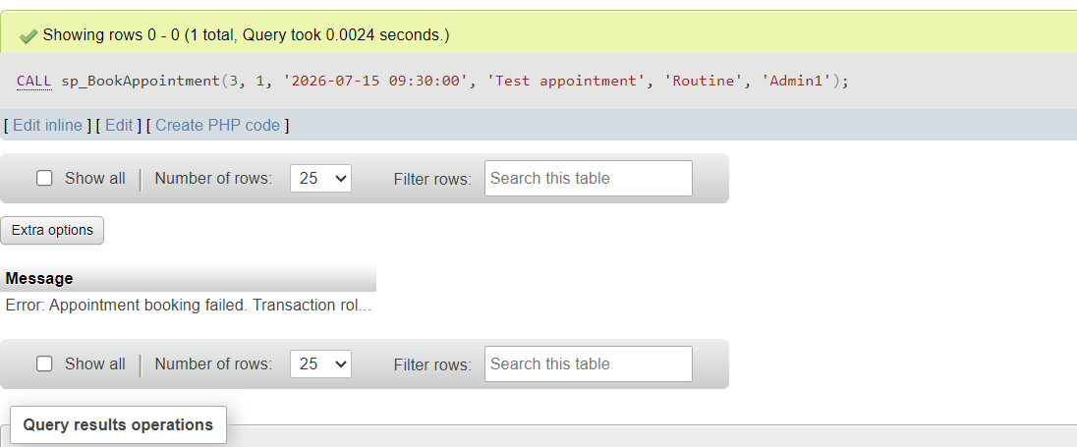

SAMPLE QUERIES FOR SYSTEM VERIFICATION
View all active doctors with their departments
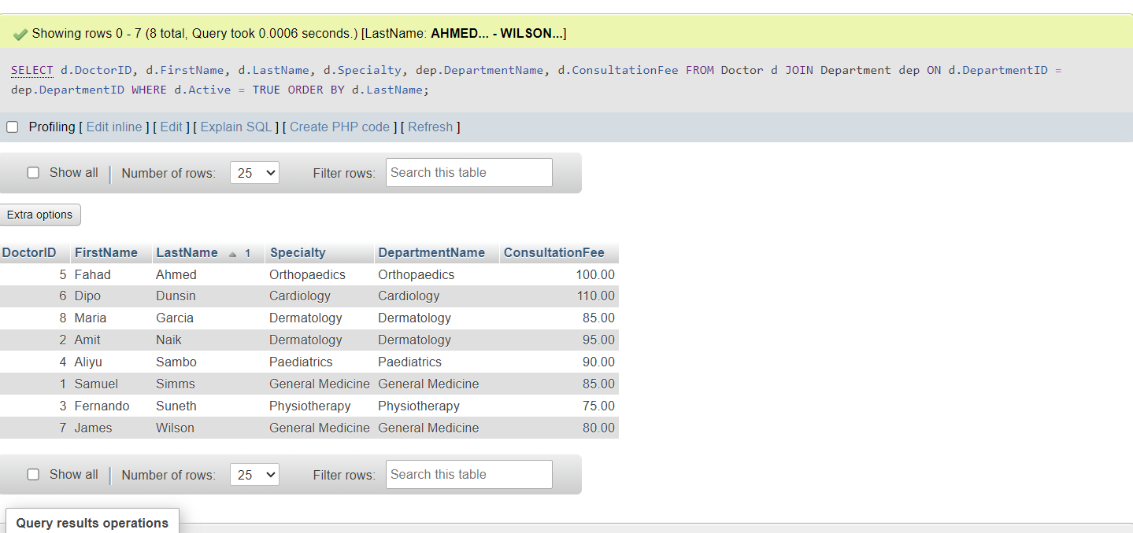

View patient treatment history
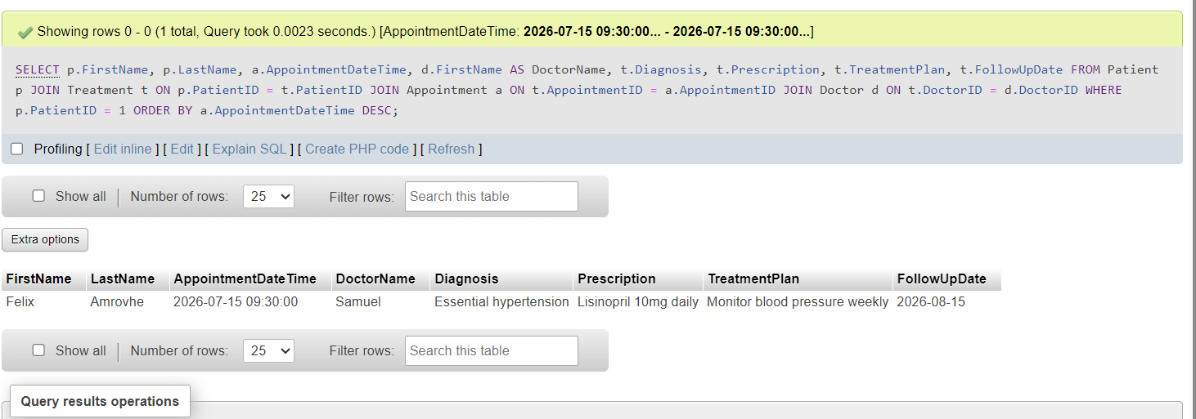

View doctor appointment statistics
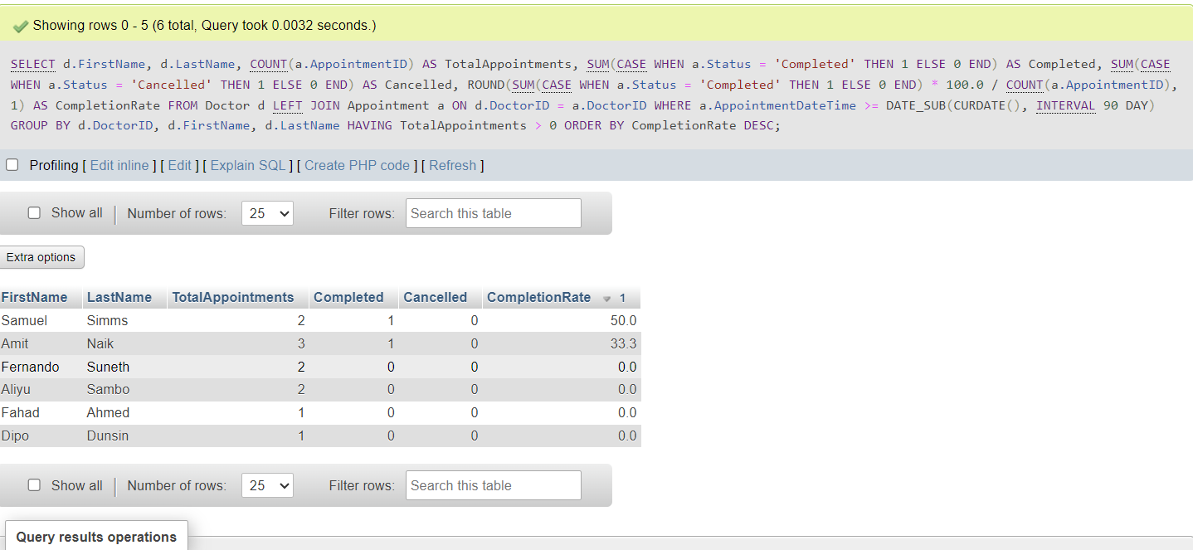

Conclusion

Summary of Design Achievements
The logical ERD schema for MedAssist Clinic represents a comprehensive, normalized database design that effectively addresses the clinic's operational requirements. The design successfully captures all essential entities and relationships, supports critical business processes, and maintains data integrity through appropriate constraints and normalization.

Business Value
The database design provides substantial business value by enabling:
- Efficient patient management and care coordination
- Streamlined appointment scheduling and resource allocation
- Comprehensive clinical documentation and continuity of care
- Data-driven decision making through reporting and analytics
- Scalable infrastructure supporting clinic growth

Quality and Integrity
The design ensures data quality and integrity through:
- Application of normalization principles up to 3NF
- Implementation of comprehensive constraints and validation rules
- Strategic indexing for performance optimization
- Support for transaction management and referential integrity

Recommendations
Based on the design analysis, the following recommendations are made:
- Implementation should prioritize index creation based on anticipated query patterns
- Regular monitoring of query performance should guide index maintenance
- Consideration should be given to implementing additional audit capabilities for regulatory compliance
- The design provides a solid foundation for future expansion into additional clinical modules

Final Thoughts
The MedAssist Clinic logical ERD schema provides a robust, well-structured foundation for the clinic's database implementation. Through careful analysis of business requirements, application of normalization principles, and strategic design decisions, the schema delivers an effective solution that will support the clinic's operations, ensure data integrity, and provide a scalable platform for future growth and enhancement.

References
[1] B. Thalheim, "Entity-Relationship Model", in Semantics of Programming Languages and Model Theory, pp. 327.
[2] A. E. Pennay and F. C. Measham, "The normalisation thesis–20 years later," vol. 23, no. 3, pp.187–189, 2016,
[3] C. J. Date, Database design and relational theory: normal forms and all that jazz, Apress, 2019.
[4] S. Abdy and S. Ramadhany, "Relational Database Design Principles: Normalization, Denormalization, and Query Optimization for Database Management Systems," vol. 9, no. 1, pp.180–192, 2026,
[5] E. Murray et al., , "Normalisation process theory: a framework for developing, evaluating and implementing complex interventions," vol. 8, no. 1, pp.63, 2010,
[6] A. MacFarlane, "Normalisation process theory: a framework for developing, evaluating and implementing complex interventions," 2010,
[7] T. Teorey, S. Lightstone, T. Nadeau and H. V. Jagadish,Database modeling and design: logical design, Elsevier, 2011.
[8] G. Ioannou* and C. Papadoyiannis, "Theory of constraints-based methodology for effective ERP implementations," Int J Prod Res, vol. 42, no. 23, pp.4927–4954, 2004,
[9] M. A. Qader, S. Cheng and V. Hristidis, "A comparative study of secondary indexing techniques in LSM-based NoSQL databases", in Proceedings of the 2018 International Conference on Management of Data, pp. 551–566.
[10] S. Sakshi¹ and A. Sharma, "Relational Database Performance Optimization Techniques", in Proceedings of the International Conference on Recent Advancement and Modernization in Sustainable Intelligent Technologies & Applications (RAMSITA-2025), pp. 112.
[11] E. Boros, P. L. Hammer, T. Ibaraki, A. Kogan, E. Mayoraz and I. Muchnik, "An implementation of logical analysis of data," IEEE Trans.Knowled.Data Eng., vol. 12, no. 2, pp.292–306, 2000,

PART B

SQL Injection Report
Overview of SQL Injection
SQL Injection is a high-risk security vulnerability in which an attacker manipulates an application’s database queries by injecting malicious input into SQL statements that are not sanitised. This occurs when user-provided data is incorporated into queries without appropriate validation or the use of parameterised statements. As a result, attackers may gain unauthorized access to sensitive information, alter or delete data, or in severe cases, compromise the entire database system.
SQL Injection presents a significant security threat because it enables attackers to manipulate backend database operations through maliciously crafted input. Its impact can be severe and multifaceted:
- Data Breaches: Attackers may extract confidential information, including authentication credentials, personal records, and financial data.
- Data Manipulation: Malicious users can alter, insert, or delete database records, compromising data integrity.
- Authentication Bypass: Improperly validated queries can allow attackers to gain unauthorized access to user accounts without valid credentials.
- Privilege Escalation: Exploited vulnerabilities may grant attackers elevated permissions, exposing administrative functions and sensitive system components.
- Denial of Service: Resource-intensive or disruptive queries can be executed to degrade performance or crash the database server.
- Remote Code Execution: In advanced cases, SQL Injection can be leveraged to execute operating system-level commands, leading to full system compromise.

Example of SQL Injection Attack:
Vulnerable login query:
SELECT * FROM users WHERE username = '$admin' AND password = '$password';
If an attacker enters:
- Username: admin' OR '1'='1
- Password: anything
The query becomes:
SELECT * FROM users WHERE username = 'admin' OR '1'='1' AND password = 'anything'
This returns all users because '1'='1' is always true, potentially allowing access to the first user account.
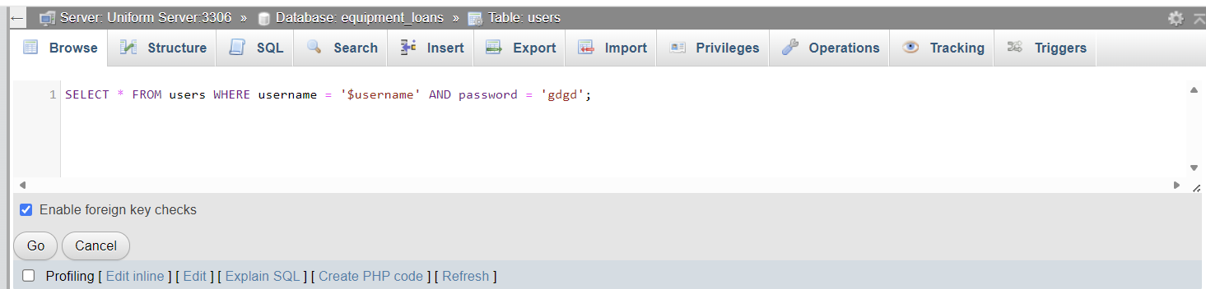
Another example for search:
SELECT * FROM equipment WHERE name LIKE '%$search%';
If an attacker enters: %' UNION SELECT username, password_hash FROM users --
The query becomes:
SQL
SELECT * FROM equipment WHERE name LIKE '%' UNION SELECT username, password_hash FROM users -- %'
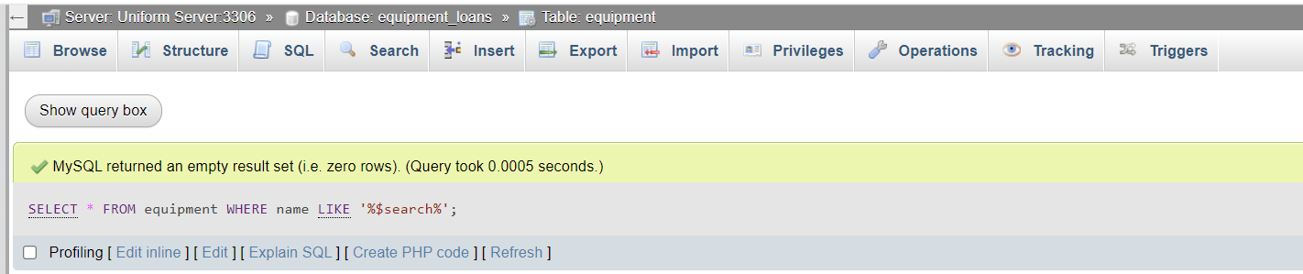
This could expose all user credentials.
SQL Injection Defences Implemented in Our Code
Our application implements multiple layers of defence against SQL injection:
1. Prepared Statements with PDO
Screenshot of Implementation:
// From equipment.php - Add Equipment
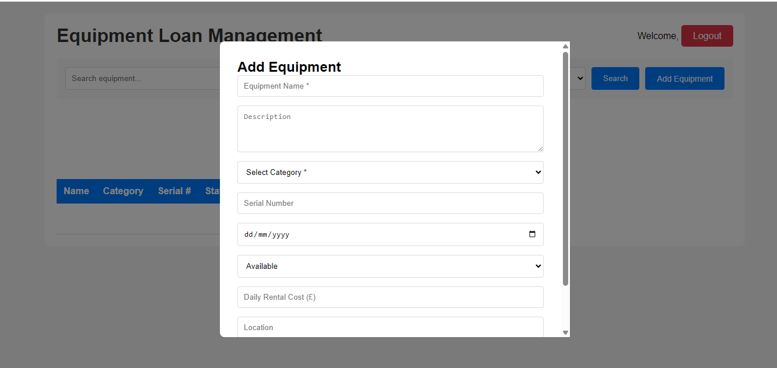Why It's Effective:
- Prepared statements separate SQL logic from data.
- The database engine compiles the query template first.
- User input is treated as data, not executable SQL code.
- Special characters automatically escaped.
- Even if attackers try to inject SQL, it's treated as literal text.
2. PDO Emulate Prepares Disabled
php
// From configdb.php
$this->conn->setAttribute(PDO::ATTR_EMULATE_PREPARES, false);
Why It's Effective:
- Forces the database to use native prepared statements.
- Prevents PDO from trying to emulate prepared statements client-side.
- Ensures proper parameterization at the database level.

