

Programme: BA Leadership and Management
Module: Coaching and Mentoring Skills for the Workplace

Module code: BMSW6105
Task 3 – Written Reflection

Lecturer Name: Nishi Ramsurrun
Student ID: 2131037
Student Name: Mariyana Rusafova

Executive Summary
The report has reflected on the difference between mentoring and coaching. It is seen that mentoring is applicable in the long term while coaching is responsible for short term specific development. The application of the “GROW coaching model” is considered effective as it enables individuals to address specific goals, assess the reality, explore different scopes as well as dedication to further appropriate actions. In addition, incorporation of this specific coaching model is beneficial for personnel in terms of increasing self-awareness, creativity practices, improving overall performance along with fostering dedication. Both peer-to-peer coaching and mentoring sessions were encouraging experiences for me and this is because both sessions guided me with strategies and techniques that can help me to perform better in future, specifically when going through a public presentation.

Table of Contents
1. Introduction 4
1.1 Overview of the report 4
1.2 Concept of coaching and mentoring 4
1.3 Key theories and models 4
2. Critical evaluation of the purpose of coaching and mentoring within a workplace 4
3. Critical analysis of a specific model of coaching 5
3.1 “Define your chosen model for coaching” 5
3.2 “Critically analyse your chosen model of coaching – advantages and disadvantages – examples of situations in which the model would be most useful” 6
4. Reflection on Practical 1 6
5. Reflection on Practical 2 8
6. Self-assessment 9
6.1 SWOT - A Personal swot analysis 9
6.2 Skill audit - Skill they have with examples and Skills they are lacking with areas of improvement 10
6.3 Action Plan - A clear action plan with developmental areas 10
6. Conclusion 11
7. Reference list 12
Appendix: Self-assessment test result 14

1. Introduction

1.1 Overview of the report
The reflective report will critically evaluate the purpose of coaching and mentoring within a workplace. The report will also analyse a specific model of coaching. Reflection on the two practical sessions will also be conducted. The report will present a personal SWOT analysis, skill audit and an action plan.

1.2 Concept of coaching and mentoring
Coaching has been understood as a philosophy that is directed towards helping learners in acknowledging their potential (Atkinson et al. 2022). Coaching strongly emphasises learning and improvement of performance that can assist personal or professional growth. Feedback has been noted as an essential aspect in the process of coaching. On the other hand, mentoring is defined as a relationship between an experienced individual and a less experienced individual directed towards the development of the former (Chong et al. 2020). From this, it can be understood that both coaching and mentoring are directed towards enhancing the development of individuals by fostering learning. However, according to Stokes et al. (2021), coaching has been associated with a focus on short-term performance, while mentoring has been related to a focus on long-term performance. Furthermore, it is seen that mentoring is directed towards overall development, while coaching can develop specialised skills.

1.3 Key theories and models
Kolb's reflective model is a tool of reflection that helps in the evaluation of personal experience through four stages that include concrete experience, reflective observation, abstract conceptualisation and active experimentation (Morris, 2020).
The GROW coaching model is an effective framework that can be used to assess goals and commit to actions that can be used to complete the goal (Grant, 2022).

2. Critical evaluation of the purpose of coaching and mentoring within a workplace
Mentoring and coaching have been identified as recognised tools in the workplace. This can further be applied in different workplace scenarios to assist employees in their professional and skill development. Both mentoring and coaching in the workplace have been noted to provide a range of benefits, which may include high employee engagement, a positive work environment, and improved employee performance (Indeed, 2025). Hence in terms of outcomes, a major similarity between coaching and mentoring can be directed towards providing benefits to the organisation.
Purpose of coaching
In the workplace coaching can help employees in assisting employees in reaching a specific level in terms of skills. According to Fadare et al. (2023), coaching can help in unlocking the potential of the individual. It is seen that coaching generally guides employees on a very precise subject. Since it focuses on specific areas, it can be evaluated in terms of improvement in specific skills such as digital skills, leadership skills or communication skills. Furthermore, when an employee is provided with effective coaching, it can assist in an enhanced level of self-awareness and accountability. As a result, employees who have been coached effectively can help in developing autonomy among the employees, which can help in leading the working process and the operations.
Purpose of mentoring
In contrast to coaching, mentoring is concerned with developing a long-term relationship which is focused on personal and professional growth (Mohtady et al. 2019). In the process of mentoring, there are generally two individuals involved: the mentor and the mentee. The mentor acts as a source of guidance, advice and support from the mentor who is generally more experienced than the mentee. However, it is important to note that in the process of mentoring, career development and psychological support are provided to the mentee that can assist in navigating career paths and organisational politics.
Comparison between coaching and mentoring
Coaching and mentoring are professional approaches that are based on one-to-one conversations directed towards uplifting the current state of an individual (CIPD, 2024). Coaching aims to improve performance and productivity within the workplace. On the other hand, mentoring is generally done to support the development of a less experienced individual (CIPD, 2024). In terms of differences, it can be said that coaching lasts for a specific period, on the other hand, mentoring is concerned with a long period of relationship. The objective of coaching is to assist the performance of employees and support self-directed learning (CIPD, 2024). In contrast, mentors guide the individual on selections, decision-making that can be beneficial for their overall professional or personal growth.

3. Critical analysis of a specific model of coaching

3.1 “Define your chosen model for coaching”
Based on the above discussion, it can be stated that the GROW coaching model has been used in this case. According to the research of Surya (2022), the “GROW coaching model” is an essential framework that allows people to determine specific goals, evaluate reality, explore different opportunities, along with committing to effective actions. Consideration of this coaching model is effective for boosting self-awareness, improving creativity, developing performance and fostering greater dedication. On the other hand, Mathew and Hakrob (2022) have claimed that by concentrating on the primary areas only, the GROW coaching model enables individuals to consider the ownership of their aimed goals and overall progress that can lead to their desired results. While considering the GROW coaching model, it is assumed that the coach or guide is not the expert in diverse situations of clients, and it indicates the coach needs to perform as facilitators who help the coach to consider the best options only, instead of providing direction.

3.2 “Critically analyse your chosen model of coaching – advantages and disadvantages – examples of situations in which the model would be most useful”
The “GROW coaching model” includes both advantages and disadvantages. As opined by Deiorio et al. (2022), the GROW model of coaching helps to improve goal setting, develop problem solving, increase confidence and motivation, as well as enhance self-awareness. The concerned structured coaching framework helps coaches to guide personnel in attaining their desired goals and improving their potential. However, the GROW model can have its own limitations. According to Patary (2023), the GROW coaching model is a structured framework that can be very rigid. As a result, it can be understood that in scenarios where more flexibility is required, the model can have limited advantages. The GROW coaching model is also framed to help individuals achieve specific goals. However, in terms of complex problems, a deeper exploration cannot be possible by the application of the GROW Model. The factors that are considered in the GROW model are beliefs, values and behaviours. As a result, external factors such as organisational culture and economic conditions can have an impact on the ability to achieve the set goals.
Furthermore, it is also stated that a Grow coaching model can lead to poor performance as it is dependent on the coach (Patary, 2023). The lack of engagement from the client can be detrimental in this case. In case of a decline in the overall performance of the team, the GROW model can be applied (Palanivel, 2024). The application of the GROW model can guide the overall team in enhancing their performance.

4. Reflection on Practical 1
By using the Kolb's reflective cycle, different experiences can be assessed to foster further conceptualization, reflection, as well as experimentation.
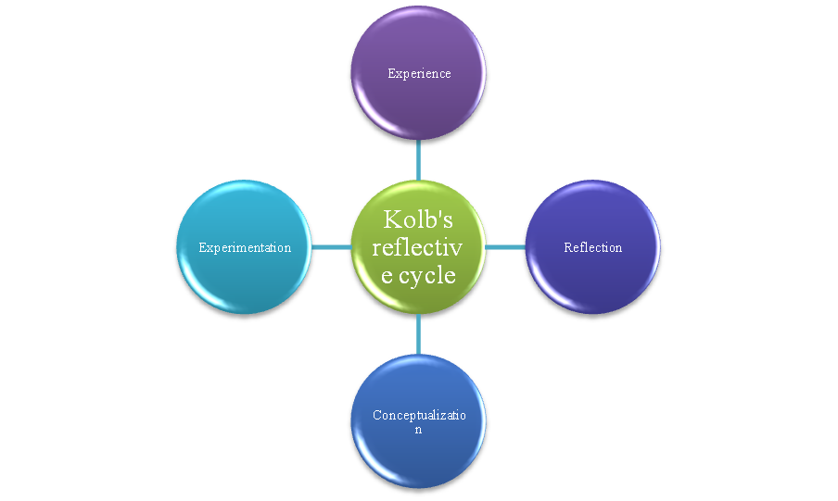
Figure 1: Kolb's reflective cycle
(Source: Developed by author)
Concrete Experience
I have experienced nervousness and confusion while thinking about standing in front to present my work. I think the lack of prior experiences, as well as anxiety and nervousness, can decline the effectiveness of my performance. According to Grieve et al. (2021), a lack of confidence and fear of being judged can reduce the potential for effectiveness. In this situation, I was guiding the coachee through a transparent conversation and I helped her to reduce excessive stress when she presents in front of people. This helps me to understand the overall situation along with presenting my performance. Henceforth, as a coach I have prepared myself to perform efficiently in front of the lecturer.
Reflective Observation
While I was communicating with the coachee I noticed that she was nervous, avoiding eye contact and speaking too fast. I felt a mix of empathy and responsibility to help her to improve. Also, I felt proud when she showed signs of progress. I have also analysed that the use of bullet points in the role play can help me to convey my opinions and findings briefly which can positively influence the overall presentation. Based on the view of Seals (2022), while presenting a topic, the use of bullet points, and other strategic approaches can improve the conversation along with increasing understanding. Thus, the application of the GROW model of coaching has helped me to improve my awareness and confidence, along with setting clear goals that can lead to better outcomes.
Abstract Conceptualisation
From the hands-on coaching conversation between me as the coach and one of my classmates as a coachee, I came to understand that her nervousness originated from a lack of self-belief and a lack of preparedness. After discussing these concerns with the coachee, I understood that the foundation of an effective presentation resides in the ability of the presenter to build on clarity, structure and connection with the target audience. It is a proven fact that engagement is the key to creating connectivity with the audience (SlideModel, 2024). I also conceptualised that self-confidence generates when there is a positive mindset and through repeated practice. Thus, to reduce anxiety in the case of a presentation, an individual must focus more on key points to attract the attention of the audience instead of looking for perfection in the first presentation attempt.
Experimentation
I need to inspire my coachee put similar strategies into practice and set a goal, I must inspire her to rehearse from time to time. At the same time, I need to seek feedback from my peers and from my instructor regarding my progress in this area of coaching.

5. Reflection on Practical 2
I am using Kolb’s model of reflection to reflect on my practical experience regarding a peer-to-peer mentoring session.
Concrete Experience
I had a peer-to-peer mentoring session where I was the mentor and one of my fellow mates was the mentee. In that mentoring session, I played a promising role in making my peer interested in discussing his anxiety and concerns around presentations at work, a key part of which is face-to-face communication. I was open enough to share my past presentation experiences in formal settings while mentioning my nervousness that often overwhelms me. This guided my mentee how to make a successful presentation. The supporting mentoring environment helped my peer to open the fact that during presentation, she often fears forgetting key points. At the same time, the fear of being judged by others gets reflected in his lack of self-confidence. In many cases, fear of being judged by others leads us to inferiority (Deccan Herald, 2020). My fellow mate, who was the mentee, listened to all my points attentively and then, provided some practical viewpoints which were extremely suitable to apply. Overall, I can say that my experience as a mentor in this peer-to-peer mentoring session was both comforting and constructive.
Reflective Observation
My reflective observation says that it was helpful for me to talk about my concerns with an individual who responded extremely empathetically. I can say that I can come up as a competent mentor in future as I did not go for critiquing my nervousness and lack of self-confidence during public presentations In this context, I noticed that immediately after I recalled a past positive experience, my mentee had a standpoint of boosting her confidence level while reminding me that I am capable enough of being successful in mentoring others. A point that I need to highlight here is that as the mentor, I successfully pointed out specific ways one can prepare for presentations (specifically, script memorisation process) that contributed to stress development.
Abstract Conceptualisation
A key abstract that I have conceptualised is that self-confidence is not in-born. Rather, self-confidence needs to be developed by applying certain intentional strategies and here comes the applicability of repeated practices. A proven fact is that stopping comparing yourself with others is a way out towards boosting self-confidence (Very Well Mind, 2024). At the same time, repeated practice helps to increase confidence, improve speed and strengthen the connectivity with the brain to learn faster. I also realised that doing things I am good at is important to boost my confidence level as a competent mentor while I must stop overthinking on those areas where I am not good enough. This insight helped me rethink my approach to mentoring.
Experimentation
To move forward and better perform in my future mentoring sessions, I will capitalise on the techniques and strategies received as feedback from my mentee. This will include utilising breathing exercises and practicing out loud followed by recording myself. All these can manage my anxiety while allowing me to better perform as a mentor.

6. Self-assessment

6.1 SWOT - A Personal swot analysis
Strengths | Weaknesses | Opportunities | Threats
- I can clearly express my feelings during one-to-one communication sessions.  - I am extremely receptive to feedback from others. | - I have lack of self-confidence  - I often feel pretty nervous and anxious during public speaking. | - Through peer mentoring, I can improve my presentation skills.  - I can improve my self-confidence by participating in mock presentation sessions. | - Poor self-belief can hinder my performance.  - Judging myself with others can reduce my motivation.
Table 1: Personal SWOT Analysis
(Source: Self-developed)

6.2 Skill audit - Skill they have with examples and Skills they are lacking with areas of improvement
Skills I Have | Example
Communication | I have received a good score of 80 in a self-assessment test [Refer to Appendix].
Skills I Would Like to Improve | Example
Self confidence | I would try to participate in more numbers of mock mentoring sessions.
Lowering of my nervousness and anxiety levels during public speaking and mentoring sessions. | I will attend a public speaking crash course of 6 months duration.
Table 2: Individual Skills Audit
(Source: Self-developed)

6.3 Action Plan - A clear action plan with developmental areas
Development Objectives | Resources Needed | Target Start Date | Target End Date | Review Date
To improve my self confidence | Workshops for confidence development and  YouTube videos | 15/04/2025 | 15/07/2025 | 15/06/2025
To reduce my nervousness and anxiety levels during public speaking | Mock speeches, feedback from peers and a public speaking crash course | 15/04/2025 | 15/10/2025 | 15/09/2025
Table 3: Action Plan
(Source: Self-developed)

6. Conclusion
Based on the above discussion, it can be concluded that to facilitate my academic and career advancement, I must be capable of attending as many possible coaching and mentoring sessions. Both coaching and mentoring sessions are exceptional in terms of finding strengths and weaknesses of an individual while receiving active guidance regarding how to build on strengths and work on weaknesses. By embracing and applying the GROW coaching model as well as applying the Kolb’s model of self-reflection, I can facilitate my self-empowerment, further critically assessing my weaknesses, strengths and future areas of improvement. My self-reflection on peer-to-peer coaching and mentoring sessions I have gone through previously, I have highlighted the ever-growing significance of goal setting, self-awareness and working on continuous feedback as all of these can critically contribute to overcoming certain barriers such as low morale and low self-confidence, both of which can decline performance level of an individual. Both peer-to-peer coaching and mentoring sessions were transformative experiences for me in the sense that I have been guided with strategies and techniques that can help me to perform better in future as a mentor and coach. The personal SWOT analysis has highlighted that I must work further on improving self-confidence and reduce anxiety level.

7. Reference list
Atkinson, A., Watling, C.J. and Brand, P.L., 2022. Feedback and coaching. European journal of pediatrics, 181(2), pp.441-446.
Chong, J.Y., Ching, A.H., Renganathan, Y., Lim, W.Q., Toh, Y.P., Mason, S. and Krishna, L.K., 2020. Enhancing mentoring experiences through e-mentoring: a systematic scoping review of e-mentoring programs between 2000 and 2017. Advances in Health Sciences Education, 25, pp.195-226.
CIPD, 2024. Coaching and mentoring. Available at: https://www.cipd.org/en/knowledge/factsheets/coaching-mentoring-factsheet/ (Accessed: 08 April 2025)
Deccan Herald, 2020. Overcome fear of being judged, be more confident. Available at: https://www.deccanherald.com/education/overcome-fear-of-being-judged-be-more-confident-839793.html (Accessed: 08 April 2025)
Deiorio, N.M., Moore, M., Santen, S.A., Gazelle, G., Dalrymple, J.L. and Hammoud, M., 2022. Coaching models, theories, and structures: An overview for teaching faculty in the emergency department and educators in the offices. AEM education and training, 6(5), p.e10801.
Fadare, A.S., Cruz, T.J.D., Rodriguez, R.M., Sacopla, K.N. and Chavez, E.M., 2023. The Unmasked Coach: Mastering Decision-Making Skills. Tuijin Jishu/Journal of Propulsion Technology4 (4); 4358, 4366.
Grant, A.M., 2022. Is it time to REGROW the GROW model? Issues related to teaching coaching session structures. Coaching Practiced, pp.29-40.
Grieve, R., Woodley, J., Hunt, S.E. and McKay, A., 2021. Student fears of oral presentations and public speaking in higher education: a qualitative survey. Journal of Further and Higher Education, 45(9), pp.1281-1293.
Indeed, 2025. Mentoring vs. coaching: key differences and benefits. Available at: https://uk.indeed.com/career-advice/career-development/mentoring-vs-coaching (Accessed: 08 April 2025)
Mathew, P. and Hakrob, A.N., 2022. Coaching in a higher education institution in the Middle East: Reflections on the obstacles and the way forward. International Journal of Evidence Based Coaching and Mentoring, 20(1), pp.66-82.
Mohtady, H.A., Könings, K.D., Al-Eraky, M.M., Muijtjens, A.M. and van Merriënboer, J.J., 2019. High enthusiasm about long lasting mentoring relationships and older mentors. BMC Medical Education, 19, pp.1-9.
Morris, T.H., 2020. Experiential learning–a systematic review and revision of Kolb’s model. Interactive learning environments, 28(8), pp.1064-1077.
Palanivel, S., 2024. GROW Model Coaching: Enhancing Contact Center Performance. Available at: https://www.linkedin.com/pulse/grow-model-coaching-enhancing-contact-center-sunthar-palanivel-plq2f (Accessed: 08 April 2025)
Patary, C., 2023. Knowing the constraints of the Coaching context is an excellent Coaching tool! Available at: https://www.linkedin.com/pulse/knowing-constraints-coaching-context-excellent-tool-chandan-patary (Accessed: 08 April 2025)
Seals, D.R., 2022. Talking the talk: tips for effective oral presentations in biomedical research. American Journal of Physiology-Regulatory, Integrative and Comparative Physiology, 323(4), pp. R496-R511.
SlideModel, 2024. Presentation Structure Guidelines for Effective Communication. Available at: https://slidemodel.com/presentation-structure/#:~:text=Engage%20Your%20Audience,between%20you%20and%20your%20audience. (Accessed: 08 April 2025)
Stokes, P., Fatien Diochon, P. and Otter, K., 2021. “Two sides of the same coin?” Coaching and mentoring and the agentic role of context. Annals of the New York Academy of Sciences, 1483(1), pp.142-152.
Surya, J., 2022. Coaching as A Strategy for Empowering Communication Skills in The Educational Context. International Journal of Educational Management & Innovation, 3(2).
Very Well Mind, 2024. How to Be More Confident: 9 Tips That Work. Available at: https://www.verywellmind.com/how-to-boost-your-self-confidence-4163098 (Accessed: 08 April 2025)

Appendix: Self-assessment test result
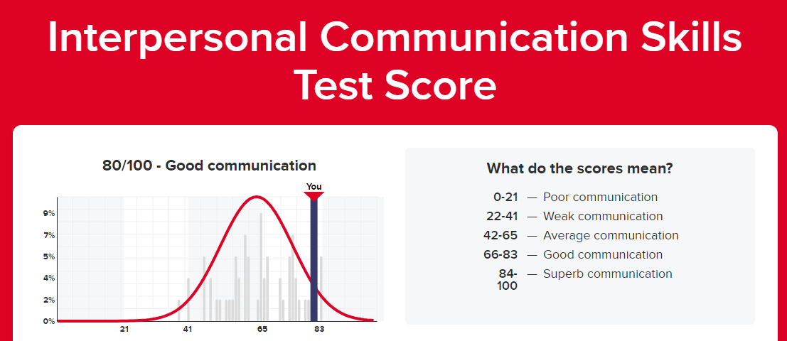
(Source: https://www.psychologytoday.com/us/tests/relationships/interpersonal-communication-skills-test/results)



