  Component One:  What are the key skills required when working in the housekeeping team? 750 words (+/- 10%) | Student No: | Liviu Zaharia 2122725
 | Module Title: | BMIH4006 Resit
 | Module Code:
 | Lecturer:
In the hospitality industry, the housekeeping department plays an important role as it is responsible for reporting safety issues and ensuring cleaning as well. Being an efficient member of a housekeeping team, a person is responsible for maintaining cleanliness and orderliness in places such as hotels, hospitals and apartment buildings which requires a unique set of skills (Singh and Jaykumar, 2019). Based on my prior experience working in a housekeeping team, I can assure you of the significance of possessing such skills and the advantageous impact they exert on the collective team. Attending guests nicely, and mannerly is an essential requirement for achieving success as a housekeeper. This requires maintaining attentive attention to guests and employing a systematic approach to ensure that all elements in the hotel are appropriately arranged. I have developed the ability to separate and notice dirt and disorder that may elude others, thereby ensuring comprehensive cleaning coverage. Housekeeping requires organising skills as it helps in prioritising work and critical tasks. The task of housekeeping needs the ability to manage time efficiently. The efficiency of a team is contingent upon the ability of a person to establish priorities, efficiently arrange tasks, and punctually fulfil responsibilities (Marneros et al., 2020). Efficient time allocation guarantees the completion of all assigned duties within the designated timeframe. For like, I have assigned the task of checking multiple spaces and different section that was needed to sanitise. The attainment of effective prioritisation skills has been achieved through the implementation of a strategy that involves breaking down large-scale projects into smaller, more manageable tasks. The approach taken is to adopt the strategy employed based on the level of urgency and complexity of each task. As a result of this, I have been able to enhance my productivity and maintain a superior level of work quality.
Proficient communication skills among housekeeping staff are crucial. Effective coordination among staff members can be achieved through transparent and open communication (Strömmer et al., 2020). It is important to facilitate the exchange of appropriate information and the resolution of any issues that may arise in offering guest services. When working in the housekeeping team, I have noticed that communication is a critical and important skill. I have endeavoured to establish a friendly and collaborative work environment by consistently maintaining open channels of communication with my colleagues. By engaging in collective problem-solving and exchanging ideas, we have enhanced our efficiency and reduced exceptional customer service. I have been working in the housekeeping department of a 3-star hotel, from which I have learned that business management skills, along with persistence and determination, are important. I have also noticed that a housekeeping member just needs to be patient and remain calm in every situation, as it helps in paying attention to small details and customer service skills. Efficient time management is crucial for ensuring the timely preparation of all rooms, particularly during periods of high check-in activity (Cañibano et al., 2020). Moreover, it is important for the person to maintain open channels of communication to effectively coordinate with team members and promptly address any specific apprehensions. The proficiency and utilisation of certain skills by housekeeping personnel in the hospitality industry can significantly impact customer satisfaction and the reputation of the hotel.
To sum up, the competencies of teamwork, organisation, and diligence are among the crucial skills required for achieving success in the domain of housekeeping. The incorporation of individuals possessing these proficiencies is anticipated to enhance the efficiency and yield of the team. As a result of self-reflection and practical application, I possess a deep understanding of the significance of refining these skills and have observed the benefits in the context of household maintenance tasks. The implementation of dress codes and the provision of uniforms for housekeeping staff are key factors contributing to the success of hotels. It provides protection to attire from potential damage and dirt. The use of a shield provides protection against exposure to various chemicals and other potentially harmful substances encountered in the workplace (Marneros et al., 2020). In addition, maintaining cleanliness and tidiness on the premises can contribute to enhancing the overall professional image of the business, as well as supporting the efforts of the housekeeping staff. It is vital for housekeepers to uphold a hygienic living environment and promptly report any probable hazards to the supervisor. The assigned tasks require individuals to execute duties such as mopping floors, vacuuming carpets, disposing of waste from garbage cans, dusting shelves, and cleaning windows. In addition to their primary duties, certain housekeepers may also undertake supplementary tasks such as laundry, ironing, and minor dishwashing. To conclude, possessing the knowledge and skills empowers an individual to develop and execute cleaning timetables, oversee their staff and assets, and maintain the entire household in an immaculate state. The capacity to engage in advance planning is a crucial factor in achieving a well-ordered and systematically arranged household.
Word Count | 780

Component Two:
Problem | Why did it happen? | What are you going to do? | How will you prevent this from happening in the future? | What measures would you introduce to improve team effectiveness?
- Disorganised and unclean rooms with unpleasant odour in the rooms on the arrival of guests. | - The main reason behind this problem is that the housekeeping staff showed an absent mind and forgot to attend to the rooms which were occupied previously. I have observed that the housekeeping staff are responsible for too many duties due to which they lacked in this area. Moreover, because of the use of the room for one guest, it is necessary to clean it before the arrival of a second guest. | - Being a team leader of the floor, I take urgent action and ask the head of the house cleaning staff to clean the room instantly and cross-check every occupied room after the departure of the guests. | - I will re-schedule the duties of the housekeeping staff and make sure that every floor will entertain and the cleanliness of each room will analyses double times before the guests arrived. | - To improve the effectiveness of the housekeeping team, I would perform housekeeping audits as well as create a cleaning checklist.
- Not enough toiletries (paper roll, shampoo, conditioner, soap, etc.) | - Because of irregular checking of the toiletries, the problem occurred. The housekeeping department was not organised properly, and no checklist system was updated as well. | - When the guests complain about the toiletries, I take an immediate step and refill all the necessary items before the guests lose their temper level. | - In the future, I will focus on one-to-one communication among staff members. I will also ensure weekly meetings in which the head of the floor will present the counting of toiletries and report before the guests ask for it. | - I would train my staff members about hotel room necessities. To entertain guests, I would assign tasks to senior members of the housekeeping staff. The task would include the evaluation of the number of guests arriving per day and the toiletries kit provided to each floor. The kit would include toothbrushes, shaving kits, cosmetics, and personal hygiene.
- Ineffective behaviour of housekeeping staff | - Because of the unlimited number of guests' arriving at a time, housekeeping staff get frustrated and behave inappropriately with guests. | - To handle the situation, I personally assisted some of the guests and made a queue at the customer service centre and front desk. This gives relief to the housekeeping staff members as well. | - I will offer staff members different chances to learn something new and reward them for their performance. | - I would ensure positive training and good behavioural attitude among staff members as this would help them to treat guests nicely and patiently.
- Improper use of technologies | - The hotel offers insufficient training to the staff. Because of this, they invest lots of time in the functions of housekeeping and are unable to satisfy guests as well. | - When I get a chance to perform my duties as a team leader on the floor, the first thing I do is to implement the use of relevant software in housekeeping operations. | - I will focus on providing training to the staff members. The training will mainly focus on advanced technological tools like artificial intelligence, the Internet of Things, automated, predictable tasks and many more. | - I would adjust the tasks according to the needs of guests. Moreover, I would focus on training sessions for employees related to the use of technologies and automate checklists that will efficiently evaluate the status of every room and integrate maintenance as well.
- The serving of food and complimentary things was unsatisfied | - The issue arises because of the increased number of guests arriving at the hotel. Before the serving of food to guests, it got cold as a minimum number of staff was positioned for this duty. | - At this time, I arranged more waiters and serving staff as the key responsibility of the floor leader is to calm down tired guests and facilitate them with desired food and complimentary. | - I will do strategic planning to hire more waiters in the area of dining and kitchen. Also, I will provide the necessary knowledge to the kitchen staff to cook food in a supplement manner and aluminium covering to keep it warm until it reaches the guest. | - I would focus on developing a possible hierarchy for the kitchen and ensure that guests are facilitated with hot and tasty food.

Component Three:
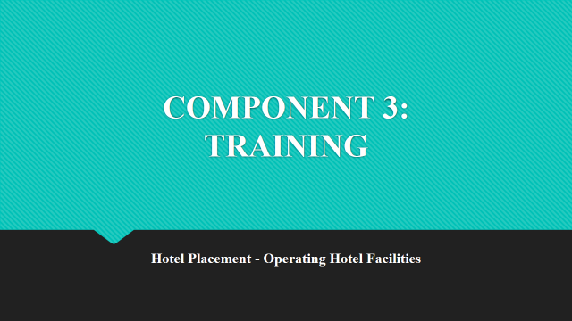

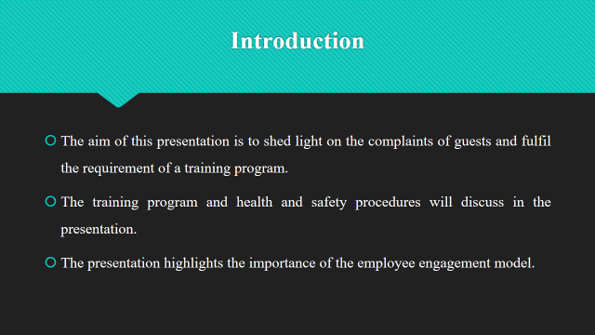

Training Notes:
The presentation mainly aims to discuss the importance of housekeeping service when listening to guests’ complaints. To move with the market change, employee training is fundamental (Kavan et al., 2023). With the use of training, it becomes easy to keep staff motivated and align their performance towards business goals and objectives.
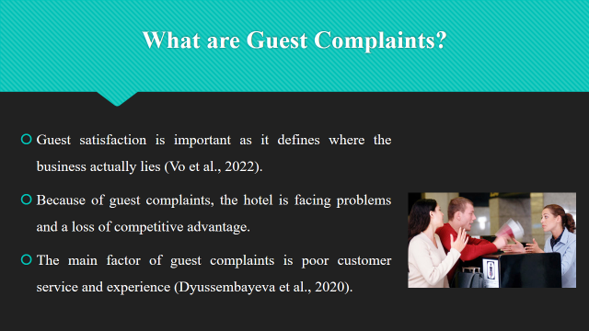

Training Notes:
The guest complaints were related to cleanliness, bad odour, non-fresh food, inappropriate behaviour of housekeeping staff, and unsatisfactory guest services. With the arrival of guests, housekeeping facilities are somehow inadequate, which causes a loss of profits and customer loyalty (Vo et al., 2022).
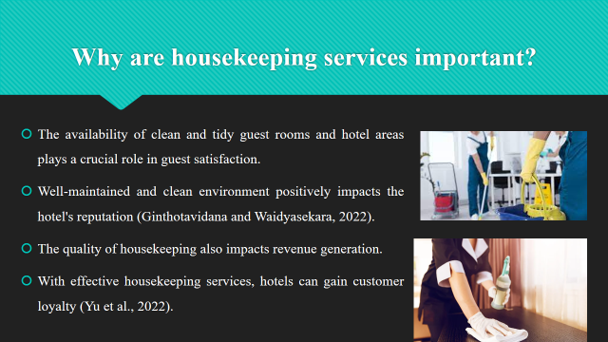

Training Notes:
Housekeeping services make sure that the guest gets a comfortable and pleasurable stay by providing them with hygienic, clean, tidy and well-maintained rooms (Ginthotavidana and Waidyasekara, 2022). Providing attention to every single detail and responding timely to guest demands also increase guest satisfaction, which ultimately improves the hotel's image.
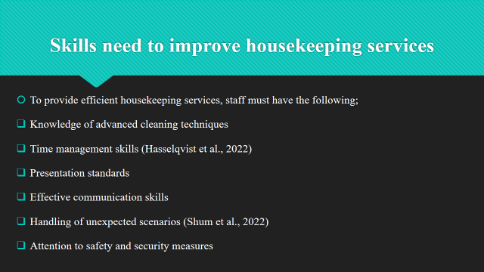

Training Notes:
To gain customer loyalty and attract guests, housekeeping staff make sure to learn effective and efficient cleaning techniques (Hasselqvist et al., 2022). They have enough skills to use different cleaning tools, materials, chemicals, and equipment. Also, staff members must have effective communication skills to understand the preferences and desires of guests (Shum et al., 2022). Housekeeping staff must have to be trained in a way that enhances their knowledge of safety and security.
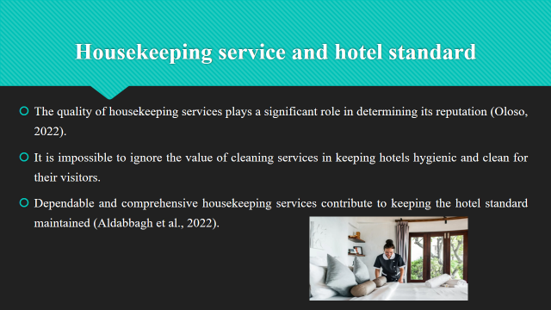

Training Notes:
The cleanliness of guest rooms, public areas, and amenities depends on who cleans them. Hotels that regularly provide top-notch cleaning services are characterised by cleanliness, attention to detail, and customer satisfaction (Oloso, 2022). An effective work environment is facilitated by cleaning schedules, cross-departmental cooperation, and open lines of communication between housekeepers and higher management (Aldabbagh et al., 2022).
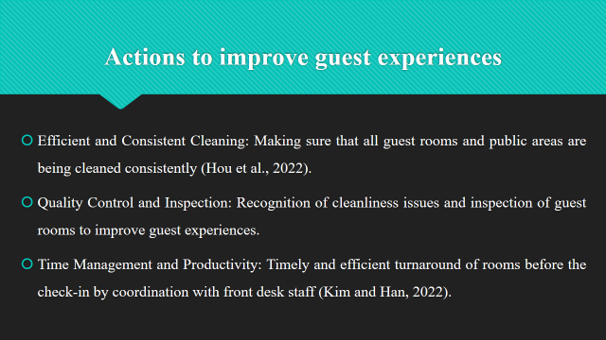

Training Notes:
To ensure guest satisfaction, training offer learning to staff on how to meet the expectations of guests (Hou et al., 2022). To improve the skills set of housekeeping staff by giving them knowledge, best practices as well as efficient cleaning techniques (Kim and Han, 2022). Apply personalised touches to the guest rooms to leave a positive impression on guests and address their concerns.

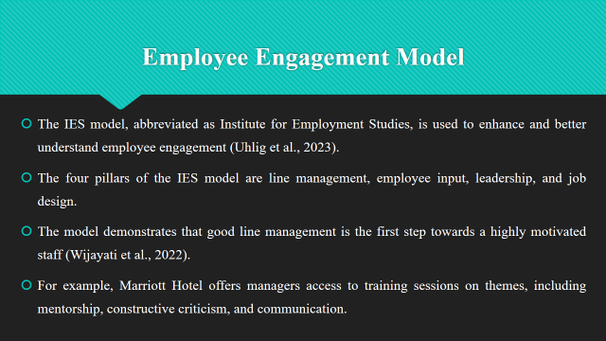

Training Notes:
At Marriott Hotel, managers often ask for input from and give support to their team members and maintain constant touch with them (Wijayati et al., 2022). The Premier Inn Hotel offers an example of quality services by using the IES employee engagement approach.

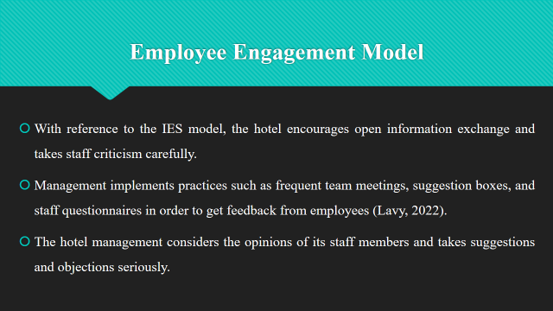

Training Notes:
The great leadership support, meaningful job design, effective line management, and a focus on employee participation, the hotel can have an engaged workforce. Increased happiness benefits both the personnel and the consumers as a consequence (Lavy, 2022). Testimonials from pleased visitors, a low staff turnover rate, and a fantastic reputation for service are all indicators of the success of the hotel.
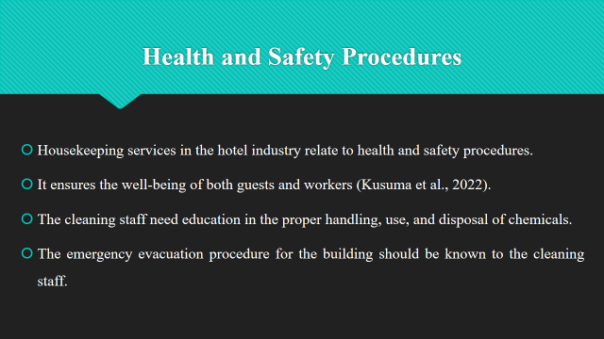

Training Notes:
Staff members who are in charge of keeping the building hygienic and tidy should get adequate training. Housekeeping staff members should never hesitate to inform their supervisors or HR of any incidents or concerns related to health and safety (Kusuma et al., 2022). Fire drills have to include practising escape routes, meeting locations, and fire extinguishers. Regular fire drills and training sessions may help staff members be more prepared to respond effectively in the event of a fire.
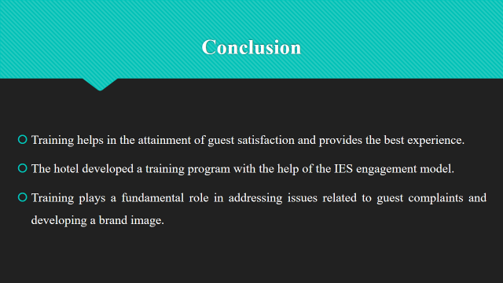

Training Notes:
Conclusively, training programs aimed to enhance the skills and learning of housekeeping staff and offer them valuable knowledge to improve the guest experience. The hotel faced various issues related to guest services.

References
Aldabbagh, A., Neyazi, D., Alsahafi, M., Sarhan, A. and Palaniswamy, T., 2022. Improving the Quality of The Housekeeping Management Process for Stay at Bridge Suites Hotel. Journal of Advances in Humanities Research, 1(1), pp.26-41.
Cañibano, A., Chamakiotis, P. and Russell, E., 2020. Virtual teamwork and employee well-being: The Covid-19 effects. Managing a Post-Covid19 Era, p.112.
Chavas, J.P. and Nauges, C., 2020. Uncertainty, learning, and technology adoption in agriculture. Applied Economic Perspectives and Policy, 42(1), pp.42-53.
Dyussembayeva, S., Viglia, G., Nieto-Garcia, M. and Invernizzi, A.C., 2020. It makes me feel vulnerable! The impact of public self-disclosure on online complaint behaviour. International Journal of Hospitality Management, 88, p.102512.
Ginthotavidana, S.S.C. and Waidyasekara, K.G.A.S., 2022. A performance measurement model for the housekeeping services in healthcare facilities. Facilities, 40(1/2), pp.56-75.
Hasselqvist, H., Renström, S., Håkansson, M. and Strömberg, H., 2022, April. Exploring Renewable Energy Futures through Household Energy Resilience. In Proceedings of the 2022 CHI Conference on Human Factors in Computing Systems (pp. 1-18).
Kim, J.J. and Han, H., 2022. Saving the hotel industry: Strategic response to the COVID-19 pandemic, hotel selection analysis, and customer retention. International Journal of Hospitality Management, 102, p.103163.
Kusuma, B.S., Hasibuan, A., Nasution, S.P., Utami, A.P. and Dalimunthe, A.R., 2022. An Increasing Knowledge About The Importance Of Occupational Safety And Health (K3) In Housekeeping Labor Hotels. INFOKUM, 10(5), pp.424-431.
Lavy, S., 2022. A meaningful boost: Effects of teachers’ sense of meaning at work on their engagement, burnout, and stress. AERA Open, 8, p.23328584221079857.
Marneros, S., Papageorgiou, G. and Efstathiades, A., 2020. Identifying key success competencies for the hospitality industry: The perspectives of professionals. Journal of Teaching in Travel & Tourism, 20(4), pp.237-261.
Marneros, S., Papageorgiou, G. and Efstathiades, A., 2020. Identifying key success competencies for the hospitality industry: The perspectives of professionals. Journal of Teaching in Travel & Tourism, 20(4), pp.237-261.
Michalcová, L., Kavan, Š., Freitinger-Skalicka, Z. and Strnad, Š., 2023. THE IMPORTANCE OF SAFETY EDUCATION FOR HOSPITAL STAFF. In INTED2023 Proceedings (pp. 974-979).
Oloso, S.E., 2022. THE IMPACT OF HOUSEKEEPING SERVICE QUALITIES ON GUESTS'SATISFACTION IN OYO STATE HOTELS. Journal of Research in Hospitality and Tourism Management, 4.
Singh, A. and Jaykumar, P., 2019. On the road to consensus: key soft skills required for youth employment in the service sector. Worldwide Hospitality and Tourism Themes.
Strömmer, M., 2020. Physical Work, Customer Service, or Teamwork?: Language Requirements for Seasonal Cleaning Work in the Booming Arctic Tourism Industry. In Language, global mobilities, blue-collar workers and blue-collar workplaces (pp. 187-203).
Uhlig, L., Baumgartner, V., Prem, R., Siestrup, K., Korunka, C. and Kubicek, B., 2023. A field experiment on the effects of weekly planning behaviour on work engagement, unfinished tasks, rumination, and cognitive flexibility. Journal of Occupational and Organizational Psychology.
Vo, N.T., Hung, V.V., Tuckova, Z., Pham, N.T. and Nguyen, L.H., 2022. Guest online review: An extraordinary focus on hotel users’ satisfaction, engagement, and loyalty. Journal of Quality Assurance in Hospitality & Tourism, 23(4), pp.913-944.
Wijayati, D.T., Rahman, Z., Rahman, M.F.W., Arifah, I.D.C. and Kautsar, A., 2022. A study of artificial intelligence on employee performance and work engagement: the moderating role of change leadership. International Journal of Manpower, 43(2), pp.486-512.
Yu, H., Shum, C., Alcorn, M., Sun, J. and He, Z., 2022. Robots can’t take my job: antecedents and outcomes of Gen Z employees’ service robot risk awareness. International Journal of Contemporary Hospitality Management
Yu, J., Fang, Y., Zhong, Y., Zhang, X. and Zhang, R., 2022. Pricing and quality strategies for an on-demand housekeeping platform with customer-intensive services. Transportation Research Part E: Logistics and Transportation Review, 164, p.102760.
Yu, W., Cui, F. and Hou, Z., 2022. The evolution of consumers’ demand for hotels under the public health crisis: opinion mining from online reviews. Current Issues in Tourism, pp.1-17.

