
My name: Mohammed Amir Rashid
Student number: 1714326
Assignment title: Essay (Assessment 1)
Module code: LCMB7001
Lecturer’s name: Efua Adams
Component: 1
Due date: 03/03/2023

Contents
Introduction……………………………………………………………………………………………3
The concept and importance of marketing
How are the internal micro and macro factors affecting the marketing strategy?....................4
The main audience for the organisation……………………………………………………………5
The types of materials used to capture target market
Marketing mix (the 7 p’s) ………………………………………………………………………...….6
SWOT analysis for the organisation……………………….……………………………………….7
The channels/methods used as a marketing strategy……………………………………………8
A managerial implication on the organisation’s marketing strategy…………………………….9
Recommendations on how the marketing strategy can be improved……………………...10-11
Conclusion…………………………………………………………………………………………..12
References………………………………………………………………………………………….13

Introduction
The purpose of this task is to be able to identify the marketing activities as a consultant towards the organisation of the Midlands Greek and Cypriot Association which is based in Birmingham in the Erdington area. A full report will be conducted of the marketing activities as well as the effectiveness of these activities within the organisation. The key elements which will be discussed within this report will be the concept and importance of marketing explaining the resources which have been used as a marketing strategy to keep the operations moving towards a successful operating business which the internal macro and micro-environments of the organisation which also be discussed which can influence the marketing strategy. Furthermore, the target market will also be discussed explaining the main audience of the organisation and the market segmentation, targeting, differentiation, positioning, and marketing mix strategy. The channels of communications will also be discussed for marketing such as the social media platforms, networking, emailing and search engine optimisation if these are appropriate for The Midlands Greek and Cypriot Association. Measuring success is also important and a critical discussion within this report explaining the campaigns assessed for example the measurement metrics and if the marketing strategy is ineffective and if so, how they control marketing following this and what the contributions are if there are any of the specified marketing activities as well as the management sector towards the overall organisations performance measures. Lastly, a managerial implication on the organisations marketing strategy will also be discussed according to relevant theories/models which have been proven to work within the modern-day working environment. Based on the managerial strategies there will be further recommendations towards how The Midlands Greek and Cypriot Association could be improved as a business to enhance a better strategic workforce.
The concept and importance of marketing
The association was founded in 1974 and moved to the Community Centre in Erdington in 1983. The association provides various facilities to support the Greek and Cypriot community in the Midlands and to promote Hellenic culture within the region, from the traditional Taverna, the Banqueting Suite, the Greek School, and the Orthodox Church which are all apart of the association. The Midlands Greek and Cypriot Association is an industrial and provident society registered in England and Wales as a not-for-profit organisation, who depend on the work of volunteers and donations to keep the centre going according to ('(The Midlands Greek and Cypriot Association) About us',). Marketing is very important as it helps companies to keep up to date with the change of trends and the demands that customers have. Marketing is an essential for all businesses as it helps with development of the economy and most importantly the growth of the business as this helps and supports businesses to multiply the sales volume, revenue and it ensures the success on a broader outlook according to (Soni, 2020). The Midlands Greek and Cypriot Association are based within a community with majority people being from different Asian backgrounds and so to promote the business they use social media platforms such as Facebook to promote their business which can have an estimated 300 people at one time to supply their services for the food that they provide to their customers. The business also has a website to approach its customers within the local area and from different Asian, and African communities and backgrounds as the food that is being is served is from the Asian and African traditions where people enjoy for booking for parties and special occasions to get together and have a nice time out with their family and friends.
How are the internal micro and macro factors affecting the marketing strategy?
The Midlands Greek and Cypriot Association has many marketing factors which are providing customers dates and times for live events which they do within the local community, as well as doing live events they also have a community church for the local community to visit as they wish according to the opening hours of the church and they have a school within the community as part of the business which is also used a marketing strategy to advertise to the local community of the charity work and foundations that they work closely with in order to maintain a smooth business structure where advertising is not only done by word of mouth but social events, websites, establishments such as the Ayia Triada Greek School they are apart of and advertising using the social media platform known to be Facebook. However, the affects of micro and macro factors within the business are dependant on how successful the business is. The business itself has a great inner structure and has a great layout on the inside which can attract many customers and as for hygiene is concerned is quite clean in some areas of the business as not all the premises are as clean as they should be and has staff internally who monitor and clean the premises to maintain and keep it clean. According to a recent research information was gathered from a theory produced by Frederick Herzberg who had stated the importance of hygiene within an organisation the hygiene factors need to be eliminated to dismiss dissatisfaction among employees at the workplace. There are various ways to do so, and the most important ones are by paying a good salary, assuring job security, and a positive work culture. While dismissing dissatisfaction is just one half of the job, the other half is to improve satisfaction at the workplace, which can be accomplished by concentrating on motivational factors according to ('Herzberg’s Motivators and Hygiene Factors – Studious Guy', 2023).

The main audience for the organisation
The audience for the Midlands Greek and Cypriot Association is mainly aimed towards the community in inner Birmingham inside and outside of the Erdington area within the West Midlands. Midlands Greek and Cypriot Association also draws its business attention to travellers who travel to Birmingham and are looking for a restaurant that serves traditional Greek Cypriot specialties cooked over charcoal and in clay ovens. The restaurant must be pre-booked before any person can make an arrival to purchase and use the facilities of the organisation so anybody who has a pre-booking is welcome to use the facilities from Monday and Wednesday at 6pm to late, Tuesday and Thursday the restaurant is closed and Friday and Saturday the website is usually updated for the opening times during the week for these days according to ('Facilities', 2013). The organisation is trying to draw customers from all Asian ethnic backgrounds, and this is said because most of the food that is provided within the organisation is traditionally served to Asian and African culture backgrounds because the food that is being provided in the restaurant is Café serving freshly made Cypriot Sandwiches, Koupes, Tahinopita, Loukanikopittes, Baklava, Greek Coffee (heated over sand) & Frappé. So, the audience for the organisation would be aimed towards Asian ethnic communities and backgrounds but anybody is welcome not necessarily just the ethnic background community anybody is welcome from the community if they have an active booking.
The types of materials used to capture target market
To capture target market the materials which the Midlands Greek and Cypriot Association has used are churches and schools which is available for the community within Birmingham, Erdington area for the local community to visit the church within the opening hours of the church to use facilities provided when needed. As for the school which is part of the Midlands Greek and Cypriot Association is called the Ayia Triada Greek School also located within the local community within Birmingham running from Monday to Saturday between 5pm and 9pm which is dependent on the campus. The aim of the organisation is to promote all facilities of every aspect of the organisation whether that is the school, church, café or the restaurant the organisation attracts its customers using such facilities to bring the community together in order to draw customers towards other aspects of the business such as the café and restaurant for instance when parents are collecting their children from school or whether individuals have visited the church to prey there are leaflets, posters and even a website as well as a Facebook page which promotes the business as a whole from all products and services. According to recent research it was suggested that whether it’s for inclusion in a product delivery, a handout at events or exhibitions, a flyer, a leaflet on a reception desk, or a takeaway from a meeting the leaflets allow your target audience to take key information away with them to return to time and time again according to ('Why Is Leaflet Marketing Important? | Photo line', 2023).
Marketing mix (the 7 p’s)
Product: - the usefulness of the products and services which The Midlands Greek Association use is that they are providing good quality of food to their customers within the restaurant and café, they provide food which is attractable towards a macro environment of people especially from an ethnic background who enjoy the food and is food that is traditional for the target audience who have knowledge and have eaten the same type of food possibly within their own ethnic country which brings a specific target audience for the food itself which becomes a visual metaphor for customers and increases target market as a strategy to keep the community and the business together. This involves the importance of quality branding which strengthens recognition of the business and the brand itself provides motivation and direction of staff and helps customers know what to expect of the business and how the brand helps create clarity to stay focused according to ('Why is Branding Important?', 2017).
Price: - as price is concerned for the organisation it isn’t quite clear of a price range for the customer to see on the website or on the social media platform (Facebook) where the organisation is advertised and this is because a 72 hour notice for a party or event is to be given to the organisation as well as the number of guests who would be attending up to a maximum of 100 guests for the restaurant and up to a maximum of 270 guests for the banqueting suite so the price is according to a number of guests who attend the organisation and therefore a quote can be requested if this information can be provided to the organisation.
Place: - in the 1980’s the committee had become a friendly society which was granted the legal right to own the land and property in the name of their trustees. They sought to find a home for their community’s social activities and began by renting a small building on Station Road in Erdington. This has since expanded and is now a larger property than it was since the 1980’s. The building structure has remained the same since the 1980’s giving the place an older antique look with antique furniture and items which give the inside a great physical look but with the downside of not looking like a restaurant but more a hotel inside which can cause confusion whether the purpose of the organisation is to provide services for a hotel accommodation or restaurant and café products to consumers.
Promotion: - the promotional aspects of the organisation are related to websites, posters, banners, leaflets, newsletters, and a Facebook campaign to promote the products and services of the organisation. The organisation is using these promotional aspects because they are aware that these are used intelligently as a marketing strategy which have the ability to produce a high account of profits and income to keep the organisation alive so need to keep the community together and advertise as much as possible with social networking strategies with regular weekly events for a good time out so the community can enjoy themselves and most importantly the organisation can profit from this to continue doing the work they do and provide the products and service and facilities needed for their target market.
Physical evidence: - the physical evidence is within the community itself where customers use the facilities of The Midlands Greek and Cypriot Association and physically make bookings to events and general parties for a special occasion. The importance of physical evidence for the organisation is that it provides tangible cues of quality and experience for people which is offered by the business. It is very useful when a customer hasn’t purchased products from the organisation before and so reassurance is needed or is expected before a service or product is delivered according to (Barrington, 2020).
People: - the stakeholders who are involved in the organisation refers to managers, customers, cleaners of the business, teachers, chefs, owners, representatives, suppliers, creditors, shareholders, and government. The importance of stakeholders helps build long-term relationships and when a company has a long-term relationship with its stakeholders it is more efficient for the business to run and has increased chances of producing profit and the same goes to the business even if it is nationalised according to (Sonawane, 2013).
Process: - the process for the organisation is to create a smooth and efficient journey which cannot be achieved without requesting information and making purchases as it helps to consider which business process needs to be in place and to create a positive experience the recruitment and selection process is very important for the organisation as employing relevant individuals with experience already saves the organisation time for training and monitoring and maintaining performances within the organisation according to ('What Is a Business Process? | Definition, Importance and Examples', 2022) which creates a positive business model structure to keep the business a sustaining business so the recruitment process for the organisation is very important.
SWOT analysis for the organisation
Strengths: -
- A business structure that is well structured on the outside which has many opportunities for a huge increase of income and more customers.
- Effective communication within the organisation.
- Promotional social events through the website.
- Effective team working skills to keep the organisation sustained.
Weaknesses: -
- In-depth information about the business structure which can be remotely accessed via the internet.
- Using more marketing strategies to increase sales and popularity outside of the community to attract customers who have interests for Greek style restaurant food.
- The building on the outside looks more like an old library than a restaurant.
Opportunities: -
- There are opportunities to promote old style restaurant looks for the business to draw more customers and increase popularity if the building from the outside just had a few amendments with paint and signages to promote the restaurant from the outside, so it has a better look and people know its also a restaurant.
- There is also opportunity for bigger events and social events which can be done more than once a week which can be done on the non-busier days of the association to attract more people towards the business.
Threats: -
- There are Greek style restaurants within the community who serve traditional food same as The Midlands Greek and Cypriot Association.
- If there is no source of income coming from charity fundraisers and the community the organisation can collapse and longer be a sustained organisation.
- Without reasonable amount of marketing strategies, the business starts to lack on a marketing to increase profits and revenue and lose potential interest from people within the community.
The channels/methods used as a marketing strategy
The channels used as a marketing strategy for The Midlands Greek and Cypriot Association first of all is social media by using Instagram pages and Facebook to publicly advertise the organisation and use this a social fundraising strategy to bring interested people as part of large groups towards the organisation which is why they use social events to gather these types of people once every week because without interested people and a lack of marketing intelligence the organisation cannot run and since its based on charity makes it more difficult so social media is important for this organisation. Social media marketing, content marketing and email marketing are also being used within the organisation as a strategy for advertisement, to bring more people towards the business and create a better and positive community in Birmingham within the Erdington area. The social media platforms are used to engage brand followers and other users through the organic reach or even by paying to reach a defined audience according to (Pecánek, 2022). The importance of social media marketing such as using Facebook for building a strong social media following and consistency where posts and high-quality content must be posted consistently to build brand reputation through social media marketing. As for email marketing it ensures content is distributed correctly as well as it’s integral to cohesive campaigns and it helps plan out promotions (Team, 2021) which is why its key and important for The Midlands Greek and Cypriot Association.
A managerial implication on the organisation’s marketing strategy
Managers’ commitment Top level managers often directly influence the organizations’ climate through formulating corporate grand strategies and firms’ control system, and the lower-level managers have less direct participation in these activities. As corporate grand strategies are usually formulated by high level managers and marketing managers often are not perceived as part of the high-level management the implementation of marketing strategies takes place only after it is formulated by the top management. One of the key barriers of strategy implementation is lack of employee commitment and commitment is the extent to which employees of the marketing department identify with and work toward organization-related goals and values. Often the high-level management formulates the strategy and leaves its implementation to the functional levels until a crisis emerges. It is therefore not uncommon if the functional managers fail to execute the strategy. Commitment towards strategy is the outcome of the strategy formulation process that embodies understanding and agreement of the manager on the strategy according to (Ramaseshan, Ishak and Rabbanee, 2013). Managers of the organisation should consider using a blueprint model which clearly outlines the aspects of the business from looking at the physical evidence both internal and external, the customer actions including visits sites and orders, on-stage actions which include greeting customers and showing customer tables and delivering the meals, backstage actions should assign a waiter and prepare food and process payments and lastly, support processes which include scheduling systems d kitchen appliances as well as point of sale systems.
Below is a detailed blueprint model which relates to the organisation discussed above: -
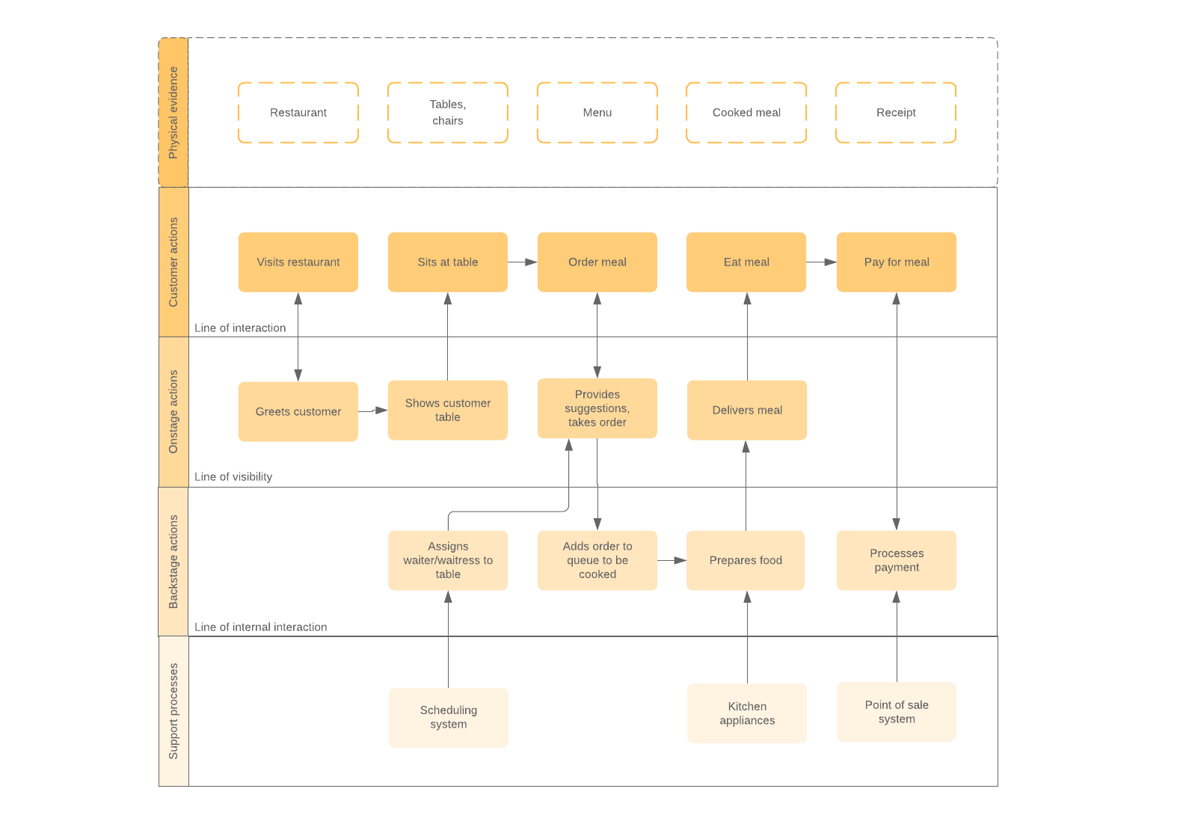
Recommendations on how the marketing strategy can be improved.
Below is a Blueprint model from McDonalds which can be used towards The Midlands Greek and Cypriot Association because it is believed to have the relevant customer actions, on-stage technology actions, on-stage employee contact, support processes and physical evidence which is relevant to The Midlands Greek and Cypriot Association.
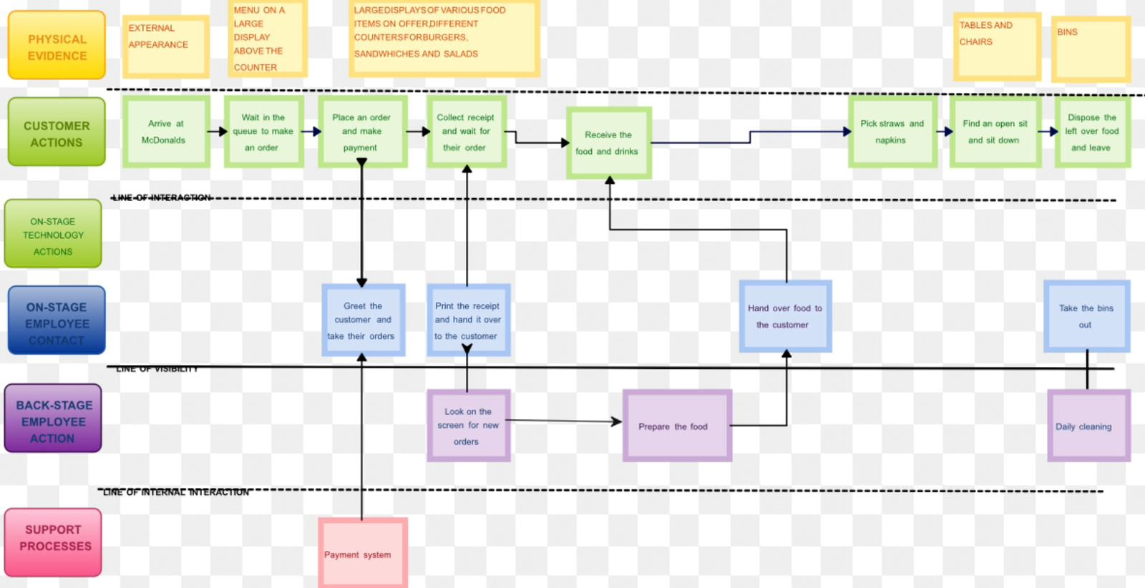
(McDonald's Restaurant - SERVICE BLUEPRINT FOR MCDONALD'S RESTAURANT Physical Evidence Clean and nice place Customer Actions Enter Restaurant/ Drive | Course Hero. 2016)
Physical evidence is needed for the organisation where the External appearance is one of the main attractions of the organisation, so a large imprint of the organisation name and a brief overview of the organisation can bring huge potential for the organisation and as for the internal physical evidence a large display and menu can increase potential of the organisation too. Using on stage digital actions is also important and recommended to use for this type of organisation and it improves processes and makes it easier to handle payments especially instead of using cash and handling cash all the time it is much quicker to take card payments and electronic payments where investment for a cash handling position is no longer needed and money of the organisation can be handled all in one place which makes this process easier for the organisation.
Customer actions are also important for the organisation because processes which are related to McDonalds process would help with The Midlands Greek and Cypriot Association because waiting in the queue, place an order, make payment electronically via card, collect receipt and wait for the order, for the organisation can be important especially with the recommendation that the organisation can offer a buffet system of food or even a better style restaurant with appropriate actions to customers who attend especially on special events which take place on the Saturday within the organisation.
Marketing can also be improved by using STP marketing using segmentation, targeting and positioning towards an audience-focused approach rather than product-focused approaches to marketing communications which helps more to deliver relevant messages to commercially appealing audiences. STP is a critical strategy and a planning tool which is a feature used for the growth system of businesses and organisations.
Conclusion
The concept and importance of marketing strategies are important for The Midlands Greek and Cypriot Association because without the right marketing strategies such businesses are not sustained business especially organisations which are non-profit organisations and rely on the community and people who have an interest to African and Greek style restaurants, local community schools and local libraries so the target market is quite broad for such an organisation to advertise and use strategic marketing strategies such as using the marketing mix (the 7 p’s) to attract and build a sustainable blueprint model of the organisation for a better target market, organisation strategy, prepare stakeholders for certain aspects of the business, a better business structure, increasing profitability and increase the number of people for expansion of the organisation to grow and adapt for a better future by making reasonable changes internally and externally to make such effects possible which will have a positive affect towards the organisation.
The importance of using the marketing mix, the blueprint model, swot analysis, micro and macro factors and marketing strategies is for the purpose of changing processes for The Midlands Greek and Cypriot Association to help sustain the organisation as well as increase income, customers, bring the local community together and aim to deliver towards the Greek and African culture as well as other people who have an interest towards the organisation making people aware that it is a non-profit organisation and the mission and vision of the concept of it being a non-profit organisation as well as the facilities it provides to the local community to make the community a better place and bring the community together so this report is to guide the organisation with relevant marketing strategies which can be considered to make the organisation a better and valuable place for the future with key implementations of marketing strategies, marketing mix, a relevant blueprint model, a swot analysis conducted and the micro and macro factors explained along with managerial implications of the organisations marketing strategies using relevant theories and models for support.

References
'Herzberg’s Motivators and Hygiene Factors – Studious Guy', (2023) . Available at: https://studiousguy.com/herzbergs-motivators-and-hygiene-factors/ (Accessed: Feb 17, 2023).
'Why Is Leaflet Marketing Important? | Photo line', (2023) Available at: https://www.photoline.co.uk/blog/why-leaflet-marketing-can-be-valuable-to-your-business/.
'What Is a Business Process? | Definition, Importance and Examples', (2022) Villanova University, -04-22T12:33:13+00:00. Available at: https://www.villanovau.com/resources/bpm/what-is-a-business-process/ (Accessed: Feb 23, 2023).
'Why is Branding Important?', (2017) Mad Cap Marketing + Creative, -05-16T19:41:21+00:00. Available at: https://madcapmarketing.com/importance-quality-branding/ (Accessed: Feb 23, 2023).
McDonald's Restaurant - SERVICE BLUEPRINT FOR MCDONALD'S RESTAURANT Physical Evidence Clean and nice place Customer Actions Enter Restaurant/ Drive | Course Hero. (2016) Available at: https://www.coursehero.com/file/17413226/McDonalds-Restaurant/ (Accessed: Mar 1, 2023).
'Facilities', (2013) (The Midlands Greek and Cypriot Association), . Available at: http://www.midlandsgreek.org/about-us/facilities/ (Accessed: Feb 23, 2023).
'(The Midlands Greek and Cypriot Association) About us', ΕΛΛΗΝΙΚΗ ΚΥΠΡΙΑΚΗ ΕΣΤΙΑ (The Midlands Greek and Cypriot Association), . Available at: http://www.midlandsgreek.org/ (Accessed: Feb 15, 2023).
Barrington, R. (2020) 'Understanding The 7Ps of The Marketing Mix', Oxford College of Marketing Blog, -10-08T06:19:54+00:00. Available at: https://blog.oxfordcollegeofmarketing.com/2020/10/08/understanding-the-7ps-of-the-marketing-mix/ (Accessed: Feb 23, 2023).
Pecánek, M.M., Michal (2022) 11 Top Marketing Channels: Examples With Pros & Cons. Available at: https://ahrefs.com/blog/marketing-channels/ (Accessed: Mar 1, 2023).
Ramaseshan, B., Ishak, A. and Rabbanee, F. (2013) 'The role of marketing managers' commitment and involvement in marketing strategy implementation', Journal of Strategic Marketing, 21 Available at: https://doi.org/10.1080/0965254X.2013.804858.
Sonawane, R. (2013) Stakeholders In Business.
Soni, A. (2020) Importance Of Marketing - Digital Vidya. Available at: https://www.digitalvidya.com/blog/importance-of-marketing/ (Accessed: Feb 15, 2023).
Team, B. (2021) How To Implement an Effective and Seamless Email Marketing Strategy. Available at: https://www.benchmarkemail.com/blog/why-having-an-email-marketing-strategy-is-important/ (Accessed: Mar 1, 2023).

