Application Development
  - DUM5002
Leoni Lewis | Assignment One | 2018/2019
Table of Contents
Introduction 2
Application development concepts 2
Web design Principles: 2
Web usability and User Experience: 3
Requirements 3
Breakpoints 4
Software Requirements Specification 4
Design 5
Implementation 6
Evaluation 13
Appendices 20
References 22

Introduction
In this report I am going to discuss the importance of following application development concepts when creating an application. From this I am then going to provide you with the relevant documentation I created during the creation of my application and reflect on what I did. I am going to go through in detail the tasks I was set and how I completed them.
I have been asked to create a website application that is user friendly and responsive. I am able to choose the subject of this website application myself, so I have decided to base the website application on Pembrokeshire, the focus on the website will be what there is to do in Pembrokeshire including food and activities.
To help me with making my website application responsive and user-friendly I will research what it takes to do this. Most of my research will be done through the internet but I will also look at books and blogs. Once I have researched this information I can use it within my design.

Application development concepts

Web design Principles:
The design of a website is constantly judged by the users of a website and not the actual creator. There are multiple factors that can affect the usability of a website, sometimes it’s not about how good the website looks by how simple it is to use. If a website isn’t designed correctly users are less likely to spend time on the site, will not return and are more inclined to view a competitor’s website.
It’s important to design each individual page on your website with a purpose to meet the users need, this could be a contact page where users can contact you with any queries/feedback or a product page which displays all the products you sell. The purpose of each page should not only be clear for the designer but the user too, this could be made clear through navigation, a title or with clear content.
The information which is provided on your website should be easy to read and understand by the user. Effective techniques which allow us to do this could be using headings, sub headings and shortening information into straight to the point bullet points.
When designing a website it is important that the font you use is easy to read and the correct size. Fonts and font sizes should flow seamlessly throughout the whole website to prevent confusion and set the tone. This is the same with the use of colour on a website. When colour is used correctly is can enhance a user’s experience on a website however, when colour is used incorrectly it can become overwhelming and even prevent users from viewing any information on your website. With both colour and font if users struggle to read the information you are displaying they will get frustrated and leave your website which wouldn’t benefit either you or the user.
Considering navigation is an important step when designing a website, it should be easy for users to move around the website and go directly to the page they wish to go without struggle. In order to make navigation more effective you can use breadcrumbs which allow users to see exactly which pages they have been and where they are now, clickable buttons which allow users to see exactly which button they are about to click through rollover CSS and a change in colour when clicked.
These days it is common for users to access websites from a range of devices which can vary in screen size, this is an important factor to consider if you wish for your website to be mobile friendly. To do this you simply have to make your website a responsive layout which will adjust to different screen sizes. (1)

Web usability and User Experience:
Web usability is the amount that an interactive web product or system is effective, easy to use, easy to learn, efficient and satisfying to users. Usability is more about how the product actually works rather than how it looks. When considering usability you need to consider the:
- Functionality: Does the product work as it should?
- Learnability: Will people be able to use the product without having to learn anything?
- Flexibility: Can the product provide users with more than the main function of the product?
- Design: is the design of the product attractive to users?
User experience refers to the user feelings and attitudes towards using a product. In order to consider user experience when designing your product you should look at the:
- Usability: How easy is it to complete tasks on the product?
- Adaptability: Will people be able to use the product?
- Desirability: Will the product attract people to use it?
- Value of the product: Does the product provide value to users? (2)

Requirements
I have designed and implemented a professional, responsive and interactive website user interface which is made up of six relevant and related pages. The website supports major browsers, is mobile compatible and has interactive functionality. The website is based on a subject that I am truly passionate about, Pembrokeshire. I wanted to create this website to provide users with a guide to Pembrokeshire’s beaches, restaurants, daytime and evening activities. The target audience of the website is the large number of tourists that visit Pembrokeshire every year and are wondering where they should visit. It is also targeted at those who already live in Pembrokeshire and want to know where to explore.

Breakpoints
Main Navigation: The first break on featured on my website is the main navigation which is used throughout the website application. At first it wasn’t responsive with other devices as it would ruin the layout of the rest of the page whenever the website application was run on a different device.

Software Requirements Specification
To gain full functionality of the web app they will need to ensure the following requirements are fulfilled. Within my website I used a variety of different languages HTML5, CSS, JavaScript, Php, jQuery and bootstrap 4. I ensured that the web app is compatible with the most popular web browsers (Google Chrome, Firefox and Internet Explorer). The web app created Pembrokeshire, A Guide To The Costal County was created to provide users with information on the county including where to eat and any activities available.
To help prioritize the work I needed to complete during designing and implementing the web app I used the MoSCoW method. This method stands for must, should, could and would:
Must have this requirement to meet the business needs.
Should have this requirement if possible, but project success does not rely on it.
Could have this requirement if it does not affect anything else on the project.
Would like to have this requirement later, but delivery won’t be this time.
My MoSCoW method looked like this:
MUST:
Be a fully functional web app that provides users with information effectively.
Have efficient navigation.
SHOULD:
Display information.
Provide links relating to the information.
Include appropriate images relating to the subject of the web app.
Have basic styling on text and a running theme.
COULD:
More advanced styling options.
A popup feature where users can sign up to a newsletter from the website application.
WOULD:
A forum where users can communicate with other users and ask for their opinions/recommendations in the area.
A review system where users can review the restaurants/activities recommended.
Using this method ensured that I kept on track to complete the tasks needed to successfully meet all the requirements stated disregarding those in the WOULD section. I ensured that I completed the tasks in order from must to would so that the most important tasks were completed first.

Design
I have ensured that I follow as many of the design principles as closely as I could. I have ensured that my website application is consistent throughout using the same colours, themes and fonts. All the information displayed is easy to read, the navigation is easy to use, and the theme used is professional.
Home Wireframe:
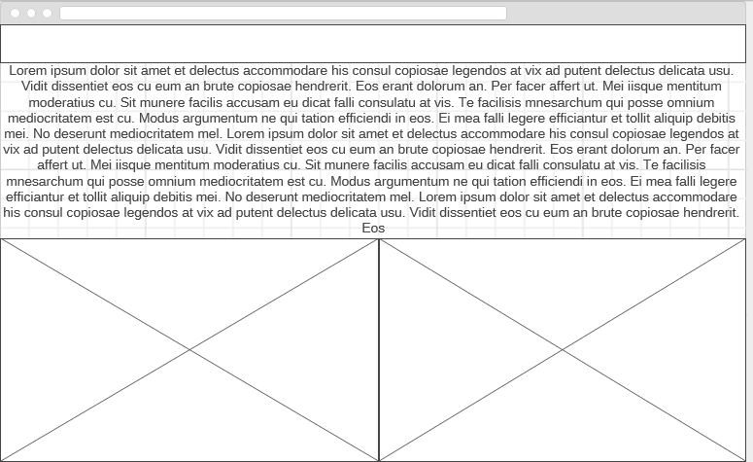
Sitemap:

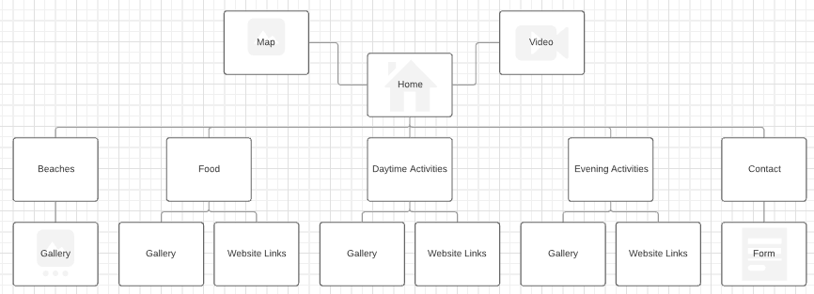

Implementation
I decided to use Bootstrap 4 as the main framework for my website application and then used JavaScript to add functionality. I used JavaScript to create the carousel feature on the food, daytime activities and evening activities pages. This helped to create an appealing gallery for users to look through. I also used JavaScript to implement the pop-up feature, when users have been on the website for 3 seconds a pop-up will appear asking them to sign up to a newsletter, here they enter their name and email address which would allow us to add them to a subscription address book. I implemented code onto my home page to allow users to read more or less text, this allows those who wish to read on to do so, but those who don’t can move onto the information bellow quicker.
IMAGES OF WEBSITE
Home:
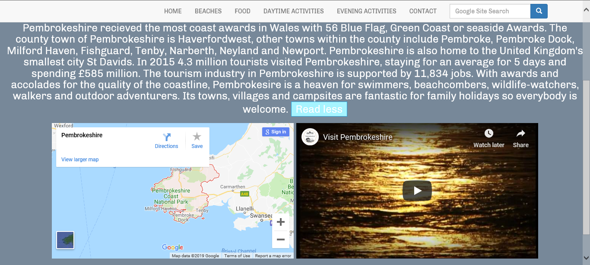
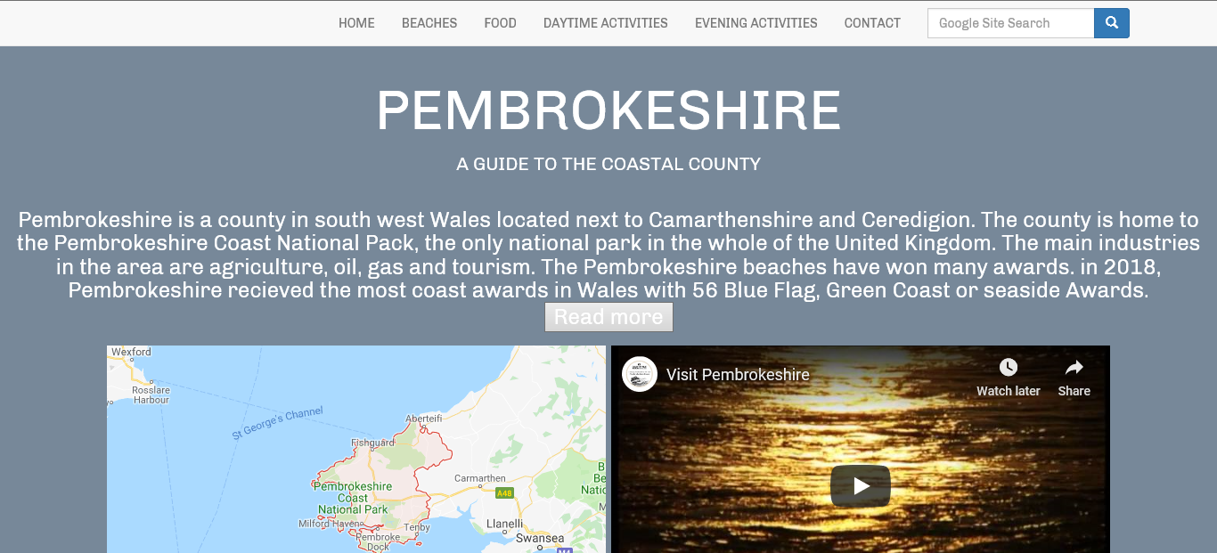
Beaches:
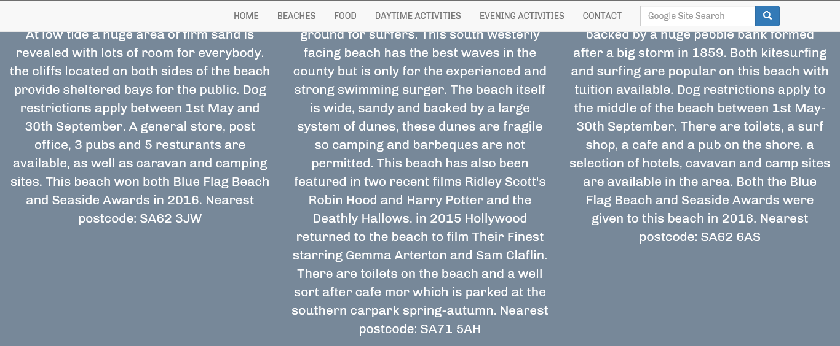
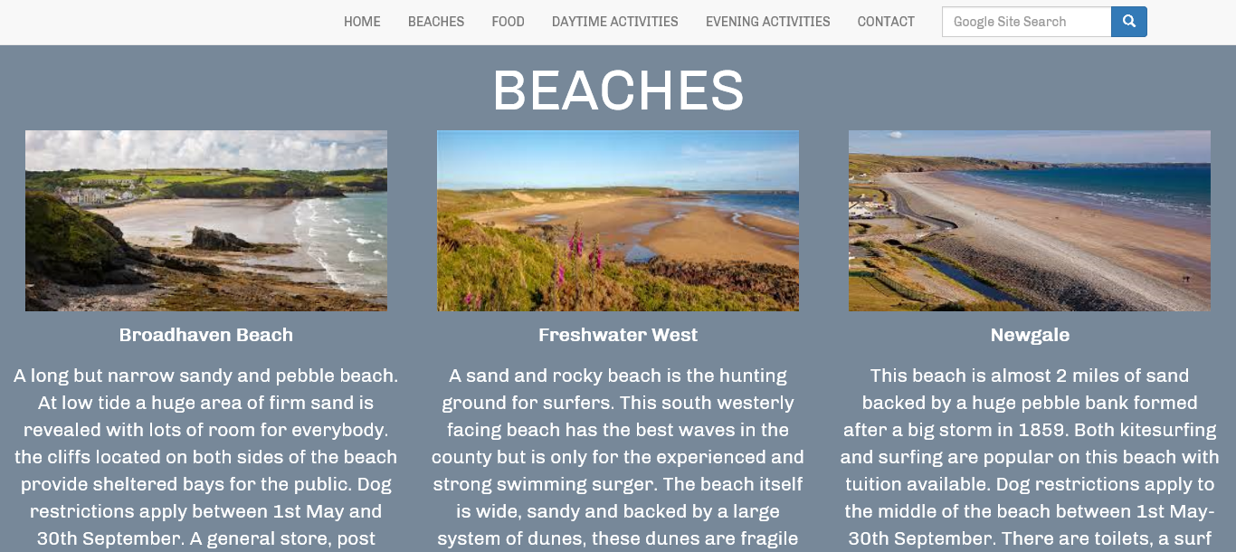
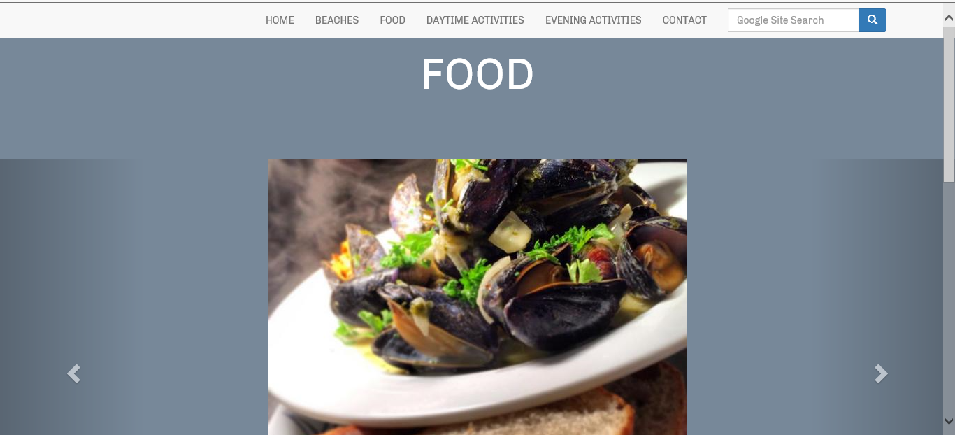
Food:

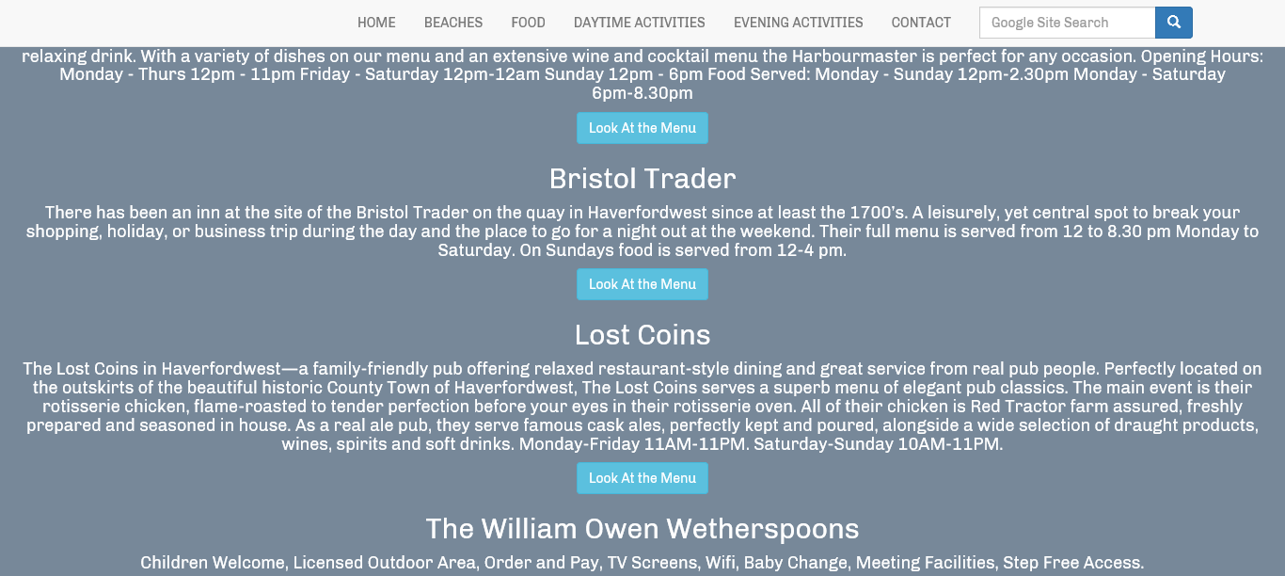
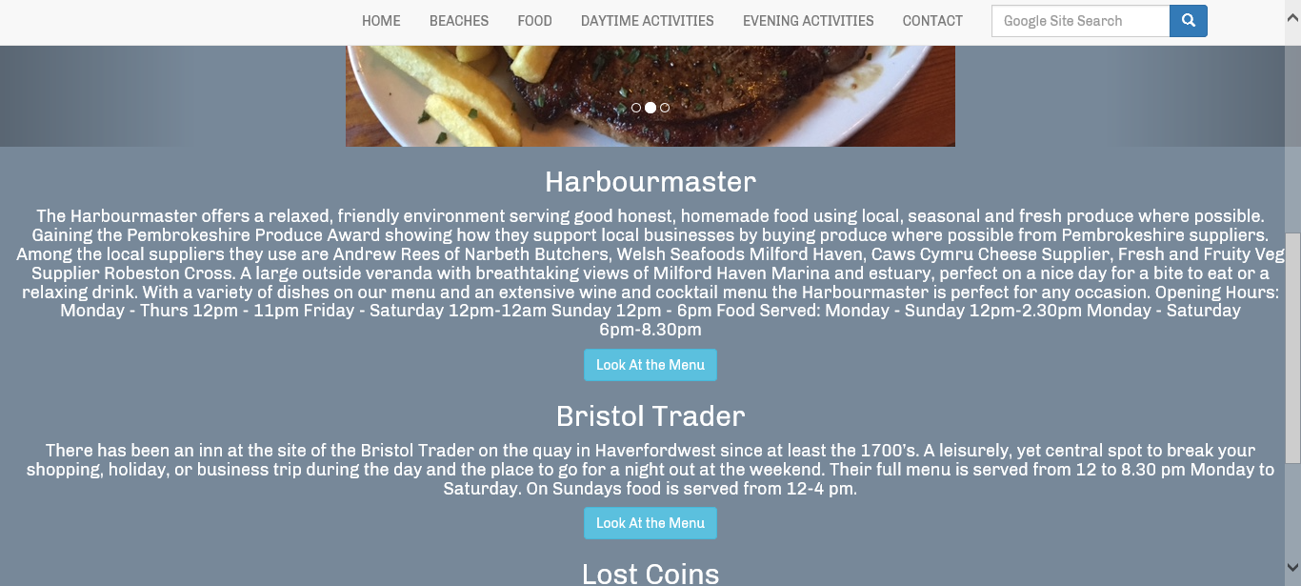
Daytime Activities:

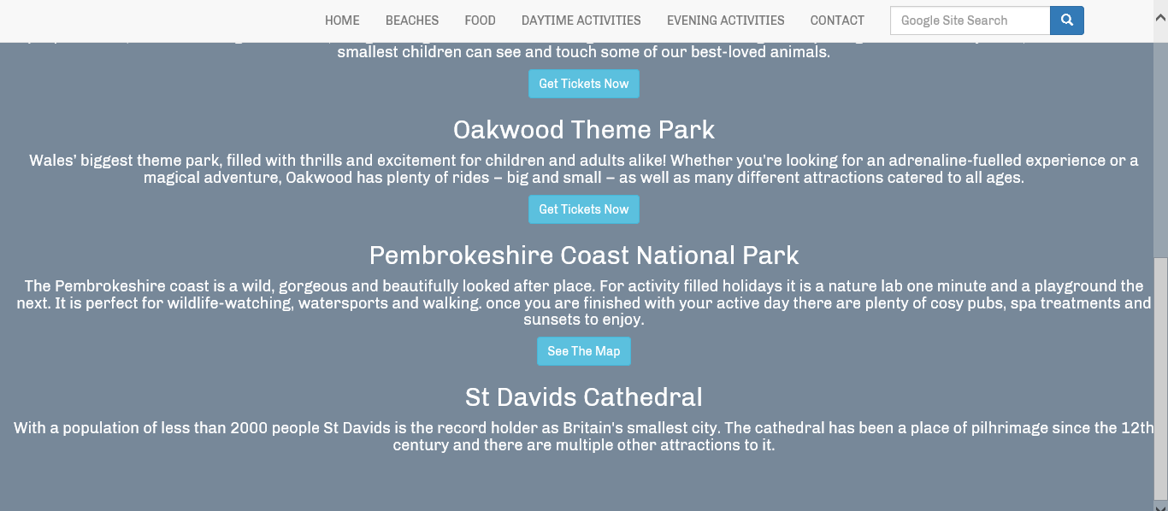
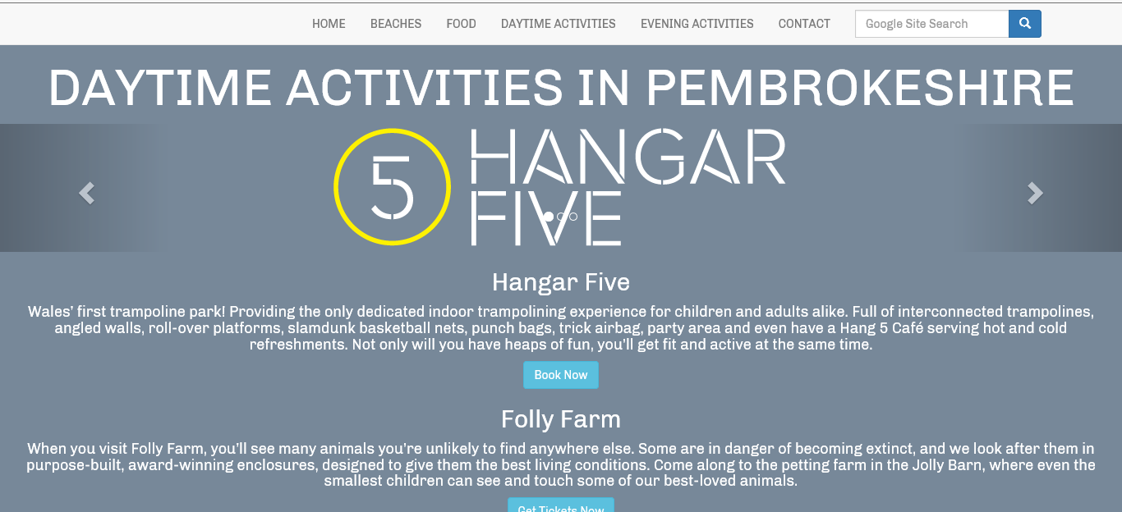
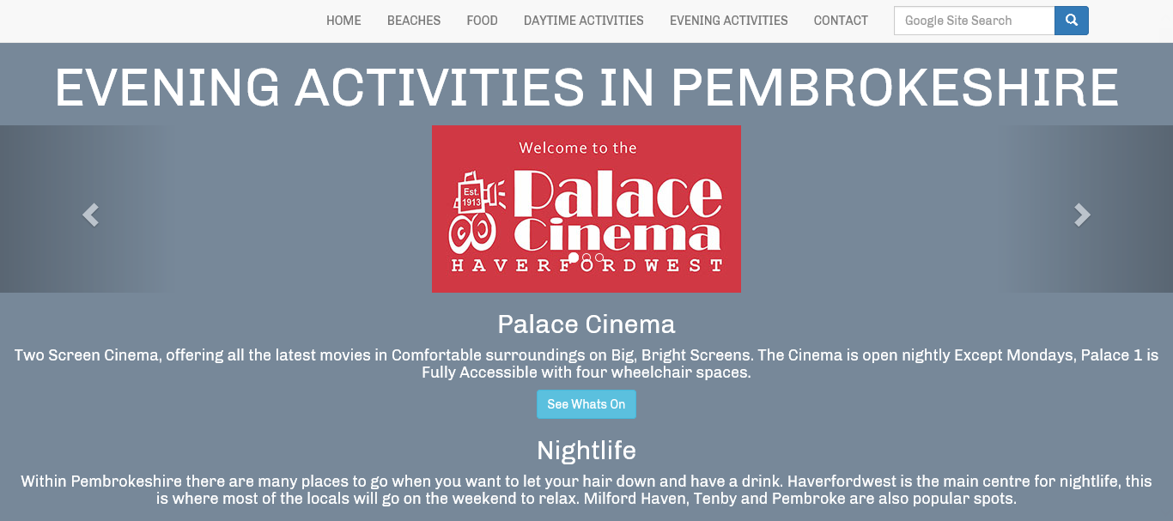
Evening Activties:
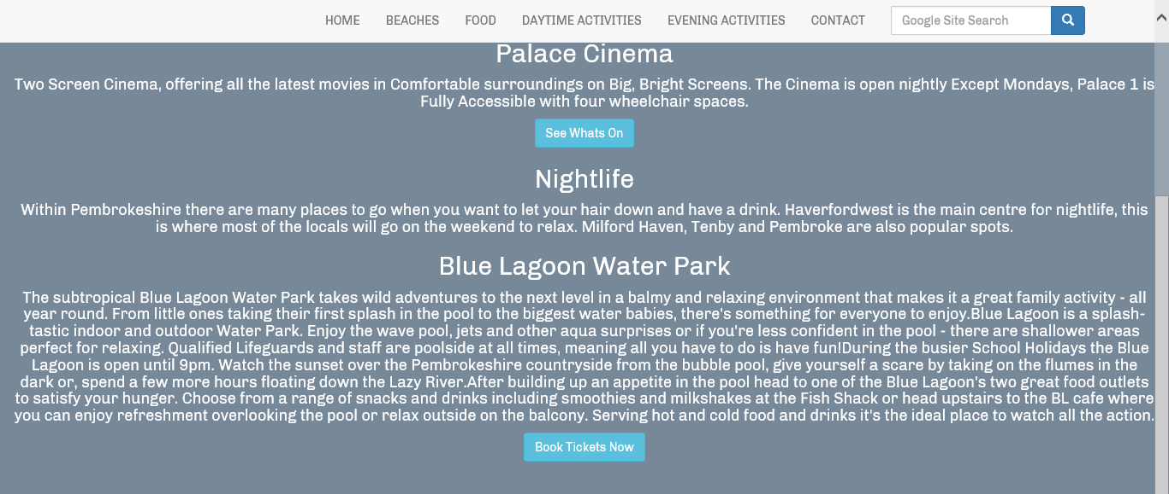
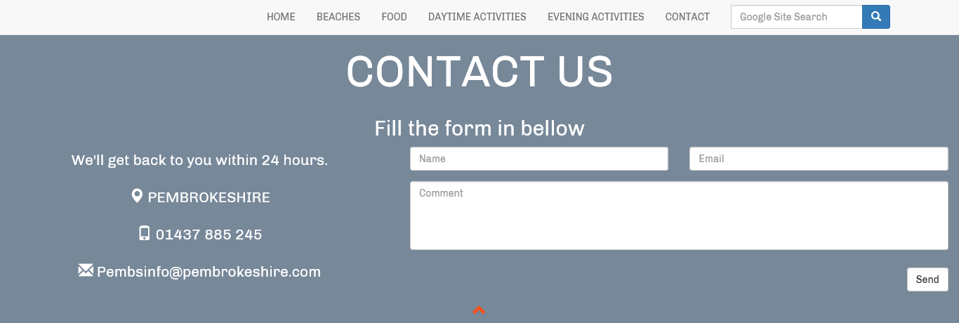
Contact:

IMAGES OF CODE:
Pop-Up:
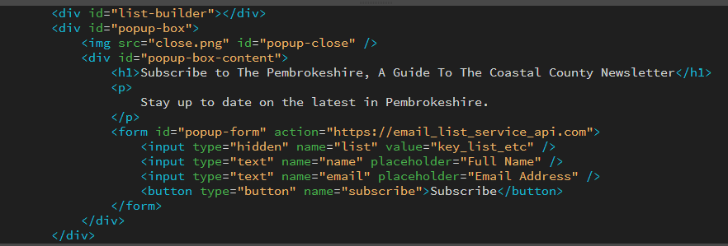

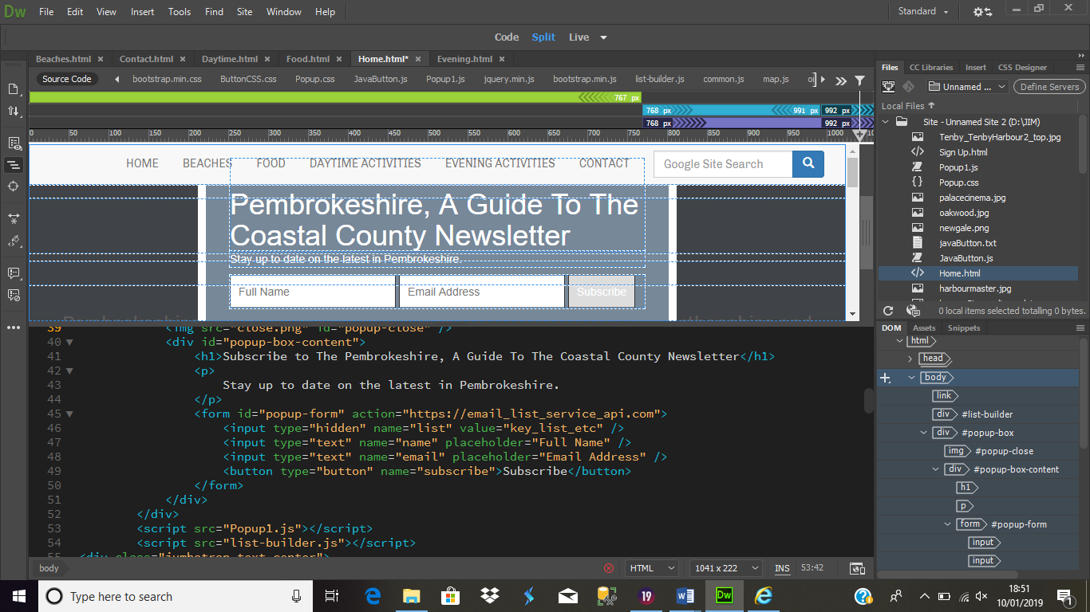

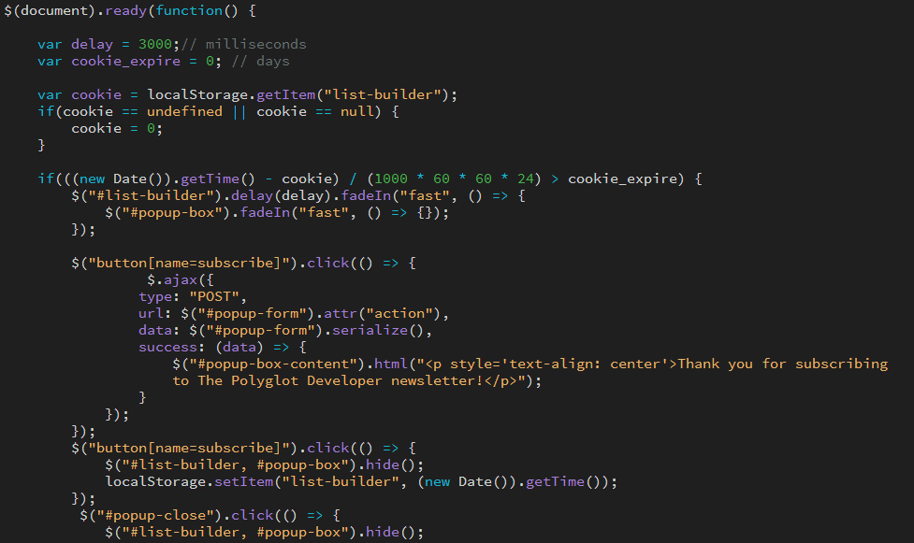

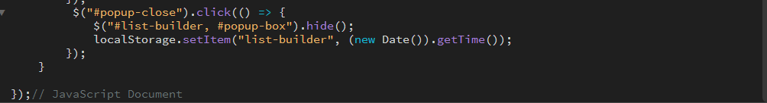
More/Less Button:

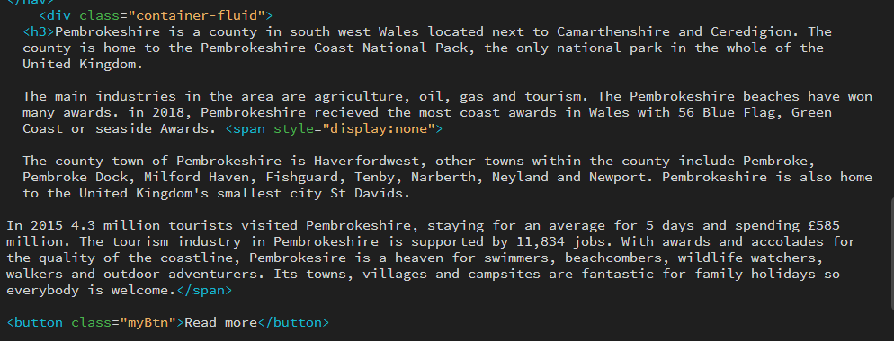
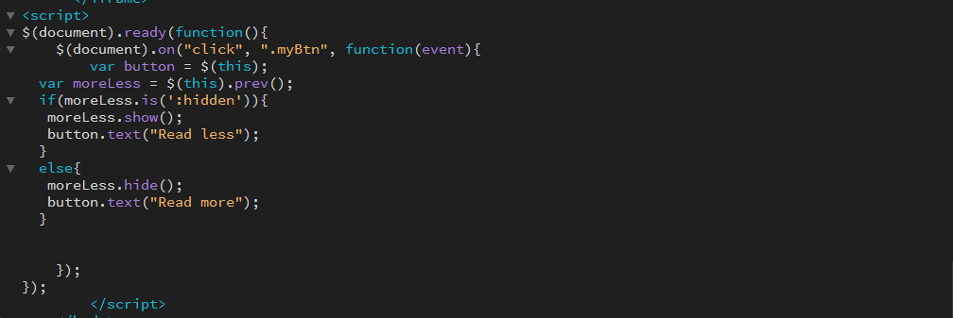

Evaluation
To ensure that my functions are working correctly and will not crash when users visit and interact with the website application I performed the following tests:
- Links: I checked all navigational and information links, here are just a few examples:

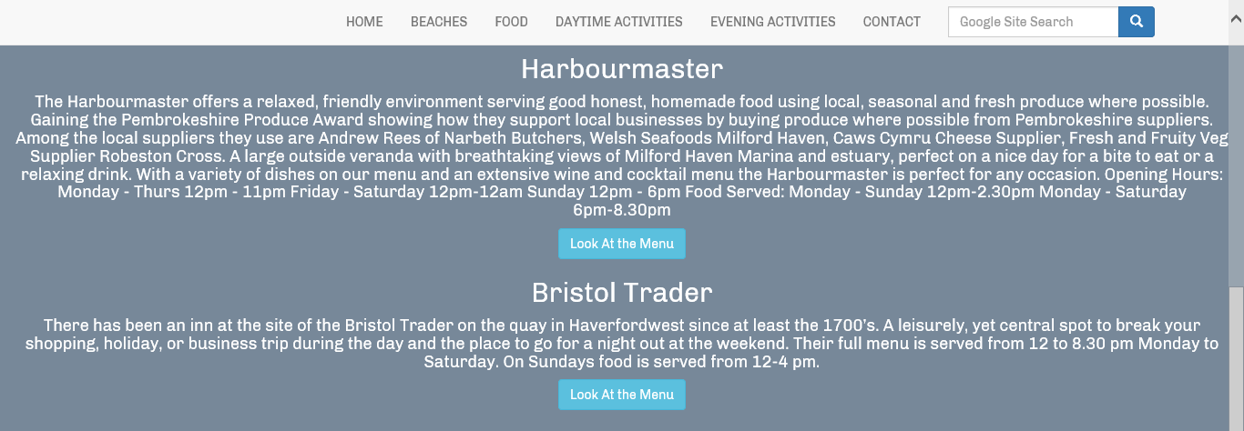
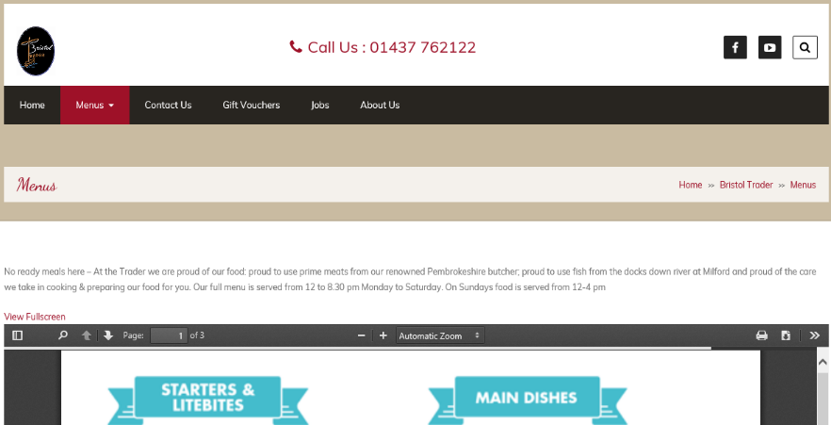
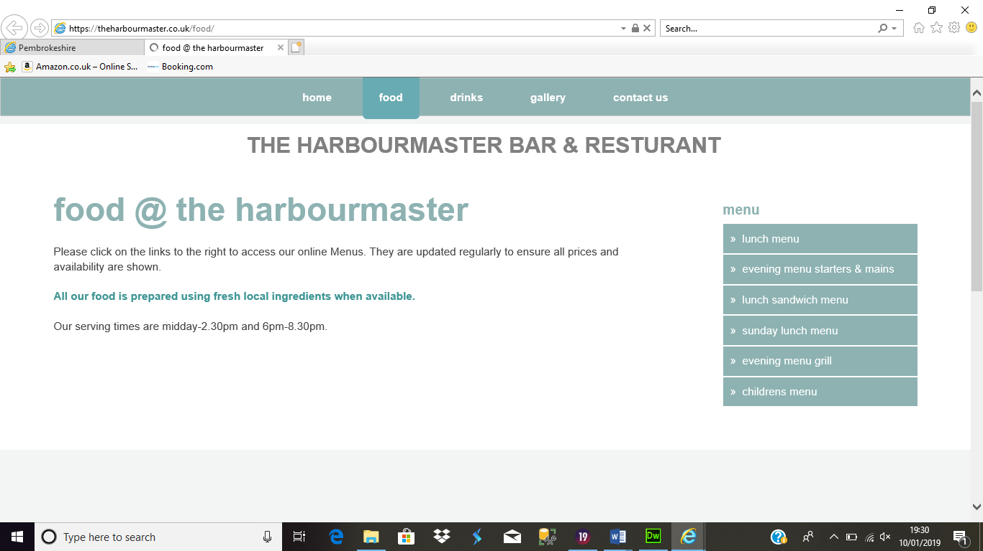

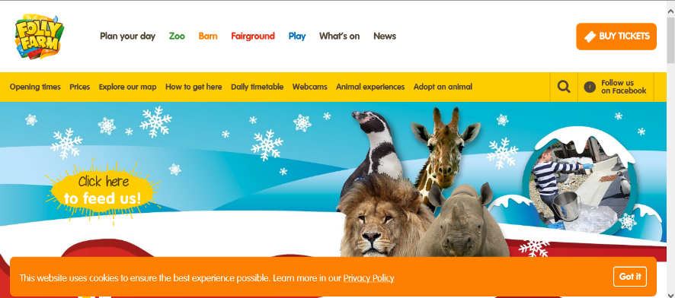
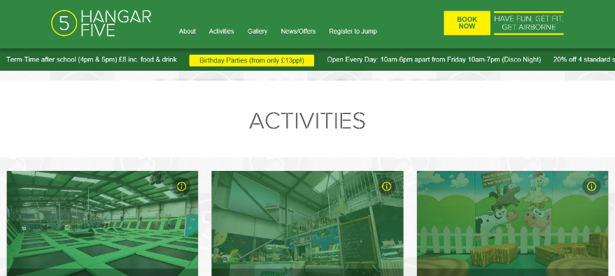
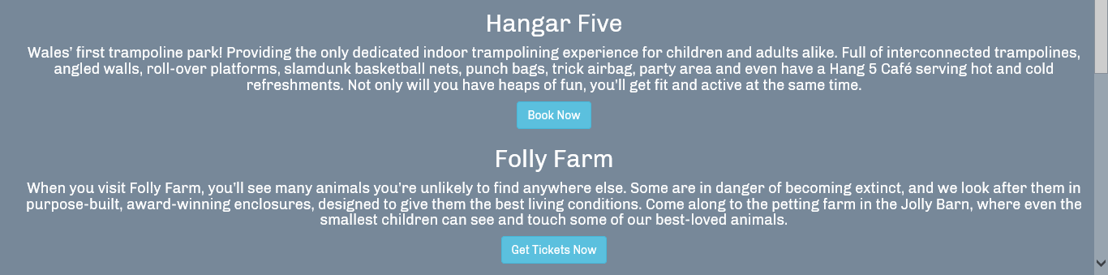

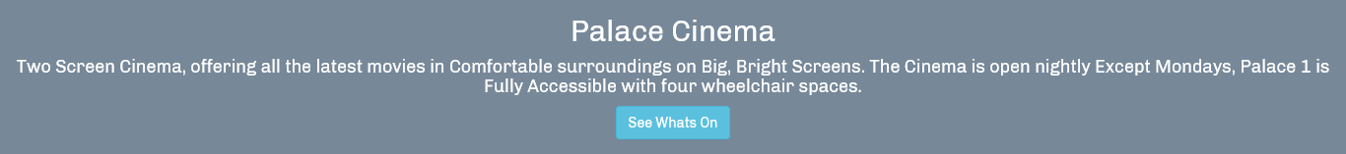

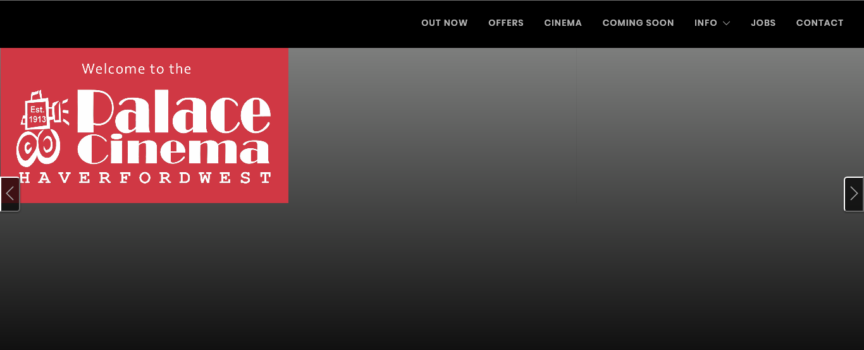

- Images: I ensured all images loaded correctly on each page and that the carousel images were working correctly.
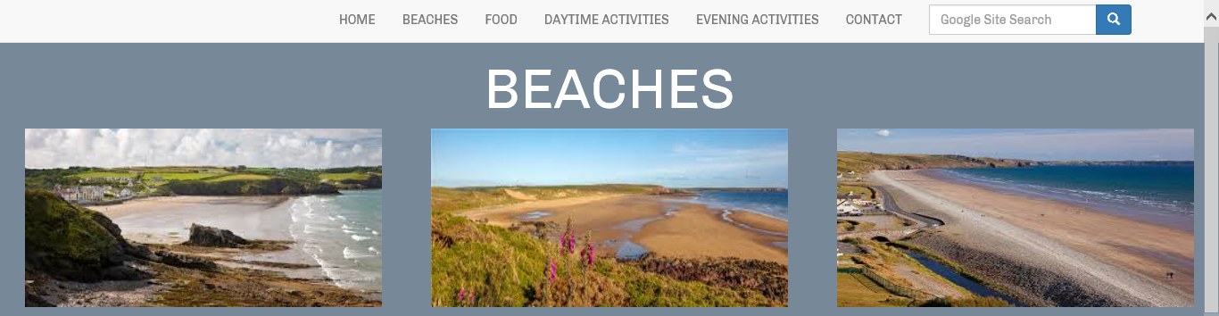

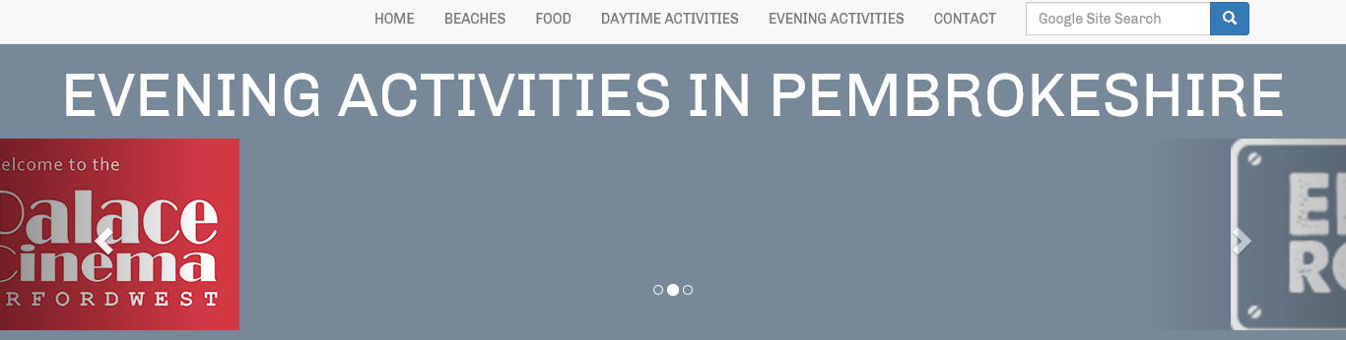

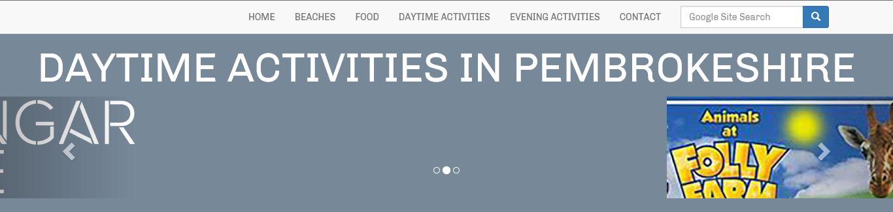

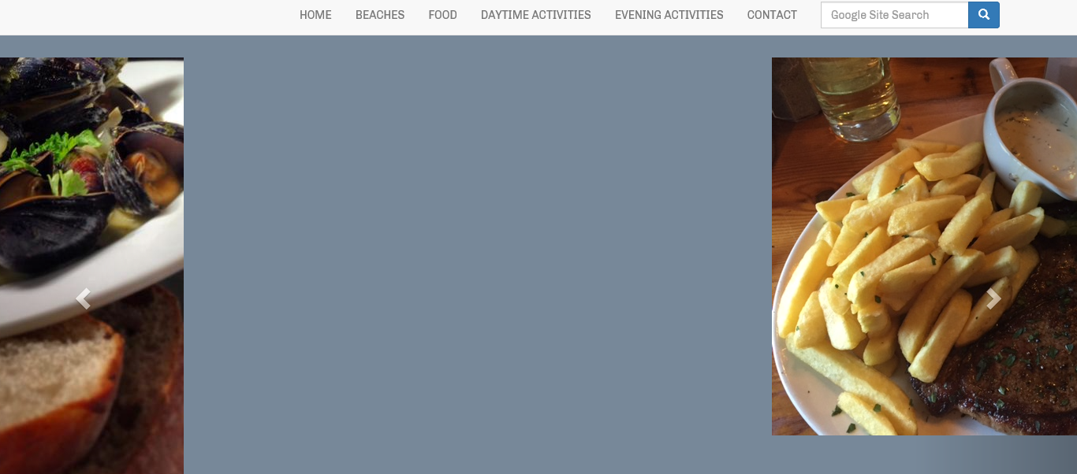

- Pop-up: I made sure that the pop-up feature on the homepage appeared after 3 seconds of me opening the website application.

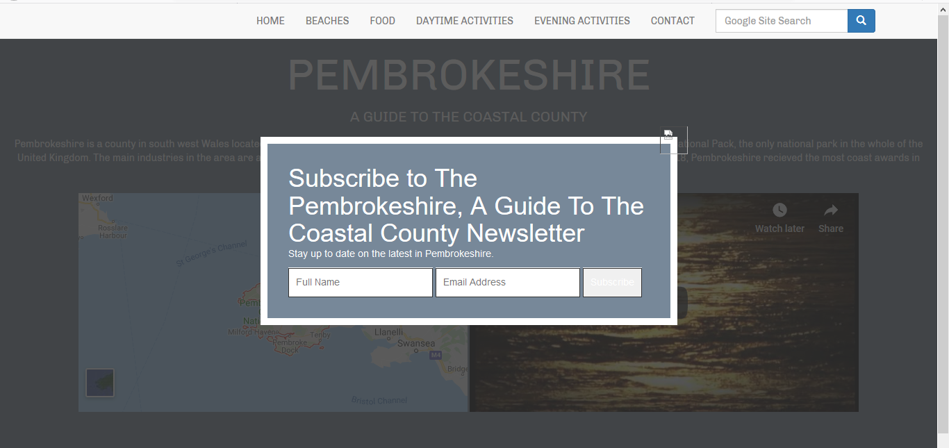

- Read more/less button: I checked that the read more/less button was working on the homepage.
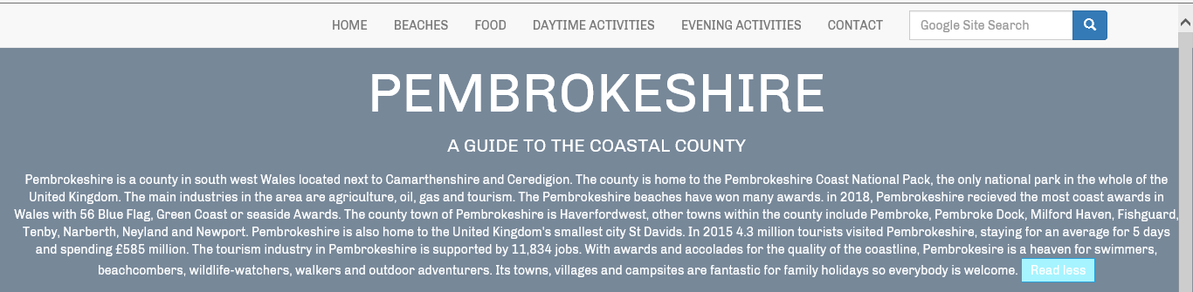
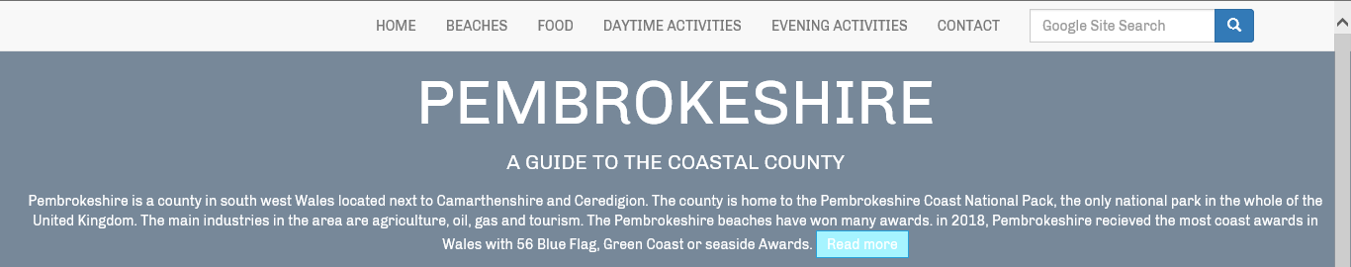
- Embedded features: I ensured that the embedded features on the homepage loaded correctly.

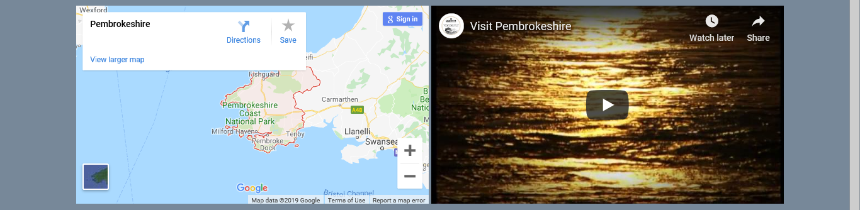
- Responsive on other devices: I ensured that the website application was responsive on other devices:

iPad:
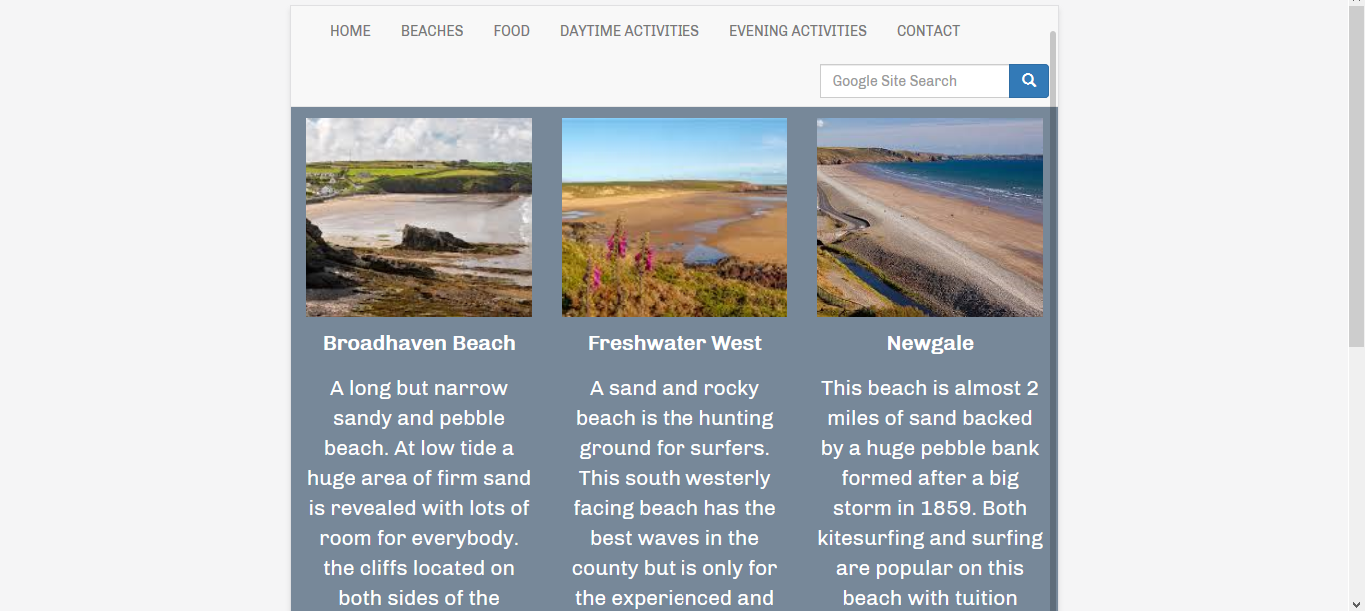
iPhone:

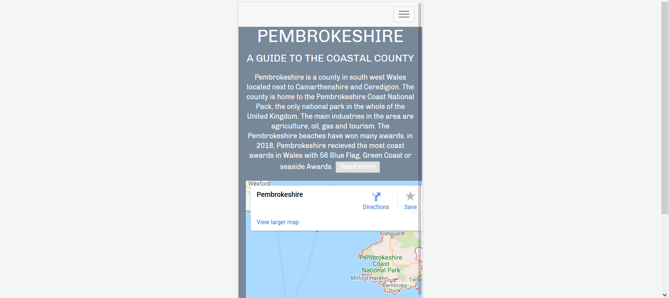

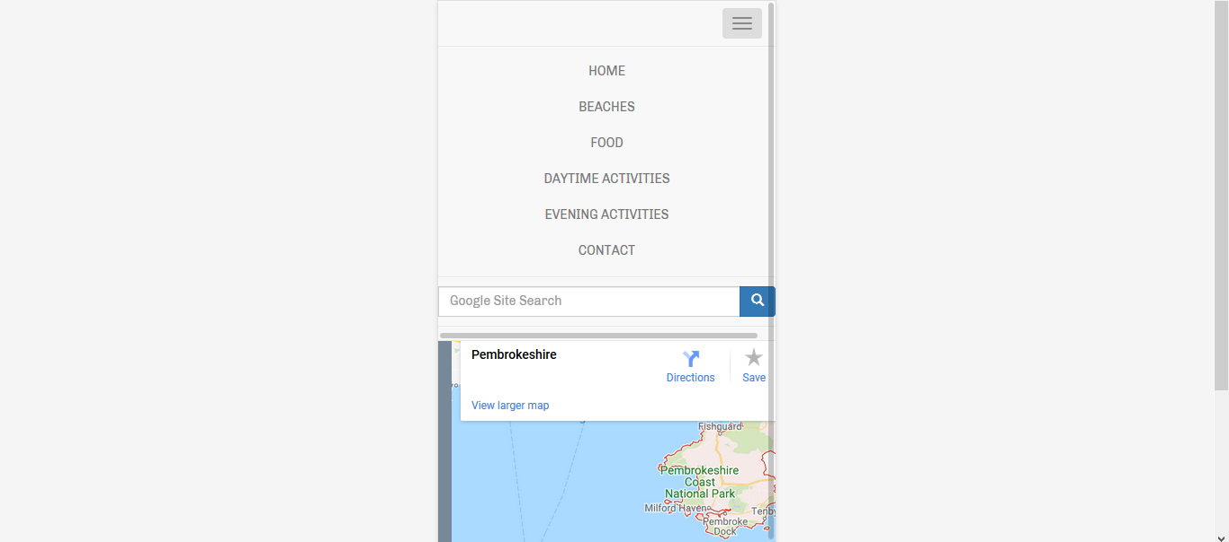
Samsung:
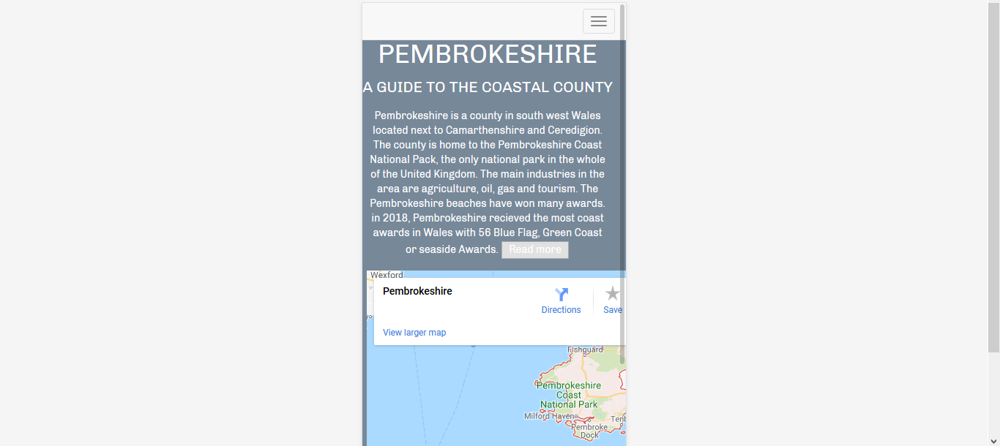
I then decided to validate all my HTML and CSS to ensure there weren’t any issues that could cause errors for users.
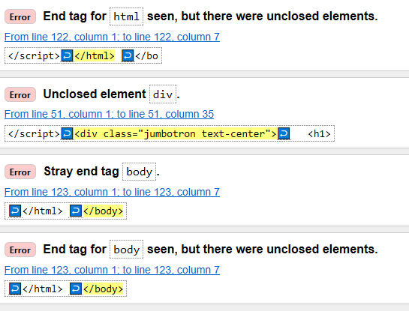
These were the errors I found on my homepage:
Once I corrected these there were no errors.
Testing table in appendices.
On reflection I am pleased with my website application, I believe that I have met all the specifications asked. The website application itself has a professional theme which runs consistently throughout, it is user friendly and is easy for users of all abilities to navigate. The information provided is easy to read and all relates to my chosen subject. The website application is responsive on multiple devices and browsers, which allows for users to access the website on whichever device they have to hand.
For added functionality I would add a forum where users can communicate with other users and ask for their opinions/recommendations in the area, I would also add a review system where users can review the recommendations on the website application, this would make the website more interactive and give users other opinions.

Appendices
Test | User Requirement | Expected Result | Actual Result | Pass/Fail | Date | Action Taken
All Pages
Navigation bar appears on all pages | Website is easy to navigate | Navigation bar appears | As expected | Pass | 12/01/2019 | None
Navigation bar links work | Website is easy to navigate | When mouse goes over links the colour of the text changes. Links take you to the correct pages. | As expected | Pass | 12/01/2019 | None
Home Page
Pop-Up | Pop-Up appears on home pages once user has been active for 3 seconds | Pop-up appears after 3 seconds | As expected | Pass | 12/01/2019 | None
Read more/less button | If the user wants to read more information they can select read more, once they have read the information they can read less. | When read more is selected more information is displayed, when read less is selected the information is retracted. | As expected | Pass | 12/01/2019 | None
Embedded Youtube video | Youtube video is displayed on the homepage and can be played. | Youtube video appears on the homepage and can be interacted with by the user. | As expected | Pass | 12/01/2019 | None
Embedded Google Map | Map shows a map of the correct area and can be used by the user. | Map displays a map of Pembrokeshire and can be interacted with by the user. | As Expected | Pass | 12/01/2019 | None
Beaches Page
Images | Images are visable to the user. | Images of each beach are displayed and available for the user to see. | As Expected | Pass | 12/01/2019 | None
Food Page
Carosel Images | Images are displayed, changed at intervals and can be manually changed by the user. | First image is displayed, image moves across and makes room for the next image to appear. The image can be changed manually when the user selects the left/right buttons. | As Expected | Pass | 12/01/2019 | None
Menu Links | The three links to three different menus take the user to the correct place. | When the user selects the button bellow the corrosponding resturant they are taken to that resturants menu page. | As expected | Pass | 12/01/2019 | Pass
Daytime Activties Page
Carosel Images | Images are displayed, changed at intervals and can be manually changed by the user. | First image is displayed, image moves across and makes room for the next image to appear. The image can be changed manually when the user selects the left/right buttons. | As Expected | Pass | 12/01/2019 | None
Activity Links | The three links to three different activities take the user to the correct place. | When the user selects the button bellow the corrosponding activity they are taken to the companies page. | As expected | Pass | 12/01/2019 | Pass
Evening Activties Page
Carosel Images | Images are displayed, changed at intervals and can be manually changed by the user. | First image is displayed, image moves across and makes room for the next image to appear. The image can be changed manually when the user selects the left/right buttons. | As Expected | Pass | 12/01/2019 | None
Activity Links | The two links to two different activities take the user to the correct place. | When the user selects the button bellow the corrosponding activity they are taken to the companies page. | As expected | Pass | 12/01/2019 | Pass
Contact Page
Form | Contact form is displayed and can be interacted with. | Contact form appears on the contact page, users are able to input all the information needed. | As Expected | Pass | 12/01/2019 | None
Form send button | Button is active | When the user selects the send button they are taken back to the home page. | As expected | Pass | 12/01/2019 | Pass

References
(1) https://shortiedesigns.com/2014/03/10-top-principles-effective-web-design/
(2) https://www.mockplus.com/blog/post/difference-between-usability-and-user-experience
https://www.w3schools.com/

