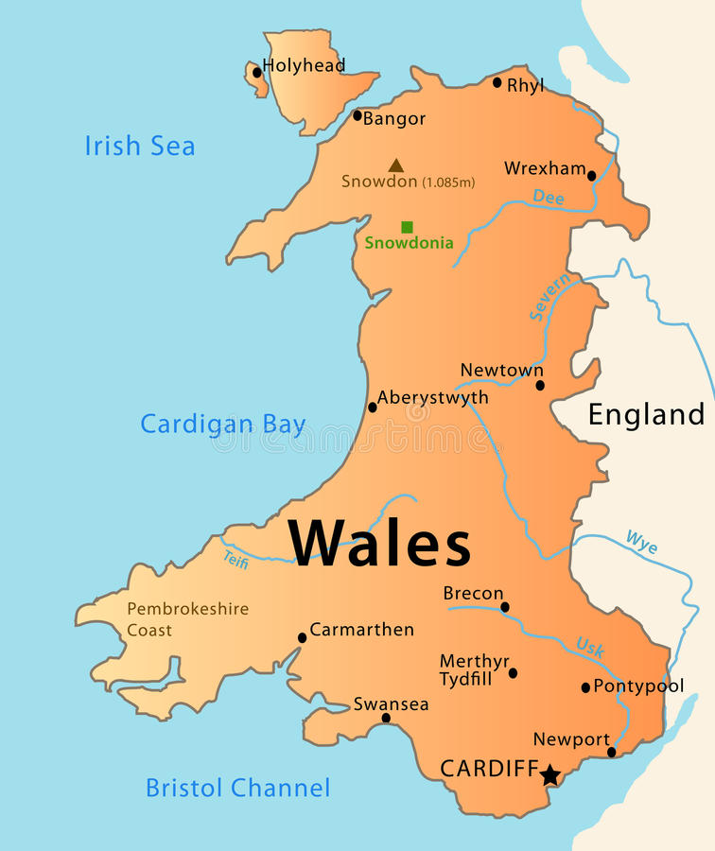

Campbell & Co

Darryl Campbell

P152218
Contents

- Introduction
- The current structure of the Welsh and UK housing market
- Mortgages
- Economic growth
- The ripple affect
- Interest rates
- The welsh and UK housing market over the next 2 years (Economic risks)
- Supply side and the demand side of the market
- Demand
- Supply
- PESTLE analysis
- SWOT analysis
- Recommendations
- Conclusion
- Appendixes
- References & Bibliography

Introduction

Campbell & Co have been employed to offer their services to the medium sized welsh developer Salahs consultants. The report will be broken down into sections looking at factors of the UK and Wales. The current housing market and the economic risks will be exposed and analysed over the next couple of years. Recommendations will be stated and a PESTLE AND SWOT analysis will be taken.

The current structure of the Wales and UK housing market

The Housing crisis is more than a shortage of houses, but there are too many buyers. A lot of places around the UK, London in particular face an unknown or insecure future because of the dysfunctional UK housing market. A lot of leasehold and freehold properties in Wales and around the UK are bought with the aid of a long term loan mortgage over a 25 year period. (Thersa.org, 2017)

Rapid fluctuations, instability distorts housing choices, increase risks, drives mortgage arrears and repossession rates in the housing market is currently an issue with home owners directly exposed.
Current house prices are to increase by 5.3% on average this year. Annual house price inflation is expected to rise to 5.7% running through to 2020. The housing stock grows gradually each year In the UK the current average property for buyers could be worth around £279,000, rising to around £360,000 by 2020. So a big rise, meaning less private housing sales on the economy. Challenging the macroeconomic environment in regards to inflation, the zero earnings growth from 2016 onwards is at its records low which could lead to stagnant mortgage lending. (Pwc.co.uk, 2017) Building more affordable homes will help fix the root cause of our broken housing market.
(JRF, 2017) There is a national issue of challenges in the current UK housing market that young people face when trying to get on to the property ladder. (Natcen.ac.uk, 2017) There isn’t any stamp duty on primary properties in wales up to £150,000 this will help the economy by encouraging first time buyers to get onto the house buying market. (Pyke, 2017) There are a lot of variations in price across the current UK regions, London have a downward pressure on prices, whilst Wales with further price gains. (Rics.org, 2017) Seen in appendix 2

Sprinkler systems are being installed in all new and converted houses in Wales from the 1st January 2016 which help save lives and enhance the safety of the occupants. (Gov.wales, 2017) They could be in the region of £3000-£9000 depending on system type. (Ultrasafe.org.uk, 2017)

Mortgages

Mortgage rates could rise in monthly payments if the banks raise their interest rates. Mortgage approvals fell to their lowest figure since September 2016 with lenders tightening their credit taps. Fixed rate mortgages for a 2 year period are the most popular. (Chu, 2017) (Meadows, 2017) (Monaghan, 2017) Mortgage companies offer a 25 to 35 year policy for payments and very rarely offer life time mortgages.

There are a range of schemes and incentives available by the government and by private housing developers to help first time buyers get on the housing ladder with just a 5% deposit.(T.Wimpy,2017)

Economic growth

Since 2008 to current Wales has the third best growth GVA (growth value added) in the UK, but eight years on it has the lowest level recorded in modern times. (Anon, 2017)

Wales unemployment rates have dropped enormously, reducing it to the same as the UK average Welsh pensions, benefits and investments has significantly fallen. (BBC News, 2017)

The UK housing market is at its lowest it’s been in 5 years with rising inflation and weak wage growth. (Partington, 2017) The housing market is extremely important in the UK because changes in house prices can have effect on the rest of the economy creating positive or negative wealth effect in the form of a mortgage, effecting the equity. It represents a household’s biggest single purchase representing the largest single item of consumer wealth. Inflation growth is affecting the housing market currently (Antonakakis and Floros, 2016)

The ripple affect

The ripple effect in house prices has to be considered. House prices in the main economic region that is in South East England influence the prices in the other UK regions.” There are four economic interactions that lead to the observed pattern of the spill over”. (Tsai, 2014 pg69)
- Migration
- Equity transfer
- Spatial arbitrage
- Spatial arbitrage
These four reasons cause the ripple affect which changes the transaction in the regional housing market. (Tsai, 2014)

Interest rates

Interest rates are increasing due to inflation, which have effect on the UK economy by driving up borrowing rates. The banks decide to increase interest rates to reduce demand and to reduce economic growth, this can affect mortgage repayments. This decreases the demand for properties and also diminishes their prices. (Economicsonline.co.uk, 2017)

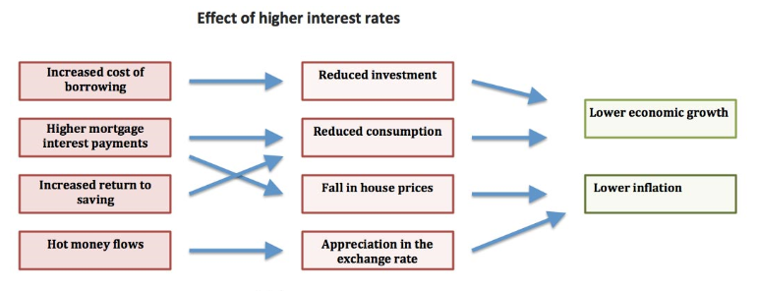
(Economicshelp.org, 2017)

The Wales and UK housing market over the next 2 years (Economic risks)

The social housing sector is going to lose £2.3bn over the next four years due to welfare Reform and Work Act 2016. Social housing providers are to reduce their rent charges by 1% over the next four years, this will have a knock-on effect that will occur a loss affecting the social housing provider’s ability to construct new housing stock in the next 2-4 years. (Duvier et al., 2017)

Data quality collection can be an issue and it can be unclear causing financial difficulties for the social housing providers to be able to afford to invest in the area. The costs of assuring and improving data affect data quality costs the most, bad data in service organisations and typical organisations can increase the expenses up to 40-60% and revenue costs can also be increased by 8-12%.(Duvier et al., 2017)

Wales is projected to see house price growth by around 2.5% as seen in appendix 1 and weekly rental rates to increase on average from £134-164 over the next 2-3 years as part of a general pattern of increased convergence across the UK regions. Seen in appendix 3 (Naea.co.uk,2017)

A lot more Private housing building sectors are holding back constructing in the near future due to the 2008 credit crisis, skill and material shortage is at it all time high. (Naea.co.uk,2017) The UK leaving Europe Brexit has affected the housing market substantially, but this will vary by region over the next couple of years.

In Wales the Welsh housing quality standard will help to improve the social housing stock by 2020, all social housing landlords will have to comply with the standard to ensure good quality homes. (Gov.wales, 2017)

Many firms are forced to offer wage increases due to the skill shortage supply, this will cause a greater challenge going forward

At least 300,000 houses would need to be built a year in the UK to meet the growth of demand. Availability of land and lack of infrastructure would be a cause of concern. A million homes by 2020 was the target set in 2015, a considerable increase in the next 3 years would need to take place in order to achieve that figure. (Ft.com, 2017) (BBC News, 2017) A scheme of 20,000 affordable houses are to be built by 2021 in wales with an additional budget of £30million taking it to £100million. This is an agreement set by the welsh government working with councils and housing associations. (Shipton, 2017)

Supply side and the demand side of the market

In the typical housing market, the housing demand is mainly determined by income of households, house prices, population and user cost of housing, whereas housing supply is influenced by the cost of the new construction and the house price.

The static equilibrium of the UK housing market can be derived by letting the demand function equal to the supply function. The UK housing market will grow dramatically by 2020 and will be demanded by supply side developments. (Naea.co.uk,2017)

Demand

Demand in housing has outstripped supply in Wales and across the UK for many years. Incomes are rising which means that people can spend more on houses so the demand will be greater. The increased Welsh life expectancy is growing and also divorce rates and an increase in single parent families are becoming more. (Economicshelp.org, 2017)

Household numbers are increasing rapidly, in 2017 there were 19 million families in the UK compared to 1996 where there were 16.6 million this is a 15% increase that is growing daily. (Horscroft and Horscroft, 2017) Wales estimated private household population has been estimated around 9,000 over the past year. 19 to 22 Welsh local authorities were increased by households.

Banks are much stronger and more resilient in lending markets so they will be able to function and satisfy demand more. (Countrywide.co.uk, 2017)

October 2017 RICS residential market shows demand and sales to be softening at the national level.

Supply

Not constructing enough housing can affect the supply side, as well as planning restrictions and also issues with being able to construct on green belt land. House prices that fall can lead to a restriction in supply. (Economicshelp.org, 2017) The lack of supply in growing households will support the level of prices, even with the slowdown of growth. (Colson, 2017) The housing supply in the UK is one of the lowest in Europe, the focus is on improving the supply so that housing building is more responsive to changes in the market demand. (tutor2u, 2017)

PESTLE analysis

Pestle analysis are used for business analysis by companies to track the environment they are operating in or if they are planning on a new project. Certain questions need to be asked to give an idea of what aspects to think of during the process. Campbell & Co are going to carry out a PESTLE analysis on the housing market for the Welsh medium sized developer salah’s consultants. (PESTLE Analysis, 2017)

 | Pestle analysis
Political | A lot of land and stock supply is awaiting planning permission from local authorities this can be a long and political process with different arguments and opinions in order for it to be granted. This can have a knock on affect to the housing supply.  Political uncertainty of tax changes low sale activity and price growth are hindering the UK housing market. (Collinson, 2017)
Economic | Changes in economic growth can impact on the housing market, as well as lower availability of mortgages, continuous increases in interest rates can lead to increase in mortgages, which can cause financial struggles in times of economic hardship.
Social | Brownfield sites help the social regeneration of areas by allowing site for developing education buildings, leisure facilities and other services to help avoid future social problems. (Research-topics.blogspot.co.uk, 2017)
Technological | Fast and new building materials and building methods such as pre fabrication increase the speed houses are built at. This can help increase the demand of property, but can affect the elasticity, supplying properties at the cheaper side of the market. (Economicsonline.co.uk, 2017)
Legal | With interest rates getting higher this means mortgages are, this can affect consumer spending levels. New UK rules have tightened up lending regulations and will potentially increase taxes for UK based buyers of British property. (Wealth.barclays.com, 2017)
Environmental | Thinking about the environment efficiently, availability of land also using it sensibly, protecting national parks and countryside from development, using brownfield sites more to save greenfield. An increase in land availability will shift the supply curve to the right. (Economicsonline.co.uk, 2017)

SWOT analysis

Strengths, Weaknesses, Opportunities and Threats (SWOT) is a key factor to a business planning, and will help make the decision easier weather to move to forward. Campbell & Co are going to carry out a SWOT analysis on the housing market for the Welsh medium sized developers Salahs consultants.
(Smartdraw.com, 2017)

Strengths  - National shelter program, housing and urban development framework in place.  - Disaster and risk reduction management (DRRM) put in place  - Scheme put into place to build 300,000 houses in UK and 20,000 in wales over the coming years.  - Wage increases.  - Social housing programme in place.  - Community mortgage program for example the Welsh help to buy scheme.  (Haley, 2017) | Weaknesses  - Shortage of affordable housing.  - Over regulated environment for housing.  - Delays in obtaining certifications, licences and clearances.  - Poor land management policies.  - Lack of available land.  (Documents-takomapark.s3.amazonaws.com, 2017)
Opportunities  - Growing economy.  - Growing housing supply.  - More job and apprenticeship opportunities.  - More available homes for people.  - Greater opportunity for banking, financial sector and lenders.  (CIOB, 2017) | Threats  - Less people are buying.  - Mortgage and interest rates are on the rise.  - Wages are not rising as quickly as the economy is changing.  - Increase in population and migration.  - Climate change.  - Ineffective housing development policies and programmes.  - Social housing sector low in return investment.  (Creba.ph, 2017)

RECOMMENDATIONS

In regard to social housing the problems and issues arising from poor quality data, the missing data and the lack of consistency between the data storage systems make the task more challenging. According to (Gov.wales, 2017) there are 228,684 social housing units in wales. Additional extensive training will help raise awareness, App like tools for recording data will help staff going into properties, splitting the data into smaller more manageable chunks, making sure the new data entered is of a high quality, change the way the data is collected and the kind of data collected, these steps will help keep expenses to a minimum. (Duvier et al., 2017)

People around the UK and in wales would like to see bank raising interest rates slow down and reach more of a steady pace over the coming years (BBC News, 2017) Interest rates cut, or even negative interest rates this will encourage people to spend rather than save. (Owen, 2017)

Planning reform and tax cuts for first time buyers would encourage people to invest helping the demand on the housing market. (Ft.com, 2017)

The government needs to take action on supplying more land for the 300,000 new homes being built a year. Cracking down on land banking and underwriting loans to small home builders to get homes built more efficient and quicker. (Mail Online, 2017)

Conclusion

The housing market over the next few years is set to expand in regards to housing and economic growth, statistics show that people especially younger people are holding back into getting onto the property ladder due to their financial situation and the slowdown in wage increase, the rise in interest and mortgage levels will surely have a knock on affect to the whole industry. The demand of new homes in the UK and Wales will help fix the broken housing market substantially but the question is are people willing to pay with the rise in valuation of properties over the coming years, this could cause people to be turning more to social housing aspect. The Welsh Governments help to buy scheme could increase the interest for young people to buy their first home but there could still be the issue of young people having to find that 5% of the overall total of the property. The skill supply shortage is a cause of concern going forward this will impact the construction industry.

Appendix 1
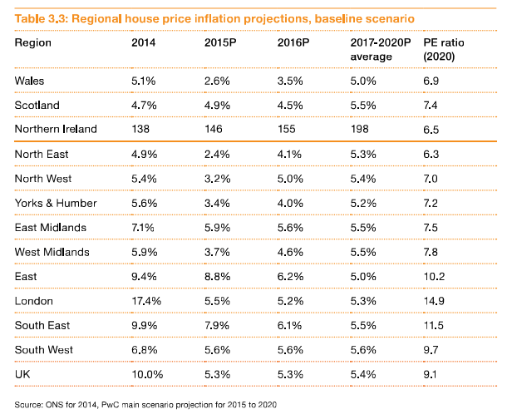
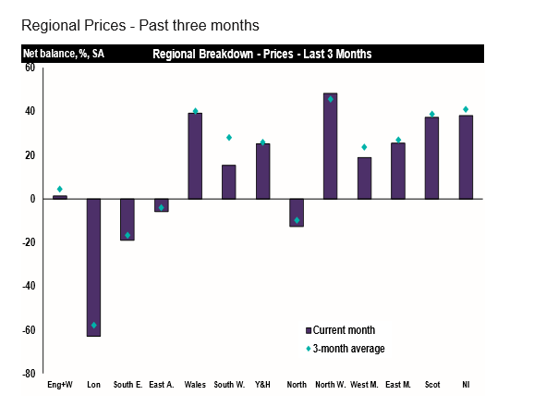

Appendix 2 (Gov.uk 2017)

Appendix 3
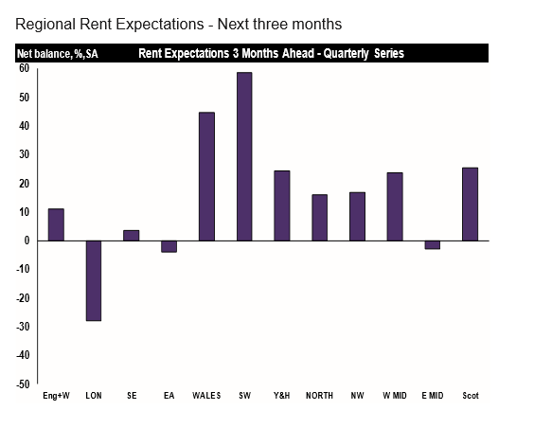
(gov.uk 2017)

References & Bibliography

Tsai, I. (2014). Ripple effect in house prices and trading volume in the UK housing market: New viewpoint and evidence. Economic modelling, pp.68-75.

Duvier, C., Neagu, D., Oltean-Dumbrava, C. and Dickens, D. (2017). Data quality challenges in the UK social housing sector. International journal of information management, 38(1), pp.196-200.

Gov.wales. (2017). Welsh Government|Social landlord housing stock and rents. [online] Available at: http://gov.wales/statistics-and-research/social-housing-stock-rents/?lang=en [Accessed 27 Nov. 2017].

Antonakakis, N. and Floros, C. (2016). international review of finacial analysis. dynamic interpendencies amoung the housing market, stock, policy, 44, pp.111-122.

Thersa.org. (2017). Why only UK taxpayers should own UK homes - RSA. [online] Available at: https://www.thersa.org/discover/publications-and-articles/rsa-blogs/2016/04/no-domicile-no-domus-why-only-uk-taxpayers-should-own-uk-homes?gclid=Cj0KCQiA6enQBRDUARIsAGs1YQgvYeazdzgSn8QoHAK19UtmqZNUZyLFQ0-wTVQ8vcOTP5r7hMBb0ZkaAt9lEALw_wcB [Accessed 27 Nov. 2017].

Economicsonline.co.uk. (2017). The UK housing market. [online] Available at: http://www.economicsonline.co.uk/Competitive_markets/The_housing_market.html [Accessed 27 Nov. 2017].

JRF. (2017). 600,000 more people face rent shortfalls. [online] Available at: https://www.jrf.org.uk/press/six-hundred-thousand-more-people-face-rent-shortfalls [Accessed 30 Nov. 2017].

Natcen.ac.uk. (2017). When life gets in the way: aspirations of home ownership. [online] Available at: http://www.natcen.ac.uk/blog/when-life-gets-in-the-way-aspirations-of-home-ownership?gclid=EAIaIQobChMI-suxzpnh1wIVxZ3tCh0QYgNSEAAYASAAEgLDHPD_BwE [Accessed 30 Nov. 2017].

Gov.uk. (2017). UK House Price Index summary: July 2017 - GOV.UK. [online] Available at: https://www.gov.uk/government/publications/uk-house-price-index-summary-july-2017/uk-house-price-index-summary-july-2017 [Accessed 11 Dec. 2017].

Pwc.co.uk. (2017)[online] Available at: https://www.pwc.co.uk/assets/pdf/ukeo-section3-housing-market-july-2015.pdf [Accessed 4 Dec. 2017].

Rics.org. (2017)[online] Available at: https://www.rics.org/Global/10._WEB_%20October_2017_RICS_UK_Residential_Market_Survey_tp.pdf [Accessed 4 Dec. 2017].

Naea.co.uk. (2017) [online] Available at: http://www.naea.co.uk/media/1043988/housing-2025.pdf [Accessed 4 Dec. 2017].

tutor2u. (2017). The Exam Performance Specialists | tutor2u Economics. [online] Available at: https://www.tutor2u.net/economics/reference/uk-housing-market-the-housing-shortage [Accessed 4 Dec. 2017].

Gov.uk. (2017). UK House Price Index summary: July 2017 - GOV.UK. [online] Available at: https://www.gov.uk/government/publications/uk-house-price-index-summary-july-2017/uk-house-price-index-summary-july-2017 [Accessed 4 Dec. 2017].

ITV News. (2017). Average house price in Wales reaches new peak. [online] Available at: http://www.itv.com/news/wales/2017-10-11/house-prices-in-wales-increase-as-buyers-take-advantage-of-low-interest-rates/ [Accessed 11 Dec. 2017].

Gov.wales. (2017). Welsh Government|Household estimates. [online] Available at: http://gov.wales/statistics-and-research/household-estimates/?lang=en [Accessed 11 Dec. 2017].

Gov.wales. (2017)[online] http://gov.wales/docs/statistics/2016/160927-household-estimates-mid-2015-en.pdf [Accessed 11 Dec. 2017].

Partington, R. (2017). Confidence in UK housing market falls to five-year low. [online] the Guardian. Available at: https://www.theguardian.com/business/2017/oct/27/uk-housing-market-confidence-weakens-5-year-low-house-prices [Accessed 6 Dec. 2017].

Chu, B. (2017). The number of UK mortgage approvals has fallen to the lowest in nine months. [online] The Independent. Available at: http://www.independent.co.uk/news/business/news/uk-mortgage-approvals-drop-lowest-level-housing-market-homes-buying-first-time-a7868406.html [Accessed 6 Dec. 2017].

Meadows, S. (2017). Mortgage warning: two-year deals 'dangerous' as house prices weaken and rates rise. [online] The Telegraph. Available at: http://www.telegraph.co.uk/personal-banking/mortgages/mortgage-warning-two-year-deals-dangerous-house-prices-weaken/ [Accessed 6 Dec. 2017].

Monaghan, A. (2017). UK house prices pick up but still under pressure, says Nationwide. [online] the Guardian. Available at: https://www.theguardian.com/business/2017/nov/01/uk-house-prices-nationwide-market [Accessed 6 Dec. 2017].

Economicshelp.org. (2017). [online] Available at:
https://www.economicshelp.org/macroeconomics/monetary-policy/effect-raising-interest-rates/ [Accessed 6 Dec. 2017].

Pyke, C. (2017). This is how much the average house costs where you live. [online] walesonline. Available at: http://www.walesonline.co.uk/business/business-news/how-much-average-house-price-13755984 [Accessed 6 Dec. 2017].

Gov.wales. (2017). Welsh Government|Welsh Housing Quality Standard. [online] Available at: http://gov.wales/topics/housing-and-regeneration/housing-quality/welsh-standard/?lang=en [Accessed 6 Dec. 2017].

Countrywide.co.uk. (2017) [online] Available at: http://www.countrywide.co.uk/media/59596/1608-countrywide-forecasts-final.pdf [Accessed 6 Dec. 2017].

Gov.uk. (2017). Economic growth in Wales - GOV.UK. [online] Available at: https://www.gov.uk/government/policies/economic-growth-in-wales [Accessed 11 Dec. 2017].

The Sun. (2017). Chancellor blasted for 300k new homes pledge and no scheme to build them. [online] Available at: https://www.thesun.co.uk/news/4950188/hammond-housing-pledge-blasted-by-mps/ [Accessed 11 Dec. 2017].

CIOB. (2017). Search Results. [online] Available at: http://www.ciob.org/search-results?keyword=housing%20market [Accessed 11 Dec. 2017].

Research-topics.blogspot.co.uk. (2017). PESTLE ANALYSIS on the UK Housing Sector. [online] Available at: http://research-topics.blogspot.co.uk/2011/08/pestle-analysis-on-uk-housing-sector.html [Accessed 11 Dec. 2017].

Wealth.barclays.com. (2017). The new rules affecting UK property buyers | Barclays. [online] Available at: https://wealth.barclays.com/en_gb/home/international-banking/insight-research/the-uk-property-market/the-new-rules-affecting-uk-property-buyers.html [Accessed 11 Dec. 2017].

Documents-takomapark.s3.amazonaws.com. (2017) [online] Available at: https://documents-takomapark.s3.amazonaws.com/housing-and-community-development/Strategic%20Plan/FINAL_Takoma_Housing_Economic_SWOT_Analysis_Oct2017.pdf [Accessed 11 Dec. 2017].

Anon, (2017). [online] Available at: http://www.walesonline.co.uk/business/business-opinion/reasons-cheerful-wales-economy-enter-12384971 [Accessed 11 Dec. 2017].

BBC News. (2017). Has Wales' economy lacked the big idea?. [online] Available at: http://www.bbc.co.uk/news/uk-wales-41419469 [Accessed 11 Dec. 2017].

Wealth.barclays.com. (2017). The new rules affecting UK property buyers | Barclays. [online] Available at: https://wealth.barclays.com/en_gb/home/international-banking/insight-research/the-uk-property-market/the-new-rules-affecting-uk-property-buyers.html [Accessed 12 Dec. 2017].

Gov.wales. (2017). Welsh Government|Sprinkler systems to be fitted in all new and converted housing from 2016. [online] Available at: http://gov.wales/newsroom/environmentandcountryside/2015/151123-sprinkler-systems-to-be-fitted-in-all-new-and-converted-housing-from-2016/?lang=en [Accessed 11 Dec. 2017].

Ultrasafe.org.uk. (2017). Fire Sprinkler System Cost | Ultrasafe Fire Suppression. [online] Available at: http://www.ultrasafe.org.uk/fire-sprinkler-system-cost/ [Accessed 11 Dec. 2017].

Ft.com. (2017). How to solve the UK housing crisis. [online] Available at: https://www.ft.com/content/d8854b1e-bf08-11e7-823b-ed31693349d3 [Accessed 11 Dec. 2017].
BBC News. (2017). Reality Check: Does England need 300,000 new homes a year?. [online] Available at: http://www.bbc.co.uk/news/business-42055623 [Accessed 11 Dec. 2017].

Shipton, M. (2017). £30m scheme announced to build 20,000 affordable homes. [online] walesonline. Available at: http://www.walesonline.co.uk/news/politics/30m-scheme-see-20000-affordable-12256539 [Accessed 11 Dec. 2017]

Economicshelp.org. (2017) [online] Available at: https://www.economicshelp.org/blog/15390/housing/factors-affecting-supply-and-demand-of-housing/ [Accessed 11 Dec. 2017].

Horscroft, D. and Horscroft, D. (2017). Families and Households - Office for National Statistics. [online] Ons.gov.uk. Available at: https://www.ons.gov.uk/peoplepopulationandcommunity/birthsdeathsandmarriages/families/bulletins/familiesandhouseholds/2017 [Accessed 11 Dec. 2017].

Colson, T. (2017). UK house price growth is set to slow by half over the next 5 years - here's why. [online] Business Insider. Available at: http://uk.businessinsider.com/uk-house-prices-will-they-rise-or-fall-in-2019-2017-9 [Accessed 12 Dec. 2017].

Economicshelp.org. (2017)[online] Available at: https://www.economicshelp.org/blog/15390/housing/factors-affecting-supply-and-demand-of-housing/ [Accessed 12 Dec. 2017].

PESTLE Analysis. (2017). What is PESTLE Analysis? A Tool for Business Analysis. [online] Available at: http://pestleanalysis.com/what-is-pestle-analysis/ [Accessed 12 Dec. 2017].

Collinson, P. (2017). 'Political uncertainty' blamed for slowdown in UK property market. [online] the Guardian. Available at: https://www.theguardian.com/business/2017/aug/10/uk-property-market-slowdown-political-uncertainty-surveyors [Accessed 12 Dec. 2017].

Research-topics.blogspot.co.uk. (2017). PESTLE ANALYSIS on the UK Housing Sector. [online] Available at: http://research-topics.blogspot.co.uk/2011/08/pestle-analysis-on-uk-housing-sector.html [Accessed 12 Dec. 2017].

Economicsonline.co.uk. (2017). The UK housing market. [online] Available at: http://www.economicsonline.co.uk/Competitive_markets/The_housing_market.html [Accessed 12 Dec. 2017].

Creba.ph. (2017). [online] Available at: http://creba.ph/pdf/HUDCC.pdf [Accessed 12 Dec. 2017].

Smartdraw.com. (2017). SWOT Analysis - SWOT Analysis Examples and How to Do a SWOT Analysis. [online] Available at: https://www.smartdraw.com/swot-analysis/#whatisSWOT [Accessed 12 Dec. 2017].

Haley, D. (2017). A SWOT Analysis for Real Estate Investors | PREITG. [online] Phillyreiopening.com. Available at: http://phillyreiopening.com/a-swot-analysis-for-real-estate-investors/ [Accessed 12 Dec. 2017].

BBC News. (2017). Interest rate rise - views from Wales. [online] Available at: http://www.bbc.co.uk/news/uk-wales-41835132 [Accessed 12 Dec. 2017].

Owen, C. (2017). How will mortgages and interest rates be affected by the Brexit vote?. [online] walesonline. Available at: http://www.walesonline.co.uk/news/politics/how-mortgages-interest-rates-affected-11521877 [Accessed 12 Dec. 2017].
Ft.com. (2017). Budget will not fix UK homes crisis, say housing chiefs. [online] Available at: https://www.ft.com/content/dacd273e-d425-11e7-8c9a-d9c0a5c8d5c9 [Accessed 12 Dec. 2017].

Mail Online. (2017). Philip Hammond to deliver 300,000 homes and nurses pay rise in Budget. [online] Available at: http://www.dailymail.co.uk/news/article-5096775/Philip-Hammond-build-300k-homes-nurses-payrise.html [Accessed 12 Dec. 2017].

T.Wimpey (2017) available at Taylor Wimpey brochure.

